# Full-Stack Developer Position Home Assignment

## User Story

As a user I would like to find either a cat or a dog in Africa.

Optional - I would like to filter my result per type(cat/dog).

## Wireframe

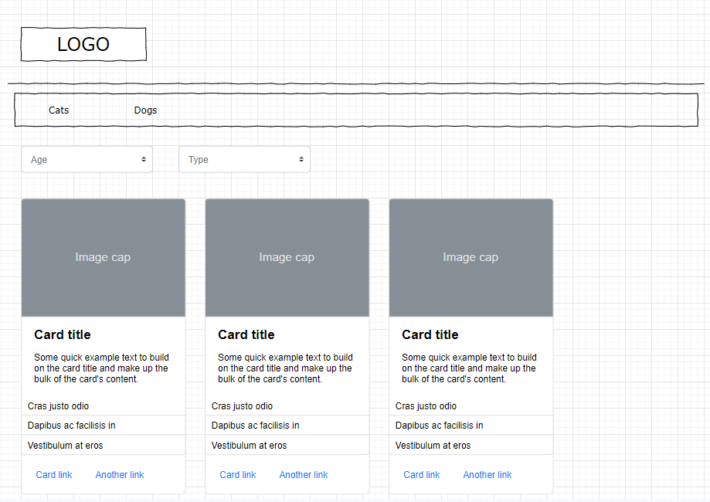

## Task Description:

* Create an End-to-End feature relying on data provided by [Animal API](https://api-ninjas.com/api/animals).

Optional - The feature will have 2 separate views:

* 1. Dogs View
  2. Cats View
* Both views should have a Card component list with the following attributes:
  1. Image
  2. Name
  3. Min life span
  4. Max life span

## Technical Requirements:

### Client

* React based webapp.
* Optional - Implement React Bootstrap as a theme. Custom design CSS is **not** required for this task.
* Optional - Integrate React Bootstrap [Card component](https://react-bootstrap.github.io/docs/components/cards) for the pets list.

### Server

* Create the project using Spring Boot for the REST service.
* Use the Animal API to find cats and dogs in Africa.  
  Note: To use Animal API you must first register free of cost on [Animal API](https://api-ninjas.com/api/animals) and get the  
  API_KEY.
* Performance – consider that Animal API is not likely to be updated very frequently, identical requests will return the same response. Implement the API usage in a way that will reduce identical requests to the API in a configurable timeframe.

Helpers:

IDE : https://spring.io/tools

Tutorial : https://spring.io/guides/gs/spring-boot/ - this will help you build a web server .

We use Maven

***Please create a readme file with simple instructions on how to run the project locally ***