Cyclist speed in downhill research

Nadav Halahmi, supervisor: Shlomo Rozenfeld

Introduction

Every descending cyclist is affected by some forces: gravity, which supports the rider and helps him to accelerate, its effect only depends on the mass of the rider. Air resistance, which opposes the rider while he is moving. Air resistance depends on the squared air speed of the rider and the rider's aerodynamic structure (mostly), so as the rider is faster, so that the air resistance has greater impact. Energy losses in the system- It has less impact on the rider than the other forces, in part due to that the rider is not pedaling, but it cannot be ignored.

In this project, I researched how descending rider’s speed is affected by time. I used GPS based speed sensors. I used a computer code in order to estimate the speed-time graph, based on the power equation I created in older project, and I checked how the real speed graph matches the calculated speed graph.

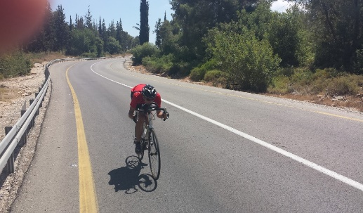 Research Method

In “Power calculation for cyclists” project, I created the power equation:

$$p=\left(mg sinα+\frac{1}{2}ρv^{2}k1+k2+ma\right)v$$

Based on this equation, I calculated how cyclist’s speed while he is not pedaling (p=0) depends on time, and presented a proper graph. After placing p=0 in the equation, I got:

$$0=mg sinα+\frac{1}{2}ρv^{2}k1+k2+ma$$

In this equation I placed $\frac{1}{2}ρ,m,g,sinα$. In order to research cyclist’s speed and acceleration (which is speed’s derivative), I had to find first k1 and k2 constants. After I found those, I could have solved the differential equation above, and compare its solution with the real speed. Therefore, I divided the project into two parts:

1. Finding k1 and k2 constants
2. Solving the differential equation and comparing its solution to the experiment.

Finding k1 and k2 constants

In order to find the constants I had to create a system of equations with two variables: k1 and k2. Based on the fact that while the rider is descending, air resistance’s impact becomes greater and gravity’s impact remains the same, after a little while, the rider would get to a constant speed. Based on that, I created this system of equations:

$$0=mg {sinα}_{1}+\frac{1}{2}ρ{v_{1}}^{2}k1+k2$$

$$0=mg {sinα}_{2}+\frac{1}{2}ρ{v_{2}}^{2}k1+k2$$

I did an experiment in two different downhills (two different inclines). I checked the final speed on each downhill, which I used to solve the system of equations.

Solving the differential equation and comparing its solution to the experiment

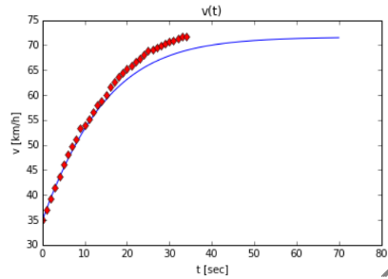I solved the differential equation using Euler method. The code of Euler method was written in Python, and the graphs were presented using Pylab. The experiment was done in a constant incline downhill, on a windless day. I have ridden in a certain constant position, without pedaling.

Results

The red graph which presents the measured speed and the blue graph which presents the calculated speed are very similar, and on under 60 km/h speeds they are almost the same. According to Pearson product-moment correlation coefficient, the match is 99.87%.

For Further Research

* Using a non-GPS based speed sensor, in order to improve measured speed accuracy.
* Experiments in wind tunnel in order to complete control of the wind, and improve measured speed accuracy.
* Research other factors’ impact on descending cyclist’s speed (like cyclist’s mass, cyclist’s clothes, cyclist’s position, incline of the downhill, bike type, etc.)