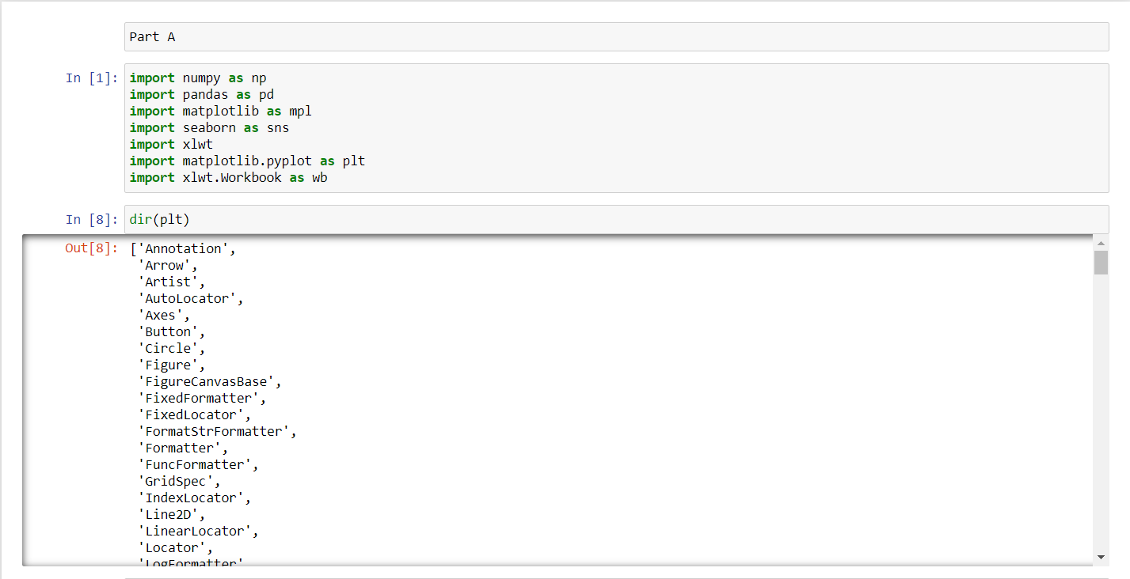**חלק א':**

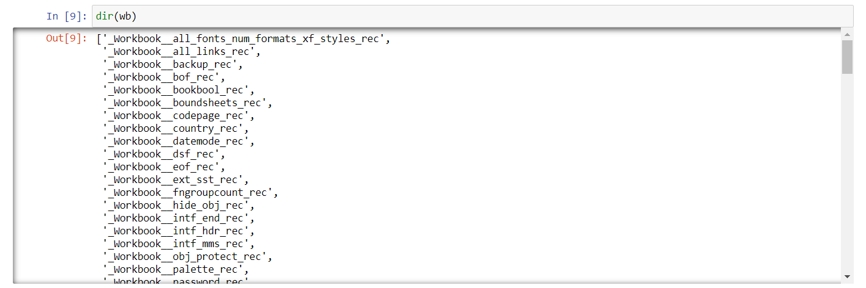

**Pandas**: Pandas is a perfect tool for data wrangling or munging. It is designed for quick and easy data manipulation, reading, aggregation, and visualization.

Pandas take data in a CSV or TSV file or a SQL database and create a Python object with rows and columns called a data frame.

What can you do with Pandas?

1. Indexing, manipulating, renaming, sorting, merging data frame
2. Update, Add, Delete columns from a data frame
3. Impute missing files, handle missing data or NANs
4. Plot data with histogram or box plot

**Numpy:** NumPy is an efficient container of generic multi-dimensional data.

NumPy’s main object is the homogeneous multidimensional array. It is a table of elements or numbers of the same datatype, indexed by a tuple of positive integers. In NumPy, dimensions are called axes and the number of axes is called rank. NumPy’s array class is called ndarray aka array.

When to use? NumPy is used to process arrays that store values of the same datatype. NumPy facilitates math operations on arrays and their vectorization. This significantly enhances performance and speeds up the execution time correspondingly.  
**What can you do with NumPy?**

1. Basic array operations: add, multiply, slice, flatten, reshape, index arrays
2. Advanced array operations: stack arrays, split into sections, broadcast arrays
3. Work with DateTime or Linear Algebra
4. Basic Slicing and Advanced Indexing in NumPy Python

**Matplotlib:** Another library from the SciPy Stack, Matplotlib plots 2D figures.  
When to use? Matplotlib is the plotting library for Python that provides an object-oriented API for embedding plots into applications. It is a close resemblance to MATLAB embedded in Python programming language.

What can you do with Matplotlib?  
Histogram, bar plots, scatter plots, area plot to pie plot, Matplotlib can depict a wide range of visualizations. With a bit of effort and tint of visualization capabilities, with Matplotlib, you can create just any visualizations: Line plots, Scatter plots, Area plots, Bar charts and Histograms, Pie charts, Stem plots, Contour plots, Quiver plots, Spectrograms.  
Matplotlib also facilitates labels, grids, legends, and some more formatting entities with Matplotlib. Basically, everything that can be drawn!

**Seaborn:**  seaborn provides a variety of visualization patterns with less complex and fewer syntax.  
**What can you do with Seaborn?**

1. Determine relationships between multiple variables (correlation)
2. Observe categorical variables for aggregate statistics
3. Analyze uni-variate or bi-variate distributions and compare them between different data subsets
4. Plot linear regression models for dependent variables
5. Provide high-level abstractions, multi-plot grids

Seaborn is a great second-hand for R visualization libraries like corrplot and ggplot.

**XLWT:** This is a library for developers to use to generate spreadsheet files compatible with Microsoft Excel versions 95 to 2003.

The package itself is pure Python with no dependencies on modules or packages outside the standard Python distribution.

# Difference Between Supervised and Unsupervised

If you’re learning a task under supervision, someone is present judging whether you’re getting the right answer. Similarly, in supervised learning, that means having a full set of labeled data while training an algorithm.  
Fully labeled means that each example in the training dataset is tagged with the answer the algorithm should come up with on its own. So, a labeled dataset of flower images would tell the model which photos were of roses, daisies, and daffodils. When shown a new image, the model compares it to the training examples to predict the correct label.

In unsupervised learning, a deep learning model is handed a dataset without explicit instructions on what to do with it. The training dataset is a collection of examples without a specific desired outcome or correct answer. The [neural network](https://developer.nvidia.com/discover/artificial-neural-network) then attempts to automatically find structure in the data by extracting useful features and analyzing its structure.

**חלק ב':**

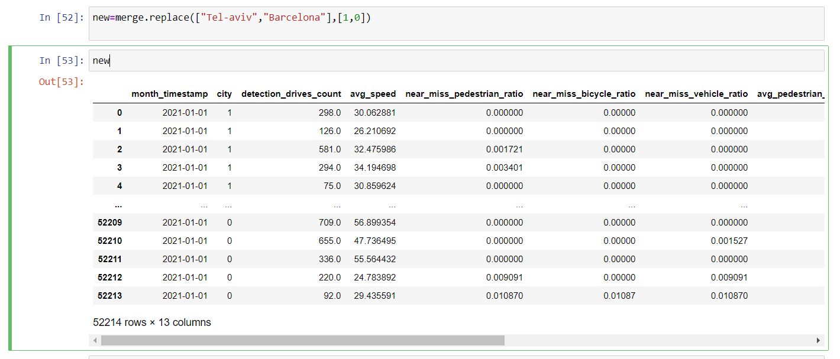 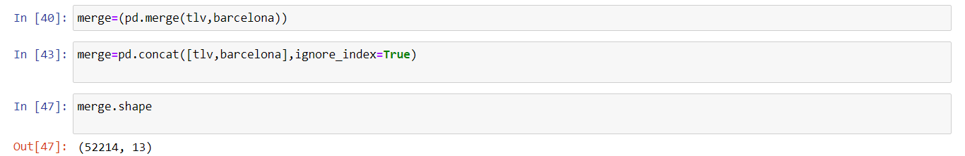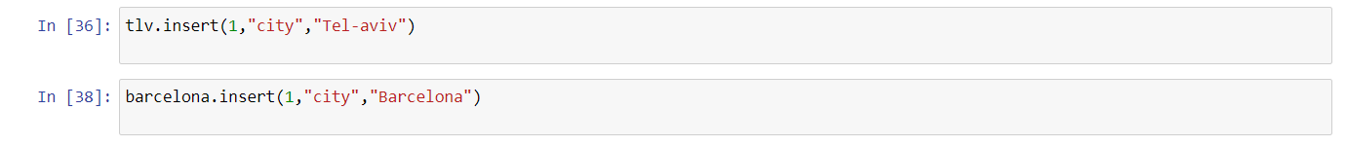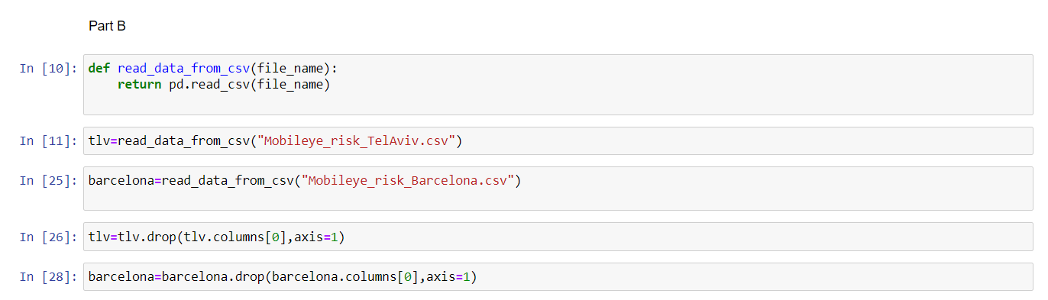

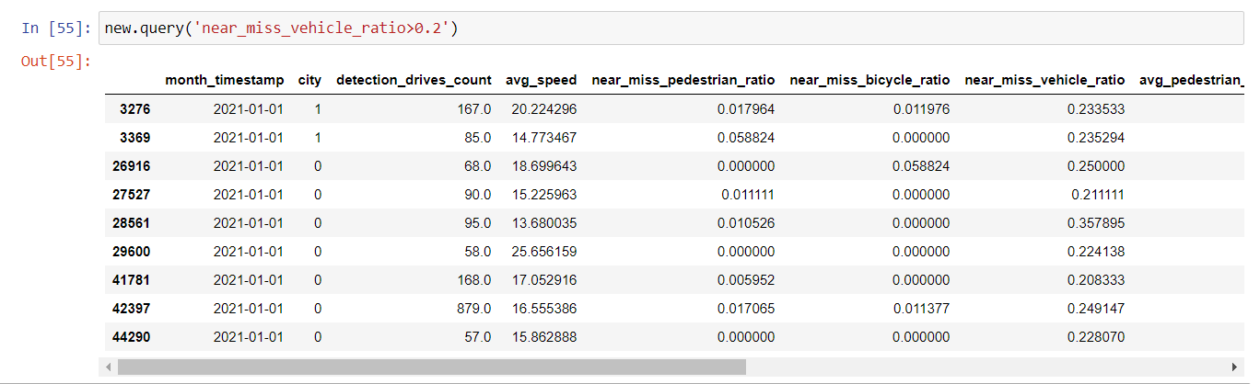



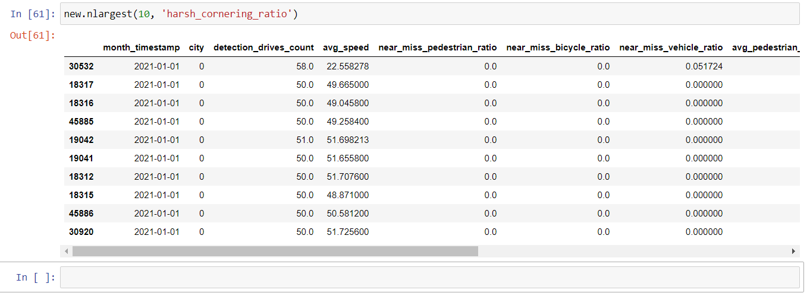 

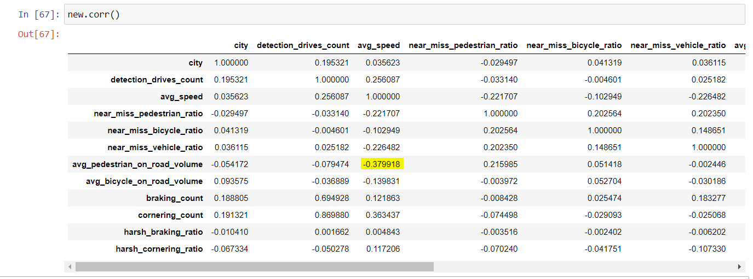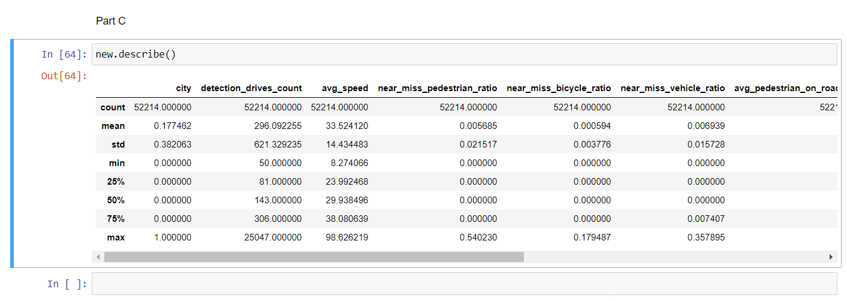**חלק ג':**

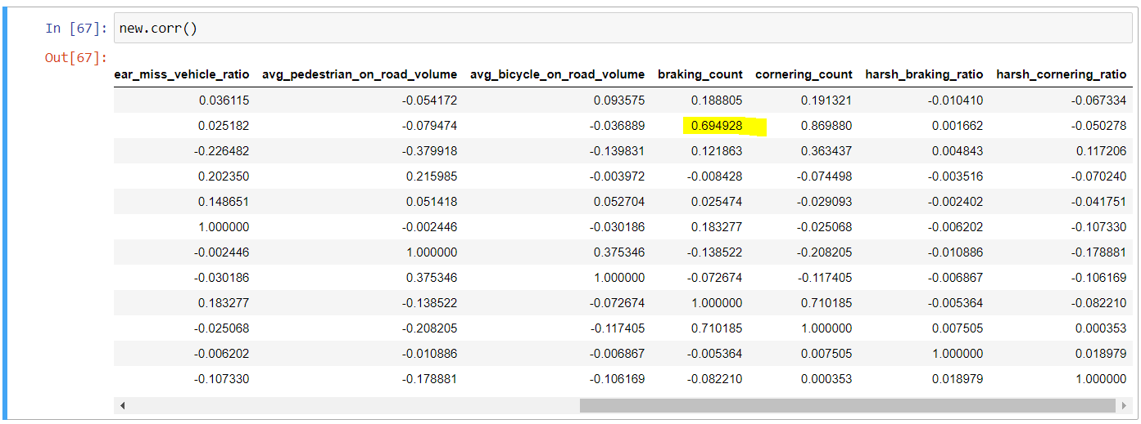

 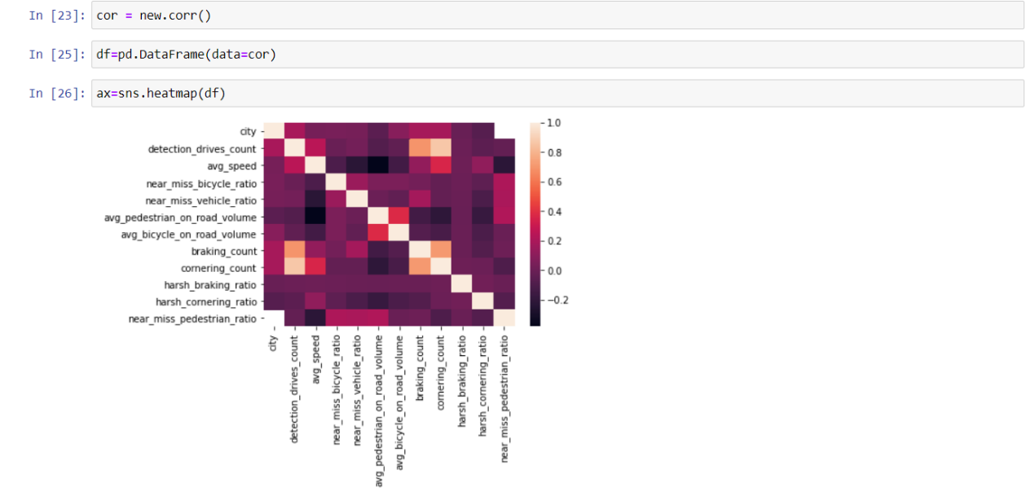

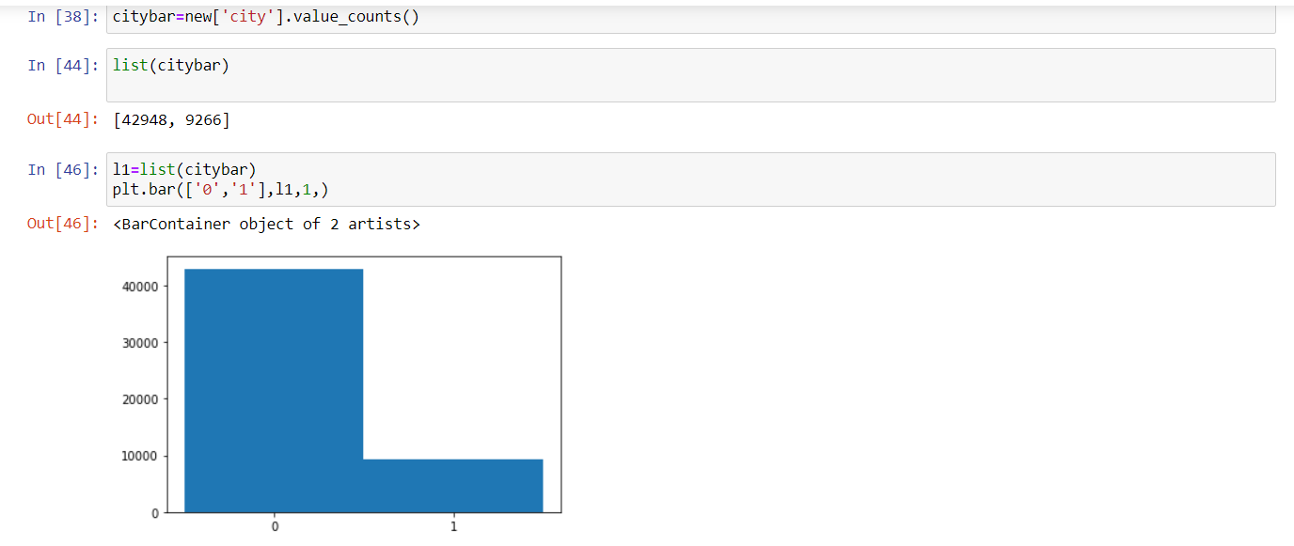

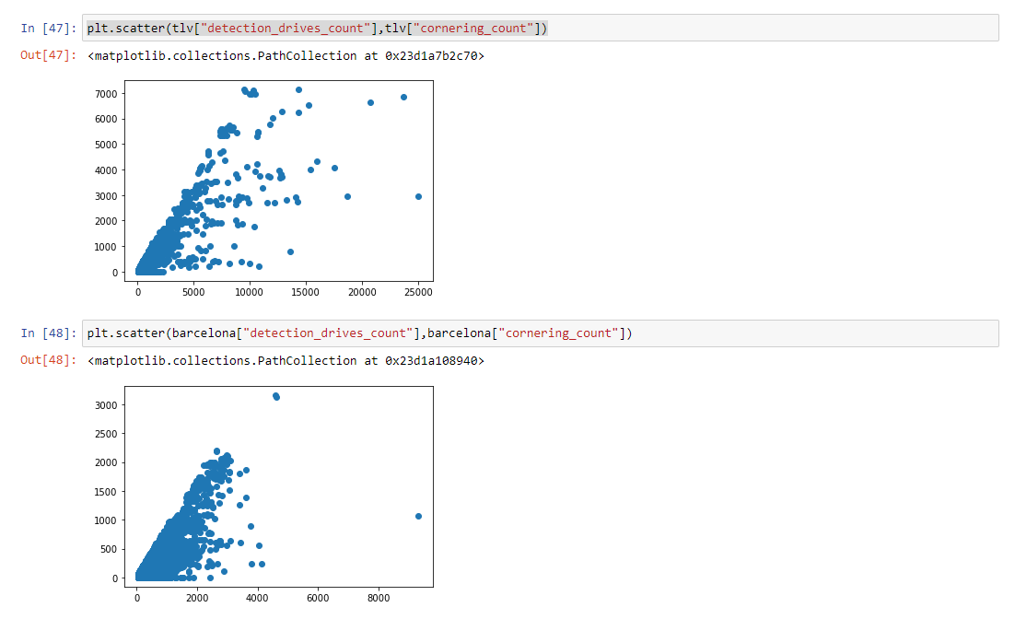

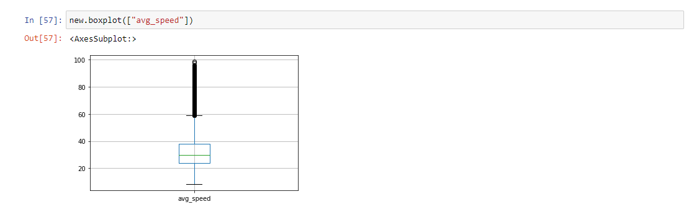



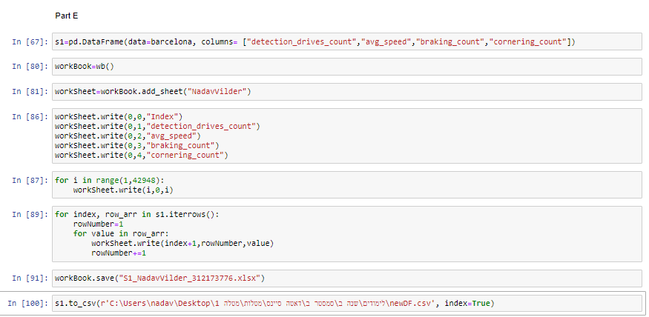**חלק ה':**

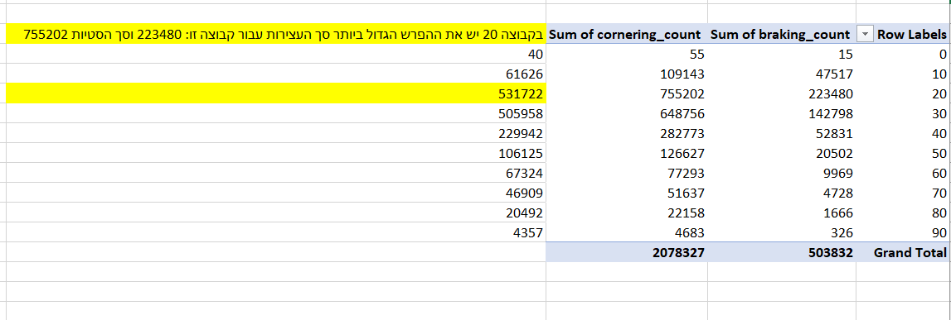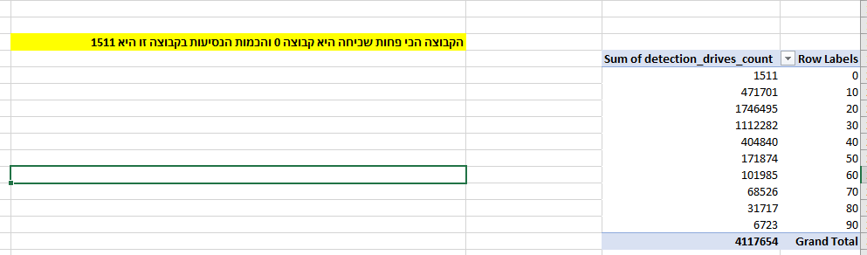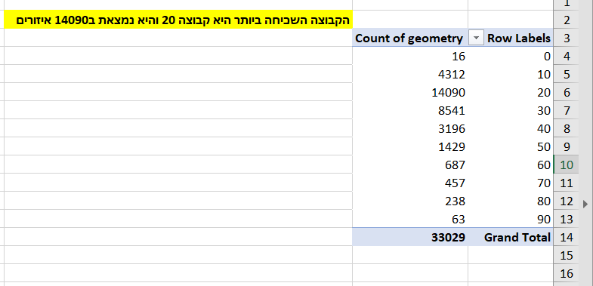**חלק ו:**

