2D-Fourier Transform

In this section we will implement the 2D Fourier Transform on images and learn about some of its properties.

1.1.1 the 2D FFT

The equations for the FFT and iFFT for an image I of size  are as follows:

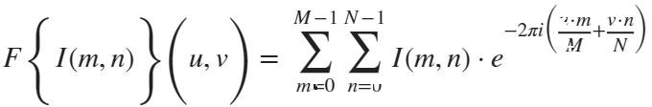

and the inverse transform:

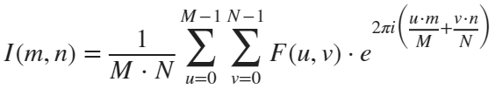

accounting to MATLAB's indexing, we will rewrite the array indices as such:

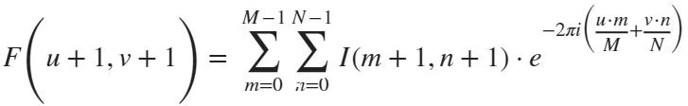

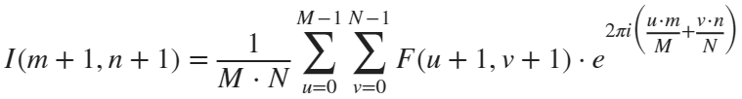

as for the algorithm, we will implement it by slightly rearranging the equation:

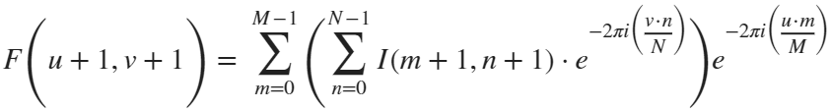

Our code:

function F = dip_fft2(I)

% Get the size of the input image

[M, N] = size(I);

% Generate arrays representing indices for rows and columns

n = 0:N-1;

m = 0:M-1;

% Generate arrays representing indices for frequency domain

u = 0:M-1;

v = 0:N-1;

% Create matrices of products of indices for later calculations

um = u'.*m;

vn = v'.*n;

% Calculate the exponential term in the frequency domain for rows

e1 = exp(-1i * 2 * pi * (vn/N));

% Calculate the exponential term in the frequency domain for columns

e2 = exp(-1i * 2 * pi * (um/M));

% Perform the row-wise Fourier transform using matrix multiplication

sum = I * e1;

% Perform the column-wise Fourier transform using matrix multiplication

F = e2 * sum;

end

function F = dip_ifft2(I)

% Get the size of the input image

[M, N] = size(I);

% Generate arrays representing indices for rows and columns

n = 0:N-1;

m = 0:M-1;

% Generate arrays representing indices for frequency domain

u = 0:M-1;

v = 0:N-1;

% Create matrices of products of indices for later calculations

um = u'.*m;

vn = v'.*n;

% Calculate the exponential term in the frequency domain for rows

e1 = exp(1i * 2 * pi * (vn/N));

% Calculate the exponential term in the frequency domain for columns

e2 = exp(1i * 2 * pi * (um/M));

% Perform the row-wise inverse Fourier transform using matrix multiplication

sum = I * e1;

% Perform the column-wise inverse Fourier transform using matrix multiplication

F = (1/(M*N)) * e2 * sum;

end

1.1.2

We wrote our own function named dip_fftshift(FFT), shift zero-frequency component to center of spectrum along two dimensions:

function shiftedFFT = dip_fftshift(FFT)

% Get the size of the input FFT

[M, N] = size(FFT);

% Calculate the center indices for both dimensions

centerX = floor(M / 2) + 1;

centerY = floor(N / 2) + 1;

% Perform the shift along the rows and columns

shiftedFFT = FFT([centerX:M, 1:centerX-1], [centerY:N, 1:centerY-1]);

end

This function takes an input FFT and shifts the zero-frequency components to the center along both dimensions using MATLAB indexing. It first calculates the center indices and then rearranges the FFT values accordingly. The result is the shifted FFT.

1.1.3. we read the beatles.png image accompanied to this assignment, and converted it to grayscale normalized image. We used our function:

function I_normalized = imread_normalized(src)

I = imread(src);

I = rgb2gray(I);

I = im2double(I);

I_min = min(I(:));

I_max = max(I(:));

I_normalized = (I - I_min) / (I_max - I_min);

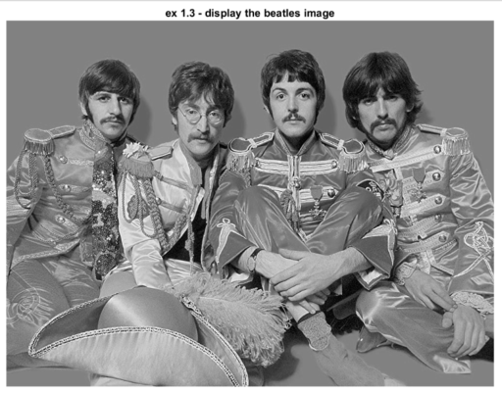end

1.1.4. We compute the 2D-FFT of the image and shifted the output image using dip_fftshift(FFT) 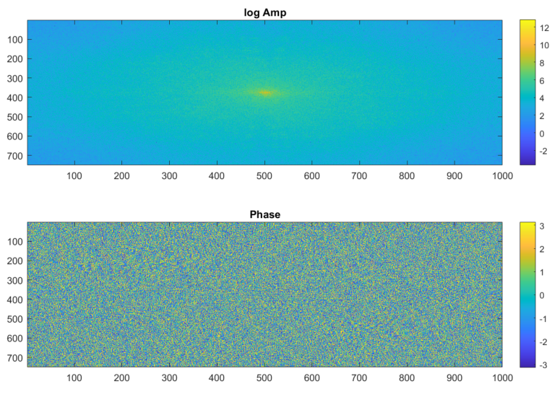function. The log of the amplitude and the phase of the resulting image are shown here:

1.1.5. We reconstructed the original image by using our inverse-FFT function. It is identical to the original image !

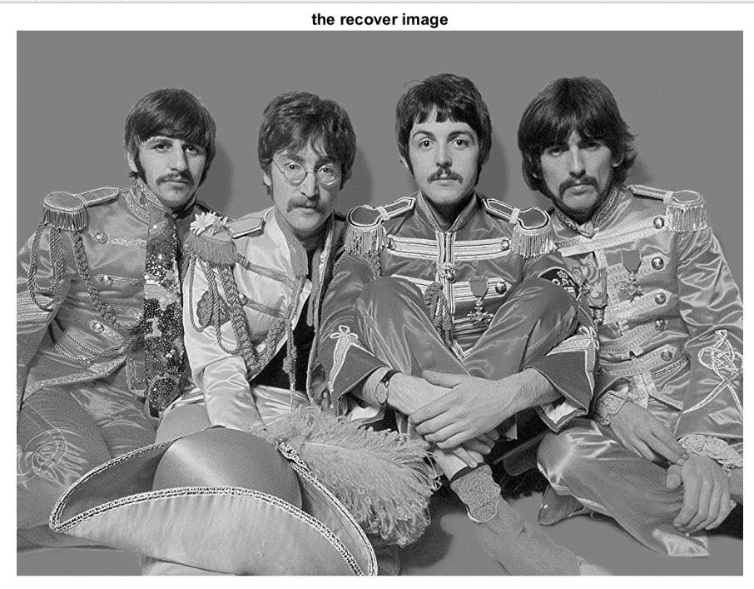Note that the output of the iFFT are complex numbers – we display only the real part of the image using imshow(real(-)).

**1.2 Transformation properties**

1.2.a. **Linearity (Free Willy)**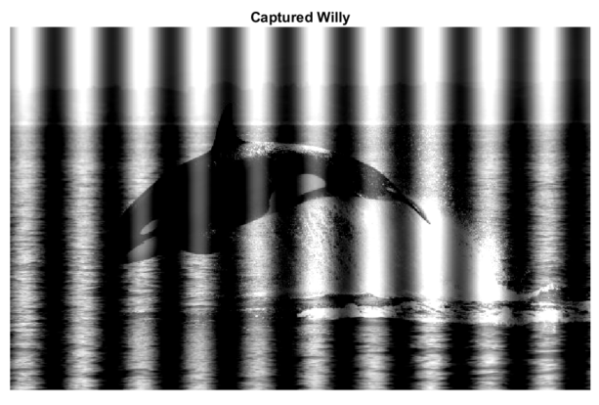

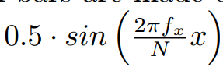1.2.b. Willy the whale is imprisoned. We will free Willy! We are told that the prison bars are made of a sinusoidal signal in the X axis that was added to the original image:

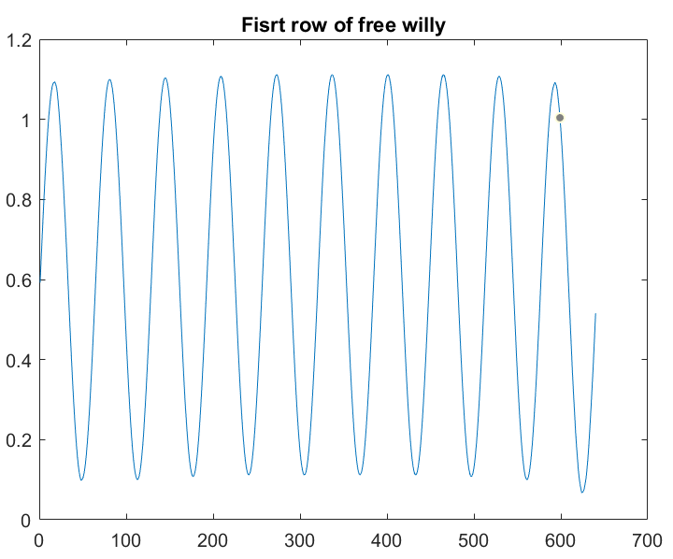where N is the number columns in the image. Given this image, find the spatial frequency of the prison bars . Let’s plot the first row of the image:

We can see it is indeed a sinusoidal wave. We used the function ‘findpeaks’ that can give us the number of peaks in the graph, and we received . **\*\* אולי להרחיב הסבר**

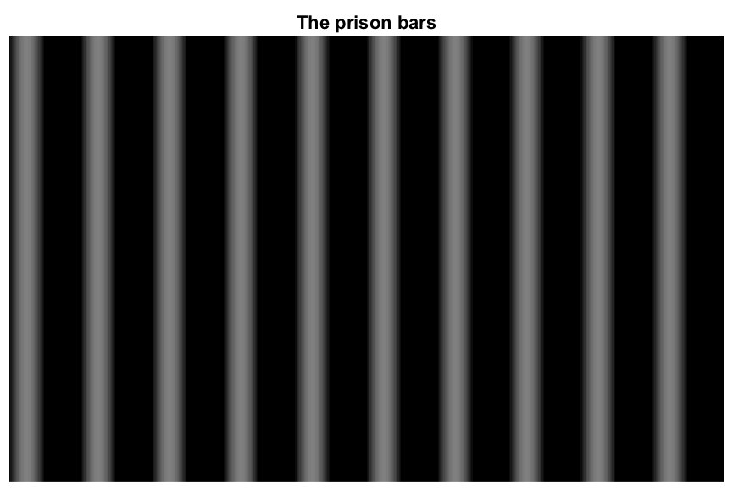1.2.c. We created a matrix with a sinusoidal wave with this frequency:

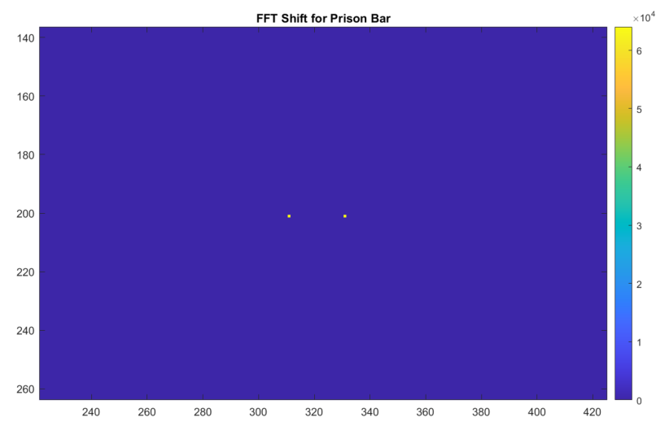 1.2.d. We compute the 2D-FFT of the prison bars image, and display its amplitude:

We obtained two deltas, meaning two singular points symmetrically positioned in the center of the transformation image. As known, the Fourier transform of a sine consists of two symmetric deltas centered around zero.

We will use the linearity of the FFT to calculate the FFT of just one of the exp,

So, in the same way we will get,

as we expected for the amplitude of the image's FFT.

1.2.e. We can free willy by subtracting the sine frequencies (prison bar) from the image frequencies in the frequency domain. We will transform into the frequency domain using the 2D FFT, subtract the sine frequencies, and go back to the image domain using the 2D iFFT.

We will do all this using our function Free_Willy(Willy) that returns and displays Willy without the prison bars:

function free_willy = Free_Willy(Willy)

% Count the number of peaks in the first row of Willy

fx = size(findpeaks(Willy(1, :)), 2);

% Get the number of columns in Willy (assuming it represents an image)

N = size(Willy, 2);

% Create a meshgrid for the x-axis

x = meshgrid(0:N-1, 1:size(Willy, 1));

% Generate a sine wave as a prison bar pattern

prison_bar = 0.5 * sin((2 * pi * fx / N) * x);

% Perform FFT on the images (Willy and prison_bar)

Willy_fft = fft2(Willy);

prison_fft = fft2(prison_bar);

% Subtract the sine frequencies (prison bar) from the image frequencies

free_willy_fft = Willy_fft - prison_fft;

% Perform Inverse FFT to get the modified image

free_willy = ifft2(free_willy_fft);

% Display the resulting image

figure;

imshow(free_willy);

title(‘Freed Willy’)

end

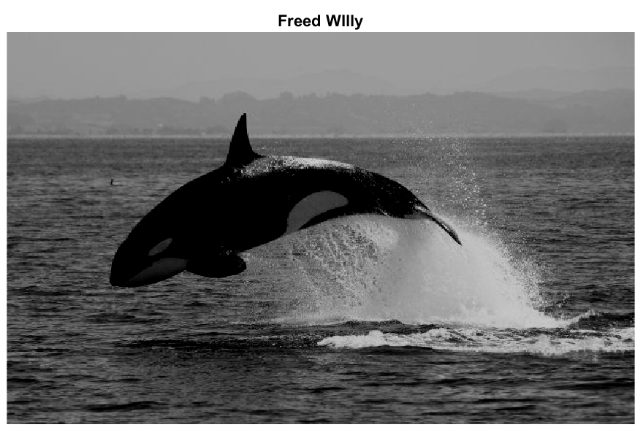The result is:

**2. Scaling, translation and separability**

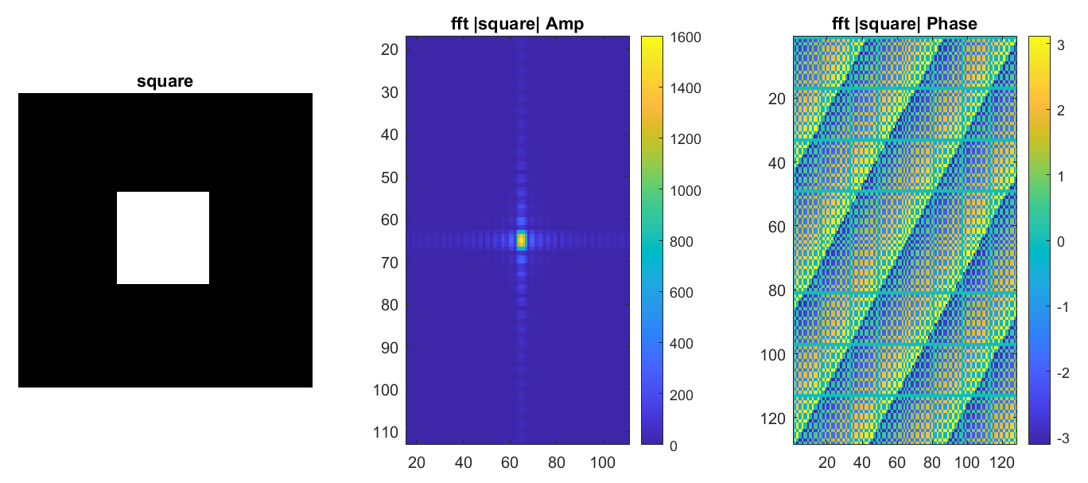2.a. We initialize a 128×128 all-zeros matrix. At the center of it, we placed a 40×40 all-ones square (in pixels 44:83 in each dimension). We display the image and its 2D-FFT:

From the amplitude image, we can see that we got a sinc function – a known result of FFT of a rectangular window. We can see the cut of the function with both x and y axes, and that the main lobe is at (0,0).

2.b now we initialize a square of equal size and locate the square at the bottom right. We displayed the image and its 2D-FFT:

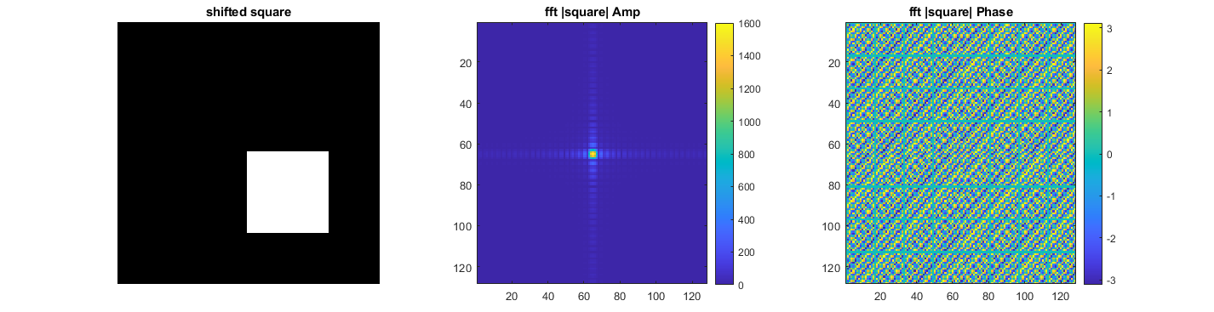We can see that the amplitude image we receive contains the sinc function again, same as earlier in (a). that is what we would expect, the square is the same as earlier, just moved in space. We know that one of the properties of the fft is that spatial displacements translates to a multiplication of the phase with a linear phase component:

This phase component has an amplitude of 1 thus, there is no change in the amplitude plot due to the multiplication.

The phase on the other hand, changes due to the multiplication. in our case, the square was spatially translated in 2 dimensions: so we get a multiplication of a phase that is a linear combination of a phase in the dimension and a phase in the dimension:

2.c now we initialized a rectangle instead of the square, at the center of the matrix. We displayed the image and its 2D-FFT:

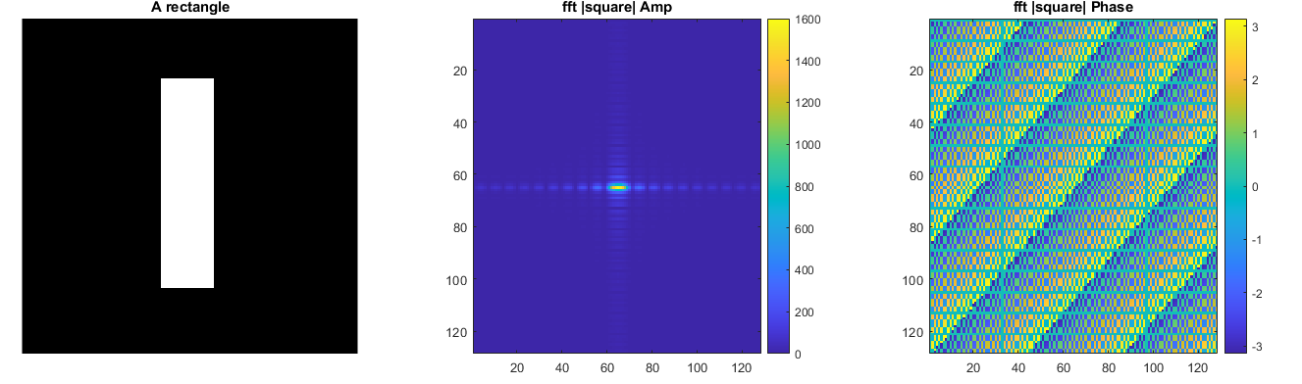

Now, we get a similar result to a but the amplitude plot has changed. This is because, as we know, scaling a sequence in a factor of scales it's fourier transform in a factor of , more intuitively, stretching in the time domain results in compressing in the frequency domain

So, since we the squeezed square on the horizontal axis, we see a stretch in the FFT amplitude on the horizontal axis. And since we stretched it on the vertical axis, the FFT amplitude is compressed on the vertical axis

2.d yes we can! Notice that

Which is the product of two waves:

We will therefore denote -

So, the image from can be represented by the product of the two vectors given by the expressions:

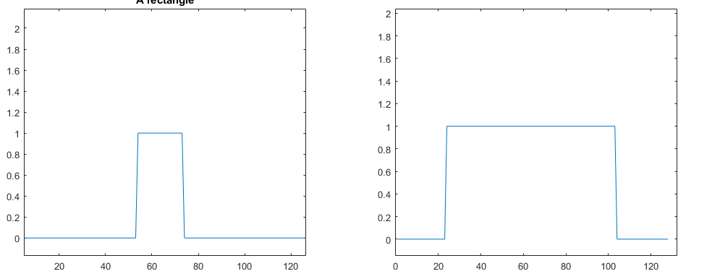

2.e we can calculate the FFT by using the representation developed in (d), then use the following identity:

Which is the product of the results:

We wrote the function according to the above calculation,

function F = sep_fft2(v1,v2)

% Calculate the fourier transform of v1

F1 = fft(v1);

% Calculate the fourier transform of v2

F2 = fft(v2);

F = F1*F2;

end

and got the same results here as with the in section :

