Module03 Observations .

1.Successfully retrieved deployment names using the API.
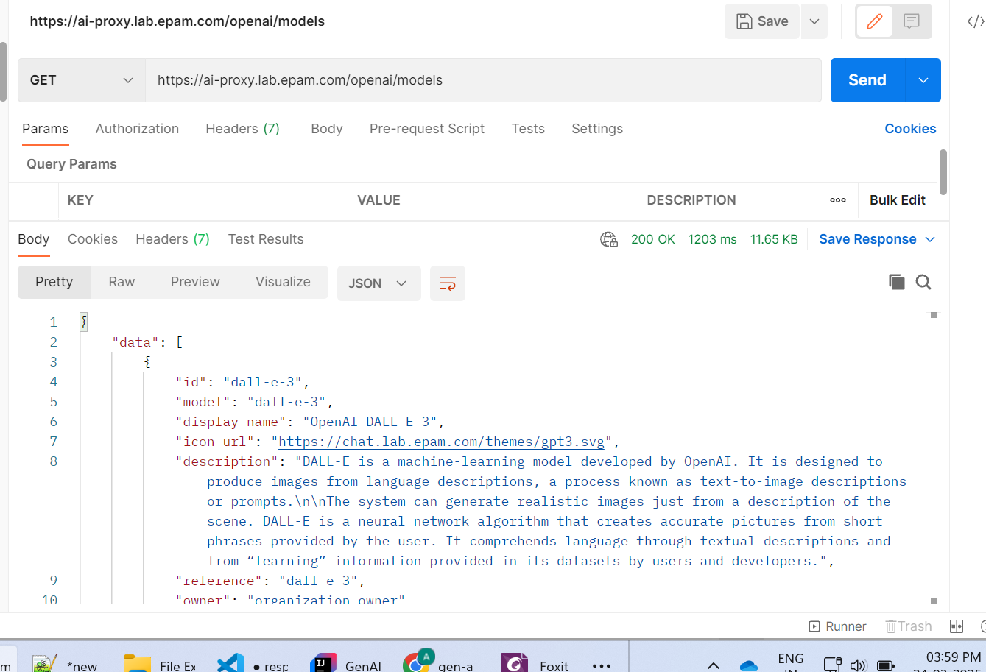

2.Modified the application properties with few of the models that are supported by DAIL to change the deployment name for different models.

Below are the responses with different deployment models when
Max_Tokens = 200
temperature = 0.9
1.model : gpt-35-turbo
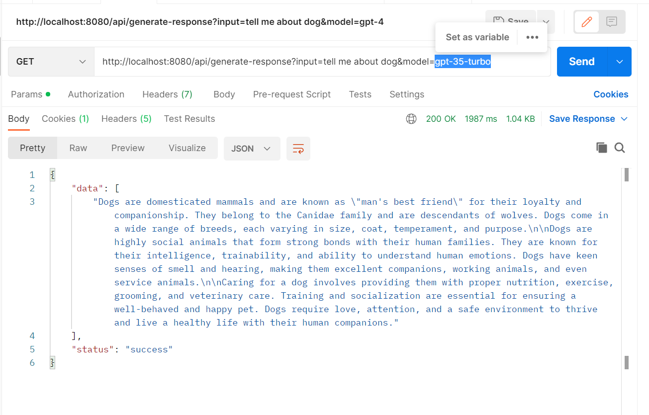

Model: gpt-4
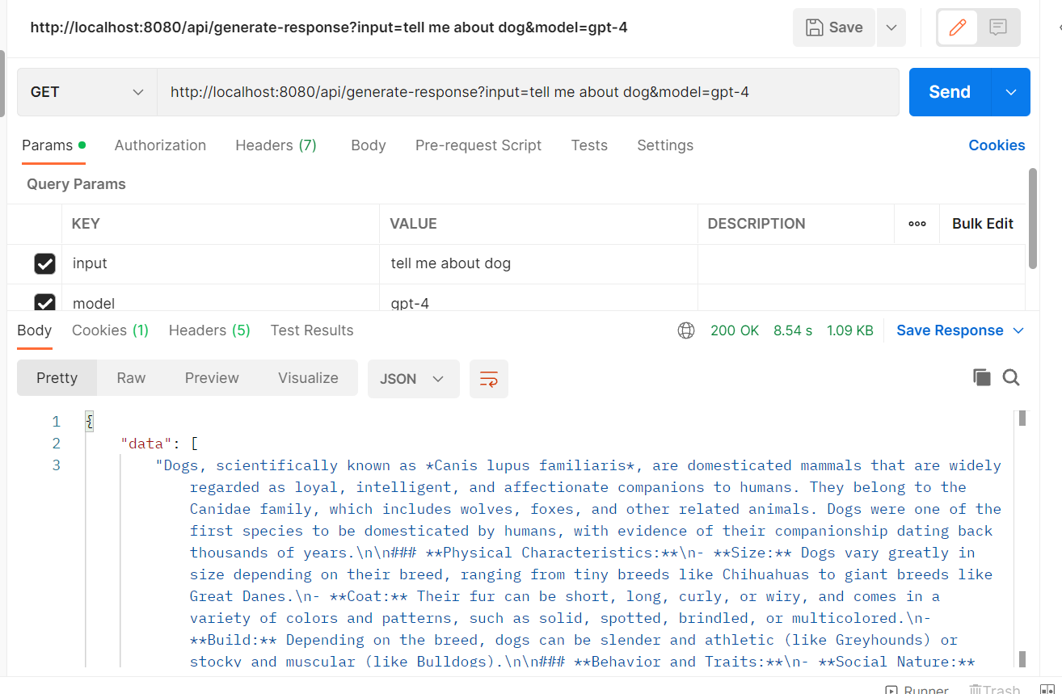

Model:gpt-4-turbo
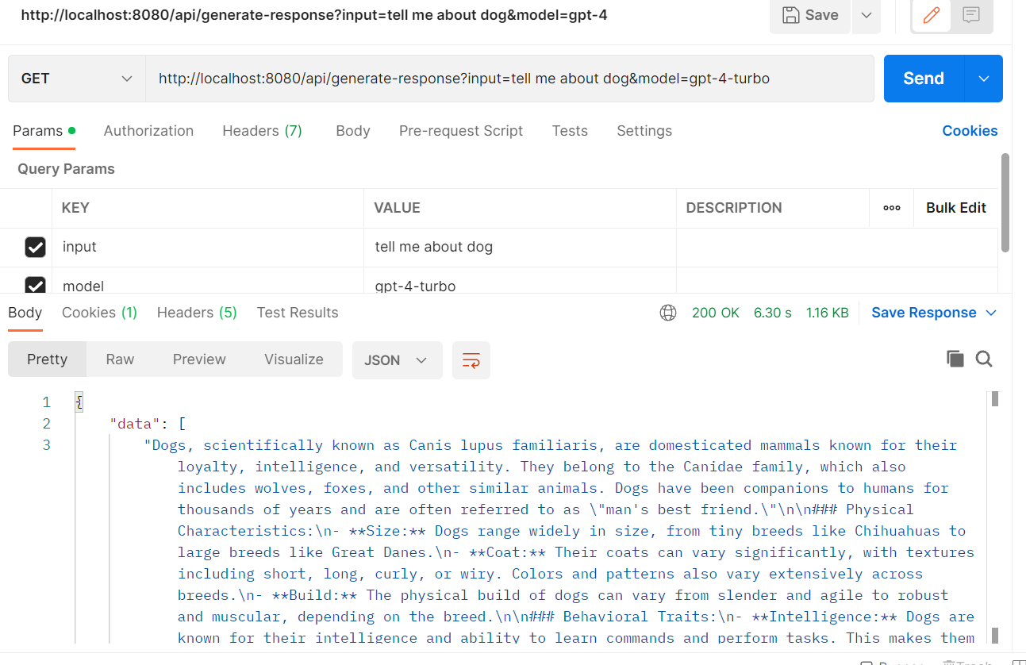

When compared to above models’ response observed that
gpt-35-turbo is bit faster accuracy is less.
Gpt-4 is slow compared to gpt-35 but accurate
Gpt-4-turbo is Faster and accurate.

Below are the responses with different deployment models when
Max_Tokens = 50
temperature = 0.3

Model: gpt-35-turbo
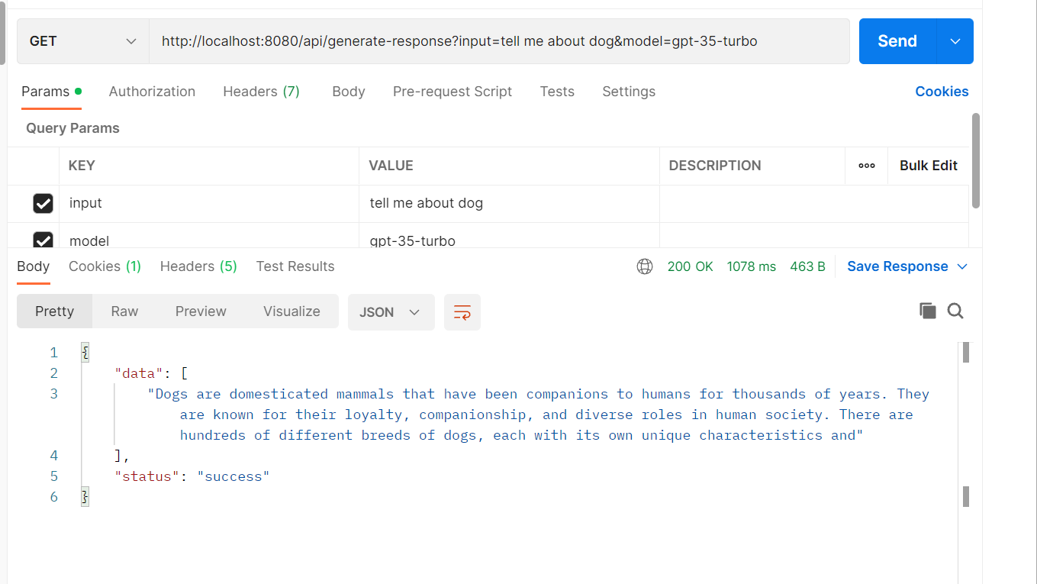
Model:gpt-4
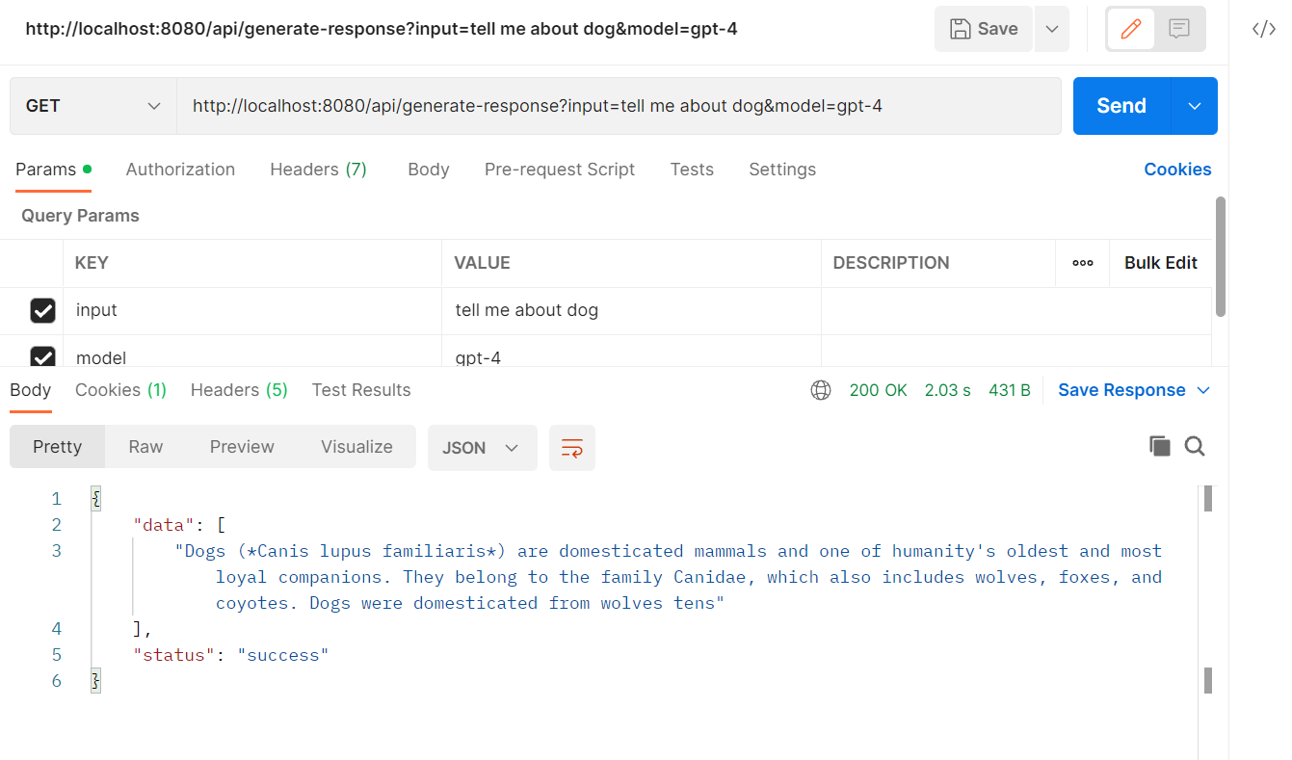

Model: gpt-4-turbo
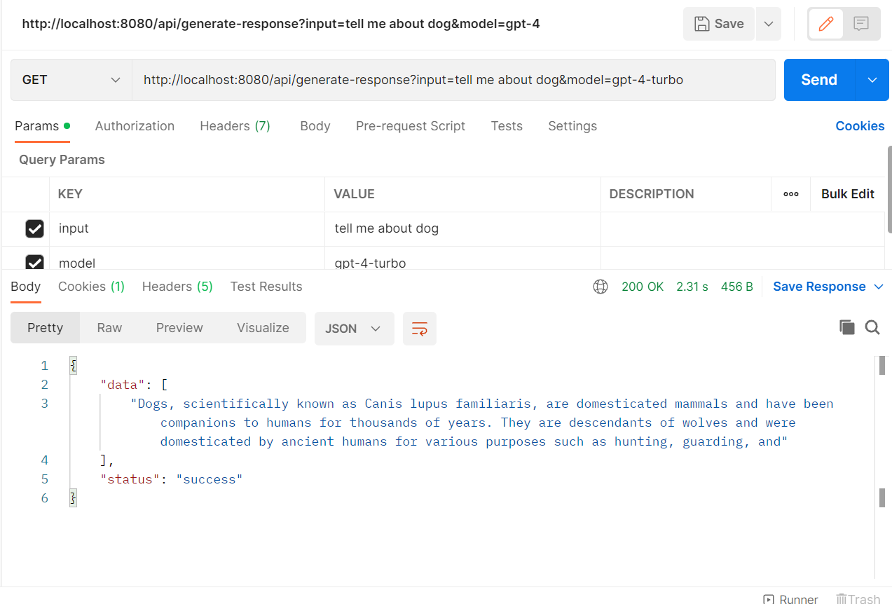

Observed that when the token size and temperate is reduced the response got shorten and processing time also reduced drastically.

