Demo of Module 4.

Created new plugins as AgeCalculator, CurrentConverter, Light with some functions in each Plugin.
Implemented the logic to call those functions through the kernel.
Created controller to test each plugin functionality.

Verified AgeCalculator functions.
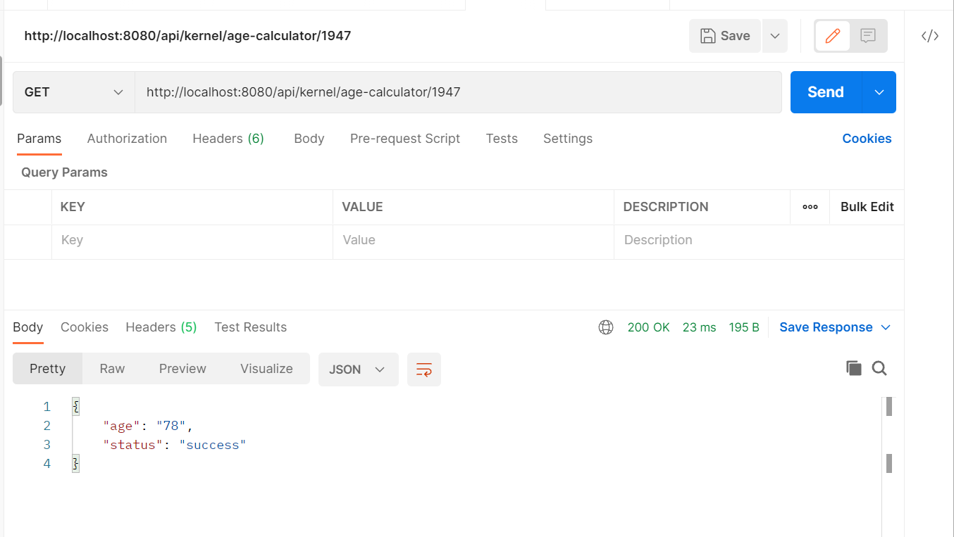
Verified CurrencyConvertor functions.
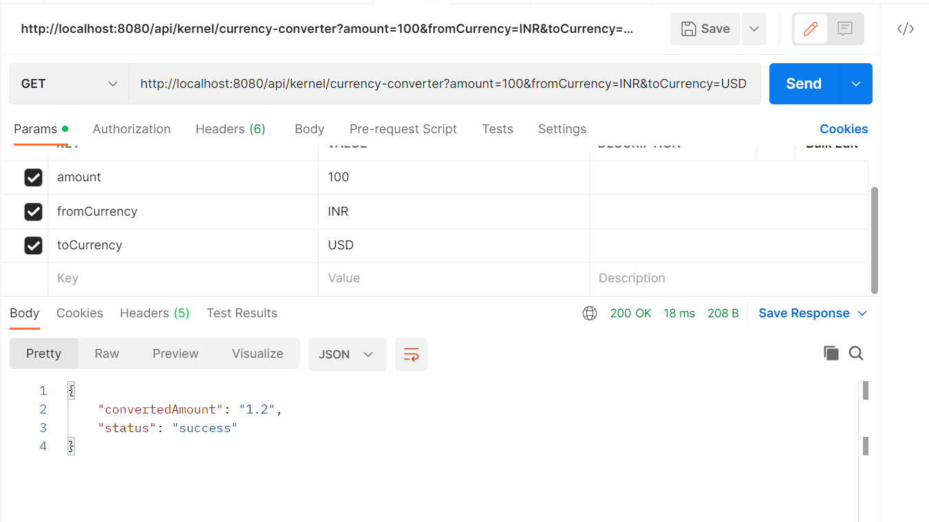
Verified Light Plugin functions.
