**Temperature Observations;**

Observation when temperature is 0.1 and MAX-TOKENS = 50;

Input: tell me a story about lion

Response:

Observation when temperature is 0.9 and MAX-TOKENS = 50;

Input: tell me a story about lion

Response:

**Notes**: Observed the when temperature is high(0.9) the response is has some creativity involved .

Observed that when temperature is low(0.1) it has given straight forward response.

**Impact of Chat History Observations**

I have tried to ask below two questions in order.

Question1 : Who wrote Harry Potter?

Question2: How many books are there?

**Observation1: Without ChatHistory configured:**

Question1 Response: 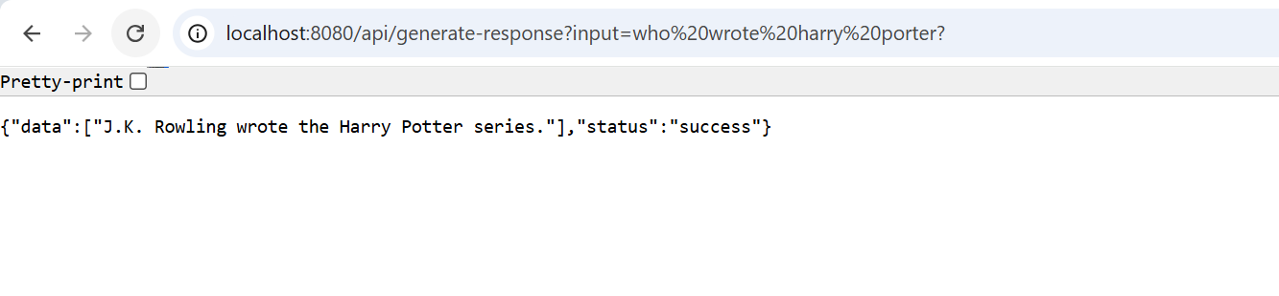

Question2 Response:

**Observation2 : With ChatHistory Configured.**

**Question1 Response:**

**Question2 Response:**

**Conclusion**

Without ChatHistory → AI responds without memory, making interactions feel disjointed.  
With ChatHistory → AI remembers context, leading to smarter and more personalized conversations.