Module03 Observations .

1.Successfully retrieved deployment names using the API.

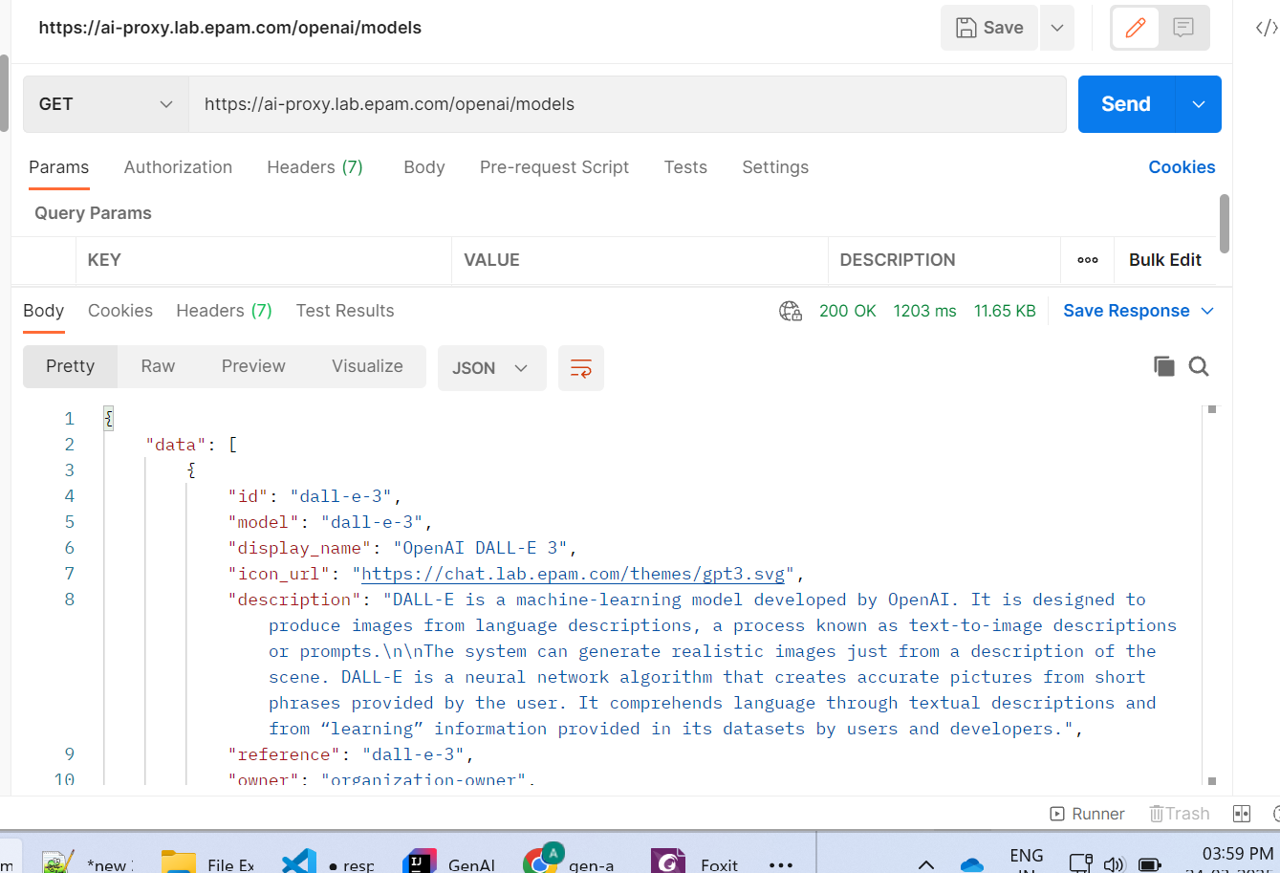

2.Modified the application properties with few of the models that are supported by DAIL to change the deployment name for different models.

**Below are the responses with different deployment models when**

**Max_Tokens = 200**

**temperature = 0.9**

1.model : gpt-35-turbo  
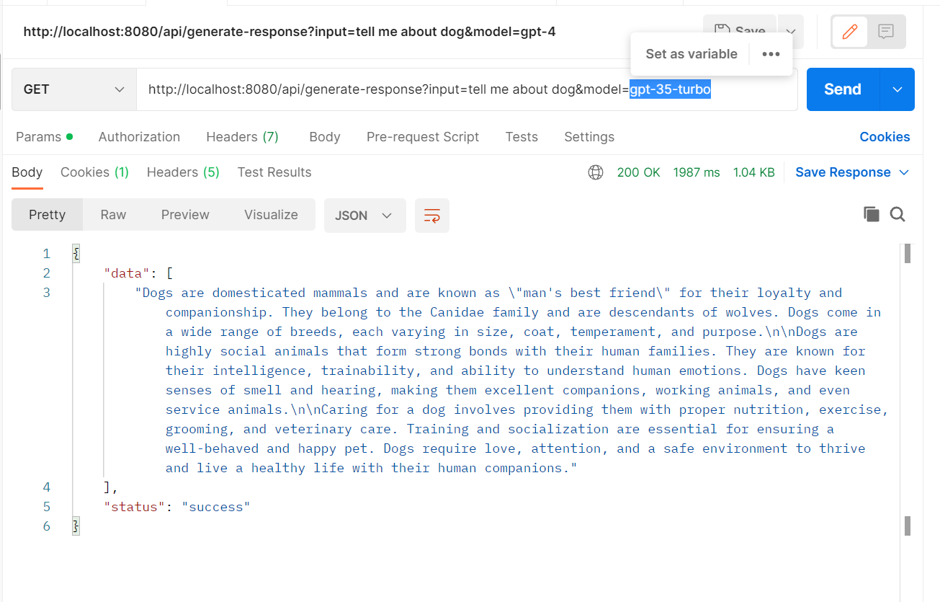

Model: gpt-4

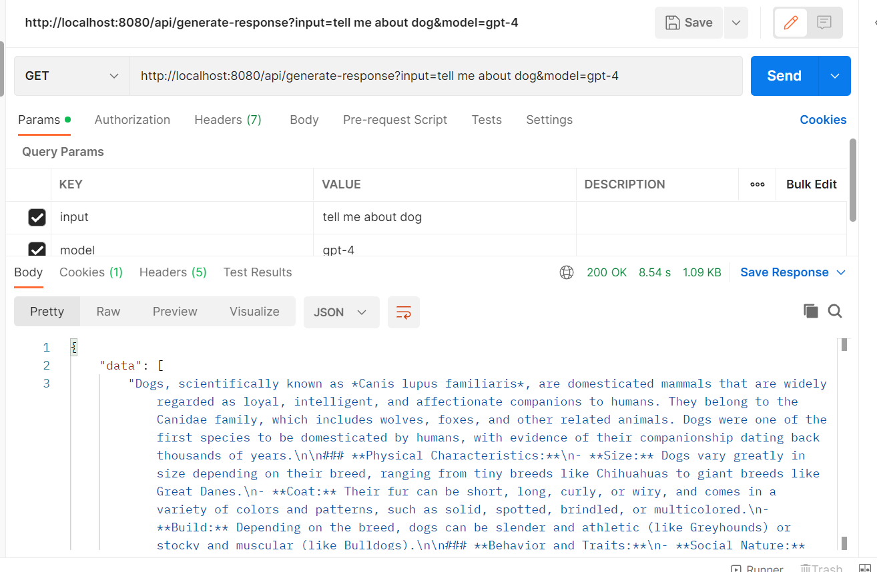

Model:gpt-4-turbo

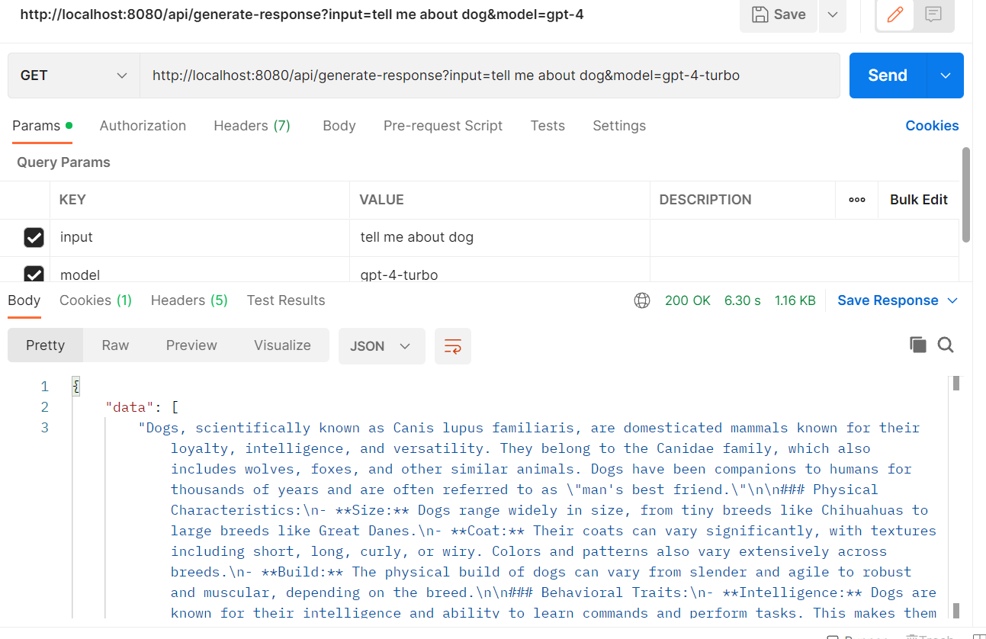

When compared to above models’ response observed that

gpt-35-turbo is bit faster accuracy is less.

Gpt-4 is slow compared to gpt-35 but accurate

Gpt-4-turbo is Faster and accurate.

**Below are the responses with different deployment models when**

**Max_Tokens = 50   
temperature = 0.3**

Model: gpt-35-turbo

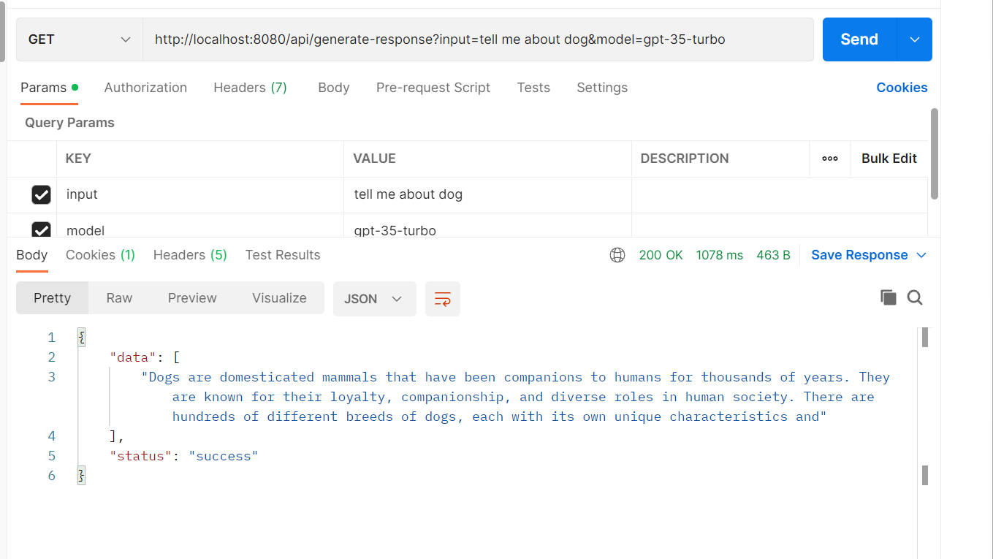

Model:gpt-4

Model: gpt-4-turbo

Observed that when the token size and temperate is reduced the response got shorten and processing time also reduced drastically.