Moduel 05 demo.

1. I have installed Qdrant on my local machine, which is running on port 6333.

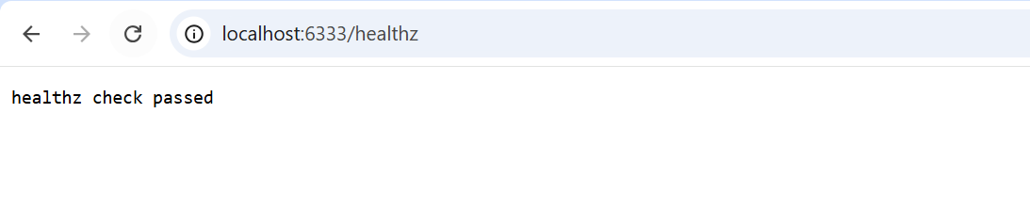

2.Configured the application to use Qdrant vector DB properly.

3. Implemented an endpoint to build an embedding from the provided text.

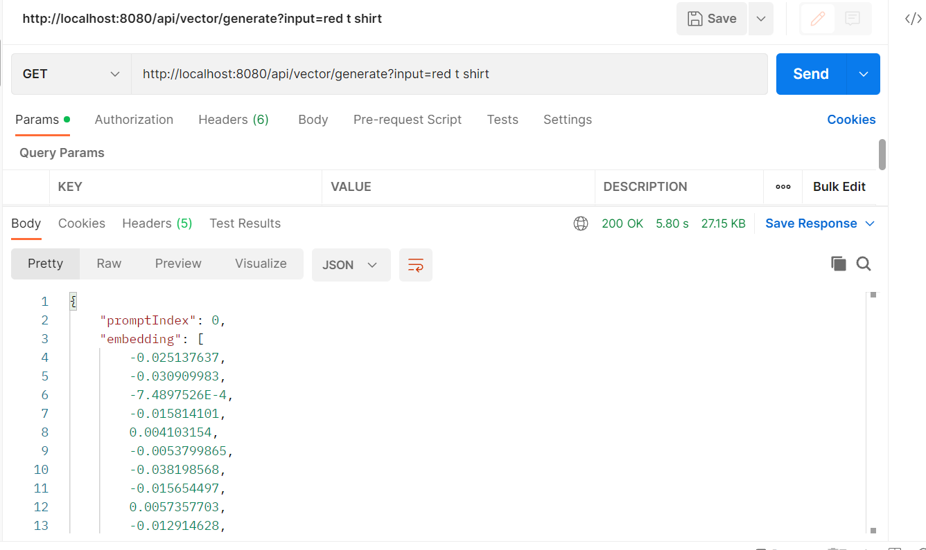

4. Implemented an endpoint to build and store an embedding from the provided text.

5.Implemented an endpoint to search for the closest embeddings in the database based on the input text.

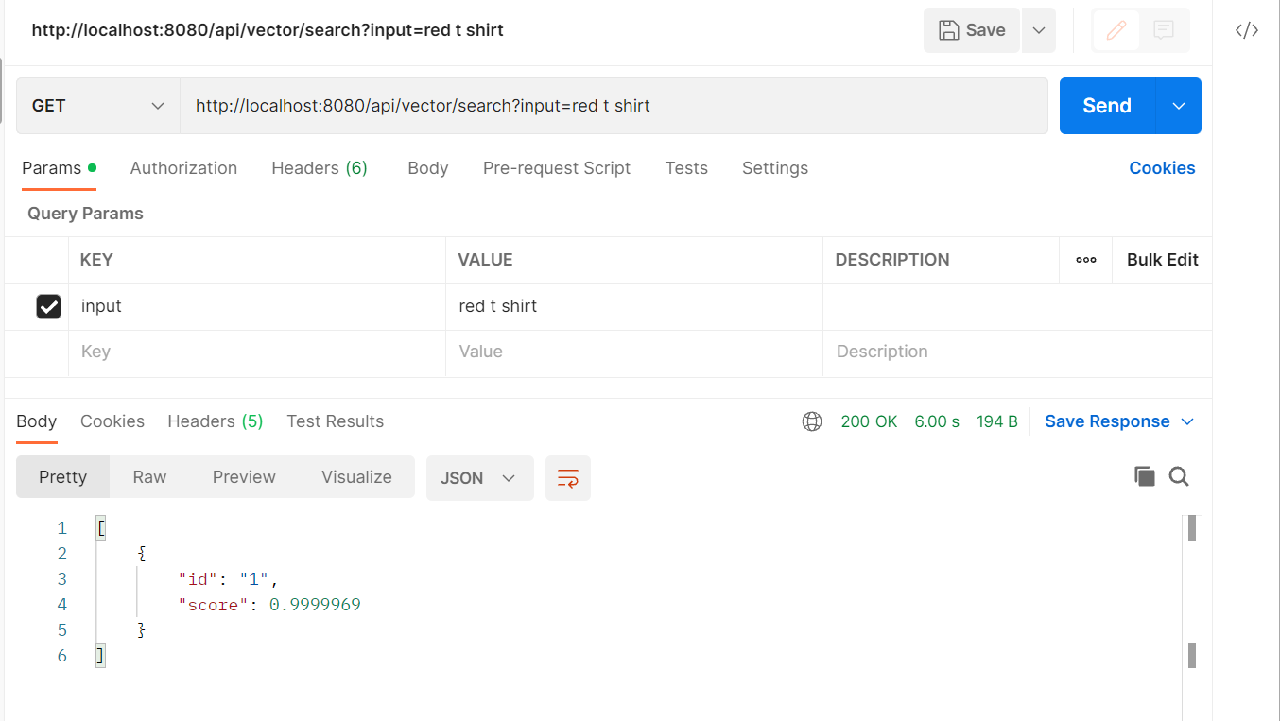

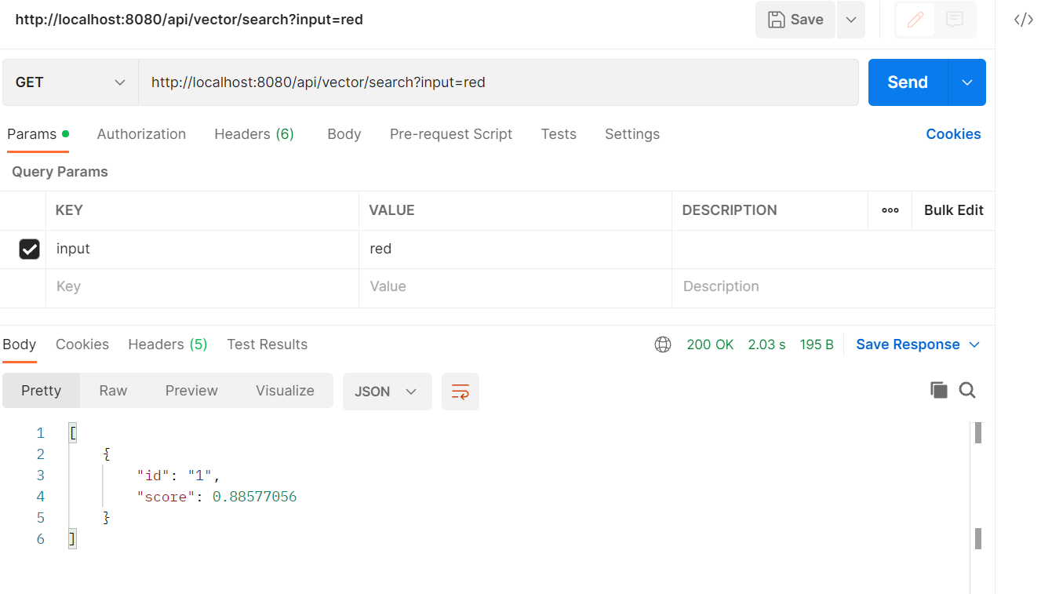

**Observation1:** When we search for the exact text that is already saved as embedding into database, the score value is almost equalling to 1.

**Observation2:** When we search for a word which is not saved in database then the score value is decreasing.