### **Department of Computer Science**

### **Faculty of Science**

### **National Textile University**

An internship report submitted to fulfill the partial requirement for the degree of Bachelors of Science in Software Engineering

Internship Report (Creative Codes)

**Syed Nad E Ali Naqvi** (20-NTU-CS-1136)

### **Session 2020-2024**

##### **Supervisor:**

#### Dr. Isma Hamid

##### **Co-Supervisor:**

#### Mr. Arsal Mehmood

**LETTER OF UNDERTAKING BY THE STUDENT**

I **Syed Nad E Ali Naqvi**, of **BSSE** confirm having received the mail of Internship allotment with **Web Application Developer**, from the Internships and Job Placement Committee, Computer Science Department, National Textile University.

Further, I shall also report to the employer as per the duration and time of internship mentioned. I hereby undertake that I will abide by the rules and regulations of the employer and the committee. I understand that I shall be liable for suitable disciplinary action in case of any violation of the guidelines, as well as the employer's rules and regulations. I further undertake to see the internship to its completion and put my best efforts towards this internship.

Date: 01-08-2023

Signature of the Student: Syed Nad E Ali Naqvi

**INTERNSHIP CERTIFICATE**

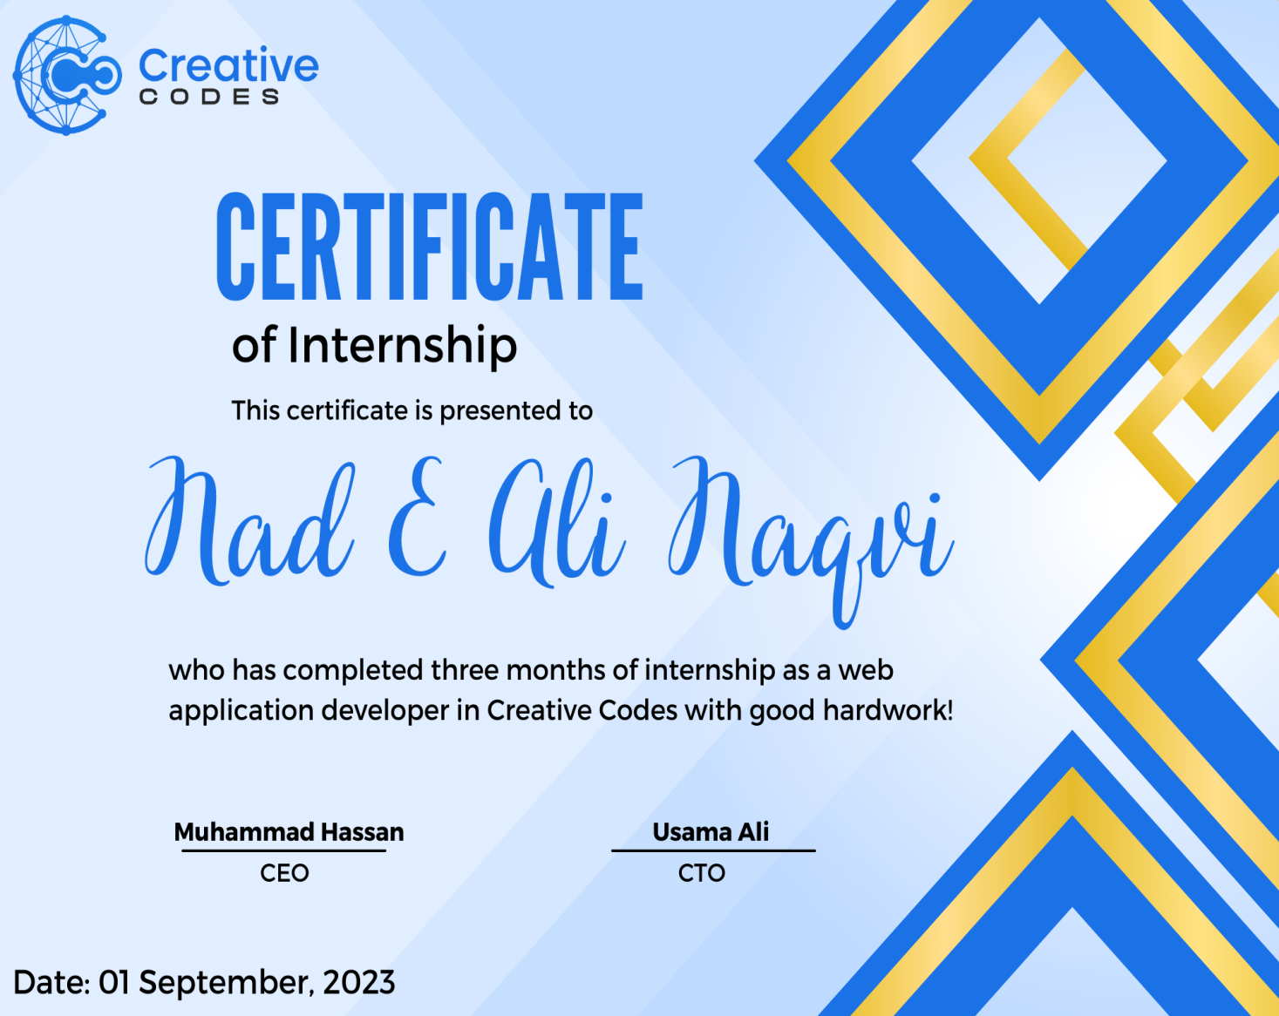

**Experience Letter**

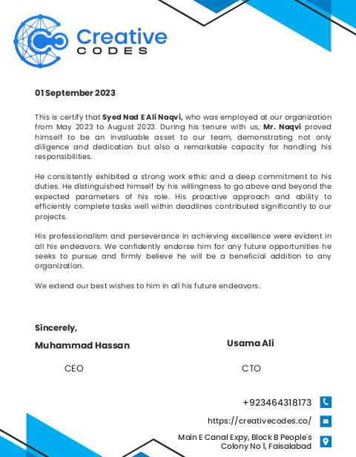

**Dedication**

##### I dedicate the entirety of my educational journey, encompassed by years of effort and perseverance, to my beloved parents. Their unwavering support and profound sacrifices have been the cornerstone of my achievements. Without their guidance and love, I would be adrift, lacking purpose and direction. They have not only nurtured me through my challenges but have also celebrated every milestone, big or small, with immense joy and pride.

##### Additionally, I extend my deepest gratitude and dedication of this internship report to my esteemed and honorable teachers. These remarkable educators have been instrumental in molding my academic and professional endeavors. Their relentless dedication to fostering learning environments that challenge and stimulate has significantly shaped my professional identity, preparing me to thrive in competitive environments.

##### Furthermore, this dedication would be incomplete without acknowledging my friends, who have been my steadfast supporters and constructive critics. They have continually encouraged me to surpass my limits and have played a crucial role in refining my skills and boosting my confidence. Their companionship and motivation have been invaluable, pushing me to achieve and excel.

##### Through this detailed acknowledgment, I wish to express my heartfelt appreciation to each individual who has been a part of my educational and professional path. Their collective contributions have been vital in my development as a capable and resilient professional.

# Acknowledgment

I am profoundly grateful to Almighty Allah for bestowing upon me the wisdom and courage that were essential in completing this internship. His guidance is the light that illuminates my path in every endeavor.

First and foremost, I extend my heartfelt appreciation to my parents, whose unwavering support has been my stronghold throughout this internship. Their encouragement and belief in my abilities have been a continuous source of strength and motivation, empowering me to pursue my goals with dedication and resilience.

I express my deepest gratitude to the individuals who supported me throughout the duration of the internship. Their guidance and assistance have been invaluable in helping me navigate the challenges and opportunities that arose during this period.

At the very outset of this acknowledgment, I must thank my Supervisor, Sir Muhammad Hassan, for his patience, enlightenment, and uplifting spirit. His insightful comments and practical advice have profoundly shaped my professional growth during this internship. I am particularly thankful for the time he invested in guiding us, responding to our queries, and being consistently available whenever we needed his support.

I also wish to express my gratitude to "Creative Codes" for providing the necessary facilities and environment that enabled us to successfully complete our internship. The resources and support offered by "Creative Codes" played a critical role in facilitating our learning and professional development.

Additionally, I am thankful to my family members, all of my classmates, and well-wishers. Their encouragement and good wishes have been a source of joy and inspiration, helping me to strive towards excellence.

Through this detailed expression of thanks, I recognize and appreciate every individual and opportunity that has contributed to the successful completion of my internship and my professional development.

**Contents**

Acknowledgment 6

Executive Summary 8

Plan of the Internship: 8

Overview of the Organization: 8

Organizational Structure(Training Programs) 9

Training Program 10

Work Samples 13

SWOT Analysis 19

Strengths: 19

Weaknesses: 19

Opportunities: 19

Threats: 19

Conclusion 21

Recommendation 21

# Executive Summary

In my internship program from Creative Codes, I covered the following topics in my three months duration as a mobile app developer.

* Introduction to Pycharm Professional
* Basics of the programming
* Python language learning
* Learning about Web Applications development
* Designing Backend with Python(Django) and front-end (HTML,bootstrap & JS)
* Database Connectivity with Postgresql

# Plan of the Internship:

I complemented my internship program from Creative codes, a new startup and competent software house by my Cousin. It is situated in Main E Canal Expy,Block B People's Colony No 1, Faisalabad.

I did my internship from 01-05-2023 to 30-08-2023 as a Web application developer.

# Overview of the Organization:

##### **Creative Codes**, an innovative IT software company, was established in 2018 with a visionary initiative to forge a new path in the technology sector. Just one year after its inception, the company has experienced remarkable growth, expanding its team to 12 dedicated professionals. During this time, Creative Codes has successfully completed over 500 projects, earning the trust and satisfaction of more than 300 clients. This rapid growth and success are testaments to the company's commitment to excellence and its ability to deliver high-quality solutions that meet the dynamic needs of its clientele.

##### **Mission Statement**

“Our mission is to discover, design and benefit companies with the use of modern practices and customized software solutions to develop complete web & mobile apps better and faster. As an IT service provider, Creative Codes thrives on providing service with a keen mission of “we develop the future solutions today.”

**VISION**

Regardless of the industry, the vision of Creative Codes is to exceptionally transform companies digitally. Furthermore, to be recognized in the industry as the most reliable, responsive, and provide high quality of services and expert solutions.

The company offers different types of web and mobile Application development services.

# Organizational Structure

The company is a new growing in the field and there are 12 employees in the company that are very professional and competent. It has only one office which is the first and the main office situated in Main E Canal Expy,Block B People's Colony No 1, Faisalabad.

There are three departments in the company

* **Design department**
* **Developing department**
* **Quality Assurance department**

All employees across various departments in our company are dedicated and work with immense passion to fulfill their roles effectively. Each department plays a critical role in our project delivery process, ensuring high-quality outcomes for our clients.

The process begins in the Design Department, where a specialized team takes the initial brief from the client and crafts the layout for the project, whether it be a website or a mobile application. This team meticulously plans and designs the user interface and user experience aspects, focusing on both aesthetics and functionality. Once the design is finalized, it serves as a blueprint for the development phase.

Following this, the Development Department takes over. Armed with the designs provided by their colleagues, this team is responsible for bringing the digital project to life. They develop the website or mobile app, ensuring that the visual elements are seamlessly integrated with the back-end functionalities. Throughout this phase, maintaining the highest quality is their foremost priority, which involves adhering to coding best practices and using cutting-edge technology to ensure reliability and performance.

Finally, the Quality Assurance (QA) Department plays a crucial role in the project lifecycle. This team conducts comprehensive testing across all aspects of the product to ensure that it not only meets the design specifications but also adheres to the highest standards of quality. They test for bugs, performance issues, and usability to guarantee that the final product is robust and user-friendly. The QA team’s approval is vital before any project is delivered to the client, ensuring that we consistently meet our commitment to excellence.

# Training Program

The tasks that are assigned to me during my internship of three months according to week-wise are described below

**Week 1: Requirement Gathering and Office Environment Observation**

* In the first week, I focused primarily on gathering detailed requirements for the live project, Aposbook. This involved discussions with project stakeholders and understanding the project scope thoroughly.
* Concurrently, I took the time to observe and integrate into the office environment. I acquainted myself with the workspace layout, the tools and technologies in use, and the dynamics among team members. This was essential to comfortably navigate through daily interactions and collaborations in subsequent weeks.

**Week 2: Dive into Django and Frontend Technologies**

* This week was dedicated to diving deep into the Django framework, leveraging my pre-existing knowledge of HTML, Bootstrap, and JavaScript. My goal was to understand how Django could be optimally used for backend operations while maintaining synergy with frontend technologies.
* I attended advanced lectures and participated in hands-on sessions provided by my mentor, focusing on Django’s structure, features, and its integration with frontend technologies. This was complemented by self-study sessions where I referred to the official Django documentation to reinforce my learning.

**Week 3: Design and Implement Authentication Features**

* I designed and implemented the authentication features for Aposbook, which included setting up user login and signup pages. This was accomplished using Django’s built-in authentication system, which provides a secure and efficient way to handle user credentials and sessions.
* Special attention was paid to the user interface of these pages to ensure they were intuitive and provided a smooth user experience. Testing and iteration were key parts of this process, ensuring all functionalities worked as expected.

**Week 4: Homepage Development with Advanced Frontend Techniques**

* The fourth week was pivotal as I developed the homepage for Aposbook. I used Bootstrap for responsive design and JavaScript for client-side interactivity, ensuring the page was both aesthetically pleasing and functional.
* I also developed a coherent set of headers and footers that would remain consistent across different pages for better navigational efficiency and visual consistency. These elements were designed to automatically adapt to various screen sizes and devices.

**Week 5: Database Concepts with PostgreSQL**

* My focus shifted towards backend technologies with an emphasis on databases during this week. I began exploring PostgreSQL, understanding its architecture, and its advantages in handling complex queries and large datasets.
* Applied learning involved configuring PostgreSQL with Django and testing its integration by performing basic CRUD (Create, Read, Update, Delete) operations. This foundational knowledge was crucial for managing data-driven aspects of Aposbook effectively.

**Week 6: Dynamic Data Management with Django**

* This week, I worked on dynamically fetching and displaying data from the PostgreSQL database using Django forms. This involved creating forms that could query the database and return results based on user inputs or actions.
* I implemented real-time data updates on the website, ensuring that any changes in the database were promptly reflected on the front end without requiring a page refresh.

**Week 7: Essential Website Pages and Authentication**

* Developed critical informational and policy pages for Aposbook, such as Contact Us, About Us, Privacy Policy, Editorial Policy, and Legal Disclaimer. Each page was crafted to provide vital information while ensuring ease of navigation and readability.
* Integrated these pages with Django’s authentication system to maintain security and privacy standards, ensuring that user data handled through these pages was protected against unauthorized access.

**Week 8: Multimedia Integration into Aposbook**

* Added a new feature to Aposbook allowing users to view and manage video content sourced from YouTube. This included designing a user-friendly interface for video uploads, viewing, and management within the platform.
* The functionality was tested extensively to ensure compatibility across different browsers and devices, focusing on load times and responsiveness.

**Week 9: Community Forum Development**

* Designed and implemented a community forum for Aposbook, enabling users to post questions, share insights, and discuss various topics related to natural medicine.
* The forum was built to support user interactions through features like commenting, threading, and direct messaging, ensuring a robust and engaging user experience.

**Week 10: Blog & News Section Development**

* The primary goal for this week was to design and implement a dedicated Blog & News section on Aposbook. This feature was intended to engage users with regular updates, insightful articles, and the latest news related to natural medicine.
* I started by designing the layout of the Blog & News section using HTML and CSS to ensure the content was presented in an organized and visually appealing manner. Bootstrap was used to make the layout responsive across various devices.
* For the backend, I used Django to manage blog and news posts. This included creating models to store articles, news entries, and associated metadata like publication date, author, and tags.
* Implemented an editorial backend in Django admin where site administrators could add, edit, and manage posts. This included features for draft, review, and publish states to streamline the content management process.

**Week 11: Debates on Controversial Topics**

* The focus for week 11 was to create a platform within Aposbook that allowed users to engage in debates on controversial topics related to natural medicine. This feature aimed to foster a community spirit and encourage active discussions.
* Developed a separate section specifically for debates, which included features for users to post topics, participate in discussions, and vote on different viewpoints.
* Utilized Django’s built-in features to manage user permissions and roles, ensuring that discussions remained moderated and constructive.
* Designed the user interface to clearly display opposing arguments and incorporated a voting system to gauge the community’s sentiment on various issues.

**Week 12: Final Review**

In the final week, efforts were concentrated on finalizing Aposbook's platform enhancements and preparing for its launch. This included a thorough review and testing phase to ensure the platform was optimized, secure, and user-friendly.

**Final Review:**

Presented the completed platform to the supervisory team for a final detailed review. This included demonstrating the functionality of each feature, the effectiveness of the user interface, and the robustness of security measures.

Collected feedback from the supervisors to make any necessary adjustments and ensure that the platform met all expected standards and requirements before its public release.

# Work Samples

The work samples of my internship program are

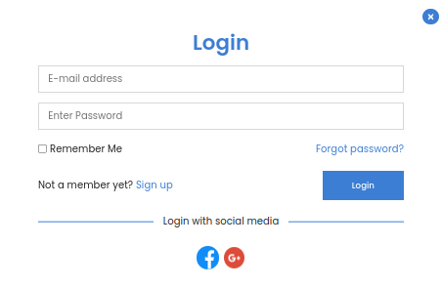

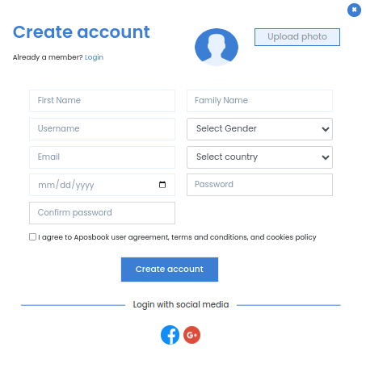

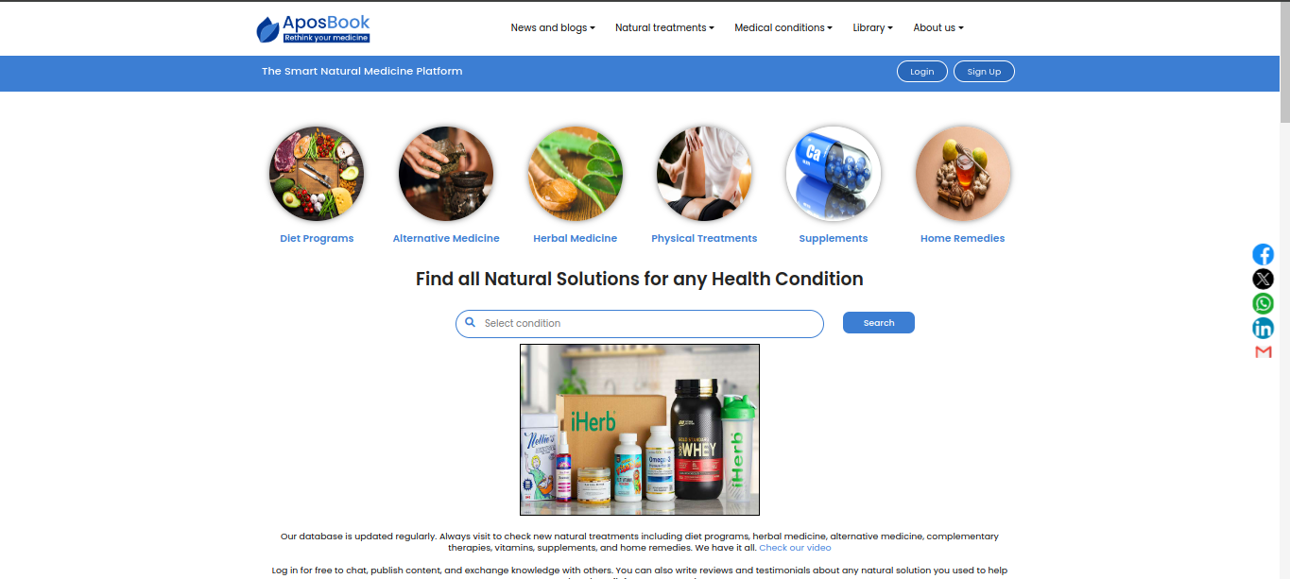

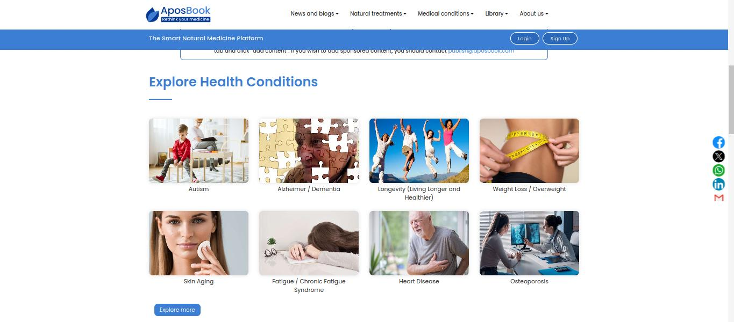

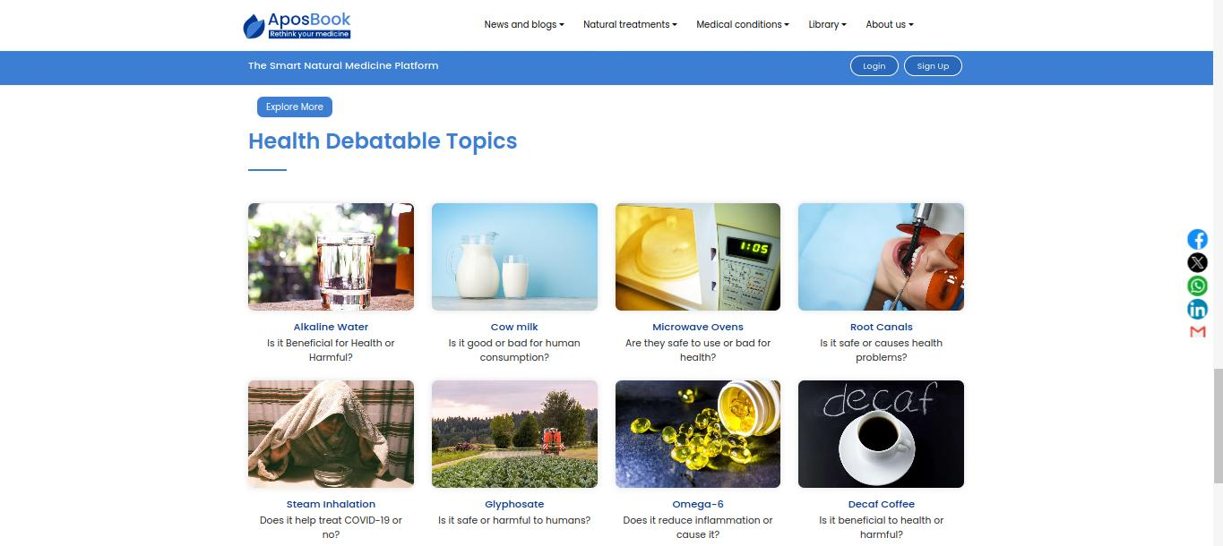

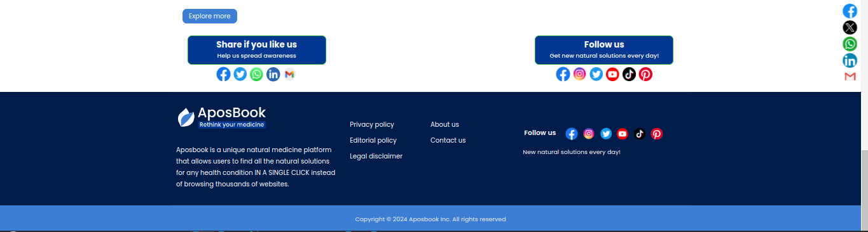

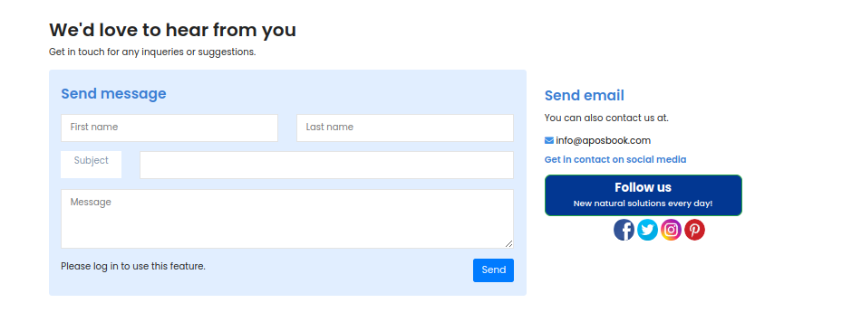

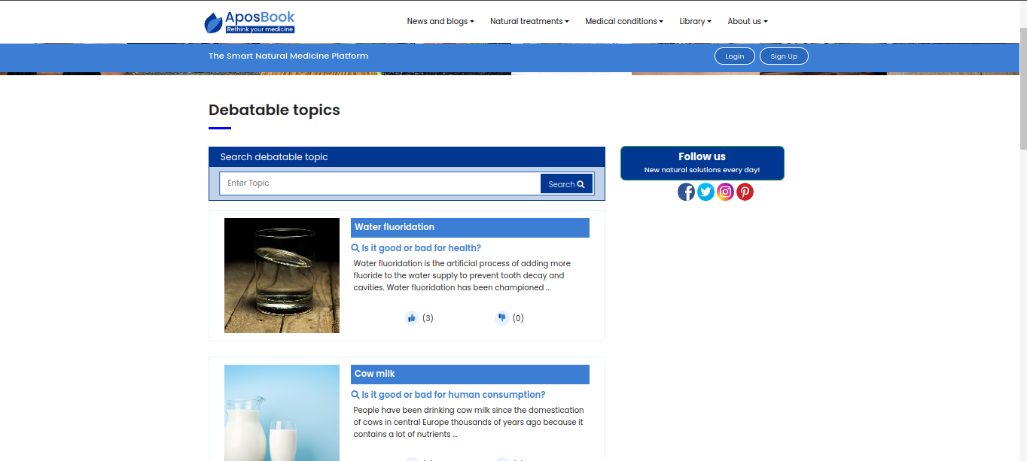

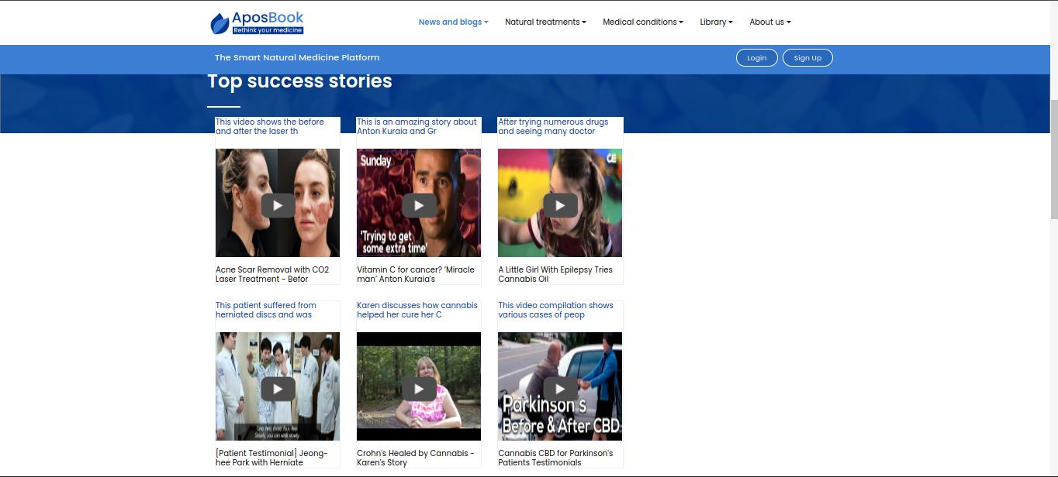

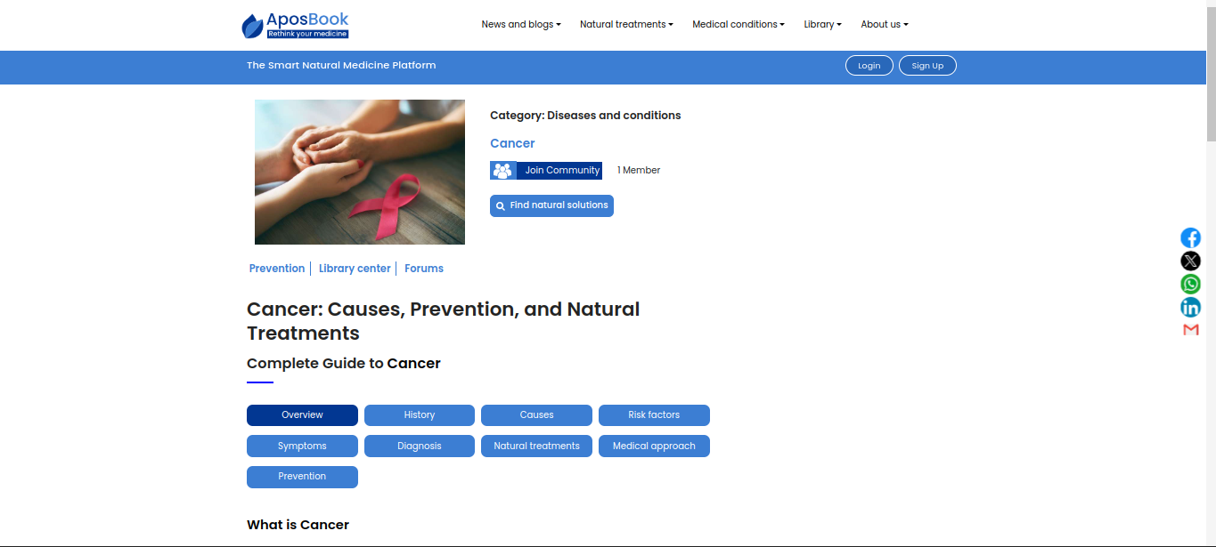

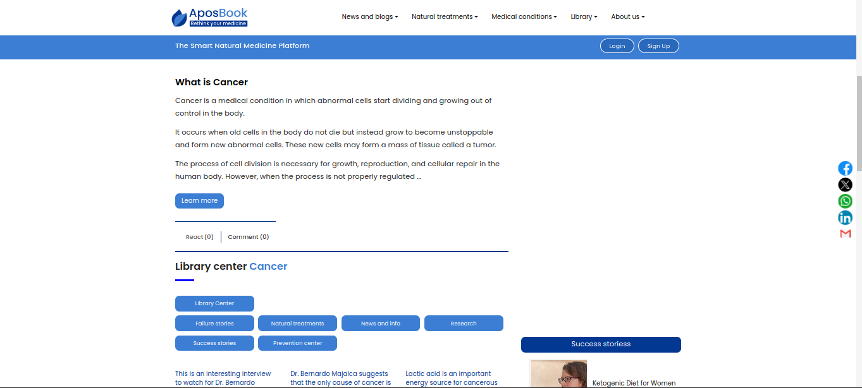

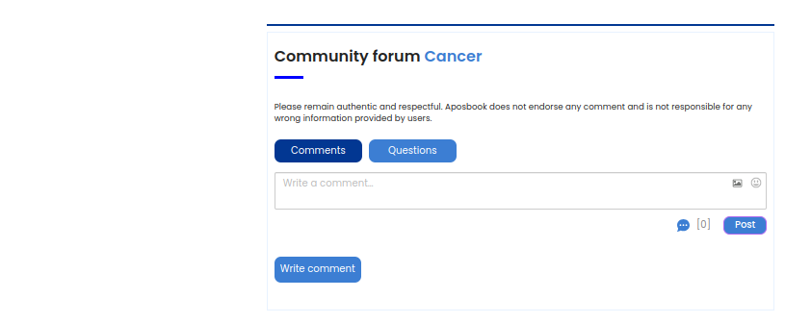

# SWOT Analysis

## Strengths:

**Innovative Technology:** The organization leverages cutting-edge technologies driven by a workforce composed primarily of recent graduates. This infusion of fresh talent keeps the company at the forefront of innovation.

**Creative and Effective Execution:** The young, educated team uses their latest knowledge and skills to execute projects creatively and effectively, setting the company apart from competitors.

**Friendly Work Environment:** The company cultivates a friendly and open atmosphere, encouraging all employees to feel comfortable discussing queries and ideas, which enhances teamwork and problem-solving.

## Weaknesses:

**Limited Workforce:** The organization has a small number of employees, which may restrict its capacity to handle multiple projects simultaneously or expand rapidly.

**Insufficient Office Space:** The limited size of the office can be a constraint on the number of employees the company can accommodate and may hinder effective operation and future growth.

## Opportunities:

**Supportive Network:** The company benefits from a robust network of knowledgeable and experienced professionals. This network includes industry veterans who provide guidance on using the latest technologies and problem-solving strategies.

**Access to Expert Advice:** The mentors and senior professionals in the network help the company navigate challenges and stay updated with modern tools and practices, offering a significant advantage in technology and business strategies.

**Potential for Expansion:** With a strong support system and expertise available through its network, the company is well-positioned to expand its services and explore new markets, capitalizing on the latest industry trends and demands.

## Threats:

**Political Instability:** The organization operates in an environment where political changes can lead to economic downturns. This instability can damage the company's reputation and the confidence of international clients, impacting business operations and profitability.

**Economic Sensitivity:** As the organization's client base includes customers from various countries, any local or global economic downturns could reduce their investment in new technologies, directly affecting the company's revenue streams.

**Conclusion:**

Over the course of my two-month internship, I had the opportunity to experience firsthand the corporate culture and interpersonal dynamics of a bustling company. Initially, entering a professional environment was daunting, especially when it came to engaging with my colleagues and superiors. I often hesitated to ask questions, fearing that I might seem underprepared or intrusive. However, the welcoming and supportive nature of the team quickly alleviated my apprehensions.

The kindness and readiness to assist shown by everyone at the company not only eased my initial discomfort but also fostered a fertile learning environment. This positive atmosphere was instrumental in helping me understand the nuances of professional communication and collaboration. I learned how to approach different personalities, adapting my communication style to meet the diverse needs and preferences of colleagues and clients alike. Understanding and adapting to various communication styles was crucial, as it directly influenced the efficacy of the team and the satisfaction of clients. This experience has been pivotal in shaping my professional demeanor and improving my interpersonal skills, which are invaluable in any career path.

**Recommendations:**

Based on my observations and experiences during the internship, I would like to offer some recommendations that could potentially enhance the operational capacity and market presence of the company. First and foremost, considering the increasing workload and the broadening scope of projects, there is a clear need to expand the workforce. Increasing the number of employees will not only distribute the workload more evenly but also bring in fresh ideas and perspectives which are crucial for innovation and growth.

Furthermore, the physical office space currently utilized is becoming increasingly insufficient to accommodate the growing team and the diverse activities of the company. Expanding the office space, or possibly opening additional locations, would provide the necessary infrastructure to support an increasing number of employees and departments. This expansion is not just about size but also about enhancing the work environment, which in turn improves productivity and employee satisfaction.

## Conclusion

As we know, nothing is perfect in the world. Everyone has something that is good but also there are some mistakes as well. During my two months internship, I found the people working in the company very helping and friendly. At the start, I felt hesitated when asking questions but after sometime due to their polite and helping nature my hesitation very gone and it was very helpful for me to work in a professional environment and it guides me on how to interact with the colleagues and how to communicate with different type of clients as very person has its own nature and it is necessary to listen to the other and understand what he or she is trying to tell and you have to convey your message in a effective way.

## Recommendation

I would recommend them to increase the number of employees and the office also needs to be expand in order to grow the name of the organization because you have to increase the departments and number of employees as there is work in every domain so more the number of departments more the company will have clients and earni