## Community Based Train Locating System (CBTLS)

## D.N.H Senevirathna

*Faculty of Information Technology, University of Moratuwa, Sri Lanka*

*nadee158@gmail.com*

**Abstract**

Rail transportation has been considered as a main mode of public transportation in Sri Lanka since a long time. It is a mass transportation medium. Hence it is important to further develop and enhance railway transportation as an alternative method of transportation, especially considering the traffic congestion that could be observed in urban areas. With the advancement of information technology, over the past few decades there have been many attempts to enhance the quality of railway services with its aid, but despite of them, some major concerns for the train passengers in Sri Lanka remaining unsolved to date.

The main objective of this project is to propose and implement a crowdsourced real time train tracking system based on GPS named Community Based Train Locating System (CBTLS), for the benefit of train passengers and train transportation of Sri Lanka, aiming to address the major concerns and enhance the railway as a service for general public.

CBTLS is a community based (crowdsourced) system, therefore its data is retrieved from the train passengers, and then organized, processed and analyzed by the system, and resulting information and predictions is given back to the train passengers.

The proposed system consists of a native Android mobile application and a Web application. Any train passenger with a smart mobile device or a computer would be able to access the system through internet, update the train locations, compartment details, and view current and/or last known locations of a train, view analysis, predictions and suggestions on train schedules. Other than static train schedules which is fed as master data to the system initially, rest of the data required for system’s functionality is acquired from the train passengers. Hence the system is community based (crowdsourced).

Data regarding each train schedule is recorded in the system daily, therefore the collected data could be analyzed to identify different patterns of railway transportation, in relation with temporal, seasonal or factors like weather conditions.

Other than above mentioned services for train passengers, the system consists of an administrative functionality as well. System administrators hold responsibility to control and overview the user accounts created by train passengers and manage static master data.

**Keywords:** Train Locating, Community Based System, Real Time Location Tracking

**Introduction**  
Railway Transportation service in Sri Lanka is owned by the government of Sri Lanka and functions as a public service offered to citizens by Sri Lanka railways Department. To use this public service efficiently, the availability, and easy access of information regarding the service is a critical factor for train passengers. Based on the available information, the passengers would be able to make decisions on their travel plans.

Since the railway transportation service in Sri Lanka is owned by the public sector of the country, the government authorities have been seeking methods to improve the efficiency of this service. The main objective of such efforts is to provide a better service to the train passengers.

According to the work done by G. Bradley, it suggest that in most of countries the governments have already recognized the potential and importance of the implementation of Information Communication Technology in the key areas of their services for general public. At present, Information Communication Technology is playing a key role as a main tool used to enhance the quality and allow easy access to government services with the aim of providing a better and efficient service for the general public[1].

As a result, e-Government and m-Government like concepts have been introduced to use Information Communication Technology as an interface to provide services offered by the public sector as well as to distribute the required information to citizens of the country.

As it is indicated in the work by S.Rainford, at present, in Sri Lanka most of the key public services has been integrated with ICT already and as a still ongoing project, rest of the services are also planned to be integrated in the future. Though the currently available service, public has access to the static train schedules [2].

Based on this e-Service provided by Sri Lanka railways Department, with the support of Information and Communication Technology Agency of Sri Lanka (ICTA), there are several applications build, both mobile and web applications for the benefit of train passengers such as the eService by The Department of Railways [3], android application like Sri Lanka Train Schedule [4], a partially implemented real time system named as “GPRS based Railway Traffic Optimisation System (RTOS)” by Sri Lanka Railway with University of Colombo [5].Some of these systems does address certain issues, but none of them are currently providing a comprehensive solution.

The most common issues which could be observed in train transportation at present day from a passenger’s perspective can be considered as, frequent delay of trains, cancellation of trains without prior notification, outdated or inaccurate train schedules available for public, miscommunications, complexity of finding destination station for novice passengers.

The approach taken here to solve these issues is to make train passengers aware of the current situation through real time data, and possible situations through predictions from analyzed data. Having this information at hand, it will allow the passengers to make a better decision on their method and time of transportation making it easier to use the service.

For Railway administration, collected data on each schedule daily could be used to analyse the existing issues in the system and find reasons for the train delays, locations where trains gets delayed, the possible related external factors, any existing patterns and find solutions for them and finally enhance the service.

With this system, it is expected to facilitate train passengers to make better travelling decisions by providing required information for them, hence facilitating efficient usage of railway services. The administration parties could use the collected data to be analyzed in any perspective they desire to make better decisions to enhance railway transportation as a service.

**Methodology**

The expected outcome of this research is to provide a comprehensive software application solution - named as Community Based Train Locating System (CBTLS), to address the identified current issues for train passengers and to enhance their experience with the service.

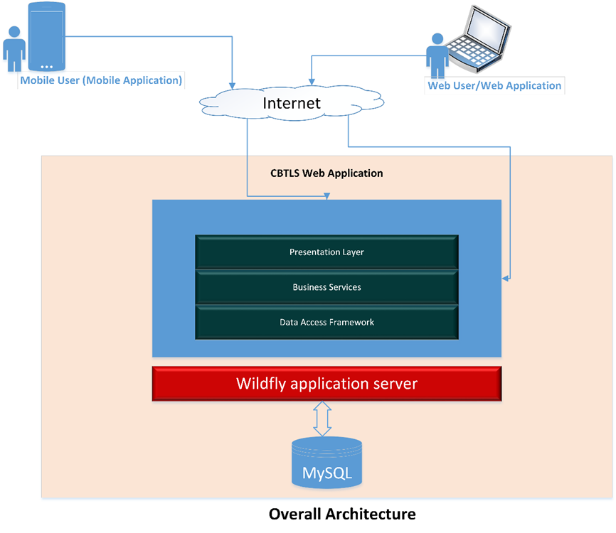

Figure 1: Detailed Architecture of CBTLS

The system consists of a web application and a mobile application. Mobile application is used to collect data about trains from passengers and the same is used to display data upon enquiries. Same functionality is available in the web application as well, and additionally administrative functionality. Since the web application consists of all the functionality of mobile application, rest of users can access the web application if required.

**Inputs for the CBTLS**

Initial data of static train schedules is fed to system using the data integration module. Data is retrieved from the web service available from ICTA and Department of railways. Based on master data on train schedules, system generates instances of each train schedule daily. For each occurrence of train schedule, train passengers who would choose to use the system provides data. For validation purposes, and for data analytical purposes, geo coordinates of train stations along the selected route, and the geo coordinates of the selected rail route is inserted into the system along with master data. For this purpose, Google Map API was used.

The users of CBTLS can update the current location of a selected train using the mobile application or web application, actively or passively, and for each two methods different parameters is taken in to the system as inputs. Active update is available for the users who are already inside the train, they could either update the location once or can allow the system to keep track of the location continuously. Here the location of the user would be captured. Passive update is for the users who are outside the train, but still aware of the location of the train. They are allowed only to update once, and when updating, instead of their lactation data, the last station passed, the located time and current moving status of the train should be provided.

Furthermore, users can update the compartment details of the train as well, and this is in terms of crowd density. They can provide one of the predefined crowd density status for a selected compartment and for the overall train. They should provide the compartment number of their reporting and the total number of compartments in the whole train as well. As an additional feature, a location aware alarm clock is integrated and users can set the alarm based on their preference.

**Outputs of CBTLS**

The CBTLS facilitate users to view real time train locations on a map, and allows to view compartment details of a selected train. Additionally, it provides the facility to view analysis and predictions on a selected train schedule. If the location aware alarm is set by the user, it will be activated once the set destination has been arrived.

The collected data set can be extracted from the system and can be used to process and analyse using data mining technologies.

**Process**

The initial static train schedule data is integrated in to the system using the data integration module. By using either mobile or web application, users could search for train schedules. For this purpose, a basic search and an advanced search both will be available for the convenience of users, once they view the train schedules, they could access the list of recommendations for the same criteria. This recommended list is prepared by analyzing the historical data collected in the system.

The user authentication module will authenticate users by the backend service, allowing to use same credentials to be used both in web and mobile applications.

In the mobile system, the user location would be acquired through GPS and Android's Network Location Provider and is sent to the web application as a series of geo coordinates. The retrieved location data into the web backend is to be validated against a set of predefined geo location data set before being recorded in the system. As an additional measure, the data will be validated against user’s ranking in the system as well.

**Users**

Three major types of users are identified in the CBTLS system as anonymous users, registered train passengers (normal system users) and system administrators. Based on the type of user, access levels to certain functionalities of the system is varying. Only the system administrators are allowed to view and use the administrator module, and only the registered users are allowed to update the system with data. Anonymous users are allowed to use the viewing functionalities only, this measure has been taken ensure the reliability of the system.

**Features**

The most distinguished feature of CBTLS among the reset of services available or proposed for the same purpose is its source of information that is the community based nature of the system. Due to this factor, the implementation cost is kept at a minimal rate compared to the rest of systems using GPS/GPRS like technologies. Since no involvement from railway Department is required, the implementation would not be complicated. Once the web system is hosted and mobile application is added to the Google Play app store, general public can easily access and use the system. Only an initial cost for the hosting environment is to be applied. Over the time CBTLS is expected to be grown mature, since large amount of valuable data will be collected through the system, which is not already available. Such data could be used for the analytical purpose and to generate new knowledge.

Although CBTLS contains static train schedule data, unlike the existing systems which are calling the remote service each time a user access the system, CBTLS would be consists of its own data set after the initial integration. This is to prevent the dependency on a third party service, specially a service which is not reliable. For the sake of accuracy and updated data, the integration process could be done periodically. Therefore CBTLS is expected to be a self-managing system without depending on any of external systems.

**System Simulation**

To test the system, the data gathering part was simulated. For this purpose, all train schedules available from Colombo Fort station to Ja-Ela station were taken as the sample set (20 were available). Geo coordinates of 13 train stations in between were taken with additional 6 random points along the rail route.

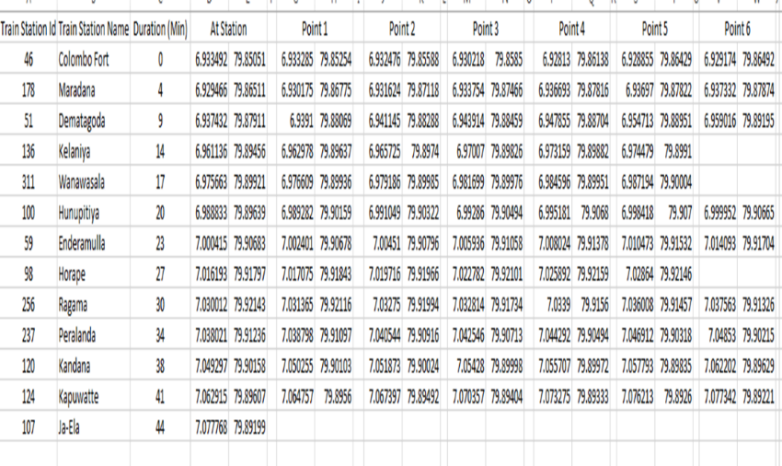

Figure 2: Master Dataset used for simulation

Based on the average time duration to reach each station, a random data set was generated as indicated below.

To simulate users – 156 random user accounts generated. To simulate location updates, 700 train schedules were generated for the time period of 2016-03-01 to 2016-04-04. Simulating the active location update process, 58806 location updates were generated along the above selected rail route.

**Results**

The following diagram illustrates the deployment environment of the CBTLS, required resources and networks for the actual deployment.

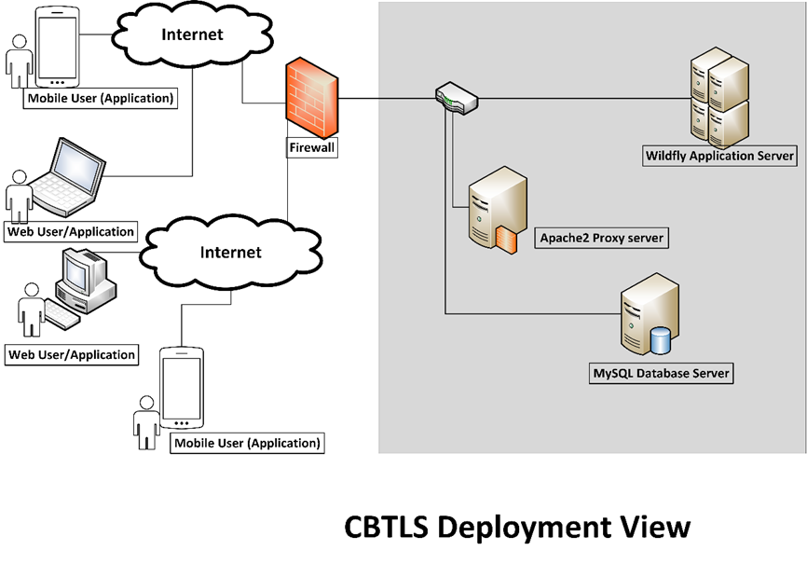

Figure 3: Deployment of CBTLS

The resulting web application and mobile applications consists of multiple user interfaces (UIs) to gather location updates and provide requested data. Below is the web UI to view current location of train.

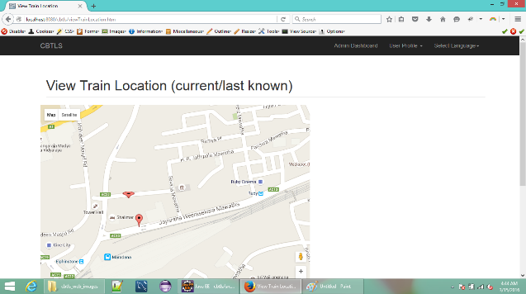

Figure 4 – Web application – View Train Location UI

Considering the factors like day of week, if it’s a holiday or not, weather conditions, collected data can be used as a source for data mining tools like WEKA and predictions can be retrieved.

Below is an example done, using a decision tree - J48, to predict if the train will get delayed if it got delayed at start station.

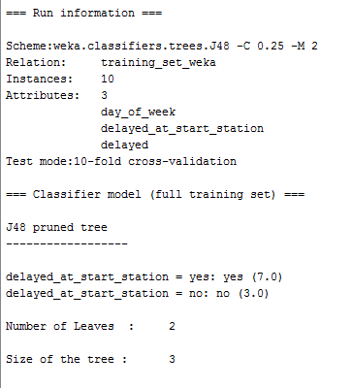

Figure 3: Predictions on train delays using WEKA tool

**Conclusion**

This new system will provide real time information to a passenger, regarding a selected train including indication if the train is available or not, and if available, the current position of the desired train and the crowd density in each compartment. System provides the facility to submit the passenger’s suggestions, comments and criticisms regarding a selected train. The location aware alarm indicates when the desired destination is reached along with facility to add train schedules in to a “Favorites List” for easy access. Passengers can view forecasts on each train schedule based on previous data. The above features would allow passengers to save the waiting time at the stations for a train. In case of delays or cancelations, to select an alternative method of transportation and allowing novice passengers use train service without hesitation with alarm facility.

For the relevant authorities, the analyzed patterns of train transportation can be used to identify the points where delays occur, hence to enhance the service. This can save many productive man hours for the country. Data collected regarding each train daily by CBTLS would be a new set of data, which could be used to generate new knowledge. For an official implementation for Railway Department, it could be done at a minimal cost - only requirement would be to place a smart mobile device inside the train. Another dimension could be integrated in to CBTLS as to collect factors such as weather information along with train location updates, by integrating a third party service.

**References**

[1] G. Bradley, International Association for Development of the Information Society, and Albert-Ludwigs-Universität Freiburg, Eds., *Proceedings of the IADIS International Conference ICT, Society and Human Beings 2010: part of the IADIS Multi Conference on Computer Science and Information Systems 2010 ; Freiburg, Germany, July 29 - 31, 2010*. Lisboa: IADIS Press, 2010.

[2] S. Rainford, “e-Sri Lanka: An integrated approach to e-government case study,” Reg. Dev. Dialogue, vol. 27, no. 2, pp. 209–218, 2006.

[3] ICTA, “Sri Lanka Railways - Train Schedule,” *Sri Lanka Railways*, 2011. [Online]. Available: http://eservices.railway.gov.lk/schedule. [Accessed: 13-Mar-2016].

[4] G. Bhashitha Nadun, “Sri Lanka Train Schedule - Android Apps on Google Play,” *Google Play*, 04-Mar-2014. [Online]. Available: https://play.google.com/store/apps/details?id=lk.icta.mobile.apps.railway. [Accessed: 13-Mar-2016].

[5] Leelaratne, “Train Schedules of Sri Lanka - Android Apps on Google Play,” *Google Play*, 14-Oct-2014. [Online]. Available: https://play.google.com/store/apps/details?id=com.aselalee.trainschedule. [Accessed: 13-Mar-2016].

[6] K. Mobiles, “Train Guide - Sri Lanka,” *Google Play*, 30-Jul-2014. [Online]. Available: https://play.google.com/store/apps/details?id=k.dw.timetable. [Accessed: 13-Mar-2016].

[7] “Railway Traffic Optimisation System,” *Sri Lanka Railways*, 01-Aug-2014. [Online]. Available: www.slrail.info/tracking/timetable.php. [Accessed: 22-Nov-2015].

[8] Prasanna, “How to search where the train is in Sri lanka (system to keep track of trains),” *Synergy Y*, 17-Jul-2014.

[9] D. Jayakody, M. Gunawardana, N. W. Surendra, D. G. Jayasekara, C. Upendra, and R. De Silva, “GPS/GSM based train tracking system – utilizing mobile networks to support public transportation,” 2011.

[10] N. S. Gunasekara, “GPS based tracking system for trains in Sri Lanka.” 07-Jan-2006.

[11] ICTA, “Future Plans - Information Technology,” *Sri Lanka Railways*, 11-Sep-2011. [Online]. Available: http://www.railway.gov.lk/web/index.php?option=com_content&view=article&id=126&Itemid=180&lang=en#IT. [Accessed: 13-Mar-2016].

[12] B. Coifman, D. Beymer, P. McLauchlan, and J. Malik, “A real-time computer vision system for vehicle tracking and traffic surveillance,” *Transp. Res. Part C Emerg. Technol.*, vol. 6, no. 4, pp. 271–288, 1998.

[13] D. J. Dailey, L. Li, T. Northwest, and others, “Video image processing to create a speed sensor,” Washington State Department of Transportation, 2000.

[14] N. Chadil, A. Russameesawang, and P. Keeratiwintakorn, “Real-time tracking management system using GPS, GPRS and Google earth,” 2008, pp. 393–396.

[15] A. Kumarage, “Urban traffic congestion. the problem and its solutions,” 2002.

[16] A. B. Jayasinghe and N. Pathiranage, “Centrality measures’ as a tool to identify the transist demand at railway stations: the case of railway network, Sri Lanka,” 2015.

[17] “Economic and social infrastructure - Central Bank of Sri Lanka - ANNUAL REPORT 2012,” CENTRAL BANK OF SRI LANKA, ANNUAL REPORT 2012, Mar. 2013.

[18] “Statistics, Ministry of Internal Transport,” *Ministry of Transport and Civil Aviation - Sri Lanka*, 28-Oct-2015. [Online]. Available: http://www.transport.gov.lk/web/index.php?option=com_content&view=article&id=141&Itemid=113&lang=en. [Accessed: 13-Mar-2016].