FocusTrack: Multimodal Concentration Detection for Screen and Non-Screen Learners
Component 1: Context-Aware Learner Interaction-State Modelling
Project ID: J26-DS-307
Project Proposal Report (Revised)
Kumari M.A.D.N. – IT23211032
B.Sc. (Hons) Degree in Information Technology Specialised in Data Science
Department of Information Technology
Sri Lanka Institute of Information Technology
Sri Lanka
October 2026

DECLARATION
I declare that this is my own work, and this proposal does not incorporate without acknowledgement any material previously submitted for a degree or diploma in any other university or institute of higher learning, and to the best of my knowledge and belief it does not contain any material previously published or written by another person except where the acknowledgement is made in the text.
Name | Student ID | Signature
Kumari M.A.D.N. | IT23211032
The above candidate is carrying out research for the undergraduate dissertation under my supervision.
Supervisor | Date | Signature
Prof. Anuradha Karunasena

ABSTRACT
Keyboard, mouse and application traces are cheap and unobtrusive sources of information about how a learner is working, and several studies have used them to estimate engagement or workload. Most of these approaches, however, aggregate events into counts per time window and give each feature a single fixed meaning. In real study sessions the same behaviour can mean different things: low keyboard activity can indicate focused reading or idling, and frequent application switching can indicate research or distraction.
This component of FocusTrack proposes a context-aware interaction-state representation. Timestamped keyboard, mouse and application metadata – never key content – are converted into one-minute temporal features, recurring interaction states are discovered with a Gaussian hidden Markov model, transitions between states (dwell time, interruptions, recovery) are quantified, and their interpretation is conditioned on the learning task recorded at the start of each session. The representation is compared with a conventional aggregated-feature baseline.
Using the shared FocusTrack protocol (20–24 SLIIT undergraduates, six sessions each, labelled by momentary focus probes), the component will be evaluated with macro-F1 under leave-one-participant-out and leave-one-task-out validation, with significance tested across participants and ablations that remove task context, states and transitions in turn. Non-screen sessions are analysed separately, where the component's role is limited to detecting interruptions.
Keywords: Learning analytics, interaction states, hidden Markov models, keystroke and mouse dynamics, context-aware modelling

ACKNOWLEDGEMENT
I thank my supervisor, Prof. Anuradha Karunasena, and the proposal evaluation panel, whose feedback on the first proposal presentation – in particular on how the data will be labelled and on what is genuinely novel – directly shaped this revised proposal. I also thank my FocusTrack teammates for the many discussions that produced the shared labelling protocol, data model and integration design used across all four components, and the Centre of Excellence for AI (CoEAI) at SLIIT.

TABLE OF CONTENTS
DECLARATION 2
ABSTRACT 3
ACKNOWLEDGEMENT 4
TABLE OF CONTENTS 5
LIST OF FIGURES 7
LIST OF TABLES 7
LIST OF ABBREVIATIONS 8
SUMMARY OF REVISIONS 9
1. INTRODUCTION 10
1.1 Background and Context 10
1.2 Literature Review 10
1.3 Research Gap 11
1.4 Research Problem and Research Questions 11
2. OBJECTIVES 13
2.1 Main Objective 13
2.2 Specific Objectives 13
3. METHODOLOGY 14
3.1 Research Design 14
3.2 Participants, Sessions and Labelling Protocol (shared) 14
3.3 Component-Specific Data and Labels 17
3.4 Data Preparation and Representation 17
3.5 Models and Technology 18
3.6 Baseline 18
3.7 Evaluation Metrics and Self-Evaluation Plan 18
3.8 Validation Strategy 19
3.9 Limitations 19
3.10 Ethical and Privacy Considerations (shared) 19
4. HIGH-LEVEL SYSTEM ARCHITECTURE 21
4.1 Overall FocusTrack Architecture 21
4.2 Component 1 Design and Novelty 22
4.3 Integration with FocusTrack 23
4.4 Individual Responsibility Boundary 23
5. USER REQUIREMENTS 25
5.1 Requirement Sources 25
5.2 Functional Requirements 25
5.3 Non-Functional Requirements 25
6. COMMERCIALISATION PLAN 26
7. BUDGET AND JUSTIFICATION 27
8. WORK BREAKDOWN STRUCTURE 28
9. GANTT CHART 29
10. REFERENCES 30
11. APPENDICES 32
Appendix A: Proposal Evidence and Decision Log (mandatory) 32
Appendix B: AI Use Disclosure (mandatory) 32

LIST OF FIGURES
Figure 1: Study design: participants, sessions per study mode (illustrative allocation) and leave-one-participant-out validation
Figure 2: Shared labelling protocol across one 50-minute study session
Figure 3: The focus probe as implemented in the prototype app, and how a rating becomes a training label
Figure 4: Unit of analysis and labels used by each component
Figure 5: Component 1 processing pipeline, from privacy-preserving logging to epoch classification
Figure 6: Component 1 evaluation design: ablation ladder and leave-one-task-out validation
Figure 7: Privacy-preserving data flow shared by all components
Figure 8: FocusTrack overall system architecture: three sensing components, the shared data layer and the fusion component
Figure 9: Interaction states, transitions and transition features (illustrative; the real states are learned from data)
Figure 10: The same interaction pattern read differently by task – hypotheses tested by the task-context ablation
Figure 11: Project schedule, September 2026 – July 2027

LIST OF TABLES
Table 1: Comparison of interaction-based approaches with this component
Table 2: Specific objectives, success measures and research questions
Table 3: Component 1 evaluation metrics and targets
Table 4: Responsibility boundary
Table 5: Functional requirements
Table 6: Non-functional requirements
Table 7: Shared project budget (estimate)
Table 8: Work breakdown structure

LIST OF ABBREVIATIONS
Abbreviation | Meaning
C1–C4 | FocusTrack Components 1–4
CV | Cross-validation / Computer vision (by context)
DGD | Downward-Gaze Disambiguation
ESM | Experience sampling method
ESP32 | Espressif ESP32 microcontroller
F1 / macro-F1 | Harmonic mean of precision and recall / its unweighted class average
FR / NFR | Functional / Non-functional requirement
HMM | Hidden Markov model
LOPO | Leave-one-participant-out validation
MAE / RMSE | Mean absolute error / Root mean square error
PnP | Perspective-n-Point pose estimation
ROC-AUC | Area under the receiver operating characteristic curve
SDG | Sustainable Development Goal
SHAP / LIME | SHapley Additive exPlanations / Local Interpretable Model-agnostic Explanations
WBS | Work breakdown structure
XAI | Explainable artificial intelligence

SUMMARY OF REVISIONS
The first proposal was returned by the evaluation panel for revision. The table below lists each issue, raised by the panel or found in the team's own logic review, and where this revised proposal addresses it.
Issue | Raised by | What changed | Where
How will the data be labelled? | Panel (all members) | One shared, multi-source labelling protocol: momentary focus probes, scripted calibration, event review and an observer audit | Section 3.2; Figure 2, Figure 3
"Focus" was not defined, and self-report was called unreliable yet used as the label | Logic review | Focus defined as momentary self-reported focus; probes checked against an observer and known-truth segments | Sections 1.1, 3.2
Faculty used to define learner groups | Logic review | Study mode recorded per session; faculty kept only as a covariate | Section 3.2
Significance tests across a few folds | Logic review | Leave-one-participant-out validation with paired tests across ≈ 22 participants | Section 3.8; Figure 1
Recruitment risk from a low incentive | Logic review | Incentive raised to LKR 2,000 per participant | Section 7
How is training data obtained? | Panel | Own data from the component's logger in every session, labelled by focus probes | Sections 3.3, 4.2
Many studies already use keystrokes – what is unique? | Panel | Novelty narrowed to context-conditioned interaction states and transitions, tested against an aggregated baseline | Sections 1.3, 4.2
Cross-task test "train on coding, test on reading" was degenerate | Logic review | Leave-one-task-out among computer-based tasks only | Section 3.8

1. INTRODUCTION

1.1 Background and Context
Sustained concentration during self-directed study is increasingly difficult to maintain. Observational studies of people working at computers report that attention on a single screen now lasts well under a minute on average [1], and a classic study of university students found that they switched to a technology-based distraction after roughly six minutes of study [2]. Students rarely see when or why their focus breaks: the usual instruments are retrospective self-reports, and the common productivity tools only record which application is open [3].
University students also study in two broadly different modes. In screen sessions they code, write or attend online lectures on a laptop; in non-screen sessions they read printed material or write by hand. The same observable signal can mean opposite things in these two modes: a downward head pose is typically a distraction when a student who is coding looks at a phone, but it is the task itself when a student reads a textbook. Low keyboard activity likewise signals focused reading in one mode and idling in another. Systems that ignore this context systematically misjudge learners who study away from the screen.
FocusTrack is a four-component research project that addresses this problem with a low-cost, privacy-first multimodal system. Throughout this proposal, focus is defined operationally as a learner's momentary self-reported focus on the study task over the preceding few minutes, rated on a 1–5 scale; "engagement" and "attention" are used only when describing other authors' work. The project supports UN Sustainable Development Goal 4 (Quality Education) [4].
This component addresses the behavioural stream: how the learner interacts with the computer. Interaction logging requires no extra hardware and is available on every participant's laptop, but its meaning depends on what the learner is doing. The component therefore asks not only how much interaction occurs but which pattern the learner is in, how patterns follow one another over a session, and how that should be read for each task.

1.2 Literature Review

1.2.1 Interaction traces as engagement signals
Altuwairqi et al. measured student engagement in online learning by combining facial-expression emotions with keyboard keystrokes and mouse movements, and reported that the multimodal combination outperformed single modalities [5]. Keystroke dynamics have also been used to recognise emotional states from typing rhythm [6]. These studies show that low-cost interaction data carry useful information, but they model features independently of the learning activity.

1.2.2 Reliability of individual behavioural features
Freihaut and Göritz reviewed the use of computer-mouse behaviour to measure stress and found that relationships between mouse features and internal states are inconsistent across studies and conditions [7]. Single features should therefore be treated as one signal among several rather than as direct indicators of concentration.

1.2.3 Sequences and task switches
Meyer et al. detected software developers' task switches and task types from interaction sequences, showing that the order of events carries information beyond event counts [8]. Their setting was professional software development; general university study activities were not examined. Hidden Markov models provide a principled way to represent such sequences as hidden states that evolve over time [9].

1.2.4 The need for context
Biedermann et al. developed contextualised logging of on-task and off-task behaviour during learning and argued that logs alone cannot reveal why a learner switched activity; context and the learner's own annotation were needed [10]. This directly motivates conditioning interaction patterns on the learning task.

1.2.5 Comparison with existing systems
Table 1: Comparison of interaction-based approaches with this component
Work / product | Representation | Context used | Temporal states / transitions | Learning tasks
Altuwairqi et al. [5] | Keyboard, mouse + facial emotion features | No | No | Online learning
Meyer et al. [8] | Interaction sequences | Developer task types | Task switches | Software development only
Biedermann et al. [10] | Contextualised logs + self-annotation | Yes (annotation) | No | Learning
RescueTime [3] | Time per application | App categories | No | General
This component | One-minute temporal features → HMM states | Task + study mode | Yes: dwell, transitions, recovery | Coding, writing, reading, assignment, lecture

1.3 Research Gap
Interaction traces are known to be informative [5], [6], sequences carry information beyond counts [8], and context is needed to interpret digital behaviour [10]. What has not been investigated is a unified representation that (1) turns learner interaction into recurring temporal states, (2) models transitions between them, (3) conditions their interpretation on the learning task, and (4) is tested against a conventional aggregated-feature baseline for concentration assessment across different study tasks. This component does not claim that no system uses keyboard or mouse data; it claims that this specific context-conditioned state-and-transition representation has not been evaluated.

1.4 Research Problem and Research Questions
Research problem. How should learner computer interaction be represented so that the same behaviour is interpreted correctly in different learning tasks?
RQ1. Does a state-and-transition representation of interaction predict self-reported focus better than aggregated features?
RQ2. Does conditioning states on the learning task improve accuracy when the model is applied to a task it was not trained on?

2. OBJECTIVES

2.1 Main Objective
To develop and evaluate a context-aware interaction-state representation of keyboard, mouse and application behaviour for momentary focus assessment.

2.2 Specific Objectives
Each specific objective is linked to a research question and has a measurable success criterion (Table 2).
Table 2: Specific objectives, success measures and research questions
ID | Specific objective | Success measure | Answers
SO1 | Build a privacy-preserving logger recording key timing, mouse movement and application category – never key content. | Zero key characters stored; CPU overhead < 3% | Enables all
SO2 | Engineer one-minute temporal features: typing bursts, inter-key interval variance, backspace ratio, mouse speed, idle ratio, switch rate. | Feature set documented; missing-data rate reported | RQ1
SO3 | Discover recurring interaction states with a Gaussian HMM (GMM as a simpler alternative). | Number of states chosen by BIC and stable across seeds | RQ1
SO4 | Quantify transitions: dwell time, transition probabilities, interruptions and recovery time. | Transition features per epoch | RQ1
SO5 | Condition states on the session task and study mode. | Context features included / ablated | RQ2
SO6 | Compare with an aggregated-feature baseline. | Higher macro-F1 under LOPO; smaller drop under leave-one-task-out | RQ1, RQ2

3. METHODOLOGY

3.1 Research Design
A quantitative, experimental design compares two representations of the same data – aggregated counts versus context-conditioned states and transitions – under identical models and validation, so that any difference is attributable to the representation.

3.2 Participants, Sessions and Labelling Protocol (shared)
Participants. 20–24 SLIIT undergraduates will be recruited after ethics approval: about half whose usual study mode is screen-based and half who usually study from printed material. Faculty is recorded as a covariate but is not used to define study mode, because faculty is confounded with subject, workload and habits. Each participant completes six study sessions of about 50 minutes, spread across at least two room types (home, library, campus), giving approximately 130 sessions and 110 hours of synchronised data (Figure 1). A five-participant pilot precedes full collection to fix window lengths, test the probe interval and measure the processing load on student laptops.
Session set-up. In every session the laptop (or a USB webcam on a small stand) faces the learner, any book or notes lie in front of it, the FocusTrack web app runs in the background, and the ESP32 unit sits beside the workspace. This fixed set-up makes non-screen sessions observable; its cost is some loss of ecological validity, which is reported as a limitation.
Labelling. Because focus is an internal state, labels are collected from several sources that are checked against each other (Figure 2):
- Study mode and task are selected at the start of every session (screen tasks: coding, writing on the laptop, assignment work, online lecture; non-screen tasks: reading printed notes, writing by hand). Study mode is therefore a property of the session, not of the person.
- Scripted calibration (2 minutes): the learner looks at the screen, reads their book and briefly picks up their phone on cue. These segments provide known-truth labels for vision detectors. They are posed behaviour, so they are used to evaluate detection, never as focus ground truth.
- Focus probes: a one-tap prompt asks "How focused were you over the last few minutes?" (1 = fully distracted … 5 = deep focus) at a random time every 8–12 minutes, about five times per session. This probe-caught experience-sampling approach is the standard way to measure momentary attention [11], [12], [13]. Each probe labels the five minutes before it, so supervision is weak (windowed) rather than per minute.
- End-of-session rating and event review: the learner rates the whole session and confirms or rejects automatically detected events (for example "phone at 10:42") without any video, following the self-annotation approach of contextual logging [10]. Reviewed events are secondary evidence only, because recall is imperfect.
- Observer audit: in library and campus sessions only (where an observer can be present without video), a trained observer codes on-/off-task behaviour every 30 seconds using a protocol adapted from BROMP [14]. Agreement with probe ratings is measured with quadratic-weighted Cohen's κ [15]. Observer presence can change behaviour; this reactivity is reported as a limitation.
Label processing. Figure 3 shows the probe as implemented in the prototype and how a rating becomes a label. Ratings are z-scored within each learner to remove personal rating style ("focused" = z > 0; "focus drop" = z ≤ −1). The statistics used for normalisation, personal comfort bands and alert thresholds are always computed on training data only, inside each validation fold, to prevent leakage. With about 650 probes the dataset yields roughly 3,000 labelled one-minute epochs out of about 6,500 in total. No public dataset combines interaction, environmental and visual signals with self-reported focus (DAiSEE, for example, is video-only and externally annotated [16]), so FocusTrack collects its own data; public benchmarks are used only to validate individual detectors. Figure 4 shows how each component uses these labels.
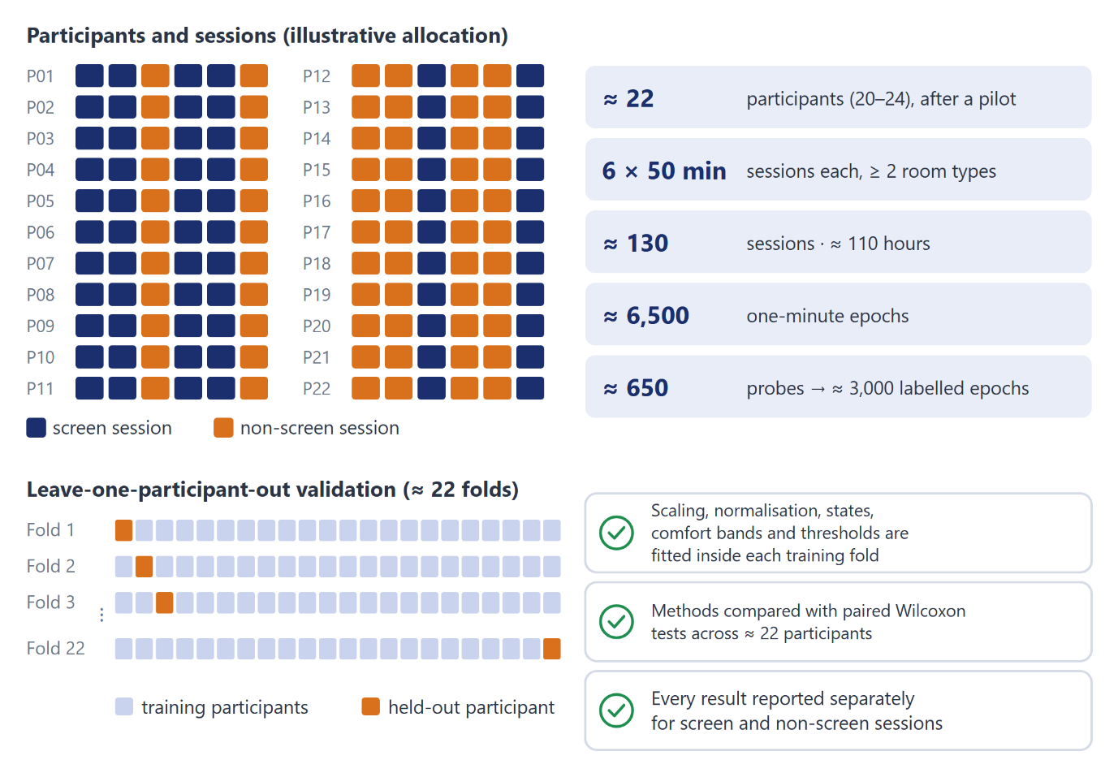
Figure 1: Study design: participants, sessions per study mode (illustrative allocation) and leave-one-participant-out validation
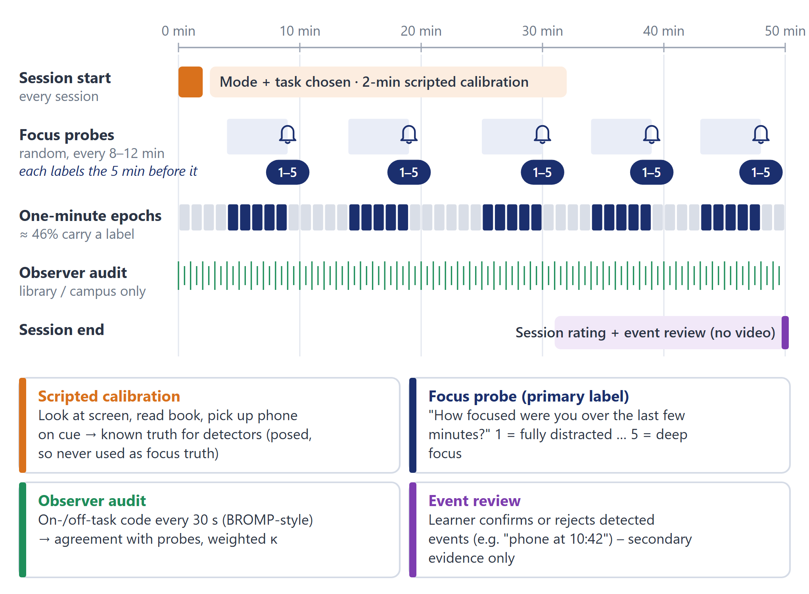
Figure 2: Shared labelling protocol across one 50-minute study session
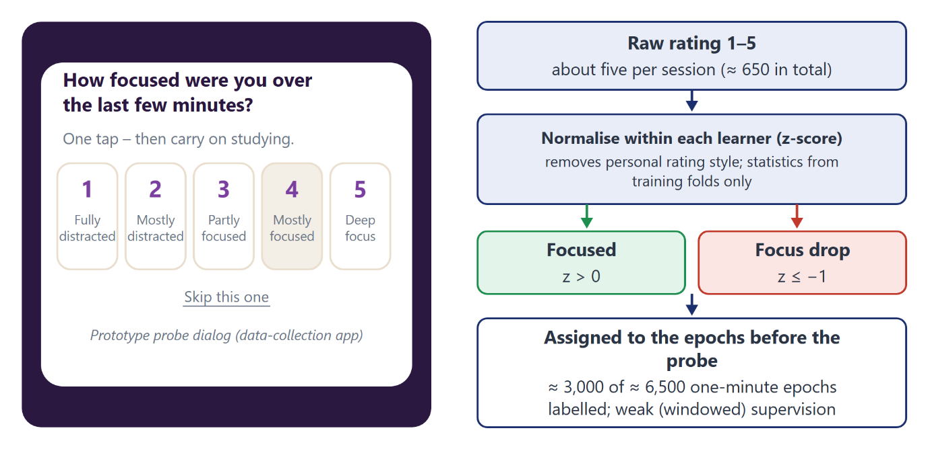
Figure 3: The focus probe as implemented in the prototype app, and how a rating becomes a training label
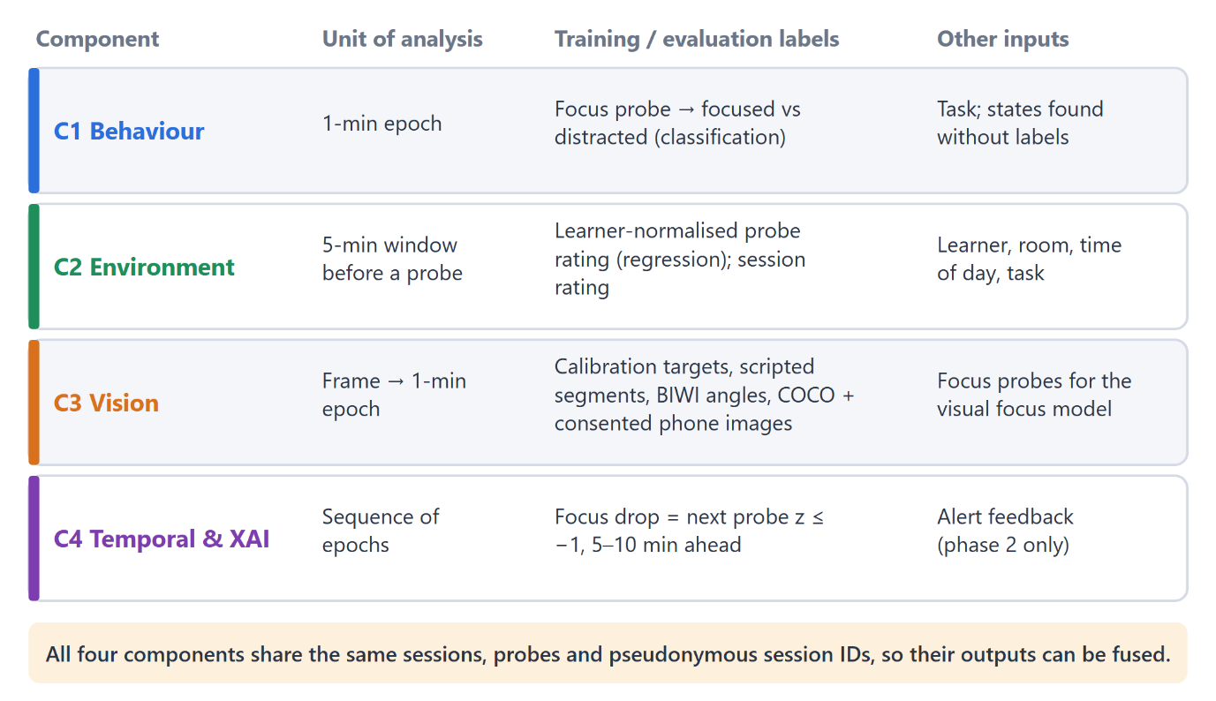
Figure 4: Unit of analysis and labels used by each component

3.3 Component-Specific Data and Labels
No public dataset contains keystroke timing, task context and focus labels together, so the logger runs in every FocusTrack session (six sessions of about 50 minutes per participant). Each probe labels the one-minute epochs in the five minutes before it (weak supervision), using learner-normalised ratings. Interaction states themselves are discovered without labels and only then related to the probes. Expected volume: about 6,500 epochs, of which about 3,000 carry focus labels.

3.4 Data Preparation and Representation
- Logging: key-down timestamps (no characters), mouse movement and clicks, active-application category (code editor, document, browser – learning, browser – other, messaging, other).
- Cleaning: remove duplicate events, align clocks with the session record, split by session and task.
- Epochs: one-minute windows with typing-burst rate, inter-key interval mean and variance, backspace ratio, mouse speed and path length, idle ratio, switch rate and application-category entropy.
- States: a Gaussian HMM is fitted on standardised epoch features from training participants only; the number of states is selected by BIC and checked for stability across random seeds.
- Transitions: for each epoch, current state, dwell time in the state, number of state changes in the last five minutes, time since the last interruption-like state and recovery time.
- Context: task and study mode, plus interaction terms between state and task.
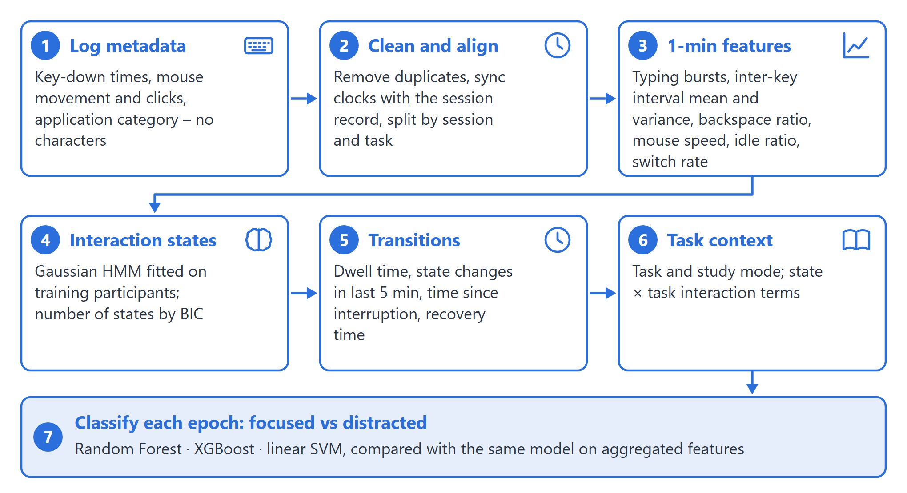
Figure 5: Component 1 processing pipeline, from privacy-preserving logging to epoch classification

3.5 Models and Technology
Random Forest [17], XGBoost [18] and a linear SVM are compared using scikit-learn [19] and hmmlearn; tree models are robust on small tabular datasets and their feature importances feed Component 4's explanations. Data are collected by an in-browser hook and a Python logger (pynput, psutil) and stored in Supabase alongside the other components.

3.6 Baseline
The baseline uses the same classifier on aggregated features only (typing rate, mouse activity, idle ratio, switch rate) without states, transitions or context. A majority-class baseline is also reported.

3.7 Evaluation Metrics and Self-Evaluation Plan
Table 3: Component 1 evaluation metrics and targets
Metric | Purpose | Target
Macro-F1 (primary) | Balanced performance on focused vs distracted windows | Higher than aggregated baseline; paired Wilcoxon across ≈22 participants
Balanced accuracy | Robust to class imbalance | Above majority-class baseline
Leave-one-task-out macro-F1 | Generalisation to unseen computer tasks (RQ2) | Smaller drop than baseline
Ablation | Contribution of context, states and transitions | Each removal reported
Logger CPU overhead | Feasibility | < 3% on a typical laptop

3.8 Validation Strategy
Models are validated leave-one-participant-out (about 22 folds), so that no learner appears in both training and test data [20]; HMMs, scaling and normalisation are fitted inside each fold. Significance is tested with a paired Wilcoxon signed-rank test across participants [21] – not across a handful of folds, where significance is impossible. For RQ2, leave-one-task-out validation is used among computer-based tasks (coding, writing, assignment, online lecture); reading sessions are excluded from this test because keyboard activity is near zero there by design. Non-screen sessions are reported separately: in them the component detects interruptions (sudden computer use) rather than focus.
Figure 6 summarises the evaluation design.
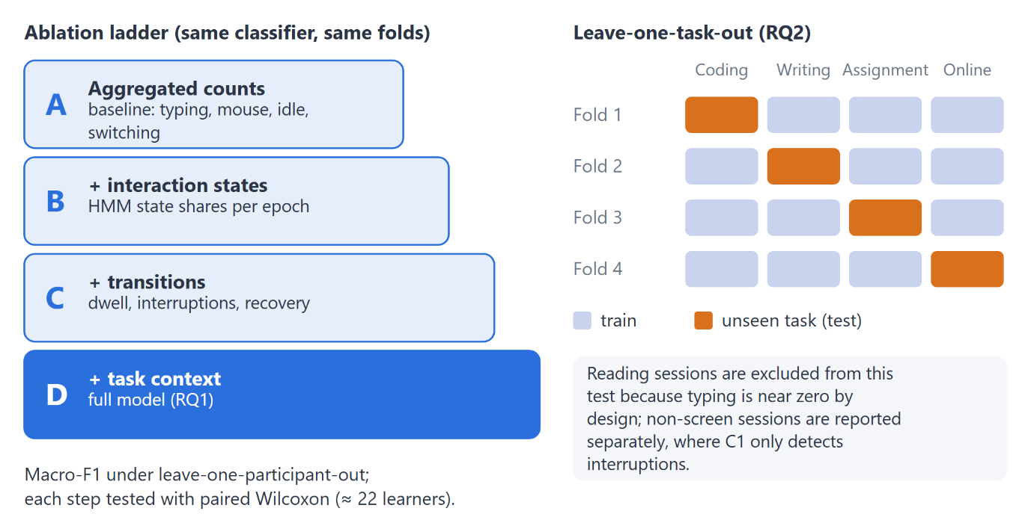
Figure 6: Component 1 evaluation design: ablation ladder and leave-one-task-out validation

3.9 Limitations
Labels are windowed self-reports; interaction tells little about focus in non-screen sessions; and application categories are coarse by design to protect privacy.

3.10 Ethical and Privacy Considerations (shared)
The study collects behavioural and biometric-adjacent data from human participants and will begin only after approval from the SLIIT ethics committee. Written informed consent will be obtained in English, Sinhala or Tamil, and participants may withdraw at any time, with their data deleted within 48 hours. Data minimisation is built into the design: no video, audio, keystroke characters, passwords or clipboard content are stored; the sound sensor records loudness only; and webcam frames are processed in browser memory and discarded. Only numeric features and ratings are stored, under participant codes, in an access-controlled database with row-level security, in line with Sri Lanka's Personal Data Protection Act [22]. The one exception is the optional, separately consented phone-image set used to fine-tune the phone detector, which is collected and stored under its own consent form. Anonymised features are retained for at most five years. Figure 7 summarises what is captured, what is processed only in memory and what is stored.
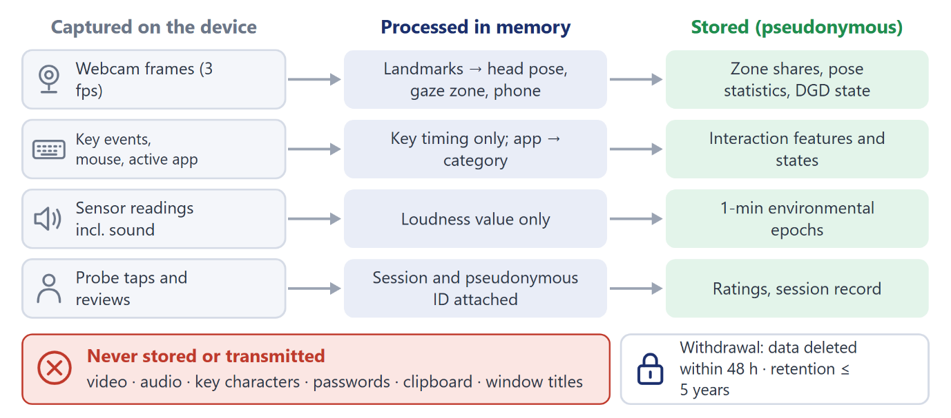
Figure 7: Privacy-preserving data flow shared by all components

4. HIGH-LEVEL SYSTEM ARCHITECTURE

4.1 Overall FocusTrack Architecture
FocusTrack has three sensing streams, each owned by one component, and one analytical component that fuses them (Figure 8). Component 1 logs keyboard, mouse and application metadata (never key content). Component 2 records temperature, humidity, light, sound level and motion with an ESP32 sensor unit. Component 3 processes the webcam stream inside the browser and exports only numeric features. All three write one-minute feature epochs, keyed by pseudonymous session ID and timestamp, to an access-controlled Supabase database, together with the labels described in Section 3.2. Component 4 fuses the epochs at feature level (with a decision-level fallback when a stream is missing), forecasts focus drops, and produces explained alerts. The focus score shown to learners is the calibrated probability of the "focused" class multiplied by 100.
The Signal Semantics Resolver – the project's shared novelty – is not a separate black box. It is implemented as explicit context rules inside components (for example, task-conditioned interaction states in Component 1 and Downward-Gaze Disambiguation in Component 3) and as context interaction features in Component 4. Every component tests its contribution by ablation: results with and without context, reported separately for screen and non-screen sessions.
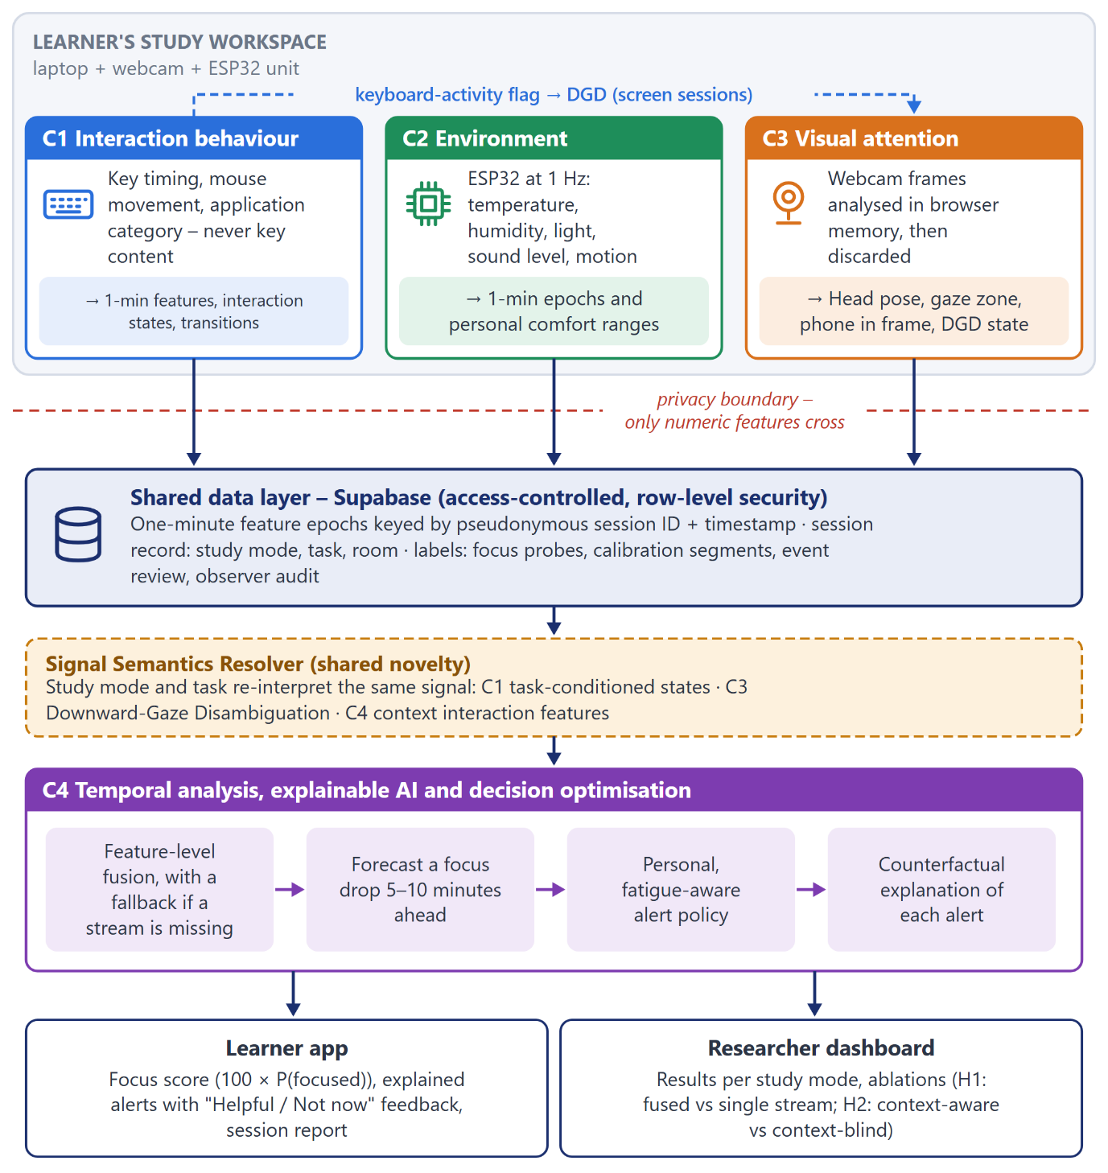
Figure 8: FocusTrack overall system architecture: three sensing components, the shared data layer and the fusion component

4.2 Component 1 Design and Novelty
The panel asked how this component differs from existing keystroke and mouse models, and where its training data come from. Typical models count events per window and give each count one fixed meaning. This component instead represents a session as a sequence of interaction states and the transitions between them (Figure 9), and reads each state in the light of the learning task (Figure 10). Training data come from the component's own logger in every FocusTrack session, labelled by the shared focus probes (Section 3.2), because no public dataset combines keystroke timing, task context and focus labels.
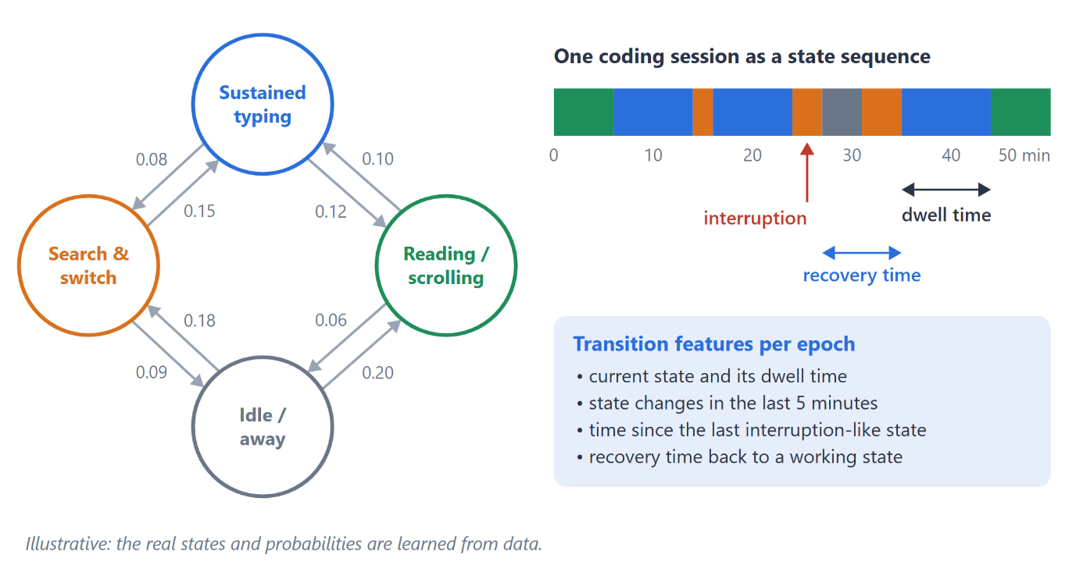
Figure 9: Interaction states, transitions and transition features (illustrative; the real states are learned from data)
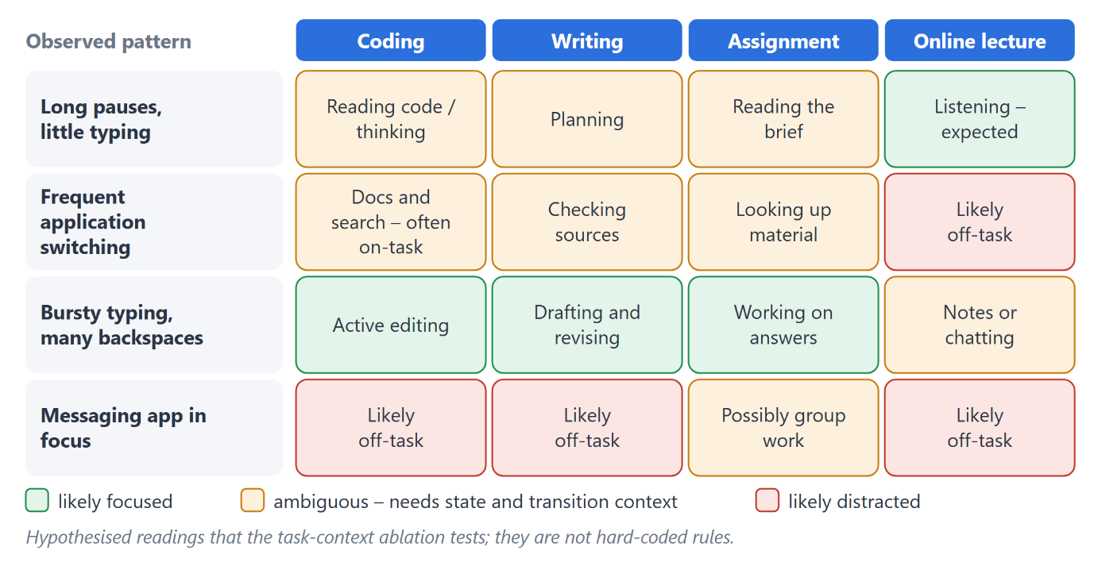
Figure 10: The same interaction pattern read differently by task – hypotheses tested by the task-context ablation

4.3 Integration with FocusTrack
Component 1 exports one-minute epochs (features, state, transition and context fields) to the shared database. It also provides a keyboard-activity flag used by Component 3's Downward-Gaze Disambiguation in screen sessions, and its feature importances support Component 4's explanations.

4.4 Individual Responsibility Boundary
Table 4: Responsibility boundary
Activity / deliverable | Responsible
Logger, features, HMM states, transitions, C1 evaluation | Kumari (C1)
Keyboard-activity flag for DGD | Kumari (C1) → Vithana (C3)
Shared labelling protocol, ethics, recruitment | All members
Feature-level fusion and explanations | Ayyash (C4)

5. USER REQUIREMENTS

5.1 Requirement Sources
Requirements were derived from four sources: the evaluation panel's feedback on the first proposal; the reviewed literature and existing products; the privacy concerns documented around camera-based proctoring; and the team's own prototype testing of the data-collection app. A short requirements and usability survey will be run with the pilot participants and will refine these requirements before full data collection; no survey results are claimed at this stage.

5.2 Functional Requirements
Table 5: Functional requirements
ID | Requirement | Description
FR1 | Metadata logging | Record key timing, mouse movement and clicks, and application category only.
FR2 | Session tagging | Tag every epoch with session ID, task and study mode.
FR3 | Epoch export | Export one-minute feature epochs to the shared database.
FR4 | Keyboard-activity flag | Publish a per-epoch keyboard-activity flag for Component 3.
FR5 | Offline buffering | Buffer data offline and synchronise when the connection returns.

5.3 Non-Functional Requirements
Table 6: Non-functional requirements
Category | Measurable requirement
Privacy | No key characters, passwords, clipboard or window titles are stored.
Performance | Logger CPU overhead below 3% on a typical laptop.
Reliability | At least 95% of minutes recorded per session.
Transparency | Participants can view exactly what is logged.

6. COMMERCIALISATION PLAN
Target market. FocusTrack addresses three segments: (1) university students, through a freemium app offering basic session feedback free and history, insights and coaching at LKR 500–1,000 per month; (2) universities and libraries, through an institutional licence providing anonymised cohort dashboards and study-space comfort maps; and (3) EdTech platforms, through an API that adds focus-aware pacing and alerts to existing learning products.
Value proposition and competitive advantage. Existing tools either track only which application is open, block distractions, or – in exam proctoring – record video, which raises serious privacy concerns [3]. FocusTrack differs in four ways: low cost (a sensor kit under LKR 5,000 plus the laptop the student already owns), privacy by design (no video, audio or key content leaves the device), support for students who study from books and notes, and explanations that tell the learner what to change. Local validation with Sri Lankan students gives a first-mover position in the region.
Persona. Nimali, 21, a business undergraduate who studies mainly from printed notes, wants to know why some study evenings are unproductive but rejects apps that film her or label her "distracted" while she reads.
Path to market. After the research study, a pilot in SLIIT library study spaces (2027) would validate the institutional offer. Open-source components are used under licences that permit commercial use.
Component 1's role in the product. Interaction states provide the "what was I doing" timeline in the student report and the interruption and recovery measures that institutions can aggregate anonymously.

7. BUDGET AND JUSTIFICATION
The budget is shared across the four components (Table 7). Participant incentives were raised to LKR 2,000 per participant who completes all six sessions (about five hours), because the earlier LKR 1,000 was a recruitment risk.
Table 7: Shared project budget (estimate)
Item | Justification | LKR
ESP32 kits and sensors (×5): DHT22, LDR, sound, PIR | One unit per concurrent participant plus a spare | 25,000
Backup USB webcams (×3) | For laptops with poor built-in cameras; fixed positioning for non-screen sessions | 9,000
Participant incentives (25 × 2,000) | About five hours of participation per person | 50,000
Hosting, storage, printing and travel | Database and web hosting, consent forms, dissertation printing, travel to collection sites | 19,000
Contingency (10%) | Hardware failure, extra recruitment | 10,300
Total |  | 113,300

8. WORK BREAKDOWN STRUCTURE
Table 8 lists the work packages for this component and the shared tasks.
Table 8: Work breakdown structure
# | Work package | Responsible | Duration | Period
1 | Literature review and gap analysis (interaction) | Kumari | 3 wks | Sep–Oct 2026
2 | Ethics application and consent forms (shared) | All | 3 wks | Oct–Nov 2026
3 | Privacy-preserving logger and feature extraction | Kumari | 3 wks | Nov 2026
4 | HMM state discovery and stability checks | Kumari | 3 wks | Dec 2026
5 | Transition and context features | Kumari | 2 wks | Jan 2027
6 | Phase-1 data collection (shared) | All | 12 wks | Dec 2026–Mar 2027
7 | Model training, baseline comparison and ablation | Kumari | 4 wks | Mar–Apr 2027
8 | Integration with C3 and C4 | Kumari + team | 3 wks | Apr 2027
9 | Dissertation writing and final review | Kumari | 8 wks | May–Jul 2027

9. GANTT CHART
Figure 11 shows the shared schedule. Ethics approval and the pilot come first; development and phase-1 data collection overlap; modelling and integration follow; the phase-2 alert study (Component 4) runs in April–May 2027; and the final report and viva conclude the project in July 2027. Later milestone dates follow the SLIIT schedule.
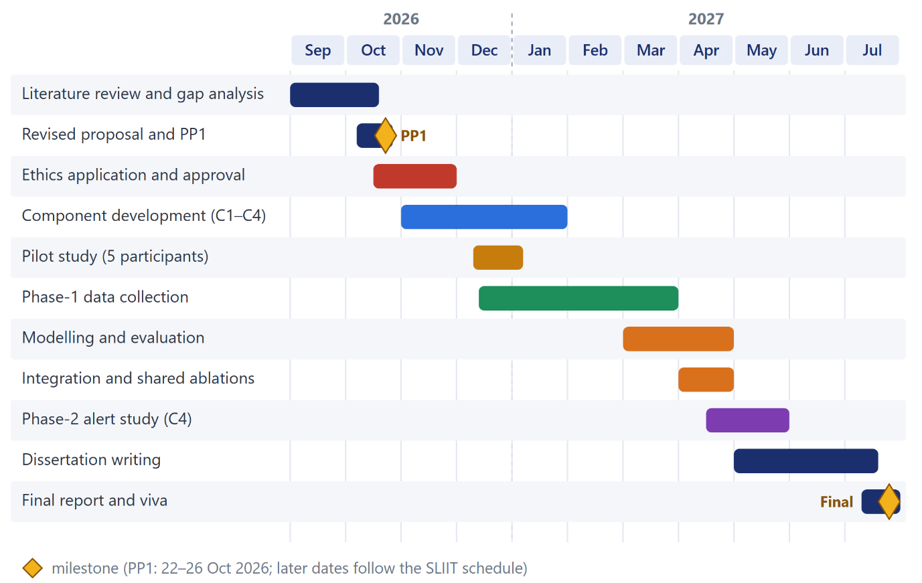
Figure 11: Project schedule, September 2026 – July 2027

10. REFERENCES
[1] G. Mark, Attention Span: A Groundbreaking Way to Restore Balance, Happiness and Productivity. Toronto, ON, Canada: Hanover Square Press, 2023.
[2] L. D. Rosen, L. M. Carrier, and N. A. Cheever, "Facebook and texting made me do it: Media-induced task-switching while studying," Comput. Hum. Behav., vol. 29, no. 3, pp. 948–958, 2013.
[3] RescueTime, Focusmate, Forest and Proctorio, official product websites, accessed Oct. 2026.
[4] United Nations, Transforming Our World: The 2030 Agenda for Sustainable Development. New York, NY, USA: United Nations, 2015.
[5] K. Altuwairqi, S. K. Jarraya, A. Allinjawi, and M. Hammami, "Student behavior analysis to measure engagement levels in online learning environments," Signal Image Video Process., vol. 15, no. 7, pp. 1387–1395, 2021.
[6] C. Epp, M. Lippold, and R. L. Mandryk, "Identifying emotional states using keystroke dynamics," in Proc. ACM CHI Conf. Human Factors in Computing Systems, 2011, pp. 715–724.
[7] P. Freihaut and A. S. Göritz, "Using the computer mouse for stress measurement – An empirical investigation and critical review," Int. J. Hum.-Comput. Stud., vol. 145, Art. no. 102520, 2021.
[8] A. N. Meyer, G. C. Murphy, T. Zimmermann, and T. Fritz, "Detecting developers' task switches and types," IEEE Trans. Softw. Eng., vol. 48, no. 1, pp. 225–240, 2022.
[9] L. R. Rabiner, "A tutorial on hidden Markov models and selected applications in speech recognition," Proc. IEEE, vol. 77, no. 2, pp. 257–286, 1989.
[10] D. Biedermann, G.-P. Ciordas-Hertel, M. Winter, J. Mordel, and H. Drachsler, "Contextualized logging of on-task and off-task behaviours during learning," J. Learn. Anal., vol. 10, no. 2, pp. 115–125, 2023.
[11] Y. Weinstein, "Mind-wandering, how do I measure thee with probes? Let me count the ways," Behav. Res. Methods, vol. 50, no. 2, pp. 642–661, 2018.
[12] J. Smallwood and J. W. Schooler, "The science of mind wandering: Empirically navigating the stream of consciousness," Annu. Rev. Psychol., vol. 66, pp. 487–518, 2015.
[13] R. Larson and M. Csikszentmihalyi, "The experience sampling method," New Dir. Methodol. Soc. Behav. Sci., vol. 15, pp. 41–56, 1983.
[14] J. Ocumpaugh, R. S. Baker, and M. M. T. Rodrigo, "Baker Rodrigo Ocumpaugh Monitoring Protocol (BROMP) 2.0 technical and training manual," Teachers College, Columbia Univ., and Ateneo Lab. for the Learning Sciences, Tech. Rep., 2015.
[15] J. Cohen, "Weighted kappa: Nominal scale agreement provision for scaled disagreement or partial credit," Psychol. Bull., vol. 70, no. 4, pp. 213–220, 1968.
[16] A. Gupta, A. D'Cunha, K. Awasthi, and V. Balasubramanian, "DAiSEE: Towards user engagement recognition in the wild," arXiv:1609.01885, 2016.
[17] L. Breiman, "Random forests," Mach. Learn., vol. 45, no. 1, pp. 5–32, 2001.
[18] T. Chen and C. Guestrin, "XGBoost: A scalable tree boosting system," in Proc. ACM SIGKDD Int. Conf. Knowledge Discovery and Data Mining, 2016, pp. 785–794.
[19] F. Pedregosa et al., "Scikit-learn: Machine learning in Python," J. Mach. Learn. Res., vol. 12, pp. 2825–2830, 2011.
[20] S. Varma and R. Simon, "Bias in error estimation when using cross-validation for model selection," BMC Bioinformatics, vol. 7, Art. no. 91, 2006.
[21] F. Wilcoxon, "Individual comparisons by ranking methods," Biometrics Bull., vol. 1, no. 6, pp. 80–83, 1945.
[22] Parliament of the Democratic Socialist Republic of Sri Lanka, Personal Data Protection Act, No. 9 of 2022. Colombo, Sri Lanka, 2022.

11. APPENDICES

Appendix A: Proposal Evidence and Decision Log (mandatory)
Claim / problem | Evidence | Alternatives considered | Decision | Supervisor discussion
How will the data be labelled? (panel) | Panel feedback on the first proposal presentation; experience-sampling literature [see 3.2] | Post-session rating only; external annotators; physiological ground truth | Shared multi-source protocol: probes + calibration + event review + observer audit | Date / outcome to be filled
Self-report called unreliable but used as the label | Logic review of the first proposal | Claim "objective" measurement | Define focus as momentary self-report; validate against observer and known-truth segments | Date / outcome to be filled
Faculty used to define learner groups | Logic review: faculty confounded with subject and habits | Keep faculty-based cohorts | Study mode recorded per session; faculty as covariate | Date / outcome to be filled
How is training data obtained? (panel) | Panel feedback; no public dataset with keystroke timing + task + focus labels | Use a public dataset; synthetic data | Own data from every FocusTrack session, labelled by probes | Date / outcome to be filled
Many studies already use keystrokes – how is this unique? (panel) | Panel feedback; [5], [8] | Claim first use of keystroke data | Novelty = context-conditioned states and transitions, tested against an aggregated baseline | Date / outcome to be filled
Earlier cross-task test "train coding → test reading" | Reading has near-zero typing, so the test is degenerate | Keep it | Leave-one-task-out among computer-based tasks | Date / outcome to be filled

Appendix B: AI Use Disclosure (mandatory)
AI tool | Purpose | What was generated | How it was verified
Claude (Anthropic), via Claude Code | Review of the first proposal, logic review, drafting of this revised report, slides and scripts | Draft text, tables and structure; verification of references against online sources | To complete by the student: which parts were rewritten in your own words, and how each reference was checked against the original paper
Grammarly (if used) | Grammar and language checking | Suggested corrections only | To complete by the student
The use of AI tools does not transfer responsibility for this work. The student remains responsible for the accuracy, originality and integrity of every claim, design decision and reference.

