**Lab 4 Submission – Nadeem Malik**

**Data Wrangler Script and Screenshot: CMSC**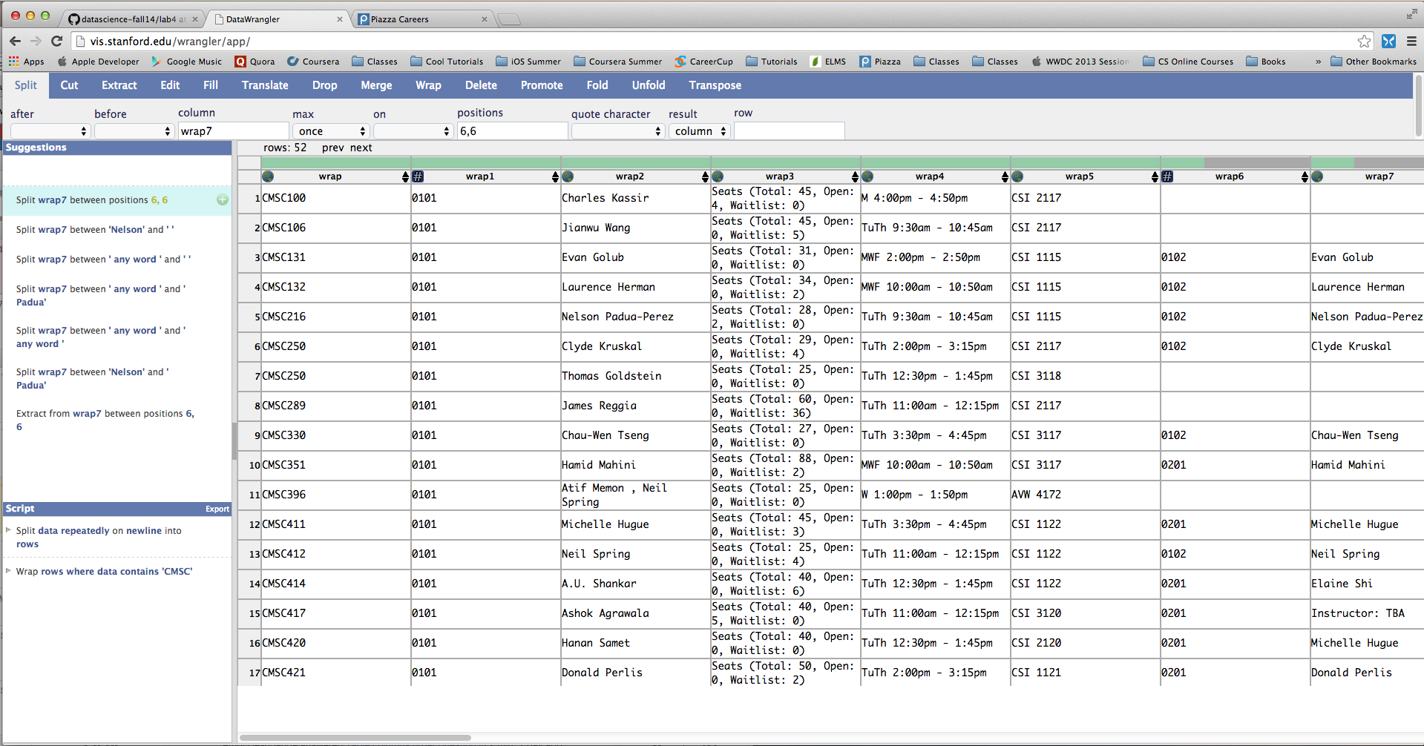

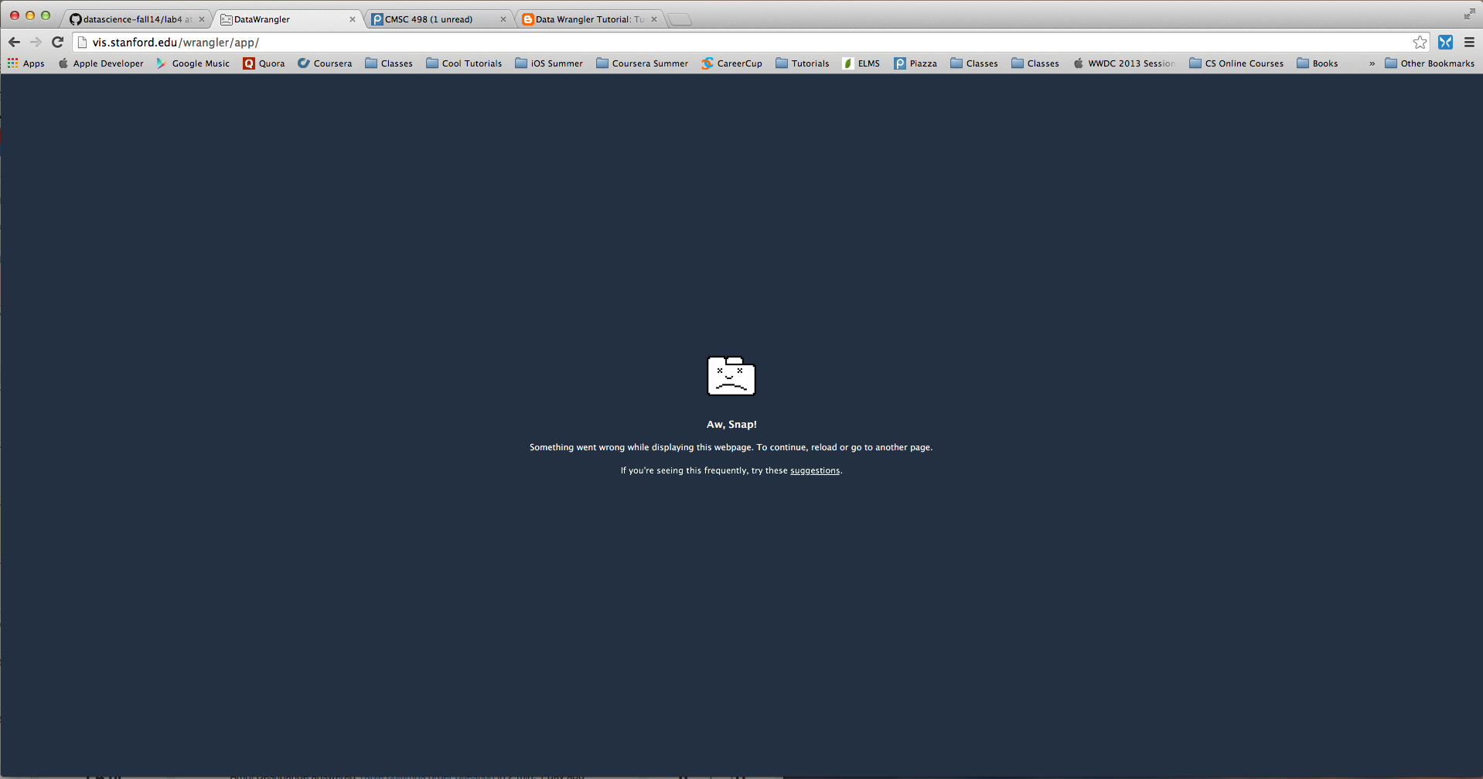

**Data Wrangler Script and Screenshot: World Cup 1**

**from wrangler import dw**

**import sys**

**if(len(sys.argv) < 3):**

**sys.exit('Error: Please include an input and output file. Example python script.py input.csv output.csv')**

**w = dw.DataWrangler()**

**# Split data repeatedly on newline into rows**

**w.add(dw.Split(column=["data"],**

**table=0,**

**status="active",**

**drop=True,**

**result="row",**

**update=False,**

**insert_position="right",**

**row=None,**

**on="\n",**

**before=None,**

**after=None,**

**ignore_between=None,**

**which=1,**

**max=0,**

**positions=None,**

**quote_character=None))**

**# Split data repeatedly on '|'**

**w.add(dw.Split(column=["data"],**

**table=0,**

**status="active",**

**drop=True,**

**result="column",**

**update=False,**

**insert_position="right",**

**row=None,**

**on="\\|",**

**before=None,**

**after=None,**

**ignore_between=None,**

**which=1,**

**max=0,**

**positions=None,**

**quote_character="\""))**

**# Cut on '"'**

**w.add(dw.Cut(column=[],**

**table=0,**

**status="active",**

**drop=False,**

**result="column",**

**update=True,**

**insert_position="right",**

**row=None,**

**on="\"",**

**before=None,**

**after=None,**

**ignore_between=None,**

**which=1,**

**max=0,**

**positions=None))**

**# Delete row 1**

**w.add(dw.Filter(column=[],**

**table=0,**

**status="active",**

**drop=False,**

**row=dw.Row(column=[],**

**table=0,**

**status="active",**

**drop=False,**

**conditions=[dw.RowIndex(column=[],**

**table=0,**

**status="active",**

**drop=False,**

**indices=[0])])))**

**# Drop split**

**w.add(dw.Drop(column=["split"],**

**table=0,**

**status="active",**

**drop=True))**

**# Extract from split3 on ' any number '**

**w.add(dw.Extract(column=["split3"],**

**table=0,**

**status="active",**

**drop=False,**

**result="column",**

**update=False,**

**insert_position="right",**

**row=None,**

**on="\\d+",**

**before=None,**

**after=None,**

**ignore_between=None,**

**which=1,**

**max=1,**

**positions=None))**

**# Extract from split3 on ' any number '**

**w.add(dw.Extract(column=["split3"],**

**table=0,**

**status="active",**

**drop=False,**

**result="column",**

**update=False,**

**insert_position="right",**

**row=None,**

**on="\\d+ ",**

**before=None,**

**after=None,**

**ignore_between=None,**

**which=1,**

**max=1,**

**positions=None))**

**# Merge extract, extract1 with glue**

**w.add(dw.Merge(column=["extract","extract1"],**

**table=0,**

**status="active",**

**drop=False,**

**result="column",**

**update=False,**

**insert_position="right",**

**row=None,**

**glue=""))**

**w.apply_to_file(sys.argv[1]).print_csv(sys.argv[2])**

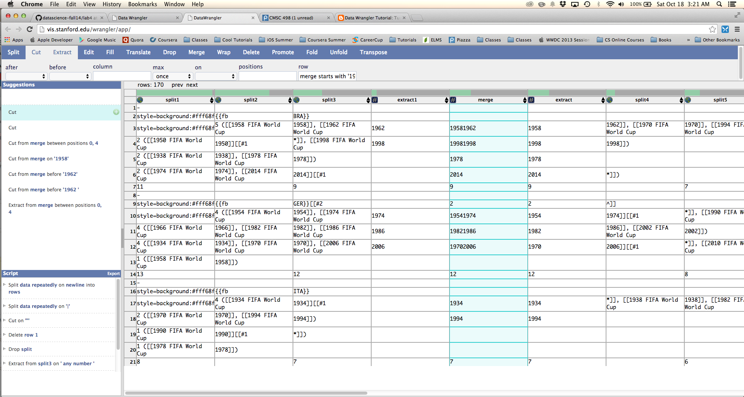

**Data Wrangler Script and Screenshot: World Cup 2**

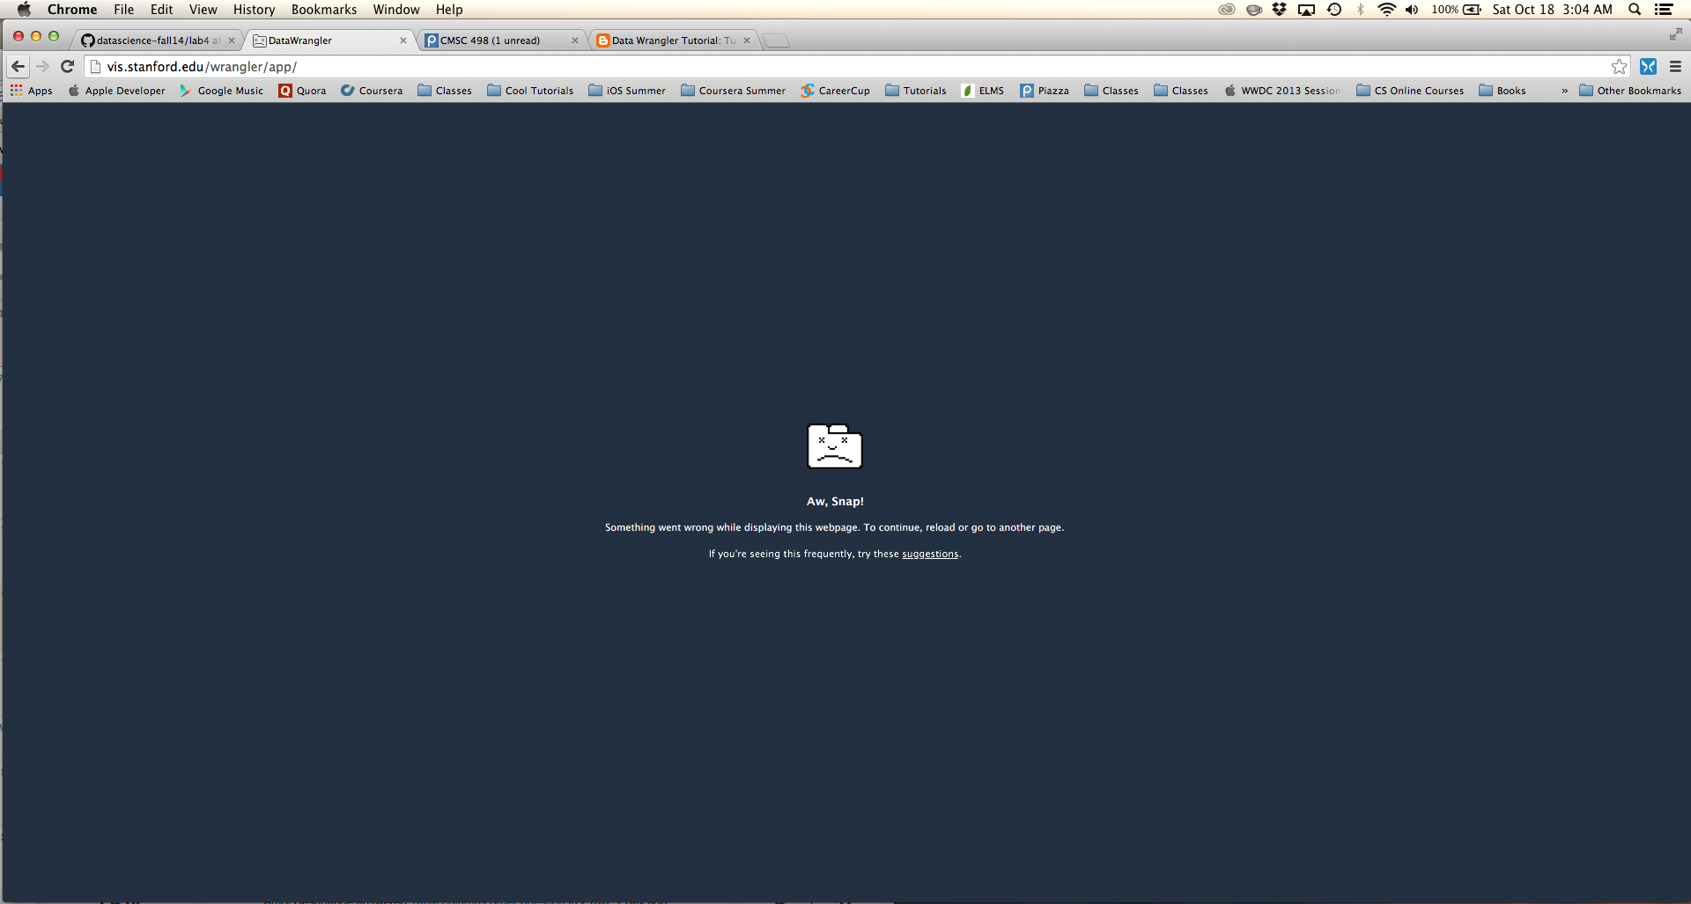

**UNIX Tools Command: CMSC**

**cat cmsc.txt | sed 's/[()]//g' | awk '/^(CMSC[0-9]{3})/ {c=$0;}**

**/^([0-9]{4})/ {d = c", "$0;}**

**/^([A-Za-z ]+ [A-Za-z]+)/ {d = d", "$0;}**

**/(Total: ([0-9]+))|(Open: ([0-9]+))|(Waitlist: ([:digit:]+))/{d = d", "$3""$5""$7;}**

**/^([MWFTuTh]+) (.{15})/ {d = d", "$1", "$2}**

**/^([A-Z]{3}) ([0-9]{4})/ {d = d", "$1", "$2"\n"; print d}'**

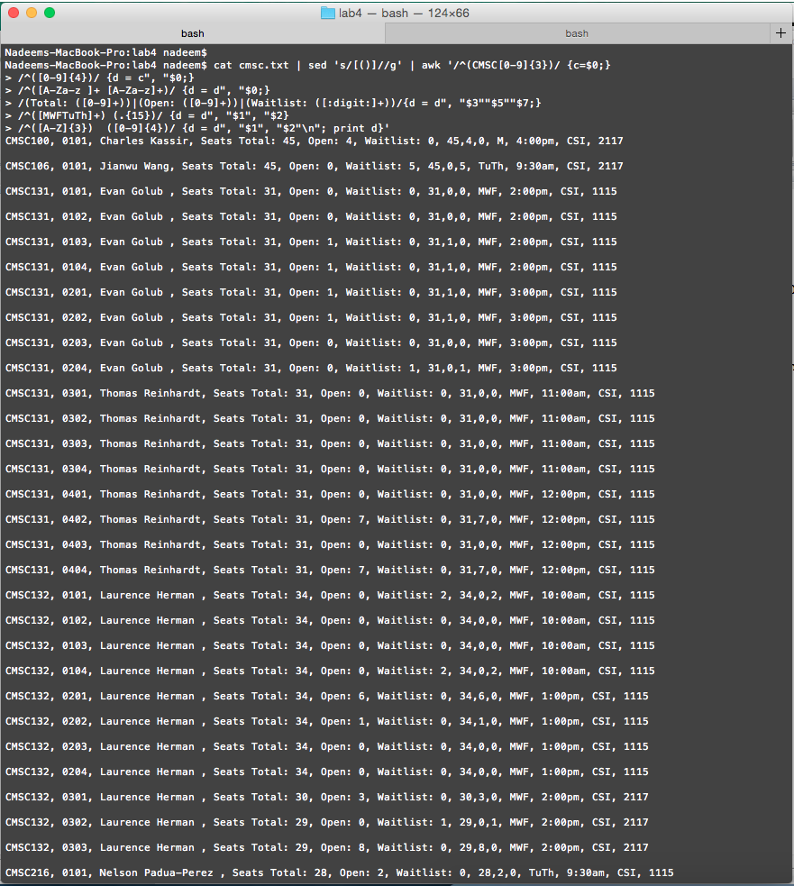

**UNIX Tools Command: World Cup 1**

**cat worldcup.txt | awk '{gsub(".style=\".+\"", "");print}'|**

**sed 's/|{{fb|\('[A-Z]'\{3\}\)}}/\1/' | awk '{gsub("\\[|\\]", "");print}' | awk '{gsub("FIFA World Cup\\|[0-9]{4}","");print}' | awk '{gsub("#..\\*","");print}' | awk '{gsub("(\\|)*[0-9]{1,}(\\|)+[0-9]{1,}(\\|)+[0-9]{1,}","");print}' | awk '{gsub("(\\|)|-","");print}' | awk '{gsub("style=whitespace:nowrapTCH<sup>","");print}' | awk '{gsub("<sup>|#.*","");print}' | awk '{gsub("\\(|\\)|,|\\}","");print}' |**

**awk '{gsub("([0-9])*\\{\\{sort dash","");print}' |**

**awk 'BEGIN {ctr=0} /^([A-Z]{3})/ {c=$0; d=$0;}**

**/^([0-9]) ([0-9]{4})+/ {ctr = ctr+1;}**

**{ i = 1**

**x = 2**

**l = $1**

**if(l ~ /[A-Z]{3}/) {**

**ctr = 0**

**d = $1**

**}else if(l ~ /align=center/) {**

**ctr++**

**}**

**else {**

**for(i = 1; i <= l; i++) {**

**d = c", "$(i+1)", " ctr;**

**print d;**

**}**

**d = c;**

**}**

**} END {d=""}'**

**Python Script: CMSC**

**import re**

**file_name = "cmsc.txt"**

**with open(file_name) as f:**

**lines = f.readlines()**

**num_lines = len(lines)**

**i = 0**

**while i < num_lines:**

**l = lines[i]**

**if re.match('^CMSC[0-9]{3}', l):**

**class_name = l.rstrip()**

**info = class_name + ", "**

**while(i + 1 < num_lines and re.match('^[0-9]{4}', lines[i+1].rstrip())):**

**section = lines[i+1].rstrip();**

**prof_name = lines[i+2].rstrip()**

**seats = lines[i+3].rstrip()**

**days_time = lines[i+4].rstrip().split(" ")**

**days = days_time[0]**

**days_time = days_time[1] + " - " + days_time[3]**

**building, room = lines[i+5].rstrip().split(" ")**

**m_seats = re.match('\d+',seats)**

**t, o, w = (seats[7:-1].split(", "))**

**t, o, w = t.split(": ")[1], o.split(": ")[1], w.split(": ")[1]**

**print(class_name + ", " + section + ", " + \**

**prof_name + ", " + t + ", " + o + ", " + w + ", " + \**

**days + "," + days_time + ", " + building + ", " + room)**

**i = i + 5**

**else:**

**i += 1**

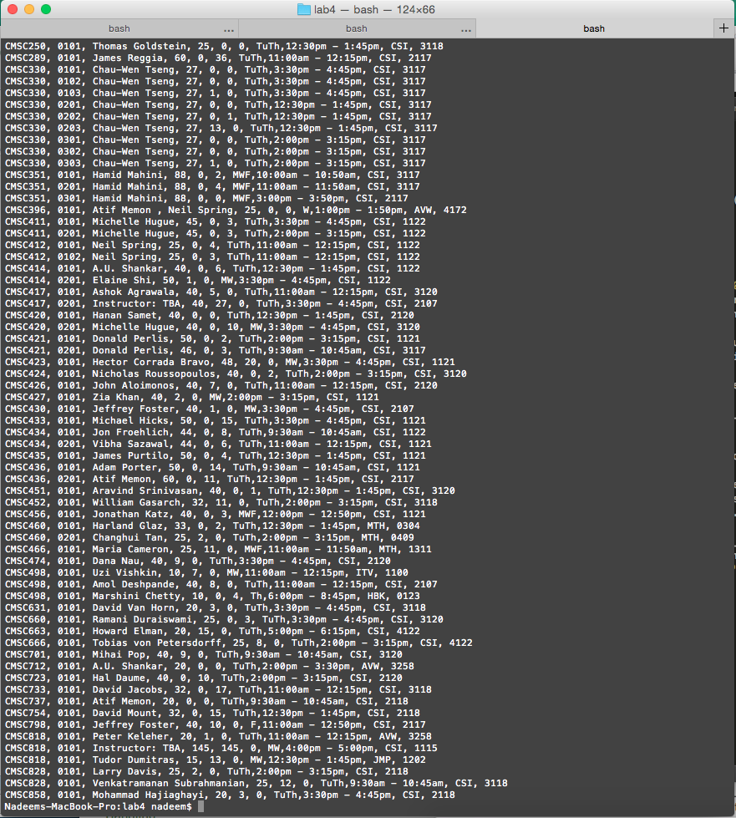

**Python Script: World Cup 1**

**import re**

**import fileinput**

**file_name = "worldcup.txt"**

**import fileinput**

**lines = []**

**for line in fileinput.input(file_name, inplace=False):**

**line = re.sub('(\\|)+(\d)+(\\|)+.+', "", line.rstrip())**

**line = re.sub('\\||{|}|fb|style=\".*\"', "", line.rstrip())**

**line = re.sub('\\[|\\]', "", line.rstrip())**

**line = re.sub('FIFA World Cup(\d){4}(#\d\\*)*', "", line.rstrip())**

**line = re.sub('#\d\\^', "", line.rstrip())**

**line = re.sub('(^style=.+)|-|<sup>...</sup>|\\(|\\)', "", line.rstrip())**

**line = re.sub(' , ', " ", line.rstrip())**

**lines.append(line)**

**num_lines = len(lines)**

**i = 0**

**while(not re.match('[A-Z]{3}', lines[i])):**

**i += 1**

**while(i < num_lines and re.match('[A-Z]{3}', lines[i])):**

**country = lines[i].rstrip()**

**x = [1,2,3,4]**

**for placing in x:**

**l2 = lines[i+placing]**

**if(not re.match('align=centersort dash', l2)):**

**for year in l2.split(" "):**

**if len(year) > 1:**

**print (country + ", " + year + ", " + str(placing))**

**i += 5**

**while(i < num_lines and not re.match('[A-Z]{3}', lines[i])):**

**i += 1**

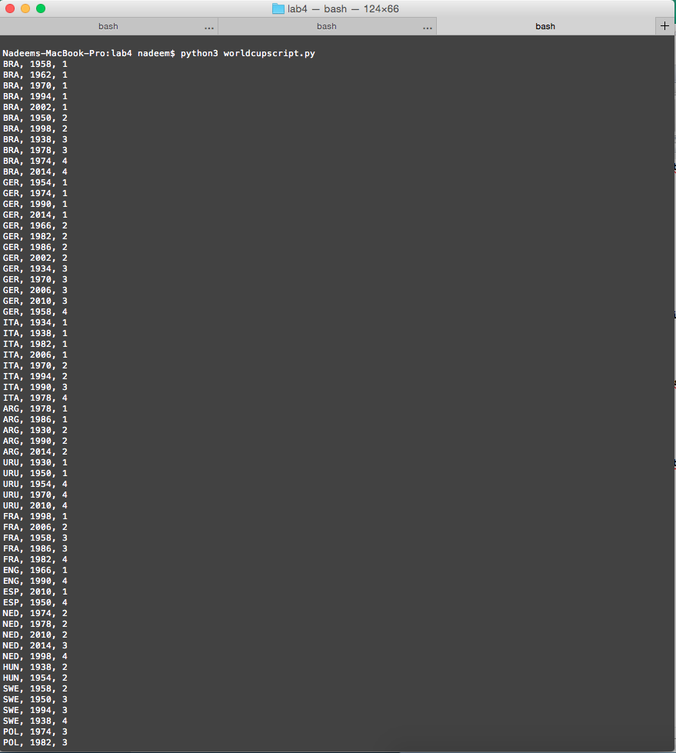

**Python Script: World Cup 2**

**import re**

**import fileinput**

**import csv**

**import pandas as pd**

**import numpy as np**

**file_name = "worldcup.txt"**

**import fileinput**

**lines = []**

**for line in fileinput.input(file_name, inplace=False):**

**line = re.sub('(\\|)+(\d)+(\\|)+.+', "", line.rstrip())**

**line = re.sub('\\||{|}|fb|style=\".*\"', "", line.rstrip())**

**line = re.sub('\\[|\\]', "", line.rstrip())**

**line = re.sub('FIFA World Cup(\d){4}(#\d\\*)*', "", line.rstrip())**

**line = re.sub('#\d\\^', "", line.rstrip())**

**line = re.sub('(^style=.+)|-|<sup>...</sup>|\\(|\\)', "", line.rstrip())**

**line = re.sub(' , ', " ", line.rstrip())**

**lines.append(line)**

**num_lines = len(lines)**

**i = 0**

**outputFile = open("output.csv", 'wb')**

**wr = csv.writer(outputFile);**

**while(not re.match('[A-Z]{3}', lines[i])):**

**i += 1**

**csv = []**

**csv.append(["country", "year", "placing"])**

**while(i < num_lines and re.match('[A-Z]{3}', lines[i])):**

**country = lines[i].rstrip()**

**x = [1,2,3,4]**

**for placing in x:**

**l2 = lines[i+placing]**

**if(not re.match('align=centersort dash', l2)):**

**for year in l2.split(" "):**

**if len(year) > 1:**

**csv.append([country, year, str(placing)])**

**i += 5**

**while(i < num_lines and not re.match('[A-Z]{3}', lines[i])):**

**i += 1**

**wr.writerows(csv)**

**# set options to display the full table**

**pd.set_option('display.max_rows', 100)**

**pd.set_option('display.max_columns', 100)**

**pd.set_option('display.width', 200)**

**# Read into pandas**

**df = pd.read_csv('output.csv')**

**table = df.pivot(index='country', columns='year', values='placing')**

**table.fillna("-", inplace=True)**

**print table**

