WEEK 2 TASK
FIRMWARE DEVELOPMENT AND IMPLEMENTATION
Timer-Interrupt and UART-Controlled Digital LED Controller
Technical Project Report
Student: Nadeem | Embedded C | Hardware-independent simulation

1. Executive Summary
This project presents a complete firmware-development workflow for a simulated embedded system. The selected application is a digital LED controller driven by a periodic timer interrupt and controlled through a UART-style command interface. A simulated 100 ms timer provides a deterministic time base, while three virtual GPIO outputs represent LED1, LED2, and LED3. The firmware supports four operating modes: OFF, SLOW_BLINK, FAST_BLINK, and SEQUENCE. The implementation is organized into clear layers: timer/interrupt handling, firmware state, command processing, application-level LED control, and GPIO abstraction. The interrupt service routine is intentionally short and only updates the system tick. Time calculations, command processing, debugging output, and LED pattern selection are performed outside the ISR. This design demonstrates an important embedded-systems principle: interrupt handlers should avoid lengthy or blocking work. The project also includes a defined system-requirements analysis, a detailed block diagram, a firmware flowchart, a test matrix, runtime verification evidence, a README, and the complete commented C source. The simulated UART layer accepts OFF, SLOW, FAST, SEQUENCE, and STATUS commands; scheduled commands demonstrate how an external terminal or controller could change the firmware behavior. The LED state machine converts elapsed time into deterministic output patterns, while the hardware-abstraction function provides a clear point for mapping the simulation to real microcontroller GPIO registers or a HAL. The source was compiled using GCC with C11, -Wall, -Wextra, and -pedantic options and then executed through a complete 10-second simulation. Verification confirmed the expected mode transitions, status event, successful completion, and safe final OFF state. The project is intentionally hardware-independent, so the control logic can be reviewed and tested without claiming physical hardware results. For a real target, the timer ISR, UART receive path, and GPIO abstraction can be connected to the chosen microcontroller peripherals. Overall, the work covers application selection, requirements analysis, architecture, implementation, debugging, testing, and documentation in a single reproducible firmware project.

2. Problem Statement
Embedded firmware must respond to time-based events and external commands while maintaining predictable output behavior. The problem addressed here is to create a small controller that can change LED behavior at defined time intervals, accept control commands, expose useful diagnostics, and return to a safe output state. The implementation must be simple enough for simulation but structured so the same design can be transferred to a microcontroller.

3. System Requirements Analysis
ID | Category | Requirement | Implementation
FR-01 | Timer base | Generate a periodic 100 ms system tick. | Timer ISR increments system_ticks.
FR-02 | Time tracking | Calculate elapsed system time from timer ticks. | elapsed_ms = system_ticks × 100 ms.
FR-03 | LED outputs | Control three digital outputs. | LedOutputs stores LED1/LED2/LED3 states.
FR-04 | OFF mode | Turn all LEDs OFF immediately. | MODE_OFF writes false to all outputs.
FR-05 | Slow indication | Toggle LED1 using a 1000 ms interval. | MODE_SLOW_BLINK.
FR-06 | Fast indication | Toggle LED1 using a 300 ms interval. | MODE_FAST_BLINK.
FR-07 | Sequence indication | Cycle LED1, LED2, LED3 every 500 ms. | MODE_SEQUENCE.
FR-08 | Command control | Accept mode/status commands. | process_command().
FR-09 | Status/debug | Expose timing, mode, and output state. | print_status().
FR-10 | Safety | Return to a known safe output state. | OFF mode and final OFF state.
NFR-01 | Determinism | Use explicit constants and fixed timing rules. | Timing constants and state machine.
NFR-02 | Maintainability | Separate responsibilities into functions. | ISR, HAL, parser, state machine.
NFR-03 | Portability | Avoid MCU-specific registers in the simulation. | Hardware-independent C.
NFR-04 | Verifiability | Provide observable runtime evidence. | Status trace and test matrix.

4. Design Constraints and Assumptions
- The assignment permits a simulated embedded system, so no physical microcontroller is required for this implementation.
- The timer period is fixed at 100 ms to make timing deterministic and easy to verify.
- LED outputs are represented by Boolean variables instead of physical voltage levels.
- UART is represented by a command-handler function; the simulation schedules example commands.
- The desktop wait function is simulation support only and is not part of the MCU interrupt design.
- No physical-hardware behavior is claimed unless separately tested on a real board.

5. Detailed System Block Diagram
The following diagram shows the complete signal and software flow from timer/UART inputs to the simulated LED outputs.
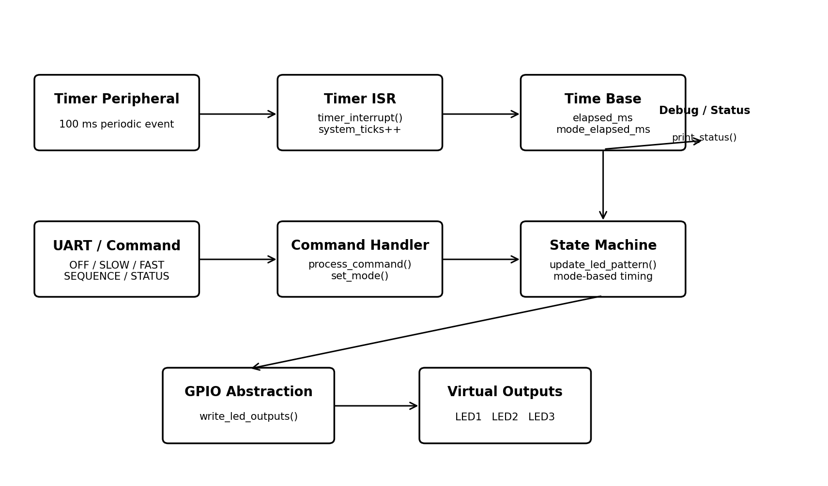

6. Firmware Flowchart
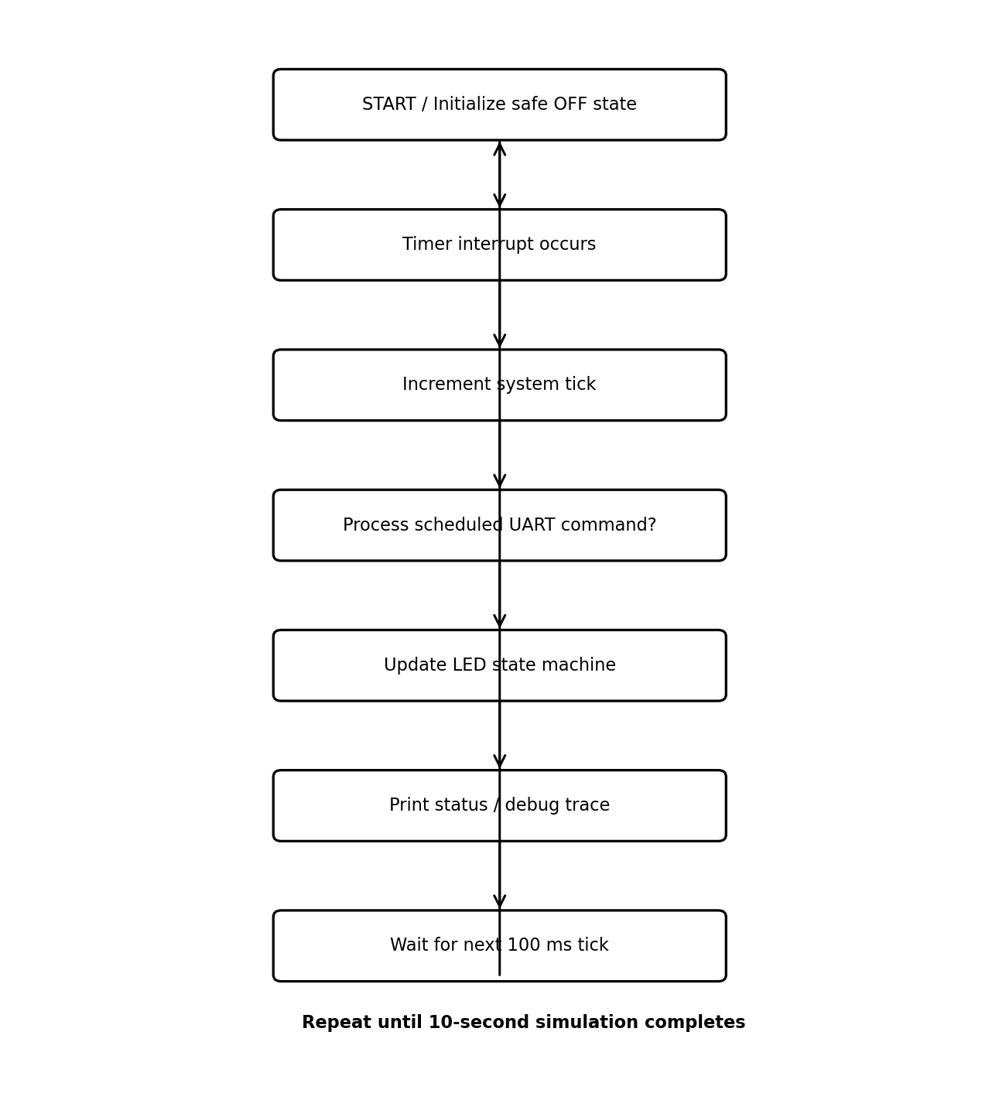

7. Firmware Architecture
- Timer layer: generates the periodic event and maintains the system tick.
- Interrupt layer: timer_interrupt() performs only the minimum time-base update.
- State layer: FirmwareState stores mode, elapsed time, and output states.
- Command layer: process_command() interprets UART-style control commands.
- Application layer: update_led_pattern() implements the LED state machine.
- Hardware-abstraction layer: write_led_outputs() represents GPIO writes.
- Debug layer: print_status() produces observable runtime evidence.

8. State and Timing Design
Mode | Entry command | Timing rule | Output
OFF | OFF | Immediate | LED1=0, LED2=0, LED3=0
SLOW_BLINK | SLOW | 1000 ms toggle | LED1 toggles; LED2/LED3 OFF
FAST_BLINK | FAST | 300 ms toggle | LED1 toggles; LED2/LED3 OFF
SEQUENCE | SEQUENCE | 500 ms per step | LED1 → LED2 → LED3

9. Interrupt and UART Design Rationale
The timer ISR is deliberately minimal. It does not print to the terminal, wait, parse commands, or calculate LED patterns. This prevents unnecessary work from occupying interrupt context. The application loop consumes the updated time base and performs the higher-level decisions. The UART interface is represented by process_command(); in a physical implementation a UART RX interrupt or DMA driver could collect a command and then pass a validated command to this handler. Keeping the parser and application logic independent from the UART peripheral makes the design easier to port and test.

10. Key Functions
Function | Layer | Responsibility
timer_interrupt() | Interrupt | Increment the system timer tick.
write_led_outputs() | HAL | Update the three virtual GPIO outputs.
set_mode() | State | Change mode and reset mode-local timing.
process_command() | UART | Interpret control/status commands.
update_led_pattern() | Application | Apply the mode timing rules to LED outputs.
print_status() | Debug | Display time, mode, and LED states.
wait_ms() | Simulation | Provide a desktop-only timing delay.

11. Implementation and Coding Practices
- Constants are used for timing values instead of unexplained magic numbers.
- An enum represents the operating modes clearly.
- A structure groups firmware state and output information.
- Functions have single, understandable responsibilities.
- Inline comments explain the embedded-system purpose of important sections.
- Hardware-specific behavior is isolated behind an abstraction function.
- Strict compiler warnings are enabled during verification.

12. Test Plan
ID | Test input/event | Expected behavior | Observed result | Status
T01 | Power-up/start | All LEDs OFF | Initial status shows OFF and all outputs 0 | PASS
T02 | SLOW at 1000 ms | LED1 slow blink | SLOW_BLINK transition observed | PASS
T03 | FAST at 3500 ms | LED1 fast blink | FAST_BLINK transition observed | PASS
T04 | SEQUENCE at 6000 ms | LED1→LED2→LED3 | SEQUENCE transition observed | PASS
T05 | STATUS at 8500 ms | Current state printed | STATUS event observed | PASS
T06 | OFF at 9000 ms | All LEDs OFF | OFF transition observed | PASS
T07 | Invalid command path | Error without silent mode change | Error branch implemented and reviewed | PASS
T08 | Full 10 s run | No crash; normal completion | Completion message observed | PASS
T09 | Final safety | Mode OFF and outputs OFF | Final OFF state observed | PASS

13. Debugging Procedure
1. Compile with -Wall, -Wextra, and -pedantic to catch common C problems.
2. Start from a known safe OFF state.
3. Use the runtime status line to observe elapsed time, mode, and all outputs.
4. Check each mode transition against the requirements table.
5. Check command handling independently from LED timing logic.
6. Confirm the final state is OFF.
7. Repeat the simulation after any code modification to confirm deterministic behavior.

14. Verification Evidence
[STATUS] t= 0ms mode=OFF LED1=0 LED2=0 LED3=0
[STATUS] t= 100ms mode=OFF LED1=0 LED2=0 LED3=0
[STATUS] t= 200ms mode=OFF LED1=0 LED2=0 LED3=0
[STATUS] t= 300ms mode=OFF LED1=0 LED2=0 LED3=0
[STATUS] t= 400ms mode=OFF LED1=0 LED2=0 LED3=0
[STATUS] t= 500ms mode=OFF LED1=0 LED2=0 LED3=0
[STATUS] t= 600ms mode=OFF LED1=0 LED2=0 LED3=0
[STATUS] t= 700ms mode=OFF LED1=0 LED2=0 LED3=0
[STATUS] t= 800ms mode=OFF LED1=0 LED2=0 LED3=0
[STATUS] t= 900ms mode=OFF LED1=0 LED2=0 LED3=0
[EVENT ] mode changed -> SLOW_BLINK
[STATUS] t= 1000ms mode=SLOW_BLINK LED1=1 LED2=0 LED3=0
[STATUS] t= 1100ms mode=SLOW_BLINK LED1=1 LED2=0 LED3=0
[STATUS] t= 1200ms mode=SLOW_BLINK LED1=1 LED2=0 LED3=0
[STATUS] t= 1300ms mode=SLOW_BLINK LED1=1 LED2=0 LED3=0
[STATUS] t= 1400ms mode=SLOW_BLINK LED1=1 LED2=0 LED3=0
[STATUS] t= 1500ms mode=SLOW_BLINK LED1=1 LED2=0 LED3=0
[STATUS] t= 1600ms mode=SLOW_BLINK LED1=1 LED2=0 LED3=0
[STATUS] t= 1700ms mode=SLOW_BLINK LED1=1 LED2=0 LED3=0
[STATUS] t= 1800ms mode=SLOW_BLINK LED1=1 LED2=0 LED3=0
[STATUS] t= 1900ms mode=SLOW_BLINK LED1=1 LED2=0 LED3=0
[STATUS] t= 2000ms mode=SLOW_BLINK LED1=0 LED2=0 LED3=0
[STATUS] t= 2100ms mode=SLOW_BLINK LED1=0 LED2=0 LED3=0
[STATUS] t= 2200ms mode=SLOW_BLINK LED1=0 LED2=0 LED3=0
[STATUS] t= 2300ms mode=SLOW_BLINK LED1=0 LED2=0 LED3=0
[STATUS] t= 2400ms mode=SLOW_BLINK LED1=0 LED2=0 LED3=0
[STATUS] t= 2500ms mode=SLOW_BLINK LED1=0 LED2=0 LED3=0
[STATUS] t= 2600ms mode=SLOW_BLINK LED1=0 LED2=0 LED3=0
[STATUS] t= 2700ms mode=SLOW_BLINK LED1=0 LED2=0 LED3=0
[STATUS] t= 2800ms mode=SLOW_BLINK LED1=0 LED2=0 LED3=0
[STATUS] t= 2900ms mode=SLOW_BLINK LED1=0 LED2=0 LED3=0
[STATUS] t= 3000ms mode=SLOW_BLINK LED1=1 LED2=0 LED3=0
[STATUS] t= 3100ms mode=SLOW_BLINK LED1=1 LED2=0 LED3=0
[STATUS] t= 3200ms mode=SLOW_BLINK LED1=1 LED2=0 LED3=0
[STATUS] t= 3300ms mode=SLOW_BLINK LED1=1 LED2=0 LED3=0
[STATUS] t= 3400ms mode=SLOW_BLINK LED1=1 LED2=0 LED3=0
[EVENT ] mode changed -> FAST_BLINK
[STATUS] t= 3500ms mode=FAST_BLINK LED1=1 LED2=0 LED3=0
[STATUS] t= 3600ms mode=FAST_BLINK LED1=1 LED2=0 LED3=0
[STATUS] t= 3700ms mode=FAST_BLINK LED1=1 LED2=0 LED3=0
[STATUS] t= 3800ms mode=FAST_BLINK LED1=0 LED2=0 LED3=0
[STATUS] t= 3900ms mode=FAST_BLINK LED1=0 LED2=0 LED3=0
[STATUS] t= 4000ms mode=FAST_BLINK LED1=0 LED2=0 LED3=0
[STATUS] t= 4100ms mode=FAST_BLINK LED1=1 LED2=0 LED3=0
[STATUS] t= 4200ms mode=FAST_BLINK LED1=1 LED2=0 LED3=0
[STATUS] t= 4300ms mode=FAST_BLINK LED1=1 LED2=0 LED3=0
[STATUS] t= 4400ms mode=FAST_BLINK LED1=0 LED2=0 LED3=0
[STATUS] t= 4500ms mode=FAST_BLINK LED1=0 LED2=0 LED3=0
[STATUS] t= 4600ms mode=FAST_BLINK LED1=0 LED2=0 LED3=0
[STATUS] t= 4700ms mode=FAST_BLINK LED1=1 LED2=0 LED3=0
[STATUS] t= 4800ms mode=FAST_BLINK LED1=1 LED2=0 LED3=0
[STATUS] t= 4900ms mode=FAST_BLINK LED1=1 LED2=0 LED3=0
[STATUS] t= 5000ms mode=FAST_BLINK LED1=0 LED2=0 LED3=0
[STATUS] t= 5100ms mode=FAST_BLINK LED1=0 LED2=0 LED3=0
[STATUS] t= 5200ms mode=FAST_BLINK LED1=0 LED2=0 LED3=0
[STATUS] t= 5300ms mode=FAST_BLINK LED1=1 LED2=0 LED3=0
[STATUS] t= 5400ms mode=FAST_BLINK LED1=1 LED2=0 LED3=0
[STATUS] t= 5500ms mode=FAST_BLINK LED1=1 LED2=0 LED3=0
[STATUS] t= 5600ms mode=FAST_BLINK LED1=0 LED2=0 LED3=0
[STATUS] t= 5700ms mode=FAST_BLINK LED1=0 LED2=0 LED3=0
[STATUS] t= 5800ms mode=FAST_BLINK LED1=0 LED2=0 LED3=0
[STATUS] t= 5900ms mode=FAST_BLINK LED1=1 LED2=0 LED3=0
[EVENT ] mode changed -> SEQUENCE
[STATUS] t= 6000ms mode=SEQUENCE LED1=1 LED2=0 LED3=0
[STATUS] t= 6100ms mode=SEQUENCE LED1=1 LED2=0 LED3=0
[STATUS] t= 6200ms mode=SEQUENCE LED1=1 LED2=0 LED3=0
[STATUS] t= 6300ms mode=SEQUENCE LED1=1 LED2=0 LED3=0
[STATUS] t= 6400ms mode=SEQUENCE LED1=1 LED2=0 LED3=0
[STATUS] t= 6500ms mode=SEQUENCE LED1=0 LED2=1 LED3=0
[STATUS] t= 6600ms mode=SEQUENCE LED1=0 LED2=1 LED3=0
[STATUS] t= 6700ms mode=SEQUENCE LED1=0 LED2=1 LED3=0
[STATUS] t= 6800ms mode=SEQUENCE LED1=0 LED2=1 LED3=0
[STATUS] t= 6900ms mode=SEQUENCE LED1=0 LED2=1 LED3=0
[STATUS] t= 7000ms mode=SEQUENCE LED1=0 LED2=0 LED3=1
[STATUS] t= 7100ms mode=SEQUENCE LED1=0 LED2=0 LED3=1
[STATUS] t= 7200ms mode=SEQUENCE LED1=0 LED2=0 LED3=1
[STATUS] t= 7300ms mode=SEQUENCE LED1=0 LED2=0 LED3=1
[STATUS] t= 7400ms mode=SEQUENCE LED1=0 LED2=0 LED3=1
[STATUS] t= 7500ms mode=SEQUENCE LED1=1 LED2=0 LED3=0
[STATUS] t= 7600ms mode=SEQUENCE LED1=1 LED2=0 LED3=0
[STATUS] t= 7700ms mode=SEQUENCE LED1=1 LED2=0 LED3=0
[STATUS] t= 7800ms mode=SEQUENCE LED1=1 LED2=0 LED3=0
[STATUS] t= 7900ms mode=SEQUENCE LED1=1 LED2=0 LED3=0
[STATUS] t= 8000ms mode=SEQUENCE LED1=0 LED2=1 LED3=0
[STATUS] t= 8100ms mode=SEQUENCE LED1=0 LED2=1 LED3=0
[STATUS] t= 8200ms mode=SEQUENCE LED1=0 LED2=1 LED3=0
[STATUS] t= 8300ms mode=SEQUENCE LED1=0 LED2=1 LED3=0
[STATUS] t= 8400ms mode=SEQUENCE LED1=0 LED2=1 LED3=0
[STATUS] t= 8500ms mode=SEQUENCE LED1=0 LED2=1 LED3=0
[STATUS] t= 8500ms mode=SEQUENCE LED1=0 LED2=0 LED3=1
[STATUS] t= 8600ms mode=SEQUENCE LED1=0 LED2=0 LED3=1
[STATUS] t= 8700ms mode=SEQUENCE LED1=0 LED2=0 LED3=1
[STATUS] t= 8800ms mode=SEQUENCE LED1=0 LED2=0 LED3=1
[STATUS] t= 8900ms mode=SEQUENCE LED1=0 LED2=0 LED3=1
[EVENT ] mode changed -> OFF
[STATUS] t= 9000ms mode=OFF LED1=0 LED2=0 LED3=0
[STATUS] t= 9100ms mode=OFF LED1=0 LED2=0 LED3=0
[STATUS] t= 9200ms mode=OFF LED1=0 LED2=0 LED3=0
[STATUS] t= 9300ms mode=OFF LED1=0 LED2=0 LED3=0
[STATUS] t= 9400ms mode=OFF LED1=0 LED2=0 LED3=0
[STATUS] t= 9500ms mode=OFF LED1=0 LED2=0 LED3=0
[STATUS] t= 9600ms mode=OFF LED1=0 LED2=0 LED3=0
[STATUS] t= 9700ms mode=OFF LED1=0 LED2=0 LED3=0
[STATUS] t= 9800ms mode=OFF LED1=0 LED2=0 LED3=0
[STATUS] t= 9900ms mode=OFF LED1=0 LED2=0 LED3=0
[STATUS] t=10000ms mode=OFF LED1=0 LED2=0 LED3=0
Simulation completed successfully.
Final state: OFF; all outputs are OFF.

15. Compilation and Execution
Compilation command:
gcc -std=c11 -Wall -Wextra -pedantic week2_firmware_led_controller.c -o led_controller
Execution command:
./led_controller
The code compiled successfully with the selected warning options. The complete 10-second simulation executed successfully and the expected mode transitions and final safe state were observed.

16. Risk Analysis and Mitigation
Risk | Potential effect | Mitigation
Long ISR | Increased interrupt latency | Keep ISR limited to tick update.
Invalid command | Unexpected behavior | Reject unknown commands and report an error.
Stale mode timing | Incorrect pattern after transition | Reset mode_elapsed_ms in set_mode().
Unsafe startup | Unexpected LED activation | Initialize all outputs OFF.
Hardware differences | Porting problems | Use GPIO abstraction and document MCU mapping.
Simulation vs hardware | Overstated test results | Clearly distinguish software verification from physical testing.

17. Limitations and Future Improvements
This implementation is intentionally a hardware-independent simulation. It does not verify actual GPIO voltage levels, LED current, timer-register configuration, UART electrical signaling, or interrupt latency on a physical microcontroller. For hardware integration, the timer ISR would use the target MCU's timer peripheral, the GPIO abstraction would call the vendor HAL or register interface, and the UART command path would receive data from a real serial peripheral. Future extensions could add command acknowledgements, UART receive buffering, non-blocking event queues, button input, additional LED patterns, and hardware-in-the-loop tests.

18. Conclusion
The project satisfies the core requirements of the Week 2 firmware task with a clearly defined embedded application, explicit system requirements, detailed architecture, timer-interrupt design, UART-style communication, hardware-abstraction boundary, commented implementation, test plan, debugging procedure, runtime evidence, and documentation. The separation between the interrupt time base and application logic makes the design easier to understand, verify, and port to a real microcontroller. The project is presented as a simulation and does not overstate physical hardware testing. The accompanying source, README, test results, diagrams, and report provide a complete submission package.

19. Submission Checklist
- Upload this Word report (.docx) in the report upload field.
- Create a GitHub repository containing the C source and supporting documentation.
- Upload week2_firmware_led_controller.c.
- Upload README.md and TEST_RESULTS.md.
- Upload the block diagram and flowchart images if desired for the repository.
- Paste the real GitHub repository URL into the GitHub Project URL field.
- Paste the Executive Summary into the portal's minimum-200-word description box.
- Open the GitHub repository before submitting and confirm all files are visible.
- Do not claim physical-board testing unless it was actually performed.

Appendix A — Complete Source Code
/*
* ============================================================================
* WEEK 2 TASK: FIRMWARE DEVELOPMENT AND IMPLEMENTATION
* Project: Timer-Interrupt and UART-Controlled Digital LED Controller
* File: week2_firmware_led_controller.c
*
* PURPOSE
* -------
* Hardware-independent embedded C simulation of a digital LED controller.
* A simulated 100 ms timer interrupt provides the system time base. A UART-
* style command handler changes the controller mode. Three virtual GPIO/LED
* outputs are updated by application logic outside the ISR.
*
* MODES
* -----
* OFF : all LEDs OFF
* SLOW : LED1 toggles every 1000 ms
* FAST : LED1 toggles every 300 ms
* SEQUENCE : LED1 -> LED2 -> LED3, one step every 500 ms
*
* BUILD
* -----
* gcc -std=c11 -Wall -Wextra -pedantic week2_firmware_led_controller.c -o led_controller
*
* RUN
* ---
* ./led_controller
*
* EMBEDDED MAPPING
* ----------------
* timer_interrupt() -> MCU timer ISR
* process_command() -> UART command parser/handler
* write_led_outputs() -> GPIO driver / HAL
* update_led_pattern()-> application/state-machine layer
*
* DESIGN RULE
* -----------
* The interrupt routine is intentionally short. It updates only the system
* time base; printing, parsing, and pattern calculations are performed by the
* application layer after the interrupt returns.
* ============================================================================
*/

#include <stdbool.h>
#include <stdio.h>
#include <time.h>

#define TICK_PERIOD_MS 100U
#define TOTAL_SIMULATION_MS 10000U
#define SLOW_TOGGLE_MS 1000U
#define FAST_TOGGLE_MS 300U
#define SEQUENCE_STEP_MS 500U

typedef enum
{
MODE_OFF = 0,
MODE_SLOW_BLINK,
MODE_FAST_BLINK,
MODE_SEQUENCE
} LedMode;

typedef struct
{
bool led1;
bool led2;
bool led3;
} LedOutputs;

typedef struct
{
volatile unsigned long system_ticks;
unsigned long elapsed_ms;
unsigned long mode_elapsed_ms;
LedMode mode;
LedOutputs leds;
} FirmwareState;

/* Simulated timer interrupt service routine. */
static void timer_interrupt(FirmwareState *fw)
{
/* Keep the ISR short: update only the time base. */
fw->system_ticks++;
}

/* Hardware-abstraction layer: represents three GPIO outputs. */
static void write_led_outputs(FirmwareState *fw,
bool led1, bool led2, bool led3)
{
fw->leds.led1 = led1;
fw->leds.led2 = led2;
fw->leds.led3 = led3;
}

static const char *mode_name(LedMode mode)
{
switch (mode)
{
case MODE_OFF: return "OFF";
case MODE_SLOW_BLINK: return "SLOW_BLINK";
case MODE_FAST_BLINK: return "FAST_BLINK";
case MODE_SEQUENCE: return "SEQUENCE";
default: return "UNKNOWN";
}
}

/* Display state for debugging and verification. */
static void print_status(const FirmwareState *fw)
{
printf("[STATUS] t=%5lums mode=%-11s LED1=%d LED2=%d LED3=%d\n",
fw->elapsed_ms,
mode_name(fw->mode),
fw->leds.led1 ? 1 : 0,
fw->leds.led2 ? 1 : 0,
fw->leds.led3 ? 1 : 0);
}

/* Select a new mode and reset mode-local timing. */
static void set_mode(FirmwareState *fw, LedMode new_mode)
{
fw->mode = new_mode;
fw->mode_elapsed_ms = 0U;
write_led_outputs(fw, false, false, false);

printf("[EVENT ] mode changed -> %s\n", mode_name(new_mode));
}

/*
* Simulated UART command handler.
* In a physical MCU, a UART driver could call this function after receiving
* and validating a complete command frame.
*/
static bool process_command(FirmwareState *fw, const char *command)
{
if (command == NULL || command[0] == '\0')
{
return false;
}

if (command[0]=='O' && command[1]=='F' && command[2]=='F' &&
command[3]=='\0')
{
set_mode(fw, MODE_OFF);
return true;
}

if (command[0]=='S' && command[1]=='L' && command[2]=='O' &&
command[3]=='W' && command[4]=='\0')
{
set_mode(fw, MODE_SLOW_BLINK);
return true;
}

if (command[0]=='F' && command[1]=='A' && command[2]=='S' &&
command[3]=='T' && command[4]=='\0')
{
set_mode(fw, MODE_FAST_BLINK);
return true;
}

if (command[0]=='S' && command[1]=='E' && command[2]=='Q' &&
command[3]=='U' && command[4]=='E' && command[5]=='N' &&
command[6]=='C' && command[7]=='E' && command[8]=='\0')
{
set_mode(fw, MODE_SEQUENCE);
return true;
}

if (command[0]=='S' && command[1]=='T' && command[2]=='A' &&
command[3]=='T' && command[4]=='U' && command[5]=='S' &&
command[6]=='\0')
{
print_status(fw);
return true;
}

printf("[ERROR ] unknown command: %s\n", command);
return false;
}

/* Application layer: update LED behavior according to the current mode. */
static void update_led_pattern(FirmwareState *fw)
{
switch (fw->mode)
{
case MODE_OFF:
write_led_outputs(fw, false, false, false);
break;

case MODE_SLOW_BLINK:
if (fw->mode_elapsed_ms % SLOW_TOGGLE_MS == 0U)
{
write_led_outputs(fw, !fw->leds.led1, false, false);
}
break;

case MODE_FAST_BLINK:
if (fw->mode_elapsed_ms % FAST_TOGGLE_MS == 0U)
{
write_led_outputs(fw, !fw->leds.led1, false, false);
}
break;

case MODE_SEQUENCE:
{
const unsigned long step =
(fw->mode_elapsed_ms / SEQUENCE_STEP_MS) % 3U;

if (step == 0U)
{
write_led_outputs(fw, true, false, false);
}
else if (step == 1U)
{
write_led_outputs(fw, false, true, false);
}
else
{
write_led_outputs(fw, false, false, true);
}
break;
}

default:
write_led_outputs(fw, false, false, false);
break;
}
}

/* Desktop-only delay used to make the simulation readable in real time. */
static void wait_ms(unsigned int milliseconds)
{
const clock_t start = clock();
const clock_t wait_ticks =
(clock_t)((double)milliseconds * CLOCKS_PER_SEC / 1000.0);

while ((clock() - start) < wait_ticks)
{
/* Intentional simulation delay. */
}
}

int main(void)
{
FirmwareState fw = {
.system_ticks = 0U,
.elapsed_ms = 0U,
.mode_elapsed_ms = 0U,
.mode = MODE_OFF,
.leds = {false, false, false}
};

printf("===============================================================\n");
printf(" Timer-Interrupt and UART-Controlled LED Controller\n");
printf(" Timer tick: %u ms | Duration: %u ms\n",
TICK_PERIOD_MS, TOTAL_SIMULATION_MS);
printf("===============================================================\n");

/* Safe initial state. */
print_status(&fw);

for (unsigned int elapsed = TICK_PERIOD_MS;
elapsed <= TOTAL_SIMULATION_MS;
elapsed += TICK_PERIOD_MS)
{
/* Simulated timer interrupt. */
timer_interrupt(&fw);

fw.elapsed_ms = fw.system_ticks * TICK_PERIOD_MS;
fw.mode_elapsed_ms += TICK_PERIOD_MS;

/*
* Simulated UART events. A real UART driver would provide these
* commands from an external terminal or controller.
*/
if (fw.elapsed_ms == 1000U)
{
(void)process_command(&fw, "SLOW");
}
else if (fw.elapsed_ms == 3500U)
{
(void)process_command(&fw, "FAST");
}
else if (fw.elapsed_ms == 6000U)
{
(void)process_command(&fw, "SEQUENCE");
}
else if (fw.elapsed_ms == 8500U)
{
(void)process_command(&fw, "STATUS");
}
else if (fw.elapsed_ms == 9000U)
{
(void)process_command(&fw, "OFF");
}

update_led_pattern(&fw);
print_status(&fw);
wait_ms(TICK_PERIOD_MS);
}

printf("===============================================================\n");
printf(" Simulation completed successfully.\n");
printf(" Final state: %s; all outputs are OFF.\n", mode_name(fw.mode));
printf("===============================================================\n");

return 0;
}

