WEEK 01 TASK

DESIGNING A
SCALABLE IoT ARCHITECTURE
A reference design for a growing IoT network

IoT Devices | Edge Gateway | IP Network | Cloud | Applications
→ → → →
MQTT • LoRaWAN • Wi‑Fi • Edge Processing • Cloud Analytics

Name: ______________________________ USN: ______________________________
Electronics and Communication Engineering

1. OBJECTIVE AND SCOPE
The objective of this project is to design a scalable IoT architecture that can support a growing network of devices and sensors. The proposed system is an environmental monitoring network for a campus or small industrial site. Sensors collect temperature, humidity, air-quality and equipment-status data. Edge gateways collect and preprocess the information before sending it through an IP network to cloud services for storage, analytics, dashboards and alerts.
The architecture is divided into layers so that capacity can be increased by adding gateways, message-processing resources and storage instead of redesigning the complete system.

2. DESIGN PRINCIPLES
- Modularity: field devices, gateways, network transport, cloud ingestion, data services and applications are separate layers.
- Horizontal scaling: add gateways, broker instances, processing workers and storage as the load increases.
- Edge processing: filter, aggregate and buffer data near the devices.
- Protocol flexibility: support different field links while using standard IP networking upstream.
- Fault isolation: a local gateway or backhaul failure should not stop the complete network.
- Observability: monitor device health, message rate, latency, queue depth and gateway utilization.

3. IoT TOPOLOGIES AND PROTOCOLS
The following topology options were considered before selecting the reference architecture.
Option | Structure | Advantage | Challenge
Star | Devices → central gateway | Simple and easy to manage | Gateway can become a bottleneck
Mesh | Devices relay through other nodes | Alternate paths and wider coverage | More routing complexity
Star-of-stars | Devices → gateways → backend | Good fit for LPWAN | Gateway and backend planning
Hierarchical edge | Devices → edge → cloud | Local processing and fault isolation | More edge infrastructure

Communication protocol choices
- MQTT: lightweight publish/subscribe messaging suitable for IoT telemetry.
- CoAP: lightweight application protocol suitable for constrained devices and REST-style communication.
- LoRaWAN: low-power, long-range option for battery-powered IoT devices.
- Wi-Fi/Ethernet: suitable for powered devices and gateways with existing IP infrastructure.
Design decision: use LoRaWAN or Wi-Fi at the field layer depending on power and coverage requirements, and use MQTT over IP between gateways and cloud services.

4. PROPOSED NETWORK ARCHITECTURE
The proposed network uses an edge–gateway–cloud structure. End devices generate telemetry. Edge gateways collect the data and perform filtering, buffering, protocol translation and local rules. The IP network provides backhaul to cloud ingestion. Cloud services provide storage, analytics, dashboards and alerts.
END DEVICES  Sensors / Actuators  LoRaWAN / Wi-Fi | EDGE GATEWAY  Protocol translation  Filter • Buffer • Rules | IP NETWORK  Ethernet / Wi-Fi  Routing + segmentation
LOCAL SERVICES  Local dashboard  Offline operation | CLOUD INGESTION  MQTT broker / API  Device registry | DATA SERVICES  Database + analytics  Dashboard / alerts
SCALE-OUT LAYER
Gateway / broker pool
Load balancing
Main data path: End Devices → Edge Gateway → IP Network → Cloud Ingestion → Data Services.
The edge layer reduces upstream traffic, buffers data during temporary connection problems and can handle simple time-sensitive decisions locally.

5. DEVICE INTERCONNECTIONS
Device | Local link | Gateway role | Scaling action
Battery sensor | LoRaWAN | Collect, buffer and forward | Add gateways / improve coverage
Powered sensor | Wi-Fi / Ethernet | Bridge and filter | Add access points / capacity
Actuator | Wi-Fi / LoRaWAN | Route commands | Partition by site/function
Edge gateway | Ethernet / cellular | Aggregate local traffic | Deploy gateway pool

6. DATA FLOW
- 1. Sense – the sensor measures the environment.
- 2. Transmit – the device sends the measurement using LoRaWAN or Wi-Fi.
- 3. Edge – the gateway validates, filters and buffers the data.
- 4. Ingest – the gateway publishes data to the MQTT broker.
- 5. Store – the cloud data service stores time-series information.
- 6. Use – dashboards, analytics and alert systems use the information.
Example MQTT topic: site/{site}/gateway/{gateway}/device/{device}/telemetry
Command path: Dashboard/rules → MQTT command topic → gateway → target device → acknowledgement/status.

7. SCALABILITY PLAN
Stage | Architecture | Upgrade path
50–100 devices | 1 gateway + broker | Validate coverage, identity and data format
100–500 | Multiple gateways + segmented network | Distribute devices by zone
500–2,000 | Gateway pool + redundant broker/processing | Load-balance consumers and add storage
2,000–5,000+ | Regional edge + horizontally scaled cloud | Add gateways, broker nodes and workers
- Gateway scaling: add gateways before sustained utilization becomes too high.
- Broker scaling: use multiple broker or consumer instances as message load increases.
- Database scaling: partition data by site/time and use retention and aggregation.
- Network scaling: use VLANs and segmentation to isolate IoT traffic.
- Device fleet scaling: automate provisioning, firmware updates, health checks and decommissioning.

8. PERFORMANCE MODEL AND SIMULATION
The assignment asks for simulation using Cisco Packet Tracer, GNS3 or another IoT simulator. The following model provides a planning baseline. These values are assumptions and should be replaced by actual simulator measurements if a simulator is used.
Parameter | Planning assumption
Device count | 50 → 5,000 devices
Telemetry frequency | 1 message/device/minute
Average payload | 180 bytes
Edge forwarding ratio | 10% after filtering/aggregation
Gateway planning capacity | 750 messages/second
Upstream protocol | MQTT over IP
Performance Graph 1 – Device Load and Edge Filtering
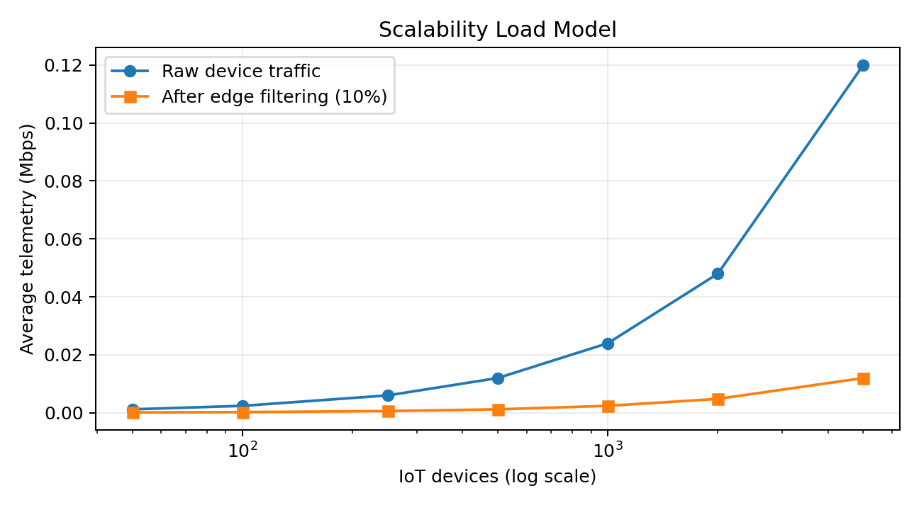
The model shows that raw traffic increases with device count, while edge filtering reduces the amount of data forwarded to the cloud.
Performance Graph 2 – Gateway Capacity Planning
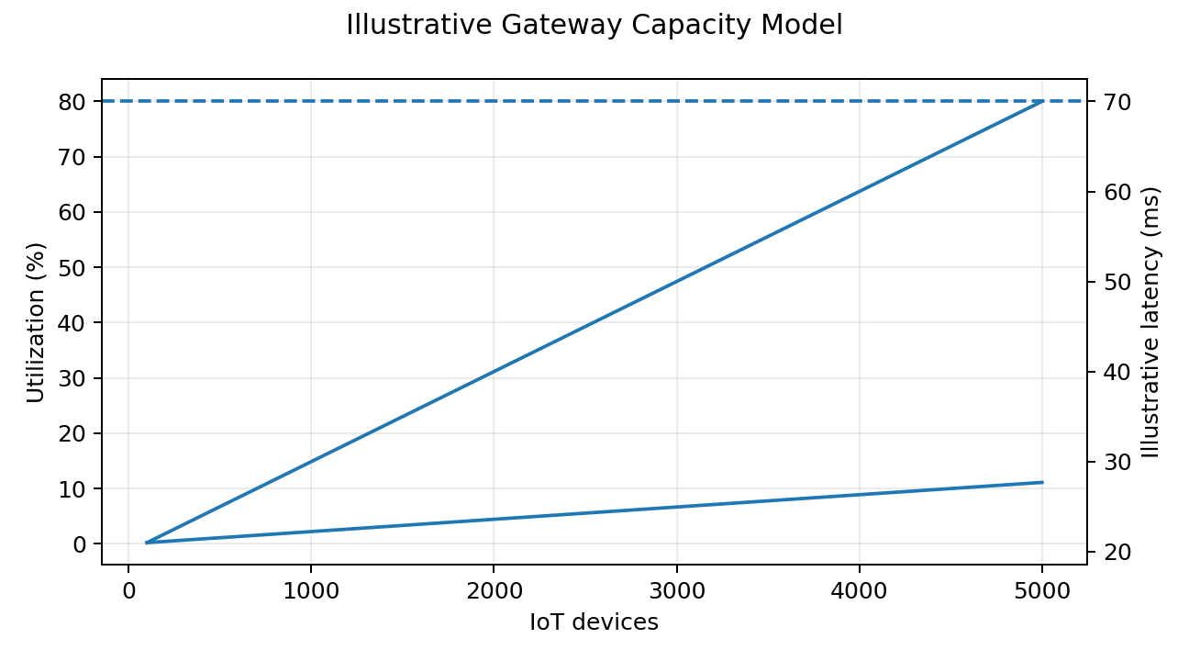
The 80% gateway utilization level is used only as a planning threshold in this model. A real deployment should use measured gateway capacity.

9. SIMULATION IMPLEMENTATION PLAN
- Cisco Packet Tracer: create IoT end devices, gateway/IP network and cloud/application sections; increase device count and observe connectivity and traffic.
- GNS3: emulate routers, switches, VLANs, gateway/server nodes and increasing MQTT traffic.
- IoT simulator: model device generation, gateway coverage, packet loss and message traffic where supported.
- Test sequence: 50 → 100 → 500 → 1,000 → 5,000 devices.
- Record throughput, packet loss, latency, gateway utilization, queue depth and server resource usage.
- Keep screenshots of the topology and graphs as evidence of the simulation.

10. RISK ASSESSMENT
Risk | Severity | Mitigation
Gateway overload | High | Monitor utilization, add gateways, distribute devices and filter at edge.
Broker bottleneck | High | Use multiple broker/consumer instances and distribute message processing.
Wireless interference | Medium–High | Site survey, channel planning and suitable gateway placement.
Backhaul/cloud outage | High | Edge buffering, local rules and store-and-forward.
Traffic bursts | High | Queueing, batching, rate limiting and backpressure.
Device identity compromise | High | Unique credentials, secure provisioning and access control.
Database growth | Medium–High | Retention, partitioning, aggregation and tiered storage.
Firmware complexity | Medium | Staged updates, monitoring and rollback procedures.

11. SECURITY AND OPERATIONS
- Use a unique identity and credentials/keys for every device.
- Use encrypted communication for network traffic where supported.
- Separate IoT networks from general user networks using VLANs/firewalls where appropriate.
- Apply least-privilege permissions to devices and applications.
- Monitor connectivity, message rates, latency, gateway health and failures.
- Maintain a lifecycle process for onboarding, configuration, firmware updates and decommissioning.

12. ASSUMPTIONS AND LIMITATIONS
- This is a conceptual reference architecture, not a production deployment specification.
- Actual radio range, gateway capacity, latency, packet loss and broker throughput depend on hardware, environment and configuration.
- The two performance graphs are analytical planning models, not claimed Packet Tracer or GNS3 measurements.
- If actual simulator evidence is required, add your own topology screenshot and measured results in Section 9.

13. CONCLUSION
The proposed architecture separates field connectivity, edge processing, network transport, cloud ingestion, data services and applications. This creates clear scaling points: additional gateways increase field capacity, broker and processing resources increase message-handling capacity, and cloud storage and analytics can scale independently.
The design covers the Week 1 requirements: topology research, device interconnections, communication protocols, network structure, data flow, scalability challenges, simulation planning, expected performance metrics, risk assessment and design justification. The architecture can start as a small pilot and grow through controlled expansion.

14. REFERENCES
- OASIS – MQTT Version 5.0 specification.
- LoRa Alliance – LoRaWAN Specification and architecture documentation.
- AWS IoT Lens – guidance on edge computing and gateway preprocessing.
- Cisco Packet Tracer / GNS3 – proposed tools for topology and traffic simulation.

