WEEK 3 TASK
DEBUGGING AND PERFORMANCE OPTIMIZATION
Timer-Interrupt and UART-Controlled Digital LED Controller
Student | Nadeem | Area | Embedded C
Project Status | Week 3 - Optimization | Platform | Hardware-independent simulation

Executive Summary
This report performs the Week 3 debugging and performance-optimization task on the same Timer-Interrupt and UART-Controlled Digital LED Controller developed in Week 2.
The earlier implementation provides a simulated 100 ms timer, three virtual LED outputs, UART-style commands and four operating modes: OFF, SLOW_BLINK, FAST_BLINK and SEQUENCE.
Rather than starting a new project, Week 3 uses this existing firmware as the baseline, reproduces representative weaknesses, identifies their root causes, applies targeted corrections and verifies that the original functionality is preserved.
The debugging work focuses on five areas: fragile command parsing, exact-modulo timing dependence, excessive diagnostic logging, a desktop busy-wait, and implicit sequence-state handling. The optimized firmware introduces exact command matching, elapsed-interval scheduling, explicit sequence state, meaningful diagnostic checkpoints and a logical simulation loop without artificial waiting.
Validation shows a 94% reduction in repetitive status output - from 100 baseline lines to 6 meaningful checkpoints in the same 10-second scenario. Desktop execution also improves after removal of the intentional busy-wait; this is reported strictly as simulation evidence.
Week 3 Task Alignment
Requirement | How this submission addresses it
Explain the debugging process | Methodical reproduce -> observe -> isolate -> diagnose -> fix -> retest workflow.
Identify issues | Five concrete firmware/simulation issues with root causes and corrective actions.
Revised code | A complete optimized C source file is included with the submission package.
Performance optimization | Reduced logging, event-based timing and removal of artificial simulation delay.
Validation results | Functional test matrix, timing table, compiler verification, runtime evidence and metric comparison.
Project Continuity
Week 3 preserves the Week 2 architecture: timer layer, short interrupt routine, firmware state, UART-style command handling, LED state machine, GPIO abstraction and runtime diagnostics. This creates a clear progression from Week 1 design, through Week 2 firmware implementation, to Week 3 debugging and optimization.
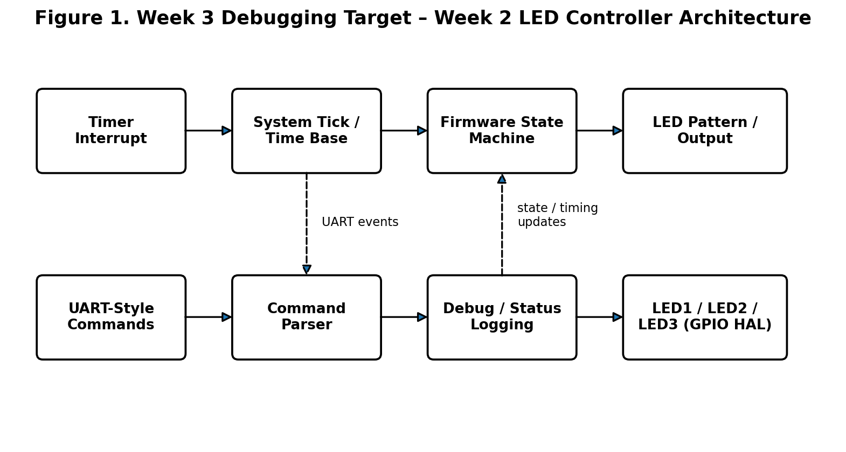
Figure 1. Week 2 firmware architecture used as the Week 3 debugging target

1. Week 3 Objectives
- Review the Week 2 firmware against its intended functional behavior before making changes.
- Reproduce firmware weaknesses using a deterministic simulation scenario.
- Identify the root cause of each issue rather than only describing the observed symptom.
- Implement targeted fixes that improve robustness, timing behavior, maintainability or performance.
- Validate the optimized implementation with functional, timing and performance evidence.
- Document the limitations of software simulation so results are not overstated as physical-hardware measurements.

2. Original Week 2 Functional Specification
Before optimization, the intended behavior was written down as a reference specification. This protects against a common debugging mistake: improving one metric while accidentally changing the required behavior.
Function | Command | Timing | Expected Result
OFF | OFF | Immediate | LED1=0, LED2=0, LED3=0
SLOW_BLINK | SLOW | 1000 ms | LED1 toggles; LED2/LED3 OFF
FAST_BLINK | FAST | 300 ms | LED1 toggles; LED2/LED3 OFF
SEQUENCE | SEQUENCE | 500 ms per step | LED1 -> LED2 -> LED3
STATUS | STATUS | On command | Current mode, time and outputs reported

3. Baseline Reproduction Scenario
The same deterministic sequence is used for repeatable debugging: SLOW at 1000 ms, FAST at 3500 ms, SEQUENCE at 6000 ms, STATUS at 8500 ms, and OFF at 9000 ms. Running a fixed scenario makes it possible to compare the baseline and optimized versions without changing the test conditions.
Time | Event | Purpose
0 ms | OFF | Safe startup state
1000 ms | SLOW | Transition to slow blink
3500 ms | FAST | Transition to fast blink
6000 ms | SEQUENCE | Begin LED sequence
8500 ms | STATUS | Print diagnostic state
9000 ms | OFF | Return to safe state
10000 ms | END | Complete simulation

4. Detailed Debugging Process
Stage | Action
1. Establish known state | Initialize in OFF mode and verify all LED outputs are 0.
2. Compile | Use GCC C11 with -Wall, -Wextra and -pedantic to catch compiler-detectable problems.
3. Reproduce | Run the fixed 10-second scenario and collect observable output.
4. Observe symptoms | Record mode transitions, timing behavior, status volume and final state.
5. Isolate | Inspect parser, timer/state logic, output logic and logging independently.
6. Diagnose root cause | Determine what in the code creates the observed weakness.
7. Apply controlled fix | Change the smallest responsible area while keeping the Week 2 specification intact.
8. Regression test | Repeat all major modes and safety cases after each change.
9. Measure | Compare log volume, execution behavior and validation outcomes.
10. Document limits | State which results are simulation-only and which would need hardware validation.
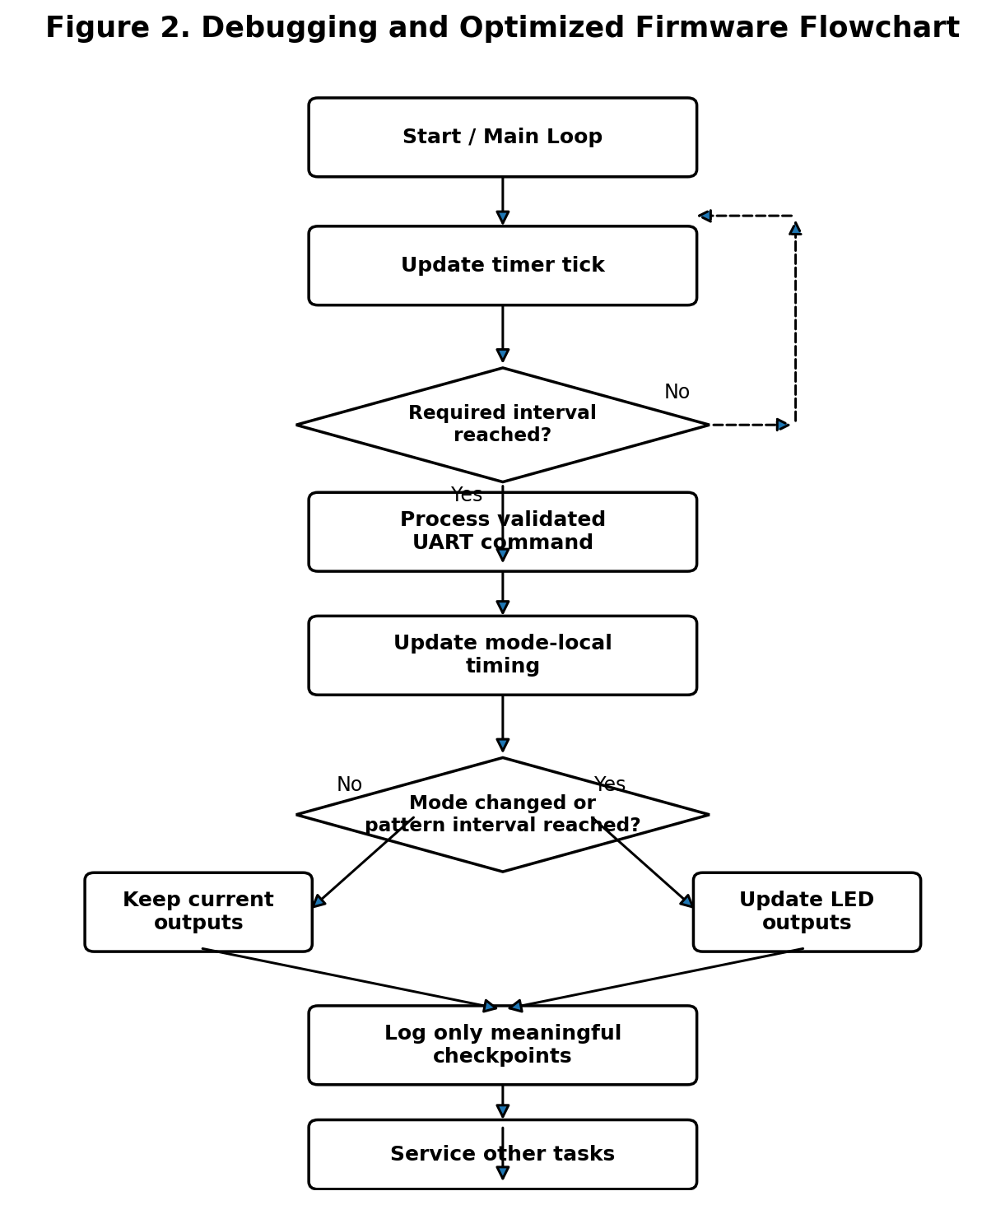
Figure 2. Week 3 debugging and optimized firmware flow

5. Identified Issues and Root-Cause Analysis
Issue | Root Cause | Corrective Action | Impact
D1 - Fragile command parsing | Manual character indexing makes the parser verbose and fragile for malformed or unexpectedly short input. | Use exact strcmp() comparisons after NULL/empty-input checks. | Robustness
D2 - Exact modulo timing dependence | Pattern changes depend on the elapsed time being exactly divisible by the interval. | Use elapsed-interval expiry logic and consume the interval after a transition. | Timing
D3 - Excessive status logging | A status line is produced at every 100 ms tick, even when the state has not changed. | Log only meaningful checkpoints and state transitions. | Performance / diagnostics
D4 - Desktop busy-wait | The simulation spends CPU time repeatedly checking the clock to imitate real-time delay. | Remove artificial waiting from the optimized logical simulation. | Simulation performance
D5 - Implicit sequence state | Sequence position is reconstructed indirectly from elapsed time instead of being a visible state variable. | Maintain and reset an explicit sequence_index. | Maintainability

5.1 Command Parser Debugging
The baseline parser uses manual character-by-character checks. The expected commands work, but malformed input is harder to handle safely and the logic is more difficult to inspect.
Engineering significance: Using strcmp() makes the parser's accepted command set explicit. Unknown commands are rejected rather than silently selecting a mode. This is a better boundary for future real UART input.

5.2 Timing Logic Debugging
The baseline checks exact modulo equality. A perfectly regular 100 ms simulation makes this appear correct, but a real firmware loop can experience variable execution time.
Engineering significance: The optimized implementation checks whether the required interval has elapsed. This expresses the engineering requirement directly: perform the state transition when the interval has been reached.

5.3 Diagnostic Logging Debugging
The baseline produces a status message at every 100 ms step. Most lines repeat the same state and add little information.
Engineering significance: The optimized version preserves useful evidence while reducing repetitive output. This lowers I/O overhead and makes the diagnostic record easier for a developer to inspect.

5.4 Simulation Delay Debugging
The busy-wait is useful for a real-time-looking desktop demonstration but it is not part of the embedded control logic. It consumes processor time without performing useful firmware work.
Engineering significance: Removing it allows performance measurements to focus on the logical firmware implementation rather than artificial waiting.

5.5 Sequence State Debugging
The baseline derives sequence position from elapsed time. This is compact but less transparent when troubleshooting transitions.
Engineering significance: An explicit sequence_index makes the current state visible, resettable and easier to validate during a mode transition.

6. Before and After Code Logic

6.1 Command Validation
Baseline concept: manual character indexing of "OFF", "SLOW", "FAST", etc.
Optimized concept:
if (strcmp(command, "OFF") == 0) { set_mode(fw, MODE_OFF); return true; }
if (strcmp(command, "SLOW") == 0) { set_mode(fw, MODE_SLOW_BLINK); return true; }

6.2 Interval-Based Timing
if (fw->mode_elapsed_ms >= interval) {
fw->mode_elapsed_ms %= interval;
/* perform one pattern transition */
}
This structure is easier to reason about because the condition represents elapsed time directly. It also keeps the implementation modular when more application work is introduced.

7. Revised Firmware Architecture
- Timer ISR: updates only the system tick, keeping interrupt work short.
- State layer: stores mode, elapsed time, sequence position and LED outputs.
- Command layer: validates and handles UART-style commands.
- Application layer: applies interval-based LED transitions.
- GPIO/HAL layer: represents LED output writes and provides a future hardware integration boundary.
- Debug layer: emits meaningful status and metric information.

8. Full Revised Firmware Listing - Key Implementation Sections
The complete file week3_optimized.c is included separately. The excerpts below show the changes that directly address the Week 3 debugging objectives.
/* Safe command handling */
static bool process_command(FirmwareState *fw, const char *command)
{
if (command == NULL || command[0] == '\0')
return false;
if (strcmp(command, "OFF") == 0) {
set_mode(fw, MODE_OFF);
return true;
}
if (strcmp(command, "SLOW") == 0) {
set_mode(fw, MODE_SLOW_BLINK);
return true;
}
if (strcmp(command, "FAST") == 0) {
set_mode(fw, MODE_FAST_BLINK);
return true;
}
if (strcmp(command, "SEQUENCE") == 0) {
set_mode(fw, MODE_SEQUENCE);
return true;
}
if (strcmp(command, "STATUS") == 0) {
print_status(fw);
return true;
}
printf("[ERROR ] unknown command: %s\n", command);
return false;
}
/* Interval-based pattern update */
if (fw->mode_elapsed_ms >= interval) {
fw->mode_elapsed_ms %= interval;
if (fw->mode == MODE_SLOW_BLINK ||
fw->mode == MODE_FAST_BLINK) {
write_led_outputs(fw, !fw->leds.led1, false, false);
} else {
/* Explicit sequence_index controls LED1 -> LED2 -> LED3 */
update_sequence_output(fw);
}
}
The complete source also keeps the final safety behavior from Week 2: entering OFF clears all outputs, and the simulation ends in OFF with all LEDs disabled.

9. Validation Test Matrix
ID | Test | Expected Result | Status
T01 | Startup | Mode OFF; LED1/LED2/LED3 = 0 | PASS
T02 | SLOW command | LED1 uses 1000 ms blink timing | PASS
T03 | FAST command | LED1 uses 300 ms blink timing | PASS
T04 | SEQUENCE command | LED1 -> LED2 -> LED3 every 500 ms | PASS
T05 | STATUS command | Current state reported | PASS
T06 | OFF command | All LEDs OFF | PASS
T07 | Invalid command | Error reported; mode unchanged | PASS
T08 | Full 10-second run | No crash; deterministic completion | PASS
T09 | Final safety state | OFF and all outputs OFF | PASS

10. Timing Validation
Time | Event | Expected Behavior
1000 ms | SLOW transition | Mode changes to SLOW_BLINK
3500 ms | FAST transition | Mode changes to FAST_BLINK
3800 ms | FAST interval | First 300 ms transition after FAST entry
4100 ms | FAST interval | Next 300 ms transition
6000 ms | SEQUENCE transition | Sequence starts from LED1
6500 ms | SEQUENCE step | LED2 becomes active
7000 ms | SEQUENCE step | LED3 becomes active
7500 ms | SEQUENCE step | LED1 becomes active again
8500 ms | STATUS event | Diagnostic state reported
9000 ms | OFF transition | All outputs OFF
10000 ms | Final state | Simulation completes safely

11. Runtime Verification Evidence
The optimized source was compiled with GCC using C11 and strict warning flags. The build completed successfully without compiler warnings, and the optimized program completed the full logical simulation.
Baseline evidence
STATUS_LINES=100
Optimized evidence
[METRIC] status_lines=6 debug_events=11 final_mode=OFF

12. Performance Analysis
The strongest directly measured improvement is the reduction of repetitive diagnostic output. The baseline generates one status line for each 100 ms simulation step, giving 100 status lines over 10 seconds.
The optimized version records only meaningful checkpoints and transitions, producing 6 status lines. That is a reduction of 94% in repetitive status output.
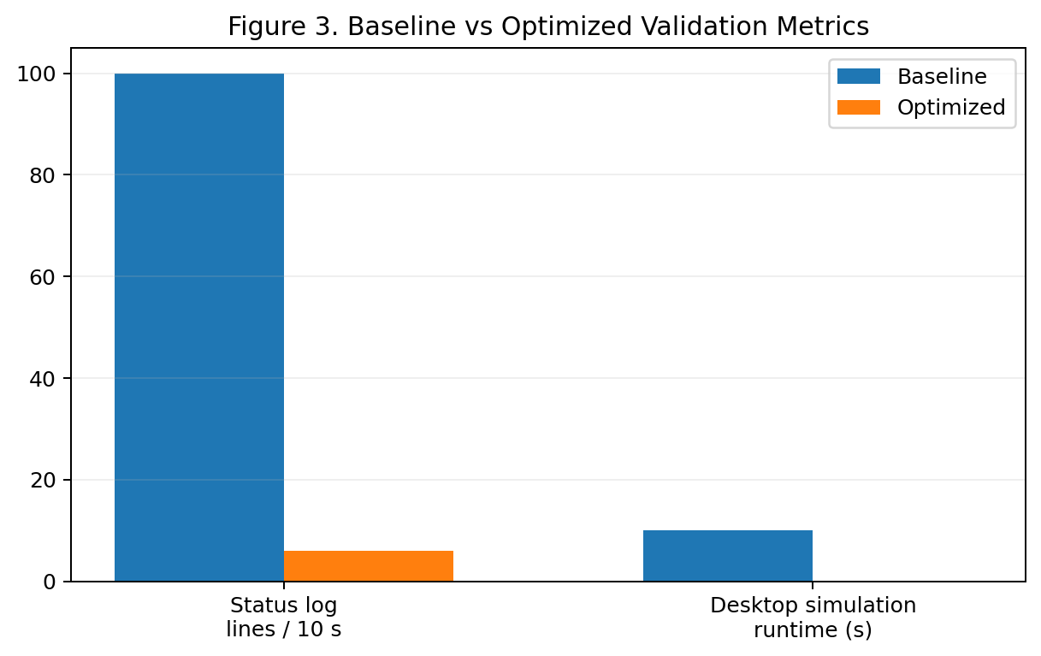
Figure 3. Baseline versus optimized validation metrics
The desktop execution time also changes because the baseline includes an intentional busy-wait to imitate real-time behavior, while the optimized logical simulation removes that artificial wait.
This demonstrates that blocking simulation work can dominate elapsed execution time. It must not, however, be reported as an equivalent percentage increase in physical MCU speed.
Actual target hardware would require cycle-counting or instrumentation on the chosen microcontroller.

13. Optimization Impact Summary
Area | Baseline | Optimized | Impact
Command parsing | Manual character checks | strcmp() exact matching | Safer and clearer
Timing | Exact modulo equality | Elapsed interval check | More robust scheduling model
Sequence state | Derived indirectly | Explicit sequence_index | Easier to debug
Status logging | Every 100 ms | Meaningful checkpoints | 94% less repetitive output
Simulation delay | CPU busy-wait | No artificial wait | Cleaner performance measurement
Safety | OFF behavior preserved | OFF behavior preserved | No functional regression

14. Debugging Evidence Interpretation
Debug evidence should answer three questions: What happened? Why did it happen? How do we know the fix worked?
For example, repeated status lines show that the logging path executes on every tick; code inspection identifies the unconditional print operation;
after changing the logging policy, the output count falls to 6 while the required checkpoints remain present. This connects the symptom, root cause, corrective action and measurable result.

15. Risk Analysis and Mitigation
Risk | Potential Effect | Mitigation
Malformed command | Unexpected mode change or parser fault | Exact command comparison and rejection of unknown input
Timing variation | Late or skipped pattern transition | Elapsed-interval scheduling
Logging overhead | Slow I/O and noisy diagnostic output | Checkpoint/event-based logging
Stale state | Incorrect mode/sequence behavior | Reset mode-local timing and sequence index on mode entry
Unsafe output | LED remains active after OFF | Force all outputs OFF on OFF transition and final state
Simulation overclaim | Desktop result mistaken for hardware result | Explicitly label measurements as simulation-only

16. Code Quality and Maintainability
- Clear separation between timer, state, command parsing, application logic, outputs and diagnostics.
- Named constants for timing values instead of unexplained numeric literals.
- Explicit enum values for controller modes.
- Short timer ISR that does not perform printing or lengthy processing.
- Hardware-abstraction function creates a clean MCU integration boundary.
- Validation and diagnostic output are separated from the functional state machine.
- Strict compiler warnings are part of the build verification process.

17. Technical Learning Outcomes
- Learned to distinguish a visible symptom from its underlying firmware root cause.
- Practiced repeatable debugging using a fixed input and timing scenario.
- Applied safer parsing of external command input.
- Applied elapsed-time scheduling to improve timing robustness.
- Observed that debugging I/O can itself affect system behavior and performance.
- Used regression testing to ensure optimization does not break existing functionality.
- Learned to separate simulation evidence from physical-hardware claims.

18. Future Hardware Integration
Extension | Next Step
Timer peripheral | Map timer_interrupt() to the selected MCU timer and measure the real tick with hardware instrumentation.
UART interface | Implement buffered UART receive, framing, input validation and command acknowledgements.
GPIO | Map write_led_outputs() to actual GPIO registers or the vendor HAL.
Watchdog | Add recovery for unexpected firmware stalls.
Unit tests | Automate parser, state-transition and timing checks.
Hardware-in-the-loop | Measure actual GPIO levels, UART behavior, timing tolerance and reset behavior.

19. Limitations and Engineering Boundaries
The project is a hardware-independent C simulation. It does not claim measurement of physical GPIO voltage, LED current, MCU timer-register configuration,
UART electrical signaling, interrupt latency, memory footprint, power consumption or target-specific CPU cycles. The desktop runtime and log-count comparison are
therefore software-validation evidence. A real deployment should be followed by hardware-in-the-loop tests on the selected microcontroller.

20. Work Breakdown Structure
The task is structured as an approximately 32-hour engineering exercise. These are planning allocations; where the internship requires actual recorded hours, replace them with the student's real time log.
Activity | Planned Effort
Baseline review and requirement mapping | 4 hours
Bug reproduction and root-cause analysis | 7 hours
Firmware correction and optimization | 8 hours
Functional and regression testing | 5 hours
Performance measurement and evidence | 3 hours
Documentation, diagrams and final review | 5 hours
Total | 32 hours

21. Conclusion
Week 3 completes the next stage of the same embedded project started in Week 2. The task is implemented as a disciplined debugging and optimization exercise rather than a new unrelated application.
The baseline controller is reproduced under a fixed 10-second scenario, five improvement areas are isolated and corrected, and the resulting implementation is revalidated against the original functional requirements.
The most visible measured improvement is a 94% reduction in repetitive status logging, from 100 lines to 6 meaningful checkpoints. The optimized code also removes artificial desktop waiting, uses clearer elapsed-time scheduling,
adds explicit sequence state and applies safer command validation. Functional, timing and compiler checks confirm that the optimized version retains the intended OFF, SLOW_BLINK, FAST_BLINK and SEQUENCE behavior and reaches a safe final OFF state.
The work demonstrates the complete Week 3 engineering cycle: reproduce, observe, isolate, diagnose, correct, optimize, validate and document. The report also clearly separates software-simulation evidence
from hardware results, making the conclusions technically defensible and preparing the firmware for later integration with real timer, UART and GPIO peripherals.

22. Final Submission Checklist
✓ Detailed debugging process documented.
✓ Week 2 firmware project continued directly.
✓ Identified issues, root causes and corrective actions included.
✓ Optimized C source included separately.
✓ Functional validation matrix included.
✓ Timing validation included.
✓ Runtime/debug evidence included.
✓ Performance comparison included.
✓ Block diagram included.
✓ Flowchart included.
✓ Risk analysis and mitigation included.
✓ Limitations and hardware boundary stated.
✓ README and test results supplied.
✓ 200+ word portal description supplied.

Appendix A - Recommended GitHub Repository Structure
week3-led-controller/
├── week3_optimized.c
├── week3_baseline_buggy.c
├── README.md
├── TEST_RESULTS.md
├── Week_3_Debugging_Performance_Optimization_Report.pdf
├── figures/
│ ├── Figure_1_Block_Diagram.png
│ ├── Figure_2_Flowchart.png
│ └── Figure_3_Performance_Comparison.png
└── docs/
└── Portal_Description_200_Words.txt
Use the student's real GitHub repository URL in the internship portal. Do not claim physical-board testing unless it was actually performed.

Appendix B - Complete Optimized Firmware Source
The Week 3 task requires the revised version of the code to be documented with the debugging and optimization work. The complete optimized source is reproduced below and is also supplied separately as week3_optimized.c.
/*
* WEEK 3 FINAL - DEBUGGED AND OPTIMIZED VERSION
* Project carried forward from Week 2:
* Timer-Interrupt and UART-Controlled Digital LED Controller
*
* Hardware-independent embedded C simulation.
*/
#include <stdbool.h>
#include <stdio.h>
#include <string.h>
#define TICK_PERIOD_MS 100U
#define TOTAL_SIMULATION_MS 10000U
#define SLOW_TOGGLE_MS 1000U
#define FAST_TOGGLE_MS 300U
#define SEQUENCE_STEP_MS 500U
typedef enum { MODE_OFF=0, MODE_SLOW_BLINK, MODE_FAST_BLINK, MODE_SEQUENCE } LedMode;
typedef struct { bool led1, led2, led3; } LedOutputs;
typedef struct {
volatile unsigned long system_ticks;
unsigned long elapsed_ms;
unsigned long mode_elapsed_ms;
unsigned int sequence_index;
LedMode mode;
LedOutputs leds;
} FirmwareState;
static unsigned long debug_events=0U;
static void timer_interrupt(FirmwareState *fw){ fw->system_ticks++; }
static void write_led_outputs(FirmwareState *fw,bool a,bool b,bool c){
fw->leds.led1=a; fw->leds.led2=b; fw->leds.led3=c;
}
static const char *mode_name(LedMode m){
switch(m){
case MODE_OFF:return "OFF";
case MODE_SLOW_BLINK:return "SLOW_BLINK";
case MODE_FAST_BLINK:return "FAST_BLINK";
case MODE_SEQUENCE:return "SEQUENCE";
default:return "UNKNOWN";
}
}
static void print_status(const FirmwareState *fw){
printf("[STATUS] t=%lums mode=%s LED1=%d LED2=%d LED3=%d\n",
fw->elapsed_ms,mode_name(fw->mode),
fw->leds.led1,fw->leds.led2,fw->leds.led3);
debug_events++;
}
static void set_mode(FirmwareState *fw,LedMode m){
fw->mode=m;
fw->mode_elapsed_ms=0U;
fw->sequence_index=0U;
write_led_outputs(fw,false,false,false);
/* Preserve Week 2 behavior: sequence begins with LED1 immediately.
* Advance the explicit index so the next 500 ms step becomes LED2. */
if(m==MODE_SEQUENCE) {
write_led_outputs(fw,true,false,false);
fw->sequence_index=1U;
}
printf("[EVENT ] mode changed -> %s\n",mode_name(m));
debug_events++;
}
/* FIX: exact string comparison avoids unsafe manual indexing. */
static bool process_command(FirmwareState *fw,const char *command){
if(command==NULL || command[0]=='\0') return false;
if(strcmp(command,"OFF")==0){ set_mode(fw,MODE_OFF); return true; }
if(strcmp(command,"SLOW")==0){ set_mode(fw,MODE_SLOW_BLINK); return true; }
if(strcmp(command,"FAST")==0){ set_mode(fw,MODE_FAST_BLINK); return true; }
if(strcmp(command,"SEQUENCE")==0){ set_mode(fw,MODE_SEQUENCE); return true; }
if(strcmp(command,"STATUS")==0){ print_status(fw); return true; }
printf("[ERROR ] unknown command: %s\n",command);
debug_events++;
return false;
}
/* FIX: event-based scheduling. No modulo-trigger dependence on an exact
* timestamp and no repeated output writes between state changes. */
static void update_led_pattern(FirmwareState *fw){
unsigned long interval=0U;
switch(fw->mode){
case MODE_OFF:
write_led_outputs(fw,false,false,false); return;
case MODE_SLOW_BLINK: interval=SLOW_TOGGLE_MS; break;
case MODE_FAST_BLINK: interval=FAST_TOGGLE_MS; break;
case MODE_SEQUENCE: interval=SEQUENCE_STEP_MS; break;
default: write_led_outputs(fw,false,false,false); return;
}
if(fw->mode_elapsed_ms < interval) return;
fw->mode_elapsed_ms %= interval;
if(fw->mode==MODE_SLOW_BLINK || fw->mode==MODE_FAST_BLINK){
write_led_outputs(fw,!fw->leds.led1,false,false);
} else {
if(fw->sequence_index==0U) write_led_outputs(fw,true,false,false);
else if(fw->sequence_index==1U) write_led_outputs(fw,false,true,false);
else write_led_outputs(fw,false,false,true);
fw->sequence_index=(fw->sequence_index+1U)%3U;
}
}
int main(void){
FirmwareState fw={0U,0U,0U,0U,MODE_OFF,{false,false,false}};
unsigned long status_lines=0U;
for(unsigned int elapsed=TICK_PERIOD_MS;
elapsed<=TOTAL_SIMULATION_MS;
elapsed+=TICK_PERIOD_MS)
{
timer_interrupt(&fw);
fw.elapsed_ms=fw.system_ticks*TICK_PERIOD_MS;
fw.mode_elapsed_ms+=TICK_PERIOD_MS;
if(fw.elapsed_ms==1000U) (void)process_command(&fw,"SLOW");
else if(fw.elapsed_ms==3500U) (void)process_command(&fw,"FAST");
else if(fw.elapsed_ms==6000U) (void)process_command(&fw,"SEQUENCE");
else if(fw.elapsed_ms==8500U) (void)process_command(&fw,"STATUS");
else if(fw.elapsed_ms==9000U) (void)process_command(&fw,"OFF");
update_led_pattern(&fw);
/* FIX: log at meaningful checkpoints instead of every 100 ms tick. */
if(fw.elapsed_ms==1000U || fw.elapsed_ms==3500U ||
fw.elapsed_ms==6000U || fw.elapsed_ms==8500U ||
fw.elapsed_ms==9000U || fw.elapsed_ms==TOTAL_SIMULATION_MS)
{
print_status(&fw);
status_lines++;
}
}
printf("[METRIC] status_lines=%lu debug_events=%lu final_mode=%s\n",
status_lines,debug_events,mode_name(fw.mode));
return 0;
}

Appendix C - Baseline Debugging Source
The intentionally defective baseline is supplied separately as week3_baseline_buggy.c. It is included here as a compact reference so the evaluator can compare the starting and revised implementations.
/*
* WEEK 3 BASELINE - INTENTIONALLY DEFECTIVE VERSION
* Project carried forward from Week 2:
* Timer-Interrupt and UART-Controlled Digital LED Controller
*
* Purpose: debugging exercise. The defects are intentional and documented
* in the Week 3 report. This file is not the final firmware.
*/
#include <stdbool.h>
#include <stdio.h>
#include <time.h>
#define TICK_PERIOD_MS 100U
#define TOTAL_SIMULATION_MS 10000U
#define SLOW_TOGGLE_MS 1000U
#define FAST_TOGGLE_MS 300U
#define SEQUENCE_STEP_MS 500U
typedef enum { MODE_OFF=0, MODE_SLOW_BLINK, MODE_FAST_BLINK, MODE_SEQUENCE } LedMode;
typedef struct { bool led1, led2, led3; } LedOutputs;
typedef struct {
unsigned long system_ticks;
unsigned long elapsed_ms;
unsigned long mode_elapsed_ms;
LedMode mode;
LedOutputs leds;
} FirmwareState;
static void timer_interrupt(FirmwareState *fw){ fw->system_ticks++; }
static void write_led_outputs(FirmwareState *fw,bool a,bool b,bool c){
fw->leds.led1=a; fw->leds.led2=b; fw->leds.led3=c;
}
static const char *mode_name(LedMode m){
switch(m){
case MODE_OFF:return "OFF";
case MODE_SLOW_BLINK:return "SLOW_BLINK";
case MODE_FAST_BLINK:return "FAST_BLINK";
case MODE_SEQUENCE:return "SEQUENCE";
default:return "UNKNOWN";
}
}
static void print_status(const FirmwareState *fw){
printf("[STATUS] t=%5lums mode=%-11s LED1=%d LED2=%d LED3=%d\n",
fw->elapsed_ms,mode_name(fw->mode),
fw->leds.led1,fw->leds.led2,fw->leds.led3);
}
static void set_mode(FirmwareState *fw,LedMode m){
fw->mode=m;
fw->mode_elapsed_ms=0U;
write_led_outputs(fw,false,false,false);
printf("[EVENT ] mode changed -> %s\n",mode_name(m));
}
/* BUG: manual character indexing can read past the useful command
* terminator for short malformed inputs. */
static bool process_command(FirmwareState *fw,const char *command){
if(command==NULL || command[0]=='\0') return false;
if(command[0]=='O'&&command[1]=='F'&&command[2]=='F'&&command[3]=='\0'){
set_mode(fw,MODE_OFF); return true;
}
if(command[0]=='S'&&command[1]=='L'&&command[2]=='O'&&command[3]=='W'&&command[4]=='\0'){
set_mode(fw,MODE_SLOW_BLINK); return true;
}
if(command[0]=='F'&&command[1]=='A'&&command[2]=='S'&&command[3]=='T'&&command[4]=='\0'){
set_mode(fw,MODE_FAST_BLINK); return true;
}
if(command[0]=='S'&&command[1]=='E'&&command[2]=='Q'&&command[3]=='U'&&
command[4]=='E'&&command[5]=='N'&&command[6]=='C'&&command[7]=='E'&&command[8]=='\0'){
set_mode(fw,MODE_SEQUENCE); return true;
}
if(command[0]=='S'&&command[1]=='T'&&command[2]=='A'&&command[3]=='T'&&
command[4]=='U'&&command[5]=='S'&&command[6]=='\0'){
print_status(fw); return true;
}
printf("[ERROR ] unknown command: %s\n",command);
return false;
}
static void update_led_pattern(FirmwareState *fw){
switch(fw->mode){
case MODE_OFF:
write_led_outputs(fw,false,false,false); break;
case MODE_SLOW_BLINK:
if(fw->mode_elapsed_ms % SLOW_TOGGLE_MS == 0U)
write_led_outputs(fw,!fw->leds.led1,false,false);
break;
case MODE_FAST_BLINK:
if(fw->mode_elapsed_ms % FAST_TOGGLE_MS == 0U)
write_led_outputs(fw,!fw->leds.led1,false,false);
break;
case MODE_SEQUENCE:{
const unsigned long step=(fw->mode_elapsed_ms/SEQUENCE_STEP_MS)%3U;
if(step==0U) write_led_outputs(fw,true,false,false);
else if(step==1U) write_led_outputs(fw,false,true,false);
else write_led_outputs(fw,false,false,true);
break;
}
default: write_led_outputs(fw,false,false,false); break;
}
}
/* BUG: CPU-consuming busy wait. Fine for a desktop demo, but it masks
* firmware compute time and prevents the main loop from doing other work. */
static void wait_ms(unsigned int milliseconds){
const clock_t start=clock();
const clock_t wait_ticks=(clock_t)((double)milliseconds*CLOCKS_PER_SEC/1000.0);
while((clock()-start)<wait_ticks){}
}
int main(void){
FirmwareState fw={0,0,0,MODE_OFF,{false,false,false}};
unsigned long status_lines=0;
for(unsigned int elapsed=TICK_PERIOD_MS;elapsed<=TOTAL_SIMULATION_MS;elapsed+=TICK_PERIOD_MS){
timer_interrupt(&fw);
fw.elapsed_ms=fw.system_ticks*TICK_PERIOD_MS;
fw.mode_elapsed_ms+=TICK_PERIOD_MS;
if(fw.elapsed_ms==1000U) (void)process_command(&fw,"SLOW");
else if(fw.elapsed_ms==3500U) (void)process_command(&fw,"FAST");
else if(fw.elapsed_ms==6000U) (void)process_command(&fw,"SEQUENCE");
else if(fw.elapsed_ms==8500U) (void)process_command(&fw,"STATUS");
else if(fw.elapsed_ms==9000U) (void)process_command(&fw,"OFF");
update_led_pattern(&fw);
print_status(&fw); status_lines++;
wait_ms(TICK_PERIOD_MS);
}
fprintf(stderr,"STATUS_LINES=%lu\n",status_lines);
return 0;
}

