**Creating the GingerJavaAgent project in Eclipse**

Visual Studio: Do get latest and make sure you see the GingerJavaAgent folder in Visual Studio

The sources are located under the JavaDriverLib

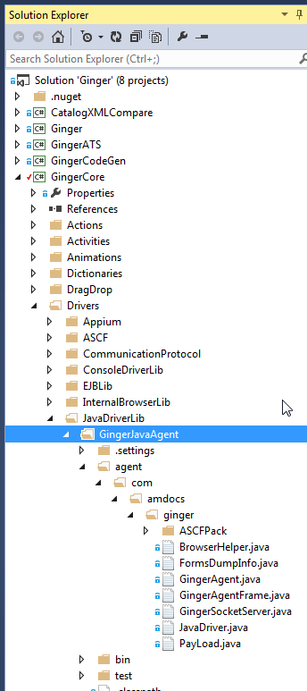

Open Eclipse

In package explorer tab

Right click 🡪 Import

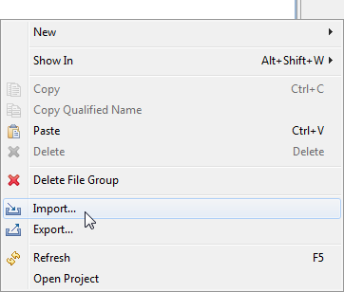

Select: Existing Project into workspace

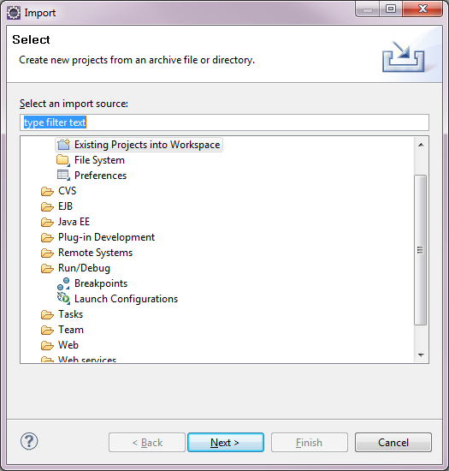

Click Next

Select Root directory – path to your local GingerJavaAgent folder

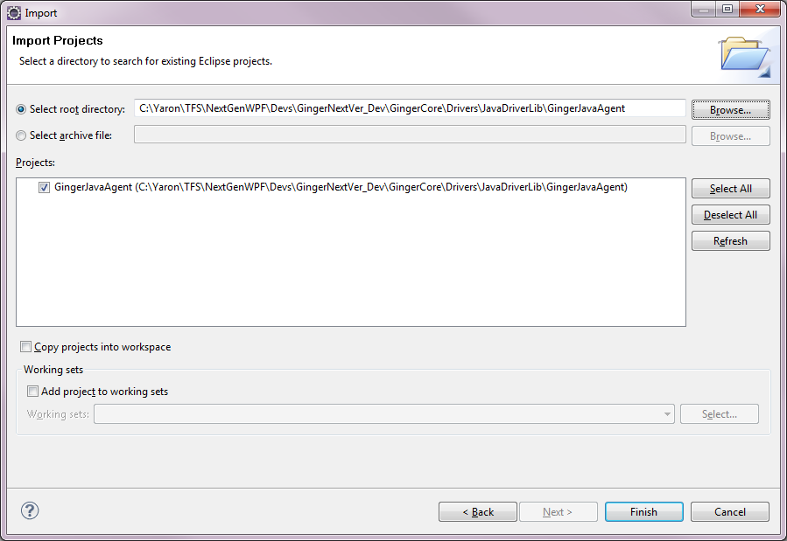

Click Finish

**Run test app**

Create Debug Configuration

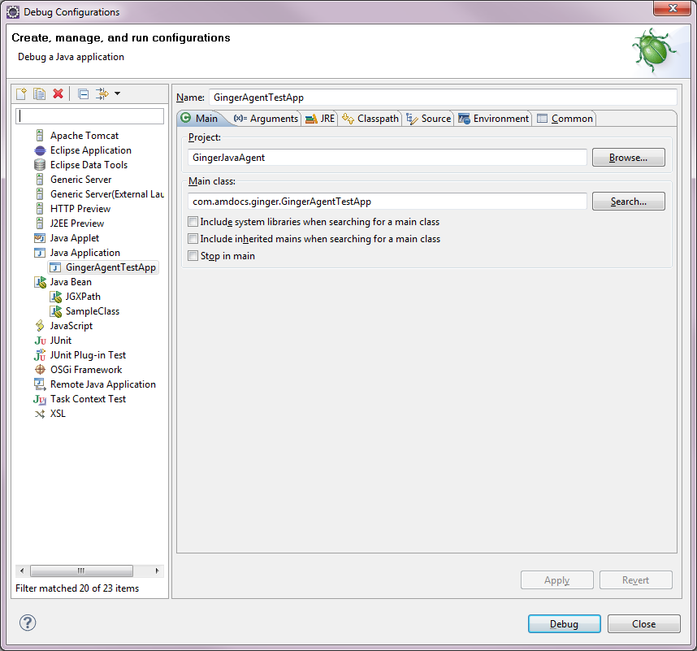

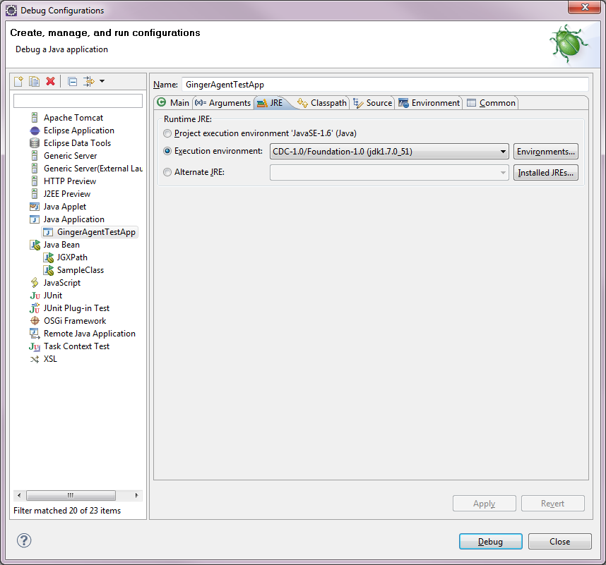

**Click Debug**

You should see the sample test app loading, it will also load the GingerServer Socket listening for commands (not via JavaAgent so we can do live debug)

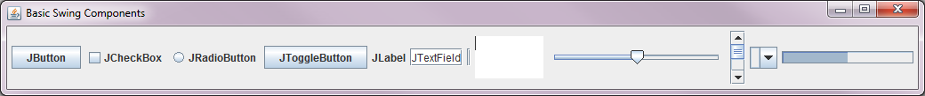

**Connect from Ginger**

Run Ginger

Create new Agent platform type: JavaDriver

Create new BF with target app/platform of Java

In Automate tab – Click Window Explorer

You should be able to see all the controls on the test app – if yes, the connection to Ginger Java socket was successful

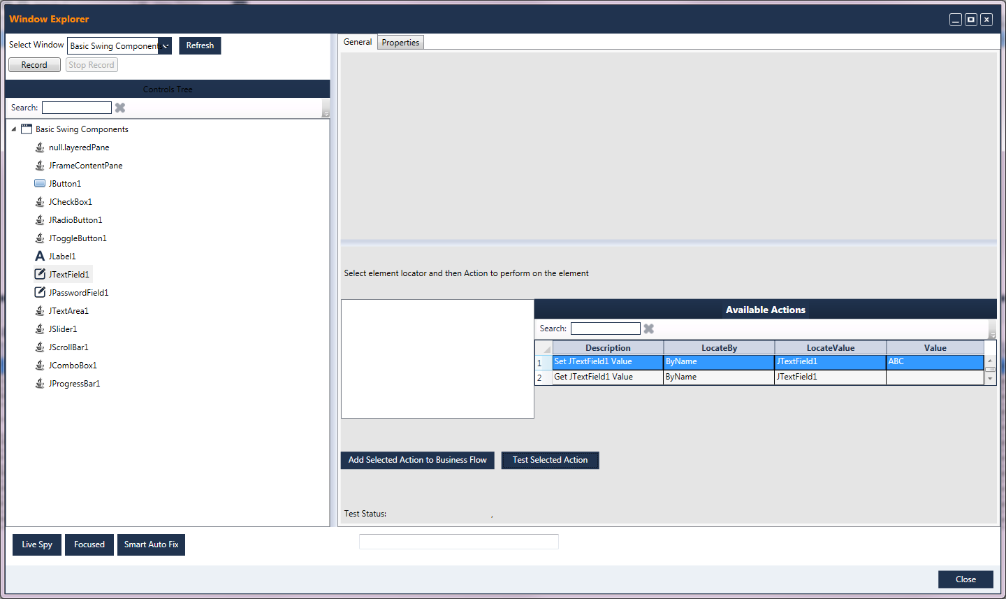

**Run a simple Set Text Box Value**

Select: JTextField1, and click Test Selected action which will set the value to ABC

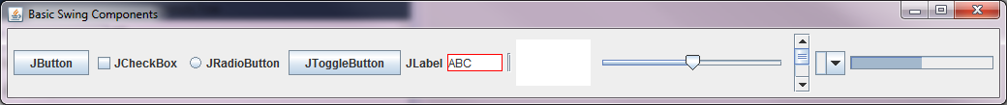

Every element selected in the tree view will be highlighted in the test app

Use the test app to try action on control, do live debug etc…

**Running on MPS – CRM/OMS with Widgets**

GingerUnitTester🡪Documents🡪JavaAgent contain 2 bat file

1. MPS.BAT which is Regular run

"C:\Program Files (x86)\Java\jdk1.7.0_51\bin\javaws.exe" <http://ilmps2397.eaas.amdocs.com:12718/Crm/CRM/Crm.jnlp>

1. MPS with Ginger agent – run MPs with Ginger Java Agent loaded

(TODO: fix hard coded ref)

"C:\Program Files (x86)\Java\jdk1.7.0_51\bin\javaws.exe" -J-javaagent:"C:\Users\YARONWE\Ginger\GingerAgent.jar" -J-Xbootclasspath/a:"c:\Users\YARONWE\Ginger\GingerAgent.jar" http://ilmps2397.eaas.amdocs.com:12718/Crm/CRM/Crm.jnlp

**Creating the Ginger Java Agent JAR file**

In Project Explorer double click on GingerAgentJar.jardesc and click finish

Jar will be created (with warnings)

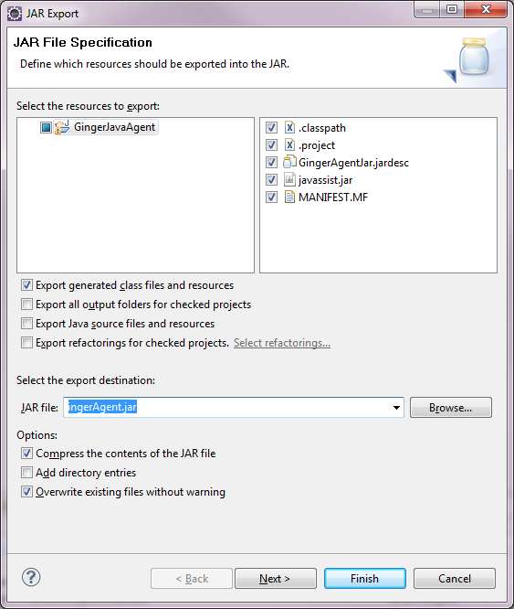

**Running on MPS with Ginger Agent**

After creating the GingerAgent.jar file

Run: MPS with Ginger Agent.bat

**Working with HTML Control - Widget**

HTMLControls.html is the test page

To run as test in standalone browser make sure you have jquery as script in the top, it is commented out as we want to inject it using ginger for pages which doesn’t have jquery, and test the jquery inject

Each line when action is done will be marked green, the target is to do it with automation, but it will work also manually

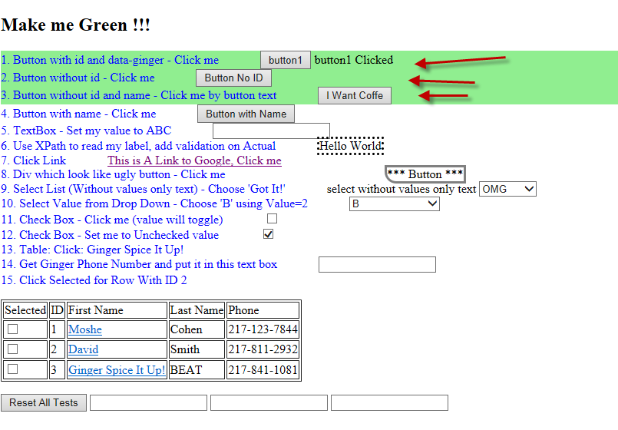

**C# Classes of the JavaDriver**

1. ActJavaBrowserElement – Contains the action definition

**Java Class**

1. JavaDriver – ProcessCommand -> ActJavaBrowserElement
   1. Keep the Active Browser control – first action is SetBrowser
2. BrowserHelper – is handling the action by doing Invoke Script

**IEBrowser**

1. Enable to test Java Script in simple IE browser
2. Run helper commands
3. See out put

JS to inject:

resources

1. JQuery-min.js
2. XPAth
3. GingerHTMLHelper.js

**TODO:**

1. Java side GingerAgent remove hard coded socket port 8888, make it read the port from properties file, code already exist in old GTB
2. Bat files – make them generic per user, removed hard coded yaron folder
3. Use JavAssit – to modify code if needed
4. Create Action for all controls
5. Create Recorder
6. Unit test
7. Try different Java version
8. Create action to launch Java Web Start with Ginger Agent
9. Put Ginger Agent in env vars
10. IE JExplorer – inject Java Script, find control and more
11. Transfer code from ASCF drvier