Hibernate

Data Persistence
- persistence storing the data permanently
- Data Persistence has 3 components.
1. Data
2. Medium
3. Storage

- Data: represents what to persist?
- Medium: represents How to persist?
- Storage: represents where to persist?
- Data:
  - raw data
  - Java object

- Medium:
  - Java I/0 streams
  - Serialization/De-serialization
  - JDBC(Java Database Connectivity)

- Storage:
  - File
  - Database

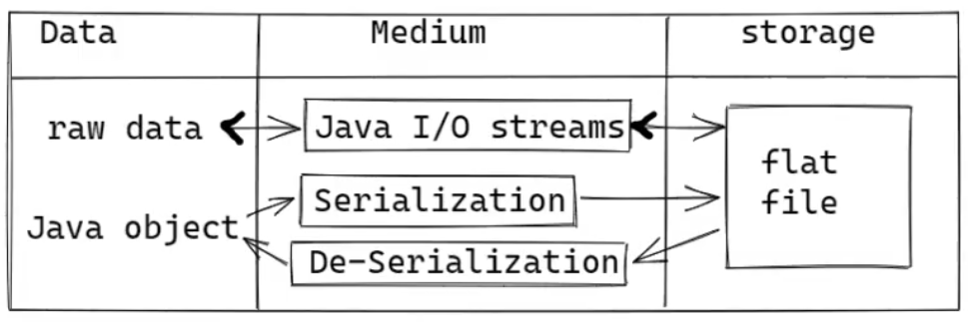
Serialization: It is a process of converting Java object into a stream of bytes. Now these stream of bytes can be stored in a file or can be transferred over a network.

De-Serialization: It is the processing converting a stream of bytes into a Java object.

What is the drawback of using a file
- Data redundancy
- Data inconsistency
- Data security
- Storage
- No transaction support
- No constraints support
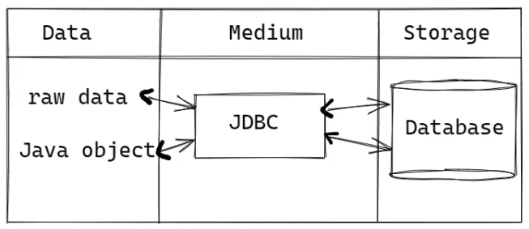

JDBC technology can be used to perform CRUD operations on the data of a Database.
C -- Create (inserting)
R -- Read (selecting)
U -- Update (modifying)
D -- Delete (removing)
requirement: I have an Employee’s object, I want to store the Employee object into a Database using JDBC
API.

What is the process?
- read the data from Employee object by calling getter methods.
- Create a PreparedStatement object of JDBC
- Now set the data to the PreparedStatement and then execute it.

Why we need ORM tools?
ORM: Object Relation Mapping.

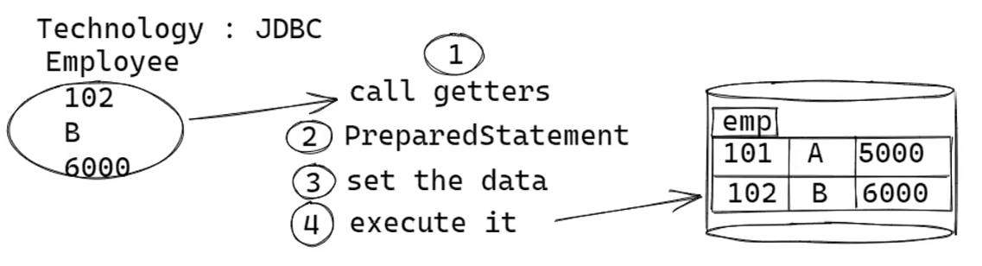

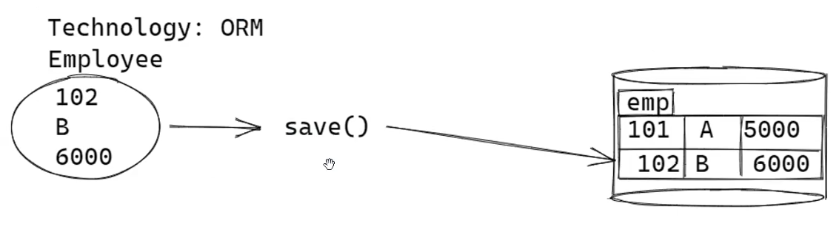
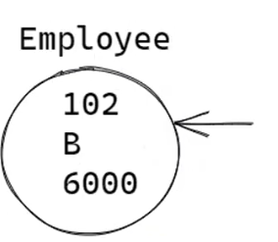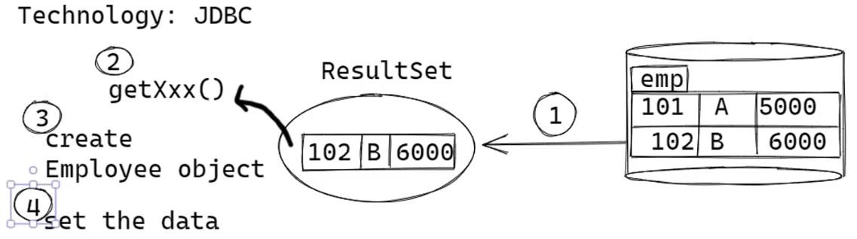

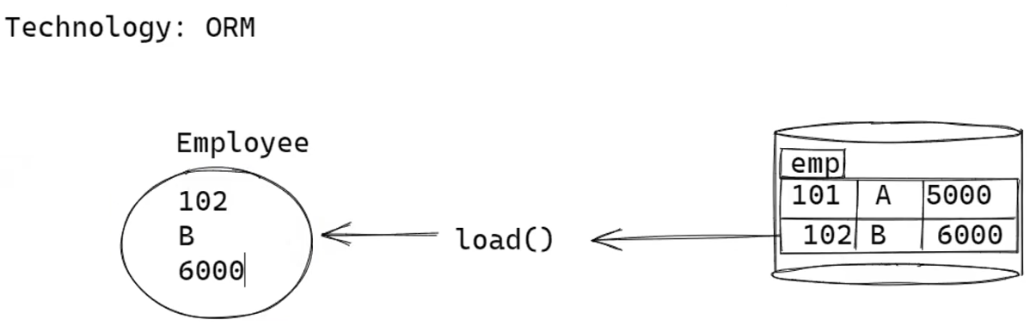
ORM tools are used to transfer the Java objects between our Java Application and a Database.

What is Hibernate?
- Hibernate is an open-source ORM framework which can transfer objects between our Java application and a Database. (both SQL & NoSQL).
- Hibernate is an ORM tool from JBoss Community. JBoss is an internal part of RedHat.
- There are multiple ORM tools from different vendors like TopLink, MyBatis, ORMLite, DataNucleus.
- But Hibernate is the most popularly used ORM Framework.

Framework
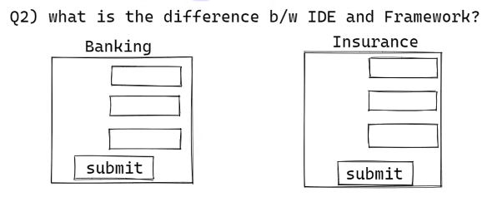
- IDE doesn't provide any libraries to reduce the code. But it helps to complete the code faster.
- Framework provides a set of libraries for the common functionalities of a Java Project. So it reduces almost 50% of the code by the developer.
- We use IDE to develop the applications using frameworks.
For ex:
- STRUTS -- is a framework to develop web applications/presentation layer of an enterprise application.
- HIBERNATE -- is a framework to develop Data Access layer/persistence layer of an enterprise applications.
- SPRING -- is a framework to develop all presentation/business/persistence layers of an enterprise application.
***Nowadays a Java Developer has to learn Spring and Hibernate frameworks to develop the real-time enterprise applications.

What is JPA?
- JPA -- Java Persistence API Initially, multiple vendors provided ORM tools
- to make Object model and Relational model to work together.
- When developers are switching from one ORM tool to another, they have faced issues.
- So to allow, developers to switch easily from one ORM tool to another, Sun Microsystems provided
- a common specification for the developers called JPA.
- For the JPA specification, the ORM tool vendors provided implementation.
- Most of the JPA specification is created by taking the features from Hibernate and some features from TopLink.
- We call the ORM tools who provided implementation for the JPA as JPA vendors/JPA providers.
Q) What is the difference writing the DAO classes directly using Hibernate and using JPA?
- 1. If we write the DAO classes directly using Hibernate then whenever if we want to switch to another ORM tool, all the DAO classes must be modified.
- If we write the DAO classes using JPA then whenever if we want to switch to another ORM tool, Just we only need to modify the project configuration file.

Features of Hibernate?

HQL(Hibernate Query Language)
- select * from emp SQL
- select * from Employee e HQL

- select empNo, ename from emp SQL
- select e.employeeNo, e.employeeName frpm Employee e HQL

- It is the own query language of Hibernate.
- Hibernate has provided HQL to make the DAO classes.
- SQL queries are database-dependent and HQL queries are database-independent.
- HQL doesn’t provide any burden on the developer, because HQL HQL queries are also looks like SQL queries only.
- In SQL query, we use column names and table names. But in HQL query, we use variables names and class reference.

Cashing
- caching improves the performance of an application by loading the objects from cache memory.
- In Hibernate, 2 levels cache can be used
- Level-1
- Level-2
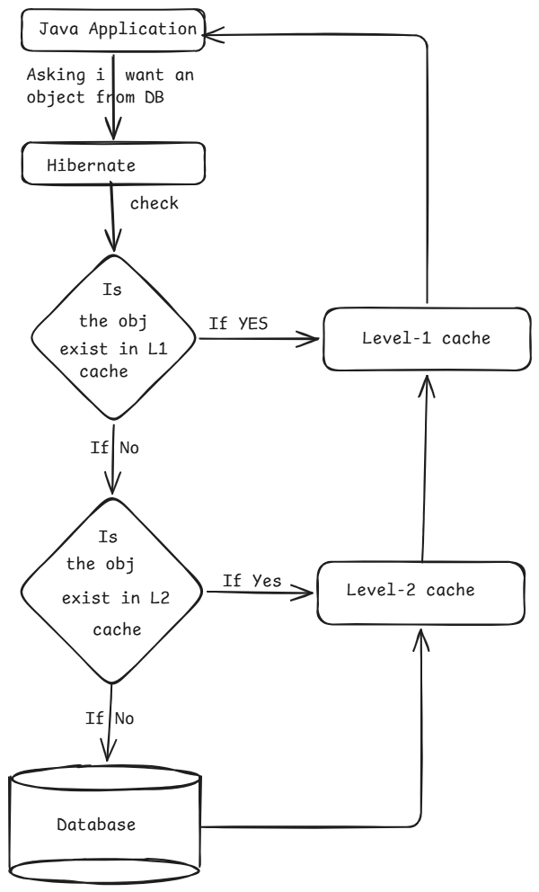

Lazy Loading
- When a Java application is asking for an object, the Hibernate will create a proxy object and returns it to the application without loading it from a cache/database.
- When application is accessing the proxy object then hibernate will load the real object from the database.
- By doing this, Hibernate will reduce the round trips b/w an application and a database.

Connection Polling
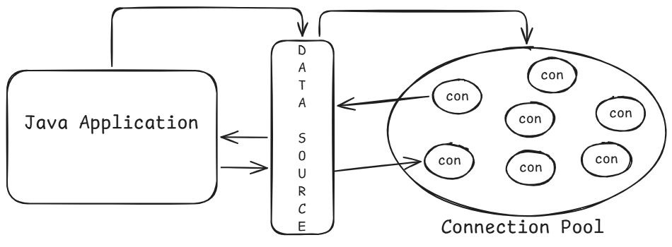
- Hibernate has a built-in connection pooling mechanism, where it creates a pool when application is started, maintains it, and destroys the pool when application is shutdown.

select * from emp;
select empno, ename, sal, deptno from emp;
- To get the same data from database, we can write different queries. But a query which returns the data fastly is important.
- In hibernate, criteria API is provided to create tuned queries. So an application will fetch the data fastly from DB and hence the performance is improved.

Locking
- By default, multiple transactions can work on the same data concurrently.
- When multiple transactions are working on the same data concurrently, one transactions made changes can be overridden by another transactions.
- To prevent it, Hibernate has provided locking.
- Two types locking can be used when multiple transactions are working on the same data.
- Optimistic locking
- Pessimistic locking

Associations
- Hibernate supports associations/relationships.
- One-to-many
- Many-to-one
- Many-to-many
- One-to-one

Files required for the first application
- POJO class
- Mapping file( *.hbm.xml)
- Configuration file(hibernate.cfg.xml)
- Client program

POJO class(Plain Old Java Object)
- A java class which does not extend or which does not implement any class/interface from any API except java.io.Serializable is called as a POJO class.

class A { // POJO class
// variables
// methods
}

Java Bean
- A class which follows the below rules can be called as Jaba Bean class.
- Class must be public.
- Class must contain default constructor/parameter-less constructor.
- Private members should contain setter/getter methods.
- Class can implement Serializable interface.
Hint: Every java bean class is a POJO class. But every POJO class is not a java bean class.

Mapping File
- Mapping file is used to map a java class with a database table and java class variables with table columns.
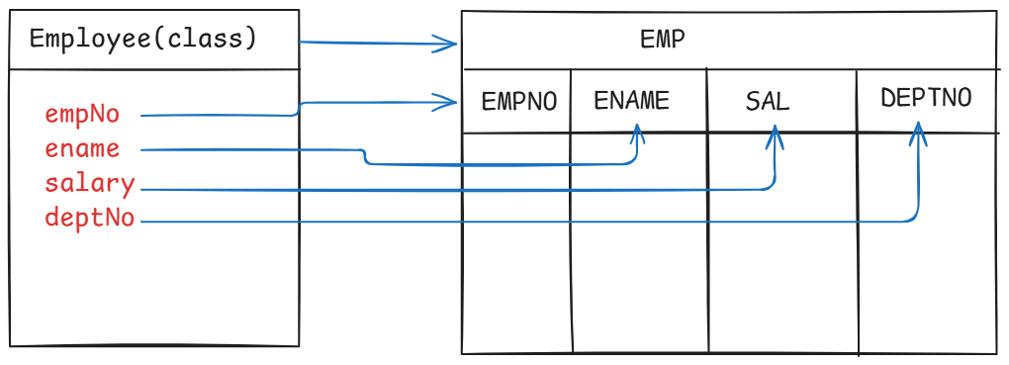
- Mapping can be done in 2 ways.
- xml file
- annotations(JPA).
employee.hbm.xml
<hibernate-mapping>
<class name="com.example.Employee" table="EMP">
<id name="empNo" column = "EMPNO"/>
<property name="ename" column="ENAME"/>
<property name="salary" column ="SAL"/>
<property name="deptNo" column ="DEPTNO"/>
</class>
</hibernate-mapping>

Configuration file:
- configuration file is for the configuring the below things.
- Connection properties
- Hibernate properties.
- Mapping files.
<hibernate-configuration>
<session-factory>
<property name="hibernate.connection.driver_class">com.mysql.cj.jdbc.Driver</property>
<property name="hibernate.connection.url">jdbc:mysql://localhost:3306/databaseName</property>
<property name="hibernate.connection.username">root</property>
<property name="hibernate.connection.password">password</property>
<property name="hibernate.dialect">org.hibernate.dialect.MySQLDialect</property>
<property name="hibernate.show_sql">true</property>
<property name="hibernate.format_sql">true</property>
<property name="hibernate.hbm2ddl.auto">create</property>
<mapping file=”employee.hbm.xml”/>
</session-factory>
</hibernate-configuration>

  - Steps to write the client program
- Create SessionFactory object.
- Create Session object.
- Create Transaction object.
- Perform CRUD operations.
- Commit/rollback the transaction.
- Close the session.
- Close the session factory.
- High-level object in Hibernate is SessionFactory object.
- SessionFactory object holds the configuration metadata.
- SessionFactory object is factory for creating Session objects.
- When a Session is created, a connection with a database is established.
- A Session object is the main runtime object is created for each request.
- In real-time applications, a session object is created for each request.
- A Session object can be used to create a Transaction object.
- In Hibernate, Transaction is mandatory to perform insert/update/delete operations. For select operation it is optional.
- End the transaction with commit/rollback.
- If no more operations are required then close the session.
- If no more sessions are required, then close the session factory object.
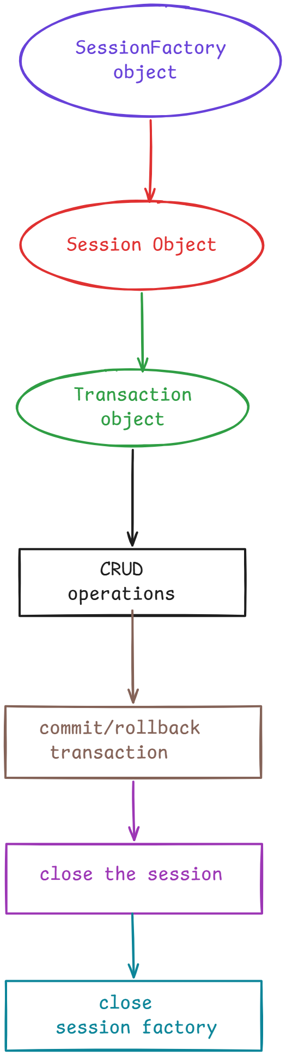

  - Some information about Maven
- Maven is a build tool from Apache, it will automate the build process of java application.
- Build process means, creating the project structure, adding the jars to project classpath, compiling the source code, compiling and executing the test cases, packaging the project to a jar/war file.
- Visit maven.apache.org and download zip fil and extract the zip file.
- Copy the path up to bin of maven and add it the path variable(System variable).
- Verify the maven setting, open CMD and execute the command. mvn –version
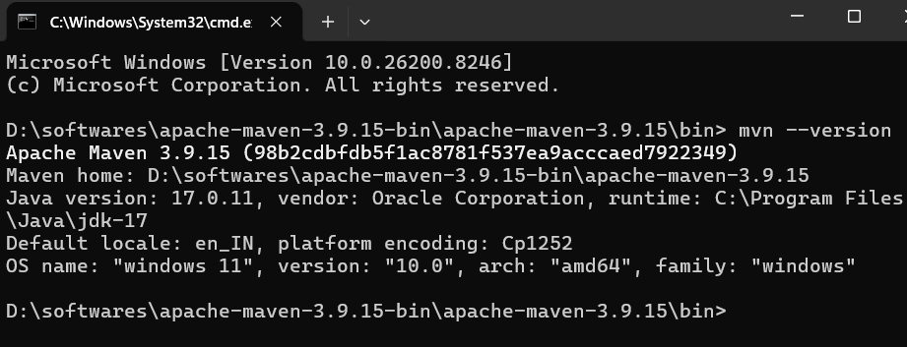

Maven build tool:
- For creating maven projectswe have archtetypes/templates
- Simple java project use archetype as maven-archetype-quickstart.
- Web app project use archetype as maven-archetype-webapp.

Maven project co-ordinates:
- Groupid: a unique id to identify a group of project of a client.
- artifactId: project name.
- version: project version.
- The main file in maven project is pom.xml(project object model).
- Mainly in pom.xml, you have to configure the dependencies(jars).
- Maven will download the jars from maven central repository and will store them into local repository.
- The location of local repository is:
C:\Users\muham\.m2\repository
- In pom.xml, we write the dependency tag like below.
<dependency>
<groupId>org.hibernate.orm</groupId>
<artifactId>hibernate-core</artifactId>
<version>8.0.0.Final</version>
<scope>compile</scope>
</dependency>
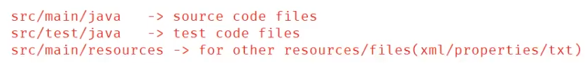

First application project structure:
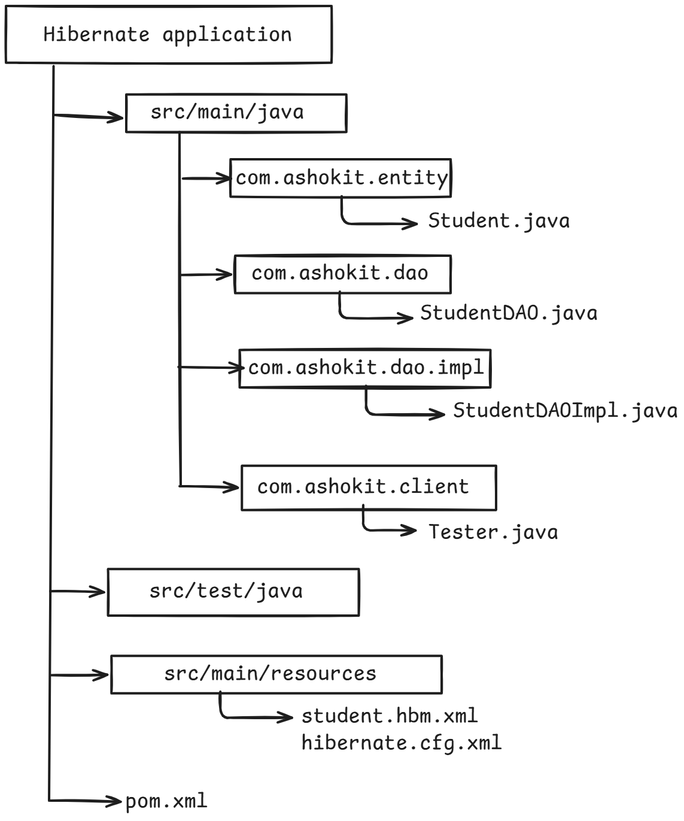

hibernate.hbm2ddl.auto :
- create
- update
- create-drop
- validate(default)

- create : Hibernate drops the existing tables, creates new tables in DB to perform operations.
<property name="hibernate.hbm2ddl.auto">create</property>
- update: Hibernate uses existing tables to perform operations.
- Create-drop: hibernate creates new tables to perform operations and drops the table at the end of the application. Mostly used in unit testing.
- Validate: Hibernate validates the tables and columns in the Database. If a table and column does not exist, it will throw an exception. This is the default value of this property.

Level-1 cache
Session new_session = factory.opensession();
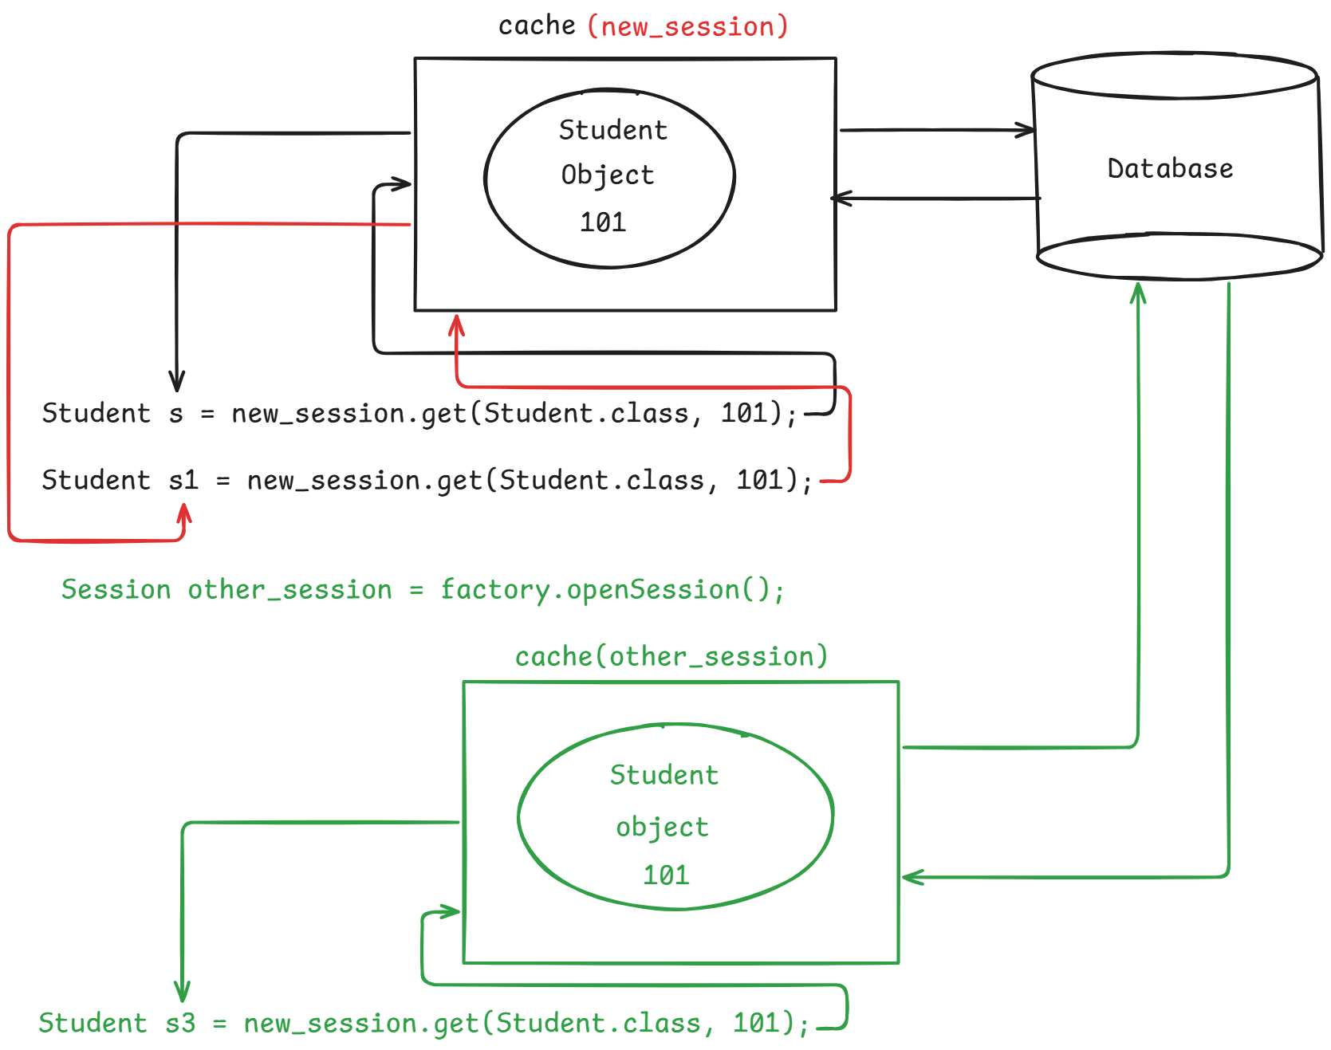
- Every session object of hibernate has its own cache.
- Whenever a session object is created, automatically its cache is also created. When a session is closed its cache is also closed.
- You don’t have to properties to enable/disable this level1 cache. It is also called as session-level cache or L1 cache or Local cache.
- When an application is trying to fetch an object from Database, hibernate will first search for that object in cache memory. If exists then object is returned from cache itself.
- If not exist then Hibernate loads the object from Database then stores it in the cache then returns the object to the application.
- One session can’t use the cache of another session.

Q) how many times Hibernate hits the database for the below code.
Student s1 = session.get(Student.class, 11011);
Student s2 = session.get(Student.class, 22022);
Student s3 = session. get(Student.class, 11011);
Student s4 = session2.get(Student.class, 11011);
Answer) 3 times.
Note: we can not delete a cache explicitly. It is removed when session is closed.
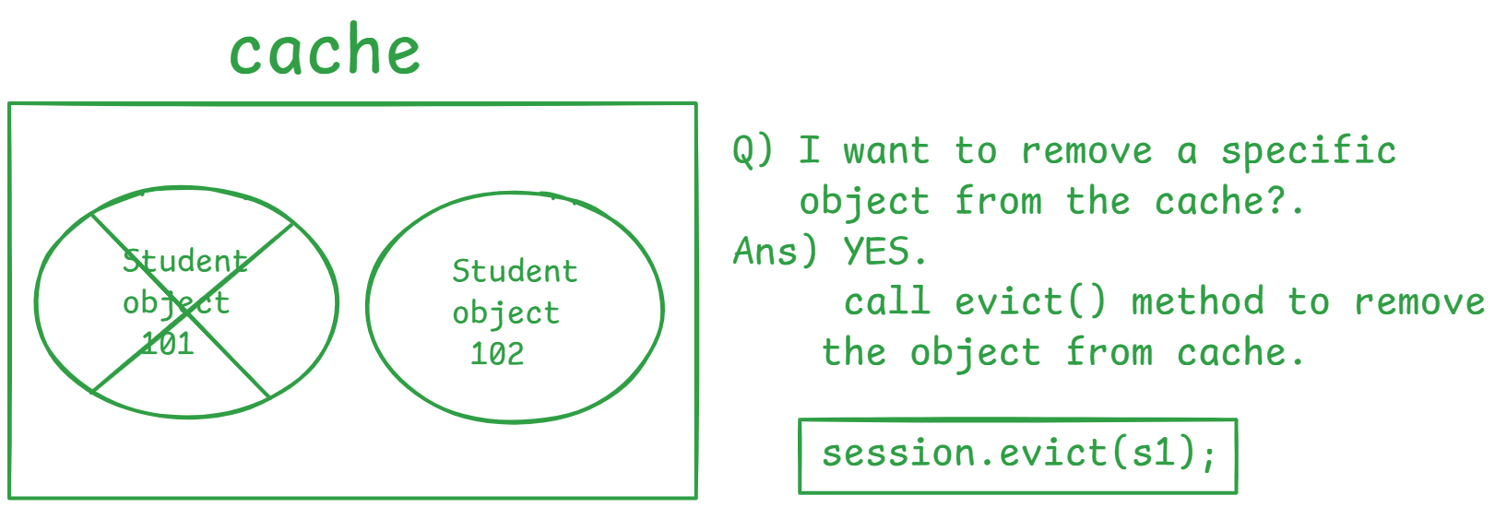
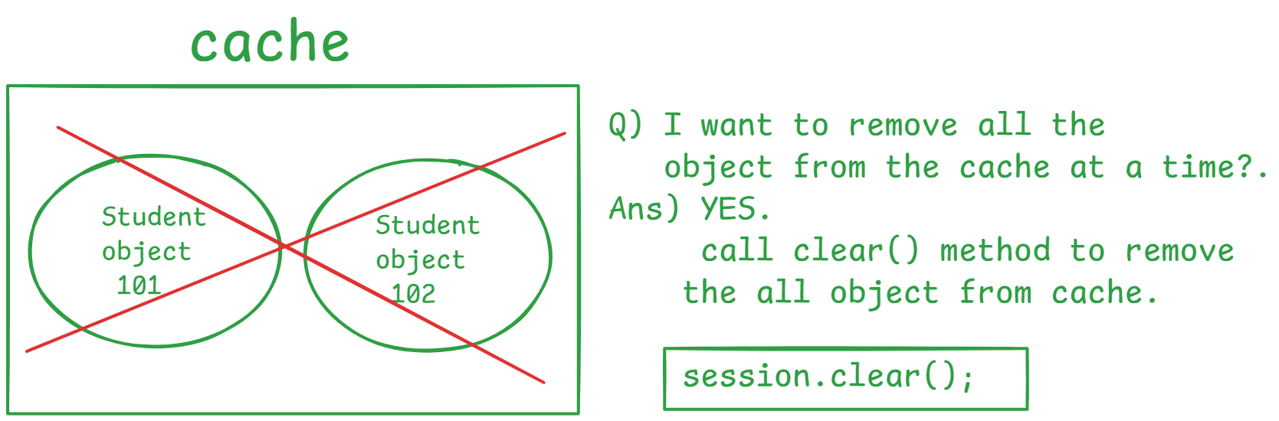

What is drawback of the cache?
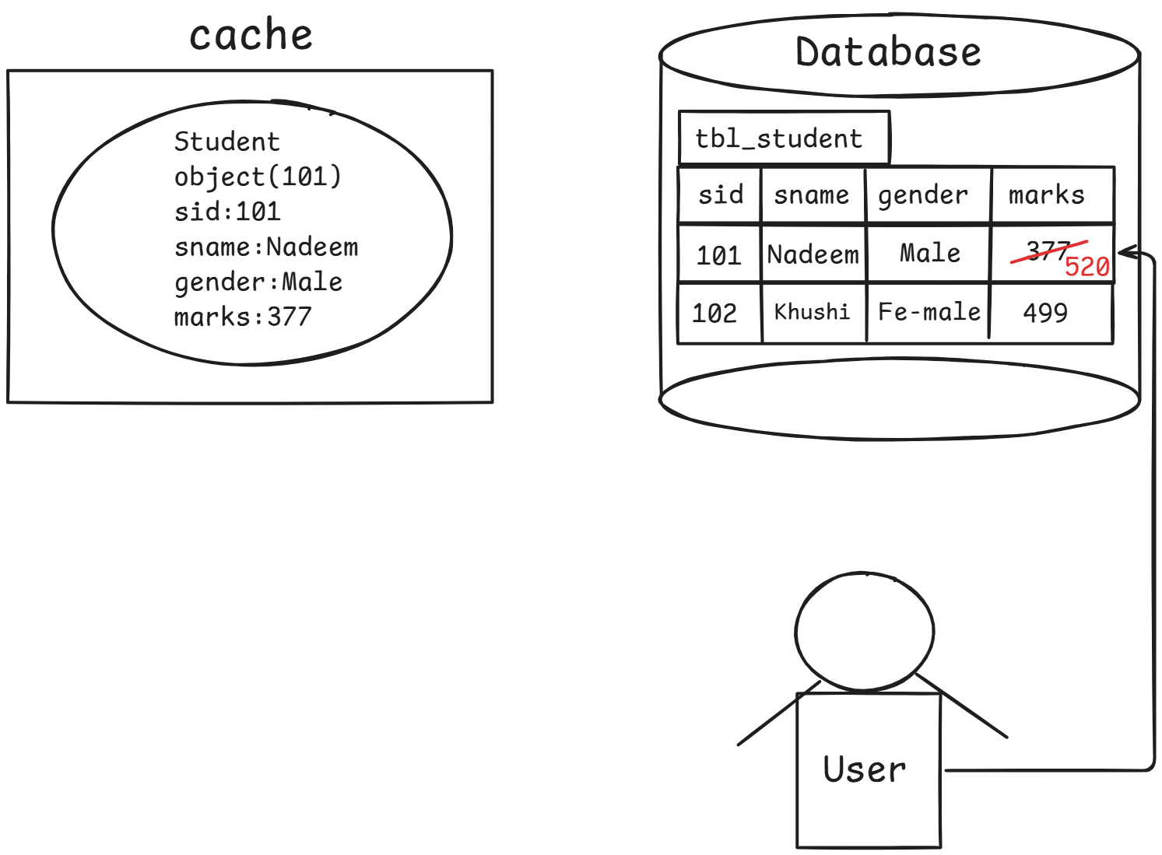
If any changes are made to the object in Database, they are not reflected in cache automatically. This is called drawback.
Solutions: You have to explicitly refresh the cache for every time
Interval to make the object in cache are in sync with database.

JPA annotations for mapping:
@Entity:- It will declare that a POJO class is an Entity class.
@Table:- It is used to map a POJO class with a table in the Database.
@Id:- It is used to map a variable in our java class with primary key column in a table.
@Column:- It is used to map a variable with a column in the table.

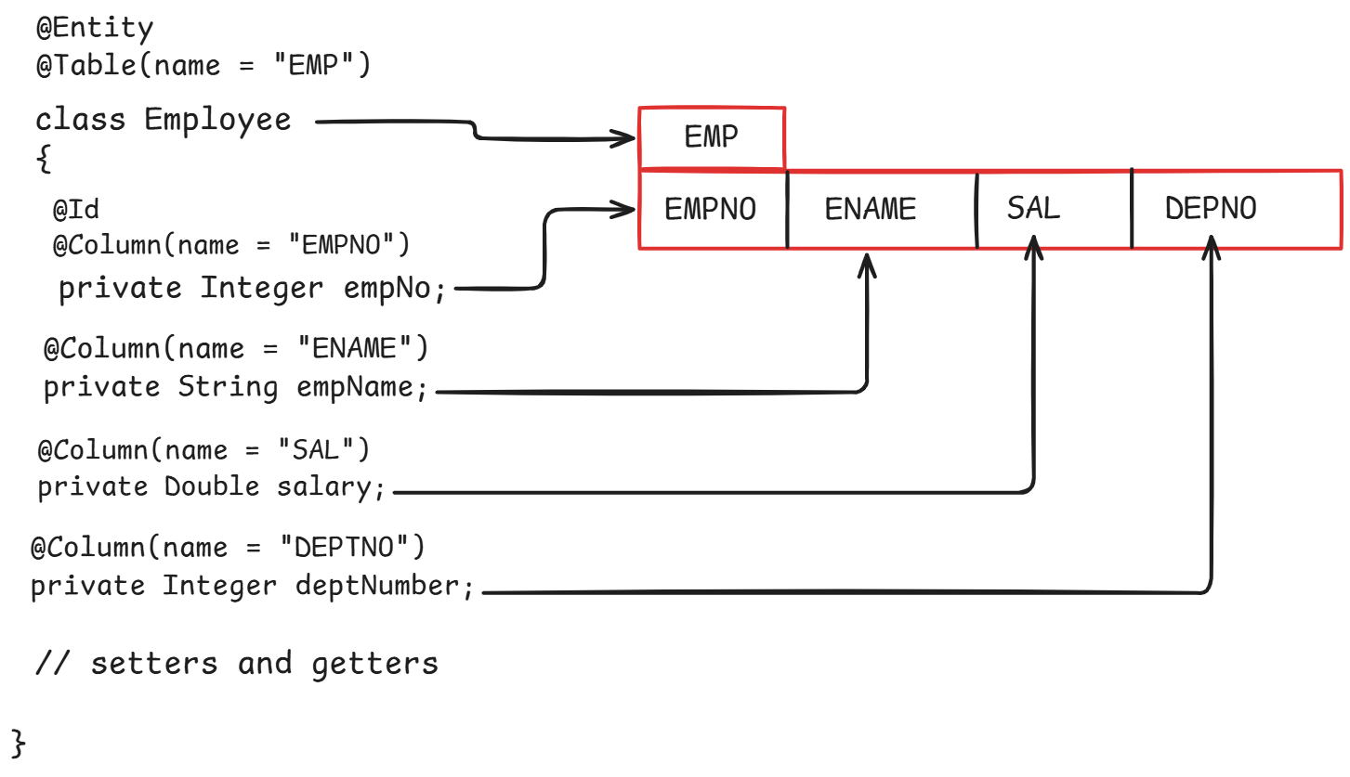
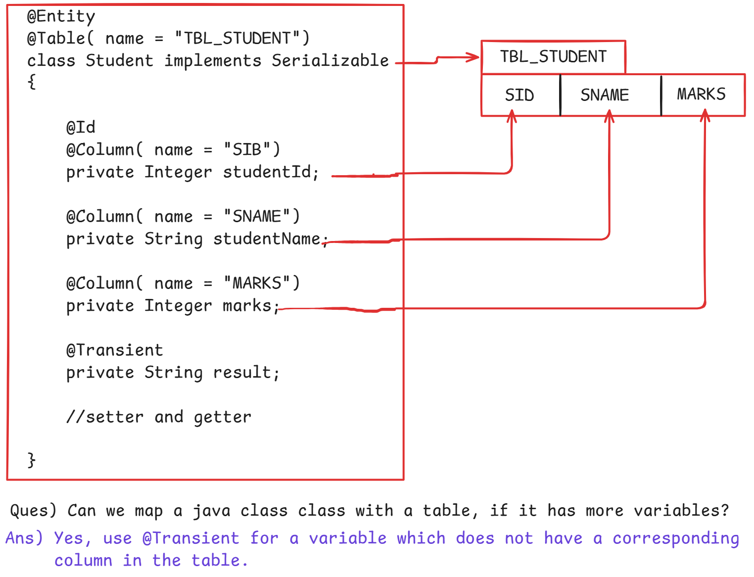
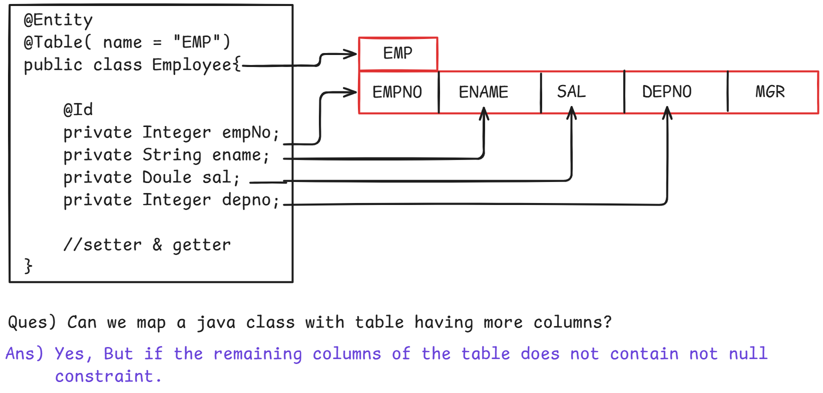
- While working with JPA and Hibernate, we have to create persistence.xml file under META-INF.
- This META-INF directory must be created under src/main/resources folder.

Write an application to perform CRUD operations using Hibernate/JPA.
<!-- Hibernate Dependency-->
<dependency>
<groupId>org.hibernate</groupId>
<artifactId>hibernate-core</artifactId>
<version>5.6.15.Final</version>
</dependency>

<dependency>
<groupId>org.hibernate</groupId>
<artifactId>hibernate-entitymanager</artifactId>
<version>5.2.17.Final</version>
</dependency>

<!-- JPA dependecies-->
<dependency>
<groupId>org.hibernate.javax.persistence</groupId>
<artifactId>hibernate-jpa-2.1-api</artifactId>
<version>1.0.2.Final</version>
</dependency>

<!-- MySQL database dependency-->
<dependency>
<groupId>com.mysql</groupId>
<artifactId>mysql-connector-j</artifactId>
<version>8.3.0</version>
</dependency>

package in.nadeem.entity;

import java.time.LocalDateTime;

import javax.persistence.Column;
import javax.persistence.Entity;
import javax.persistence.Id;
import javax.persistence.Table;

import org.hibernate.annotations.CreationTimestamp;
import org.hibernate.annotations.UpdateTimestamp;

@Entity
@Table(name = "tbl_products")
public class ProductEntity {

@Id
@Column(name = "product_id")
private Integer productId;

@Column(name = "product_name")
private String productName;

private Integer quantity;

@Column(name = "unit_price")
private Double unitPrice;

@Column(name = "CREATED_ON")
@CreationTimestamp
private LocalDateTime createdOn;

@Column(name = "LASTUPDATED_ON")
@UpdateTimestamp
private LocalDateTime updatedOn;

// Setter & Getters

@Override
public String toString() {
return "ProductEntity [productId=" + productId + ", productName=" + productName + ", quantity=" + quantity
+ ", unitPrice=" + unitPrice + ", createdOn=" + createdOn + ", updatedOn=" + updatedOn + "]";
}
}

package in.nadeem.dao;

import in.nadeem.entity.ProductEntity;

public interface ProductDAO {

ProductEntity insertProduct(ProductEntity productEntity);

ProductEntity loadProductById(Integer productId);

ProductEntity updateProductById(Integer productId, Double new_Unit_Price);

public void deleteProductById(Integer productId);
}

package in.nadeem.dao.impl;

import javax.persistence.EntityManager;
import javax.persistence.EntityManagerFactory;
import javax.persistence.EntityTransaction;
import javax.persistence.Persistence;

import in.nadeem.dao.ProductDAO;
import in.nadeem.entity.ProductEntity;

public class ProductDAOImpl implements ProductDAO {

private EntityManagerFactory factory = Persistence.createEntityManagerFactory("test");

@Override
public ProductEntity insertProduct(ProductEntity product) {
EntityManager entityManager = factory.createEntityManager();
EntityTransaction transaction = entityManager.getTransaction();
transaction.begin();
try {
entityManager.persist(product);
transaction.commit();
System.out.println("Product is inserted to the Database....!!!");
} catch (Exception e) {
transaction.rollback();
System.out.println("Error in inserting a product" + e);
} finally {
entityManager.close();
}
return product;
}

@Override
public ProductEntity loadProductById(Integer productId) {
EntityManager entityManager = factory.createEntityManager();
/*
* find() : early load getRefrence() : lazy load
*/
ProductEntity productEntity = entityManager.find(ProductEntity.class, productId);

entityManager.close();
return productEntity;
}

@Override
public ProductEntity updateProductById(Integer productId, Double new_Unit_Price) {

EntityManager entityManager = factory.createEntityManager();
ProductEntity productEntity = entityManager.find(ProductEntity.class, productId);
EntityTransaction transaction = entityManager.getTransaction();
transaction.begin();
productEntity.setUnitPrice(new_Unit_Price);
transaction.commit();
entityManager.close();

return productEntity;
}

@Override
public void deleteProductById(Integer productId) {

EntityManager entityManager = factory.createEntityManager();
ProductEntity productEntity = entityManager.find(ProductEntity.class, productId);
EntityTransaction transaction = entityManager.getTransaction();
transaction.begin();
try {
entityManager.remove(productEntity);
transaction.commit();
System.out.println("Record Based on id deleted succcessfully....!!");
} catch (Exception e) {
transaction.rollback();
System.out.println("Record did not deleted...Invalid operation");
} finally {
entityManager.close();
}
}

}

package in.nadeem.client;

import in.nadeem.dao.ProductDAO;
import in.nadeem.dao.impl.ProductDAOImpl;
import in.nadeem.entity.ProductEntity;

public class Tester {

public static void main(String[] args) {

ProductDAO dao = new ProductDAOImpl();

// insert Product record

ProductEntity productEntity = new ProductEntity();
productEntity.setProductId(101);
productEntity.setProductName("Mouse");
productEntity.setQuantity(15);
productEntity.setUnitPrice(1000.0);

// call insertProduct() from DAO class
dao.insertProduct(productEntity);

//load(fetch) record based on id
ProductEntity productById = dao.loadProductById(102);
System.out.println("Fetched Record: Successfully :: " + productById);

// updated the record
ProductEntity updateProductById = dao.updateProductById(101, 1500.0);
System.out.println(updateProductById);

// deleted the record
dao.deleteProductById(104);

}
}

<?xml version="1.0" encoding="UTF-8"?>

<persistence xmlns="http://java.sun.com/xml/ns/persistence"
xmlns:xsi="http://www.w3.org/2001/XMLSchema-instance"
xsi:schemaLocation="
http://java.sun.com/xml/ns/persistence
http://java.sun.com/xml/ns/persistence/persistence_2_0.xsd"
version="2.0">

<persistence-unit name="test"
transaction-type="RESOURCE_LOCAL">

<!-- Persistence Provider -->
<provider>
org.hibernate.jpa.HibernatePersistenceProvider
</provider>

<!-- Entity Class -->
<class>in.nadeem.entity.ProductEntity</class>

<properties>

<!-- JDBC Configuration -->
<property name="javax.persistence.jdbc.driver"
value="com.mysql.cj.jdbc.Driver" />

<property name="javax.persistence.jdbc.url"
value="jdbc:mysql://localhost:3306/test" />

<property name="javax.persistence.jdbc.user" value="root" />

<property name="javax.persistence.jdbc.password"
value="Faeem@2004" />

<!-- Hibernate Properties -->
<property name="hibernate.dialect"
value="org.hibernate.dialect.MySQL5Dialect" />

<property name="hibernate.hbm2ddl.auto" value="update" />

<property name="hibernate.show_sql" value="true" />

<property name="hibernate.format_sql" value="true" />

</properties>

</persistence-unit>

</persistence>

May 09, 2026 1:27:33 PM org.hibernate.jpa.internal.util.LogHelper logPersistenceUnitInformation
INFO: HHH000204: Processing PersistenceUnitInfo [name: test]
May 09, 2026 1:27:33 PM org.hibernate.Version logVersion
INFO: HHH000412: Hibernate ORM core version 5.6.15.Final
May 09, 2026 1:27:34 PM org.hibernate.annotations.common.reflection.java.JavaReflectionManager <clinit>
INFO: HCANN000001: Hibernate Commons Annotations {5.1.2.Final}
May 09, 2026 1:27:34 PM org.hibernate.engine.jdbc.connections.internal.DriverManagerConnectionProviderImpl configure
WARN: HHH10001002: Using Hibernate built-in connection pool (not for production use!)
May 09, 2026 1:27:34 PM org.hibernate.engine.jdbc.connections.internal.DriverManagerConnectionProviderImpl buildCreator
INFO: HHH10001005: using driver [com.mysql.cj.jdbc.Driver] at URL [jdbc:mysql://localhost:3306/test]
May 09, 2026 1:27:34 PM org.hibernate.engine.jdbc.connections.internal.DriverManagerConnectionProviderImpl buildCreator
INFO: HHH10001001: Connection properties: {password=****, user=root}
May 09, 2026 1:27:34 PM org.hibernate.engine.jdbc.connections.internal.DriverManagerConnectionProviderImpl buildCreator
INFO: HHH10001003: Autocommit mode: false
May 09, 2026 1:27:34 PM org.hibernate.engine.jdbc.connections.internal.DriverManagerConnectionProviderImpl$PooledConnections <init>
INFO: HHH000115: Hibernate connection pool size: 20 (min=1)
May 09, 2026 1:27:35 PM org.hibernate.dialect.Dialect <init>
INFO: HHH000400: Using dialect: org.hibernate.dialect.MySQL5Dialect
May 09, 2026 1:27:36 PM org.hibernate.resource.transaction.backend.jdbc.internal.DdlTransactionIsolatorNonJtaImpl getIsolatedConnection
INFO: HHH10001501: Connection obtained from JdbcConnectionAccess [org.hibernate.engine.jdbc.env.internal.JdbcEnvironmentInitiator$ConnectionProviderJdbcConnectionAccess@67514bdd] for (non-JTA) DDL execution was not in auto-commit mode; the Connection 'local transaction' will be committed and the Connection will be set into auto-commit mode.
May 09, 2026 1:27:36 PM org.hibernate.engine.transaction.jta.platform.internal.JtaPlatformInitiator initiateService
INFO: HHH000490: Using JtaPlatform implementation: [org.hibernate.engine.transaction.jta.platform.internal.NoJtaPlatform]
Hibernate:
insert
into
tbl_products
(CREATED_ON, product_name, quantity, unit_price, LASTUPDATED_ON, product_id)
values
(?, ?, ?, ?, ?, ?)
Product is inserted to the Database....!!!
Hibernate:
select
productent0_.product_id as product_1_0_0_,
productent0_.CREATED_ON as created_2_0_0_,
productent0_.product_name as product_3_0_0_,
productent0_.quantity as quantity4_0_0_,
productent0_.unit_price as unit_pri5_0_0_,
productent0_.LASTUPDATED_ON as lastupda6_0_0_
from
tbl_products productent0_
where
productent0_.product_id=?
Fetched Record: Successfully :: ProductEntity [productId=102, productName=Phone, quantity=10, unitPrice=30000.0, createdOn=2026-05-09T13:15:46, updatedOn=2026-05-09T13:15:46]
Hibernate:
select
productent0_.product_id as product_1_0_0_,
productent0_.CREATED_ON as created_2_0_0_,
productent0_.product_name as product_3_0_0_,
productent0_.quantity as quantity4_0_0_,
productent0_.unit_price as unit_pri5_0_0_,
productent0_.LASTUPDATED_ON as lastupda6_0_0_
from
tbl_products productent0_
where
productent0_.product_id=?
Hibernate:
update
tbl_products
set
CREATED_ON=?,
product_name=?,
quantity=?,
unit_price=?,
LASTUPDATED_ON=?
where
product_id=?
ProductEntity [productId=101, productName=Mouse, quantity=15, unitPrice=1500.0, createdOn=2026-05-09T13:27:37, updatedOn=2026-05-09T13:27:37.162226400]
Hibernate:
select
productent0_.product_id as product_1_0_0_,
productent0_.CREATED_ON as created_2_0_0_,
productent0_.product_name as product_3_0_0_,
productent0_.quantity as quantity4_0_0_,
productent0_.unit_price as unit_pri5_0_0_,
productent0_.LASTUPDATED_ON as lastupda6_0_0_
from
tbl_products productent0_
where
productent0_.product_id=?
Hibernate:
delete
from
tbl_products
where
product_id=?
Record Based on id deleted succcessfully....!!

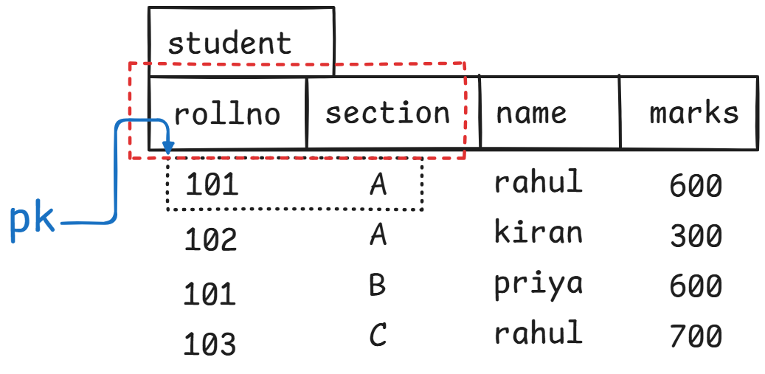
- Composite primary key: combination of columns as a primary key.
- To work with composite id in JPA, we have to create two classes.
- Embeddable class
- Entity class.
- Embeddable class should contain the variables to map with composite primary key columns. This class must implement Serializable interface.
Embeddable Project Link: D:\AshokIT-All-Code\hibernate-7am\workspace\03-Embeddable-App

Entity states in JPA/Hibernate
- Transient state
  - Whenever a new object is created for an entity class then that entity will be in transient state.
ProductEntity productEntity = new ProductEntity();
productEntity.setProductId(101);
productEntity.setProductName("Mouse");
productEntity.setQuantity(15);
productEntity.setUnitPrice(1000.0);

- Persistent state
- Detached state.

- After setting the data to the database. Now the entity is in persistent state
- When entity manager is closed or when cleared an object is detached then the entity enters into detached state.
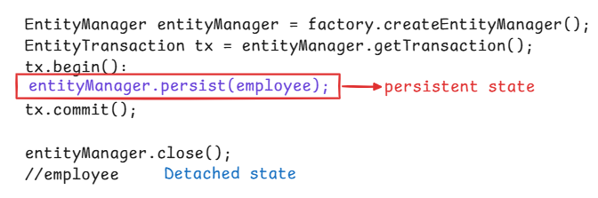
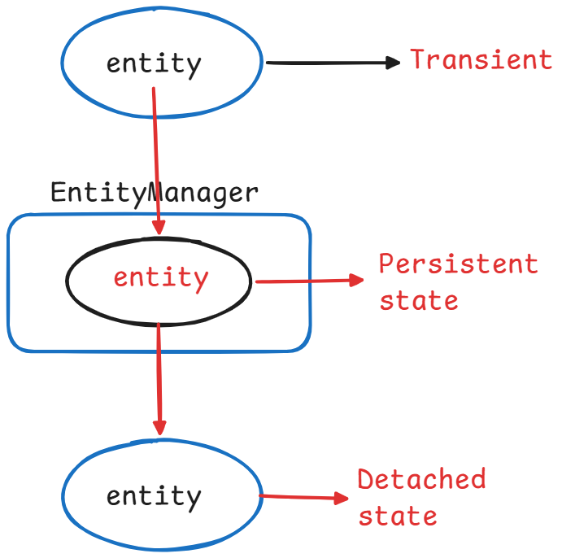

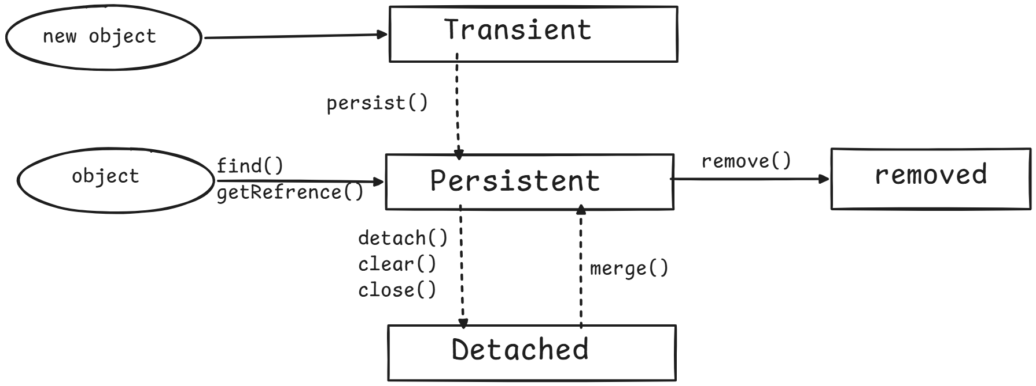
Project over types of states.
D:\AshokIT-All-Code\hibernate-7am\workspace\04-JPA-TypesOfStates-App

Writing JPQL queries.
- JPQL Java Persistence Query Language.

Question:- suppose I’m calling find() method then how many objects can be loaded at a time from the database?
Answer:- One Object.

Question:- Suppose I am calling remove() method then how many objects can be removed at a time from the database.
Answer:- one object.

Question:- How can I load or update or delete multiple objects or bulk objects at time from the Database?
Answer:- Use JPQL & SQL queries.

- JPQL queries are database-independent & SQL queries are Database-dependent.
- When we write a JPQL query, it will be converted to SQL query with respect to the underlying database by the JPA provider(Hibernate).
- JPQL looks like SQL, but in place of table name provide entity class reference variable and in place of column names, provide variable names.

Examples:
SQL query select * from emp;
JPQL query select emp from EmployeeEntity emp;
(Or)
From EmployeeEntity emp;

Examples2:-
SQL query : select ename, sal from emp;
JPQL query: select emp.empName, emp.salary from EmployeeEntity emp;

Examples3:-
SQL Query select * from emp where sal > ?;
JPQL Query: select emp from EmployeeEntity emp where e.salary > ?1;
(or)
From EmployeeEntity e where e.salary > ?1;

