Core java notes

instance variables
- Variables which are declared inside the class and outside the method are called as instance variables
- instance variables can be accessed by all the methods available in the class
- Initialization is optional for instance variables
- Instance variables are called as Object variables
- When we create the object, memory will be allocated for instance variables
- If we don't initialize instance variable, it will be initialized with default value when the object is created.

public class Student {

public static void main(String[] args) {
System.out.println("Hi, i am a student");

Student s1 = new Student();
s1.hello();

Student.greet();

void hello() {
System.out.println("Hello My Friend ... ");
}
static void greet() {
System.out.println("Good Evening .. ");
}
}

- Methods are divided into 2 types

1) instance methods --- > Object level methods
2) static methods ---- > Class level method

- instance method will be called by using Object
- static method will be called by using Class
- When we write methods in java class, by default JVM will not execute them.

Note: JVM will start our program execution from main method. Main method is called as entry point for JVM execution.

- Every method contains 2 parts

1) Method Declaration
2) Method Body

What is Method Declaration ?
method declaration means we are going to decide what is the name of method
will take and what kind of value is return by the method.

syntax:
returntype methodname (list of parameters);

What is returntype ?
- returntype is data type that indicates what type of value is return by the particular method.
- returntype can be any primitive type or array type or reference type
- if method does not return any value then return type must be specified using a java keyword called " void ".
- specifying returntype is mandatory

//lecture - 35
// Take Product class with productld, productName, productPrice
// Create Driver class with print ( ) method to print product data

package in.nadeem.instanceVariable2;

class Product {

int productId = 101;
String productName = "Laptop";
double productPrice = 50000.0;
}
public class Driver {

void printProductData(Product product) {
System.out.println("Product ID: " + product.productId);
System.out.println("Product Name: " + product.productName);
System.out.println("Product Price: " + product.productPrice);
}

public static void main(String[] args) {

Driver d = new Driver();
Product p = new Product();
d.printProductData(p);
}
}
package in.nadeem.instanceVariable1;

class Employee {
int empId;
String empName;
double empSal;
}

public class Driver {

public void printEmp(Employee emp) {
System.out.println("Employee ID :" + emp.empId + " , " + "Employee Name : " + emp.empName + " , "
+ "Employee Salary : " + emp.empSal);
}

public static void main(String[] args) {

Driver d = new Driver();

Employee emp = new Employee();
emp.empId = 101;
emp.empName = "Ahmad";
emp.empSal = 15000.00;

d.printEmp(emp);
}
}

package in.nadeem.instanceVariable1;

class Employee {
int empId;
String empName;
double empSal;
}

public class Driver {

public void printEmp(Employee emp) {
System.out.println("Employee ID :" + emp.empId + " , " + "Employee Name : " + emp.empName + " , "
+ "Employee Salary : " + emp.empSal);
}

public static void main(String[] args) {

Driver d = new Driver();

Employee emp = new Employee();
emp.empId = 101;
emp.empName = "Ahmad";
emp.empSal = 15000.00;

d.printEmp(emp);
}
}

package in.nadeem.instanceVariable3;

class Person {
int id;
String name;
int age;
}

public class Driver {

public void print(Person p) {
System.out.println(p.id + "--" + p.name + "--" + p.age);
}

public static void main(String[] args) {
Driver d = new Driver(); // object creation

Person p = new Person();
p.id = 201;
p.name = "Raja";
p.age = 24;

d.print(p);
}
}

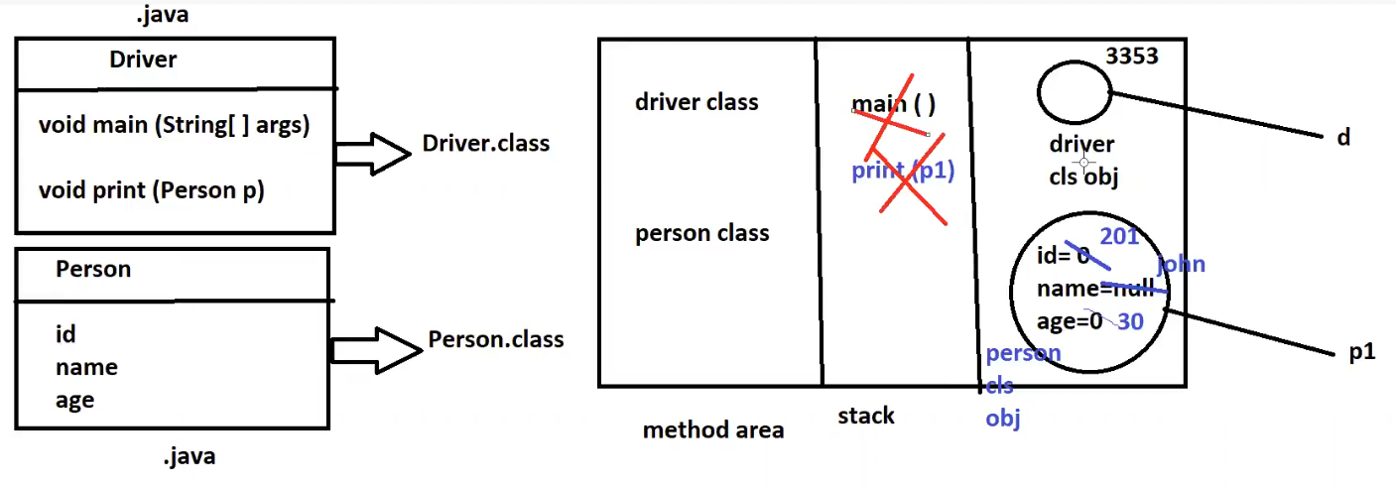
Write a java method which will give Person Object with data.
package in.nadeem.instanceVariable3;

class Person {
int id;
String name;
int age;
}

public class Driver {

public Person print() {
Person p = new Person();
p.id = 201;
p.name = "Raja";
p.age = 24;
//System.out.println(p.id + "--" + p.name + "--" + p.age);
return p;

}

public static void main(String[] args) {
Driver d = new Driver(); // object creation

Person p = d.print();
System.out.println(p.id + "--" + p.name + "--" + p.age);

}
}
Write a java method to return College Data(id, name).
package in.nadeem.instanceVariable4;

class College {
int id;
String name;
}

public class Driver {

public College getCollegeData() {
College college = new College();
college.id = 101;
college.name = "Nadeem Ahmad";
System.out.println("College ID: " + college.id + " , " + "College Name: " + college.name);
return college;
}

public static void main(String[] args) {

Driver driver = new Driver();
driver.getCollegeData();
}
}

Write a java method which will take id as input, based on id return person data.
package in.nadeem.instanceVariable5;

class Person {
int id;
String name;
int age;
}

public class Driver {

public Person geData(int id) {
Person p = new Person();
if (id == 101) {
p.id = 101;
p.name = "Raju";
p.age = 30;
} else if (id == 102) {
p.id = 102;
p.name = "Rani";
p.age = 32;
}
return p;
}
public static void main(String[] args) {

Driver d = new Driver();
Person person = d.geData(102);
System.out.println(person.id + " -- " + person.name);

}
}
// write a java method which will return player data based on player id.
Player Data -- > id, name, age
7 ---- > Dhoni , 18 --- > Kohli , 45 --- > Rohit Sharma

package in.nadeem.instanceVariable6;

class Player {
int playerId;
String PlayerName;
}

public class Driver {

public Player getData(int id) {

Player p = new Player();
if (id == 7) {
p.playerId = 7;
p.PlayerName = "Dhoni";
} else if (id == 18) {
p.playerId = 18;
p.PlayerName = "Kohli";
} else if (id == 45) {
p.playerId = 45;
p.PlayerName = "Rohit";
}
return p;

}

public static void main(String[] args) {

Driver d = new Driver();

Player player = d.getData(7);
System.out.println(player.playerId + " , " + player.PlayerName);
}

}

// first method should take 2 Person objects as input
package in.nadeem.instanceVariable9;

public class Person {

int id;
String name;

public void getPersons(Person p1, Person p2) {
System.out.println(p1.id + "--" + p1.name);
System.out.println(p2.id + "--" + p2.name);
}

public static void main(String[] args) {

Person p = new Person();

Person p1 = new Person();
p1.id=101;
p1.name="Nadeem";

Person p2 = new Person();
p2.id=102;
p2.name="Ahmad";

p.getPersons(p1, p2);
}
}

// second method should give 3 Person Objects as ouput
package in.nadeem.instanceVariable10;

public class Person {

int id;
String name;

public Person[] getPersons() {

Person p1 = new Person();
p1.id = 101;
p1.name = "Nadeem";

Person p2 = new Person();
p2.id = 102;
p2.name = "Ahmad";

Person p3 = new Person();
p3.id = 103;
p3.name = "Raja";

return new Person[] { p1, p2, p3 };

}

public static void main(String[] args) {

Person p = new Person();

Person[] persons = p.getPersons();

for (Person person : persons) {
System.out.println("Person ID " + person.id + " , " + "Person Name: " + person.name);
}
}
}

Constructor
- It is a special method in java which is used to initialize current class instance variables.
- Constructor name should be same as class name.
- Constructor will not have any return type(not even void).
Note: if we write return type for the constructor then it will become method.
Syntax:
class Demo{
Demo(){
}
}
Demo d = new Demo();
Note: at the time of object creation our class constructor will be executed. Constructor is mandatory to create the object.
Note: if we do not write the constructor then java compiler adding one default constructor to our class.
- We can check default constructor for the class using javap classname
- If we write constructor in the class, then compiler will not add any constructor.
Types of Constructor
- Zero Parameterized Constructor(Default Constructor)
- Parameterized Constructor
This Keyword:
- “this” is a predefined keyword in java.
- It is used to represent current class object.
package in.nadeem.constructor;

public class Employee {

String name;
double salary;

public Employee(String name_, double salary_) {
this.name = name_;
this.salary = salary_;
System.out.println(name + " " + salary);
}

public static void main(String[] args) {
Employee employee = new Employee("Nadeem", 25000);
}
}

package in.nadeem.constructor;

public class Student {

int id;
String name;
int age;
String gender;

public Student(int id_, String name_, int age_, String gender_) {
super();
this.id = id_;
this.name = name_;
this.age = age_;
this.gender = gender_;

System.out.println("Student.Student(int id_, String name_, int age_, String gender_)");

System.out.println(this.id + " " + this.name + " " + this.age + " " + this.gender);
}

public static void main(String[] args) {

Student nadeem = new Student(101, "Nadeem", 24, "Male");
Student ahmad = new Student(102, "Ahmad", 18, "Male");
}
}

Constructor Overloading
- Writing more than one constructor with different parameter is called as Constructor overloading.
package in.nadeem.constructorOverloading;

public class Employee {

String name;
double salary;

public Employee(String name_, double salary_) {
this.name = name_;
this.salary = salary_;
System.out.println(this.name + " " + this.salary);
}

public Employee(String name) {
super();
this.name = name;
System.out.println(this.name + " " + this.salary);
}

public static void main(String[] args) {
Employee employee = new Employee("Nadeem", 25000);

Employee employee2 = new Employee("Ahmad");
}
}

Access Specifiers/modifiers
- These are used to specify accessibility for our classes, variables and methods.

- Public
- Private
- Protected
- Default
public: It is used to specify global access for classes, variables, methods and constructors.
  - We can take class, constructors, methods and variables as public.
private: It is used to specify local access(within the class). private variables, methods, constructors can not be accessed outside of the class.
  - We can not use private as class(not allowed).
  - We can take variables as private.
  - We can take constructor as private(nobody can create object from outside of the class).
  - We can take method as private(nobody can call our methods from outside of the class).
Note: To make our java class as a singleton, we will use private constructor. The java class which is having only one object is called as Singleton class.
protected: Protected members can be accessed in same package and sub classes.
default: default members can be accessed in same package.
Note:
- Only public and default specifiers are allowed for classes. Private and protected are not allowed.
- If we use public for the class name then class name and file name should be same. We should have only one public class in the file.

