Server Setup Guide

Prepared for: Sebestian Hoffmann
Prepared By: Nadeem Yasin

Type: Multi user/projects
Date: 10 July 2012

- Installing some pre-requisite/basic libraries
$: sudo apt-get build-essential
$: apt-get install postgresql libpq-dev

- Settings in Terminal
Go to start menu -> terminal -> edit -> Profile Preferences
Click on the tab highlighted in RED box in image,
and check the check box specified in Red in image.

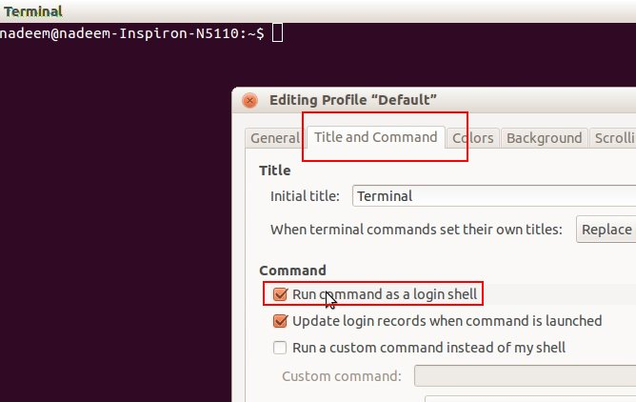
and then click “close”

- RVM setup

Prerequisites
:~$ sudo apt-get install build-essential
:~$ sudo apt-get install zlib1g-dev libreadline-dev libssl-dev libxml2-dev
:~$ sudo apt-get install curl git-core

RVM
:~$ bash -s stable < <(curl -s https://raw.github.com/wayneeseguin/rvm/master/binscripts/rvm-installer)

Now, close your shell/terminal and open a new one and run the following command.

:~$ source ~/.profile

Now open ./profile in any of your favourite editor and put the following line at the end of this file. Then save and close this file.
In my case i will using vim

:~$ vim ~/.profile
:~$ [[ -s "$HOME/.rvm/scripts/rvm" ]] && . "$HOME/.rvm/scripts/rvm"

You can install vim by apt-get package manager, like

:~$ sudo apt-get install vim

Executes the following command, it will read and run the each command in the script:

:~$ . "$HOME/.rvm/scripts/rvm"

Now close this terminal and open a new shell/terminal, and play around with rvm.
Issue the following commands to see the list of known ruby versions and then you can install any version of ruby by just typing the number of that version.
In my case, i will be installing 1.9.2-p320

Install Ruby:

:~$ rvm pkg install zlib
:~$ rvm install 1.9.2-p320

Now issue the following command to see the installed rubies, and then you can switch between any of the ruby version by just telling the version number to RVM, as below.

:~$ rvm list
:~$ rvm use 1.9.2-p320

You Ruby is installed and you can install any number of rubies.

- Creating GEMSETS

This is the beauty of RVM that i like the most, you can create one gemset for each of your project and all of your gems including rails get installed within this gemset. The concept of Gemset is just like an empty folder where you install all of the gems specific to a single application. Remember, rails is also a gem. :)

:~$ rvm use 1.9.2-p320
:~$ rvm gemset create project1
:~$ rvm gemset create project2
:~$ rvm gemset create project3

To view all of the created gemsets, issue the following command

:~$ rvm list gemsets
:~$ rvm use 1.9.2-p320@project1

The last command is telling to RVM that use this particular Ruby version with the gemset with name project1, you can use a gemset even with different versions of rubies without any conflict.

- Installing RAILS

:~$ gem install rails -v=’3.2.6’

To see the of the installed gems within the current gemset, use the following command

:~$ gem list

- Installing Passenger and Nginx web server

To install passenger, you need to issue the following command
Install passenger gem

:~$ gem install passenger
:~$ sudo apt-get install libcurl4-openssl-dev
or
:~$ sudo apt-get install libcurl4-gnutls-dev

Install passenger nginx module (and nginx if you haven't installed it yet), choose first option(Yes: download, compile and install Nginx for me) when it asks you what to do
If there are more requirements the script will tell you and after you install them rerun the command

:~$ sudo chmode 777 -R /opt/
:~$ passenger-install-nginx-module

- Installing PostgreSql

:~$ sudo apt-get install python-software-properties
:~$ sudo add-apt-repository ppa:pitti/postgresql
:~$ sudo apt-get update
:~$ sudo apt-get install postgresql

if you having any error, make sure you already install libpq-dev.The libpq-dev package is for compiling wrappers/clients against libpq.

:~$ sudo apt-get install postgresql-9.1 libpq-dev

Now check it out installation is successful or

:~$ locate postgresql
If done then cheers otherwise let me know

- Capistrano settings

This PART NEEDS TO BE DONE

Hurrah..!!!!
All of the environment is setup

