Comsats University of Information and Technology

(Attock campus)



**Game Development**

**Group Members:**MUHAMMAD USAMA (FA18-BSE-021)

MUHAMMAD NADEEM(FA18-BSE-074)

***Class:***“BSE 6B”

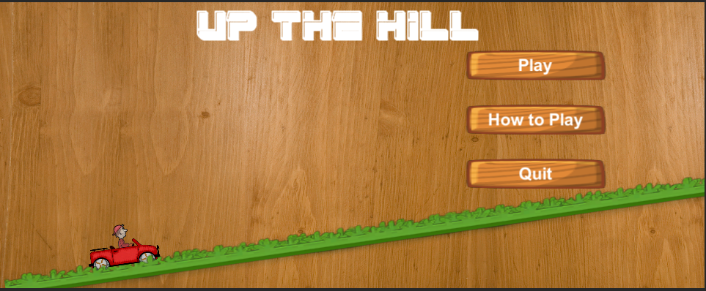**User Interface:**

If we click on **Play** button then we enter in **Gameplay** Scene

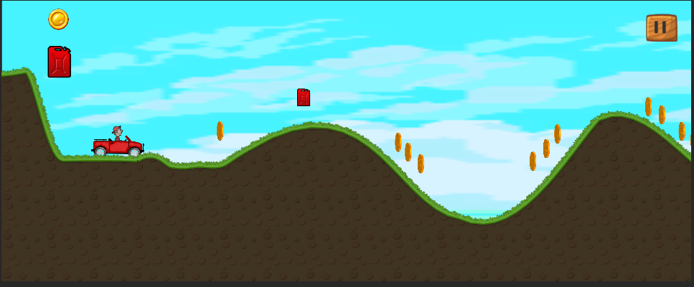

If we click on **How to Play** button then we enter into new Screen

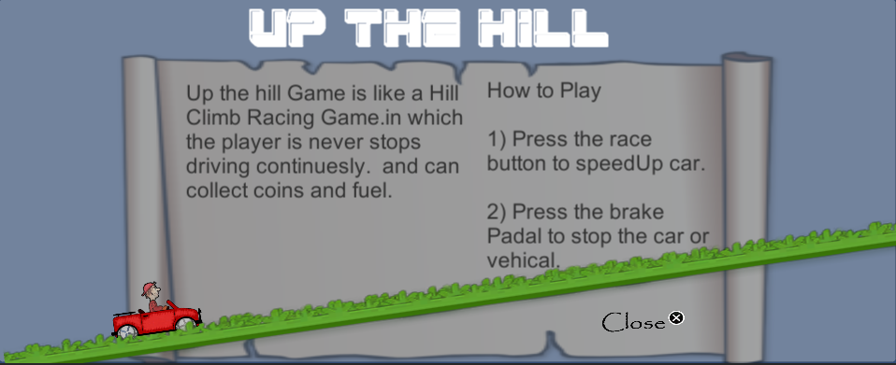

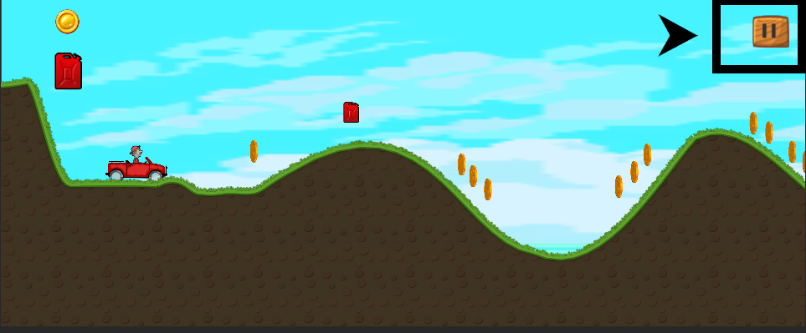

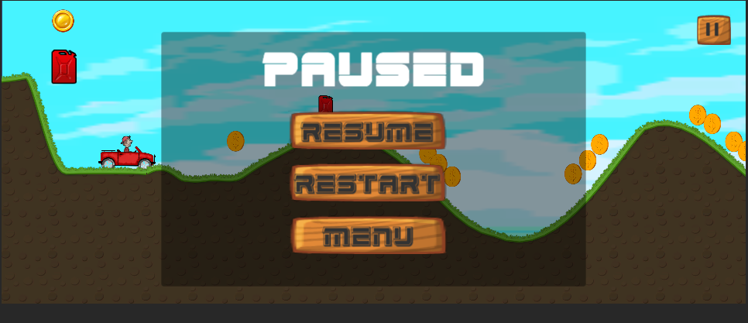

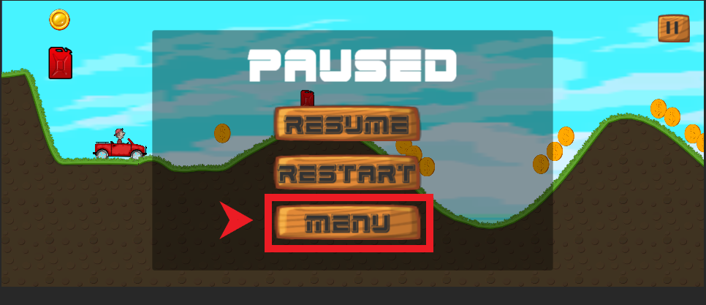

If we click on Menu button we back to our main Screen given below..

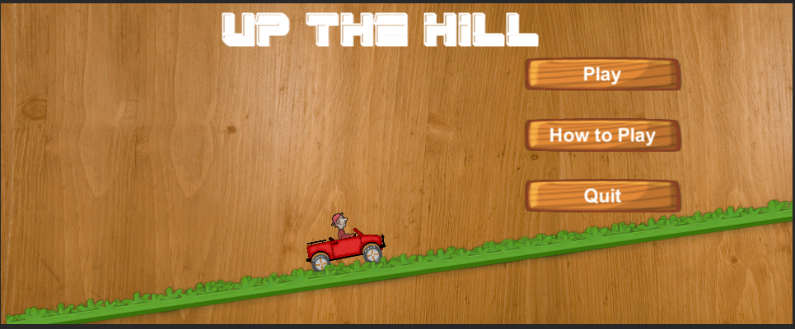

Similarly, if we click on **Restart** button the game will be restart…

And if we click on **Resume** button the current game will be continue…

**Interaction Model:**

* Avatar Model

**Camera Model:**

* dynamic Camera Model, third Person, Side Scrolling

**Game Challenges:**

* Take fuel to keep moving.
* Keep the vehicle from fall over and killing the player.