OZ_TECH · TECHNOLOGY DEPARTMENT
Donation Management System
Business Requirements, Software Requirements Specification, Architecture, Data Model & 12-Week Delivery Plan
Single-NGO deployment · Laravel 13 · Filament 5 · Blade + Alpine.js · REST API for mobile
Item | Detail
Document | SRS / BRD — Donation Management System
Version | 1.2 — Draft (Laravel 13 / Filament 5; card payments moved to Phase 2; WhatsApp via Green API)
Date | 26 October 2026
Prepared by | Nadeem Ahmad, Founder & Technical Lead
Status | Awaiting stakeholder review and sign-off

Contents

Right-click the table and choose “Update Field” if page numbers are not shown.

1. Introduction

1.1 Purpose
This document defines what the Donation Management System must do (business and software requirements), how it will be built (architecture and data model) and when each part will be delivered (12-week plan). It is the single reference for the build, for user acceptance testing and for change control.

1.2 Product summary
A web-based system for one NGO to raise, receive, account for and spend donations. Donors give through a public website or a mobile app using local payment channels. Staff manage everything through a Filament admin panel: campaigns, donors, payment verification, receipts, beneficiaries, approvals, disbursements, Qurbani and reporting. Zakat and other restricted money is tracked in a fund-wise ledger so it is never mixed or misused.

1.3 Technology decisions
Decision | Choice | Reason
Tenancy | Single NGO | Simpler schema and deployment; no tenant scoping needed
Admin / staff UI | Filament 5 | Fast, consistent CRUD, actions, widgets and permissions
Public website | Blade + Alpine.js + Livewire | Server-rendered for SEO and low-end phones; Livewire ships with Filament already
Mobile | REST API only (/api/v1) | Mobile app is a separate project consuming documented APIs
Inertia.js | Not used | Filament covers admin; Blade covers public pages — a third rendering stack adds cost without benefit

1.4 Glossary
Term | Meaning
Zakat | Obligatory annual alms; must be kept in a separate fund and spent only on eligible recipients.
Sadqa / Atiya | Voluntary charity; can be used for general welfare and operating needs.
Fitrana | Charity paid per person before Eid-ul-Fitr; seasonal collection.
Fidya | Compensation for missed fasts; restricted to feeding the needy.
Fund | A ledger bucket that holds money by type (Zakat, Sadqa, Restricted, etc.).
Campaign | A time-bound or open appeal (e.g., Winter Relief) that collects money into one fund.
Disbursement | Money or goods paid out of a fund to a beneficiary or project.
Raast / IBFT | State Bank of Pakistan instant payment system / inter-bank funds transfer.
CNIC / NTN | Computerised National Identity Card / National Tax Number.
PSP | Payment Service Provider (card processing) — Phase 2.
Green API | Third-party WhatsApp gateway (green-api.com) used to send WhatsApp messages and PDF receipts over HTTP.
Filament | Laravel admin-panel framework used for all staff panels.
Sanctum | Laravel token authentication used by the mobile API.

2. Business Requirements (BRD)

2.1 Business context
The NGO is new, so it can start digital-first instead of moving off spreadsheets later. Without a system, donations through bank transfers, wallets and cash lead to slow receipts, manual reconciliation, risk of mixing Zakat with general funds, and little visibility for the founder and trustees. Seasonal peaks — Ramadan (Zakat, Fitrana) and Eid-ul-Adha (Qurbani) — multiply the workload.

2.2 Business objectives
ID | Objective
OBJ-1 | Accept donations online (web + mobile) through local payment channels with instant confirmation and receipts.
OBJ-2 | Keep Zakat, Sadqa, Fitrana and restricted money strictly separated with a fund-wise ledger.
OBJ-3 | Give donors self-service: history, receipts, annual tax certificates and recurring pledges.
OBJ-4 | Run the full program cycle: beneficiary intake, verification, approval and disbursement.
OBJ-5 | Give management and auditors real-time, trustworthy reporting with a complete audit trail.
OBJ-6 | Handle seasonal peaks (Ramadan, Qurbani) without manual spreadsheets.

2.3 Stakeholders
Stakeholder | Role | Interest / responsibility
Founder / NGO Management (Nadeem Ahmad) | Owner, sponsor & approver | Vision, scope sign-off, campaign strategy, policies
Board of Trustees (as constituted) | Governance | High-value disbursement approval, annual accounts
Finance Team | Primary user | Payment verification, reconciliation, ledger, receipts
Program / Field Officers | Primary user | Beneficiary intake, verification visits, disbursement requests
Campaign / Content Team | Primary user | Campaigns, updates, website content
Donors (individual & corporate) | External user | Donate, manage pledges, download receipts
External Auditor | Read-only user | Reviews ledgers, approvals and audit trail
Technical Lead (Nadeem Ahmad) | Builder | Architecture, development with Claude Code, deployment, maintenance

2.4 Scope

In scope
- Public donation website (Blade + Alpine.js + Livewire), donor portal and Zakat calculator
- Filament 5 admin panel for all staff roles
- Versioned REST API (/api/v1) for the mobile app, with API documentation
- Payment integration: JazzCash, Easypaisa, bank/Raast transfer with proof upload, cash/cheque entry (card payments in Phase 2; gateway interface ready)
- Funds, campaigns, donations, receipts, tax certificates, recurring pledges
- Beneficiaries, verification, approvals, disbursements, projects and impact updates
- Qurbani booking and in-kind donation inventory
- Fund ledger, gateway reconciliation, dashboards, reports, audit trail

Out of scope
- Mobile app UI/UX and build (separate project; only the APIs are delivered here)
- Multi-tenancy (system serves one NGO)
- Full double-entry accounting / payroll (export to the NGO's accounting software instead)
- Card payments via a PSP, peer-to-peer fundraising, CSR matching, volunteer management (Phase 2 roadmap)
- Payment-gateway merchant onboarding paperwork (NGO responsibility)

2.5 Business rules
ID | Rule
BR-01 | Every donation belongs to exactly one fund. A campaign always maps to one fund.
BR-02 | Zakat money can only be disbursed to beneficiaries flagged Zakat-eligible. The system blocks any other use.
BR-03 | A donation is credited to the fund ledger only after payment is confirmed: a verified gateway webhook, or manual proof approved by Finance.
BR-04 | Donation, receipt and disbursement numbers are sequential, unique and never reused (e.g., DN-2026-000123).
BR-05 | Paid donations cannot be edited or deleted. Corrections happen only through refund / reversal entries.
BR-06 | Disbursements need an approval from someone other than the requester. Exception while the NGO has one approver: when the 'Allow founder self-approval' setting is on (default on at launch), a Super Admin may approve their own request; each such approval is flagged 'self-approved' and audit-logged. Turning the setting off enforces two-person approval for all new requests.
BR-07 | A fund balance can never go negative. Disbursement approval checks available balance at approval time.
BR-08 | Anonymous donors are hidden on all public surfaces but retained internally for receipts and audit.
BR-09 | A campaign closes automatically at its end date. Later donations go to the campaign's parent fund.
BR-10 | Restricted-fund money is used only for the restriction recorded on the fund.
BR-11 | Qurbani bookings close at the season cut-off. Shares per animal follow the configured count (cow = 7).
BR-12 | Tax certificates are issued only to donors with a CNIC or NTN on file.

2.6 Assumptions & dependencies
- Merchant accounts with JazzCash and Easypaisa are applied for in Week 1; sandbox credentials are available by Week 4. A card PSP is applied for later (Phase 2).
- Sandbox credentials for each gateway are available at the start of Week 4.
- A Green API instance (WhatsApp) is already available. An SMS provider is optional and only used as a fallback for OTP.
- The founder (Nadeem Ahmad) owns the requirements and builds the system with Claude Code; UAT is done with the NGO's first staff/volunteers.
- Hosting is a Linux VPS or managed Laravel host with MySQL 8, Redis and S3-compatible storage.
- Interface language is English at launch; the public site is built translation-ready for Urdu (RTL).

2.7 Success criteria
- Every online donation is confirmed and receipted automatically without staff action.
- Fund balances in the system match bank/gateway settlements after daily reconciliation.
- No Zakat money can be disbursed to a non-eligible beneficiary (proved by tests and UAT).
- Trustees can see collections and disbursements by fund at any time from the dashboard.
- The mobile developer can build all donor journeys from the published API documentation alone.

3. Software Requirements (SRS)

3.1 User roles & permissions
F = full control · C = create / edit · A = approve · V = view only · – = no access. Donors are a separate guard and only see their own data.
Area | Super Admin | Manager | Finance | Campaign Mgr | Field Officer | Trustee | Auditor
Users, roles & settings | F | V | - | - | - | - | V
Donors | F | C | C | V | - | V | V
Funds & campaigns | F | C | V | C | - | V | V
Donations & payments | F | V | C | V | - | V | V
Proof verification | F | - | A | - | - | - | V
Receipts & certificates | F | V | C | - | - | - | V
Beneficiaries & applications | F | C | V | - | C | V | V
Disbursements | F | A | C | - | C | A | V
Qurbani & inventory | F | C | C | C | C | V | V
Ledger & reconciliation | F | V | C | - | - | V | V
Reports & dashboard | F | V | V | V | V | V | V
CMS content | F | C | - | C | - | - | -
Audit log | V | V | - | - | - | V | V

3.2 Functional requirements
Priority uses MoSCoW: Must (go-live), Should (go-live if time allows, else first patch), Could (Phase 2).

M01 Access Control & Settings
ID | Requirement | Priority
FR-ACC-01 | Staff log in to /admin with email + password; 2FA (TOTP) is mandatory for Super Admin, Finance and Trustee roles. | Must
FR-ACC-02 | Super Admin manages users, roles and granular permissions per Filament resource and action. | Must
FR-ACC-03 | Settings screens hold organisation profile, receipt template text, numbering prefixes, approval thresholds and gateway credentials (encrypted). | Must
FR-ACC-04 | Login attempts are rate-limited and logged with IP and user agent. | Must

M02 Donor Management
ID | Requirement | Priority
FR-DNR-01 | Donors can give as guest (name, phone, email) or register; a guest is auto-linked to an account later by phone/email match. | Must
FR-DNR-02 | Donor profile stores type (individual/corporate), CNIC/NTN (encrypted), city, communication preferences and opt-outs. | Must
FR-DNR-03 | Staff can view a donor timeline: donations, receipts, pledges, messages sent. | Must
FR-DNR-04 | Staff can merge duplicate donor records; all history moves to the surviving record. | Should

M03–M04 Funds & Campaigns
ID | Requirement | Priority
FR-CMP-01 | Finance defines funds with type, Zakat flag, restriction note and active status. | Must
FR-CMP-02 | Campaign Manager creates campaigns with fund, goal, start/end dates, story (rich text), cover image, gallery and status. | Must
FR-CMP-03 | Raised amount and donor count update automatically when a donation is confirmed. | Must
FR-CMP-04 | Campaign updates (text + media) can be published and are visible on web/API; optionally notify donors of that campaign. | Should
FR-CMP-05 | Scheduler closes expired campaigns daily. | Must

M05 Donations Core
ID | Requirement | Priority
FR-DON-01 | A donation records donor, fund, campaign (optional), amount (PKR), channel, payment method, anonymity flag and notes. | Must
FR-DON-02 | Statuses: pending → paid / failed / cancelled; paid → refunded (partial or full) via a reversal record. | Must
FR-DON-03 | Finance can enter offline donations (cash, cheque, bank deposit) with attachment; these go through the same confirmation path. | Must
FR-DON-04 | Pending online donations older than a configurable time are auto-marked failed after a gateway status check. | Should
FR-DON-05 | Donation list supports filters by date, fund, campaign, method, status and export to Excel. | Must

M06 Payments & Gateways
ID | Requirement | Priority
FR-PAY-01 | Each gateway is implemented behind a common PaymentGateway interface (initiate, verifyCallback, queryStatus, refund). | Must
FR-PAY-02 | Webhooks/callbacks verify signature/hash and amount, are idempotent on gateway reference, and store the raw payload. | Must
FR-PAY-03 | Bank/Raast transfers: donor uploads proof; Finance approves or rejects in a verification queue. | Must
FR-PAY-04 | Admin can enable/disable gateways and set display order without code changes. | Should

M07 Receipts & Tax Certificates
ID | Requirement | Priority
FR-RCP-01 | A PDF receipt with organisation details, receipt number, fund, amount in figures and words is generated on payment confirmation. | Must
FR-RCP-02 | Receipts are emailed and downloadable from the donor portal and API; staff can resend. | Must
FR-RCP-03 | Annual consolidated tax certificate per donor per fiscal year (July–June), bulk-generated by Finance. | Must

M08 Recurring Donations
ID | Requirement | Priority
FR-REC-01 | Donor sets up a pledge (fund, amount, frequency, start date) and can pause or cancel it. | Must
FR-REC-02 | Scheduler sends a pay-now reminder (SMS/WhatsApp/email with payment link) on each due date. | Must
FR-REC-03 | Pledge fulfilment report shows due vs paid per period. | Should

M09 Notifications
ID | Requirement | Priority
FR-NTF-01 | Templates per event and channel (email, SMS, WhatsApp) with placeholders, editable in admin. | Must
FR-NTF-02 | All messages are queued, retried on failure and logged with status. | Must
FR-NTF-03 | WhatsApp is sent through Green API: text messages and PDF receipts (send file by URL/upload); phone numbers normalised from 03XX… to 923XX…@c.us. | Must
FR-NTF-04 | Messages are sent only to donors who opted in to WhatsApp; a per-minute send limit protects the number. | Must

M10 Public Website & Donor Portal
ID | Requirement | Priority
FR-WEB-01 | Pages: home, campaign list/detail, fund pages, about, transparency, contact, FAQ, CMS pages. | Must
FR-WEB-02 | Donate flow: choose fund/campaign → amount (presets + custom) → donor details → payment method → result page; max 3 steps. | Must
FR-WEB-03 | Zakat calculator (gold, silver, cash, business assets, liabilities) with a 'Donate this amount' action. | Must
FR-WEB-04 | Donor portal: profile, donation history, receipt downloads, pledges, tax certificates, Qurbani bookings. | Must
FR-WEB-05 | Public pages are SEO-friendly (server-rendered, meta tags, sitemap) and mobile-first. | Must

M11 Mobile REST API
ID | Requirement | Priority
FR-API-01 | Versioned REST API under /api/v1 with JSON resources and a consistent envelope and error format. | Must
FR-API-02 | Donor auth via Sanctum tokens; registration and login with phone OTP and/or email + password. | Must
FR-API-03 | Endpoints cover catalog, donate/initiate, status polling, history, receipts, pledges, Qurbani and profile. | Must
FR-API-04 | API documentation is auto-generated (Scribe) and published for the mobile developer. | Must
FR-API-05 | App config endpoint returns enabled gateways, minimum app version and feature flags. | Should

M12 Beneficiary Management
ID | Requirement | Priority
FR-BEN-01 | Field Officer registers a beneficiary (CNIC unique, household, income, address, documents). | Must
FR-BEN-02 | Applications per need category move through submitted → verifying → approved / rejected. | Must
FR-BEN-03 | Verification visits record findings, photos, recommendation and Zakat-eligibility decision. | Must

M13 Disbursements & Approvals
ID | Requirement | Priority
FR-DSB-01 | A disbursement request references a fund and an application or project, with amount and payout method. | Must
FR-DSB-02 | Approval chain is configurable by amount threshold; each decision is recorded with comments. | Must
FR-DSB-04 | Self-approved disbursements are visibly flagged in lists, reports and the audit log, and a report lists them by period for trustee review. | Must
FR-DSB-03 | On approval the system checks fund balance and Zakat eligibility, then posts a ledger debit when marked paid. | Must

M14 Projects & Impact
ID | Requirement | Priority
FR-PRJ-01 | Projects have budget, fund, milestones and status; spend is the sum of linked disbursements. | Should
FR-PRJ-02 | Impact updates can be published to web/API and pushed to donors of the linked fund/campaign. | Should

M15 Qurbani Management
ID | Requirement | Priority
FR-QRB-01 | Admin opens a season with prices per animal type/share and a booking cut-off. | Must
FR-QRB-02 | Donor books shares with names on behalf of whom Qurbani is offered; booking is paid through the normal donation flow. | Must
FR-QRB-03 | Staff allocate bookings to tagged animals and update status (allocated → slaughtered → distributed); donors are notified. | Must

M16 In-kind & Inventory
ID | Requirement | Priority
FR-INV-01 | Record goods received from donors with estimated value; stock-in to items. | Should
FR-INV-02 | In-kind disbursements stock-out items; stock levels and movement history are visible. | Should

M17 Fund Ledger & Reconciliation
ID | Requirement | Priority
FR-FIN-01 | Every confirmed donation, refund and paid disbursement posts an immutable ledger entry with running balance per fund. | Must
FR-FIN-02 | Finance imports gateway settlement files (CSV) and the system matches them to payments, flagging mismatches. | Must
FR-FIN-03 | Inter-fund transfers (where permitted) need Trustee approval and post paired entries. | Could
FR-FIN-04 | Ledger export to Excel for the NGO's accounting software. | Must

M18–M20 Reports, Audit & CMS
ID | Requirement | Priority
FR-RPT-01 | Dashboard widgets: today/month collections, by fund, by gateway, top campaigns, pending verifications, pending approvals. | Must
FR-RPT-02 | Reports: collections, donor retention, disbursements vs collections by fund, campaign performance; Excel/PDF export. | Must
FR-AUD-01 | All create/update/delete on financial and beneficiary records is logged with user, time and before/after values. | Must
FR-CMS-01 | Staff manage pages, posts, FAQs and homepage banners with SEO fields. | Must

3.3 Non-functional requirements
ID | Category | Requirement
NFR-01 | Performance | Public pages render in under 2 s on a typical 4G connection; API p95 under 500 ms for read endpoints.
NFR-02 | Peak load | Handles Ramadan / Qurbani peaks via queues, Redis caching of catalog data and horizontal worker scaling.
NFR-03 | Availability | 99.5% monthly target; health-check endpoint and uptime monitoring.
NFR-04 | Security | OWASP Top 10 controls, CSRF on web, HTTPS only, encrypted CNIC/NTN and gateway secrets, 2FA for privileged roles.
NFR-05 | Payment security | No card data stored or processed by the app (hosted checkout / redirect only); webhook signature verification mandatory.
NFR-06 | Data integrity | Money stored as DECIMAL(14,2) PKR; ledger entries immutable; DB transactions + row locks on balance changes.
NFR-07 | Auditability | Activity log retained for at least 7 years; financial records soft-deleted only, never hard-deleted.
NFR-08 | Backups | Daily automated DB + storage backups to off-site storage, 30-day retention, quarterly restore test.
NFR-09 | Localisation | Timezone Asia/Karachi, PKR formatting, translation-ready strings; public site Urdu/RTL-ready.
NFR-10 | Maintainability | Laravel conventions, service classes for domain logic, Pest test coverage on all money paths, Larastan level 6+.
NFR-11 | Privacy | Beneficiary data visible only to authorised roles; donor data never shared publicly; align with applicable Pakistani data-protection requirements.

3.4 External interfaces
Interface | Type | Notes
JazzCash | Hosted checkout / API + callback | Hash verification; status inquiry for stale payments
Easypaisa | Hosted checkout / API + callback | Same adapter contract as JazzCash
Card PSP | Phase 2 | Applied for after launch; plugs into the same gateway interface; no card data touches our servers
Bank / Raast | Manual | Donor uploads proof; Finance verifies
WhatsApp (Green API) | HTTP API | Receipts (PDF), thank-you, reminders, Qurbani updates, OTP
SMS gateway | HTTP API (optional) | Fallback for OTP only
Email | SMTP / SES | Receipts, certificates, notifications
Mobile app | REST /api/v1 | Sanctum token auth; Scribe documentation

4. Module List
Twenty modules are delivered in the 12-week MVP. Surfaces show where each module appears: Admin (Filament), Web (public site / donor portal) and API (mobile).
# | Module | Key features | Surfaces | Week
M01 | Access Control & Settings | Staff users, roles/permissions, 2FA, gateway + notification settings, general settings | Admin | W1
M02 | Donor Management | Profiles, guest vs registered, CNIC/NTN, preferences, merge duplicates, timeline | Admin · Web · API | W2
M03 | Funds & Donation Types | Zakat / Sadqa / Fitrana / Fidya / General / Restricted funds, live balances | Admin · API | W2
M04 | Campaigns | Goal, dates, story, media, progress, updates, featured flag, auto-close | Admin · Web · API | W2
M05 | Donations Core | Donation lifecycle, numbering, manual cash/cheque entry, refunds/reversals | Admin · Web · API | W3
M06 | Payments & Gateways | Gateway adapters, webhooks, idempotency, bank/Raast proof verification queue | All | W4–W5
M07 | Receipts & Tax Certificates | PDF receipts, annual consolidated certificates, resend, bulk generate | Admin · Web · API | W5
M08 | Recurring Donations | Monthly/quarterly/yearly pledges, reminders, pause/cancel, fulfilment tracking | Admin · Web · API | W8
M09 | Notifications | WhatsApp (Green API) + email templates, optional SMS, queued delivery, message log | Admin | W5
M10 | Public Website & Donor Portal | Home, campaigns, donate flow, Zakat calculator, donor dashboard | Web | W6
M11 | Mobile REST API | Sanctum auth + OTP, catalog, donate, history, receipts, Qurbani, docs | API | W7
M12 | Beneficiary Management | Profiles, applications, verification visits, Zakat eligibility | Admin | W9
M13 | Disbursements & Approvals | Requests, multi-level approval, balance checks, payout recording | Admin | W10
M14 | Projects & Impact | Projects, milestones, impact updates pushed to donors | Admin · Web · API | W10
M15 | Qurbani Management | Seasons, pricing, bookings, animal + share allocation, distribution status | Admin · Web · API | W11
M16 | In-kind & Inventory | Goods received, items, stock in/out linked to disbursements | Admin | W11
M17 | Fund Ledger & Reconciliation | Credit/debit ledger, settlement import, mismatch flags, accounting export | Admin | W3 · W11
M18 | Reports & Dashboard | KPI widgets, collection/disbursement reports, Excel/PDF export | Admin | W8 · W11
M19 | Audit Trail & Security | Activity log on all financial records, login history, backups | Admin | W1 · W12
M20 | CMS | Pages, posts, FAQs, banners, SEO meta | Admin · Web · API | W6

4.1 Phase 2 roadmap (after go-live)
- Card payments via a PSP (adapter on the existing gateway interface)
- Peer-to-peer fundraising pages
- Corporate / CSR accounts and matching gifts
- Volunteer management
- Public transparency portal with live fund utilisation
- Donor segmentation and bulk campaigns (lapsed, major, recurring)
- Urdu translation of the public website
- Push-notification campaigns for the mobile app

5. System Architecture

5.1 Overview
One Laravel 13 application serves three entry points — the public website, the Filament admin panel and the mobile REST API. All three call the same domain services, so business rules (Zakat restrictions, approvals, ledger posting) live in one place and behave the same everywhere.
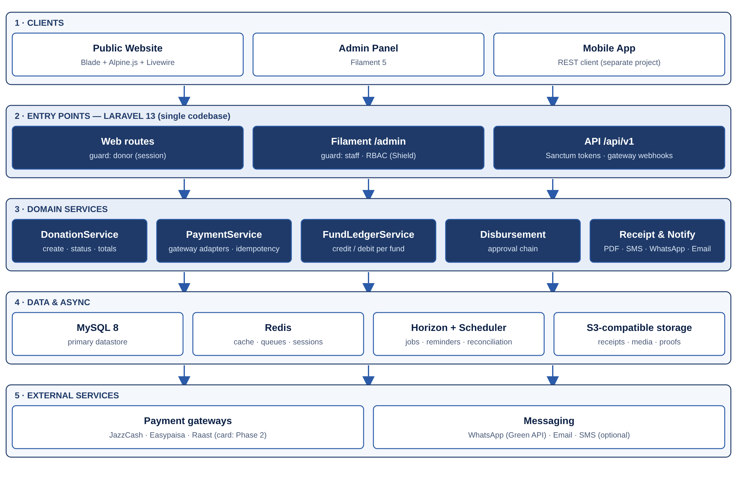
Figure 1 — Layered architecture

5.2 Technology stack
Layer | Technology | Purpose
Framework | Laravel 13 (PHP 8.3+) | Single codebase for web, admin and API
Admin panels | Filament 5 | All staff UIs: resources, widgets, approvals, settings
Public frontend | Blade + Alpine.js + Livewire 4, Tailwind CSS | SEO-friendly server rendering; Livewire for the donate wizard and calculator
Mobile API | Laravel Sanctum, API Resources, Scribe docs | Token auth, versioned /api/v1
Database | MySQL 8 | InnoDB, utf8mb4, strict mode
Cache / queue | Redis + Laravel Horizon | Queued receipts, notifications, reconciliation
Storage | S3-compatible object storage | Receipts, media, payment proofs (private disks + signed URLs)
PDF | spatie/laravel-pdf (Chromium) | Handles Urdu text in receipts, unlike most pure-PHP PDF engines
Permissions | spatie/laravel-permission + Filament Shield | Role/permission UI generated per resource
Audit / media / settings | spatie/laravel-activitylog, laravel-medialibrary, laravel-settings | Battle-tested Spatie packages with Filament plugins
Messaging | Green API (WhatsApp) via Laravel HTTP client; mail via SMTP/SES | Custom notification channel; no SDK needed
Quality | Pest, Larastan, Laravel Pint | Tests on every money path; static analysis in CI
Ops | spatie/laravel-backup, Sentry (or similar), Bitbucket Pipelines | Backups, error tracking, CI/CD

5.3 Code organisation
Location | Responsibility
app/Models | Eloquent models, casts, relationships, scopes
app/Services | DonationService, PaymentService, FundLedgerService, ReceiptService, DisbursementService, QurbaniService
app/Payments | Gateway contract + adapters (JazzCash, Easypaisa, ManualBank; CardPsp in Phase 2) and DTOs
app/Actions | Single-purpose actions used by Filament, web and API (e.g., ConfirmDonation, ApproveDisbursement)
app/Filament | Panel provider, resources, pages, widgets, clusters
app/Http/Controllers/Api/V1 | Thin API controllers + FormRequests + API Resources
app/Livewire | Donate wizard, Zakat calculator, donor portal components
app/Events · Listeners · Jobs | DonationPaid, DisbursementPaid, SendReceipt, SendNotification, ReconcileSettlement
app/Policies | Authorization per model, shared by Filament, web and API
tests/Feature · Unit | Pest tests: payment webhooks, ledger posting, approvals, API contracts

Design principle
Controllers, Livewire components and Filament resources stay thin. Anything that moves money or changes a status goes through a service or action class inside a database transaction, so the same rule cannot be bypassed from a different screen.

5.4 Donation & payment flow
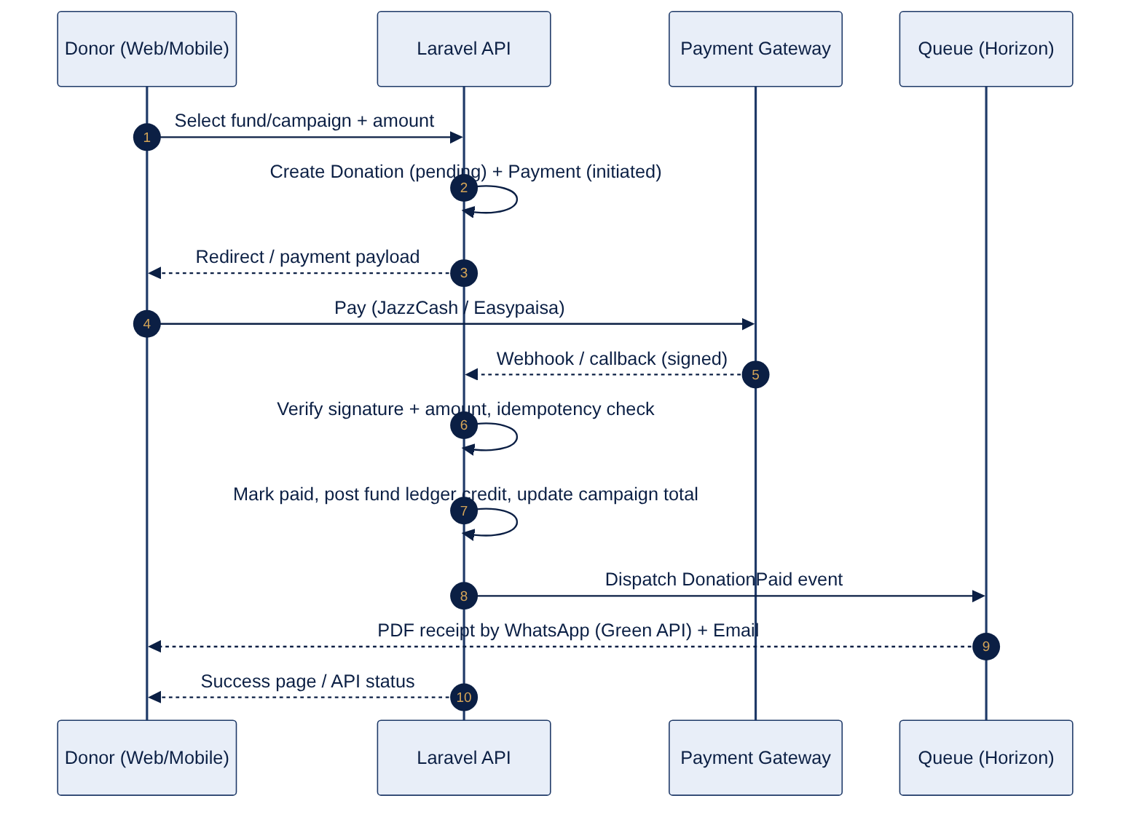
Figure 2 — Online donation sequence

5.5 Admin panel structure (Filament)
Navigation group | Resources / pages
Dashboard | KPI stats, collections chart, by-fund chart, pending verifications, pending approvals
Donations | Donations · Payments · Proof Verification Queue · Recurring Plans · Receipts
Campaigns | Funds · Campaigns · Campaign Updates
Donors | Donors · Tax Certificates
Programs | Beneficiaries · Applications · Verification Visits · Disbursements · Projects · Impact Updates
Seasonal | Qurbani Seasons · Animals · Bookings
Inventory | Items · In-kind Donations · Stock Movements
Finance | Fund Ledger · Settlements / Reconciliation · Reports
Content | Pages · Posts · FAQs · Banners
Settings | Users · Roles · Gateways · Notification Templates · General · Activity Log

5.6 Security architecture
- Separate guards: staff (web) and donors (donor session + Sanctum tokens); policies shared by all three entry points.
- Filament Shield generates permissions per resource and action; menu items hide automatically.
- Webhooks verify gateway signatures, compare amounts and are idempotent on the gateway reference.
- Payment proofs, beneficiary documents and receipts live on a private disk and are served via short-lived signed URLs.
- CNIC/NTN and gateway secrets use encrypted casts; APP_KEY rotation procedure is documented.
- Rate limiting on login, OTP, donate-initiate and all API routes.

5.7 Deployment
Environment | Purpose | Notes
Local | Development | Laravel Herd / Sail, MySQL, Redis, Mailpit
Staging | UAT + mobile developer | Gateway sandboxes, seeded demo data, Scribe docs published
Production | Live | Nginx + PHP-FPM, Horizon under Supervisor, scheduler cron, daily backups, error monitoring, HTTPS

6. Data Model & ERD
The model is split into three domains for readability. Only key columns are shown; timestamps, soft-delete and audit columns exist on every table.

6.1 Table catalogue
Table(s) | Purpose
users | Staff accounts for Filament (guard: web)
roles, permissions, model_has_* | RBAC (Spatie)
donors | Donor accounts (guard: donor; Sanctum tokens for API)
funds | Money buckets by type with Zakat flag and cached balance
campaigns, campaign_updates | Appeals and their progress posts
donations | One row per pledge-to-give; status lifecycle
payments, payment_proofs | Gateway attempts and manual transfer evidence
payment_webhook_logs | Raw inbound webhook payloads + verification result
receipts, tax_certificates | Issued documents and file paths
recurring_plans | Donor pledges with frequency and next due date
fund_ledger_entries | Immutable credit/debit entries with running balance
settlements, settlement_lines | Imported gateway settlement files for reconciliation
beneficiaries, applications, verification_visits | Program intake and verification
disbursements, approvals | Payouts and polymorphic approval decisions
projects, project_milestones, impact_updates | Program delivery and donor-facing impact
qurbani_seasons, qurbani_animals, qurbani_bookings, animal_shares | Seasonal Qurbani operations
inventory_items, inkind_donations, stock_movements | Goods in and out
notification_templates, message_logs | Templates and delivery log
pages, posts, faqs, banners | CMS content
settings, activity_log, media | Spatie settings, audit trail and media library

6.2 Data conventions
- Money columns DECIMAL(14,2); currency fixed to PKR but stored on donations for future-proofing.
- Public numbers (donation_no, receipt_no) come from a locked sequence table, never auto-increment IDs.
- Soft deletes on master data; no deletes at all on donations, payments and ledger entries.
- Status columns are PHP backed enums; transitions are enforced in services, not in controllers.
- CNIC, NTN and gateway secrets use encrypted casts; a hashed CNIC column enforces uniqueness.
- All foreign keys indexed; composite indexes on (fund_id, posted_at) and (status, created_at) for reporting.

6.3 ERD — Donations domain
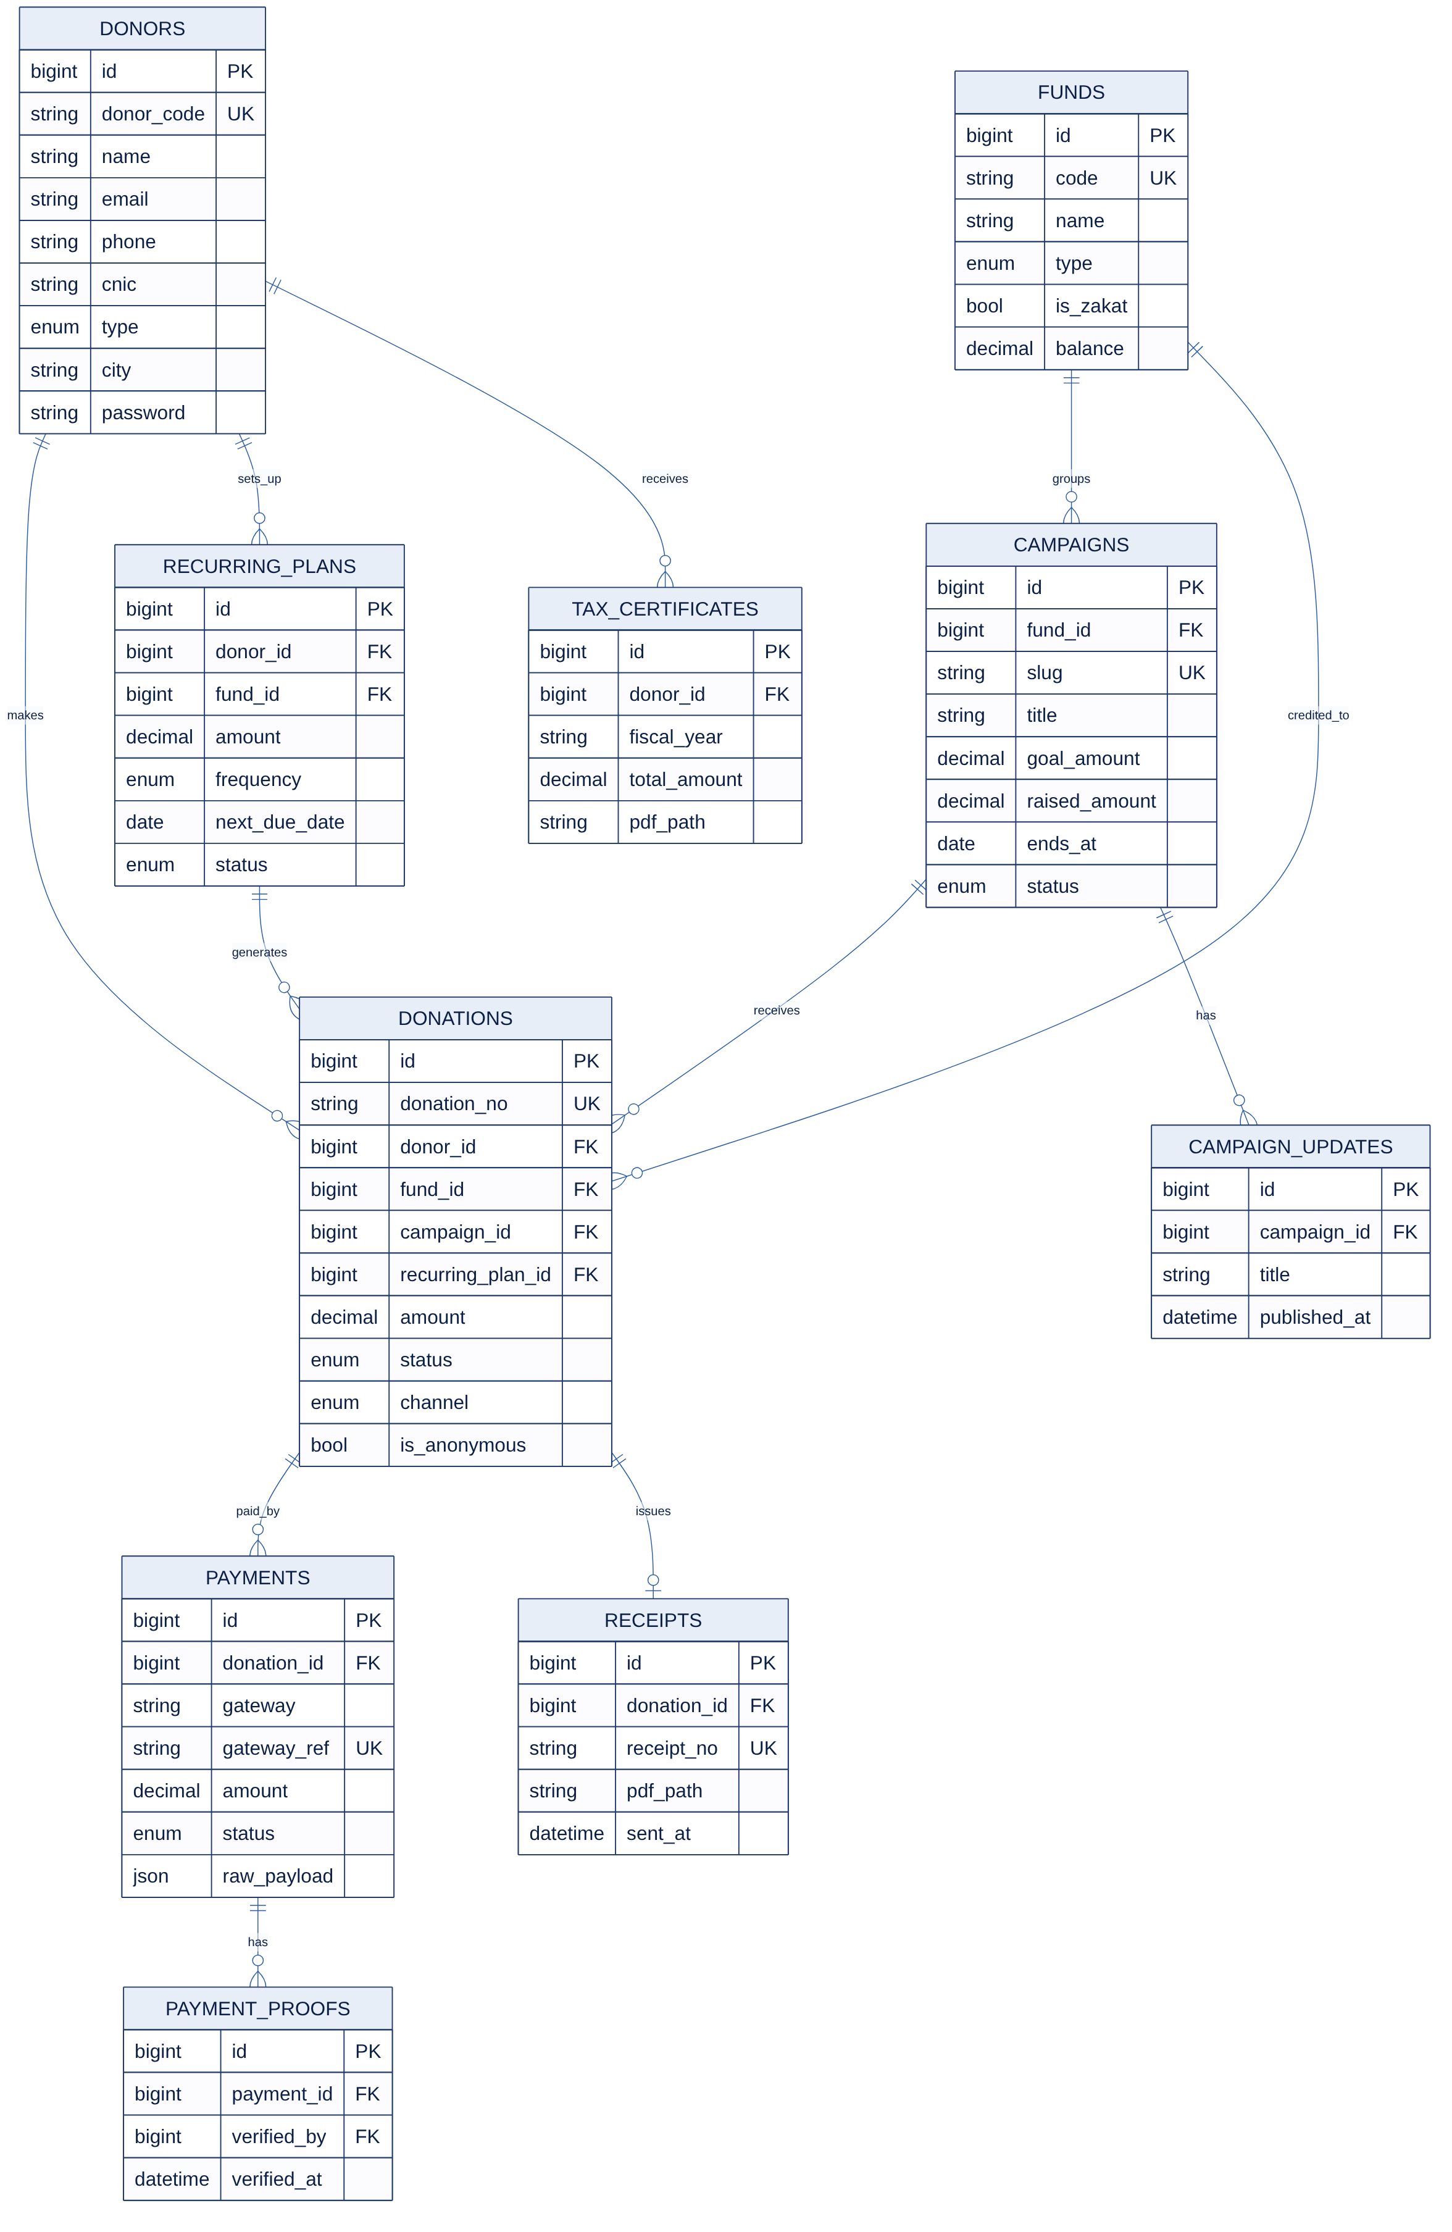
Figure 3 — ERD: donors, funds, campaigns, donations, payments, receipts

6.4 ERD — Programs & finance domain
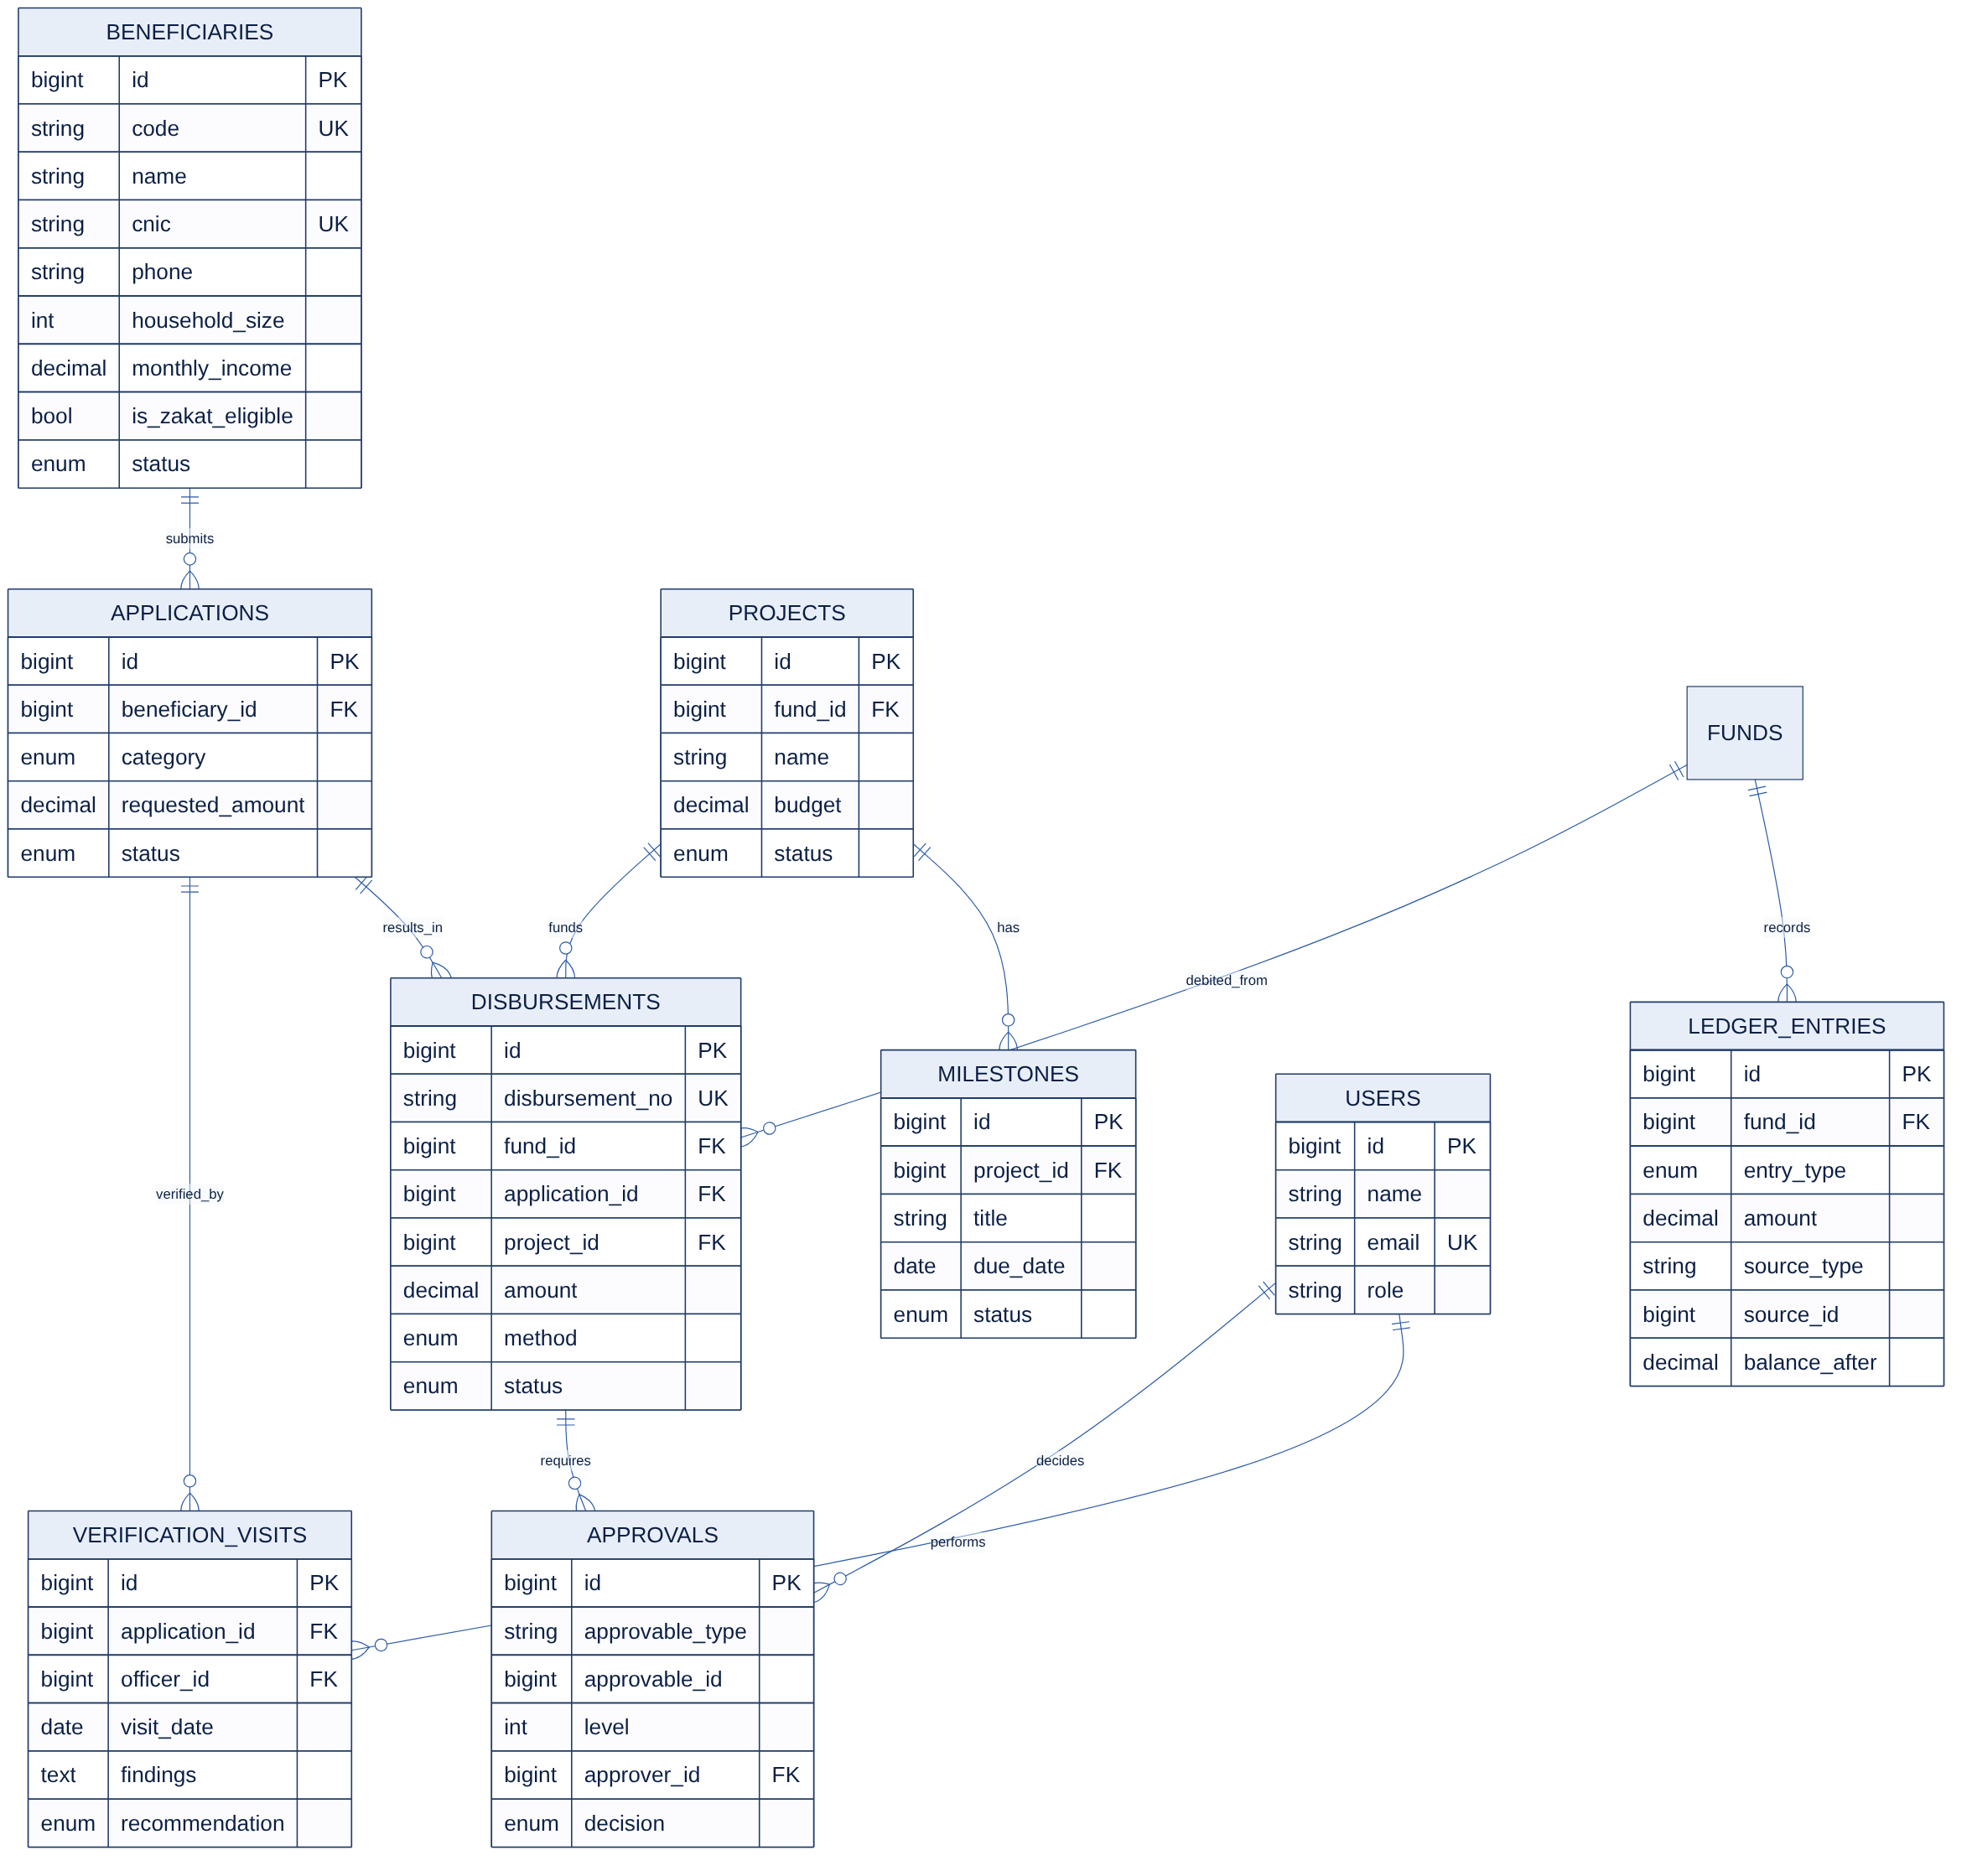
Figure 4 — ERD: beneficiaries, applications, disbursements, approvals, projects, ledger

6.5 ERD — Seasonal & inventory domain
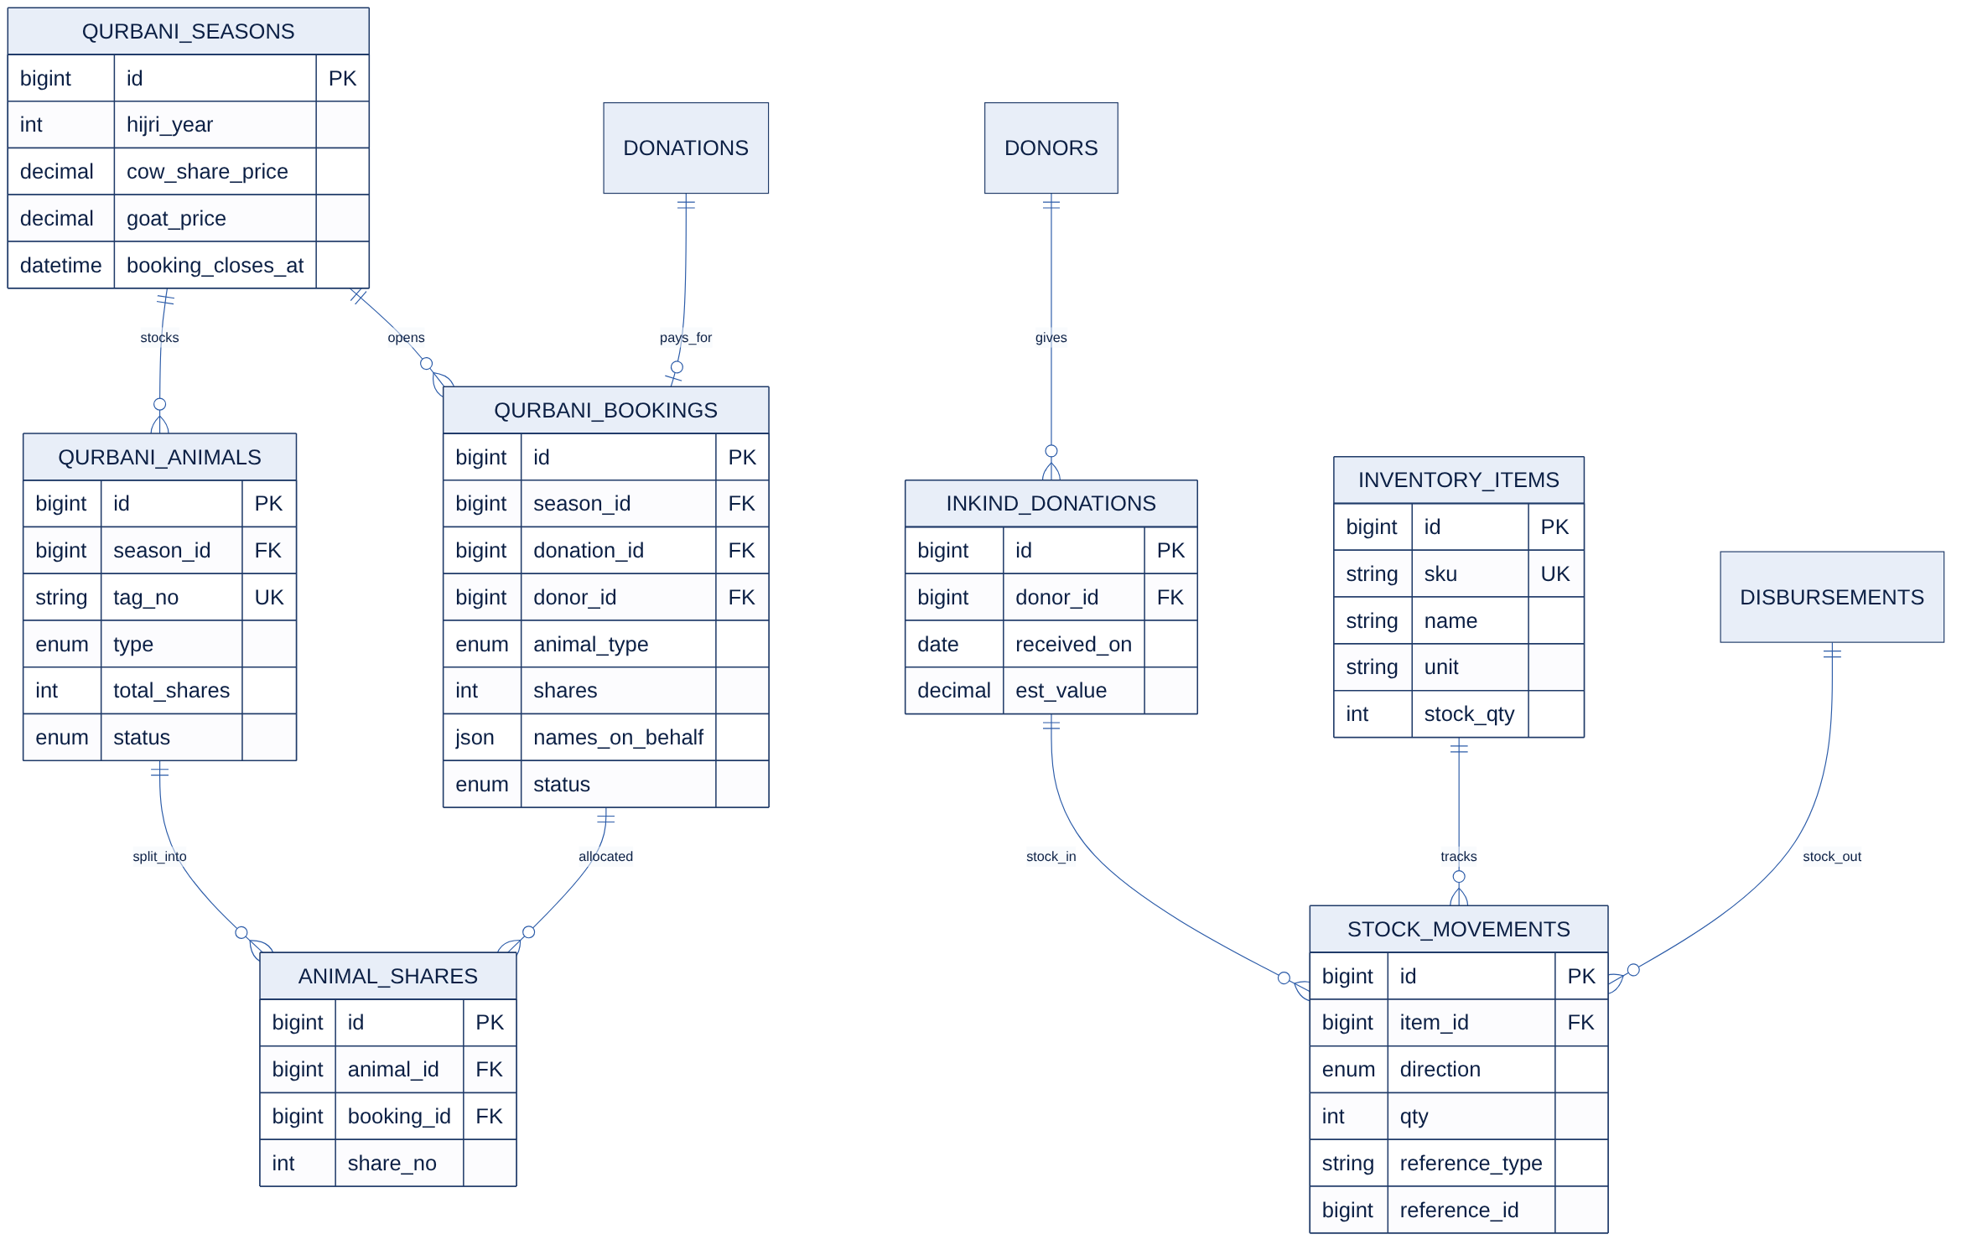
Figure 5 — ERD: Qurbani and in-kind inventory

7. Mobile API Specification (v1)
Base URL /api/v1. JSON only. Authenticated routes use a Sanctum bearer token. All responses follow one envelope: { "success", "data", "message", "errors", "meta" }.
Group | Method | Endpoint(s) | Access
Auth | POST | /auth/register · /auth/login · /auth/otp/send · /auth/otp/verify · /auth/logout | Public / token
Config | GET | /app/config | Public
Catalog | GET | /funds · /campaigns · /campaigns/{slug} · /campaigns/{slug}/updates | Public
Donate | POST | /donations (initiate, returns gateway payload) | Public / token
Donate | GET | /donations/{no}/status | Public (signed)
Donate | POST | /donations/{no}/proof (bank / Raast upload) | Public (signed)
Profile | GET/PUT | /me | Token
History | GET | /me/donations · /me/receipts/{id}/download · /me/tax-certificates | Token
Pledges | GET/POST/PATCH | /me/recurring-plans · /me/recurring-plans/{id} | Token
Qurbani | GET/POST | /qurbani/season · /qurbani/bookings · /me/qurbani-bookings | Public / token
Tools | POST | /zakat/calculate | Public
Content | GET | /pages/{slug} · /impact-updates | Public
Devices | POST | /devices (push token register) | Token
Webhooks | POST | /webhooks/{gateway} | Gateway signature

7.1 API rules
- Breaking changes only in a new version (/api/v2); v1 stays live until the app forces an upgrade via /app/config.
- Pagination via cursor or page meta; list endpoints default to 20 items.
- Validation errors return HTTP 422 with field-level messages; auth errors 401/403; rate limit 429.
- Donate-initiate returns the gateway payload or redirect URL; the app polls /donations/{no}/status until paid or failed.
- Every endpoint has a Pest contract test and appears in the Scribe docs.

8. 12-Week Delivery Plan
The plan assumes one developer (Technical Lead) building every module and panel with Claude Code, starting Monday 2 November 2026. Go-live lands on 22 January 2027, about two weeks before Ramadan 2027 (expected early February), the NGO’s highest-volume season.

8.1 Overview
Week | Dates | Theme | Goal
W1 | 2 Nov – 6 Nov | Foundation & access control | Running skeleton with auth, RBAC, settings, CI and audit logging.
W2 | 9 Nov – 13 Nov | Donors, funds & campaigns | Master data needed before any money moves.
W3 | 16 Nov – 20 Nov | Donations core & fund ledger | The money model is correct before any gateway is added.
W4 | 23 Nov – 27 Nov | Payment gateways (part 1) | Wallet payments working end-to-end in sandbox.
W5 | 30 Nov – 4 Dec | Receipts & notifications | Donor gets a receipt and message seconds after paying.
W6 | 7 Dec – 11 Dec | Public website & donor portal | Donors can give from the website.
W7 | 14 Dec – 18 Dec | Mobile REST API v1 | Mobile developer can build against stable, documented APIs.
W8 | 21 Dec – 25 Dec | Recurring donations & dashboard | Pledges and management visibility.
W9 | 28 Dec – 1 Jan 2027 | Beneficiary management | Program intake and verification digitised.
W10 | 4 Jan – 8 Jan 2027 | Disbursements, approvals & projects | Money goes out safely and visibly.
W11 | 11 Jan – 15 Jan 2027 | Qurbani, inventory & reconciliation | Seasonal operations and finance controls.
W12 | 18 Jan – 22 Jan 2027 | Hardening, UAT & go-live | Production launch before Ramadan 2027.

8.2 Milestones
Milestone | End of | Exit check
M1 — Money model proven | Week 3 | Offline donations post correctly to the fund ledger; money tests green
M2 — Online payments live (sandbox) | Week 5 | All gateways confirm donations; receipts and messages sent automatically
M3 — Donor channels ready | Week 7 | Website donate flow + documented mobile API on staging
M4 — Operations complete | Week 11 | Beneficiaries → approvals → disbursements, Qurbani, reconciliation
M5 — Go-live | Week 12 | UAT signed, production live with real gateways

8.3 Working method with Claude Code
- Keep this document in the repo (docs/srs.md) and summarise conventions in CLAUDE.md so every session starts with the same rules.
- One module per session: start in plan mode, agree the plan, then let Claude Code generate migration → model → enum → factory → policy → service → Filament resource → tests.
- Money paths (ledger, webhooks, approvals) are written test-first; never merge without green Pest + Larastan.
- Commit at the end of each task row with a clear message; tag a release at the end of each week.
- Review every generated migration and service by hand; Claude Code does the typing, you own the design.

8.4 Weekly task lists

Week 1 · 2 Nov – 6 Nov — Foundation & access control
Goal: Running skeleton with auth, RBAC, settings, CI and audit logging.
Day | Task | Output | Done
D1 | Create Laravel 13 project, Git repo, CLAUDE.md (conventions from this document), .env per environment | Repo + CLAUDE.md | ☐
D1 | Install Filament 5, Pest, Larastan, Pint; set up Bitbucket Pipelines (lint + tests) | Green CI pipeline | ☐
D2 | Two auth guards: staff (users) and donors; Sanctum installed; donor model scaffold | Guards configured | ☐
D3 | spatie/laravel-permission + Filament Shield; seed 7 roles and base permissions | Roles seeded | ☐
D3 | 2FA for privileged roles, login throttling and login history | Secure admin login | ☐
D4 | Settings module (organisation, numbering prefixes, thresholds, gateway credentials encrypted) | Settings pages | ☐
D5 | Activity log on base models; sequence-number service with row locking + Pest tests | Audit + numbering service | ☐

Definition of done: Admin can log in with 2FA, manage users/roles/settings; CI passes on every push.

Week 2 · 9 Nov – 13 Nov — Donors, funds & campaigns
Goal: Master data needed before any money moves.
Day | Task | Output | Done
D1 | Migrations, models, factories, enums for donors, funds, campaigns, campaign_updates | Schema v1 | ☐
D2 | Filament resources: Funds (type, Zakat flag, restriction), Donors (encrypted CNIC/NTN, timeline tab) | 2 resources | ☐
D3 | Filament Campaigns resource with media library (cover + gallery), rich-text story, status workflow | Campaign CRUD | ☐
D4 | Campaign updates; scheduled command to auto-close expired campaigns | Updates + scheduler | ☐
D4 | Donor duplicate detection + merge action | Merge action | ☐
D5 | Policies for all resources; Pest tests for policies and auto-close | Tests green | ☐

Definition of done: Staff can create funds, campaigns and donors with correct permissions per role.

Week 3 · 16 Nov – 20 Nov — Donations core & fund ledger
Goal: The money model is correct before any gateway is added.
Day | Task | Output | Done
D1 | donations, fund_ledger_entries migrations; DonationStatus enum and state transitions | Schema v2 | ☐
D2 | DonationService (create, confirm, fail, cancel) and FundLedgerService (credit/debit, running balance, row locks) | Core services | ☐
D3 | ConfirmDonation action: ledger credit + campaign totals + DonationPaid event, inside a DB transaction | Confirmation path | ☐
D3 | Refund/reversal flow with paired ledger debit | Refund action | ☐
D4 | Filament Donations resource: filters, manual cash/cheque/bank entry with attachment, Excel export | Donations admin | ☐
D5 | Pest tests: balances, concurrency, BR-03/04/05/07 enforcement | Money tests green | ☐

Definition of done: An offline donation entered by Finance credits the right fund and updates the campaign; tests prove balances never drift.

Week 4 · 23 Nov – 27 Nov — Payment gateways (part 1)
Goal: Wallet payments working end-to-end in sandbox.
Day | Task | Output | Done
D1 | PaymentGateway contract, DTOs, payments + webhook log tables, gateway registry from settings | Gateway abstraction | ☐
D2 | JazzCash adapter: initiate, hash verification, callback, status inquiry (sandbox) | JazzCash working | ☐
D3 | Easypaisa adapter: initiate, callback, status inquiry (sandbox) | Easypaisa working | ☐
D4 | Webhook controller: signature + amount check, idempotency, raw payload logging | Safe webhooks | ☐
D4 | Bank/Raast manual method: proof upload + Filament verification queue (approve/reject) | Proof queue | ☐
D5 | Stale-pending job (status query then fail); Pest tests with faked gateway responses | Tests green | ☐

Definition of done: Sandbox payment via JazzCash and Easypaisa confirms the donation automatically; replayed webhooks do nothing.

Week 5 · 30 Nov – 4 Dec — Receipts & notifications
Goal: Donor gets a receipt and message seconds after paying.
Day | Task | Output | Done
D1 | Green API WhatsApp channel: send text + file, phone normaliser (03XX → 923XX@c.us), rate limit, opt-in check | WhatsApp channel | ☐
D2 | Horizon + Redis queues; ReceiptService with spatie/laravel-pdf template (amount in words, Urdu-safe) | PDF receipts | ☐
D3 | Notification templates (WhatsApp/email, optional SMS), message log, Green API status check in admin | Notifications module | ☐
D4 | DonationPaid listener → receipt + thank-you on preferred channels; resend action in admin | Automated receipts | ☐
D5 | Annual tax certificate generation (fiscal year July–June), bulk action for Finance | Tax certificates | ☐

Definition of done: Every confirmed donation, from any channel, produces a receipt PDF and a delivered (logged) message.

Week 6 · 7 Dec – 11 Dec — Public website & donor portal
Goal: Donors can give from the website.
Day | Task | Output | Done
D1 | Layout, Tailwind theme, home page, campaign list/detail, fund pages (Blade) | Public pages | ☐
D2 | Livewire donate wizard: fund/campaign → amount → details → method → result | Donate flow | ☐
D3 | Zakat calculator (Livewire/Alpine) with 'Donate this amount' | Calculator | ☐
D4 | Donor auth (register/login/OTP), portal: history, receipts, pledges, certificates | Donor portal | ☐
D5 | CMS (pages, posts, FAQs, banners) + SEO meta, sitemap, translation-ready strings | CMS + SEO | ☐

Definition of done: A first-time visitor can donate via every gateway on mobile and download the receipt.

Week 7 · 14 Dec – 18 Dec — Mobile REST API v1
Goal: Mobile developer can build against stable, documented APIs.
Day | Task | Output | Done
D1 | API conventions: versioning, response envelope, error format, rate limits, API Resources | API base | ☐
D2 | Auth endpoints: register, login, OTP send/verify, logout (Sanctum) | Auth API | ☐
D3 | Catalog + app config + content endpoints | Read APIs | ☐
D4 | Donate initiate, status polling, proof upload, history, receipts, profile, device tokens | Donor APIs | ☐
D5 | Scribe docs + Postman export; Pest API contract tests | Published API docs | ☐

Definition of done: All endpoints in section 7 are documented, tested and reachable on staging.

Week 8 · 21 Dec – 25 Dec — Recurring donations & dashboard
Goal: Pledges and management visibility.
Day | Task | Output | Done
D1 | recurring_plans schema, service, Filament resource | Pledges admin | ☐
D2 | Scheduler: due-date reminders with pay link; pledge fulfilment tracking | Reminders | ☐
D3 | Pledge management in donor portal and API | Donor self-service | ☐
D4 | Dashboard widgets: collections today/month, by fund, by gateway, top campaigns, pending queues | Dashboard v1 | ☐
D5 | Buffer / bug-fix day (25 Dec is a public holiday) | — | ☐

Definition of done: A monthly pledge triggers a reminder on its due date and shows fulfilled when paid.

Week 9 · 28 Dec – 1 Jan 2027 — Beneficiary management
Goal: Program intake and verification digitised.
Day | Task | Output | Done
D1 | beneficiaries, applications, verification_visits schema + models (CNIC hash for uniqueness) | Schema v3 | ☐
D2 | Beneficiaries resource with documents (private media) and field-officer scoping | Beneficiary admin | ☐
D3 | Applications workflow (submitted → verifying → approved/rejected) with Filament actions | Application workflow | ☐
D4 | Verification visits with photos, recommendation, Zakat eligibility decision | Visits | ☐
D5 | Policies + Pest tests; data-visibility checks per role | Tests green | ☐

Definition of done: A field officer can register a family, record a visit and get the application approved.

Week 10 · 4 Jan – 8 Jan 2027 — Disbursements, approvals & projects
Goal: Money goes out safely and visibly.
Day | Task | Output | Done
D1 | disbursements + polymorphic approvals schema; ApprovalService with threshold-based chain | Approval engine | ☐
D2 | Disbursement resource: request, approve/reject actions; self-approval only via setting, flagged + audit-logged | Disbursement admin | ☐
D3 | Balance + Zakat-eligibility checks; ledger debit on 'paid'; Pest tests for BR-02/06/07 | Safe payouts | ☐
D4 | Projects, milestones; spend roll-up from disbursements | Projects | ☐
D5 | Impact updates published to web/API and notified to linked donors | Impact updates | ☐

Definition of done: A disbursement above threshold needs two approvals and cannot overdraw or misuse Zakat.

Week 11 · 11 Jan – 15 Jan 2027 — Qurbani, inventory & reconciliation
Goal: Seasonal operations and finance controls.
Day | Task | Output | Done
D1 | Qurbani seasons, animals, bookings, shares; booking via donation flow (web + API) | Qurbani booking | ☐
D2 | Animal allocation tool + status updates with donor notifications | Qurbani ops | ☐
D3 | Inventory items, in-kind donations, stock movements linked to disbursements | Inventory | ☐
D4 | Settlement CSV import per gateway, auto-matching, mismatch report | Reconciliation | ☐
D5 | Reports: collections, disbursements vs collections by fund, campaign performance; Excel/PDF export | Reports | ☐

Definition of done: Finance can reconcile a day's gateway settlement and export fund-wise reports.

Week 12 · 18 Jan – 22 Jan 2027 — Hardening, UAT & go-live
Goal: Production launch before Ramadan 2027.
Day | Task | Output | Done
D1 | Security review (OWASP checklist, permissions audit, rate limits, headers), Larastan clean-up | Security sign-off | ☐
D2 | Performance: query optimisation, caching, indexes; load test donate + webhook paths | Perf report | ☐
D3 | UAT with NGO staff per role; fix critical issues | UAT sign-off | ☐
D4 | Production setup: server, Horizon supervisor, scheduler, backups, monitoring, live gateway keys | Production ready | ☐
D5 | Data import (existing donors), go-live, staff quick-reference guides, hypercare plan | Live system | ☐

Definition of done: System live with real gateways, backups verified, staff trained.

9. Risks & Mitigation
Risk | Impact | Mitigation
Gateway merchant approval delayed | High | Build the manual bank/Raast path first; start merchant applications in Week 1; keep adapters behind feature flags.
Solo developer bottleneck | High | Strict weekly scope, buffer day in Week 8, Phase 2 items held back; Claude Code for scaffolding and tests.
Zakat / fund misuse via bugs | High | Rules enforced in services with Pest tests; immutable ledger; two-level approvals.
Green API is an unofficial WhatsApp gateway — the number can be restricted | Medium | Dedicated NGO number, opt-in only, send-rate limit, email always sent too; channel behind an interface so it can move to WhatsApp Cloud API later.
Ramadan traffic spike | Medium | Queue everything non-critical, cache catalog, load test in Week 12.
Scope creep from stakeholders | Medium | Change requests go to the Phase 2 backlog unless the founder swaps them for equal-size work.

10. Approval & Sign-off
By signing, the parties agree that this document is the baseline for the build. Changes after sign-off follow the change-request process (impact on scope, timeline and Phase 2 backlog).
Name | Role | Signature | Date
Nadeem Ahmad | Founder & Technical Lead
 | Board of Trustees

