WRO 2026 Future Engineers
Team BirTics Hardware Distribution & Selection V1
Arabic note: هذا الملف يثبت توزيع القطع واختيارها خطوة بخطوة قبل الشراء والتركيب.
Architecture  3D printed car chassis | Drive  1 DC motor -> rear axle | Steering  1 front servo linkage | Legal target  No differential drive

1. Confirmed Design Decisions
Based on the uploaded WRO 2026 Future Engineers rules, the vehicle must stay within the legal limits: 4 wheels, real driving axle, real steering actuator, max 300 x 200 mm footprint, max 300 mm height, max 1.5 kg weight, no differential wheeled base, no left/right independent drive motors for steering, no omni/ball/spherical wheels, and wired communication only during rounds.
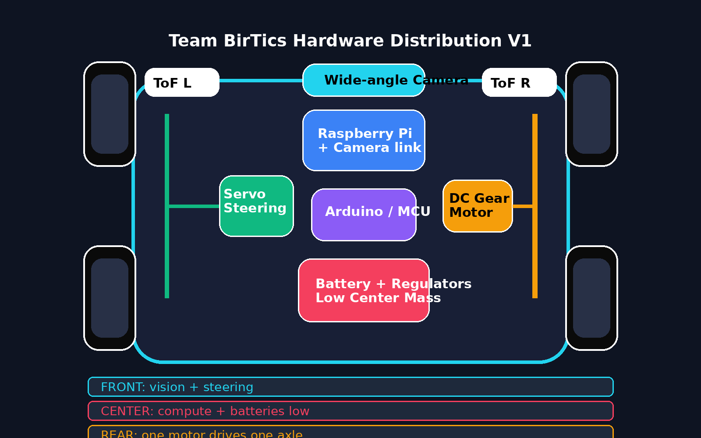
Figure 1. Proposed top-view distribution: front steering, rear axle drive, central compute and low battery placement.

2. One-Table Hardware Selection & Placement Matrix
Subsystem | Selected choice | Placement on chassis | Voltage / power target | Why we chose it | Alternative / backup | Risk / check before buying | Status
Chassis | Custom 3D printed chassis | Full base, approx. 240-270 mm length and 150-180 mm width | N/A | Maximum control over size, sensor mounts, weight distribution, and engineering documentation | Small RC chassis | Must remain under 300 x 200 mm and total height under 300 mm | SELECTED
Drive architecture | Rear-wheel drive | Rear section | Motor voltage decided by selected motor, likely 6-12V | Simple, legal, car-like, easy to document | Front-wheel drive | Do not use left motor + right motor steering | SELECTED
Driving motor | 1 DC gear motor, preferably with encoder | Rear center, connected to rear axle | 6-12V target; choose current after motor datasheet | One motor avoids differential-drive risk and keeps control simple | 2 motors mechanically coupled to same axle | Must not independently drive left and right sides | SELECTED CONCEPT
Rear axle | Single metal rear axle with bearings | Rear, connecting both rear wheels | Mechanical part | Distributes motor motion mechanically to both wheels | Belt/pulley or gear transfer | Axle must be straight, low friction, and strong | SELECTED
Steering actuator | Metal gear servo, DS3218 preferred; MG996R backup | Front center with steering linkage | 6V rail, at least 3A peak available | Real steering actuator required; strong enough for rubber wheels | MG996R for prototype | Never power servo from Raspberry Pi/Arduino 5V pin | SELECTED
Wheels | 4 rubber RC wheels | Two front steering wheels, two rear driven wheels | N/A | Grip, stability, legal; supports parking and corner control | Foam/rubber wheels if same legal type | No omni, ball caster, or spherical wheels | SELECTED
Motor driver | Cytron MD10C if motor current is high; TB6612FNG only for small motors | Near rear motor, short motor wires | Input follows motor battery; logic from MCU | Reliable speed control with PWM and direction control | BTS7960 for high current | Driver current rating must exceed motor stall current | NEED MOTOR DATASHEET
Main computer | Raspberry Pi 5 or Pi 4 | Center/top deck with airflow | 5.1V, 5A stable supply for Pi 5 | Good for camera + OpenCV processing | Jetson only if heavy AI needed | Heat, brownouts, and weight must be controlled | SELECTED
Microcontroller | Arduino Nano or UNO | Center deck near motor driver and servo signal wires | 5V logic; powered from regulated 5V rail | Stable real-time control of motor, servo, encoder, button | Pico / STM32 | All connections to Pi must be wired; no wireless use | SELECTED
Camera | Wide-angle camera | Front/top, adjustable tilt | Powered by Pi CSI or USB | Needed for lane, wall, red/green pillar detection | USB wide-angle camera | Mount angle must avoid glare and see near track | SELECTED
Distance sensors | 2 x VL53L1X ToF sensors | Front-left and front-right | Usually 3.3V/5V module input; check board | Useful for walls, parking, obstacle confirmation | Ultrasonic sensors | ToF can be affected by angle/surface; test placement | SELECTED
IMU | BNO055 preferred | Near center of gravity | 3.3V/5V module input depending board | Gives orientation; useful for turns and stability | MPU6050 lower cost | Needs calibration and vibration isolation | SELECTED
Encoder | Motor encoder or magnetic wheel encoder | On motor shaft or rear axle/wheel | 3.3V or 5V depending model | Measures speed/distance, helps stop after laps and park | Optical encoder | Must be mounted securely and tested for noise | SELECTED
Power: motor | 2S LiPo battery as initial target | Low center/rear-center | 7.4V nominal, current depends motor | Good energy density and common for small cars | NiMH pack or 3S only if motor supports it | Need safe charger and fuse/protection plan | SELECTED TARGET
Power: Pi | Dedicated buck regulator or power bank | Low center, separate from motor noise | 5.1V / 5A for Raspberry Pi 5 | Prevents resets when motor/servo draw current | Official Pi supply for bench testing | Common ground required with MCU when signals shared | SELECTED
Power: servo | Dedicated buck regulator | Near servo/front center | 6V, 3A+ recommended | Servo peaks can reset electronics if shared badly | 5V high-current rail if servo supports it | Do not share weak Pi/Arduino supply | SELECTED
Start system | One power switch + one start push button | Power switch accessible; start button top side | Depends circuit; button to MCU GPIO | Matches required start procedure and avoids illegal interactions | Integrated button on controller | Only one start button; no switches used to enter data | SELECTED
Wiring/structure | JST/XT connectors, screw terminals, zip ties, heat shrink | All around, fixed and strain-relieved | Wire gauge based on current | Reliability and easy maintenance | Dupont only for low-current signals | Loose wires can fail during rounds | SELECTED

3. Build Order: What to Buy and Test First
Phase | Buy / prepare | Goal | Pass condition | Do not move forward until
Phase 1 - Mechanical skeleton | 3D printed base, 4 rubber wheels, rear axle, bearings, steering linkage prototype | Check size, wheel alignment, and steering freedom | Car rolls smoothly by hand and steering moves without binding | Footprint and height are safely below WRO limits
Phase 2 - Motion control | DC gear motor, motor driver, steering servo, Arduino, 6V servo regulator, motor battery | Make the car drive forward/backward and steer left/right | Start button works; motor PWM and servo angles are controllable | No overheating, no servo jitter, no illegal differential behavior
Phase 3 - Vision and sensors | Raspberry Pi, wide camera, 2 ToF sensors, IMU, encoder | Add perception and feedback | Camera sees track; ToF readings stable; encoder counts correctly | Power rails remain stable while motor and servo run
Phase 4 - Competition reliability | Cable management, spare connectors, fuse/protection, final mounts | Make the robot robust for repeated rounds | 10+ test runs without loose wires, resets, or mechanical failures | Documentation photos, wiring diagram, and test logs are updated

4. Final Architecture Statement for the Engineering Journal
Selected hardware architecture: Team BirTics will build a custom 3D printed four-wheel self-driving car using rear-wheel drive and front-wheel steering. A single DC gear motor drives one rear axle mechanically connected to both rear wheels. A metal gear servo controls the front steering linkage. This choice avoids differential drive, keeps the robot car-like, supports autonomous parking, and makes the design easier to reproduce and document.

5. Quick Legal Red Flags Before Buying
Do NOT buy: 2WD smart robot chassis, 4WD differential robot kit, tank/tracked chassis, omni wheels, ball caster, spherical caster, left/right independent drive motor system, or any module intended for wireless control during the round.

