

Capstone project phase A

25-2-R-5

Intelligent CV Screening and Candidate Ranking System

Supervisor – Gur Arye Yehuda

Students
Lilian Harb
Nadeen Halabi

GitHub link : https://github.com/nadeenhalabi1/projectPhaseB

Table of contents
0 | Abstract | 4
1 | Introduction | 4
2 | Background | 5
2.1 | The Necessity of Automated Resume Screening Systems | 5
2.2 | CV Analysis Using Machine Learning | 5
2.3 | Existing Solutions | 6
3 | Expected Achievements | 7
3.1 | Success Criteria of the Project | 8
4 | System architecture | 9
5 | Research and Model Selection | 10
5.1 | The models | 10
5.1.1 | K-Means | 11
5.1.2 | K-Nearest Neighbors (KNN) | 11
5.1.3 | Support Vector Machines (SVM) | 11
5.1.4 | Decision Tree | 11
5.1.5 | Neural Networks | 11
5.2 | Model Selection Based on Accuracy | 11
5.3 | Calculating Accuracy: Step-by-Step | 12
5.4 | The decision | 12
5.5 | Overview of the K-Nearest Neighbors (KNN) Algorithm | 13
5.6 | Conclusion and Findings | 14
6 | Engineering Process | 15
6.1 | Conclusion and Findings | 15
6.1.1 | Preliminary Research and Literature Review | 15
6.1.2 | Competitive and Market Research | 15
6.1.3 | Interview with a Recruiting Professional | 15
6.1.4 | Potential Challenges in Resume Analysis | 15
6.1.5 | System Database | 16
6.1.5.1 | The Importance of a Diverse Resume Dataset | 16
6.1.5.2 | Datasets | 16
6.1.5.3 | Datasets options | 16
6.1.6 | Ranking candidates and how KNN helps | 17
6.1.7 | Implementing the Project | 18
6.2 | Product | 19
6.2.1 | Project Requirements | 19
6.2.1.1 | Functional Requirements | 19
6.2.1.2 | Non-Functional Requirements | 19
6.2.2 | Use Case diagram | 20
6.2.3 | Activity diagram | 21
6.2.4 | Interface | 22
6.2.4.1 | Log in screen | 22
6.2.4.2 | Weights Configuration Screen | 22
6.2.4.3 | Resume database screen | 24
6.2.4.4 | Candidate Rankings Screen | 24
6.2.5 | Verification and Evaluation | 25
6.2.6 | Validation | 26
7 | References | 27
8 | Appendix A | 28

Abstract
The rapid growth of job applications in modern recruitment has created a pressing need for efficient and fair candidate screening. This project presents the design and development of an Intelligent CV Screening and Candidate Ranking System, a web-based platform that leverages Natural Language Processing (NLP) and Machine Learning (ML) techniques to automate the resume review process. The system extracts key information such as skills, education, and work experience from submitted CVs, converts it into structured data, and ranks candidates based on their alignment with job requirements. At its core, the system employs a K-Nearest Neighbors (KNN) algorithm, chosen for its simplicity, high accuracy, and suitability for small to medium datasets. The platform features customizable weighting of job criteria, transparency in candidate evaluation through explainable rankings, and an intuitive recruiter interface. By standardizing and accelerating the initial screening stage, the system aims to improve hiring efficiency, minimize human bias, and ensure a fairer evaluation process for all applicants.
1 Introduction
Hiring the right people is an important part of any company, but it can also take a lot of time and effort. When a new job is posted, companies often get many CVs from people who apply. Each CV needs to be read and checked to see if the person is a good fit for the job.
This manual work takes a long time and can lead to mistakes or unfair decisions, especially when there is a tight deadline or too many applications.
Sometimes recruiters use their judgment to choose who to move forward, but this can be inconsistent. Different people may focus on different things in a CV, which makes it hard to keep things fair and objective.
This project is about building a smart system that can help with this problem. The system will automatically read CVs, find important information (like education, skills, and work experience), and compare it to the job’s specifications. Then, it will rank the candidates from most to least suitable.
With this system, recruiters will save time, reduce human errors, and avoid missing strong candidates. It will also help standardize the selection process, so every applicant is judged by the same criteria.
For candidates, this system increases the chances of being evaluated fairly, regardless of resume design or formatting.

2 Background
In the digital era of recruitment, companies often receive many applications for each job they post we are talking about an average of 250 CVs per position, from which 4 – 6 candidates are selected for an interview, and finally only one is hired for the position [3]. Reviewing all resumes manually requires a lot of time and resources and can lead to errors or missed opportunities when qualified candidates are overlooked. To address this challenge, automated resume screening systems have been developed to help process and filter resumes efficiently, consistently, and based on objective criteria.
These systems rely on Natural Language Processing (NLP) technologies that allow them to understand human language and extract relevant information from free-form text. They also use Information Extraction techniques to convert unstructured content into organized data that can be analyzed more easily.
One of the biggest challenges in building such a system is the large variety in how resumes are written and formatted. Some people use clear and organized templates, while others write more freely. Some resumes have personal wording, or use visual elements like tables, or colors. Also, the same skill or job experience can be described in different ways, depending on the field, language, or background of the candidate.
2.1 The Necessity of Automated Resume Screening Systems
The necessity of automated resume screening systems has become increasingly evident as the volume of job applications continues to grow and the demand for efficient, unbiased hiring processes rises. Traditional manual screening methods are time-consuming, prone to inconsistencies, and often influenced by subjective human judgment. In fast-paced recruitment environments, this can lead to delays in hiring, overlooked talent, and unfair evaluations. Automated systems provide a scalable solution by quickly analyzing large numbers of resumes, extracting relevant information, and ranking candidates based on predefined job criteria. This automation accelerates recruitment timelines and enhances decision-making by standardizing candidate evaluations [1]. They not only improve efficiency but also promote fairness, transparency, and consistency in the selection process, making them an essential tool for modern recruitment.

2.2 CV Analysis Using Machine Learning
CV Analysis Using Machine Learning is a smart approach to improving the recruitment process by automatically analyzing job applicants' resumes. Instead of manually reviewing each CV, the system uses machine learning algorithms to extract key information such as skills, experience, and education, and then compares it to the job requirements. This helps recruiters identify the most relevant candidates faster, more accurately, and with less bias. Research has demonstrated not only the feasibility but also the remarkable efficiency and accuracy of automating resume classification. The results highlighted the superior performance of the KNN model (which is an ML model), achieving impressive accuracy.[2]. As a result, the hiring process becomes more efficient, consistent, and fair saving valuable time and improving the quality of recruitment outcomes.

2.3 Existing Solutions Several platforms in the market provide automated solutions for analyzing resumes using Natural Language Processing (NLP) and resume parsing technologies.
- RChilli
RChilli is a resume parsing solution that supports multiple file formats including PDF, DOCX, and TXT. It extracts structured data such as contact details, skills, work experience, and education. It is known for its easy-to-integrate API and is commonly used by small to medium-sized businesses.
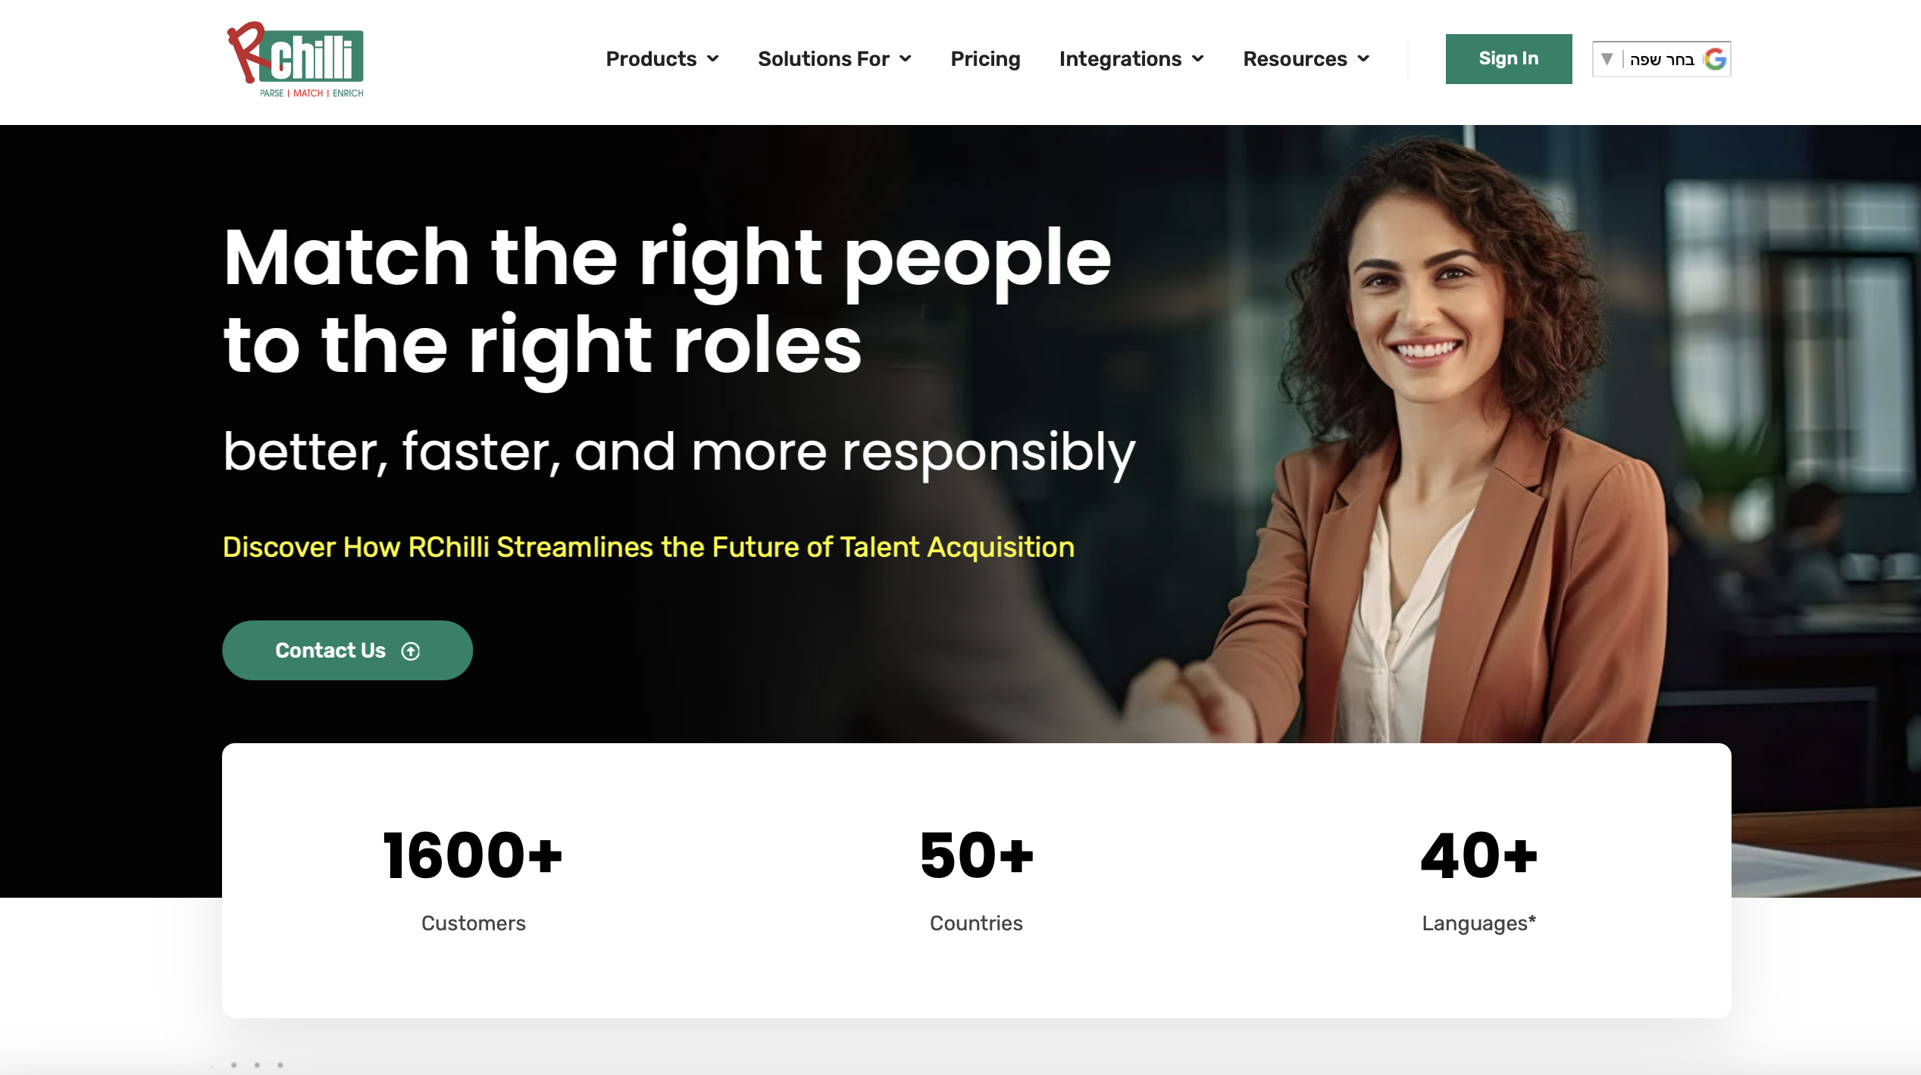
Figure 1: Rchilli website homepage
- Sovren
Sovren is a powerful and mature platform offering both resume parsing and candidate-job matching capabilities. It supports multiple languages and provides advanced matching scores between resumes and job descriptions. Sovren is best suited for enterprise-level HR systems.

Figure 2: Sovern website homepage
- HireAbility
HireAbility focuses on parsing resumes and job descriptions with strong support for non-standard resume formats. It is known for its flexibility and customization capabilities, making it a good option for organizations that deal with highly varied resume designs

Figure 3: HireAbility website homepage

3 Expected Achievements
Our project goal is to develop a smart, user-friendly web platform that automatically analyzes resumes using ML. The system will extract important information, such as education, skills, and work experience, and compare it to job requirements to rank candidates based on relevance.
We expect to achieve:
- Functional CV Analysis System: A fully functioning system that receives a CV, analyzes it using NLP techniques, and outputs structured candidate data.
- Candidate Ranking Algorithm: An algorithm that scores and ranks candidates based on how well they match a given job description.
- Resume Conversion Feature: A tool that allows users to convert text or online profiles into standardized PDF or Word files for analysis.
- Admin Dashboard: A clean interface for recruiters to view ranked candidates, filter results, and track candidate evaluations.
- Explainability: The system will display which features (skills, experience, education) affected each candidate's rank, increasing transparency.
- Accurate Resume Screening: The system will use machine learning algorithms KNN to analyze resumes and evaluate how well each candidate matches a specific job description (by rank). By extracting features such as skills, education, and experience, the system aims to provide accurate candidate rankings and reduce human error in the screening process.
- Tailored to Real Recruitment Needs: Our platform is designed to reflect the actual needs of hiring teams, including support for multi-position screening and job-specific matching criteria. It is trained on real-world resume data to ensure practical performance and relevance to modern recruitment workflows.
- Improving Hiring Efficiency: By automating the initial screening stage, the system will save time and reduce the workload on HR teams. Recruiters will be able to focus on top candidates, while the system handles the repetitive and time-consuming evaluation tasks.
- User-Friendly and Transparent Interface: We aim to build an intuitive web-based interface that allows recruiters to upload resumes, define job requirements, and instantly view ranked candidate results. The system will highlight key factors that influenced each score, providing transparency and confidence in the decision-making process.

3.1 Success Criteria of the Project
- Resume Screening Accuracy – The system should demonstrate high accuracy and reliable performance in classifying and ranking candidates based on their fit to the job description. Evaluation will be based on precision, recall, F1 score, and confusion matrix analysis. High accuracy is critical.
- Design and implement a candidate ranking algorithm - One of the core goals of this project is to develop an ML-based algorithm specifically designed to rank candidates according to how well their resumes match a given job description. Each candidate will be assigned a relevance score, and the system will produce a ranked list that prioritizes the most suitable applicants. The algorithm will also support explainable scoring, highlighting the attributes that most influenced the rank, to ensure transparency and trust in automated decision-making.
- System Responsiveness - The platform is expected to return ranked candidate results within 3 - 5 seconds after resumes are uploaded, ensuring a seamless and efficient workflow for recruiters and the HR team.
- Real-World Adaptability - The model should handle multiple job postings simultaneously, support custom job requirement inputs, and process a variety of resume formats (PDF, Word, plain text).
- Transparency and Explainability - The system must present the reasoning behind each candidate’s score, highlighting key factors such as skills match, relevant experience, or educational background.
- Scalability - The solution should support hundreds of resumes per job posting without significant degradation in performance or accuracy.
- Ease of Maintenance and Extension - The system architecture should allow for easy model updates, integration of additional ML algorithms in the future

4 System architecture
This diagram illustrates the architecture of the resume screening system, showing how different components interact to enable automated candidate evaluation and ranking using ML algorithms – we are going to test several algorithms, then decide which model we will use
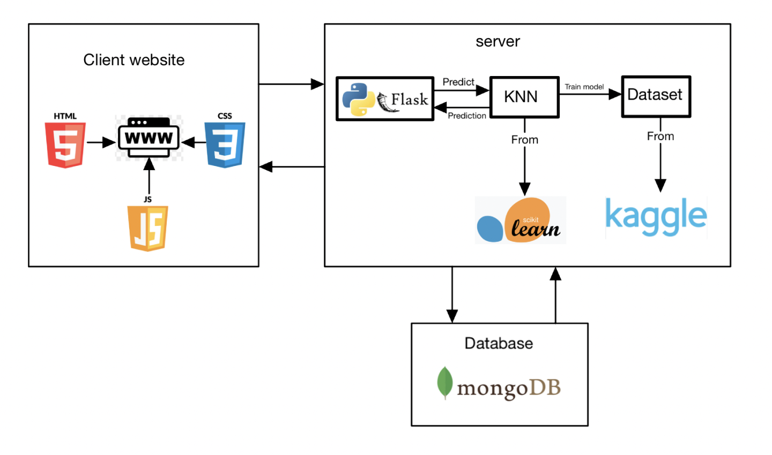
Figure 4 : Software Architecture Diagram
Client Website:
- The client website is developed using HTML, CSS, and JavaScript.
- Recruiters can modify job requirements and assign custom weight to each criterion to influence the candidate ranking calculation.
- After candidates submit their resumes, the recruiter is presented with a list of all candidates along with their rankings, sorted from highest to lowest.
Server:
- The Flask server accepts incoming data from the client website, which includes uploaded resumes and recruiter-defined job criteria.
- The server parses and converts the input (resumes and job requirements) into structured feature vectors suitable for analysis.
- The structured data is sent to the KNN algorithm for similarity comparison and ranking.
- The KNN model, implemented using the Scikit-learn library, calculates a relevance score for each candidate based on proximity to job criteria.
- The model may utilize labeled resume data from a dataset for initial training or performance tuning.
- Once the model completes its analysis, the server formats the output and sends the ranked candidate list back to the client website.
Machine Learning Model:
- The KNN model is used to rank candidates.
Dataset:
- The dataset used is from Kaggle
- It is used to train the KNN model.

Database: It used to store all the information.

5 Research and Model Selection
In the context of building an intelligent resume screening system, selecting the most appropriate machine learning model is crucial. This section presents a comparative analysis of five widely used and well-established ML models: K-Means, K-Nearest Neighbors (KNN), Support Vector Machines (SVM), Decision Tree, and Neural Networks to determine the most suitable algorithm for extracting, classifying, and ranking candidate information from resumes.
5.1 The models
5.1.1 K-Means
An unsupervised algorithm that clusters resume into groups based on feature similarity, useful for exploratory grouping but not for classification.
5.1.2 K-Nearest Neighbors (KNN)
A simple and effective supervised algorithm that classifies resumes based on similarity to existing labeled data, ideal for smaller datasets.
5.1.3 Support Vector Machines (SVM)
A robust classifier that performs well in high-dimensional spaces, especially effective at distinguishing between qualified and unqualified candidates.
5.1.4 Decision Tree
An interpretable model that splits data based on features but may overfit if not carefully controlled.
5.1.5 Neural Networks
A powerful and highly accurate model for learning complex resume patterns, best suited for large datasets with sufficient computing resources.

5.2 Model Selection Based on Accuracy
Among the various performance metrics used to evaluate models, accuracy remains one of the most intuitive and widely adopted. Accuracy measures the percentage of correct predictions made by the model out of all predictions, providing a clear indicator of how well the model distinguishes between suitable and unsuitable candidates. Accuracy is a fundamental metric for evaluating the performance of a classification model, providing a quick snapshot of how well the model is performing in terms of correct predictions. It is calculated as the ratio of correct predictions to the total number of input samples [4].
In this project, we will prioritize the model with the highest accuracy score, as our goal is to maximize the number of correct classifications while minimizing errors. A high accuracy score indicates that the model can consistently predict whether a candidate matches the job requirements based on features such as skills, experience, and education. This is particularly important in resume screening, where even small mistakes can result in qualified candidates being overlooked or unsuitable ones advancing.
By comparing the results of different algorithms using real-world data and validating them through performance metrics, we ensure that our final model choice is not only theoretically sound but also empirically justified. Therefore, the selected model will be the one that achieves the best accuracy during testing, reflecting its reliability and effectiveness in practical recruitment scenarios.

5.3 Calculating Accuracy: Step-by-Step
The goal is to determine how many predictions the model got right out of all predictions it made. The process begins after the model has been trained on a training set and is evaluated on a separate test set.
The first step - find all parameters:
- True Positive (TP): The model predicted "yes", and the actual label is also "yes".
- True Negative (TN): The model predicted "no", and the actual label is also "no".
- False Positive (FP): The model predicted "yes", but the actual label is "no".
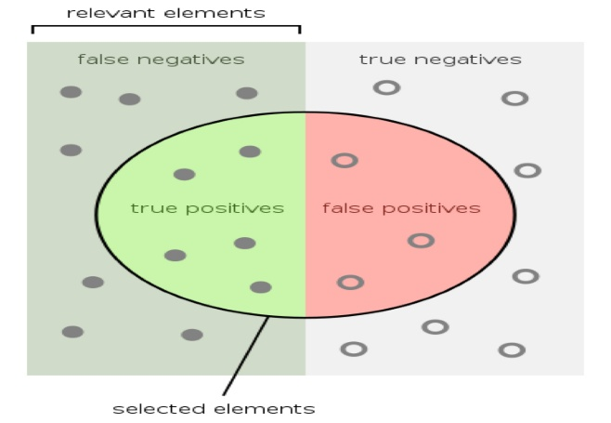
- False Negative (FN): The model predicted "no", but the actual label is "yes".

Figure 5: Confusion matrix zones – TP, FP, TN, FN
The second step - using the confusion matrix, accuracy is then calculated using the following formula:

$$ACCURACY= \frac{( TP+TN )}{\left( TP+TN+FP+FN \right)}$$
5.4 The decision
KNN has consistently demonstrated high accuracy in resume classification tasks. For instance, one study reported that KNN achieved an impressive accuracy of 98.44%, outperforming on SVM in terms of accuracy when applied to structured resume datasets [2].
Another source went even further, showing 99% accuracy using a One-vs-Rest strategy with KNN, suggesting its adaptability to multi-class problems commonly found in recruitment scenarios [5].
Additionally, its simplicity, interpretability, and ease of implementation make it especially appealing for small to mid-sized datasets where computational overhead is a concern.
While Neural Networks have shown superior accuracy in large-scale and complex scenarios, such as in the DeepResume study [6], they come with higher training complexity and require large volumes of labeled data and computational power. This makes them less practical for small to medium-sized teams or projects with limited resources.
SVM, despite being a strong performer in high-dimensional spaces, was slightly outperformed by KNN in multiple studies focused on resume data [2, 7].
Decision Trees, on the other hand, offer high interpretability but suffer from overfitting unless carefully tuned and pruned, and they achieve lower accuracy rates in most relevant tests sometimes as low as 74% [8].
Unsupervised models like K-Means are valuable for clustering similar resumes, such as grouping candidates by skill sets, but they lack the supervised capabilities required for precise candidate-job matching. As such, they are better suited for supplementary analysis rather than core classification.
In conclusion, KNN stands out as the most practical and high-performing model for resume screening in this project. It provides an ideal balance between accuracy, simplicity, and performance, supported by multiple independent studies. Unless working with a significantly large and complex dataset that justifies the use of deep learning, KNN is the recommended choice for moving forward.
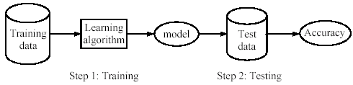
Figure 6: General training and testing process for KNN classification model
5.5 Overview of the K-Nearest Neighbors (KNN) Algorithm – Summary Based on IBM[9].
The K-Nearest Neighbors (KNN) algorithm is one of the most widely used and intuitive supervised machine learning techniques. It is primarily applied to classification and regression tasks. KNN is a non-parametric, instance-based learning algorithm, meaning it does not build a model during training. Instead, it stores all the training data and performs computation at prediction time.
How It Works
When a new data point is introduced for example, a candidate's resume, the algorithm:
- Calculates the distance between the new point and all training samples.
- Selects the k nearest neighbors based on the chosen distance metric.
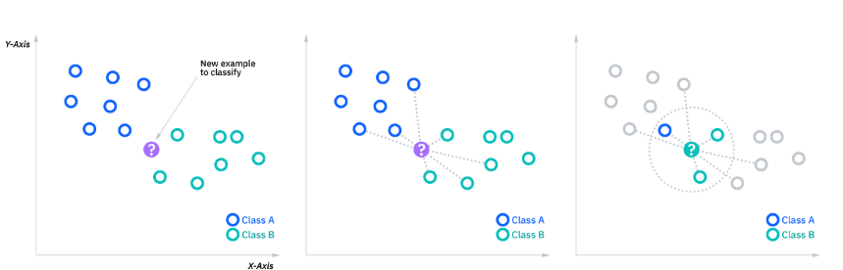
- Uses majority voting (for classification) or averaging (for regression) from the neighbors to assign a predicted value or class.
Figure 7: KNN diagram

- Distance Formula - In order to determine which data points are closest to a given query point, the distance between the query point and the other data points will need to be calculated.
The most common way to find the distance between two points is :

$d\left(x,y\right)= \sqrt{\sum_{i=1}^{n}{{( x_{i}-y_{i})}^{2}}}$
5.6 Conclusion and Findings
During this section, we examined several machine learning models to determine which would be most suitable for an automated resume screening system. We compared five leading algorithms: K-Means, KNN, SVM, Decision Tree, and Neural Networks. while considering parameters such as accuracy, ease of use, computational requirements, and their applicability to real-world recruitment scenarios. Based on our comparisons and the data collected, the KNN model emerged as the most appropriate choice for our project. It offers an effective combination of high accuracy (reaching up to 99% in some studies), simplicity in implementation, and adaptability to complex classification tasks. Since the system is expected to process a relatively moderate amount of data, an average of 250 resumes per job posting the KNN model appears capable of handling this volume efficiently.
Therefore, based on these findings, we recommend continuing with KNN as the primary model; it is accurate, easy to understand, and well-suited for practical use in intelligent resume screening systems.

6 Engineering Process
6.1 Research and Review
6.1.1 Preliminary Research and Literature Review
As preparation for the project, we reviewed numerous academic articles and professional sources related to resume screening, machine learning algorithms, and NLP techniques. This research deepened our understanding of the field and helped us evaluate different models. Based on insights from the literature, we selected KNN as the core algorithm for its accuracy, simplicity, and suitability for our project needs.

6.1.2 Competitive and Market Research
We explored various existing platforms and tools used for automated resume screening. By analyzing commercial systems such as RChilli, Sovren, and HireAbility, we gained practical insight into current market standards, features, and limitations.

6.1.3 Interview with a Recruiting Professional – Rawan Abu Saada
To ensure our system meets real-world recruitment needs, we interviewed Rawan. The goal was to gather practical insights about resume screening workflows, daily challenges in hiring, and expectations from automated tools. This conversation also allowed us to present the current version of our project and receive direct feedback regarding its usability.
* Questions and answers in appendix A.
6.1.4 Potential Challenges in Resume Analysis
The development of an automated resume screening system may face the following challenges:
Problem with recognizing visual elements such as icons, tables, and non-textual formatting.
Problems with spelling mistakes, grammar mistakes, and mixed languages can affect parsing. Also, Candidates may use different terms to describe the same skills or job roles. (B.Sc. = Bachelor of Science).

6.1.5 System Database
6.1.5.1 The Importance of a Diverse Resume Dataset
To develop a reliable and efficient resume screening system, a database containing a wide variety of resumes is required. Diversity in the data in terms of industries, job roles, formatting styles, languages, and candidate backgrounds is essential to enable the system to analyze a broad range of resumes and effectively handle expected challenges. Such exposure improves the model’s ability to generalize, reduces bias, and contributes to higher accuracy in real-world resume analysis. Therefore, a rich and diverse dataset is a critical component in building a robust, fair, and effective system. This foundation will directly influence the quality of candidate ranking and the overall trust users place in the platform’s recommendations.
6.1.5.2 Datasets
Today a wide range of preexisting resume datasets can be found online, offering a valuable starting point for developing and testing automated screening systems. These datasets available through platforms such as Kaggle, GitHub, and open academic archives contain both real and synthetic resumes, often accompanied by job descriptions and relevance labels. Using such resources allows for faster system prototyping while exposing the model to diverse formatting styles, job sectors, and candidate profiles. Nevertheless, these datasets usually require careful adaptation and refinement to align with the specific goals, structure, and performance standards of our platform. In necessary, we will manually add values because KNN is supervised algorithm.
6.1.5.3 Datasets options
Our intention is not to confine the analysis to a single dataset or to become overly reliant on one fixed source of information. Instead, We aim to demonstrate a spectrum of possibilities and conceptual directions. This approach allows for greater flexibility, encourages open exploration, and avoids premature commitment to any dataset, which may otherwise limit the scope or adaptability of the work.
Examples of suitable datasets that we can use:
- https://www.kaggle.com/datasets/gauravduttakiit/resume-dataset/data
- https://www.kaggle.com/datasets/snehaanbhawal/resume-dataset

6.1.6 Ranking candidates and how KNN helps
In this project, the K-Nearest Neighbors (KNN) algorithm plays a central role in the candidate ranking process. Its simplicity, transparency, and effectiveness make it highly suitable for real-world recruitment applications, where explainability and reliability are critical. By leveraging KNN, the system is able to evaluate each candidate’s resume against predefined job requirements and identify the most relevant profiles based on similarity. KNN allows us to see which past examples influenced the outcome, making it ideal for a transparent and fair hiring system.
KNN will be applied after resumes are parsed and converted into structured feature vectors. Each resume is represented numerically based on attributes such as years of experience, number of relevant skills, education level, certifications, and language proficiency. The job description is also encoded as a vector of desired criteria. Once the resume is vectorized, the algorithm calculates the distance between the candidate's profile and the job requirements.
The system then identifies the k closest resumes (neighbors) from the labeled training set. These could be previous resumes marked as "suitable" for similar positions. The candidate receives a relevance score based on how many of these neighbors are classified as strong matches. This score is then used to rank the candidate within the applicant pool.
In addition, the system can highlight which features contributed most to the closeness between the resume and the job criteria such as shared technical skills or matching experience years. This enables recruiters to not only receive a ranked list but also understand why a candidate was placed in a specific position, supporting trust and decision-making.
To ensure that the system can accurately rank candidates for a wide range of job postings, we must also treat the job description itself as a feature vector just like we do with resumes. This allows the algorithm to compare any candidate directly to the specific requirements of a given job.
How is this implemented?
- Step 1 – Unified Data Representation
We use NLP techniques to extract structured information from job descriptions, including required skills, years of experience, education level, certifications, and languages. This information is converted into a numerical feature vector just like we do with candidate resumes.
- Step 2 – Custom Weighting
Not all features are equally important for every job. The system will allow feature weighting, either automatically, based on job description content or manually, set by the recruiter.
- Step 3 – Distance Calculation
Once both the job and each resume are represented in the same vector format, we compute the distance between each candidate and the job. The smaller the distance, the higher the match and the higher the candidate’s rank.
- Step 4 – Final Scoring and Ranking
The algorithm identifies the k most similar resumes to the job profile and calculates a relevance score. This score determines the candidate’s position in the ranked list.

6.1.7 Implementing the Project
This project will be developed using a structured approach to create a smart, user-friendly platform for automated resume screening and candidate ranking.
- Backend: Python with Flask for server-side logic and KNN integration
- Frontend: HTML, CSS, JavaScript for a responsive recruiter interface
- Machine Learning: Scikit-learn for implementing the KNN algorithm

Data Preparation
Resumes from various sources will be cleaned, standardized, and converted into structured vectors. Missing values will be filled, and job descriptions will be processed similarly to allow accurate comparison.
Model Development
KNN will match candidate profiles to job criteria based on similarity. Each candidate will receive a relevance score and be ranked. The system will also show which features influenced the score.
Website Development
When a candidate uploads their resume through the platform, the file is immediately processed by the system. It is parsed, converted into a structured format, and sent directly to the ranking algorithm. The candidate is then automatically scored and positioned in the ranked list based on their relevance to the job description, without requiring any manual intervention from the recruiter.

6.2 Product
6.2.1 Project Requirements
6.2.1.1 Functional Requirements
1. | The system will allow users to upload resumes in various formats.
2. | The system will extract structured data from resumes such as skills, education, and experience using NLP techniques.
3. | The system will rank candidates based on their relevance to the job description using a KNN-based algorithm
4. | The system will allow users to define custom job criteria
5. | The system will display a ranked list of candidates with a relevance score for each.
6. | The system will provide explanations for the ranking, highlighting the key features that affected each candidate's score.

6.2.1.2 Non-Functional Requirements
1 | The system will be a web, accessible from any device with internet connectivity.
2 | The platform will be used by recruiters, HR managers, and hiring professionals.
3 | The interface will highlight the factors influencing each candidate’s rank
4 | The system will process and return ranked candidate results in under 5 seconds.
5 | The model will achieve an accuracy of at least 90% in candidate ranking based on job relevance.
6 | The explanation of candidate rankings will be presented in a transparent and easy-to-understand format.

6.2.2 Use Case diagram
To better understand the interaction between users and the system, we created a use case diagram that maps the main functionalities and user roles within the resume screening platform.
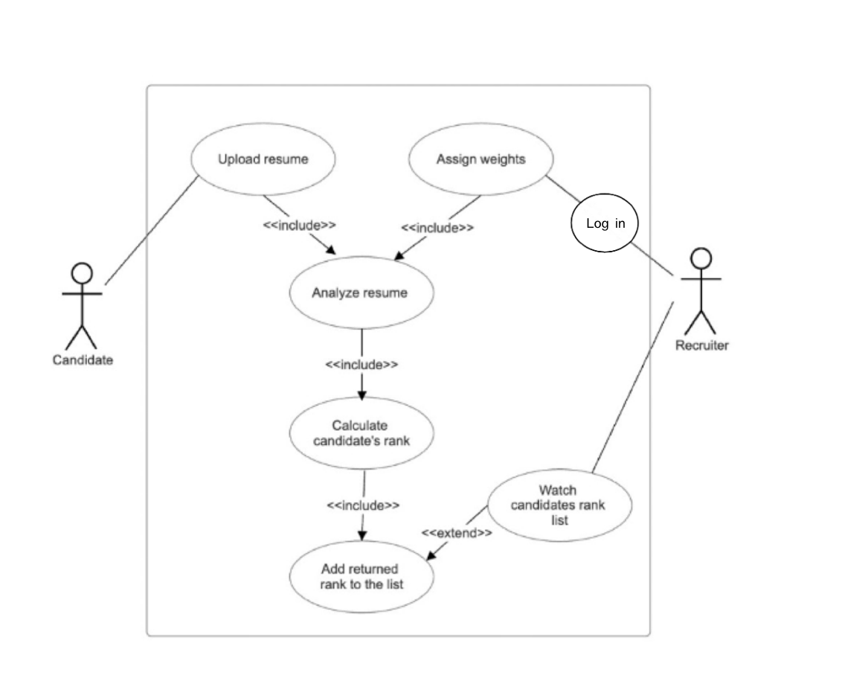
Figure 8: Use case diagram

6.2.3 Activity diagram
To illustrate the workflow of the resume screening system, we created an activity diagram that shows the key steps from resume submission to candidate ranking.
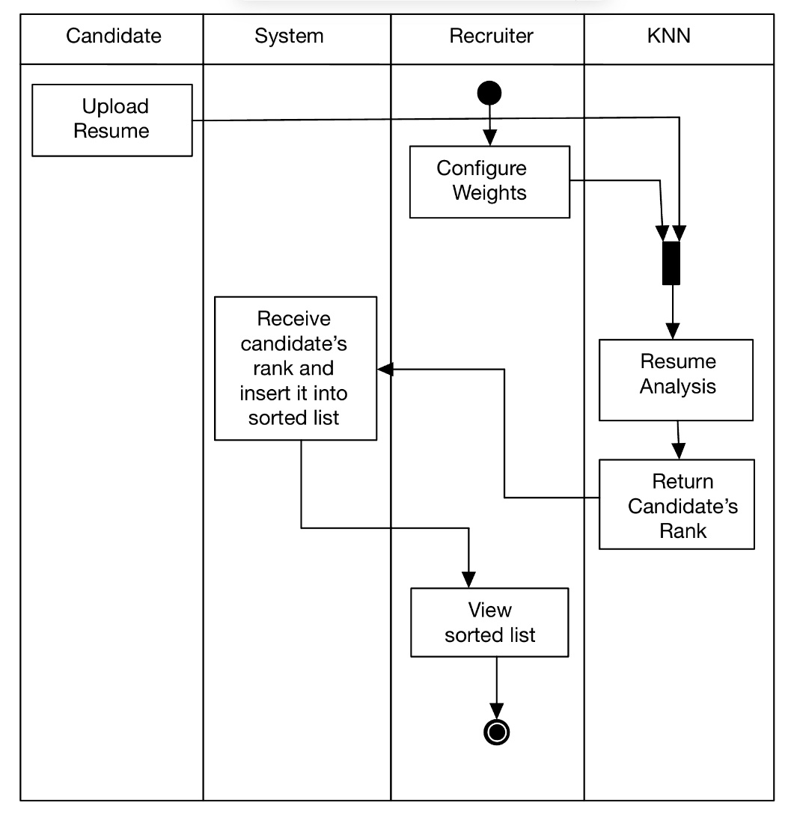
Figure 9: Activity diagram

6.2.4 Interface
6.2.4.1 Log in screen:
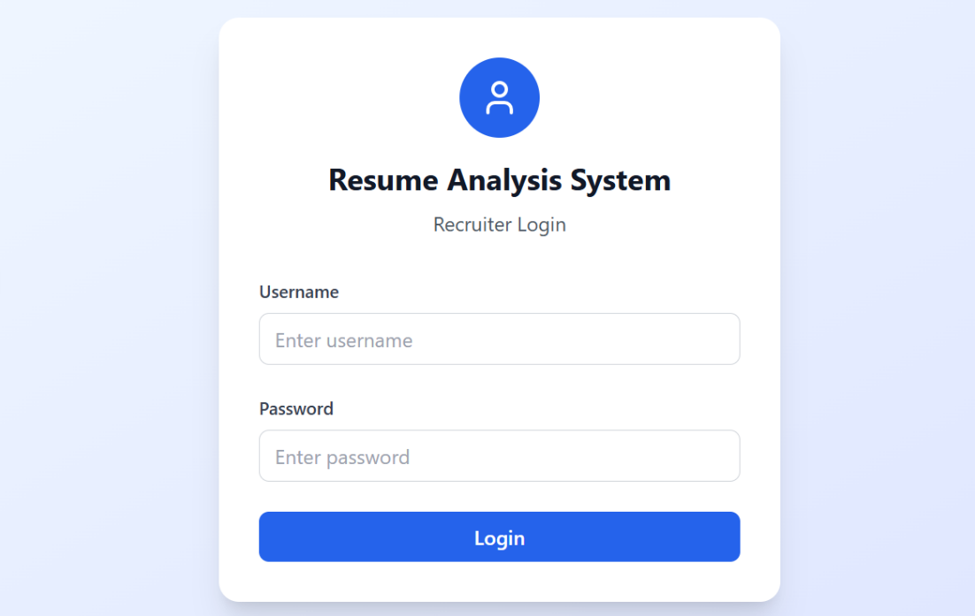

Figure 10: Log in screen
- Username and Password fields
- "Login" button
6.2.4.2 Weights Configuration Screen:
Step 1 – view positions:
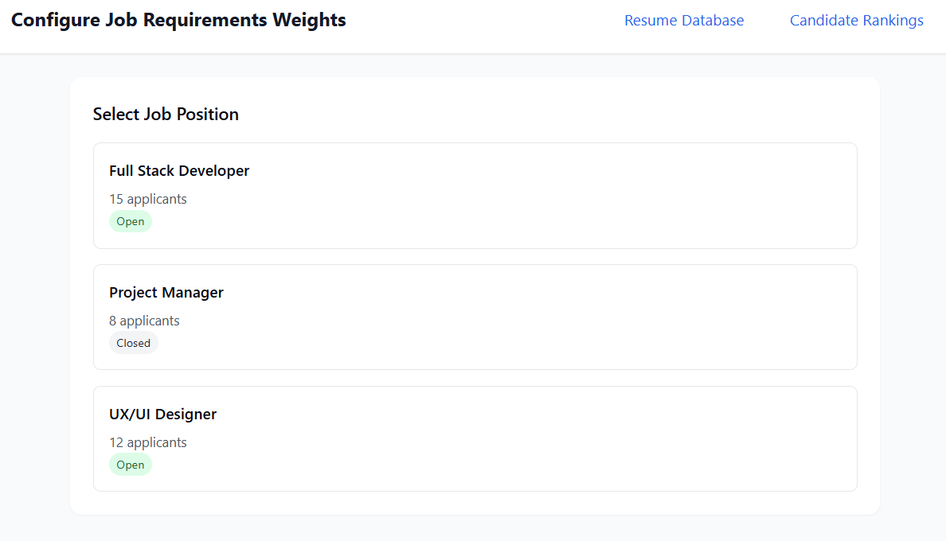
Figure 11: Weights configuration screen-step 1
- Job positions: "Full Stack Developer", "Project Manager", "UX/UI Designer"

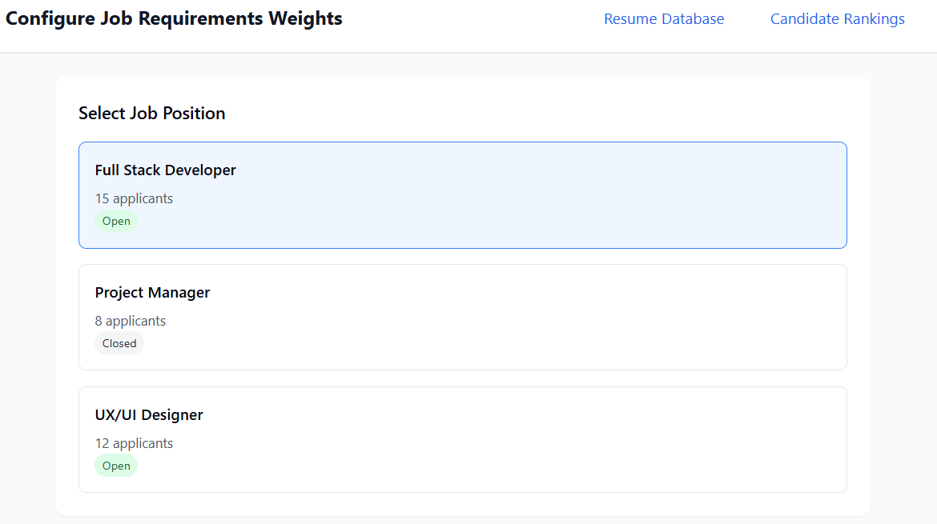
Step 2 – select position:

Figure 12: Weights configuration screen-step 2

Step 3 – configure weights and save settings:
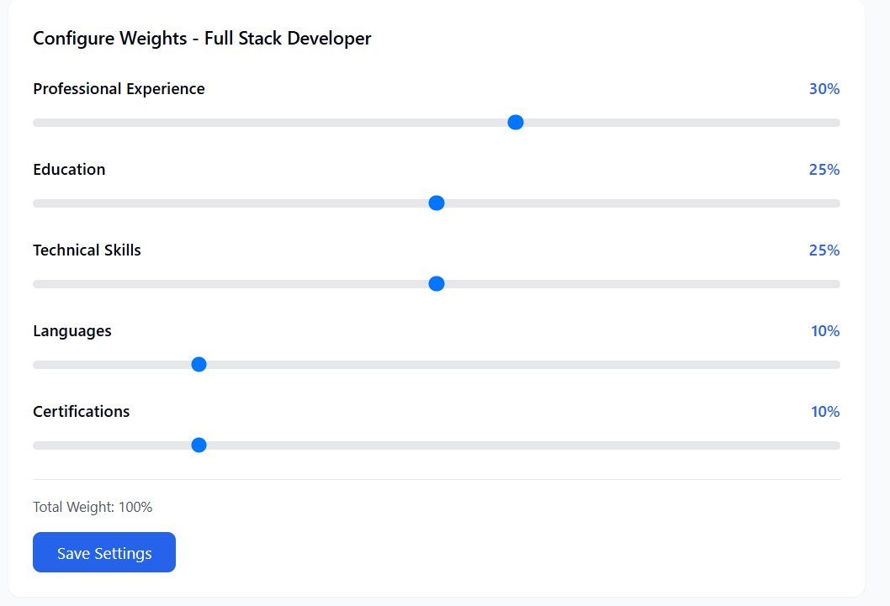
Figure 13: Weights configuration screen-step 3

- Weight categories: "Professional Experience", "Education", "Technical Skills", "Languages", "Certifications"
- Slide bar to configure each category
- "Save Settings" button

6.2.4.3 Resume database screen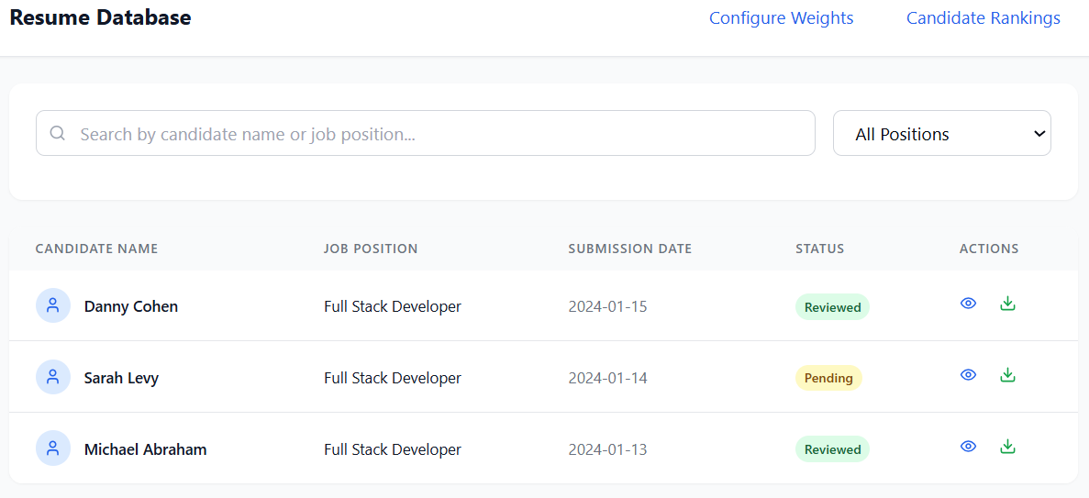
Figure 14: Resume database screen
- Search placeholder: "Search by candidate name or job position..."
- Table headers: "Candidate Name", "Job Position", "Submission Date", "Status", "Actions"
- Status values: "Reviewed", "Pending"

6.2.4.4 Candidate Rankings Screen:
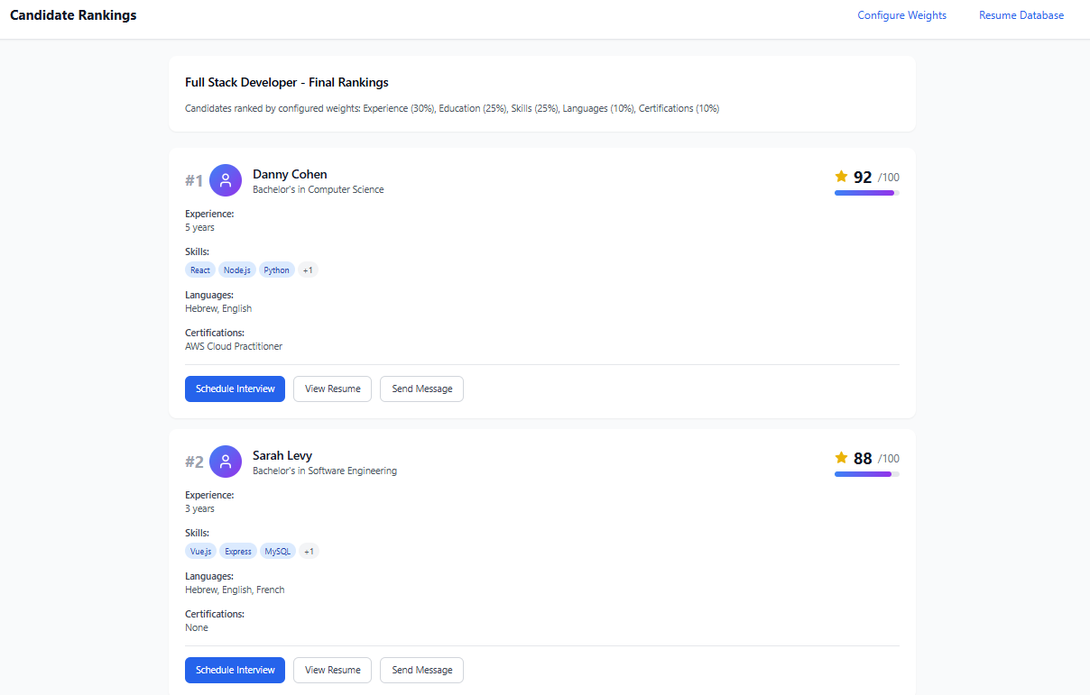
Figure 15: Candidate Rankings Screen
- Candidate details
- Candidate rank
- Action buttons: "Schedule Interview", "View Resume", "Send Message"

6.2.5 Verification and Evaluation
Case | Test case | Expected result
1 | Enter valid username and password and click 'Login'. | User is successfully logged in
2 | Leave at least one field empty and click 'Login'. | An error message is displayed indicating required fields.
3 | Click any position. | The job position is highlighted, and corresponding weights are shown.
4 | Move sliders to change weight distribution and click 'Save Settings'. | Weights are saved and reflected in the candidate ranking.
5 | Try saving weights that don’t add up to 100%. | An error message appears instructing to correct the total to exactly 100%.
6 | Open a position where no resumes have been submitted yet. | A message appears: “No resumes submitted yet.”
7 | Two candidates or more receive the same final score. | The system will display alphabetically when receiving the same grade.
9 | Navigate to 'Resume Database' to view submitted resumes. | A list of candidates with status and actions is displayed.

6.2.6 Validation
Interface Validation
To ensure accessibility and consistent performance, the system’s user interface will be tested across a range of devices, including computers and smartphones.
Model Evaluation
The K-Nearest Neighbors (KNN) model used for candidate ranking will be validated for accuracy. The model will be trained on 80% of the dataset and tested on the remaining 20% to evaluate its performance using metrics such as precision, recall, and F1-score.
Recruiter Feedback & Usability Testing
We will conduct user testing with recruiters from different industries to assess the platform’s usability, clarity, and value in real-world recruitment processes. Participants will be asked to perform typical tasks, such as uploading resumes, configuring job requirements, and reviewing ranked candidates. Their feedback will help identify points of friction, suggest usability improvements, and ensure the platform effectively supports recruitment goals. Any insights gained will be used to refine the system and enhance the user experience before final deployment.

7 References
[1] Moses Blessing (2025). AI-Powered Resume Screening: Benefits and Challenges https://www.researchgate.net/publication/388688179_AI-Powered_Resume_Screening_Benefits_and_Challenges
[2] Dr. Sandeep Tayal, Taniya Sharma, Shivansh Singhal, Anurag Thakur (2024). Resume Screening using Machine Learninghttps://www.researchgate.net/publication/379994980_Resume_Screening_using_Machine_Learning
[3] Drushim IL system (2022). 10 Burning Questions About Writing a Resume https://www.drushim.co.il/article/423/
[4] Evaluation Metrics in Machine Learning(2025). https://www.geeksforgeeks.org/metrics-for-machine-learning-model/#accuracy
[5] Best Approach for Resume screening by Machine Learning- Part 1(2022).
https://blog.nashtechglobal.com/best-approach-for-resume-screening-by-machine-learning/
[6] 1Dr.T. Amalraj Victoire, 2M. Vasuki,3Yazhisai Selvi.S(2024). DEEPRESUME: DEEP LEARNING-BASED RESUME PARSING FOR CANDIDATE SCREENING https://rjpn.org/ijcspub/papers/IJCSP24B1154.pdf
[7] Ahmed Heakl Youssef MohamedNoran MohamedAly ElsharkawyAhmed Zaky(2024). ResuméAtlas: Revisiting Resume Classification with Large-Scale Datasets and Large Language Models https://arxiv.org/html/2406.18125v2
[8] Kirill Smelyakov 1 , Yuliia Hurova 1 and Serhii Osiievskyi 2(2023). Analysis of the Effectiveness of Using Machine Learning Algorithms to Make Hiring Decisions https://ceur-ws.org/Vol-3387/paper7.pdf
[9] IBM. What is the k-nearest neighbors (KNN) algorithm? https://www.ibm.com/think/topics/knn

8 *Appendix A
Interview with a Recruiting Professional – Rawan Abu Saada
- How do you currently screen resumes for a job opening?
Answer: There’s a system that filters based on specific keywords to see if it fits the job or the required skills. Also, there are certain jobs I look at first based on education for example, if they’re looking for a technician or a practical engineer.
So, in general, I search based on what’s most relevant to the position whether it’s a specific technology, experience, or education - to first make sure the candidate has what’s needed.

- On average, how much time do you spend reviewing resumes for a single position?
Answer: It really depends on the complexity of the role and how many candidates there are. Usually, it takes between a minute and a half to 10 minutes, depending on how complex the job and its requirements are.
For example, I once had a position for an automation developer, but they also needed to have knowledge in several other areas - so it took longer.
So yes, it depends on the role and how complex it is. On average, it takes me around 6–7 minutes.

- What are the key criteria you look for in a candidate’s resume?
Answer: I look at this from two sides.
The first side is the experience - if the candidate has the right technical skills, technological background, or relevant education. In this case, I usually focus on the technical part. For example, if it’s a hands-on job, I’ll pay more attention to their technical abilities.
The second side is the candidate’s personality. When I meet the candidate or even just look at their resume, I’m interested to see if they do things beyond just work - like hobbies or other interests. That gives me a sense of who they are as a person.
If someone is, let’s say, an excellent engineer but doesn’t really do anything beyond that or work on personal development, it’s different from someone who does - and that extra effort really stands out and gives them an advantage.

- What are the main challenges or bottlenecks you face during the initial screening stage?
Answer: One of the challenges is that sometimes, when I search using keywords, I get flooded with thousands of resumes and many of them aren’t really relevant. That part takes time and can make it harder to find the strongest candidates. On the other hand, I can also come across really great resumes that match the job requirements perfectly. So, the search always needs to be as accurate as possible. For example, I sometimes add a year to the search, because when I used to search for an industrial engineer, I would get a lot of very old resumes and by now, those people are already working in finance or something completely different. So I try to be as precise as I can, but the problem is that when I narrow it down too much, I end up with only a few candidates and might miss out on the ones who are actually the best fit for the job.

- Have you ever felt that strong candidates were overlooked? If so, why do you think that happens?
Answer: Sometimes it really does happen- we’re busy, not fully focused, or thinking about other things. And sometimes we believe we’ve already found the perfect candidate based on a resume we saw earlier, so we might miss someone who’s the strongest fit for the role we’re reviewing now.
But we usually solve that by going through several filtering stages. If we notice the same person showing up in multiple filters, that’s a red flag and we review their resume.
If the role they were a great fit for has already been filled, we mark them in the system as a “star” candidate, so they’ll show up again for future openings.

- Do you currently use any automated screening tools? If yes, what works well and what doesn’t?
Answer: Like I mentioned earlier, we do use a system that helps us. The system comes pre-built, and we can’t really make changes to it. I use it to search by keywords, which does help it narrows down the pool of resumes, so I get a more relevant set to work with.
But there’s still a challenge, because the system doesn’t always identify the right matches. In those cases, I need to invest more time and really fine-tune the search and the keywords I already entered.

- Would you find it helpful to receive an automatically ranked list of candidates based on their relevance to the job? Why or why not?
Answer: I think the answer is yes and no.
On one hand, it can be helpful because it saves time and lets us focus on the strongest candidates.
But at the same time, it can also be a disadvantage especially when it comes to very specific or complex roles. In those cases, mistakes or misses can happen, and human screening might catch things that the system doesn’t.

- How important is it for you to understand why a candidate received a certain ranking?
Answer: First, it’s important for me to see if the score the candidate received matches the requirements and values of the company, I’m submitting them to.
In addition, I want to be able to identify if there’s potential for keeping the candidate in the screening process. Sometimes we get a candidate with 100% match, and sometimes we get one who’s missing just one requirement but it’s something they can quickly learn or develop.
In that case, it’s worth considering them, or even evaluating them specifically on that missing point, so we don’t miss out on a great candidate just because of something minor, especially when they’re strong in all the other areas.

- Do you see value in being able to set custom weights for criteria like skills, experience, or education?
Answer: Absolutely, the answer is yes. When it comes to setting weights for different requirements, it can help.
Sometimes a candidate comes along who is the best fit in terms of the most important skills and requirements and like I mentioned in the previous question, they might be missing just one small detail that isn’t really critical.
So, when we assign different weights, it helps us see the bigger picture and move forward with candidates who are strong where it really matters.

- What kind of information or visual display would help you better understand a candidate’s suitability?
Answer: Something I think could be added and would be a great addition is graphs that show the match in terms of skills and experience.
This would make things easier for me, since I could see everything visually with percentages, instead of just reading through text. It would be more interesting and much clearer.

