

Capstone project phase B

25-2-R-5

Intelligent CV Screening and Candidate Ranking System

Supervisor – Gur Arye Yehuda

Students

Lilian Harb
Nadeen Halabi

GitHub link : https://github.com/nadeenhalabi1/projectPhaseB
Table of Contents
Abstract 3
1. Introduction 4
2. Problem overview and background 4
2.1. Technologies used in the project – General overview 5
2.1.1. Frontend technology – React 5
2.1.2. Backend technology – Node.js & Express 6
2.1.3. Machine Learning – K-Nearest Neighbors (KNN) 6
2.1.4. Database and data management - MongoDB 7
2.1.5. Security and Authentication - JWT 7
3. The project 7
3.1. Website 7
3.1.1. Activity diagram 7
3.2. Ranking resumes using Machine Learning 8
4. System description 9
4.1. System architecture 9
4.1.1. Frontend (Client side) 9
4.1.2. Backend (Server side) 9
4.1.2.1. Database (Data layer) 9
5. System Implementation 10
5.1. Functional flow 10
5.1.1. User authentication 10
5.1.2. Dashboard overview 10
5.1.3. Job creation 11
5.1.4. Resume upload and processing 11
5.1.5. AI-powered data extraction 11
5.1.6. Candidate ranking algorithm 11
5.1.7. Smart re-ranking and Quick re-rank 12
5.1.8. Candidate management 12
5.2. Frontend User Workflow 13
5.3. Technical Features Summary 13
6. Challenges and Lessons Learned 14
6.1. Challenges Faced 15
7. Testing 16
8. Summary and conclusions 17
8.1. Lessons learned 18
8.2. Future enhancements and extensions 18
9. References 19
1. User Guide 20
1.1. Introduction 20
1.2. Website Usage 20
1.3. User Interface 20
1.3.1. Login page 20
1.3.2. Registration Page 21
1.3.3. Dashboard – Before Job Creation 21
1.3.4. Job page 23
1.3.5. Create new job page 23
1.3.5.1. Job Information Section 24
1.3.5.2. Requirements Section 24
1.3.5.3. Evaluation Criteria Section 25
1.3.5.4. Create Job Action 26
1.3.5.5. Job page (after creating job) 27
1.3.6. Job Overview Page 27
1.3.6.1. Upload section 28
1.3.6.2. Candidates section 28
1.3.6.2.1. Candidate profile page 29
1.3.6.3. Re-rank section 31
1.3.7. Dashboard (after creating job and upload resumes) 31
1. Maintenance Guide 34
1.1. System Requirments 34
1.1.1. Backend 34
1.1.2. Frontend 34
1.1.3. Database Schema 35
1.1.3.1. Users Collection (users) 35
1.1.3.2. Jobs Collection (jobs) 35
1.1.3.3. Candidates Collection (candidates) 36
1.1.3.4. Key Validation Rules 37
1.2. Installation Instructions 37
1.3. System Components 40
1.3.1. Backend Components 40
1.3.2. Frontend Components 42
1.4. Project Structure 46
1.5. Package Diagram 47
1.5.1. Backend Package Diagram 47
1.5.2. Frontend Package Diagram 47
1.6. Modifying or Updating the System 47

Abstract

The rapid growth of job applications in modern recruitment has created a pressing need for efficient and fair candidate screening. This project presents the design and development of an Intelligent CV Screening and Candidate Ranking System, a web-based platform that leverages Natural Language Processing (NLP) and Machine Learning (ML) techniques to automate the resume review process. The system extracts key information such as skills, education, and work experience from submitted CVs, converts it into structured data, and ranks candidates based on their alignment with job requirements. At its core, the system employs a K-Nearest Neighbors (KNN) algorithm, chosen for its simplicity, high accuracy, and suitability for small to medium datasets. The platform features customizable weighting of job criteria, transparency in candidate evaluation through explainable rankings, and an intuitive recruiter interface. By standardizing and accelerating the initial screening stage, the system aims to improve hiring efficiency, minimize human bias, and ensure a fairer evaluation process for all applicants.

Introduction
Hiring the right people is an important part of any company, but it can also take a lot of time and effort. When a new job is posted, companies often get many CVs from people who apply. Each CV needs to be read and checked to see if the person is a good fit for the job.
This manual work takes a long time and can lead to mistakes or unfair decisions, especially when there are a tight deadline or too many applications.
Sometimes recruiters use their judgment to choose who to move forward, but this can be inconsistent. Different people may focus on different things in a CV, which makes it hard to keep things fair and objective.
This project is about building a smart system that can help with this problem. The system will automatically read CVs, find important information (like education, skills, and work experience), and compare it to the job’s specifications. Then, it will rank the candidates from the most suitable.
With this system, recruiters will save time, reduce human errors, and avoid missing strong candidates. It will also help standardize the selection process, so every applicant is judged by the same criteria.
For candidates, this system increases the chances of being evaluated fairly, regardless of resume design or formatting.

Problem overview and background
In the modern digital era, recruitment and hiring processes face a significant challenge resulting from the very large volume of applications received for each open position. On average, each job posting attracts hundreds of resumes, while only a small number of candidates advance to the interview stages, and ultimately only one candidate is selected. Manual resume screening at such a scale is a time consuming and resource intensive process, and it is highly susceptible to human error, inconsistency, and subjective bias. Different recruiters often focus on different criteria, and workload pressure or time constraints may lead to overlooking highly qualified candidates.
To address these challenges, automated resume screening systems have been developed in recent years, relying on Natural Language Processing (NLP) and Machine Learning (ML) techniques. These systems are designed to analyze free form text written in diverse formats, extract relevant information such as education, work experience, and skills, and convert it into structured representations that enable systematic comparison between candidates and job requirements. Academic literature indicates that the use of machine learning algorithms can improve the efficiency of the screening process, enhance consistency in decision making, and reduce human bias. For example, research on the use of artificial intelligence in recruitment highlights how machine learning techniques can accelerate hiring decisions, improve overall recruitment effectiveness, and support fairness in candidate evaluation [1].
However, resume analysis presents several unique challenges. These include high variability in structure and wording, the use of different terms to describe similar skills, multilingual content, spelling and grammatical errors, and the presence of non-textual visual elements. In addition, transparency and explainability are critical aspects of automated recruitment systems, as their decisions directly affect candidates’ employment opportunities. Studies emphasize that systems which fail to provide explanations for their rankings may undermine user trust and hinder adoption.
Comparative analyses of different machine learning models for resume classification and ranking indicate that the K-Nearest Neighbors (KNN) algorithm offers an effective balance between high accuracy, implementation simplicity, and interpretability. Prior research has shown that KNN achieves particularly high accuracy in small to medium sized datasets, while maintaining transparency in the decision-making process. These characteristics make it a suitable choice for intelligent recruitment systems that require strong performance and clear explanations of candidate rankings.
Against this background, the present project aims to develop an intelligent resume screening and candidate ranking system that integrates Natural Language Processing and Machine Learning techniques, with the goal of creating a more efficient, consistent, fair, and transparent recruitment process tailored to real world hiring needs.

Technologies used in the project – General overview
This project is developed using a modern full stack web development approach that combines widely used and reliable technologies with advanced artificial intelligence and machine learning techniques. The frontend is built using React (JavaScript), which enables the development of a dynamic, responsive, and user friendly user interface with clear component separation and efficient state management. The backend is implemented using Node.js and Express, providing a modular and scalable server side architecture responsible for handling business logic, authentication, and API communication. Data persistence is managed using MongoDB, a NoSQL database that is particularly suitable for handling flexible and semi structured data such as resumes and AI extracted candidate information. In addition, the system incorporates artificial intelligence for automated text extraction and semantic analysis of resumes, as well as a machine learning based K-Nearest Neighbors (KNN) algorithm for candidate evaluation and ranking. The KNN algorithm is used to compare candidates based on predefined criteria by measuring their similarity to an ideal job profile, enabling the calculation of an overall score and objective ranking of candidates. Together, these technologies form a robust, scalable, and maintainable platform designed to improve efficiency and decision making in the recruitment process.

Frontend technology – React
The frontend of the system is developed using React, a JavaScript library for building user interfaces. React enables the creation of a component-based architecture, allowing the user interface to be modular, reusable, and easy to maintain. By using React, the system provides a dynamic and responsive user experience, where data updates are efficiently reflected in the interface without requiring full page reloads. This approach improves

Backend technology – Node.js & Express
The backend of the system is implemented using Node.js with the Express framework. This combination provides an efficient and scalable server-side environment for handling application logic, user authentication, and communication between the frontend and the database through RESTful APIs. The backend architecture is designed to be modular and well structured, allowing for clear separation of responsibilities and easier maintenance. This approach ensures reliable data processing and supports the overall stability and scalability of the system.

Artificial Intelligence – OpenAI API for resume analysis
The system integrates the OpenAI API to perform automated resume analysis and information extraction. Specifically, the project uses the GPT-4o-mini language model, which was selected due to its strong natural language understanding capabilities, fast response time, and cost efficiency compared to larger models. Recent technical reviews highlight that lightweight language models such as GPT-4o-mini are well suited for real-world applications, as they balance high language understanding performance with reduced computational cost and faster inference times [2]. This model is used to process unstructured resume text and convert it into structured candidate data, such as skills, education, and professional experience. By leveraging advanced natural language processing, the system can analyze resumes consistently and efficiently, reducing manual effort and improving the accuracy of candidate evaluation. The use of the OpenAI API enables scalable and intelligent resume analysis as part of the overall recruitment process.

Machine Learning – K-Nearest Neighbors (KNN)
The system utilizes the K-Nearest Neighbors (KNN) machine learning algorithm as the core method for candidate evaluation and ranking. Unlike many machine learning models, KNN does not require a traditional training phase, as it operates directly on available data by calculating similarity measures at runtime. In this project, KNN is used to compare each candidate against an ideal job profile defined by predefined criteria and weights. By computing the distance between candidate profiles and the ideal profile, the system is able to calculate an overall score and produce an objective ranking of candidates. The KNN algorithm was chosen due to its simplicity, transparency, and suitability for multi criteria comparison in scenarios where labeled training data is limited or unavailable.

Database and data management - MongoDB
The system uses MongoDB as the primary database for data storage and management. MongoDB is a NoSQL database that supports flexible and schema less data structures, making it suitable for handling complex and semi structured data such as resumes, extracted candidate information, and job criteria. Data is managed through a structured backend data access layer, ensuring consistent validation, integrity, and secure access to stored information. This approach allows the system to efficiently store, retrieve, and update data while supporting scalability and future system extensions.

Security and Authentication - JWT
The system implements security and authentication mechanisms to protect user data and ensure controlled access to system resources. User authentication is managed using JSON Web Tokens (JWT), which enables secure and stateless verification of user identity. Access to protected endpoints is restricted based on authentication status and user roles, ensuring that only authorized users can perform sensitive operations. In addition, the system applies input validation and secure handling of requests to reduce potential security risks and maintain data integrity.

The project

Website
The system is provided through a web-based application that includes a structured user interface with multiple functional views. The website contains a dashboard displaying system data, job management pages for creating and editing job postings, and dedicated views for uploading resumes and reviewing candidates. It also includes detailed candidate pages presenting extracted resume information, evaluation scores, and ranking results. Navigation elements such as a sidebar and header are used to organize access to the different sections of the system across all supported screen sizes.

Activity diagram

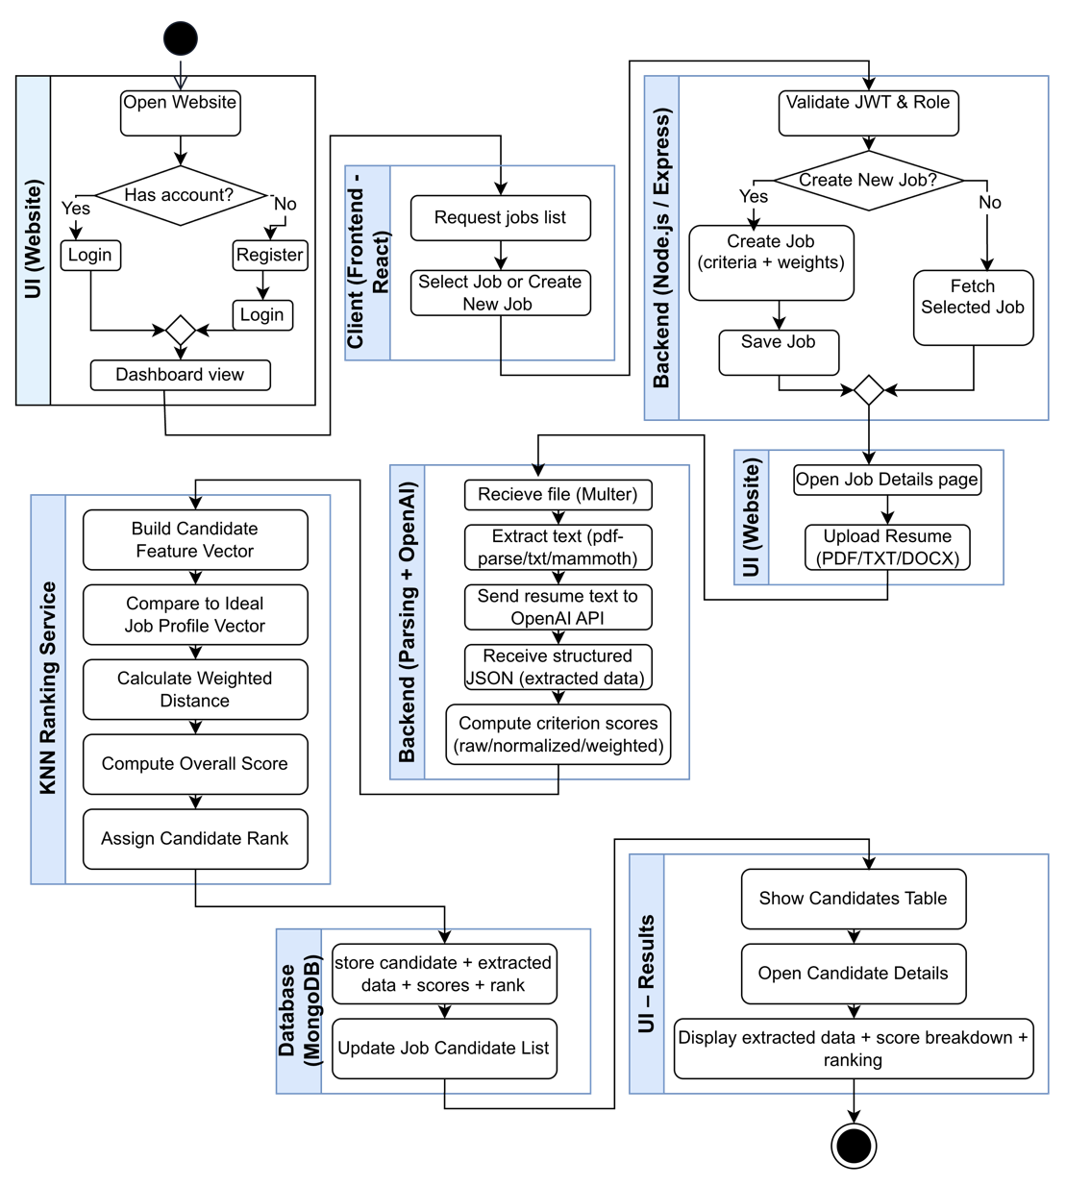

Ranking resumes using Machine Learning
In this system, resume ranking is performed using a K-Nearest Neighbors (KNN) based machine learning approach that compares each candidate to an ideal job profile. After a resume is uploaded and processed, the system extracts structured evaluation data for each predefined job criterion. For every criterion, the candidate receives a raw score on a scale from 0 to 10, representing how well the resume matches that specific requirement. If no relevant information is found for a given criterion, the system assigns a raw score of 0 and marks it accordingly. Each raw score is then normalized to a 0-1 range by dividing it by 10, ensuring consistency across all criteria. Job criteria weights, defined as percentages by the recruiter, are converted into decimal values and used to control the relative importance of each criterion in the ranking process.
To evaluate a candidate, the system constructs a feature vector containing the normalized scores for all criteria and compares it to an ideal job vector, in which all criteria have a value of 1 (representing a perfect match). The similarity between the candidate and the ideal profile is calculated using a weighted Euclidean distance, defined as:
$$distance=\sqrt{\sum_{i=1}^{n}{(w_{i}*{\left(x_{i}-1\right)}^{2})}}$$
Where $x_{i}$ is the normalized score of the candidate for criterion $i$, and $w_{i}$is the corresponding criterion weight. The resulting distance value is then converted into an overall candidate score on a 0-100 scale by subtracting the distance from 1 and multiplying by 100. Candidates with smaller distances to the ideal profile receive higher scores.
For transparency, the system also calculates a weighted contribution for each criterion and stores detailed scoring information, including raw values, normalized values, weights, weighted values, and textual explanations. Finally, all candidates associated with a job are sorted by their overall score in descending order, and a rank is assigned accordingly.

System description
The system is a full stack web application designed to support and manage recruitment processes. It consists of a client-side interface for user interaction and data presentation, and a server side component responsible for business logic, data processing, and communication with the database. The system integrates artificial intelligence and machine learning capabilities for resume analysis and candidate ranking, and is built using a modular structure that enables clear separation between system layers

System architecture
The project is structured as a full stack system with a clear separation between the client-side application, the server side application

Frontend (Client side)
React based web application that provides the user interface, navigation, and communication with the server through API requests.

Backend (Server side)
built with Node.js and Express and is responsible for authentication, business logic, resume processing, AI based extraction, and KNN based candidate ranking through RESTful endpoints

Database (Data layer)
implemented with MongoDB and stores system entities such as users, jobs (including criteria and weights), and candidates (including resume text, extracted data, scores, and ranking results).

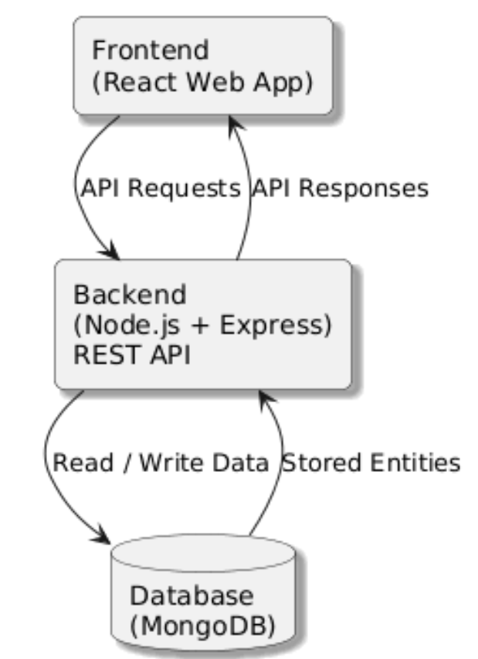

System Implementation

5.1. Functional flow

5.1.1. User authentication
The system begins with a secure user authentication process designed to protect sensitive recruitment data while maintaining a smooth user experience.
When a new user registers, the system hashes the provided password using bcrypt and creates a new user document in MongoDB. Upon successful registration, two JSON Web Tokens are generated: an access token, which is stored in memory for active session handling, and a refresh token, which is stored as an httpOnly cookie to enhance security. In addition, the user object is saved in localStorage to allow quick access to basic user information on the client side.
During login, the system retrieves the user's record by email and compares the provided password with the stored hash. If authentication succeeds, new access and refresh tokens are generated. For all protected routes, an authentication middleware intercepts incoming requests, verifies the access token, and attaches the authenticated user to the request context.
Authorization is enforced in the service layer. Users are permitted to access only jobs they created, and ownership validation ensures that no user can read or modify jobs or candidates belonging to another account.

5.1.2. Dashboard overview
After authentication, the user is directed to the dashboard, which serves as a centralized overview of recruitment activity.
The dashboard aggregates multiple statistics using a single database query. These include the total number of jobs, the number of active jobs with status “open”, and the total number of candidates across all jobs. In addition, the system retrieves the five most recently created jobs.
This data is presented through statistics cards, charts that visualize job status distribution, and tables highlighting top-performing jobs.

5.1.3. Job creation
When creating a new job, users provide detailed job information, including the job title, description, location, salary range, requirements, and evaluation criteria.
Each evaluation criterion includes a name, description, weight (ranging from 0 to 100), and a data type. Supported data types include "Scale (0 - 10), “Yes/No”, “YEARS of experience” and “Text match”. The system enforces a strict validation rule requiring that the sum of all criterion weights equals exactly 100%.
Once validated, MongoDB creates a new job document containing all provided information along with creation and update timestamps.

5.1.4. Resume upload and processing
When a recruiter uploads candidate resumes, supported file formats include PDF, DOCX, and TXT. For each uploaded file, the system initiates a MongoDB transaction and creates a new candidate record with status “processing”. A parser service then extracts text from the resume based on file type.

5.1.5. AI-powered data extraction
The extracted resume text is sent to OpenAI’s GPT-4o-mini model with a temperature setting of 0.3 to ensure consistent and deterministic results.
The system constructs a prompt that includes the resume text and all job evaluation criteria, requesting a structured JSON response. The AI extracts basic candidate information such as name, email, and phone number, and evaluates the candidate against each criterion.
For every criterion, the AI returns a score ranging from 0 to 10 along with a textual explanation. The response includes a candidate object and a criteria Score.
The candidate record is updated with the extracted data. Once processing is complete, the candidate's status is updated to "processed”, and the database transaction is committed.

5.1.6. Candidate ranking algorithm
Candidate ranking is performed using a weighted K-Nearest Neighbors approach with Euclidean distance.
The system first constructs an ideal feature vector in which each criterion has a normalized value of 1.0 representing a perfect match to the job requirements.
For each candidate, a feature vector is generated by mapping job criteria to the candidate’s extracted scores. Each criterion includes the raw score (0 - 10), a normalized value (0 - 1), the criterion weight represented as a decimal, and the associated explanation.
The weighted Euclidean distance is calculated by iterating over all criteria and computing the squared difference between the candidate’s normalized value and the ideal value (1.0), multiplied by the criterion weight.
The distance formula is defined as:
$$distance=\sqrt{\left(\sum{(weight*{\left(normalizedValue-1.0\right)}^{2}}\right))}$$
This distance is then converted into a similarity score using the following formula:
$$overallscore=\left(1-distance\right)*100$$
The resulting score represents a percentage between 0 and 100, where 100 indicates a perfect match. Candidates are sorted in descending order by overallScore .
The rankings persisted in the database, updating each candidate with their overallScore, rank, and a detailed breakdown of criterion level contributions.

5.1.7. Smart re-ranking and Quick re-rank
When the definition of a job changes, the system is able to intelligently adjust candidate rankings to reflect the updated requirements. It first determines which candidates were evaluated under an earlier version of the job definition and identifies those evaluations as no longer fully relevant. For these candidates, the system performs a renewed analysis based on the most recent requirements, ensuring that their evaluation accurately reflects the current expectations of the role.
Once all outdated evaluations have been refreshed, the system applies the standard ranking logic to the entire candidate pool, producing an updated and consistent ordering. In cases where the core requirements remain the same and only their relative importance has been adjusted, the system can efficiently recalculate rankings using previously extracted information, without repeating the full analysis process. This approach balances accuracy with performance, allowing the system to remain responsive while preserving evaluation of quality.

5.1.8. Candidate management
The candidate's detail view provides a comprehensive overview of each candidate, including extracted personal details, full resume text, a detailed score breakdown per criterion with explanations, the overall score, rank, and status.
Status updates are performed through a dropdown selector within the candidate's table. The system also supports bulk operations, allowing multiple candidates to be selected and deleted in a single action. Candidate deletion removes the document from the database, with ownership verification ensuring that users can delete candidates only from jobs they own.

5.2. Frontend User Workflow
Step | Description
1 | The user opens the web application and accesses the registration or login screens.
2 | After successful authentication, the user is redirected to the dashboard.
3 | From the dashboard, the user navigates to the jobs section.
4 | The user creates a new job or selects an existing job for editing, depending on permission.
5 | The user defines job details, evaluation criteria, and assigns weights to each criterion.
6 | The user saves the job configuration.
7 | The user selects a job and opens the job details page.
8 | The user accesses the resume upload and candidate management views for the selected job.
9 | The user uploads a resume through the interface.
10 | The system updates and displays the candidate’s list.
11 | The user opens an individual candidate page.
12 | The candidate page displays extracted resume information, evaluation scores, and ranking results.
13 | Navigation between pages is handled through structured routes and consistent user interface components.

5.3. Technical Features Summary
Category | Technical Feature | Description
Architecture | Full Stack web architecture | Separation between frontend (client), backend (server), and database layers.
Frontend | React based client | Web application that provides user interface, navigation, and API communication.
Backend | Node.js & Express server | Handles RESTful API requests, business logic, and system workflows.
Authentication | JWT based authentication | Secure user authentication and authorization using JSON Web Tokens.
Job management | Configurable job criteria | Supports job creation with custom evaluation criteria and assigned weights.
Resume handling | Resume upload & parsing | Accepts resume files and extracts textual content for processing.
AI processing | Structured data extraction | Converts unstructured resume text into structured candidate information.
Machine Learning | KNN based candidate ranking | Calculates normalized scores, weighted values, overall scores, and candidate ranks.
Scoring logic | Weighted scoring mechanism | Applies criterion weights to influence overall candidate evaluation.
Data storage | MongoDB persistence | Stores users, jobs, candidates, extracted data, scores, and ranking results.
API communication | RESTful API | Enables consistent data exchange between client and server.

Challenges and Lessons Learned
The development of an automated resume screening and candidate ranking system involves several technical and practical challenges. These challenges arise mainly from the unstructured and diverse nature of resume data, the need for fair and consistent candidate evaluation, and the requirement to ensure transparency and security throughout the system. The following table summarizes the key challenges identified during the project development, along with the corresponding solutions that were implemented to address them.

Challenges Faced
Challenge | Description | Solution
Unstructured resume formats | Resumes are provided in different file formats (PDF, DOCX, TXT) with an inconsistent structure and layout. | All resume files are converted into plain text before processing to ensure a uniform analysis pipeline.
Visual elements and non-textual content | Visual elements such as icons, tables, columns, and graphical layouts are not always correctly represented when converted to text. | The system focuses on textual content extraction and performs analysis only on the extracted text, ignoring visual formatting.
Spelling and grammar variations | Spelling of mistakes, grammatical errors, and inconsistent writing styles may affect text parsing and interpretation. | Natural language processing is applied to analyze the extracted text in a flexible manner, reducing sensitivity to minor language errors.
Mixed languages in resumes | Resumes may contain multiple languages within the same document, which can complicate text analysis. | The extraction process is designed to handle multilingual content within a single resume and analyze it as unstructured text.
Different terminology for the same concepts | Candidates may use different terms or abbreviations to describe the same skills or qualifications (e.g., “B.Sc.” vs. “Bachelor of Science”). | The AI-based extraction process interprets semantic meaning rather than relying on exact keyword matching.
Subjective candidate evaluation | Manual resume screening may lead to inconsistent and subjective evaluation results. | Predefined evaluation criteria with explicit weights are applied to ensure consistent and objective scoring.
Lack of labeled training data | The system does not rely on historical labeled datasets for training a machine learning model. | A KNN-based approach without a training phase is used, comparing candidates directly to an ideal job profile.
Explainability of ranking results | Machine learning based ranking decisions can be difficult to justify. | The system stores and presents detailed per criterion of scores, weights, and explanations for transparency.
Secure handling of sensitive data | Resume data and candidate information are sensitive and require protection. | JWT based authentication and role-based access control restrict access to authorized users only.

Testing

Case | Test Case | Expected Result | Results
1 | Open the website landing page | Login page is displayed correctly | Pass
2 | Navigate to the registration page | Registration form is displayed | Pass
3 | Register with valid user details | User is registered and redirected to the dashboard | Pass
4 | Login with valid credentials | User is redirected to the dashboard | Pass
5 | Login with invalid credentials | Error message is displayed | Pass
6 | Access dashboard after login | Dashboard data is displayed correctly | Pass
7 | Navigate to Jobs page | List of jobs is displayed | Pass
8 | Create a new job | Job creation form is displayed | Pass
9 | Define job details, criteria, and weights | Criteria and weights are saved correctly | Pass
10 | Enter criteria weights with a total greater than 100 | Error message is displayed, and job cannot be saved | Pass
11 | Save a new job with valid weights (total = 100) | Job appears in jobs list | Pass
12 | Open job details page | Job information and criteria are displayed | Pass
13 | Navigate to resume upload view | Resume upload component is displayed | Pass
14 | Upload a valid resume file | Upload completes successfully | Pass
15 | Upload an unsupported file type | Error message is displayed | Pass
16 | View candidates list after upload | Candidates list is updated and displayed | Pass
17 | Open candidate details page | Candidate data, scores, and ranking are displayed | Pass
18 | Navigate between tabs | Tab content changes correctly | Pass
19 | Logout from the system | User is logged out and redirected to login | Pass

Summary and conclusions
- This project presented the design and implementation of a full-stack web-based recruitment system that automates resume screening and candidate ranking.
- The system successfully integrates a user-facing web interface with a server-side application and a centralized database, providing an end-to-end solution for managing recruitment workflows.
- Automated resume analysis was achieved by converting unstructured resume documents into structured candidate data, enabling consistent evaluation across different resume formats and styles.
- The use of predefined job criteria and configurable weights allows recruiters to explicitly define job requirements and control the importance of each criterion in the evaluation process.
- A machine learning–based approach using the K-Nearest Neighbors (KNN) algorithm was effectively applied to rank candidates by comparing them to an ideal job profile, without relying on labeled training data.
- The ranking mechanism produces transparent and explainable results by storing and presenting detailed per-criterion scores, supporting trust and interpretability in automated decision-making.
- The system architecture, based on a clear separation between frontend, backend, and data layers, improves maintainability, scalability, and clarity of responsibility.
- Security considerations, including authentication and role-based authorization, were incorporated to protect sensitive user and candidate information.
- User interface testing confirmed that the system supports the complete recruitment workflow, from job creation and criteria definition to resume upload and candidate evaluation.
- Overall, the project demonstrates how artificial intelligence and machine learning techniques can be practically applied to improve efficiency, consistency, and objectivity in recruitment processes, while remaining flexible and understandable for end users.

Lessons learned
- We learned that designing the evaluation logic before implementing the user interface helped keep the system consistent, especially when connecting job criteria, weights, and ranking results.
- Implementing a KNN-based ranking approach showed that not every machine learning solution requires complex model training. In this case, a simple and interpretable algorithm was more suitable for comparing candidates against an ideal job profile.
- We realized that transparency in scoring is just as important as accuracy, as users need to understand how and why candidates are ranked in a certain way.
- We chose to work with the OpenAI API because we understood that traditional rule-based parsing is not sufficient for analyzing resumes. Natural language processing capabilities were required to handle free-text content, different writing styles, and variations in how candidates describe their skills and experience.
- Building the system as a complete end-to-end application highlighted the importance of designing both the technical structure and the user experience together, rather than treating them as separate concerns.

Future enhancements and extensions
The system was designed with future growth and continuous improvement in mind, allowing additional capabilities to be integrated to further streamline and enhance the recruitment workflow. These enhancements focus on extending existing functionalities and improving user interaction, efficiency, and candidate management within the system.
One possible extension is the ability to schedule interviews directly from the system. By adding a dedicated action within the candidate profile or candidates table, recruiters could send interview invitations via email with a single click. Candidates would receive a message containing a link that allows them to select a preferred date and time from predefined availability options set by the recruiter, with the selected option automatically reflected in the candidate’s status.
Another enhancement involves supporting long-term candidate tracking. The system could allow recruiters to mark candidates as “saved” or “for follow-up,” even if they were not selected for the current position. This would enable recruiters to easily revisit and reuse relevant candidate profiles for future job openings, improving efficiency and continuity across recruitment cycles.

References

[1] Dadaboyev, S. M. U. (2025). Role of Artificial Intelligence in EmployeeRecruitment. https://link.springer.com/article/10.1007/s44282-025-00246-w?utm_source=chatgpt.com

[2] Everyday AI. (2024). GPT-4o Mini Review and Comparison with GPT-4. https://www.youreverydayai.com/gpt-4o-mini-review-and-gpt-4o-mini-vs-gpt-4o/?utm_source=chatgpt.com

User Guide

Introduction
This user guide is designed to assist users in understanding how to interact with the system and use its main functionalities effectively. The guide explains the basic steps required to navigate the application, manage job postings, upload resumes, and review candidate evaluation results. It focuses on the practical use of the system from the user’s point of view and is intended for users with no prior technical knowledge.

Website Usage
The application is available online at: https://resume-capstone-34rn.onrender.com/
The website provides users with access to the main recruitment workflow through dedicated pages and screens. Users can log in or register, view the dashboard, and navigate to the jobs section to manage job postings. Recruiters can create and edit jobs by defining job details and evaluation criteria with weights, where the total weight must equal 100%. For each job, the website includes separate views for reviewing job information, viewing the candidates list, and uploading resumes. Resumes can be uploaded as PDF, DOC, DOCX, or TXT files (up to 10MB per file), and the system then displays candidates with evaluation scores and ranking results, including detailed candidate profiles.

User Interface

Login page
This page is the entry point to the CV Screening System. It allows users to sign in using their email and password or navigate to the account creation page if they do not yet have an account. Access to the system’s features is granted only after successful authentication.
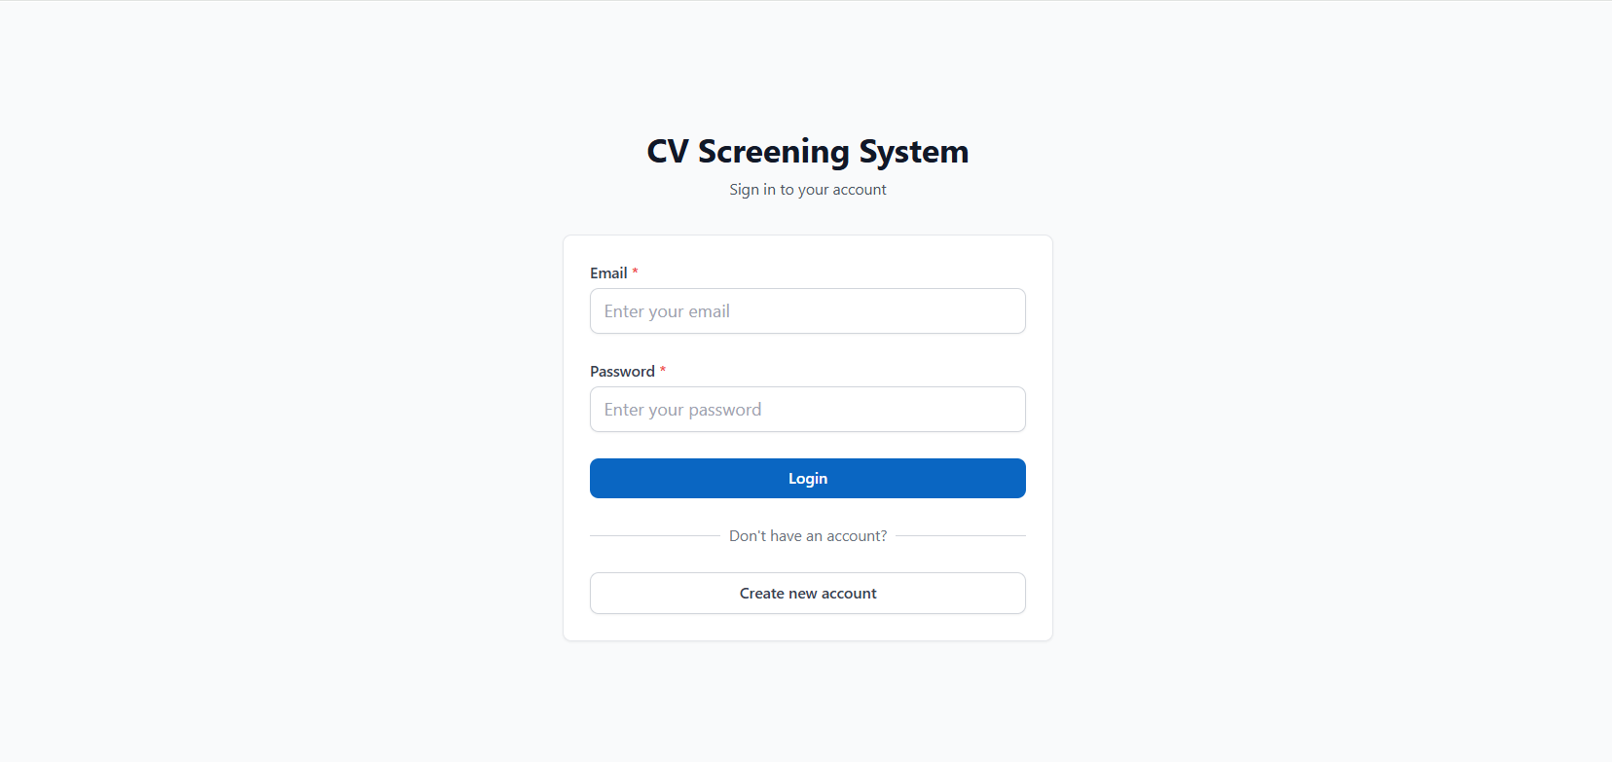

Registration Page
This page allows new users to create an account in the CV Screening System by providing basic personal details and login credentials. Users are required to enter their full name, email address, and password to complete the registration process.
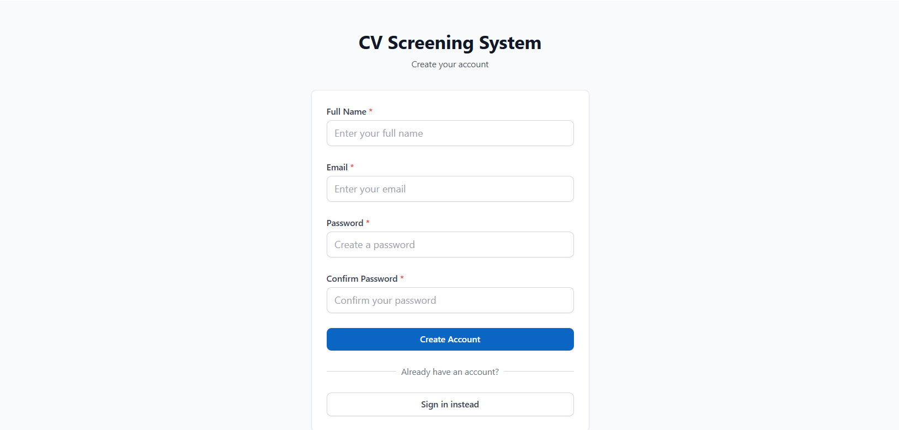

Dashboard – Before Job Creation
This dashboard is displayed after the user logs in, before any jobs have been created. It provides an overview of the recruitment system, including summary statistics and status sections, which are initially empty. The dashboard guides the user to create their first job through quick actions and navigation options.

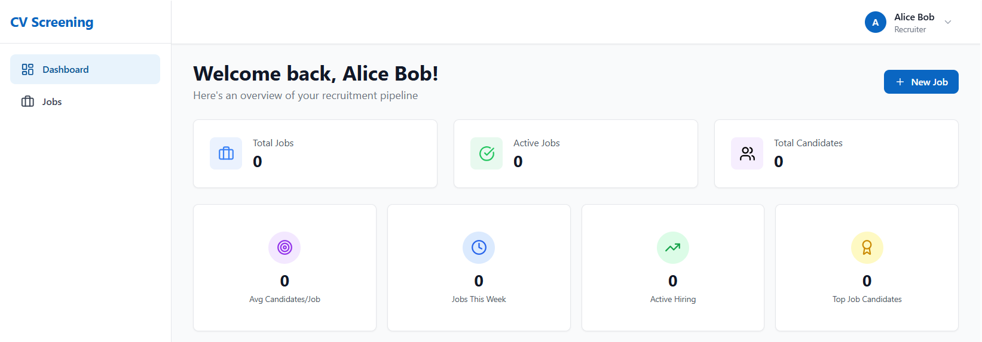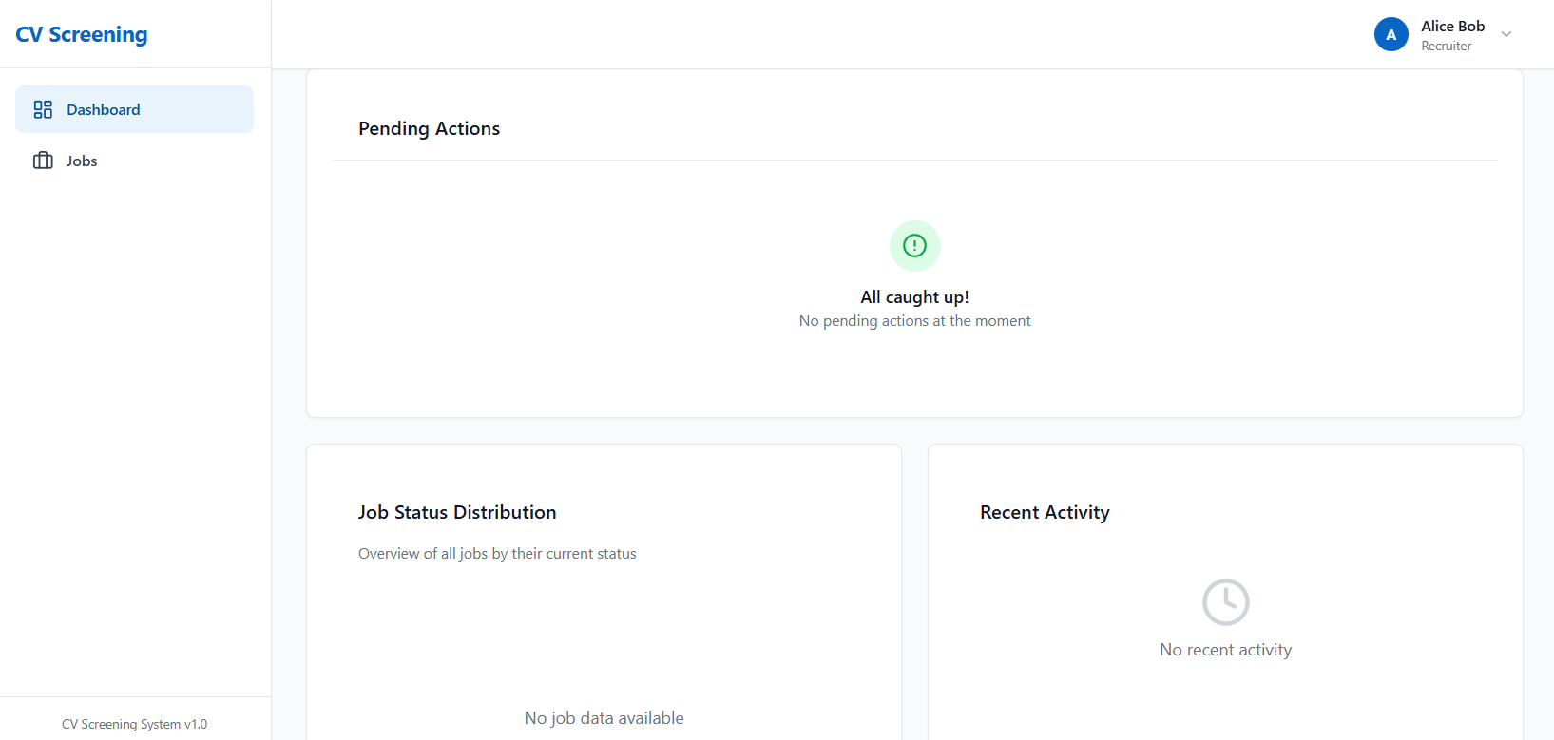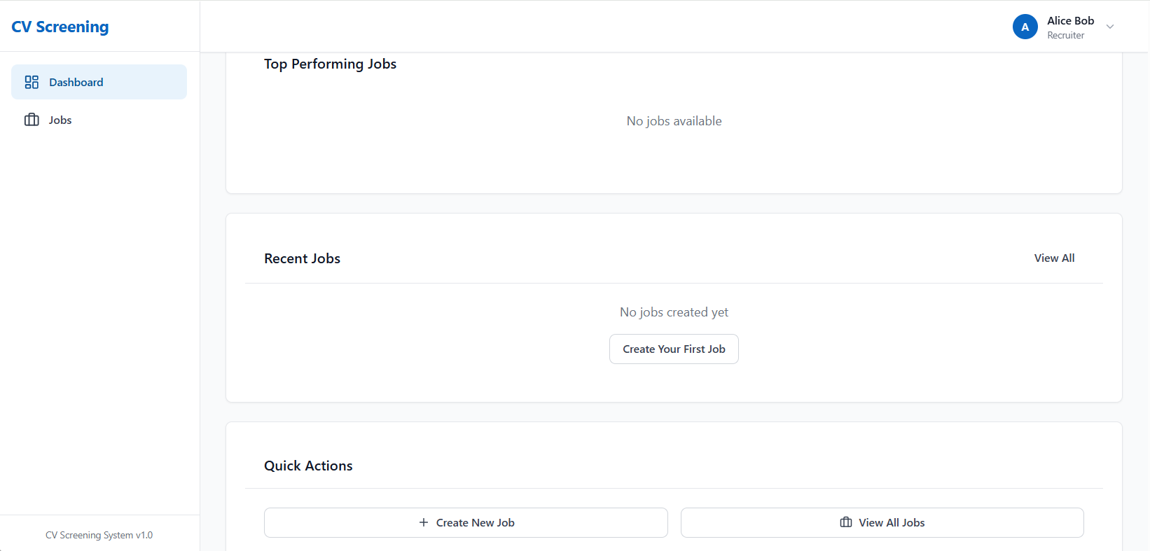

Job page
This page displays the list of job postings in the system and allows users to manage their recruitment positions. From this screen, users can create a new job, search jobs by title or description, and sort or filter jobs by status or date. When no jobs exist, the page prompts the user to create their first job.
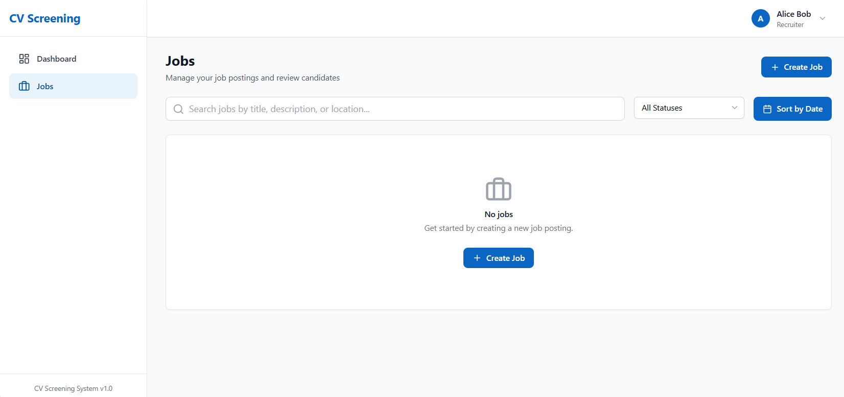

Create new job page
This page allows recruiters to create a new job posting by entering job details such as title, description, location, and salary range. In addition, recruiters define evaluation criteria that will be used later to assess and rank candidates. The information entered on this page forms the basis for the resume screening and candidate evaluation process.
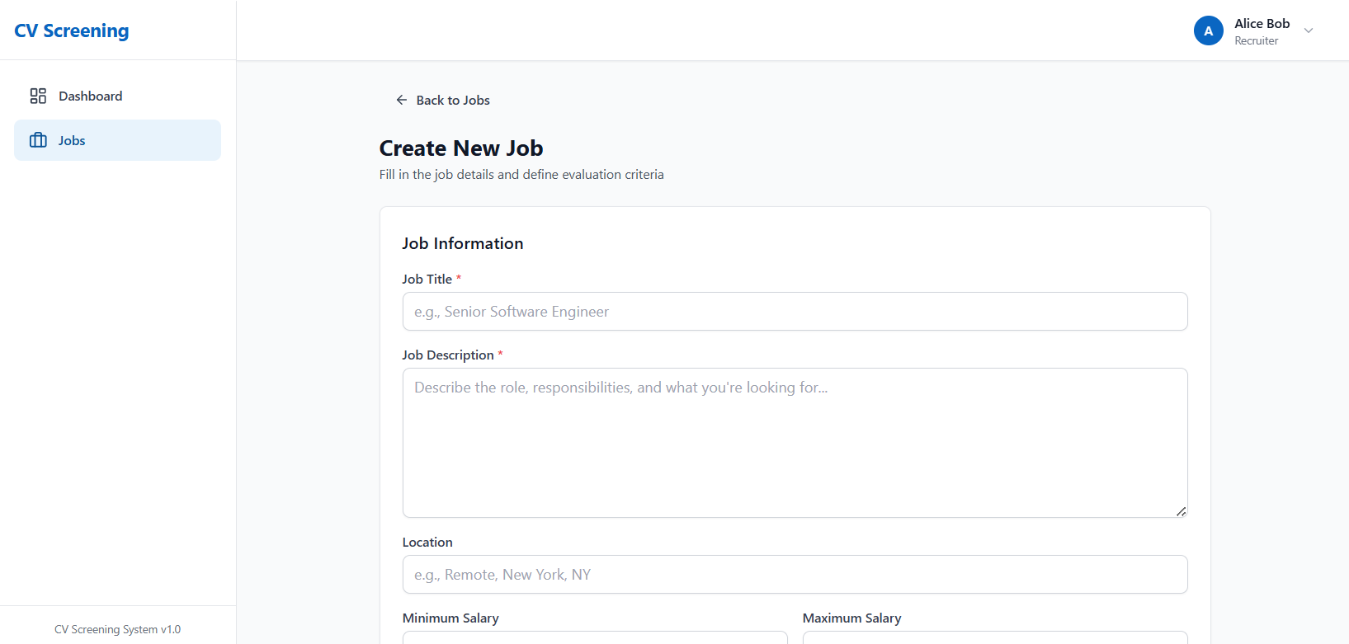

Job Information Section
This section is used to define the basic details of the job posting. It includes fields for the job title, job description, location, and salary range. The information provided in this section describes the position and serves as the foundation for candidate evaluation.
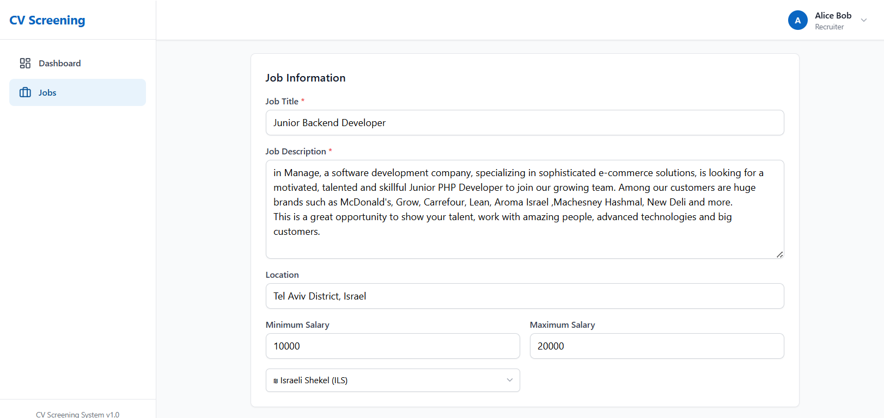

Requirements Section

This section is used to list the key requirements and qualifications for the job position. Recruiters can add, edit, or remove individual requirements to clearly define what is expected from candidates. These requirements help describe the role and guide the candidate evaluation process.
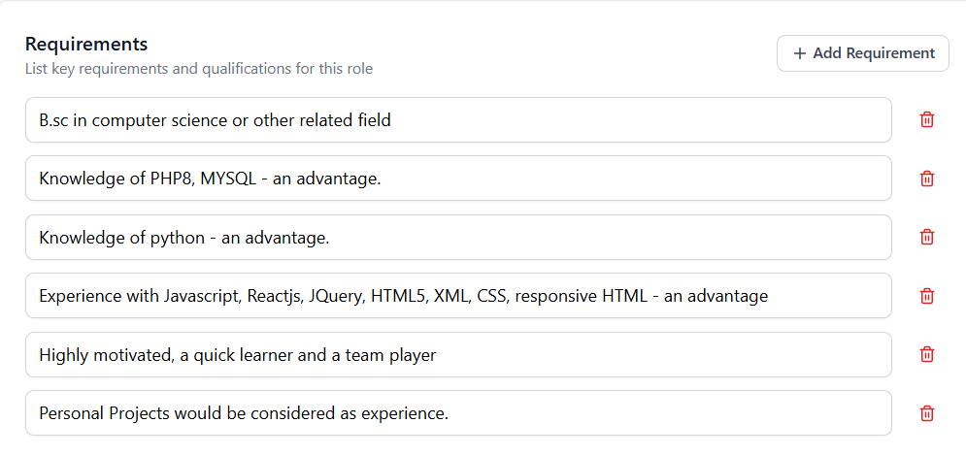

Evaluation Criteria Section
This section is used to define the criteria according to which candidates will be evaluated and ranked. For each criterion, the recruiter specifies a name, description, data type, and weight percentage. The total weight of all criteria must equal 100%, ensuring a balanced and consistent evaluation process. Each evaluation criterion includes a Data Type that determines how the system evaluates the candidate for that criterion:
- Scale (0–10):
Used for qualitative or graded attributes where the candidate is scored on a numeric scale between 0 and 10.
- Years of Experience:
Used when the evaluation is based on the number of years of experience related to the criterion.
- Yes / No:
Used for binary requirements where the candidate either meets the requirement or does not.
- Text Match:
Used to evaluate how well the candidate’s resume text matches the criterion description based on textual similarity.
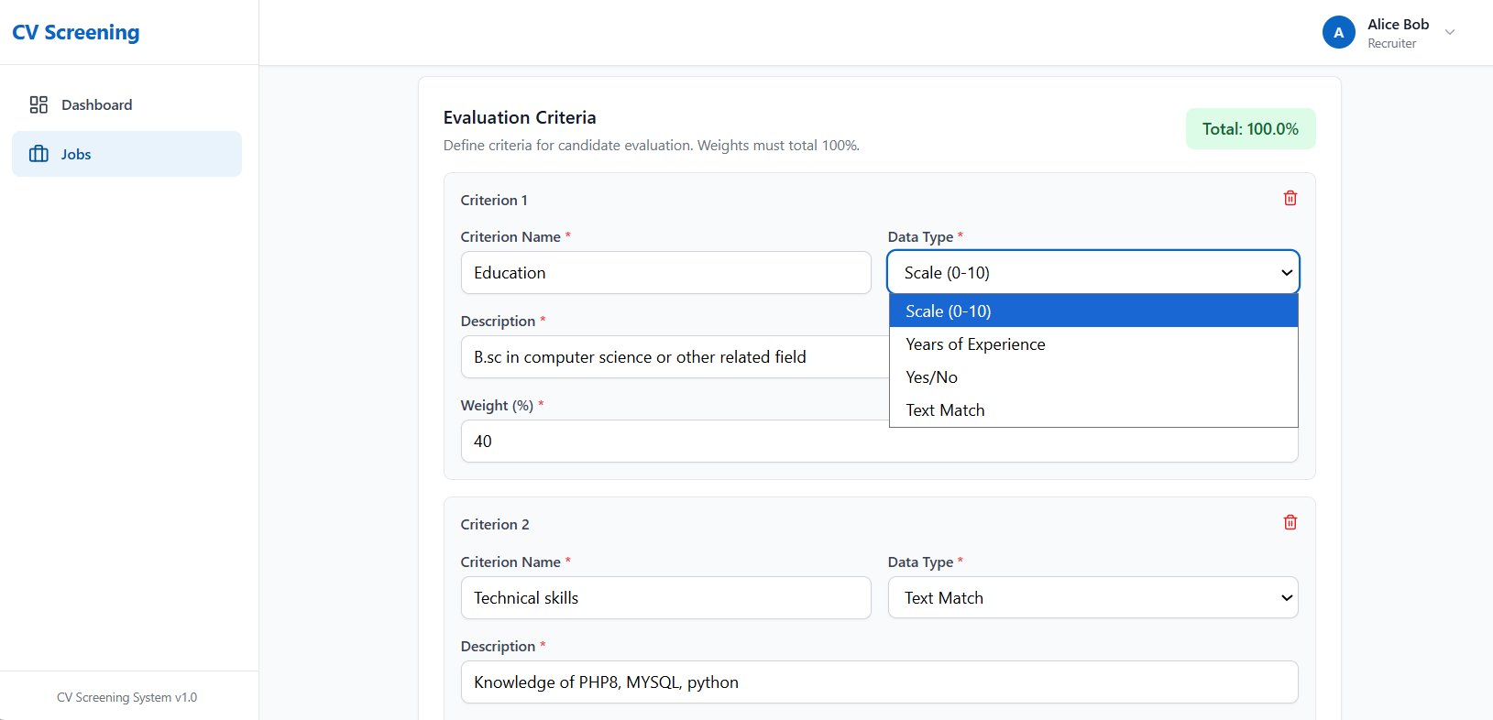

Create Job Action
The Create Job action is used to finalize and save the job posting in the system. When selected, the system validates the entered information and creates a new job based on the defined details and evaluation criteria. After successful creation, the job becomes available for resume upload and candidate evaluation.
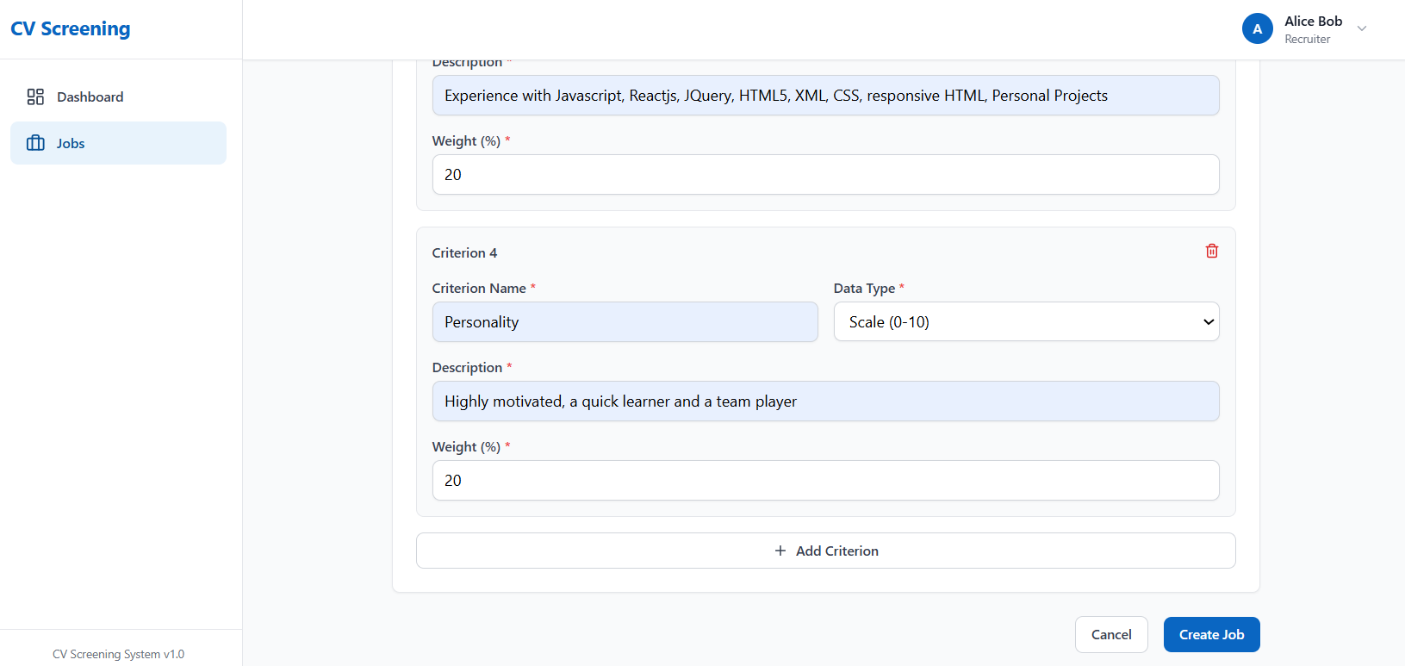

Job page (after creating job)
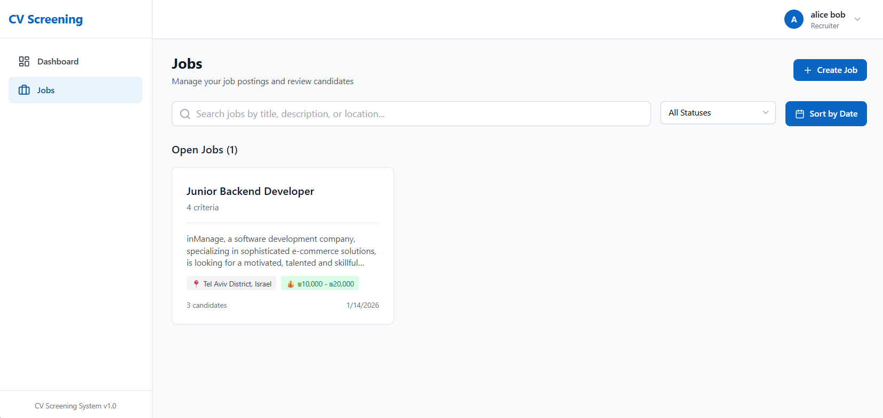

Job Overview Page
This page displays an overview of the created job and allows the user to review the job details and requirements. From this screen, the user can manage the job status, edit or delete the job, and navigate between different sections related to the job, such as candidates and resume uploads.
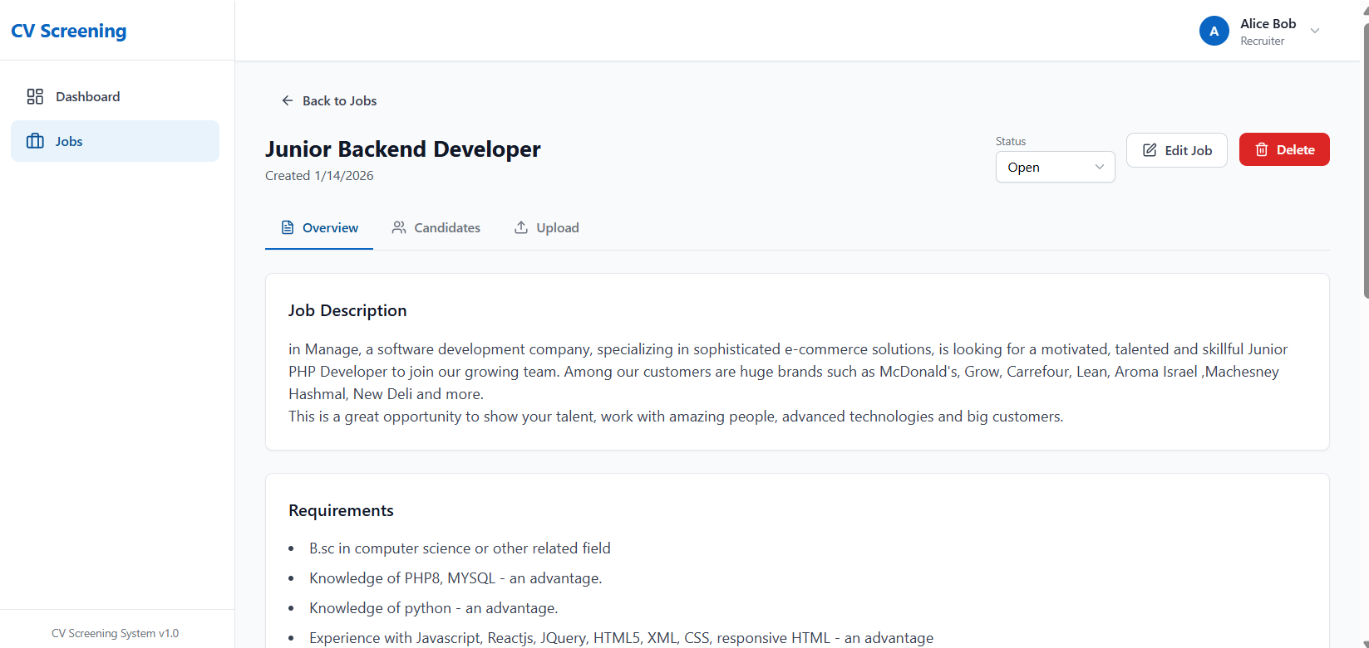

Upload section
This page allows the user to upload resumes for the selected job position. Resumes can be added using drag and drop or file selection, and multiple files can be uploaded at once. After uploading, the resumes are processed by the system for candidate analysis and evaluation.
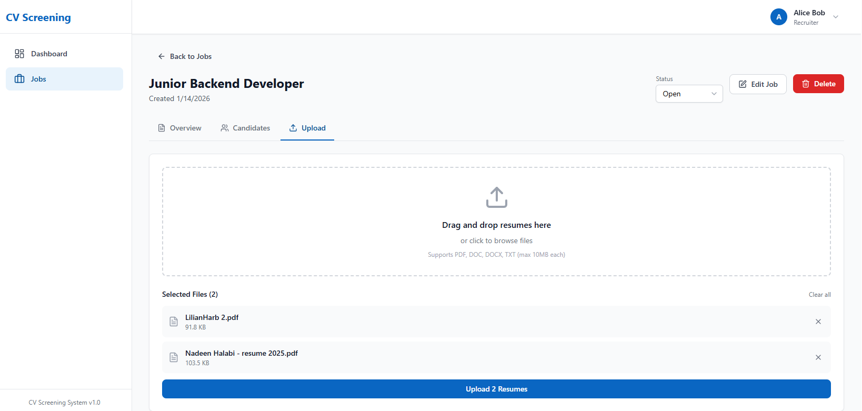

Candidates section
This section displays the list of candidates associated with the selected job after their resumes have been uploaded and processed. Candidates are shown in a table and ranked according to their overall evaluation score, allowing the recruiter to quickly compare applicants. From this screen, the recruiter can review each candidate’s score and status and trigger the ranking action to update the ordering when needed.
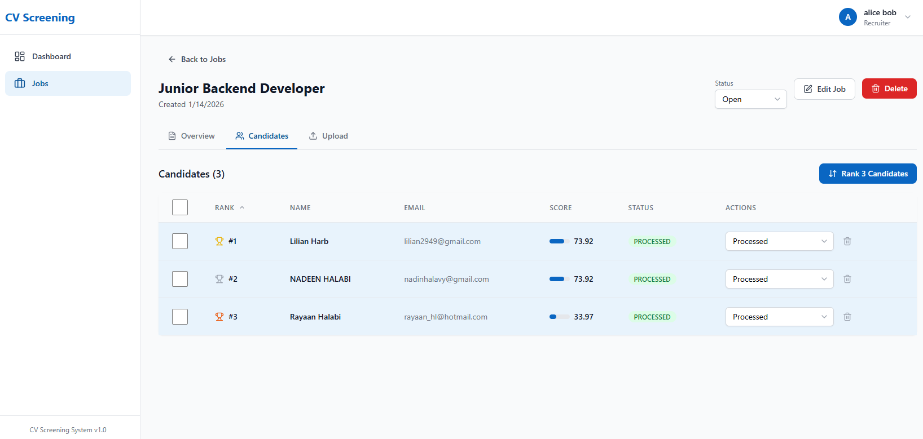

Candidate profile page
This page displays the detailed profile of a candidate selected from the ranked candidates list. It presents the candidate’s personal information, overall evaluation score, and a detailed breakdown of the scores for each evaluation criterion. This view allows the recruiter to understand how the candidate was evaluated and why a specific ranking was assigned.

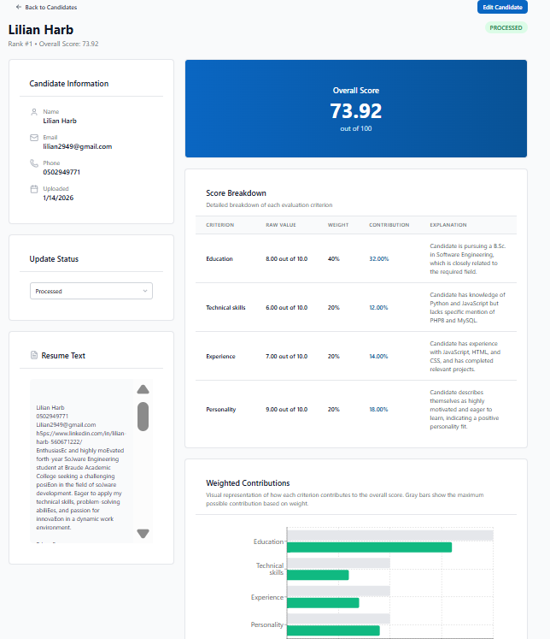
- Candidate Header: The top section of the page displays the selected candidate’s name, ranking position, and overall evaluation score. It also includes navigation back to the candidates list and indicates the current processing status of the candidate.
- Candidate Information: This section presents the basic personal details of the candidate, including name, email address, phone number, and upload date. It provides a quick overview of the candidate’s identity and contact information.
- Overall Score: This section highlights the candidate’s total evaluation score of 100. The score represents the weighted result of all evaluation criteria defined for the job.
- Score Breakdown: The score breakdown table displays a detailed evaluation of the candidate per criterion. For each criterion, the table shows the raw score, assigned weight, contribution to the total score, and a textual explanation describing how the score was determined.
- Weighted Contributions: This visual section illustrates how each evaluation criterion contributes to the overall score. The chart helps users quickly understand the relative impact of each criterion based on its weight and score
- Resume Text: This section displays the extracted plain text version of the candidate’s resume. It allows the recruiter to review the resume content as processed by the system and used for evaluation.
- Update Status: This section allows the recruiter to update the candidate’s status in the recruitment process. Status changes help track the progress of candidates throughout the hiring workflow.

Re-rank section
- Smart Re-rank: This option should be used when there have been changes to the job’s evaluation criteria, such as modifying criterion definitions, data types, or adding/removing criteria. The system automatically detects whether a full AI-based re-evaluation is required and only reprocesses candidates when necessary, ensuring accurate and up-to-date ranking with optimized performance.
- Quick Re-rank: This option should be used when only the weights of existing evaluation criteria have changed, without modifying the criteria themselves. The system recalculates candidate scores using previously cached results, providing an instant and cost-free reranking without reanalyzing resumes.
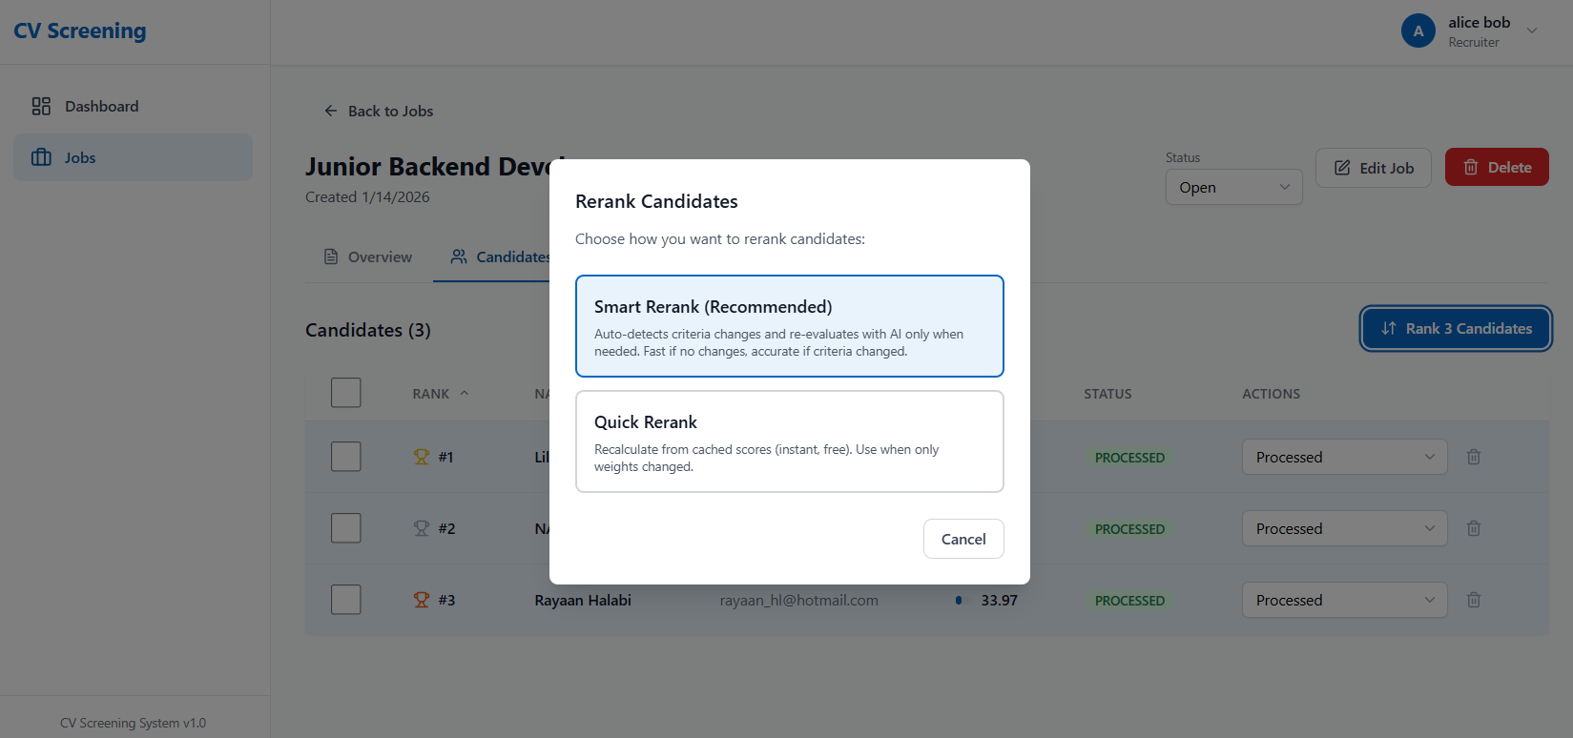

Dashboard (after creating job and upload resumes)

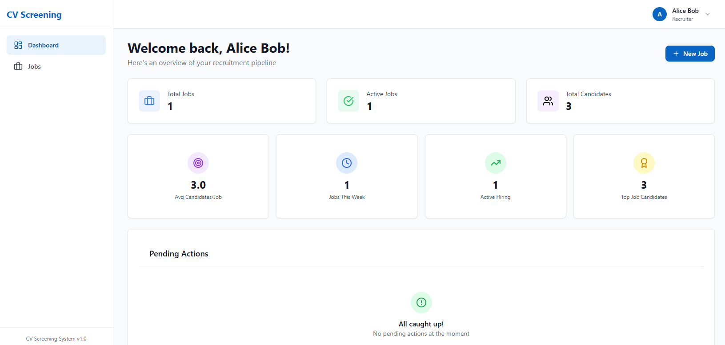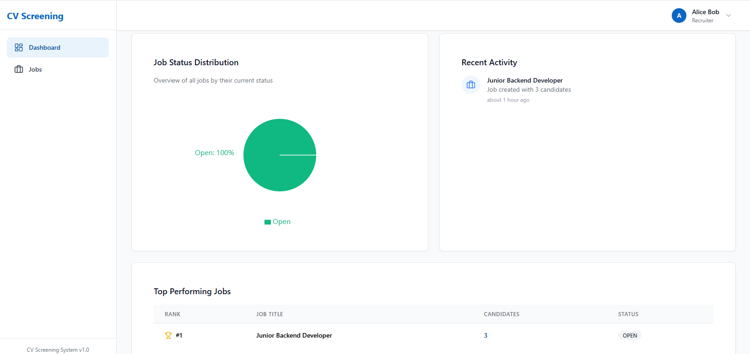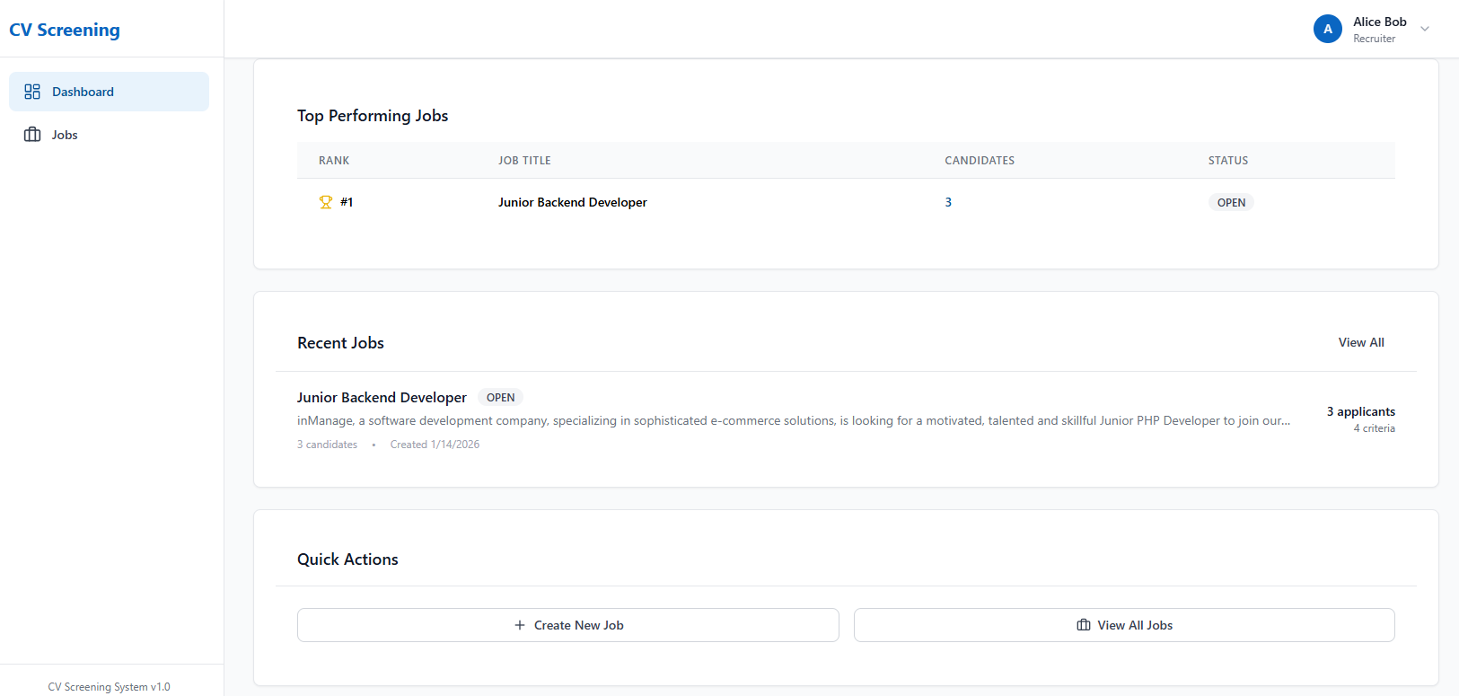

Maintenance Guide

System Requirments

Backend
- Language: JavaScript
- Runtime environment: Node.js
- Framework: Express.js
- Main file: src/index.js
- API type: REST API
- Authentication: JWT (JSON Web Token)
- Database connection: MongoDB (via Mongoose)
- AI Integration: OpenAI API - GPT-4o-mini language model (used for resume analysis and information extraction)
- Machine Learning: K-Nearest Neighbors (KNN) algorithm for candidate ranking, No training phase (distance-based comparison to job profile)
- Required Libraries (installed via package.json):
  - express
  - mongoose
  - jsonwebtoken
  - bcryptjs
  - cors
  - multer
  - dotenv
  - openai
  - helmet
  - cookie-parser
  - mammoth
  - pdf-parse

Frontend
- Framework: React.js
- Language: JavaScript
- Build Tool: Vite
- Styling: Tailwind CSS
- Main entry file: src/main.jsx
- Main application file: src/App.jsx
- API Communication: REST API communication with the backend using Axios
- Authentication Handling: JWT token stored in localStorage and attached to API requests via Axios interceptors
- Required Dependencies (installed via npm install):
- React
- react-dom
- react-router-dom
- @tanstack/react-query
- Zustand
- Axios
- react-hook-form
- @headlessui/react
- lucide-react
- Recharts
- Tailwindcss
- Clsx
- date-fns

Database Schema
The database consists of three main collections:
- Users - System users (recruiters)
- Jobs - Job postings with evaluation criteria
- Candidates - Candidate profiles with resume data and scores

Users Collection (users)
Fields
- _id – ObjectId (Primary Key)
- email – String (required, unique, validated)
- passwordHash – String (required)
- name – String (required, minimum 2 characters)
- role – String (default: RECRUITER)
- createdAt, updatedAt – Date (auto-generated timestamps)
Indexes
- email – Single-field index
Relationships
- One-to-Many relationship with Jobs (userId)

Jobs Collection (jobs)
Fields
- _id – ObjectId (Primary Key)
- title – String (required, minimum 3 characters)
- description – String (required, minimum 10 characters)
- department – String
- location – String
- minSalary – Number
- maxSalary – Number (maxSalary ≥ minSalary)
- currency – String (default: USD)
- requirements – Array[String]
- status – String (DRAFT, OPEN, CLOSED, ARCHIVED, default: OPEN)
- userId – ObjectId (required, indexed, references User)
- criteria – Array[Criterion] (required, minimum 1, weights must sum to 100)
- createdAt, updatedAt – Date (auto-generated timestamps)
Embedded Schema: Criterion
- _id – ObjectId
- name – String (required)
- description – String
- weight – Number (required, 0–100)
- dataType – String (SCALE, BOOLEAN, YEARS, LEVEL, TEXT_MATCH, default: SCALE)
- minValue – Number (default: 0)
- maxValue – Number (default: 10)
- order – Number (default: 0)
Validation Rules
- Criteria weights must sum to 100
- maxSalary must be greater than or equal to minSalary (if both are provided)
Indexes
- userId + status – Compound index
- userId + createdAt – Compound index
- department + location – Compound index
- status + createdAt – Compound index
Relationships
- Many-to-One relationship with Users (userId)
- One-to-Many relationship with Candidates (jobId)

Candidates Collection (candidates)
Fields
- _id – ObjectId (Primary Key)
- name – String (required)
- email – String (validated format)
- phone – String
- status – String (PENDING, PROCESSING, PROCESSED, REVIEWED,
SHORTLISTED, REJECTED, INTERVIEW_SCHEDULED, default: PENDING)
- resumeText – String (required)
- extractedData – Mixed (AI-extracted structured data)
- criteriaHash – String (indexed, used for smart re-ranking)
- overallScore – Number (0–100)
- rank – Number (minimum: 1)
- scores – Array[Score] (embedded)
- jobId – ObjectId (required, indexed, references Job)
- createdAt, `updatedAt`` – Date (auto-generated timestamps)
Embedded Schema: Score
- criterionId – ObjectId (references criterion in Job)
- criterionName – String (required)
- rawValue – Number (required, 0–10)
- normalizedValue – Number (required, 0–1)
- weightedValue – Number (required)
- weight – Number (required, decimal 0–1)
- explanation – String
Indexes
- jobId + overallScore – Compound index (descending order)
- jobId + status – Compound index
- jobId + rank – Compound index
- criteriaHash – Single-field index
- name + email – Text index
Relationships
- Many-to-One relationship with Jobs (jobId)

Key Validation Rules
- Users – Email must be unique and in a valid format
- Jobs – Criteria weights must sum to 100; maxSalary ≥ minSalary
- Candidates – overallScore must be in the range 0–100 and reference a valid jobId

Installation Instructions

STEP 1: prerequisites
Before starting, ensure you have the following installed on your computer:
- Node.js version 18 or higher
- npm (comes with Node.js)
- MongoDB version 6 or higher
- Git
- OpenAI API Key
Verify installations by running these commands in your terminal:
- node --version
- npm --version
- mongod --version
- git –version

STEP 2: download from GITHUB
Open your terminal and navigate to the directory where you want to save the project.
Run the following command to clone the repository:
git clone https://github.com/nadeenhalabi1/projectPhaseB.git
Navigate into the project directory:
- cd projectPhaseB

STEP 3: INSTALL BACKEND DEPENDENCIES
Navigate to the backend directory:
- cd backend
Install all required packages:
- npm install
Wait for the installation to complete. This may take a few minutes.

STEP 4: INSTALL FRONTEND DEPENDENCIES \
Navigate back to the project root and then into the frontend directory:
- cd ..
- cd frontend
Install all required packages:
- npm install
Wait for the installation to complete.

STEP 5: CONFIGURE BACKEND ENVIRONMENT VARIABLES
Navigate to the backend directory:
- cd backend
Create a new file named .env in the backend directory.
Add the following content to the .env file (replace the placeholder values with your actual values):
- MONGODB_URI=mongodb://localhost:27017/cv-screening
- JWT_SECRET=your-secret-key-here
- OPENAI_API_KEY=sk-your-openai-api-key
- PORT=3001
- NODE_ENV=development
- MAX_FILE_SIZE=10485760
- UPLOAD_DIR=./uploads
- FRONTEND_URL=http://localhost:5173
Important notes:
- Replace your-secret-key-here with a random long string (at least 32 characters)
- Replace sk-your-openai-api-key with your actual OpenAI API key
- If MongoDB is running on a different port or remote server, update MONGODB_URI accordingly

STEP 6: CONFIGURE FRONTEND ENVIRONMENT VARIABLES
Navigate to the frontend directory:
- cd frontend
Create a new file named .env in the frontend directory.
Add the following content to the .env file:
- VITE_API_URL=http://localhost:3001/api
Note: If you changed the backend port in step 5, update the port number here as well.
STEP 7: START MONGODB
Open a new terminal window (keep it open).
Start MongoDB by running:
- mongod
If MongoDB is installed as a service, it may already be running. Verify by checking if the command completes without errors.

STEP 8: START BACKEND SERVER
Open a new terminal window (keep MongoDB terminal open).
Navigate to the backend directory:
- cd backend
Start the backend server in development mode:
- npm run dev
You should see a message indicating the server is running on port 3001.
Keep this terminal window open.

STEP 9: START FRONTEND SERVER
Open a new terminal window (keep MongoDB and Backend terminals open).
Navigate to the frontend directory:
- cd frontend
Start the frontend development server:
- npm run dev
You should see a message with a local URL, typically http://localhost:5173
Keep this terminal window open.

STEP 10: ACCESS THE APPLICATION
Open your web browser (Chrome, Firefox, Edge, etc.).
Navigate to the URL shown in the frontend terminal (usually http://localhost:5173).
The application should now be running and accessible in your browser.
ADDITIONAL COMMANDS
Backend commands:
- npm start (run in production mode)
- npm run dev (run in development mode with auto-reload)
Frontend commands:
- npm run dev (run development server)
- npm run build (build for production)
- npm run preview (preview production build)
- npm run lint (check code for errors)

System Components

Backend Components
- Controllers
- auth.controller.js - Handles user registration, login, logout, and token refresh operations.
- jobs.controller.js - Manages job creation, retrieval, update, and deletion operations.
- resumes.controller.js - Processes resume file uploads and manages resume data retrieval.
- candidates.controller.js - Handles candidate ranking, status updates, and bulk operations.
- dashboard.controller.js - Aggregates and returns dashboard statistics and data.
- Services
- auth.service.js - Implements authentication logic including password hashing and JWT token generation.
- jobs.service.js - Contains business logic for job management and ownership verification.
- resumes.service.js - Orchestrates resume processing workflow including file parsing and AI extraction.
- candidates.service.js - Manages candidate ranking, re-ranking, and statistics calculation.
- openai.service.js - Integrates with OpenAI API to extract structured data from resume text.
- parser.service.js - Parses PDF, DOCX, and TXT files to extract text content.
- knn.service.js - Implements K-Nearest Neighbors algorithm for candidate ranking using weighted Euclidean distance.
- dashboard.service.js - Aggregates dashboard statistics including job and candidate counts.
- dummyAI.service.js - Provides mock AI service for testing without OpenAI API costs.
- Models
- User.js - Defines user schema with email, password hash, name, and role fields.
- Job.js - Defines job schema with title, description, criteria, and embedded criterion objects.
- Candidate.js - Defines candidate schema with resume text, extracted data, scores, and ranking information.
- Routes
- index.js - Main router that mounts all route modules and defines API structure.
- auth.routes.js - Defines authentication endpoints for registration, login, and profile management.
- jobs.routes.js - Defines job management endpoints for CRUD operations.
- resumes.routes.js - Defines resume upload and retrieval endpoints.
- candidates.routes.js - Defines candidate management, ranking, and statistics endpoints.
- dashboard.routes.js - Defines dashboard data retrieval endpoint.
- Middleware
- auth.js - Verifies JWT tokens and attaches authenticated user to request object.
- errorHandler.js - Handles global errors and formats error responses consistently.
- upload.js - Manages file uploads using Multer with validation and temporary storage.
- Utils
- hash.js - Provides password hashing and comparison functions using bcryptjs.
- jwt.js - Handles JWT token generation, verification, and extraction from headers.
- prompts.js - Builds structured prompts for OpenAI API with resume text and job criteria.
- Config
- constants.js - Defines application constants including status enums, file types, and HTTP status codes.
- database.js - Manages MongoDB connection and database initialization.
- Core Files
- index.js - Server entry point that loads environment variables, connects to database, and starts HTTP server.
- app.js - Express application configuration including middleware setup, CORS, and route mounting.

Frontend Components
- Pages
- Login.jsx - Displays login form and handles user authentication.
- Register.jsx - Displays registration form and creates new user accounts.
- Dashboard.jsx - Main dashboard page showing statistics, charts, and recent activity.
- Jobs.jsx - Lists all jobs with search, filtering, and view mode options.
- JobNew.jsx - Form page for creating new job postings with criteria definition.
- JobEdit.jsx - Form page for editing existing job postings and criteria.
- JobDetail.jsx - Detailed view of a job with tabs for overview, candidates, and upload.
- CandidateDetail.jsx - Detailed view of a candidate with resume text and score breakdown.
- Components - Auth
- LoginForm.jsx - Form component for user login with email and password fields.
- RegisterForm.jsx - Form component for user registration with validation.
- ProtectedRoute.jsx - Route wrapper that requires authentication and role-based access.
- Components - Candidates
- CandidatesTable.jsx - Table component displaying ranked candidates with sorting and status updates.
- ScoreBreakdown.jsx - Component showing detailed score breakdown per criterion for a candidate.
- Components - Dashboard
- DashboardStats.jsx - Displays key statistics cards for total jobs, active jobs, and candidates.
- JobStatusChart.jsx - Pie chart component showing job status distribution.
- TopJobsTable.jsx - Table component displaying top performing jobs by candidate count.
- RecentActivity.jsx - Component showing recent job and candidate activity timeline.
- PendingActions.jsx - Component displaying pending actions and reminders.
- QuickMetrics.jsx - Component showing quick metrics and key performance indicators.
- Components - Jobs
- CriteriaBuilder.jsx - Dynamic form component for building job evaluation criteria with weights.
- RequirementsBuilder.jsx - Component for adding and managing job requirements list.
- Components - Layout
- MainLayout.jsx - Main application layout wrapper with sidebar and top bar.
- Sidebar.jsx - Navigation sidebar component with menu items and user info.
- TopBar.jsx - Top navigation bar with user menu and notifications.
- Components - Resumes
- ResumeUploader.jsx - File upload component for uploading multiple resume files with progress tracking.
- Components - UI
- Badge.jsx - Badge component for displaying status labels with color variants.
- Button.jsx - Reusable button component with multiple variants and loading states.
- Card.jsx - Card container component with header and content sections.
- Input.jsx - Form input component with label, error handling, and validation.
- ProgressBar.jsx - Progress bar component for displaying score percentages.
- Select.jsx - Dropdown select component with search and custom styling.
- Spinner.jsx - Loading spinner component with different size options.
- Table.jsx - Table component with sorting, pagination, and row selection.
- Toast.jsx - Toast notification component for displaying success and error messages.
- Components - Common
- ConfirmDialog.jsx - Modal dialog component for confirmation actions like delete operations.
- Hooks
- useCandidates.js - Custom hook for fetching and managing candidates data with React Query.
- useDashboard.js - Custom hook for fetching dashboard statistics and data.
- useJobs.js - Custom hook for fetching and managing jobs data with CRUD operations.
- useResumes.js - Custom hook for uploading resumes and managing upload state.
- API
- index.js - Axios instance configuration with interceptors for token management and error handling.
- auth.js - API client functions for authentication endpoints including login, register, and token refresh.
- candidates.js - API client functions for candidate management endpoints including ranking and status updates.
- dashboard.js - API client functions for dashboard data retrieval.
- jobs.js - API client functions for job management endpoints including CRUD operations.
- resumes.js - API client functions for resume upload and retrieval endpoints.
- Store
- authStore.js - Zustand store managing authentication state, user data, and auth methods.
- uiStore.js - Zustand store managing UI state including toast notifications and loading states.
- Utils
- currencyHelpers.js - Utility functions for currency formatting and currency list management.
- salaryParser.js - Utility functions for parsing and formatting salary ranges.
- currencies.json - JSON file containing currency codes and names for dropdown options.
- Core Files
- main.jsx - Application entry point that renders the root App component to the DOM.
- App.jsx - Main application component with React Router setup, React Query provider, and route definitions.

Project Structure
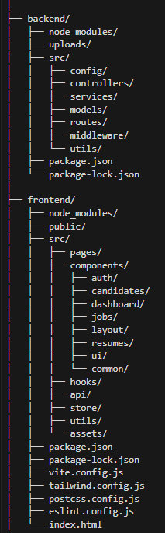

Package Diagram

Backend Package Diagram
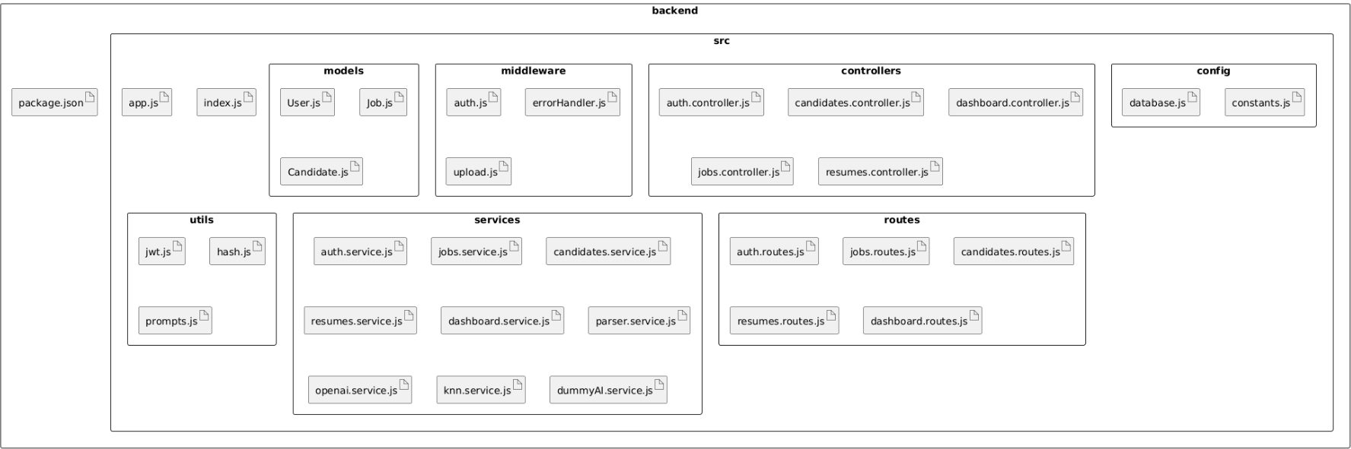

Frontend Package Diagram
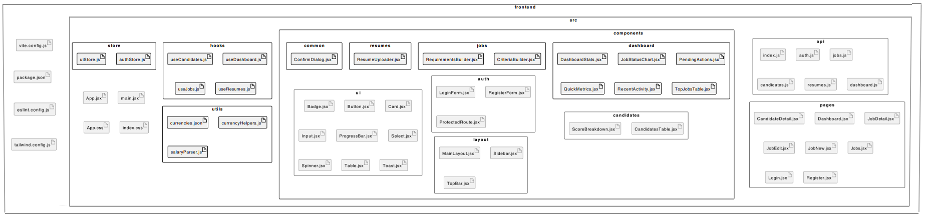

Modifying or Updating the System
- Adding New Features: When adding new features, maintain consistency with existing architecture patterns. Create components in appropriate directories, update related services, and ensure new features to integrate seamlessly with existing functionality. Consider user experience and maintain design consistency throughout the application.
- Updating AI Integration: The system's AI integration is designed to be replaceable. You can switch to different AI providers by creating a new service that implements the same interface. Consider factors such as cost, accuracy, response time, and API capabilities when choosing an alternative provider. Ensure the new provider can return structured JSON data matching the expected format. The system can also be configured to support multiple AI providers with automatic selection or fallback mechanisms.
- Modifying Ranking Algorithm: The ranking algorithm can be modified to use different distance metrics, weight application methods, or score scaling approaches. You can incorporate additional factors beyond criteria, such as experience levels or education qualifications. When making algorithm changes, test thoroughly with various candidate profiles and consider the impact on existing rankings. Document changes and ensures the algorithm remains fair and transparent.

