Creating a virtual environment
Python -m venv <envname>
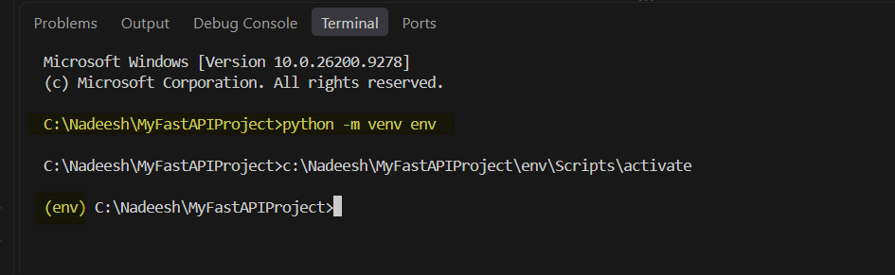

Deactivating virtual environment
Deactivate
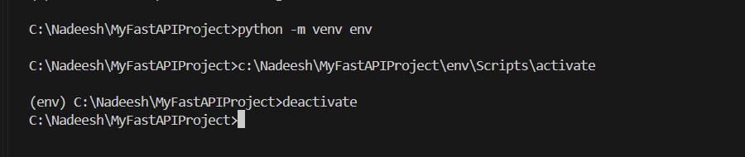

How to activate virtual environment
env\Scripts\activate
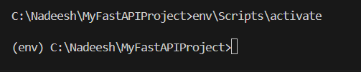

Installing fast api
pip install fastapi

