SOC Hashing Framework - Test Results Walkthrough

1. Execution Summary
- Dataset Used: URLhaus
- Entries Collected: 7500
- Iterations: 9
- Platform: Windows (Force UTF-8)

2. Benchmark Results
The following table shows the statistical breakdown of algorithm performance.
Algorithm | Throughput (H/s) | Avg Latency (us) | Median (us) | P95 (us) | Std Dev (us)
MD5 | 336,092.20 | 2.84 | 2.30 | 4.00 | 1.91
SHA-256 | 474,630.52 | 1.96 | 1.80 | 3.10 | 1.06
SHA3-256 | 316,649.84 | 3.04 | 2.70 | 5.00 | 3.42
BLAKE2b | 365,836.23 | 2.58 | 2.40 | 3.70 | 1.25
BLAKE3 | 367,023.94 | 2.59 | 2.30 | 3.80 | 4.90

3. Visual Comparisons

Throughput Comparison
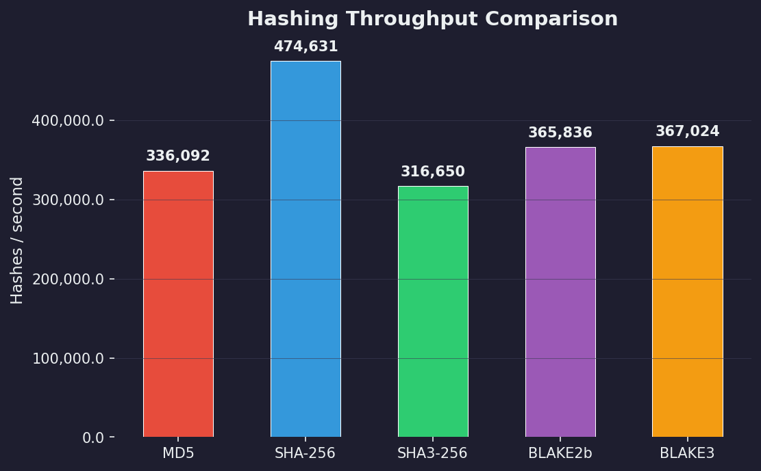

Latency Comparison
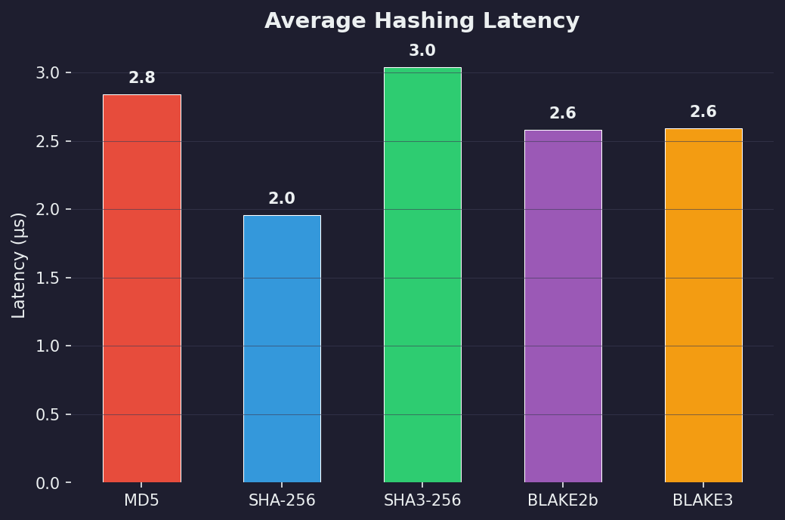

P95 Latency
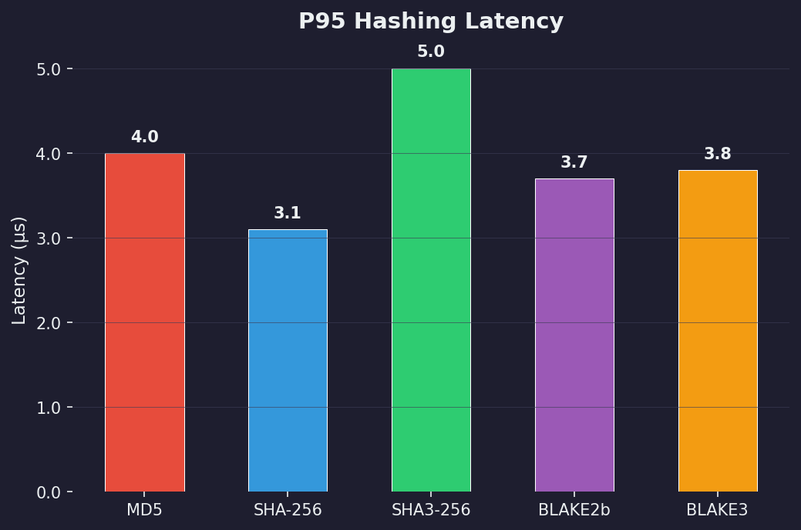

Resource Utilization (CPU)
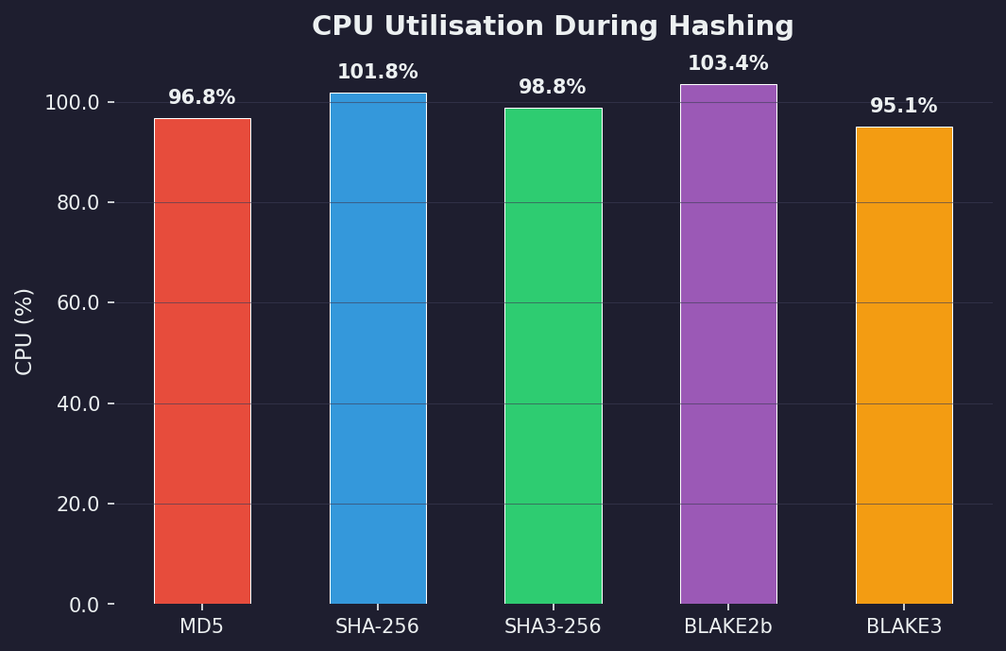

Memory Usage
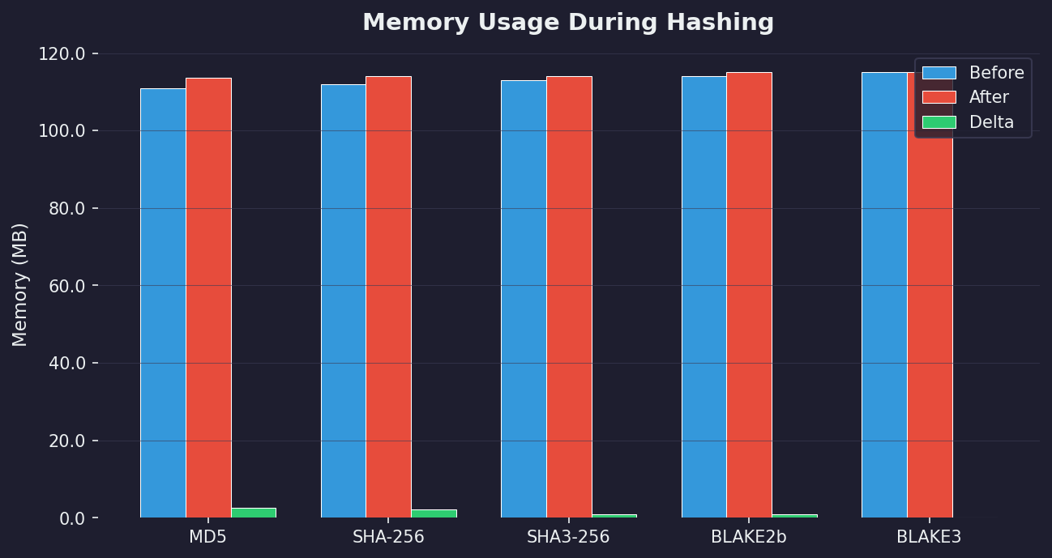

Integrity & Security Verification
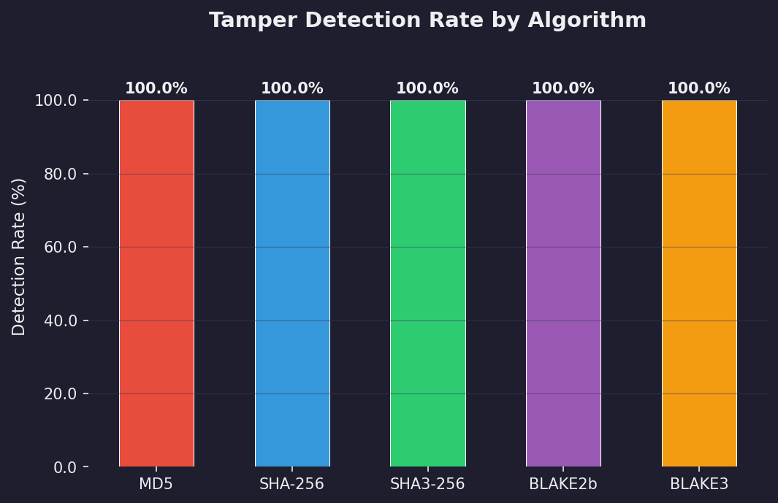

Tamper Detection Response Time
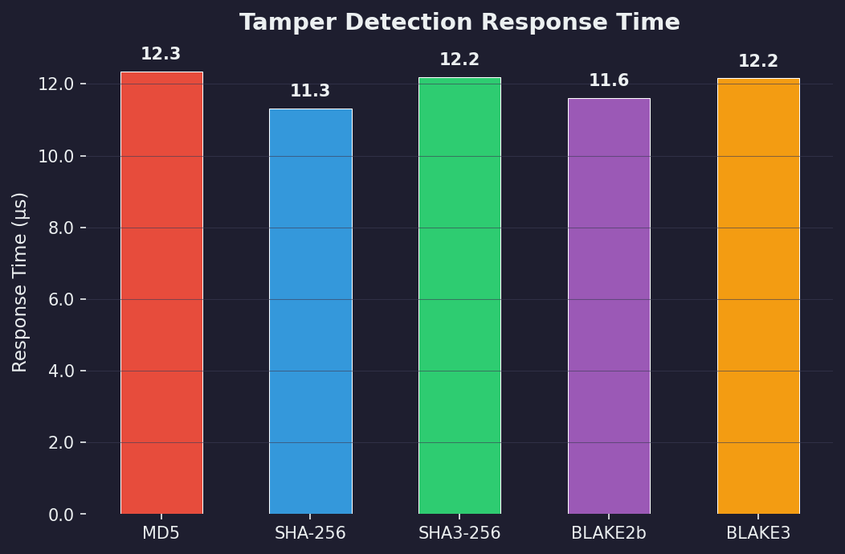

Ingestion Impact (Baseline vs Hashed)
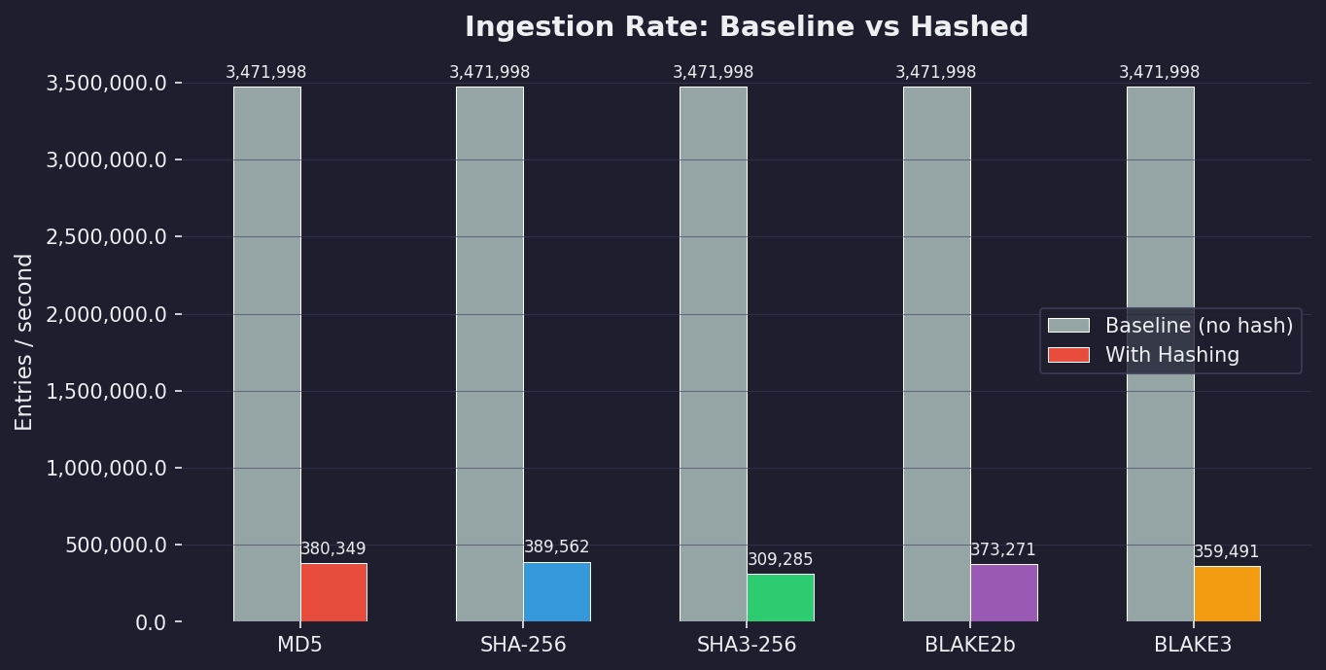

4. Integrity Verification
- MD5: PASSED (7500/7500 passed)
- SHA-256: PASSED (7500/7500 passed)
- SHA3-256: PASSED (7500/7500 passed)
- BLAKE2b: PASSED (7500/7500 passed)
- BLAKE3: PASSED (7500/7500 passed)

5. Tamper Detection
2400 of 7500 collected entries (32.0%) were randomly selected and deliberately tampered by mutating the domain field. The remaining 5100 entries were left intact to test for false positives.
Algorithm | TP | TN | FP | FN | Accuracy | Precision | Recall | F1
MD5 | 2400 | 5100 | 0 | 0 | 100.00% | 100.00% | 100.00% | 1.0000
SHA-256 | 2400 | 5100 | 0 | 0 | 100.00% | 100.00% | 100.00% | 1.0000
SHA3-256 | 2400 | 5100 | 0 | 0 | 100.00% | 100.00% | 100.00% | 1.0000
BLAKE2b | 2400 | 5100 | 0 | 0 | 100.00% | 100.00% | 100.00% | 1.0000
BLAKE3 | 2400 | 5100 | 0 | 0 | 100.00% | 100.00% | 100.00% | 1.0000

Response Times
Algorithm | Mean (µs) | Median (µs) | P95 (µs)
MD5 | 12.34 | 11.50 | 16.60
SHA-256 | 11.32 | 10.70 | 15.10
SHA3-256 | 12.20 | 11.60 | 16.00
BLAKE2b | 11.60 | 11.00 | 15.10
BLAKE3 | 12.15 | 11.30 | 15.70

6. Ingestion Impact Analysis
Comparison of baseline log ingestion rate (serialise-only) against hashed ingestion rate for each algorithm.
Algorithm | Baseline (eps) | Hashed (eps) | Rate Overhead % | Latency Overhead %
MD5 | 3,471,998 | 380,349 | 89.0% | 1713.7%
SHA-256 | 3,471,998 | 389,562 | 88.8% | 1737.4%
SHA3-256 | 3,471,998 | 309,285 | 91.1% | 2161.1%
BLAKE2b | 3,471,998 | 373,271 | 89.2% | 1754.2%
BLAKE3 | 3,471,998 | 359,491 | 89.7% | 1844.1%

