PRINCE MOHAMMAD BIN FAHD UNIVERSITY · ADMISSIONS OFFICE
Content Audit of the Admissions Office Web Pages
An independent, evidence-based review of the information published behind the 36 links of pmu.edu.sa/admission/admission
Prepared for | Associate Director for Enrollment, Admissions Office
Scope | Content only — data, rules, figures, dates and their accuracy, consistency and completeness
Evidence date | 28 September 2026 (live pages, read-only)
Version | 1.0
Classification | Internal — for discussion
Independent review. This document is not an official publication of Prince Mohammad Bin Fahd University and does not state University policy. Where published values conflict, it does not choose the correct value; each such case is referred to its decision owner.

Document Control
Title | Content Audit of the Admissions Office Web Pages
Version / date | 1.0 · 28 September 2026
Prepared by | ________________________ (audit owner)
Reviewed by | ________________________
Approved for circulation | ________________________
Status | Draft for discussion with the Associate Director for Enrollment
Related records | Findings Register (45 findings, F-01–F-45) · Arabic interactive report · Link audit · UX / IA Blueprint
Revision history
Version | Date | Change
1.0 | 28 Sep 2026 | First issue. Observations F-31–F-45 added to the Findings Register with the audit owner's approval.
Contents

1. Executive Summary
This audit reviewed what the Admissions Office website tells applicants. Each of the 36 links on the live Admissions Office page (pmu.edu.sa/admission/admission) was followed, and the full text of every target page was read and compared with the other 35. The review covers content only: admission rules, thresholds, fees, dates, programme information and their consistency. Technical matters (redirects, accessibility, code) are reported separately.
36  links reviewed | 80  content observations | 15  high severity | 15  new register findings (F-31–F-45) | 91  verbatim quotes machine-checked

Key messages
- No link is broken, but the information behind the links is not reliable as a whole. 80 content observations were recorded: 15 high, 39 medium and 26 low.
- The same fact is published with different values. Nine data points are contradicted across pages, including the application fee (SAR 950, SAR 1000 and SAR 500 excluding VAT), the application channel, SAT alternatives, the meaning of a 'Very Good' GPA and the list of majors with specific requirements (Section 4).
- The calendar is out of date. On the audit date every published date of the Fall 2026–2027 intake had passed, and no page states whether admission is currently open (F-08).
- Several programme pages contain errors of fact or arithmetic. The Medicine composite minimum cannot be reached at the published component minimums (F-20); the MA in International Business Law cannot be completed in the stated two years at six credits per semester (F-32); the EMGMS page reproduces another university's requirements (F-21).
- Most issues are governance issues, not editing issues. They arise because each page restates rules independently. They will recur unless rules are published from a single approved record, with an owner and an effective date.

Decisions required
Each high-severity observation belongs to a register finding. The following findings need a decision by their owner before the pages can be corrected:
Finding | Decision required | Decision owner
F-08 | The calendar is stale for the audit date and does not match the portal | Admissions Director + IT (portal)
F-02 | The application channel is contradictory. The calendar sends Saudi applicants to Qabool and non-Saudis to Study in Saudi, while other pages send everyone to the PMU portal | Admissions Director + VP (MoE platform liaison)
F-11 | Contact routing is broken or misdirected | Admissions Director + IT
F-31 | International transfer and visiting students are quoted two different application fees | Finance + Admissions Director
F-05 | Tahseely equivalence for SAT applicants is stated three ways, one of them impossible | Admissions Committee
F-21 | The EMGMS requirements page contains another university's checklist | Dean, College of Engineering + Graduate Admissions
F-32 | The MA in International Business Law cannot be completed in the stated time at the stated load | Dean, College of Law + Graduate Studies
F-20 | The Medicine composite minimum cannot be reached at the published component minimums | Dean, College of Medicine + Admissions Committee
F-23 | The Medicine programme duration is stated as 7 years in one place and 6 in another | Dean, College of Medicine + Finance
F-07 | The Medicine admission page omits material commitments and contains unedited draft prose | Dean, College of Medicine + Admissions + Finance

Overall conclusion
The Admissions Office pages cannot currently be relied on as a single, consistent statement of admission requirements. The priority is to decide the contested values (fees, channel, thresholds, programme facts) and to publish them once, from an approved record, before the pages are restructured into the proposed 17-page architecture (Section 7). Moving the current text without these decisions would carry the conflicts into the new site.

2. Scope and Methodology

2.1 Scope
In scope | Out of scope
- The 36 content links on the Admissions Office page and the pages they open  - Admission rules, thresholds, weights, documents, fees, dates, programme names and facts  - Consistency between the 36 pages  - Accuracy against authoritative external sources where a claim can be checked | - Technical issues: redirects, page code, accessibility (reported in the separate link audit)  - Pages not linked from the Admissions Office page, except where needed as a comparison  - The logged-in application portal  - University policy decisions — the audit identifies conflicts but does not choose values

2.2 Method
- Every link on the live page was extracted and numbered C01–C36 in page order.
- The main text of each target page was extracted in a browser, with collapsed sections expanded, on 28 September 2026.
- Each page was read in full and compared with the other pages on every data point it states.
- Each observation records the exact published wording. An automated check confirms that every quotation appears verbatim in the live text; the report cannot be built if one does not. Where a quotation spans the cells of a table, the cells are separated by “ | ”.
- For each quoted observation, the relevant region of the live page was captured with the quoted text highlighted (Appendix A).
- Observations were mapped to the Findings Register. Thirty new observations were consolidated into fifteen new findings (F-31–F-45), and one joined F-26.

2.3 Evidence standard
Text in quotation marks is verbatim from the University's live pages. External facts are cited to the issuing body (Appendix C). Where the audit could not verify a statement, it says so. The audit was strictly read-only: no form was submitted, no account was created and no application step was taken.

2.4 Severity scale
Severity | Definition
HIGH | Materially misleading or contradictory on a decision path: eligibility, money, the application route or programme duration.
MEDIUM | Inconsistency, gap or ambiguity with an indirect effect on the applicant's decision or file.
LOW | Quality, wording or completeness issue with limited decision impact.

2.5 Limitations
- C04 (Contact Us) opens a staff list with personal names; its text was not reproduced.
- C06 and C08 open the application portal, a JavaScript application that was not reviewed in this content audit.
- Page code on C07 contains bank payment details that are not displayed; they are referred to but not reproduced.
- The ETS (6993) and College Board (7647) institution codes, and the University's own AACSB status, were not verified.
- Findings reflect the pages on 28 September 2026 and may change if the pages are edited.

3. Results at a Glance

3.1 Observations by section of the Admissions Office page
Section | Links | High | Medium | Low | Total
Future Students | 6 | 4 | 2 | 5 | 11
International Students’ Office | 2 | 3 | 3 | 2 | 8
Graduate Admissions | 14 | 3 | 17 | 11 | 31
Undergraduate Admissions | 9 | 5 | 13 | 5 | 23
Undergraduate Placement Tests | 5 | 0 | 4 | 3 | 7
Total | 36 | 15 | 39 | 26 | 80

3.2 Observations by type
Type | Observations
Claim requiring verification | 2
Missing information | 30
Out of date | 7
Cross-page conflict | 28
Wording / language | 9
Incorrect information | 4

3.3 Findings Register entries evidenced by this audit
The 80 observations evidence 34 findings of the Findings Register, which now contains 45 findings.
ID | Finding | Register severity | Obs. | Links
F-02 | The application channel is contradictory. The calendar sends Saudi applicants to Qabool and non-Saudis to Study in Saudi, while other pages send everyone to the PMU portal. | Critical | 3 | C03, C06, C08
F-03 | The Medicine application fee differs by SAR 150 between two official pages. | Critical | 1 | C24
F-04 | English-proficiency thresholds conflict, and one uses a test format retired about 20 years ago. | High | 1 | C35
F-05 | Tahseely equivalence for SAT applicants is stated three ways, one of them impossible. | High | 3 | C07, C30, C36
F-07 | The Medicine admission page omits material commitments and contains unedited draft prose. | High | 2 | C24
F-08 | The calendar is stale for the audit date and does not match the portal. | High | 2 | C03
F-09 | Decisive cut-offs are not published. | High | 4 | C07, C26, C30, C33
F-10 | Fee information is fragmented across generations and entry points. | Medium | 1 | C31
F-11 | Contact routing is broken or misdirected. | Medium | 2 | C04, C22
F-13 | Required documents differ by page for the same route. | Medium | 2 | C07, C26
F-15 | The information architecture is fragmented. | Medium | 1 | C33
F-17 | Typos and grammar errors on policy pages. | Low | 5 | C05, C23, C27, C30, C36
F-20 | The Medicine composite minimum cannot be reached at the published component minimums. | High | 1 | C24
F-21 | The EMGMS requirements page contains another university's checklist. | High | 3 | C19
F-23 | The Medicine programme duration is stated as 7 years in one place and 6 in another. | High | 1 | C24
F-25 | The programme catalogue differs across four surfaces. | Medium | 6 | C02, C09, C21, C23
F-26 | Admission pages have empty required sections. | Medium | 2 | C14, C20
F-27 | The same GPA descriptor is attached to different thresholds. | Medium | 8 | C10, C12, C13, C15, C16, C17, C18, C20
F-28 | Prep→UG page: mismatched footnotes and an undefined exit exam. | Low | 2 | C29
F-31 | International transfer and visiting students are quoted two different application fees. | High | 3 | C07, C27, C28
F-32 | The MA in International Business Law cannot be completed in the stated time at the stated load. | High | 1 | C20
F-33 | The English-test equivalence and the list of recognised tests are not defined consistently. | Medium | 2 | C20, C32
F-34 | The majors that carry specific (higher) admission requirements are listed differently. | Medium | 2 | C30, C36
F-35 | Visiting-student eligibility and documents are defined inconsistently. | Medium | 2 | C23, C28
F-36 | The PhD in Business Administration eligibility rule says the opposite of what it intends. | Medium | 1 | C11
F-37 | Accreditation and quality claims are imprecise or unsourced. | Medium | 2 | C01, C11
F-38 | Graduate programme coverage is incomplete on the entry pages. | Medium | 2 | C07, C09
F-39 | The Medicine curriculum for Years 1–2 is written as a list of US pre-medical prerequisites, not as a PMU curriculum. | Medium | 1 | C24
F-40 | Programme and route pages omit core facts: credit hours, duration, cost and deadlines. | Low | 3 | C10, C14, C25
F-41 | Launch-era and time-bound wording leaves the programme status unclear. | Low | 4 | C16, C17, C18, C20
F-42 | Graduate requirement wording is inconsistent within and across pages. | Low | 2 | C12, C13
F-43 | Placeholder and empty sections remain on applicant pages. | Low | 2 | C03, C07
F-44 | Information is hidden from applicants or left in page code. | Low | 2 | C02, C07
F-45 | The admission query form sets no response-time expectation and offers no alternative channel. | Low | 1 | C05

4. Cross-page Inconsistencies
The same fact is stated with different values on different pages. An applicant who reads two pages cannot tell which value applies. Each row needs one decision and one published value.
Data point | What the pages say | Severity · Ref.
Application fee | - C23, C25, C26, C27, C28, C30: SAR 950 (incl. VAT)  - C24 (Medicine): SAR 1000 (incl. VAT)  - C07 (international transfer/visiting): SAR 500 (excl. VAT) | HIGH  F-31 + F-03
GPA descriptor 'Very Good' | - C12, C13, C15, C16, C17, C18: 2.50 / 4.00  - C10: 3.00 / 4.00  - C20: no number | MEDIUM  F-27
English — graduate | - Nine programmes: IELTS 6.0 (5.5 each skill) or TOEFL iBT 83 (19)  - C20 MA IBL: IELTS 6.5 or TOEFL iBT 83  - C19 EMGMS: IELTS 7, TOEFL iBT 79, PTE 60 or CESL | HIGH  F-21 + F-33
SAT alternative | - C36: 1200 instead of Qudrat and Tahseely  - C30: SAT 1 (1200) instead of Tahseely  - C24: SAT 1 1300 instead of Tahseely  - C07: SAT I + SAT II | HIGH  F-05
Identity document | - C26, C30: Saudi ID only  - C24, C25, C27, C28: Saudi ID or Iqama  - C07: National ID for an applicant without residence | MEDIUM  F-13
Majors with specific requirements | - C30: seven majors  - C36: eight + 'etc.'  - C02: Chemical Engineering and Cybersecurity listed, requirements not stated | MEDIUM  F-34
Application channel | - C03: Qabool (Saudi) / Study in Saudi — Closed (non-Saudi)  - C06, C08: PMU portal for all  - C07: 'completed entirely online' | HIGH  F-02
Graduate programme names | - C09: Master of Human Development · Doctorate in ME  - C14: Master of Science in Human Development  - C21: … Education and Human Development · Doctoral program | MEDIUM  F-25
Graduate programme list | - Admissions Office page: 11 links  - C09: 10 — without EMGMS  - C21: 12 + Pre-Master  - C07: 3 for international applicants | MEDIUM  F-25

5. New Findings Added to the Register (F-31 to F-45)
With the audit owner's approval, the new observations of this audit were added to the Findings Register on 28 September 2026 as fifteen findings. The register text is reproduced below; quotations are verbatim.

F-31 International transfer and visiting students are quoted two different application fees
HIGH Verified Conflict (money)
Where | C07 /admission/international_students (Transfer Students, Visitor Students) vs C27 /admission/admission-from-other-universities · C28 /admission/visiting-student-admission
Published text | C07 (transfer and visitor): "Pay a non-refundable application fee of SAR 500 (excl. VAT) upon submission of documents".
Conflicting source / value | C27 and C28: "Pay a non-refundable application fee of SAR 950 (incl. VAT) upon submission of documents".
Impact on applicants | The same applicant is told two amounts (SAR 500 + VAT vs SAR 950 incl. VAT) and cannot tell which will be charged.
Recommended treatment | Finance confirms one fee per applicant category. Publish it from the canonical fee record on every route page.
Decision owner | Finance + Admissions Director
Evidence | Figure E-C07-1, Figure E-C27-1, Figure E-C28-1

F-32 The MA in International Business Law cannot be completed in the stated time at the stated load
HIGH Arithmetic contradiction (internal)
Where | C20 /admission/admissions_requirements_milbl_gdp · C21 /admission/post_graduate_fees_tf_ro
Published text | C20: "Typically, candidates will complete the program within two years in a full-time mode (maximum 6 credits in each semester)".
Conflicting source / value | C21: "Master of Arts in International Business Law (36)". 36 credits at a maximum of 6 per semester = 6 semesters (3 academic years), not two.
Impact on applicants | Applicants plan time, employment and cost on a duration the programme cannot deliver.
Recommended treatment | College of Law confirms the credit total, per-semester maximum and normal duration. Publish consistent figures.
Decision owner | Dean, College of Law + Graduate Studies
Evidence | Figure E-C20-1

F-33 The English-test equivalence and the list of recognised tests are not defined consistently
MEDIUM Verified Conflict
Where | C20 (MA IBL) vs the other graduate pages · C32 /admission/overview-undergraduate-placement-tests vs C19 (EMGMS)
Published text | C20: "minimum scores of 6.5 overall and 5.5 in each skill or equivalent TOEFL iBT minimum scores of 83 overall".
Conflicting source / value | Nine other graduate pages treat TOEFL iBT 83 as equivalent to IELTS 6.0. C32 refers to "PMU recognized proficiency English language test certificates" and names only IELTS and TOEFL, while C19 also accepts Pearson PTE (see F-21).
Impact on applicants | The same TOEFL score is equivalent to two different IELTS bands. Applicants cannot tell which tests are accepted.
Recommended treatment | Publish one concordance table (IELTS / TOEFL iBT 1–6 and 0–120 / others) and a closed list of recognised tests, with an effective date.
Decision owner | English/Prep Program Director + Graduate Studies
Evidence | Figure E-C20-3, Figure E-C32-1

F-34 The majors that carry specific (higher) admission requirements are listed differently
MEDIUM Verified Conflict
Where | C30 /admission/admissions_requirements_cs_eng_majors · C36 /admission/sat-admission · C02 /admission/degrees_programs_fs_ro
Published text | C30: "These majors are Architecture, Computer Science, Computer Engineering, Software Engineering, Mechanical Engineering, Electrical Engineering and Civil Engineering."
Conflicting source / value | C36 adds "Artificial Intelligence" and ends the list with "etc.". C02 lists "B.S. in Chemical Engineering" and "B.S. in Cybersecurity", which neither list mentions.
Impact on applicants | Applicants to AI, Chemical Engineering or Cybersecurity cannot tell whether Tahseely and the higher thresholds apply.
Recommended treatment | Publish one closed list of majors with specific requirements, generated from the programme register.
Decision owner | Admissions Committee + Colleges
Evidence | Figure E-C30-1, Figure E-C36-1

F-35 Visiting-student eligibility and documents are defined inconsistently
MEDIUM Verified Conflict
Where | C23 /admission/undergraduate_programs_admission · C28 /admission/visiting-student-admission · C07
Published text | C23 and C28: "Visiting students are students registered in other local or international recognized universities".
Conflicting source / value | C07: "registered in other international recognized universities". C28 also asks a university student for "Copy of secondary school certificate or equivalent" and "Copy of General Aptitude Test score report (Qudrat) or equivalent (SAT 1) - if available".
Impact on applicants | Local visiting students may assume they are excluded. Applicants gather documents that may not be needed.
Recommended treatment | Define visiting-student eligibility once. Confirm the minimum document set.
Decision owner | Registrar + Admissions Director
Evidence | Figure E-C23-3, Figure E-C28-2

F-36 The PhD in Business Administration eligibility rule says the opposite of what it intends
MEDIUM Wording error (eligibility)
Where | C11 /admission/admissions_requirements_phdba_gdp
Published text | "Otherwise, if the master degree is not from another discipline they must successfully attend and complete with minimum GPA 2.80 12 credit hours of MBA"
Conflicting source / value | The context (a bridging requirement for non-business master's holders) requires *is from another discipline*. The two GPA conditions (3.00 cumulative vs 3.20 in "an applicable master's degree program") are not assigned to cases.
Impact on applicants | An eligibility rule for a SAR 150,000 programme can be read two ways.
Recommended treatment | Rewrite the rule as a table: applicant background → bridging courses → minimum GPA.
Decision owner | Dean, College of Business Administration
Evidence | Figure E-C11-1

F-37 Accreditation and quality claims are imprecise or unsourced
MEDIUM Claim needing verification
Where | C11 · C01 /admission/future_students_ro
Published text | C11: "The Ph.D. program is internationally accredited by AACSB as top 6% of business schools worldwide."
Conflicting source / value | AACSB accredits business schools (institution level), and fewer than 6% of business schools hold it (AACSB’s own wording); it is not a programme ranking (X10, aacsb.edu). C01: "Texas International Education Consortium (TIEC), which is a consortium of 32 universities in Texas, USA" and "reviewed and verified by around 70 multinational academic and industrial experts". No date or source is given, and the accrediting "prestigious national and international organizations" are not named.
Impact on applicants | Overstated or unverifiable claims expose the University to credibility and consumer-protection risk.
Recommended treatment | State accreditations precisely (body, scope, date) with a link to the accreditor's register. Remove unsourced figures.
Decision owner | Quality Assurance + College of Business Administration + Communications
Evidence | Figure E-C01-1, Figure E-C11-2

F-38 Graduate programme coverage is incomplete on the entry pages
MEDIUM Verified Gap
Where | C07 (Graduate Studies section) · C09 /admission/admission_graduate_degree_programs
Published text | C07 lists only "MBA", "MSHD" and "MSME" for international graduate applicants.
Conflicting source / value | The hub links 11 graduate programmes. On C09, MSCE, MSEE and MSID show "Application Form" without a link, while the other programmes have one.
Impact on applicants | International applicants may conclude that only three programmes are open to them. Some applicants have no form link.
Recommended treatment | Generate both lists from the programme register, including status and eligibility for international applicants.
Decision owner | Graduate Studies + International Admissions
Evidence | Figure E-C07-5, Figure E-C09-3

F-39 The Medicine curriculum for Years 1–2 is written as a list of US pre-medical prerequisites, not as a PMU curriculum
MEDIUM Content accuracy
Where | C24 /admission/college_of_medicine_admission
Published text | "Biology: One full year (2 courses) of general biology with laboratory." (similar lines for chemistry, organic chemistry, physics and behavioural science)
Conflicting source / value | The phrasing (*One full year (2 courses) of …*) describes prerequisites for entering a medical school. It does not describe courses taken at PMU (see also F-07 and F-23).
Impact on applicants | Applicants cannot tell what they will study in Years 1–2 or whether prior coursework is expected.
Recommended treatment | College of Medicine rewrites the curriculum section from its approved study plan.
Decision owner | Dean, College of Medicine
Evidence | Figure E-C24-4

F-40 Programme and route pages omit core facts: credit hours, duration, cost and deadlines
LOW Verified Gap
Where | C10 (PhD-ME) · C14 (MSHD) · C25 (Preparatory Program)
Published text | C10 and C14 give no credit total, duration, fee or deadline. C25 states no duration or cost of the Preparatory Program.
Conflicting source / value | C21 prices the PhD-ME at "(72)" credits and SAR 150,000; the MSHD fee implies 42 credits (SAR 50,000 ÷ 1,191), but no page states it.
Impact on applicants | Applicants must combine several pages to learn basic facts.
Recommended treatment | Add a standard "programme facts" block (credits, duration, mode, cost, next intake) to every programme page.
Decision owner | Graduate Studies + Preparatory Program
Evidence | Figure E-C25-1

F-41 Launch-era and time-bound wording leaves the programme status unclear
LOW Stale / launch-era wording
Where | C16 (MSEE) · C17 (MSCE) · C18 (MSID) · C20 (MA IBL)
Published text | C16 and C17: "The program will be offered under the College of Engineering." C18: "The Department of Interior Design at PMU will educate tomorrow’s interior design leaders". C20: "The year 2025 marks another milestone".
Conflicting source / value | C21 prices all four programmes as current.
Impact on applicants | Applicants cannot tell whether these programmes are open for admission.
Recommended treatment | Show the admission status per programme. Rewrite the text in the present tense.
Decision owner | Graduate Studies + Colleges
Evidence | Figure E-C16-1, Figure E-C17-1, Figure E-C18-1, Figure E-C20-5

F-42 Graduate requirement wording is inconsistent within and across pages
LOW Consistency
Where | C12 (EMBA) · C13 (MBA)
Published text | C12: "Successful candidates should have from three to five years of professional work experience" and, on the same page, "Participants are required to have several years of work experience".
Conflicting source / value | C13 lists no supporting documents (no references, statement or CV), unlike every other graduate page. It is unconfirmed whether none are required.
Impact on applicants | Candidates with more than five years' experience may think they are excluded. MBA applicants may submit incomplete files.
Recommended treatment | State *at least three years*. Confirm the MBA document list.
Decision owner | College of Business Administration
Evidence | Figure E-C12-2

F-43 Placeholder and empty sections remain on applicant pages
LOW Verified Gap
Where | C07 · C03 /admission/admission_calendar_fs_ro
Published text | C07: the "Transportation" section has a heading and no content. Its Housing text is in the future tense ("will be located"). C03: "Orientation for new applicants TBA", although classes began on 2026-08-30.
Conflicting source / value | —
Impact on applicants | Applicants see unfinished information on relocation and orientation.
Recommended treatment | Complete these sections or remove them. Add a pre-publication check for empty sections.
Decision owner | International Admissions + Student Affairs
Evidence | Figure E-C03-4, Figure E-C07-6

F-44 Information is hidden from applicants or left in page code
LOW Content visibility
Where | C02 /admission/degrees_programs_fs_ro · C07
Published text | C02 shows only "Undergraduate Programs" and "Graduate Programs" until the collapsed lists are opened, and the page code keeps a hidden Master of LAW entry. C07 holds international payment instructions, including bank details, only inside page code that is not displayed (not reproduced in this audit).
Conflicting source / value | —
Impact on applicants | Applicants do not see the programme list or the payment method. Hidden legacy entries can resurface.
Recommended treatment | Show the programme list openly. Decide whether to publish official payment instructions, and remove leftover code.
Decision owner | Admissions + IT/Web + Finance
Evidence | Figure E-C02-2, Figure E-C07-7

F-45 The admission query form sets no response-time expectation and offers no alternative channel
LOW Service information
Where | C05 /admission/admissions_queries
Published text | The form collects name, email, mobile and query. It does not state when a reply can be expected or give a direct phone or email alternative.
Conflicting source / value | —
Impact on applicants | Applicants cannot tell when to follow up, especially near deadlines.
Recommended treatment | State the service standard (e.g. reply within N working days) and link the admissions contact component (F-11).
Decision owner | Admissions Director
Evidence | —

6. Link-by-Link Review
Each of the 36 links is reviewed below in the order in which it appears on the Admissions Office page. For each link the report gives the page's purpose, the key facts it states, its destination in the proposed architecture, and every content observation with the verbatim wording, the recommended action and a reference to the evidence figure.

Future Students

C01 · Overview
Page | https://pmu.edu.sa/admission/future_students_ro
Purpose | General introduction to the University for prospective students
Key facts stated | - No admission data; links to undergraduate and graduate admissions
Proposed destination | Admissions (home) (/admissions)
Observations | 1 — 0 high, 0 medium, 1 low
C01-1 LOW Claim requiring verification F-37
Numerical claims carry no date or source, and the phrase 'accredited by prestigious national and international organizations' names no accrediting body.
PMU’s system and academic programs were designed by the international educational consultant, Texas International Education Consortium (TIEC), which is a consortium of 32 universities in Texas, USA
reviewed and verified by around 70 multinational academic and industrial experts
Recommended action: Name each accreditation (body, scope, date) or remove unsourced figures.
Evidence: Figure E-C01-1 (Appendix A)

C02 · Degrees & Programs
Page | https://pmu.edu.sa/admission/degrees_programs_fs_ro
Purpose | List of undergraduate and graduate programmes, with availability for male and female students
Key facts stated | - Undergraduate programmes in five colleges (Architecture & Design, Engineering, Computer Engineering & Science, Business Administration, Law)  - Graduate programmes in Engineering, Business Administration, Sciences & Human Studies, Architecture & Design and Law
Proposed destination | Programme finder (/admissions/programs)
Observations | 2 — 0 high, 1 medium, 1 low
C02-1 MEDIUM Missing information F-25
The list omits the College of Medicine and the College of Sciences and Human Studies (undergraduate), while it adds programmes (Chemical Engineering, Cybersecurity) that the major-specific requirement pages (C30, C36) do not mention.
B.S. in Chemical Engineering
B.S. in Cybersecurity
Recommended action: Publish one programme list from a single programme register, with admission status per programme.
Evidence: Figure E-C02-1 (Appendix A)
C02-2 LOW Missing information F-44
The programmes sit inside two collapsed lists; a visitor initially sees two headings only. The page code also keeps a hidden 'Master of LAW' entry.
Undergraduate Programs
Graduate Programs
Recommended action: Show the list openly, with each programme linked to its requirements; remove leftover code.
Evidence: Figure E-C02-2 (Appendix A)

C03 · Admissions Calendar
Page | https://pmu.edu.sa/admission/admission_calendar_fs_ro
Purpose | Admission dates for the current intake
Key facts stated | - Fall 2026-2027 (undergraduate and graduate)  - First day of classes: 2026-08-30  - Saudi applicants via Qabool; non-Saudi applicants via Study in Saudi (marked Closed)
Proposed destination | Dates & cycle status (/admissions/dates)
Observations | 4 — 2 high, 1 medium, 1 low
C03-1 HIGH Out of date F-08
On the audit date (28 September 2026) every date of the published intake has passed, and there is no information on the next intake or on whether admission is open.
Fall 2026-2027
First day of classes | 2026-08-30
Recommended action: Add an 'admission status now' component and the next intake's dates, or state explicitly that admission is closed until a given date.
Evidence: Figure E-C03-1 (Appendix A)
C03-2 MEDIUM Cross-page conflict F-08
Results are announced from 19 July, before the 20 July deadline for IELTS/TOEFL scores and for transfer documents.
Announcement of admission results through Qabool platform | From July 19 to July 21, 2026
Last day to submit IELTS or TOEFL iBT | 2026-07-20
Last day for Transfer applicants to submit documents in person | 2026-07-20
Recommended action: Re-sequence the dates or state which applicant groups the early results cover.
Evidence: Figure E-C03-2 (Appendix A)
C03-3 HIGH Cross-page conflict F-02
The calendar states that non-Saudi applications via Study in Saudi are 'Closed', while C07 states that international applicants apply entirely online through the PMU portal.
For non Saudi Students: Apply online through Study in Saudi platform: https://studyinsaudi.sa/ar | Closed
Recommended action: Define one channel per applicant category and show it identically on both pages.
Evidence: Figure E-C03-3 (Appendix A)
C03-4 LOW Missing information F-43
Orientation is still 'TBA' although classes have started.
Orientation for new applicants | TBA
Recommended action: Update or remove the entry once it has passed.
Evidence: Figure E-C03-4 (Appendix A)

C04 · Contact Us
Page | https://pmu.edu.sa/Staff_Profile/Staff_List.aspx?&DEpt=4&Name=Staff%20Name
Purpose | Contact with the Admissions Office
Key facts stated | - Opens a staff list with personal names (not reproduced)
Proposed destination | Contact & enquiries (/admissions/contact)
Observations | 1 — 1 high, 0 medium, 0 low
C04-1 HIGH Missing information F-11
The target gives no Admissions Office telephone number, shared mailbox or office hours; applicants are directed to named individuals.
Recommended action: Link to a single admissions contact page (role mailbox, telephone, hours, enquiry form).

C05 · Admission Query
Page | https://pmu.edu.sa/admission/admissions_queries
Purpose | Enquiry form for applicants
Key facts stated | - Fields: name, email, mobile, query, preferred contact method
Proposed destination | Contact & enquiries (/admissions/contact)
Observations | 2 — 0 high, 0 medium, 2 low
C05-1 LOW Wording / language F-17
Spelling errors in four Arabic labels and one English label of the form (published and correct spellings are listed in the table below).
Name [الأسم]
مكتب القبول يسعد بالإجابة على إستفساراتكم
Email [البريد الإللكتروني]
Enter Verifaction Code
As published | Correct spelling
الأسم | الاسم
إستفساراتكم | استفساراتكم
الإستفسار | الاستفسار
الإللكتروني | الإلكتروني
Verifaction | Verification

Recommended action: Proof-read both languages and apply the corrections.
Evidence: Figure E-C05-1 (Appendix A)
C05-2 LOW Missing information F-45
The form states no expected response time and offers no direct alternative channel.
Recommended action: State the service standard and link the admissions contact component.

C06 · Apply Now
Page | https://admissions.pmu.edu.sa/welcome
Purpose | Apply button (Future Students)
Key facts stated | - Opens the application portal (admissions.pmu.edu.sa)
Proposed destination | Apply now (channel router) (/admissions/apply)
Observations | 1 — 1 high, 0 medium, 0 low
C06-1 HIGH Cross-page conflict F-02
'Apply Now' sends every applicant to the same portal, while the calendar (C03) sends Saudi applicants to Qabool and non-Saudi applicants to Study in Saudi — three channels for one step.
Recommended action: Replace the button with an application router by applicant category.

International Students’ Office

C07 · International Students without Saudi Residence
Page | https://pmu.edu.sa/admission/international_students
Purpose | Admission of international students without Saudi residence (freshman, transfer, visiting, graduate, fees, housing)
Key facts stated | - Freshman: secondary GPA 80%, SAT I, IELTS 6.0 (5.5 writing), online interview  - Application fee: SAR 950 incl. VAT (freshman); SAR 500 excl. VAT (transfer and visiting)
Proposed destination | International (no Saudi residence) (/admissions/undergraduate/international)
Observations | 7 — 2 high, 3 medium, 2 low
C07-1 HIGH Cross-page conflict F-31
The application fee for international transfer and visiting students is SAR 500 excluding VAT, while C27 (transfer) and C28 (visiting) state SAR 950 including VAT for the same applicants.
Pay a non-refundable application fee of SAR 500 (excl. VAT) upon submission of documents
Recommended action: Finance to confirm one fee per category, published from the fee record.
Evidence: Figure E-C07-1 (Appendix A)
C07-2 HIGH Incorrect information F-05
SAT II (Subject Tests) is required for Engineering and Computer Science; College Board discontinued these tests internationally in 2021.
SAT II 30%
Recommended action: Replace with the approved requirement (Tahseely or its approved equivalent).
Evidence: Figure E-C07-2 (Appendix A)
C07-3 MEDIUM Incorrect information F-13
A 'National ID' is requested from an international applicant without Saudi residence — a document such applicants do not hold.
Copy of National ID
Recommended action: Request the passport only.
Evidence: Figure E-C07-3 (Appendix A)
C07-4 MEDIUM Missing information F-09
No minimum SAT I score is stated, whereas the SAT page (C36) sets 1200.
Acceptable SAT I
Recommended action: State the numerical minimum.
Evidence: Figure E-C07-4 (Appendix A)
C07-5 MEDIUM Missing information F-38
The graduate section for international applicants lists three programmes, out of eleven linked from the Admissions Office page.
MBA
MSHD
MSME
Recommended action: Link to the full programme list and state which programmes accept international applicants.
Evidence: Figure E-C07-5 (Appendix A)
C07-6 LOW Missing information F-43
The 'Transportation' section is a heading without content, and the housing text is written in the future tense ('will be located').
Transportation
Recommended action: Publish current transport and housing information.
Evidence: Figure E-C07-6 (Appendix A)
C07-7 LOW Missing information F-44
Payment instructions for international students exist in the page code but are not displayed (not reproduced here because they contain bank details).
Get Information on Tuition and Fees
Recommended action: Decide whether to publish the official payment method; remove leftover code.
Evidence: Figure E-C07-7 (Appendix A)

C08 · Apply
Page | https://admissions.pmu.edu.sa/welcome
Purpose | Apply button (International Students' Office)
Key facts stated | - Opens the same general application portal
Proposed destination | Apply now (channel router) (/admissions/apply)
Observations | 1 — 1 high, 0 medium, 0 low
C08-1 HIGH Cross-page conflict F-02
The button does not indicate the correct channel for non-residents, whose channel the calendar marks as 'Closed'.
Recommended action: As for C06.

Graduate Admissions

C09 · Home
Page | https://pmu.edu.sa/admission/admission_graduate_degree_programs
Purpose | Graduate admissions home and programme list
Key facts stated | - Ten programmes, each with 'Application Form' and 'Admissions Requirements' entries
Proposed destination | Graduate (/admissions/graduate)
Observations | 3 — 0 high, 2 medium, 1 low
C09-1 MEDIUM Missing information F-25
The list omits EMGMS (linked from the Admissions Office page as C19 and priced in C21) and the Master of Engineering in Innovation, Sustainability, and Entrepreneurship priced in C21.
Admissions to the Master of Arts (MA) in International Business Law Program
Recommended action: Generate the list from the programme register.
Evidence: Figure E-C09-1 (Appendix A)
C09-2 MEDIUM Cross-page conflict F-25
Programme names differ between pages: 'Master of Human Development' here, 'MSHD' on the Admissions Office page, 'Master of Science in Human Development' in C14 and 'Master of Science in Education and Human Development' in C21; 'Doctorate' here, 'PhD' in C10 and 'Doctoral program' in C21.
Admission to the Master of Human Development
Admissions to the Doctorate in Mechanical Engineering Program
Recommended action: Adopt one official name per programme, in Arabic and English.
Evidence: Figure E-C09-2 (Appendix A)
C09-3 LOW Missing information F-38
MSCE, MSEE and MSID show 'Application Form' without a link, while the other programmes have one.
Admissions to the Master of Science in Civil Engineering (MSCE) Program
Recommended action: Provide a working form link for every programme.
Evidence: Figure E-C09-3 (Appendix A)

C10 · Admissions to the PhD in Mechanical Engineering Program
Page | https://pmu.edu.sa/admission/application_form_deme_gdp
Purpose | Admission requirements: PhD in Mechanical Engineering
Key facts stated | - Bachelor's and master's in Mechanical Engineering  - GPA 3.00/4.00  - IELTS 6.0 (5.5 each skill) or TOEFL iBT 83 (19 each)  - Two references, statement of purpose, interview
Proposed destination | Programme page (one template × 11) (/admissions/graduate/{programme})
Observations | 2 — 0 high, 1 medium, 1 low
C10-1 MEDIUM Cross-page conflict F-27
The descriptor 'Very Good' is attached here to 3.00, and on six other pages to 2.50.
A minimum cumulative GPA of 3.00 out of 4.00 or equivalent (Very Good)
Recommended action: Registrar to publish one grade-conversion table.
Evidence: Figure E-C10-1 (Appendix A)
C10-2 LOW Missing information F-40
The page states no credit hours, duration, fees or deadlines (C21 gives 72 credits and SAR 150,000).
Recommended action: Add a 'programme facts' block.

C11 · Admissions to the PhD in Business Administration Program
Page | https://pmu.edu.sa/admission/admissions_requirements_phdba_gdp
Purpose | Admission requirements: PhD in Business Administration
Key facts stated | - Two tracks: Management and Finance  - Master's in Business Administration, Finance or a related field  - Three recommendation letters
Proposed destination | Programme page (one template × 11) (/admissions/graduate/{programme})
Observations | 2 — 0 high, 2 medium, 0 low
C11-1 MEDIUM Wording / language F-36
A double negative reverses the intended meaning (the intended condition is a master's degree from another discipline), and it is unclear to whom each GPA condition (3.00 or 3.20) applies.
Otherwise, if the master degree is not from another discipline they must successfully attend and complete with minimum GPA 2.80 12 credit hours of MBA
Recommended action: Rewrite the rule as a table: background → bridging courses → minimum GPA.
Evidence: Figure E-C11-1 (Appendix A)
C11-2 MEDIUM Claim requiring verification F-37
AACSB accredits business schools (institution level), not individual programmes, and 'fewer than 6%' describes the share of accredited schools, not a ranking ('top').
The Ph.D. program is internationally accredited by AACSB as top 6% of business schools worldwide.
Recommended action: Use precise wording once the College confirms: 'The College of Business Administration holds AACSB accreditation, held by fewer than 6% of business schools worldwide.'
Evidence: Figure E-C11-2 (Appendix A)

C12 · Admissions to the EMBA Program
Page | https://pmu.edu.sa/admission/admissions_requirements_emba_gdp
Purpose | Admission requirements: Executive MBA
Key facts stated | - 33 credit hours over two years, weekend delivery  - GPA 2.50  - Three to five years' experience  - Employer letter and three references
Proposed destination | Programme page (one template × 11) (/admissions/graduate/{programme})
Observations | 2 — 0 high, 1 medium, 1 low
C12-1 MEDIUM Cross-page conflict F-27
2.50 is described as 'Very Good', while 3.00 carries the same descriptor in C10.
A minimum GPA of 2.50 out of 4.00 or equivalent (Very Good) in Bachelor’s Degree
Recommended action: One grade-conversion table.
Evidence: Figure E-C12-1 (Appendix A)
C12-2 LOW Cross-page conflict F-42
Experience is 'from three to five years' (are candidates with six or more years excluded?) but 'several years' in the same page.
Successful candidates should have from three to five years of professional work experience
Participants are required to have several years of work experience
Recommended action: State 'at least three years'.
Evidence: Figure E-C12-2 (Appendix A)

C13 · Admissions to the MBA Program
Page | https://pmu.edu.sa/admission/admissions_requirements_mba_gdp
Purpose | Admission requirements: MBA
Key facts stated | - 36 credit hours, evening delivery, six concentrations  - GPA 2.50  - IELTS 6.0 or TOEFL iBT 83
Proposed destination | Programme page (one template × 11) (/admissions/graduate/{programme})
Observations | 2 — 0 high, 1 medium, 1 low
C13-1 MEDIUM Cross-page conflict F-27
As for C12.
A minimum GPA of 2.50 out of 4.00 or equivalent (Very Good) in Bachelor’s Degree
Recommended action: One grade-conversion table.
Evidence: Figure E-C13-1 (Appendix A)
C13-2 LOW Missing information F-42
No supporting documents are listed (references, statement, CV), unlike every other graduate programme; it should be confirmed that none are required.
Recommended action: College to confirm the document list.

C14 · Admissions to the MSHD Program
Page | https://pmu.edu.sa/admission/admissions_requirements_msehd_gdp
Purpose | Admission requirements: MS in Human Development
Key facts stated | - Relevant bachelor's degree with GPA 2.50  - Two references, statement of purpose, interview
Proposed destination | Programme page (one template × 11) (/admissions/graduate/{programme})
Observations | 2 — 0 high, 1 medium, 1 low
C14-1 MEDIUM Missing information F-26
A 'Work Experience' heading has no requirement under it (the CV item follows directly).
Work Experience
Recommended action: State the experience requirement or remove the heading.
Evidence: Figure E-C14-1 (Appendix A)
C14-2 LOW Missing information F-40
No credit hours or duration are stated (the fee table in C21 implies 42 credits: 50,000 ÷ 1,191).
Recommended action: Add a 'programme facts' block.

C15 · Admissions to the MSME Program
Page | https://pmu.edu.sa/admission/admissions_requirements_msme_gdp
Purpose | Admission requirements: MS in Mechanical Engineering
Key facts stated | - Minimum 30 credit hours, two tracks, thesis or non-thesis  - GPA 2.50  - Two references
Proposed destination | Programme page (one template × 11) (/admissions/graduate/{programme})
Observations | 1 — 0 high, 1 medium, 0 low
C15-1 MEDIUM Cross-page conflict F-27
As for C12.
A minimum cumulative GPA of 2.50 out of 4.00 or equivalent (Very Good) in Bachelor’s Degree
Recommended action: One grade-conversion table.
Evidence: Figure E-C15-1 (Appendix A)

C16 · Admissions to the MSEE Program
Page | https://pmu.edu.sa/admission/application_form_msee_gdp
Purpose | Admission requirements: MS in Electrical Engineering
Key facts stated | - Two tracks  - Bachelor's in any engineering discipline  - GPA 2.50
Proposed destination | Programme page (one template × 11) (/admissions/graduate/{programme})
Observations | 2 — 0 high, 1 medium, 1 low
C16-1 LOW Out of date F-41
'will be offered' suggests the programme has not launched — is it open for admission?
The program will be offered under the College of Engineering.
Recommended action: Show programme status (open / not open) and update the wording.
Evidence: Figure E-C16-1 (Appendix A)
C16-2 MEDIUM Cross-page conflict F-27
As for C12.
A minimum cumulative GPA of 2.50 out of 4.00 or equivalent (Very Good) in Bachelor’s Degree
Recommended action: One grade-conversion table.
Evidence: Figure E-C16-2 (Appendix A)

C17 · Admissions to the MSCE Program
Page | https://pmu.edu.sa/admission/application_form_msce_gdp
Purpose | Admission requirements: MS in Civil Engineering
Key facts stated | - Two tracks  - Bachelor's in Civil Engineering  - GPA 2.50
Proposed destination | Programme page (one template × 11) (/admissions/graduate/{programme})
Observations | 2 — 0 high, 1 medium, 1 low
C17-1 LOW Out of date F-41
As for C16.
The program will be offered under the College of Engineering.
Recommended action: As for C16.
Evidence: Figure E-C17-1 (Appendix A)
C17-2 MEDIUM Cross-page conflict F-27
As for C12.
A minimum cumulative GPA of 2.50 out of 4.00 or equivalent (Very Good) in Bachelor’s Degree
Recommended action: One grade-conversion table.
Evidence: Figure E-C17-2 (Appendix A)

C18 · Admissions to the MSID Program
Page | https://pmu.edu.sa/admission/application_form_msid_gdp
Purpose | Admission requirements: MS in Interior Design
Key facts stated | - Bachelor's in Interior Design  - GPA 2.50
Proposed destination | Programme page (one template × 11) (/admissions/graduate/{programme})
Observations | 2 — 0 high, 1 medium, 1 low
C18-1 LOW Out of date F-41
The whole introduction is in the future tense ('will educate', 'will be to provide').
The Department of Interior Design at PMU will educate tomorrow’s interior design leaders
Recommended action: Update the wording.
Evidence: Figure E-C18-1 (Appendix A)
C18-2 MEDIUM Cross-page conflict F-27
As for C12.
A minimum cumulative GPA of 2.50 out of 4.00 or equivalent (Very Good) in Bachelor’s Degree
Recommended action: One grade-conversion table.
Evidence: Figure E-C18-2 (Appendix A)

C19 · Admissions to the EMGMS Program
Page | https://pmu.edu.sa/admission/admissions_requirements_emgms_gdp
Purpose | Admission requirements: MS in Engineering Management (EMGMS)
Key facts stated | - GPA 3.00  - IELTS 7 / TOEFL iBT 79 / PTE 60
Proposed destination | Programme page (one template × 11) (/admissions/graduate/{programme})
Observations | 3 — 2 high, 1 medium, 0 low
C19-1 HIGH Incorrect information F-21
Content copied from another university (University of Arizona); a pathway that does not apply to PMU applicants.
Graduate English Language Endorsement from UA Center for English as Second Language (CESL)
Recommended action: Withdraw the page and rewrite it from PMU's requirements.
Evidence: Figure E-C19-1 (Appendix A)
C19-2 HIGH Cross-page conflict F-21
IELTS 7 is higher than every other PMU programme (6.0) while TOEFL 79 is lower (83) — the equivalence contradicts itself within the page.
IELTS – minimum composite score of 7, with no subject area below a 6
TOEFL – minimum of 79 iBT
Recommended action: Adopt PMU's single graduate threshold.
Evidence: Figure E-C19-2 (Appendix A)
C19-3 MEDIUM Missing information F-21
No programme description, duration or interview, unlike every other graduate programme.
Recommended action: Use the standard programme-page template.

C20 · Admissions to the MIBL
Page | https://pmu.edu.sa/admission/admissions_requirements_milbl_gdp
Purpose | Admission requirements: MA in International Business Law
Key facts stated | - Thesis and non-thesis tracks  - Bachelor's in Law with a 'Very Good' grade  - IELTS 6.5  - Weights: GPA 50%, written test 30%, interview 20%
Proposed destination | Programme page (one template × 11) (/admissions/graduate/{programme})
Observations | 5 — 1 high, 3 medium, 1 low
C20-1 HIGH Cross-page conflict F-32
The programme has 36 credits (C21); a maximum of 6 credits per semester means six semesters (three years), not two years.
Typically, candidates will complete the program within two years in a full-time mode (maximum 6 credits in each semester)
Recommended action: Correct the duration or the per-semester maximum.
Evidence: Figure E-C20-1 (Appendix A)
C20-2 MEDIUM Missing information F-26
A 30% weight is given to a 'written test' that is neither listed among the admission criteria nor described.
30% for the written test.
Recommended action: Describe the test (content, date, minimum score).
Evidence: Figure E-C20-2 (Appendix A)
C20-3 MEDIUM Cross-page conflict F-33
IELTS 6.5 is paired with TOEFL iBT 83, whereas TOEFL 83 is paired with IELTS 6.0 in the other programmes.
minimum scores of 6.5 overall and 5.5 in each skill or equivalent TOEFL iBT minimum scores of 83 overall
Recommended action: One concordance table.
Evidence: Figure E-C20-3 (Appendix A)
C20-4 MEDIUM Missing information F-27
The 'Very Good' grade has no numerical value (other programmes state a number).
A minimum (Very Good) in Bachelor’s Degree
Recommended action: State the numerical GPA.
Evidence: Figure E-C20-4 (Appendix A)
C20-5 LOW Out of date F-41
A statement tied to the year 2025.
The year 2025 marks another milestone
Recommended action: Use time-independent wording.
Evidence: Figure E-C20-5 (Appendix A)

C21 · Tuition & Fees
Page | https://pmu.edu.sa/admission/post_graduate_fees_tf_ro
Purpose | Graduate tuition and fees
Key facts stated | - 13 programmes priced in total and per credit hour, for PMU alumni and others  - VAT: 15% on tuition and fees for non-Saudi students; Saudi students pay VAT on fees only
Proposed destination | Costs & scholarships (/admissions/costs)
Observations | 2 — 0 high, 1 medium, 1 low
Verified | Arithmetic check: total price = rate per credit hour × credit hours for EMBA (33), MBA (36), PhD (72), MSME/MSEE/MSCE/MSID (30), EMGMS (30), M.Eng (33) and MA IBL (36) — consistent.
C21-1 MEDIUM Missing information F-25
Two priced programmes have no admission page among the 36 links.
Master of Engineering in Innovation, Sustainability, and Entrepreneurship (33)
PRE-Master for Master of Education
Recommended action: Add admission pages or remove the rows if the programmes are not open.
Evidence: Figure E-C21-1 (Appendix A)
C21-2 LOW Cross-page conflict F-25
The same programme appears under two names in the two tables.
Master of Science in Human Development | SAR 50,000
Master of Science in Education and Human Development | 1,191 SAR /Credit hour
Recommended action: One official name.
Evidence: Figure E-C21-2 (Appendix A)

C22 · Contact Info
Page | https://pmu.edu.sa/admission/admission_contact_gdp
Purpose | Graduate admissions contact
Key facts stated | - Graduate Study Admission Coordinator, office G-017, graduateadm@pmu.edu.sa
Proposed destination | Contact & enquiries (/admissions/contact)
Observations | 1 — 0 high, 0 medium, 1 low
C22-1 LOW Missing information F-11
Only an email address and an office number; no telephone or office hours.
Recommended action: Single admissions contact component.

Undergraduate Admissions

C23 · Home
Page | https://pmu.edu.sa/admission/undergraduate_programs_admission
Purpose | Undergraduate admissions home
Key facts stated | - Secondary GPA 80% and Qudrat 60% (or SAT 1)  - 60/40 weighting for lower scores  - Application fee SAR 950 incl. VAT  - Day students up to 20 credits; evening students up to 12
Proposed destination | Undergraduate (/admissions/undergraduate)
Observations | 3 — 0 high, 2 medium, 1 low
C23-1 MEDIUM Missing information F-25
Lists five colleges only, omitting the College of Medicine (described on the same page) and the College of Sciences and Human Studies.
PMU offers various degrees under the College of Architecture and Design, College of Computer Engineering and Science, College of Business Administration, College of Law and College of Engineering.
Recommended action: Generate the list of colleges from the programme register.
Evidence: Figure E-C23-1 (Appendix A)
C23-2 LOW Wording / language F-17
'College of Medical' is incorrect (College of Medicine).
College of Medical Admissions
Recommended action: Correct.
Evidence: Figure E-C23-2 (Appendix A)
C23-3 MEDIUM Cross-page conflict F-35
Here visiting students come from 'local or international' universities; C07 says 'international' only. It should be clear whether local visiting students are accepted.
Visiting students are students registered in other local or international recognized universities
Recommended action: One definition.
Evidence: Figure E-C23-3 (Appendix A)

C24 · Admission to the College of Medicine
Page | https://pmu.edu.sa/admission/college_of_medicine_admission
Purpose | Admission to the College of Medicine
Key facts stated | - Seven-year programme  - Composite: (20% secondary + 40% Qudrat + 40% Tahseely) × 60% + interview 40%; minimum 86  - Minimums: secondary 95%, Qudrat 80, Tahseely 80  - Application fee SAR 1000 incl. VAT
Proposed destination | College of Medicine (/admissions/undergraduate/medicine)
Observations | 6 — 3 high, 3 medium, 0 low
C24-1 HIGH Cross-page conflict F-20
An applicant who meets every published minimum (95/80/80) scores 83, below the stated minimum of 86.
20% high school + 40% Qudrat + 40% Tahseely were 86 is the minimum acceptable score
Copy of secondary school certificate or equivalent (95%)
Recommended action: Publish consistent minimums or a worked example.
Evidence: Figure E-C24-1 (Appendix A)
C24-2 HIGH Cross-page conflict F-23
The programme is described as seven years, but the curriculum shown stops at Year 6, and the College's academic page states six years.
The PMU College of Medical curriculum is based on a 7-year hybrid model
Recommended action: College to confirm the duration and publish the total cost.
Evidence: Figure E-C24-2 (Appendix A)
C24-3 HIGH Wording / language F-07
Unedited draft text (generic explanatory style) and 'to be developed' placeholders.
the process typically involves understanding the weighting and criteria that the medical college uses to evaluate applicants
Population Health (to be developed in launch phase)
Recommended action: Rewrite the page.
Evidence: Figure E-C24-3 (Appendix A)
C24-4 MEDIUM Wording / language F-39
Years 1–2 are described as a list of US-style prerequisites, not as a PMU study plan.
Biology: One full year (2 courses) of general biology with laboratory.
Recommended action: Describe the curriculum as actually taught.
Evidence: Figure E-C24-4 (Appendix A)
C24-5 MEDIUM Missing information F-07
The page states neither the English requirement, nor the SAR 20,000 non-refundable seat reservation, nor the programme cost.
Recommended action: Add complete requirements and a cost block.
C24-6 MEDIUM Cross-page conflict F-03
The Medicine application fee is SAR 1000 here and SAR 1,150 on the Medicine fees page.
Pay a non-refundable application fee of SAR 1000 (incl. VAT)
Recommended action: One value from Finance.
Evidence: Figure E-C24-6 (Appendix A)

C25 · Admissions to the Preparatory Program
Page | https://pmu.edu.sa/admission/admission-to-the-preparatory-program
Purpose | Admission to the Preparatory Program
Key facts stated | - Secondary GPA 80% and Qudrat 60%  - Aptis placement test and interview  - Application fee SAR 950 incl. VAT  - Study-skills courses by English level
Proposed destination | Preparatory Program (/admissions/undergraduate/preparatory)
Observations | 1 — 0 high, 0 medium, 1 low
C25-1 LOW Missing information F-40
Content is broadly sound; the duration and cost of the Preparatory Program are not stated.
If employed, a letter of no objection from the employer is required
Recommended action: Add duration and cost.
Evidence: Figure E-C25-1 (Appendix A)

C26 · Direct Admissions from Secondary School
Page | https://pmu.edu.sa/admission/direct-admissions-from-secondary-school
Purpose | Direct admission from secondary school
Key facts stated | - Secondary GPA 80%, Qudrat 60%, IELTS 6.0 (5.5 writing)  - 60/40 weighting
Proposed destination | High-school graduate in KSA (/admissions/undergraduate/high-school)
Observations | 2 — 0 high, 2 medium, 0 low
C26-1 MEDIUM Missing information F-13
Only a 'Saudi ID' is requested, without the Iqama option available on the Preparatory and Transfer pages — non-Saudi residents cannot see themselves in this route.
Copy of Saudi ID
Recommended action: 'National ID or Iqama'.
Evidence: Figure E-C26-1 (Appendix A)
C26-2 MEDIUM Missing information F-09
The required TOEFL score is not stated on the page (it is in C35: 83/19).
equivalent TOEFL iBT (Learn more)
Recommended action: State the number in place.
Evidence: Figure E-C26-2 (Appendix A)

C27 · Admissions from Other Universities
Page | https://pmu.edu.sa/admission/admission-from-other-universities
Purpose | Transfer admission from another university
Key facts stated | - Cumulative GPA 2.0/4.0  - Last course passed within five years  - Credit-transfer review of at least five weeks  - Application fee SAR 950 incl. VAT
Proposed destination | Transfer (/admissions/undergraduate/transfer)
Observations | 2 — 1 high, 0 medium, 1 low
C27-1 HIGH Cross-page conflict F-31
SAR 950 including VAT here, and SAR 500 excluding VAT on the international page (C07).
Pay a non-refundable application fee of SAR 950 (incl. VAT) upon submission of documents
Recommended action: One value per category.
Evidence: Figure E-C27-1 (Appendix A)
C27-2 LOW Wording / language F-17
Grammatical error ('to be consider').
In order to be consider as a transfer candidate
Recommended action: Correct to 'considered'.
Evidence: Figure E-C27-2 (Appendix A)

C28 · Visting Students
Page | https://pmu.edu.sa/admission/visiting-student-admission
Purpose | Visiting-student admission
Key facts stated | - Home-institution approval and college approval  - Application fee SAR 950 incl. VAT
Proposed destination | Visiting student (/admissions/undergraduate/visiting)
Observations | 2 — 1 high, 0 medium, 1 low
C28-1 HIGH Cross-page conflict F-31
SAR 950 including VAT here, and SAR 500 excluding VAT in C07.
Pay a non-refundable application fee of SAR 950 (incl. VAT) upon submission of documents
Recommended action: One value per category.
Evidence: Figure E-C28-1 (Appendix A)
C28-2 LOW Missing information F-35
A visiting university student is asked for a secondary-school certificate and an aptitude test — necessity should be confirmed.
Copy of secondary school certificate or equivalent
Copy of General Aptitude Test score report (Qudrat) or equivalent (SAT 1) - if available
Recommended action: Review the document list.
Evidence: Figure E-C28-2 (Appendix A)

C29 · Admissions from the Preparatory Program
Page | https://pmu.edu.sa/admission/admission-from-the-prep-to-ug-programs
Purpose | Progression from the Preparatory Program to degree programmes
Key facts stated | - Complete the Preparatory Program, pass the EXIT exam, meet college requirements  - Mathematics courses by college
Proposed destination | Preparatory Program (/admissions/undergraduate/preparatory)
Observations | 2 — 0 high, 2 medium, 0 low
C29-1 MEDIUM Incorrect information F-28
Footnote markers are swapped: (*) sits on Engineering and Architecture but concerns Information Technology; (**) sits on Computer Engineering & Science but concerns Architecture.
* Department of Information Technology is excluded from PRPM 0022
** Department of Architecture is excluded from PRPM 0012
Recommended action: Correct the footnotes.
Evidence: Figure E-C29-1 (Appendix A)
C29-2 MEDIUM Missing information F-28
The 'EXIT exam' is not defined (content and passing standard).
Successfully pass the EXIT exam
Recommended action: Define the exam.
Evidence: Figure E-C29-2 (Appendix A)

C30 · Computer Science and Engineering Majors Admission Requirements
Page | https://pmu.edu.sa/admission/admissions_requirements_cs_eng_majors
Purpose | Specific requirements for Computer Science and Engineering majors
Key facts stated | - General: secondary ≥80 (60%) + Qudrat ≥60 (40%)  - Specific: secondary ≥85 (40%) + Qudrat ≥65 (30%) + Tahseely ≥65 (30%)  - SAT 1 (1200) as the Tahseely alternative
Proposed destination | High-school graduate in KSA (/admissions/undergraduate/high-school)
Observations | 4 — 0 high, 3 medium, 1 low
C30-1 MEDIUM Cross-page conflict F-34
Seven majors carry specific requirements here; the SAT page (C36) adds 'Artificial Intelligence … etc.', and the programme list (C02) includes Chemical Engineering and Cybersecurity without stating their requirements.
These majors are Architecture, Computer Science, Computer Engineering, Software Engineering, Mechanical Engineering, Electrical Engineering and Civil Engineering.
Recommended action: One closed list of majors with specific requirements.
Evidence: Figure E-C30-1 (Appendix A)
C30-2 MEDIUM Missing information F-09
The minimum weighted total is not published.
the minimum weighted total, defined by the Admissions Office, should be met.
Recommended action: Publish the number or state that it varies by intake.
Evidence: Figure E-C30-2 (Appendix A)
C30-3 MEDIUM Cross-page conflict F-05
The Tahseely alternative is SAT 1200 here and 1300 on the Medicine page.
Copy of Standard Achievement Admission Test score report (SAAT – Tahseely) or SAT 1 (1200)
Recommended action: Set the official equivalence.
Evidence: Figure E-C30-3 (Appendix A)
C30-4 LOW Wording / language F-17
'wave' should read 'waive'.
may wave one or more
Recommended action: Correct.
Evidence: Figure E-C30-4 (Appendix A)

C31 · Tuition & Fees
Page | https://pmu.edu.sa/admission/fees_tf_ro
Purpose | Undergraduate fees (index page)
Key facts stated | - Links to Medical Program fees, Fall 2026/2027, Fall 2025/2026 and Continuing Students 2024–2025
Proposed destination | Costs & scholarships (/admissions/costs)
Observations | 1 — 0 high, 1 medium, 0 low
C31-1 MEDIUM Out of date F-10
Three generations of fee schedules are shown with no indication of which is current.
Fall Semester 2025/2026
Continuing Students 2024–2025
Recommended action: One current schedule plus a clearly labelled archive.
Evidence: Figure E-C31-1 (Appendix A)

Undergraduate Placement Tests

C32 · Overview
Page | https://pmu.edu.sa/admission/overview-undergraduate-placement-tests
Purpose | Overview of English-language tests
Key facts stated | - Aptis for placement; IELTS and TOEFL for exemption
Proposed destination | English & tests (/admissions/requirements/english-and-tests)
Observations | 1 — 0 high, 0 medium, 1 low
C32-1 LOW Missing information F-33
'PMU recognized' is undefined; the page names only IELTS and TOEFL while C19 accepts PTE.
Candidates with PMU recognized proficiency English language test certificates
Recommended action: Publish the list of recognised tests.
Evidence: Figure E-C32-1 (Appendix A)

C33 · Aptis
Page | https://pmu.edu.sa/admission/aptis-placement-test
Purpose | Aptis placement test
Key facts stated | - Test duration about four hours  - Four placement levels
Proposed destination | English & tests (/admissions/requirements/english-and-tests)
Observations | 2 — 0 high, 1 medium, 1 low
C33-1 MEDIUM Missing information F-09
No Aptis score bands are published for the placement levels, whereas IELTS and TOEFL have published tables.
Based on candidates overall and writing scores, they will be placed on one of the following levels:
Recommended action: Publish the Aptis score table.
Evidence: Figure E-C33-1 (Appendix A)
C33-2 LOW Wording / language F-15
'Core Program' is undefined (other pages say 'degree program').
direct entry into the Core Program
Recommended action: Use one term.
Evidence: Figure E-C33-2 (Appendix A)

C34 · IELTS
Page | https://pmu.edu.sa/admission/ielts-admission
Purpose | IELTS requirements
Key facts stated | - Core 6.0/5.5; Advanced 5.0/4.5; Intermediate 4.5/4.0; Beginner 4.0/3.5  - Valid for two years to the start of the applied semester
Proposed destination | English & tests (/admissions/requirements/english-and-tests)
Observations | None — no content issue found
Verified | Consistent with C26 and C07 (IELTS 6.0 overall, 5.5 writing for direct entry).

C35 · TOEFL
Page | https://pmu.edu.sa/admission/toefl-admission
Purpose | TOEFL iBT requirements
Key facts stated | - Core 83/19; Advanced 63/15; Intermediate 54/13; Beginner 42/11  - ETS institution code 6993
Proposed destination | English & tests (/admissions/requirements/english-and-tests)
Observations | 1 — 0 high, 1 medium, 0 low
Verified | The ETS code (6993) was not verified against an ETS source; confirmation is recommended.
C35-1 MEDIUM Out of date F-04
The table uses the 0–120 scale only. Since 21 January 2026 ETS reports TOEFL iBT on a 1–6 band scale; the comparable 0–120 score is shown only through January 2028. The page gives no 1–6 thresholds.
TOEFL iBT Overall
Recommended action: Add the new-scale column once the concordance is approved.
Evidence: Figure E-C35-1 (Appendix A)

C36 · Scholastic Aptitude Test (SAT)
Page | https://pmu.edu.sa/admission/sat-admission
Purpose | SAT requirements
Key facts stated | - SAT 1200 instead of Qudrat and Tahseely for international certificates  - Mathematics course waivers by SAT Math score  - College Board code 7647
Proposed destination | English & tests (/admissions/requirements/english-and-tests)
Observations | 3 — 0 high, 2 medium, 1 low
C36-1 MEDIUM Cross-page conflict F-34
An open list ('etc.') that differs from C30.
These majors are Architecture, Computer Science, Computer Engineering, Software Engineering, Artificial Intelligence, Mechanical Engineering, Electrical Engineering and Civil Engineering etc.
Recommended action: One closed list.
Evidence: Figure E-C36-1 (Appendix A)
C36-2 MEDIUM Cross-page conflict F-05
1200 replaces both tests here; 1300 replaces Tahseely on the Medicine page; C07 requires SAT I and SAT II.
Students with international high school certificate might submit SAT with minimum score of 1200 instead of Qudrat and Tahseely tests.
Recommended action: One SAT rule per applicant category.
Evidence: Figure E-C36-2 (Appendix A)
C36-3 LOW Wording / language F-17
'Wave' should read 'Waive'.
Introductory Algebra | Wave | Wave
Recommended action: Correct.
Evidence: Figure E-C36-3 (Appendix A)

7. From 36 Links to 17 Proposed Pages
The UX / Information Architecture Blueprint proposes a 17-page admissions structure. Every current link has a destination in that structure. The table shows which current pages feed each proposed page and how many content observations must be resolved before the content is moved.
Proposed page | Path | Current links | Obs. | High
Admissions (home) | /admissions | C01 | 1 | 0
Undergraduate | /admissions/undergraduate | C23 | 3 | 0
High-school graduate in KSA | /admissions/undergraduate/high-school | C26, C30 | 6 | 0
International (no Saudi residence) | /admissions/undergraduate/international | C07 | 7 | 2
Transfer | /admissions/undergraduate/transfer | C27 | 2 | 1
College of Medicine | /admissions/undergraduate/medicine | C24 | 6 | 3
Preparatory Program | /admissions/undergraduate/preparatory | C25, C29 | 3 | 0
Visiting student | /admissions/undergraduate/visiting | C28 | 2 | 1
Graduate | /admissions/graduate | C09 | 3 | 0
Programme page (one template × 11) | /admissions/graduate/{programme} | C10, C11, C12, C13, C14, C15, C16, C17, C18, C19, C20 | 25 | 3
English & tests | /admissions/requirements/english-and-tests | C32, C33, C34, C35, C36 | 7 | 0
Costs & scholarships | /admissions/costs | C21, C31 | 3 | 0
Dates & cycle status | /admissions/dates | C03 | 4 | 2
Apply now (channel router) | /admissions/apply | C06, C08 | 2 | 2
Programme finder | /admissions/programs | C02 | 2 | 0
Contact & enquiries | /admissions/contact | C04, C05, C22 | 4 | 1
Archive (not indexed) | /admissions/archive | New page (no current source) | 0 | 0

8. Recommendations and Next Steps

8.1 Recommended sequence
- Decide. Each decision owner confirms the contested values listed in Section 1 and Section 4 (fees, channel, English and SAT thresholds, GPA descriptors, programme facts and durations).
- Record. Enter each approved value once in a canonical admissions record, with its owner, effective intake and date of last review.
- Rewrite. Correct or rewrite the affected pages from the record, starting with the high-severity links (C03, C06, C07, C08, C19, C20, C24, C27, C28).
- Restructure. Move the corrected content into the proposed 17-page structure (Section 7), and retire the superseded pages.
- Verify. Re-run the automated consistency check and a second content review before each intake opens.

8.2 Publishing controls
- Show 'Effective for intake · Owner · Last reviewed' on every rule page (F-19).
- Block publication of pages with empty required sections or placeholder text such as 'TBA' or 'to be developed' (F-26, F-43).
- Generate programme lists, names and facts from a single programme register (F-25, F-38, F-40).
- Add an editorial review in both languages before publication (F-17).
- State accreditations precisely, with the accreditor, scope and date (F-37).

9. Corrections to Earlier Findings
F-26 (empty required sections). On 28 September 2026 the sections previously recorded as empty were present and visible: EMBA 'Educational Background' and 'Personal Interview'; PhD-BA 'Personal Interview'; MSME and MA IBL 'Educational Background'; and the Preparatory Program criteria and process. It cannot be established from the evidence whether they were added after 27 September or were misread earlier. F-26 is kept with a narrowed scope: the undescribed MA IBL written test and the empty MSHD 'Work Experience' heading. The correction is recorded in the register's self-correction log.

Appendix A — Evidence Figures
Each figure shows the live page region with the quoted text highlighted (red: high; orange: medium; blue: low). Captured read-only on 28 September 2026 at 1,366 px width.
Figure E-C01-1. C01 Overview — claim requiring verification (F-37).
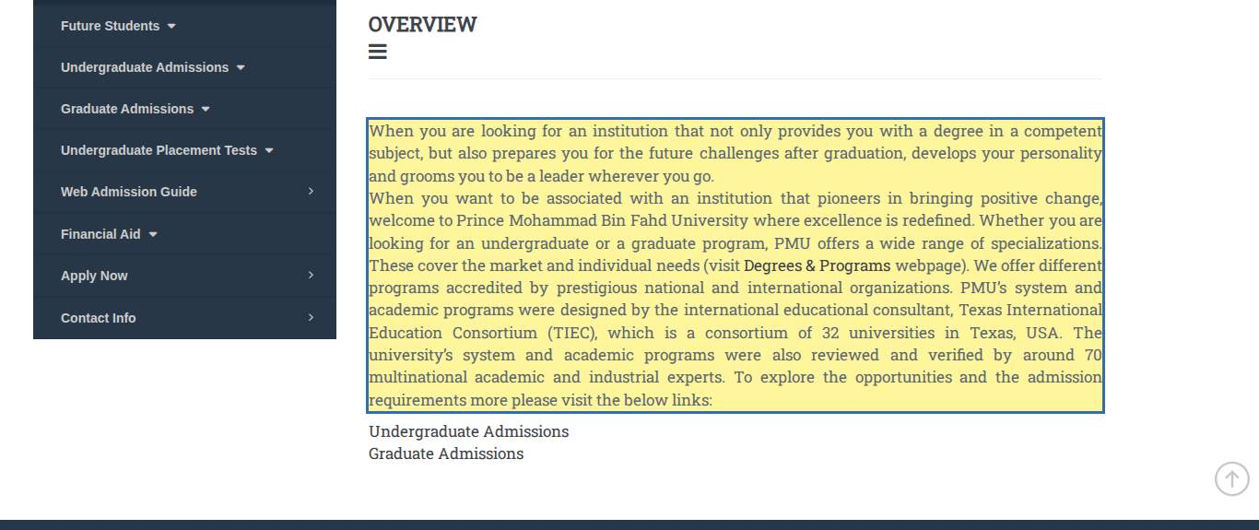
Source: https://pmu.edu.sa/admission/future_students_ro
Figure E-C02-1. C02 Degrees & Programs — missing information (F-25).
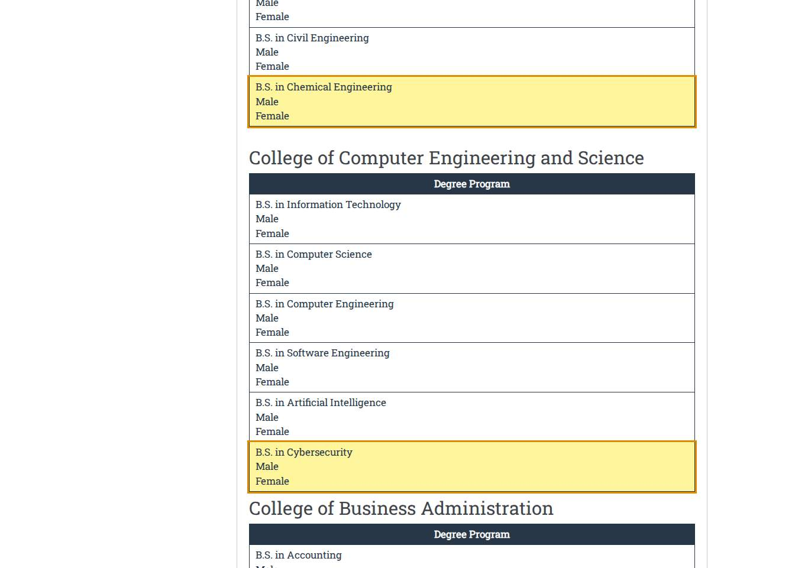
Source: https://pmu.edu.sa/admission/degrees_programs_fs_ro
Figure E-C02-2. C02 Degrees & Programs — missing information (F-44).
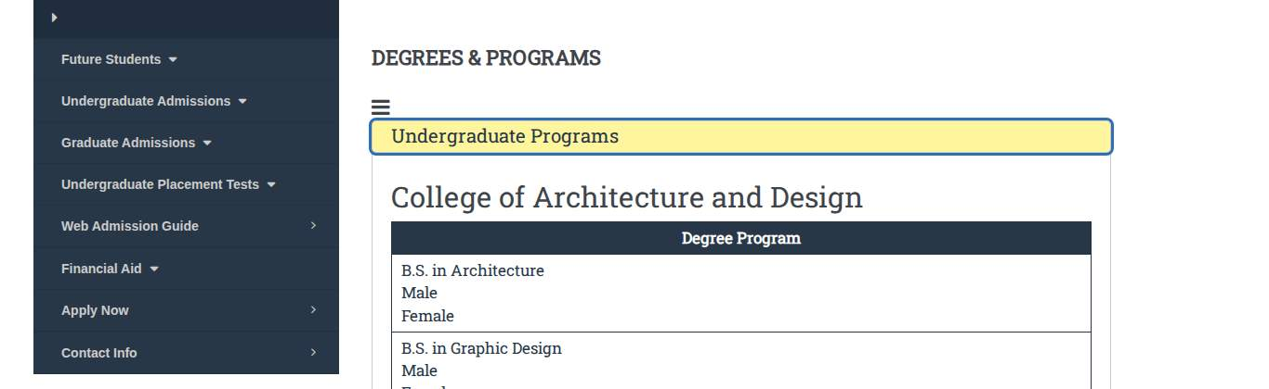
Source: https://pmu.edu.sa/admission/degrees_programs_fs_ro
Figure E-C03-1. C03 Admissions Calendar — out of date (F-08).
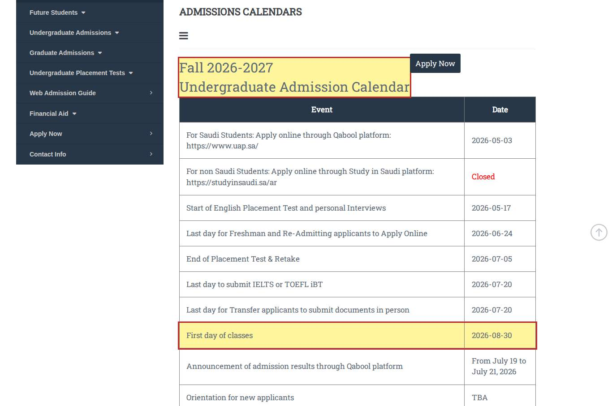
Source: https://pmu.edu.sa/admission/admission_calendar_fs_ro
Figure E-C03-2. C03 Admissions Calendar — cross-page conflict (F-08).
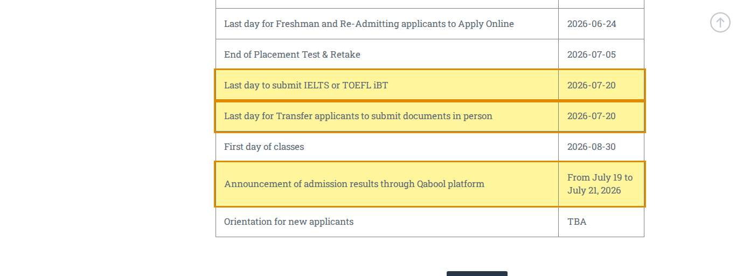
Source: https://pmu.edu.sa/admission/admission_calendar_fs_ro
Figure E-C03-3. C03 Admissions Calendar — cross-page conflict (F-02).
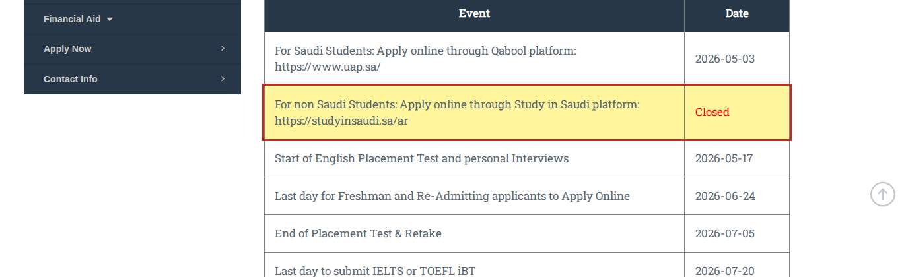
Source: https://pmu.edu.sa/admission/admission_calendar_fs_ro
Figure E-C03-4. C03 Admissions Calendar — missing information (F-43).
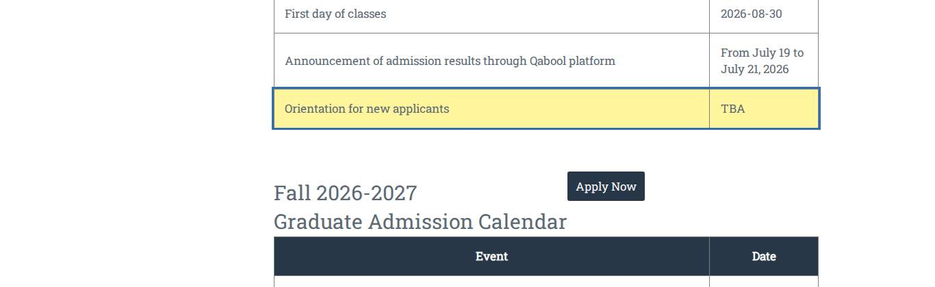
Source: https://pmu.edu.sa/admission/admission_calendar_fs_ro
Figure E-C05-1. C05 Admission Query — wording / language (F-17).
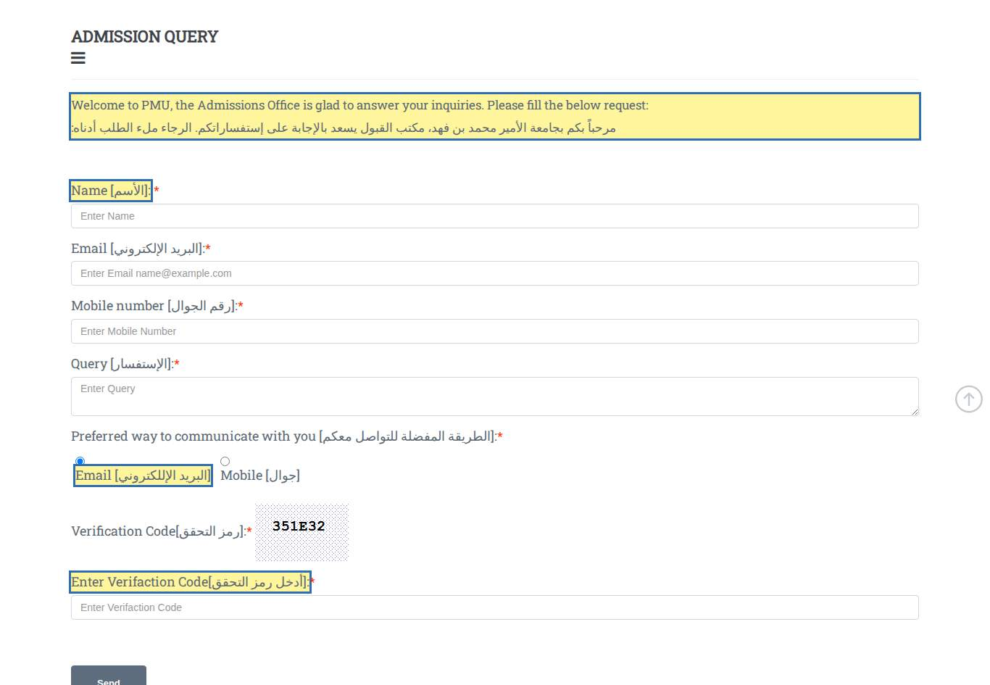
Source: https://pmu.edu.sa/admission/admissions_queries
Figure E-C07-1. C07 International Students without Saudi Residence — cross-page conflict (F-31).
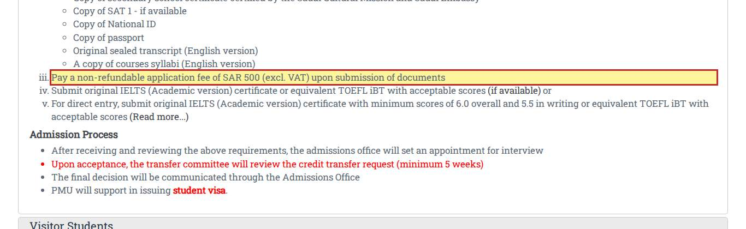
Source: https://pmu.edu.sa/admission/international_students
Figure E-C07-2. C07 International Students without Saudi Residence — incorrect information (F-05).
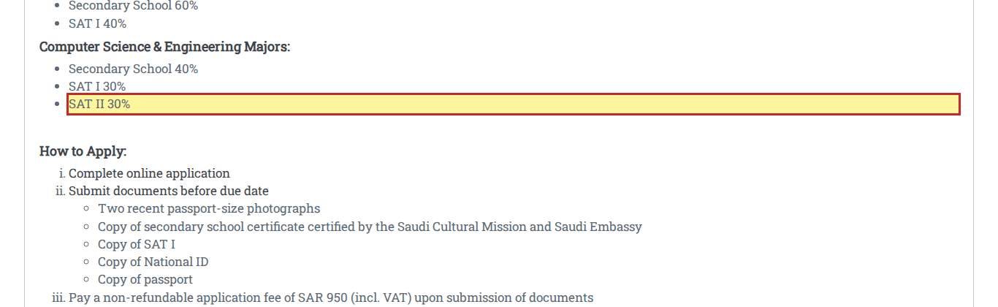
Source: https://pmu.edu.sa/admission/international_students
Figure E-C07-3. C07 International Students without Saudi Residence — incorrect information (F-13).
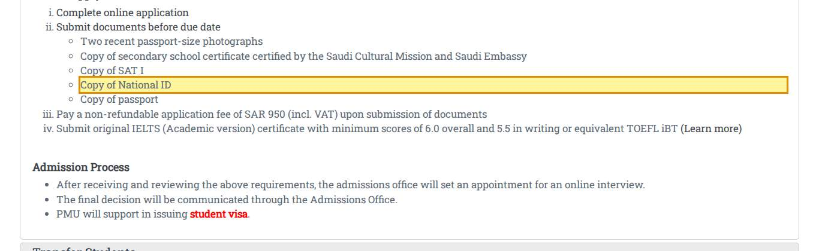
Source: https://pmu.edu.sa/admission/international_students
Figure E-C07-4. C07 International Students without Saudi Residence — missing information (F-09).
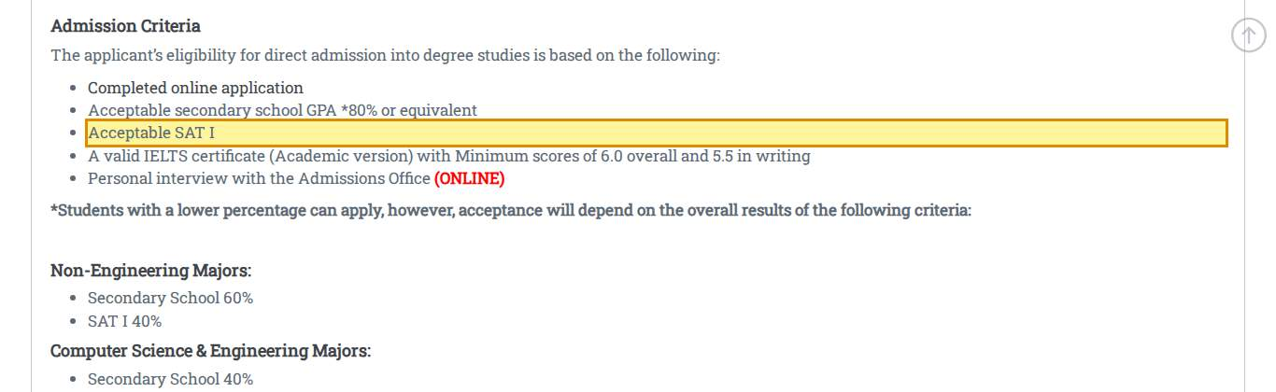
Source: https://pmu.edu.sa/admission/international_students
Figure E-C07-5. C07 International Students without Saudi Residence — missing information (F-38).
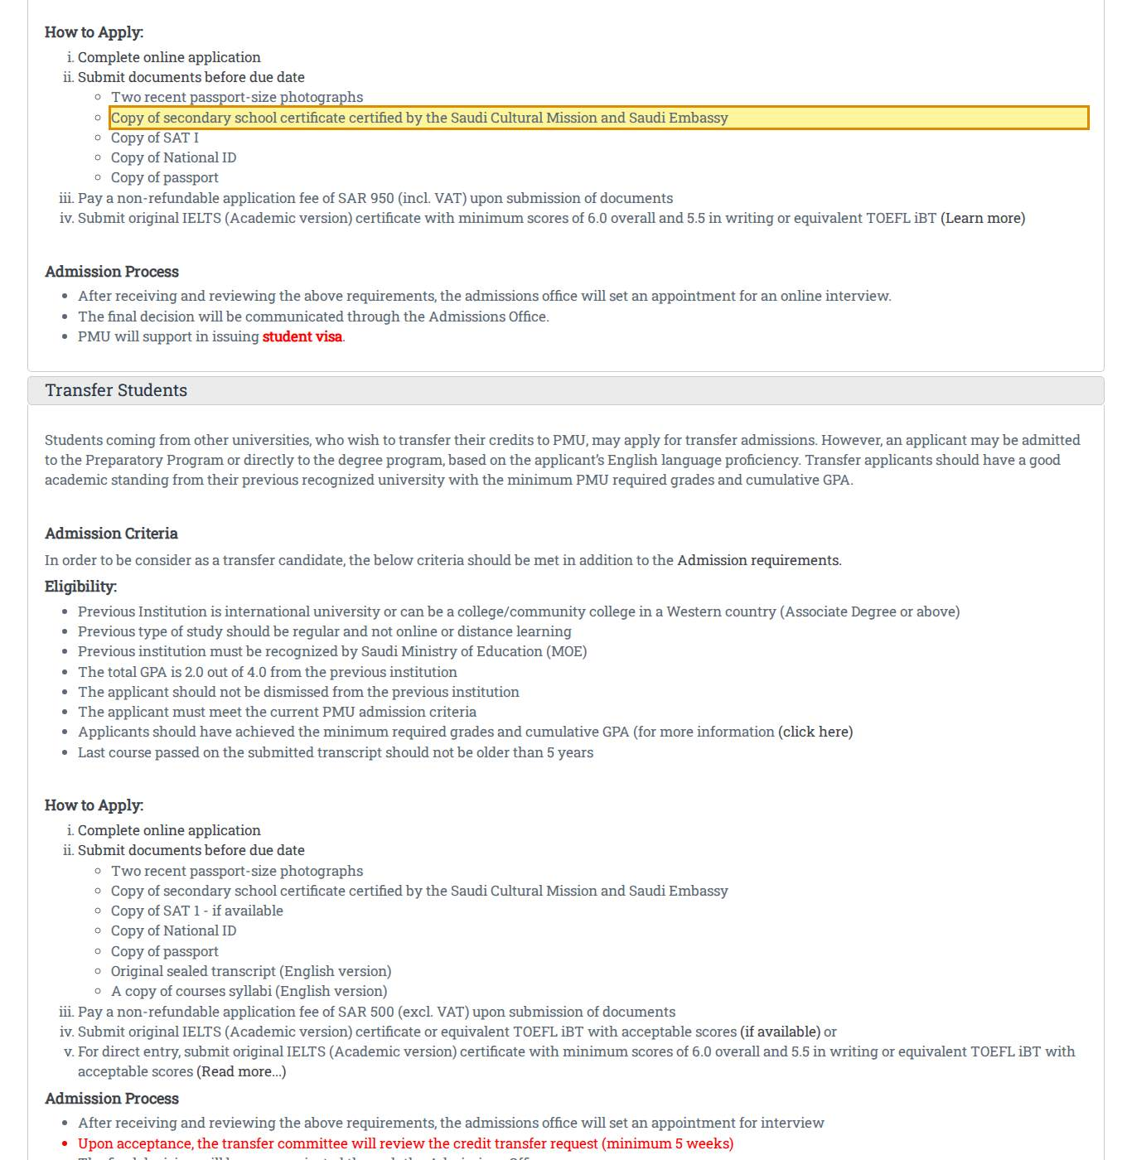
Source: https://pmu.edu.sa/admission/international_students
Figure E-C07-6. C07 International Students without Saudi Residence — missing information (F-43).
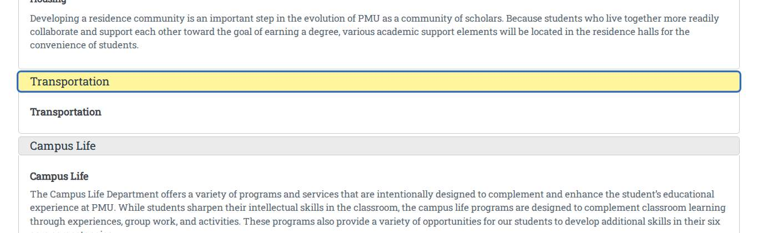
Source: https://pmu.edu.sa/admission/international_students
Figure E-C07-7. C07 International Students without Saudi Residence — missing information (F-44).
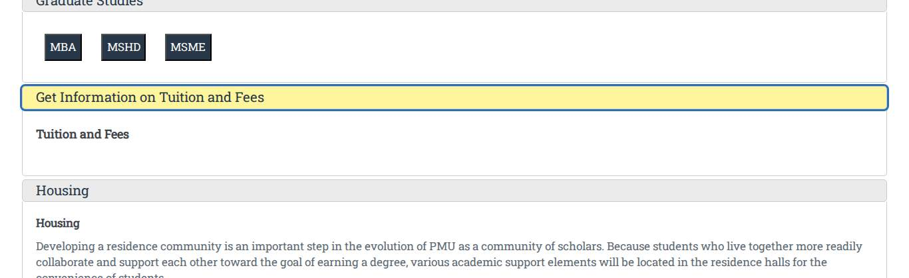
Source: https://pmu.edu.sa/admission/international_students
Figure E-C09-1. C09 Home — missing information (F-25).
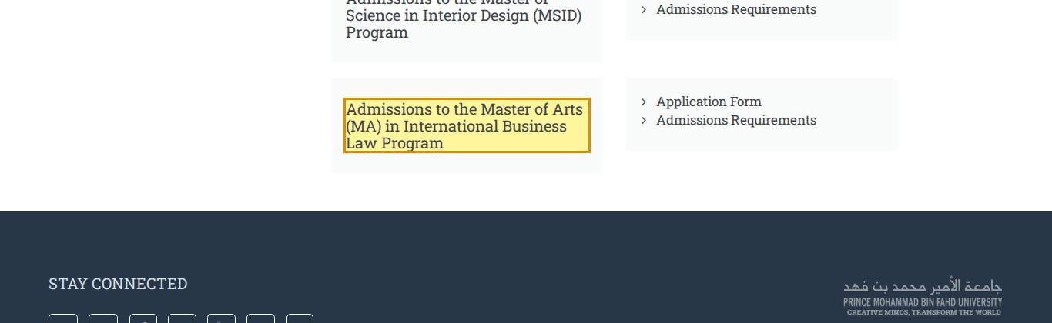
Source: https://pmu.edu.sa/admission/admission_graduate_degree_programs
Figure E-C09-2. C09 Home — cross-page conflict (F-25).
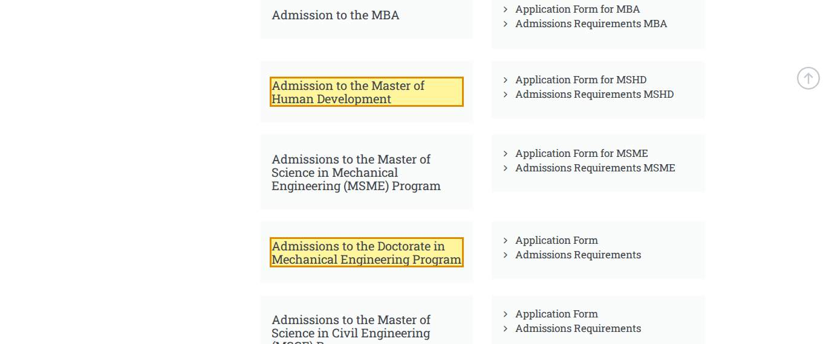
Source: https://pmu.edu.sa/admission/admission_graduate_degree_programs
Figure E-C09-3. C09 Home — missing information (F-38).
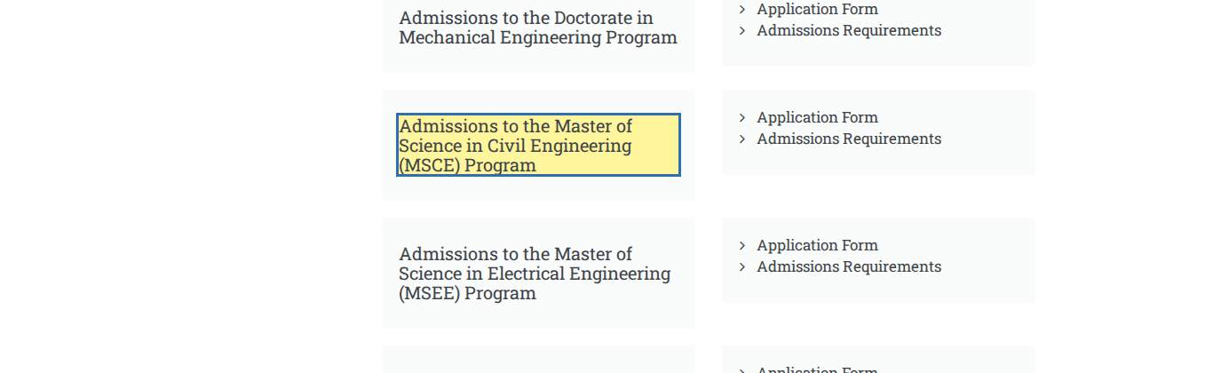
Source: https://pmu.edu.sa/admission/admission_graduate_degree_programs
Figure E-C10-1. C10 Admissions to the PhD in Mechanical Engineering Program — cross-page conflict (F-27).
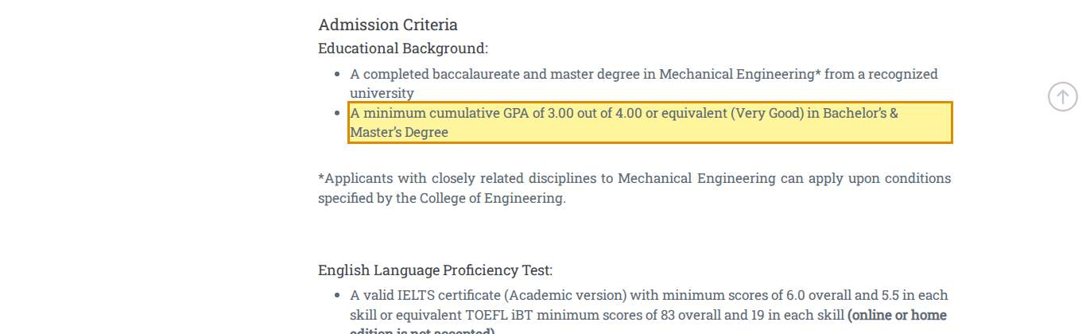
Source: https://pmu.edu.sa/admission/application_form_deme_gdp
Figure E-C11-1. C11 Admissions to the PhD in Business Administration Program — wording / language (F-36).
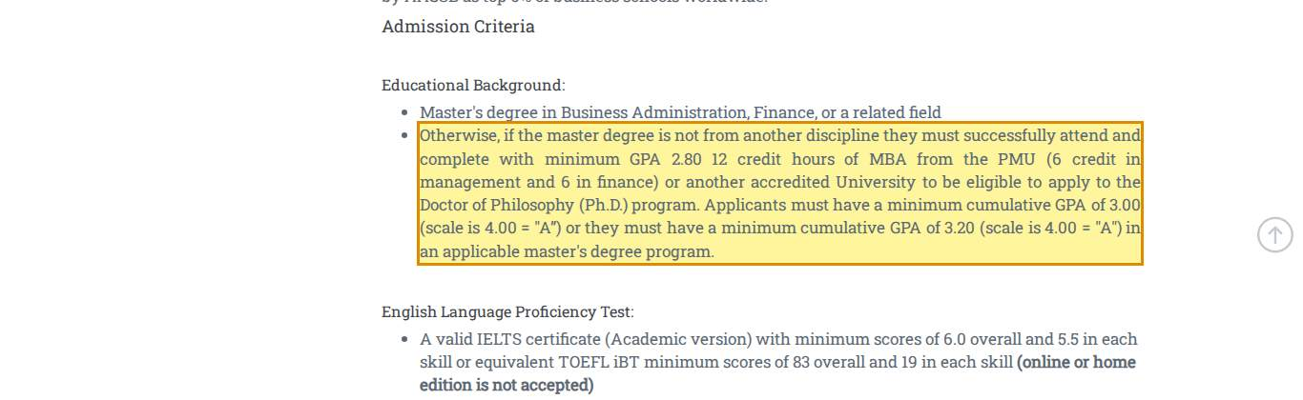
Source: https://pmu.edu.sa/admission/admissions_requirements_phdba_gdp
Figure E-C11-2. C11 Admissions to the PhD in Business Administration Program — claim requiring verification (F-37).
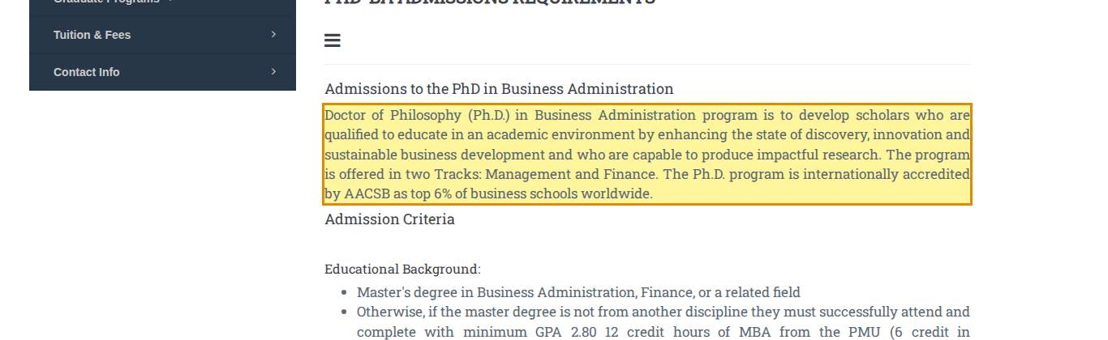
Source: https://pmu.edu.sa/admission/admissions_requirements_phdba_gdp
Figure E-C12-1. C12 Admissions to the EMBA Program — cross-page conflict (F-27).
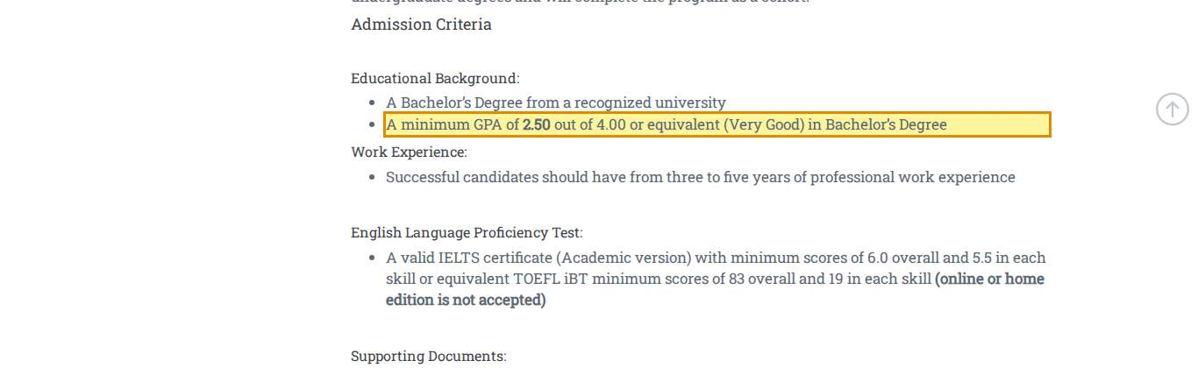
Source: https://pmu.edu.sa/admission/admissions_requirements_emba_gdp
Figure E-C12-2. C12 Admissions to the EMBA Program — cross-page conflict (F-42).
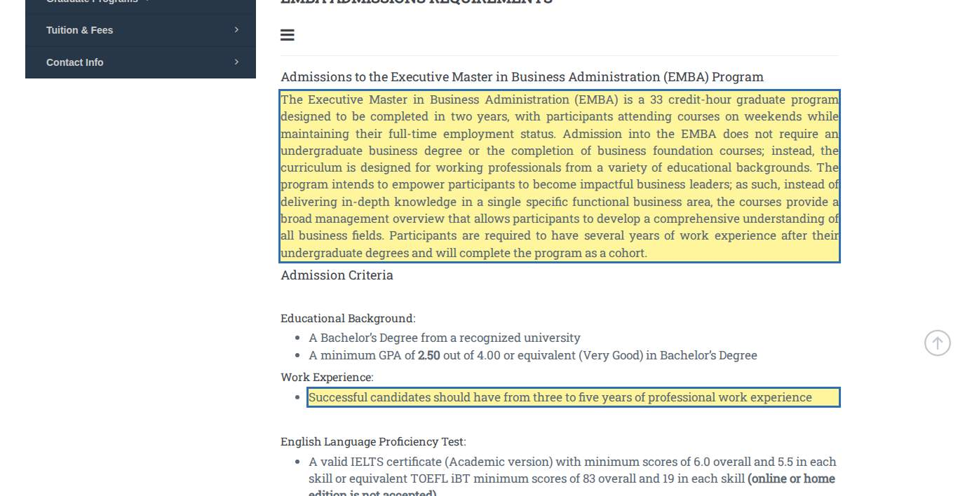
Source: https://pmu.edu.sa/admission/admissions_requirements_emba_gdp
Figure E-C13-1. C13 Admissions to the MBA Program — cross-page conflict (F-27).
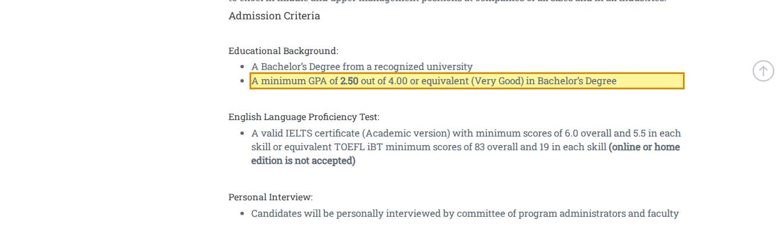
Source: https://pmu.edu.sa/admission/admissions_requirements_mba_gdp
Figure E-C14-1. C14 Admissions to the MSHD Program — missing information (F-26).
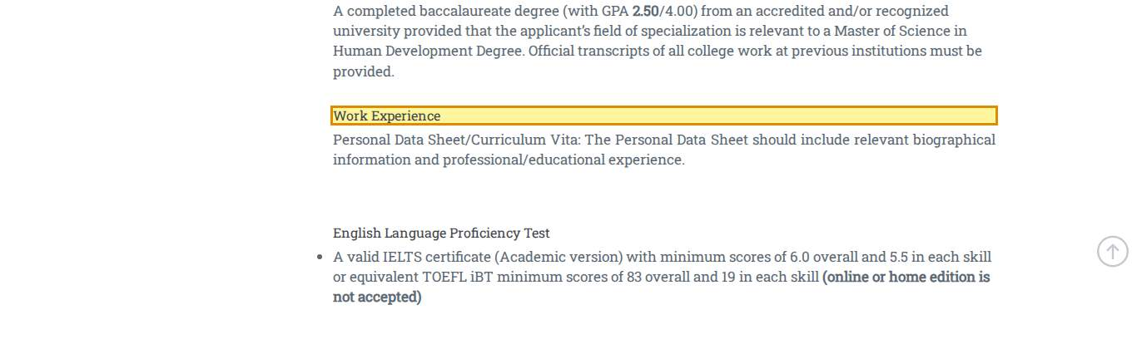
Source: https://pmu.edu.sa/admission/admissions_requirements_msehd_gdp
Figure E-C15-1. C15 Admissions to the MSME Program — cross-page conflict (F-27).
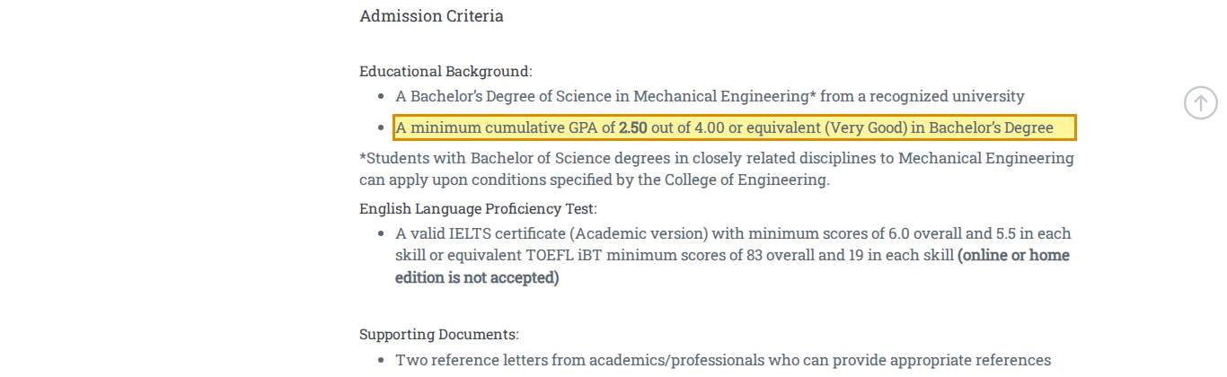
Source: https://pmu.edu.sa/admission/admissions_requirements_msme_gdp
Figure E-C16-1. C16 Admissions to the MSEE Program — out of date (F-41).
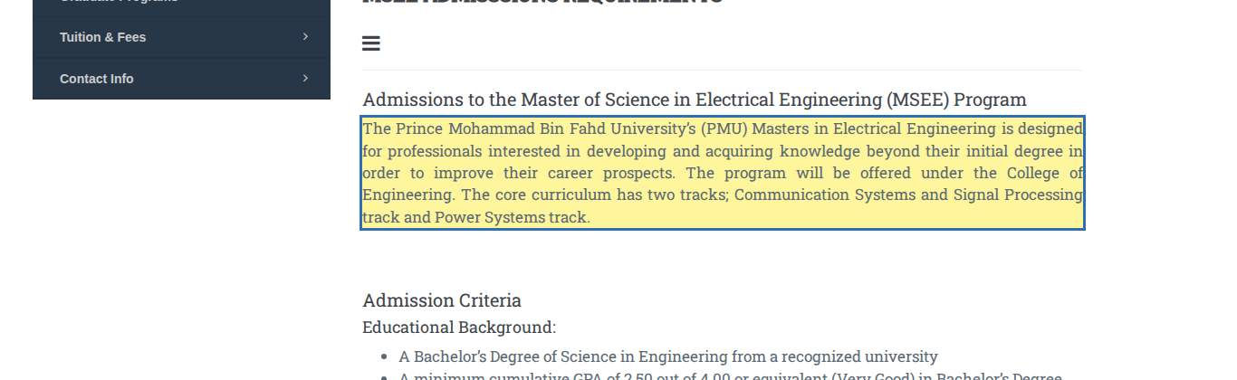
Source: https://pmu.edu.sa/admission/application_form_msee_gdp
Figure E-C16-2. C16 Admissions to the MSEE Program — cross-page conflict (F-27).
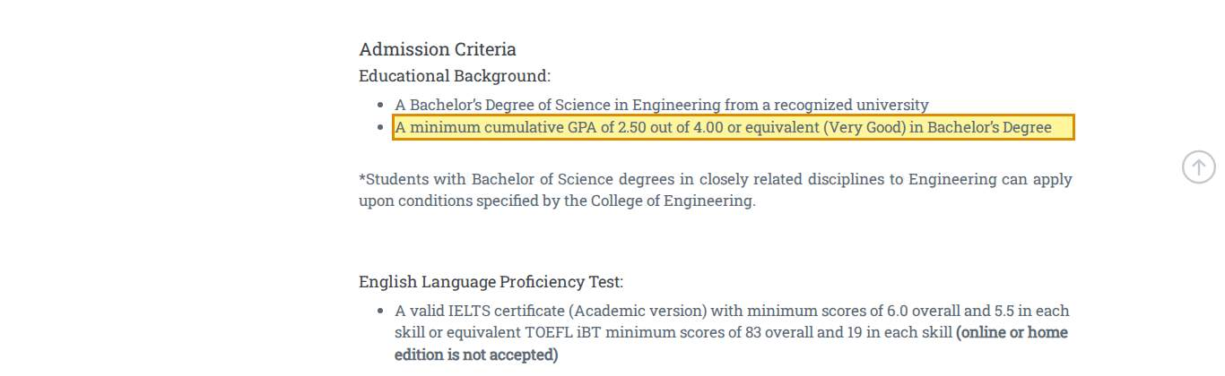
Source: https://pmu.edu.sa/admission/application_form_msee_gdp
Figure E-C17-1. C17 Admissions to the MSCE Program — out of date (F-41).
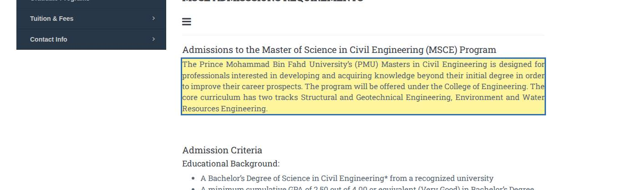
Source: https://pmu.edu.sa/admission/application_form_msce_gdp
Figure E-C17-2. C17 Admissions to the MSCE Program — cross-page conflict (F-27).
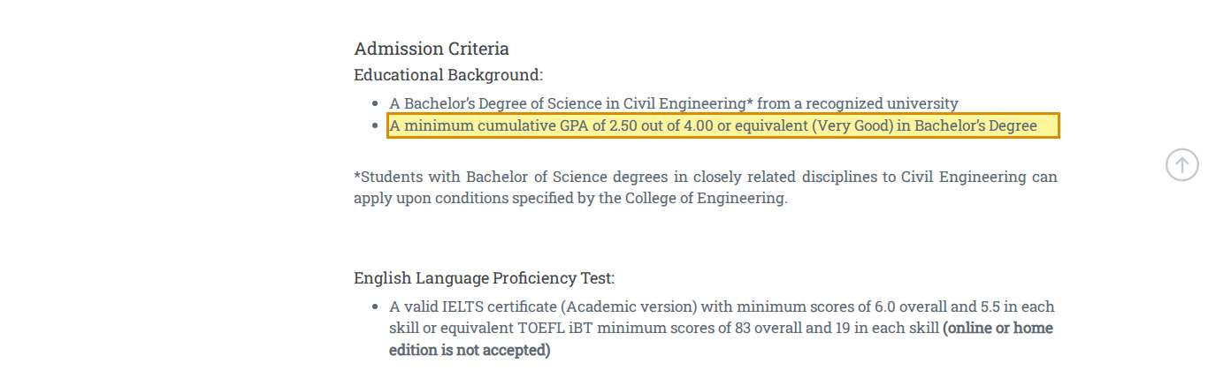
Source: https://pmu.edu.sa/admission/application_form_msce_gdp
Figure E-C18-1. C18 Admissions to the MSID Program — out of date (F-41).
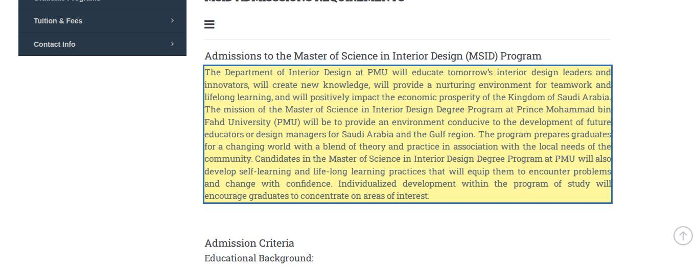
Source: https://pmu.edu.sa/admission/application_form_msid_gdp
Figure E-C18-2. C18 Admissions to the MSID Program — cross-page conflict (F-27).
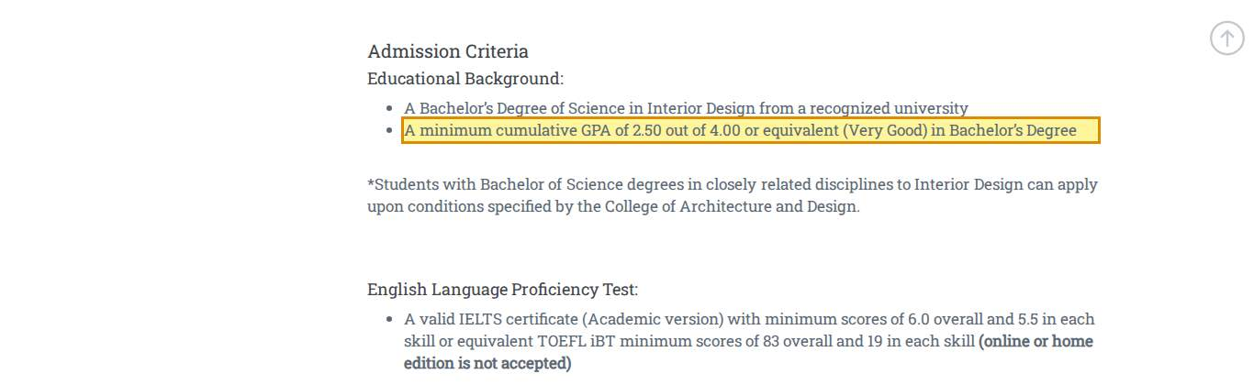
Source: https://pmu.edu.sa/admission/application_form_msid_gdp
Figure E-C19-1. C19 Admissions to the EMGMS Program — incorrect information (F-21).
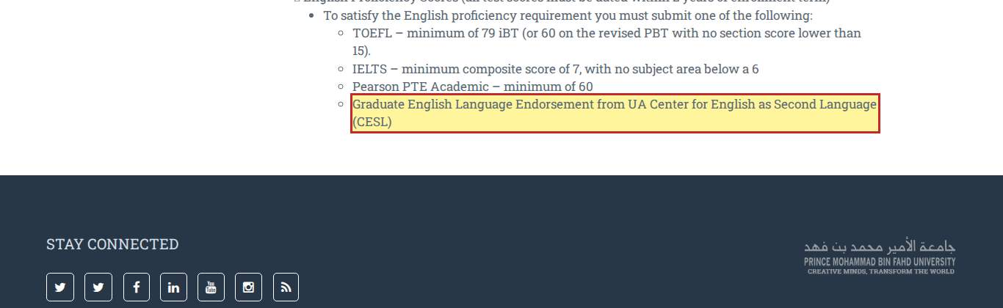
Source: https://pmu.edu.sa/admission/admissions_requirements_emgms_gdp
Figure E-C19-2. C19 Admissions to the EMGMS Program — cross-page conflict (F-21).
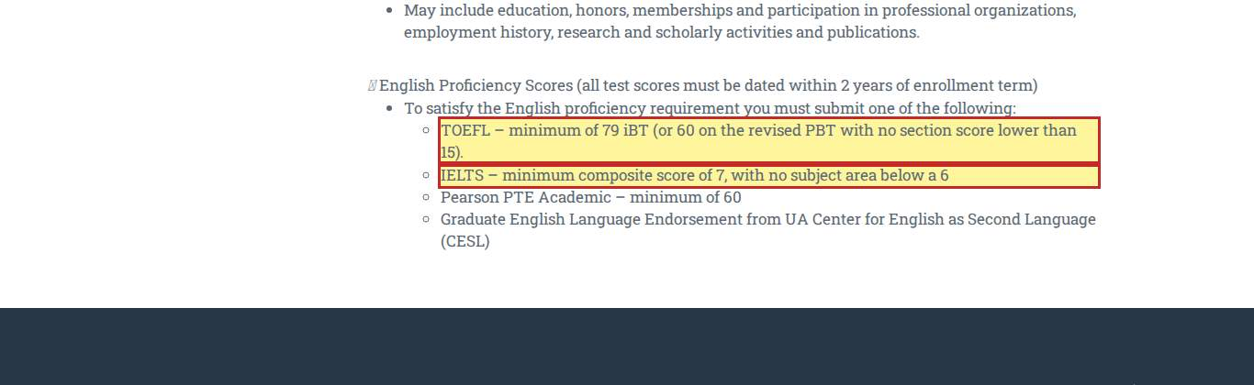
Source: https://pmu.edu.sa/admission/admissions_requirements_emgms_gdp
Figure E-C20-1. C20 Admissions to the MIBL — cross-page conflict (F-32).
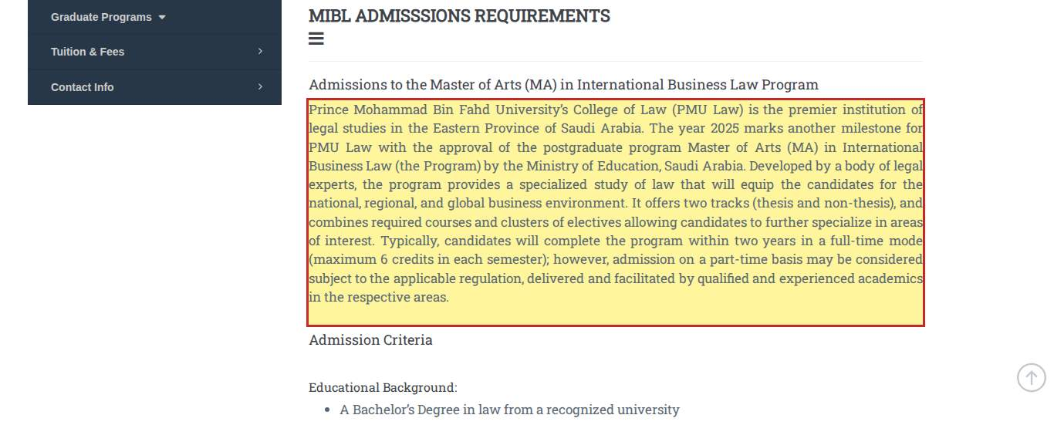
Source: https://pmu.edu.sa/admission/admissions_requirements_milbl_gdp
Figure E-C20-2. C20 Admissions to the MIBL — missing information (F-26).
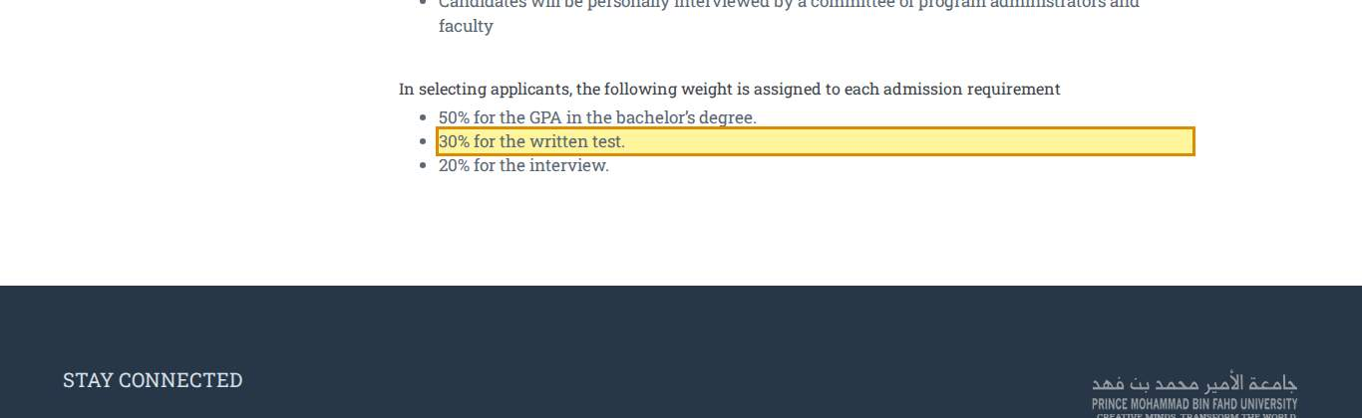
Source: https://pmu.edu.sa/admission/admissions_requirements_milbl_gdp
Figure E-C20-3. C20 Admissions to the MIBL — cross-page conflict (F-33).
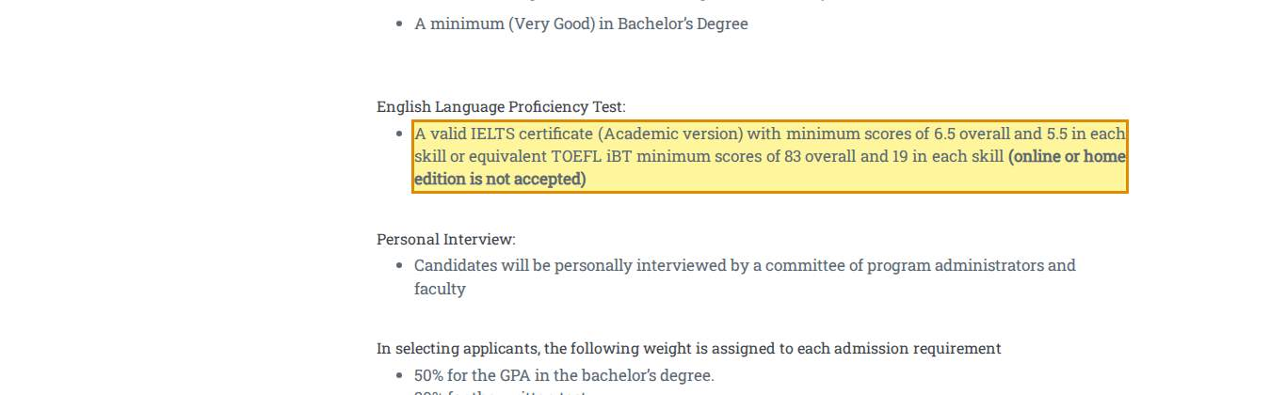
Source: https://pmu.edu.sa/admission/admissions_requirements_milbl_gdp
Figure E-C20-4. C20 Admissions to the MIBL — missing information (F-27).
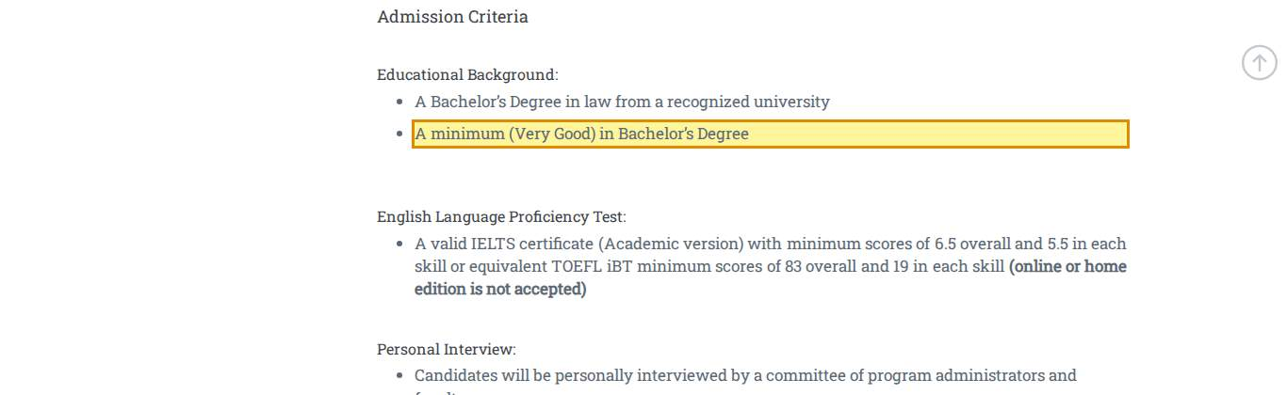
Source: https://pmu.edu.sa/admission/admissions_requirements_milbl_gdp
Figure E-C20-5. C20 Admissions to the MIBL — out of date (F-41).
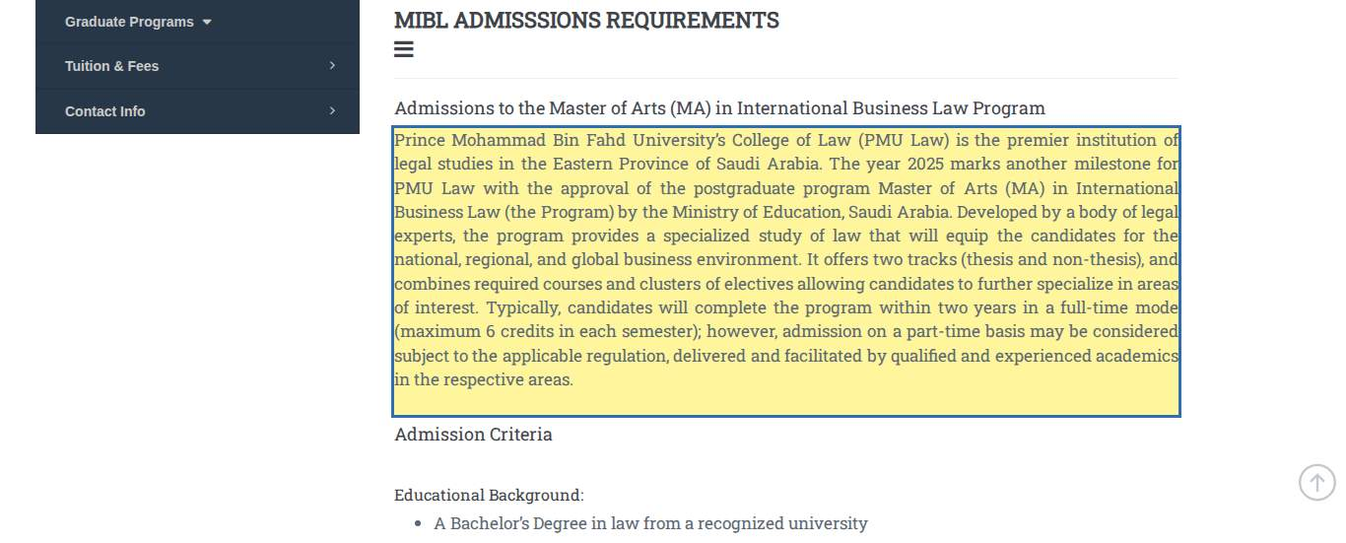
Source: https://pmu.edu.sa/admission/admissions_requirements_milbl_gdp
Figure E-C21-1. C21 Tuition & Fees — missing information (F-25).
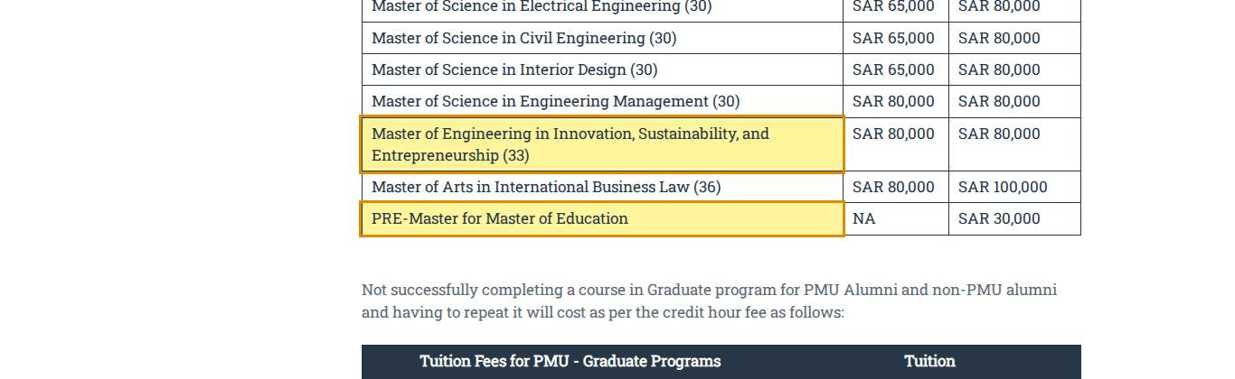
Source: https://pmu.edu.sa/admission/post_graduate_fees_tf_ro
Figure E-C21-2. C21 Tuition & Fees — cross-page conflict (F-25).
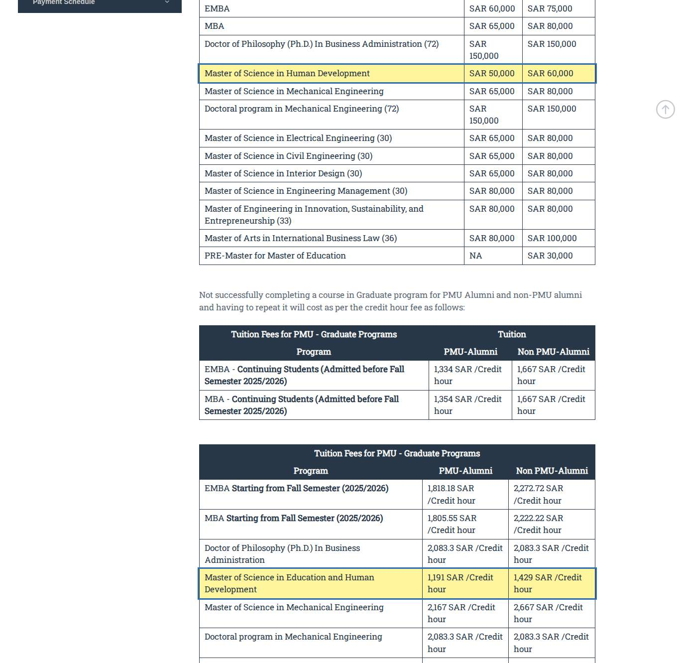
Source: https://pmu.edu.sa/admission/post_graduate_fees_tf_ro
Figure E-C23-1. C23 Home — missing information (F-25).
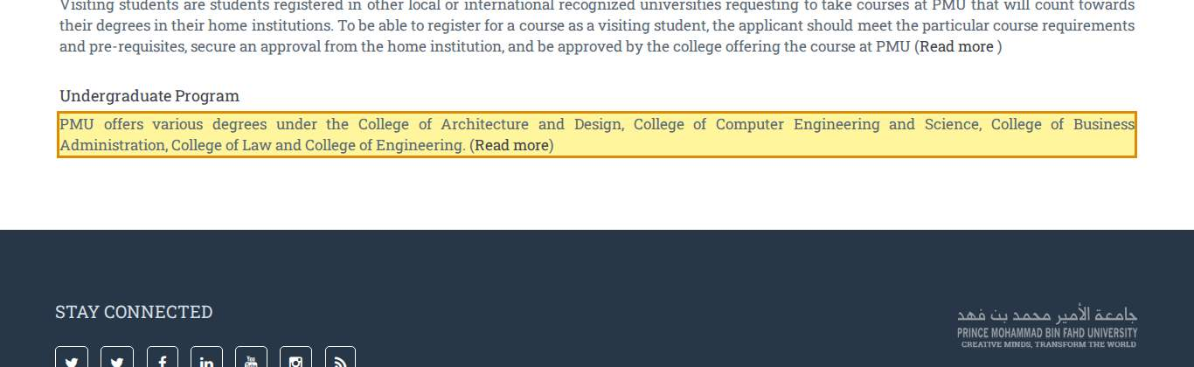
Source: https://pmu.edu.sa/admission/undergraduate_programs_admission
Figure E-C23-2. C23 Home — wording / language (F-17).
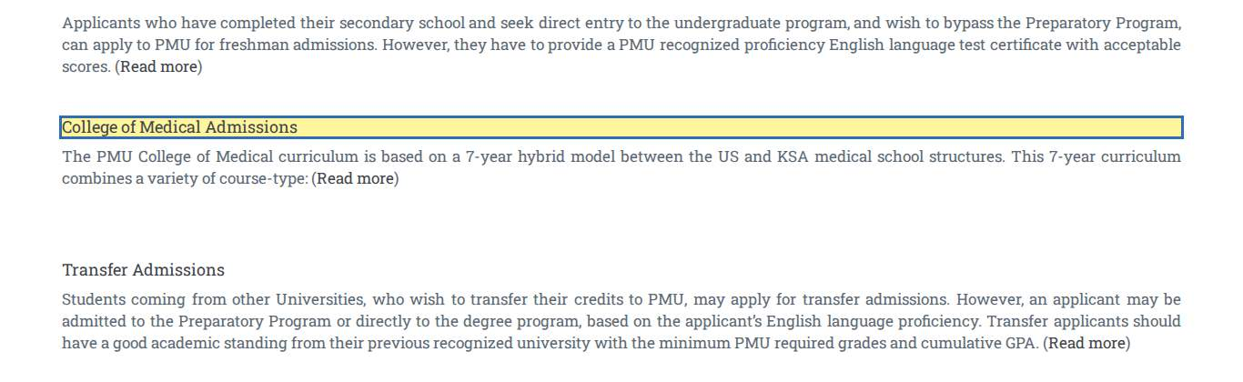
Source: https://pmu.edu.sa/admission/undergraduate_programs_admission
Figure E-C23-3. C23 Home — cross-page conflict (F-35).
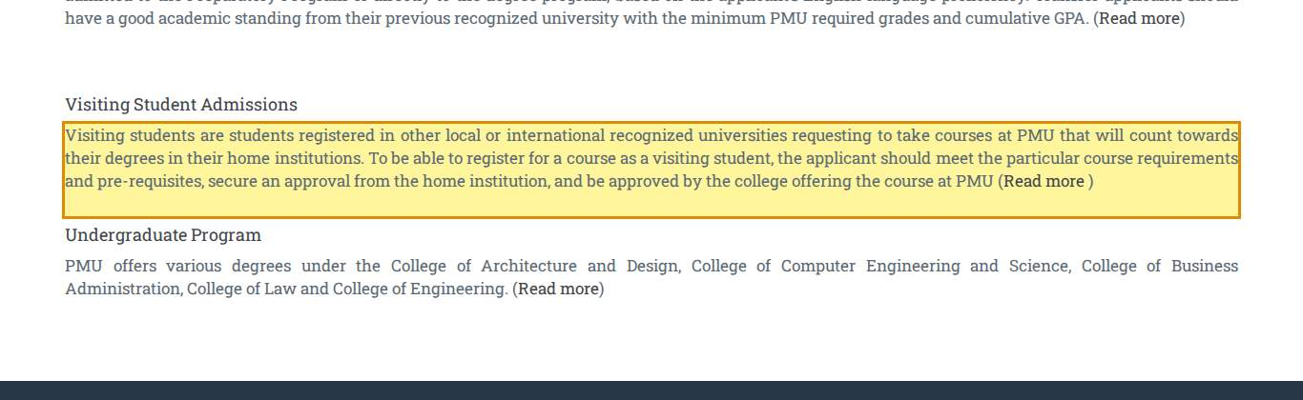
Source: https://pmu.edu.sa/admission/undergraduate_programs_admission
Figure E-C24-1. C24 Admission to the College of Medicine — cross-page conflict (F-20).
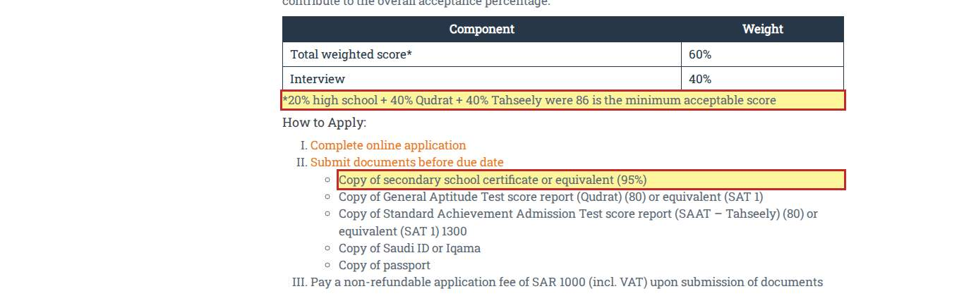
Source: https://pmu.edu.sa/admission/college_of_medicine_admission
Figure E-C24-2. C24 Admission to the College of Medicine — cross-page conflict (F-23).
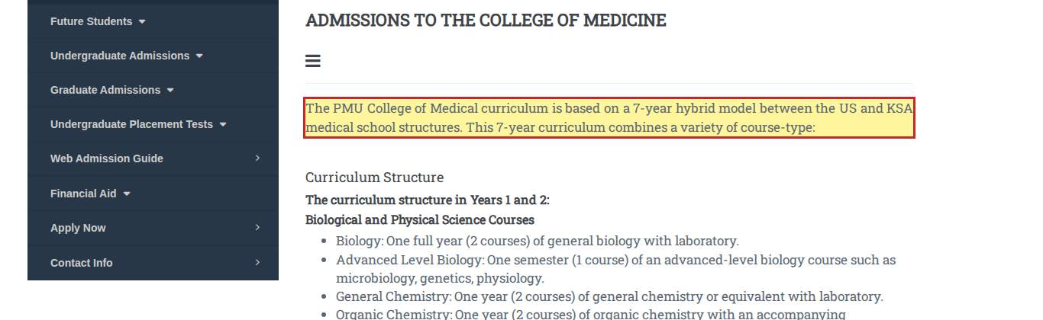
Source: https://pmu.edu.sa/admission/college_of_medicine_admission
Figure E-C24-3. C24 Admission to the College of Medicine — wording / language (F-07).
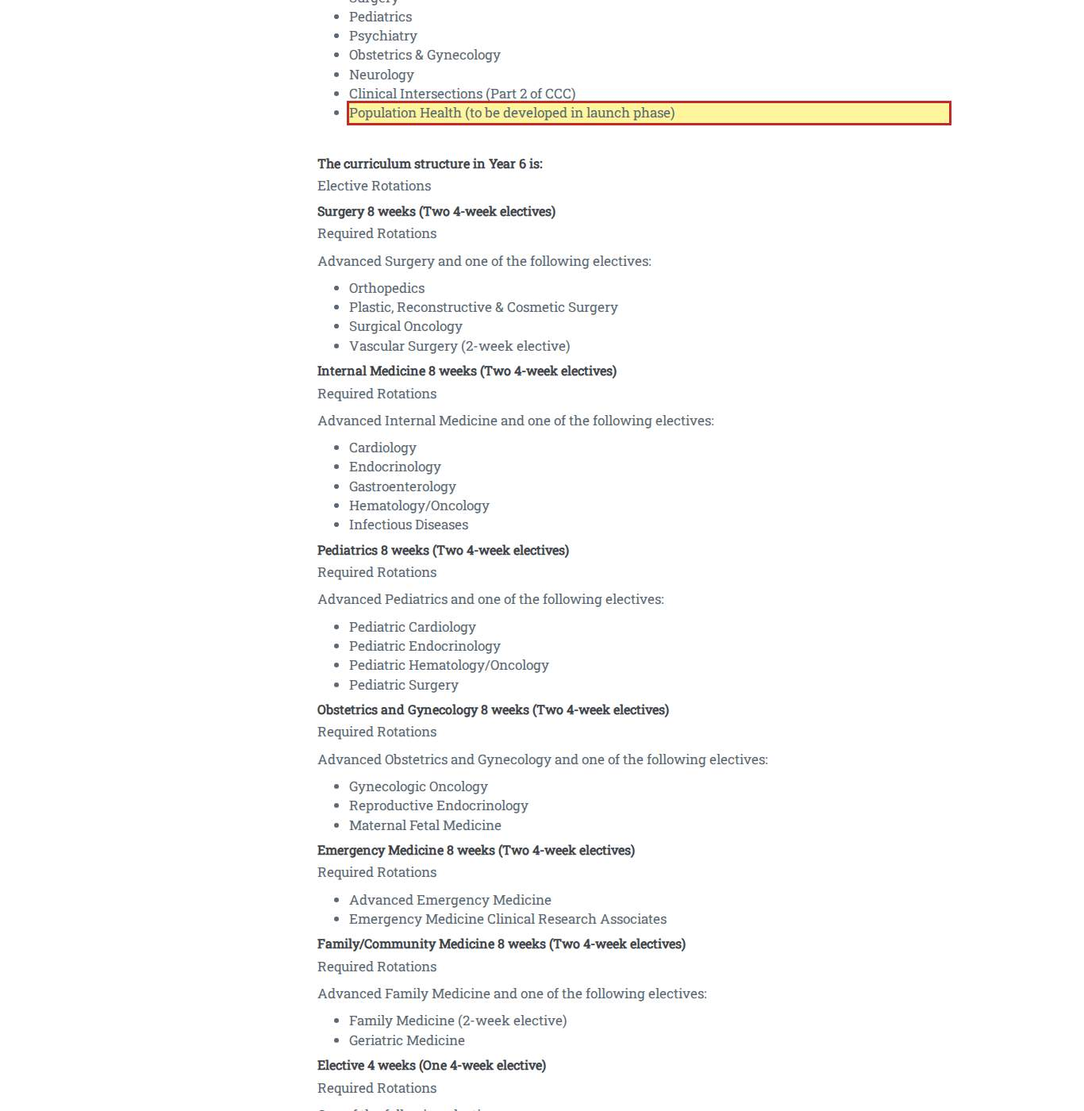
Source: https://pmu.edu.sa/admission/college_of_medicine_admission
Figure E-C24-4. C24 Admission to the College of Medicine — wording / language (F-39).
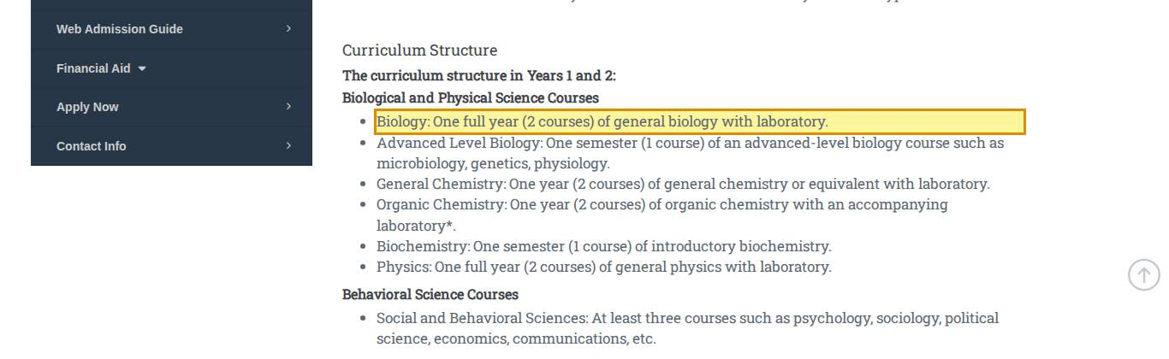
Source: https://pmu.edu.sa/admission/college_of_medicine_admission
Figure E-C24-6. C24 Admission to the College of Medicine — cross-page conflict (F-03).
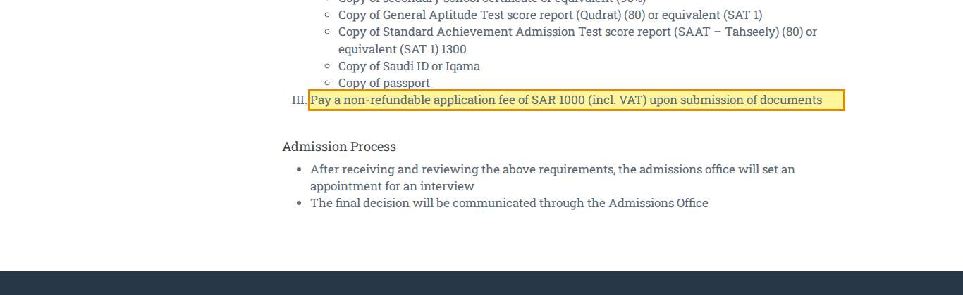
Source: https://pmu.edu.sa/admission/college_of_medicine_admission
Figure E-C25-1. C25 Admissions to the Preparatory Program — missing information (F-40).
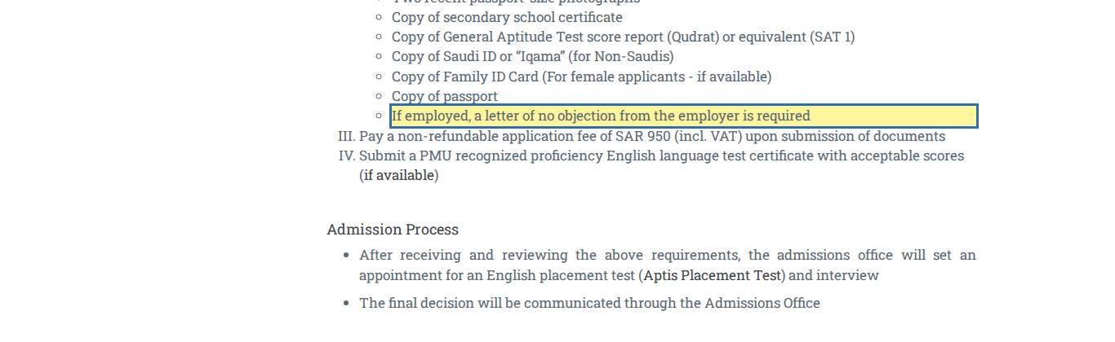
Source: https://pmu.edu.sa/admission/admission-to-the-preparatory-program
Figure E-C26-1. C26 Direct Admissions from Secondary School — missing information (F-13).
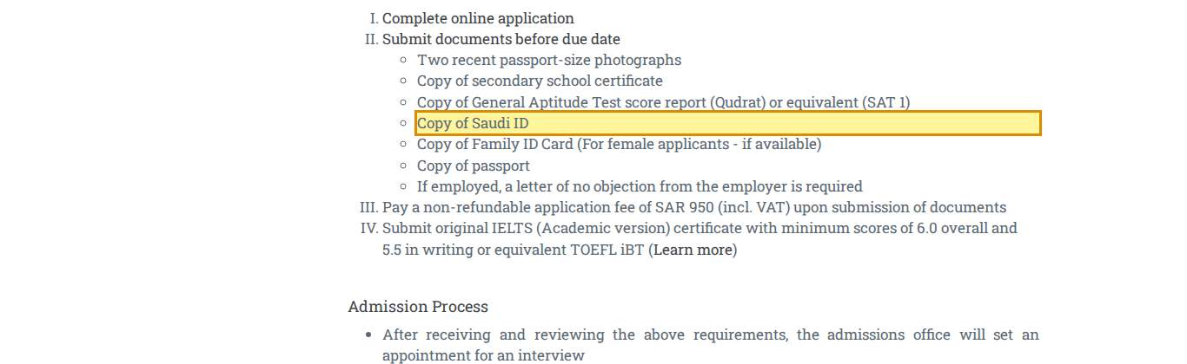
Source: https://pmu.edu.sa/admission/direct-admissions-from-secondary-school
Figure E-C26-2. C26 Direct Admissions from Secondary School — missing information (F-09).
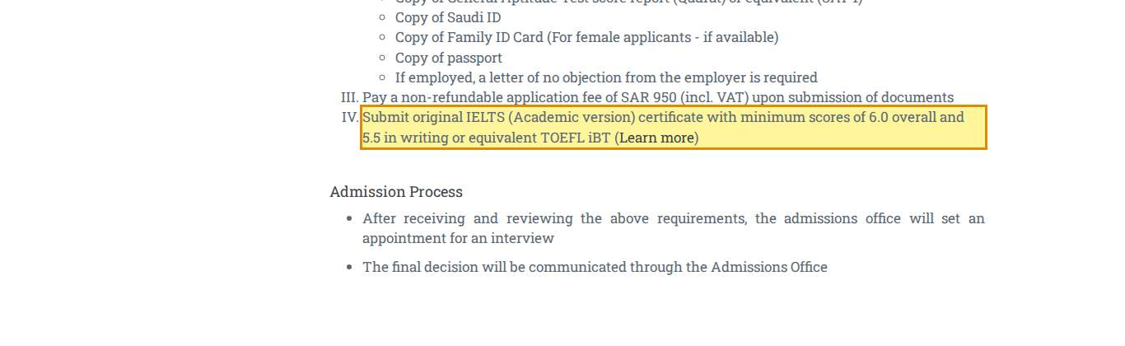
Source: https://pmu.edu.sa/admission/direct-admissions-from-secondary-school
Figure E-C27-1. C27 Admissions from Other Universities — cross-page conflict (F-31).
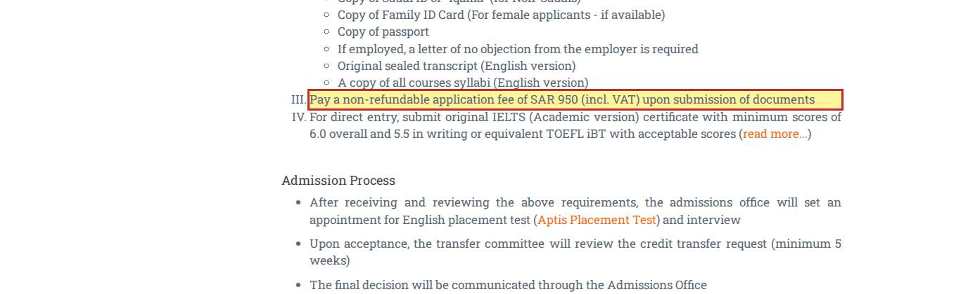
Source: https://pmu.edu.sa/admission/admission-from-other-universities
Figure E-C27-2. C27 Admissions from Other Universities — wording / language (F-17).
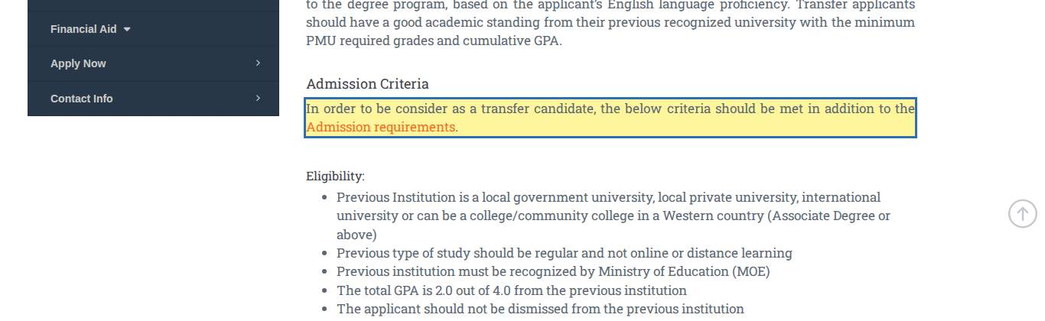
Source: https://pmu.edu.sa/admission/admission-from-other-universities
Figure E-C28-1. C28 Visting Students — cross-page conflict (F-31).
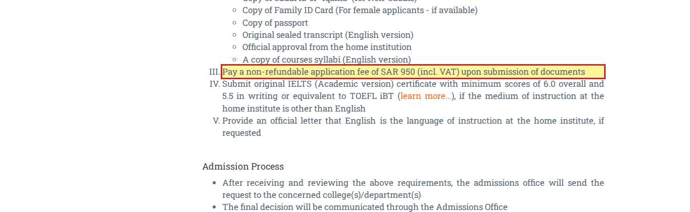
Source: https://pmu.edu.sa/admission/visiting-student-admission
Figure E-C28-2. C28 Visting Students — missing information (F-35).
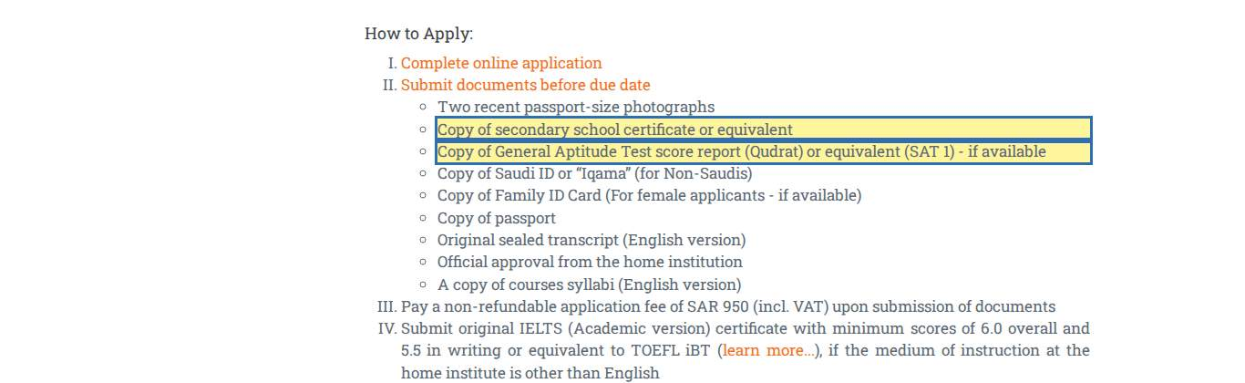
Source: https://pmu.edu.sa/admission/visiting-student-admission
Figure E-C29-1. C29 Admissions from the Preparatory Program — incorrect information (F-28).
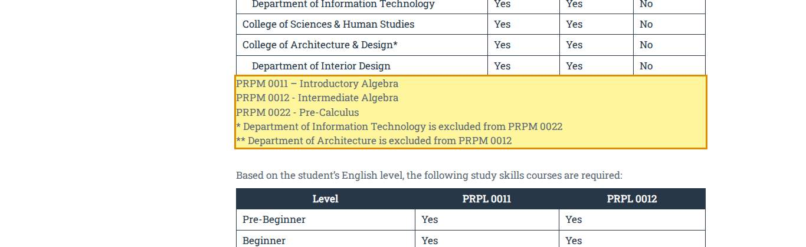
Source: https://pmu.edu.sa/admission/admission-from-the-prep-to-ug-programs
Figure E-C29-2. C29 Admissions from the Preparatory Program — missing information (F-28).
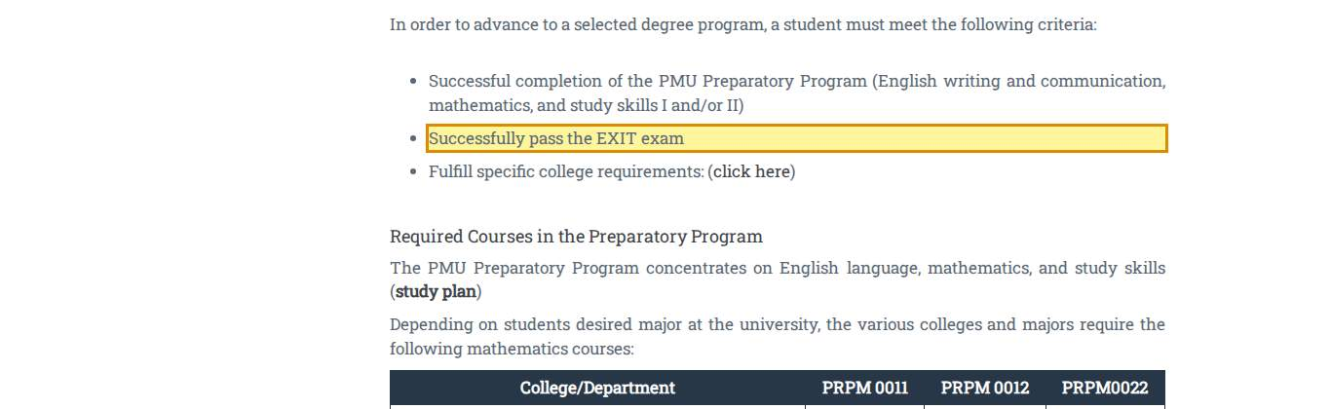
Source: https://pmu.edu.sa/admission/admission-from-the-prep-to-ug-programs
Figure E-C30-1. C30 Computer Science and Engineering Majors Admission Requirements — cross-page conflict (F-34).
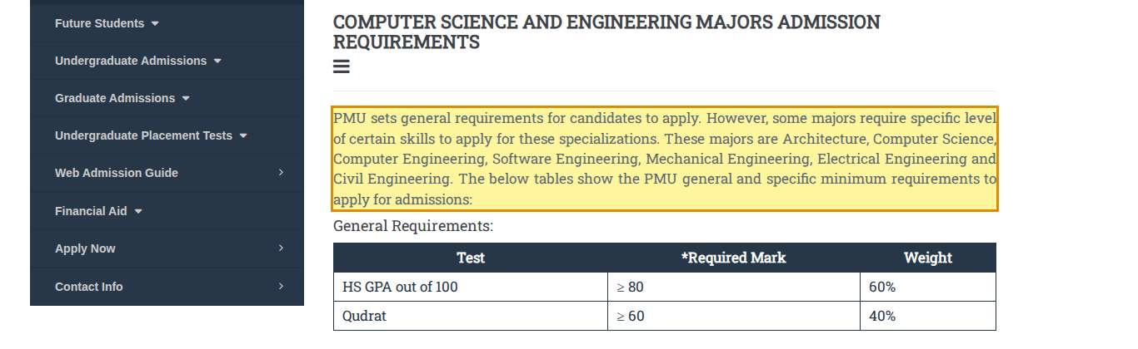
Source: https://pmu.edu.sa/admission/admissions_requirements_cs_eng_majors
Figure E-C30-2. C30 Computer Science and Engineering Majors Admission Requirements — missing information (F-09).
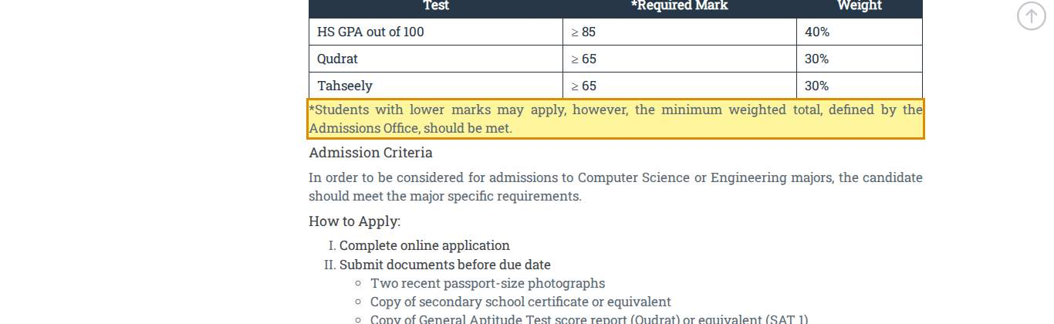
Source: https://pmu.edu.sa/admission/admissions_requirements_cs_eng_majors
Figure E-C30-3. C30 Computer Science and Engineering Majors Admission Requirements — cross-page conflict (F-05).
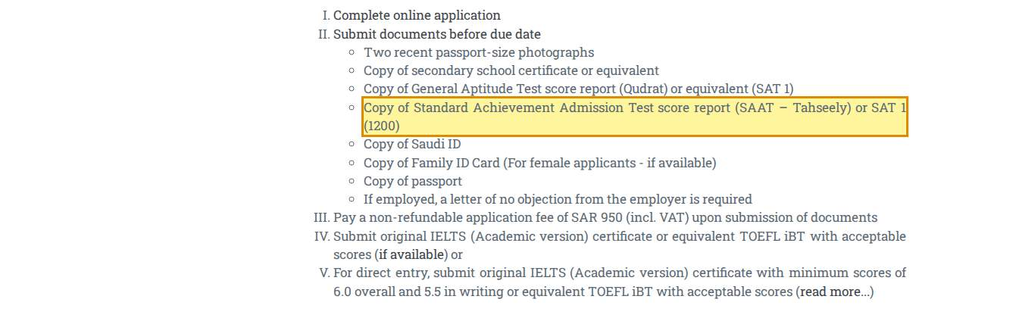
Source: https://pmu.edu.sa/admission/admissions_requirements_cs_eng_majors
Figure E-C30-4. C30 Computer Science and Engineering Majors Admission Requirements — wording / language (F-17).
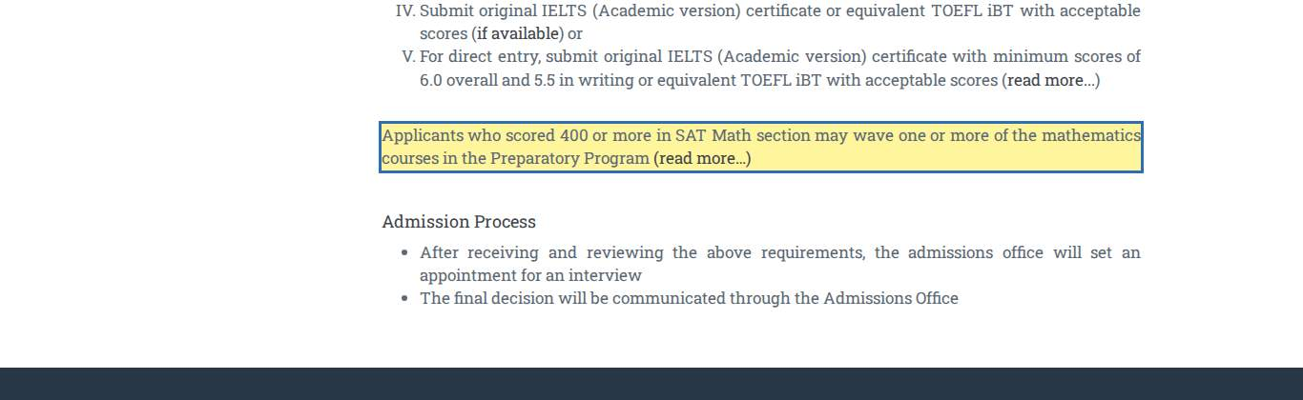
Source: https://pmu.edu.sa/admission/admissions_requirements_cs_eng_majors
Figure E-C31-1. C31 Tuition & Fees — out of date (F-10).
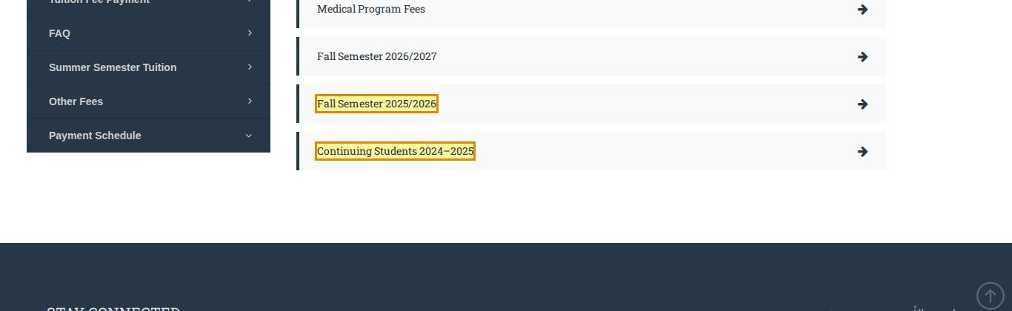
Source: https://pmu.edu.sa/admission/fees_tf_ro
Figure E-C32-1. C32 Overview — missing information (F-33).
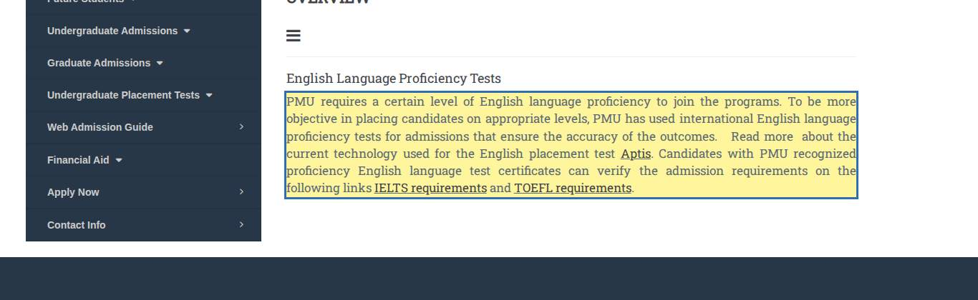
Source: https://pmu.edu.sa/admission/overview-undergraduate-placement-tests
Figure E-C33-1. C33 Aptis — missing information (F-09).
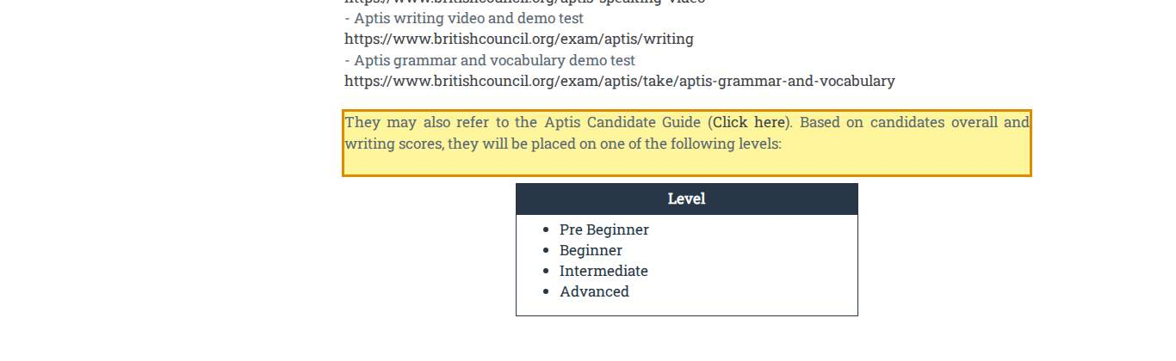
Source: https://pmu.edu.sa/admission/aptis-placement-test
Figure E-C33-2. C33 Aptis — wording / language (F-15).
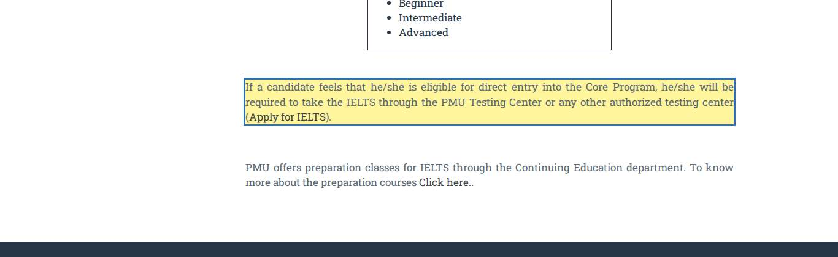
Source: https://pmu.edu.sa/admission/aptis-placement-test
Figure E-C35-1. C35 TOEFL — out of date (F-04).
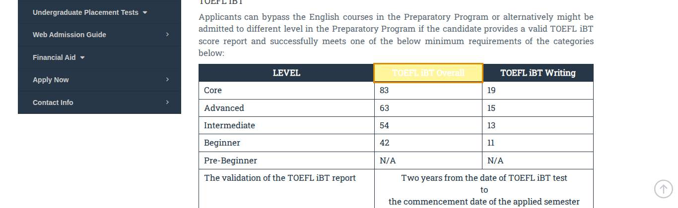
Source: https://pmu.edu.sa/admission/toefl-admission
Figure E-C36-1. C36 Scholastic Aptitude Test (SAT) — cross-page conflict (F-34).
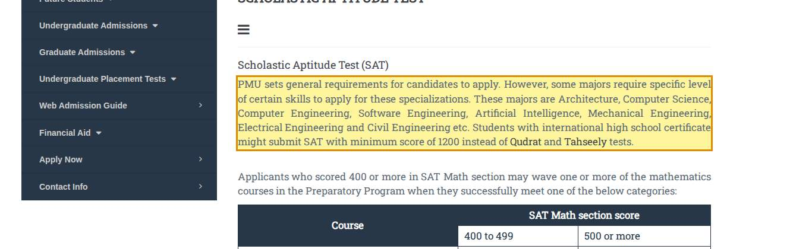
Source: https://pmu.edu.sa/admission/sat-admission
Figure E-C36-2. C36 Scholastic Aptitude Test (SAT) — cross-page conflict (F-05).
Source: https://pmu.edu.sa/admission/sat-admission
Figure E-C36-3. C36 Scholastic Aptitude Test (SAT) — wording / language (F-17).
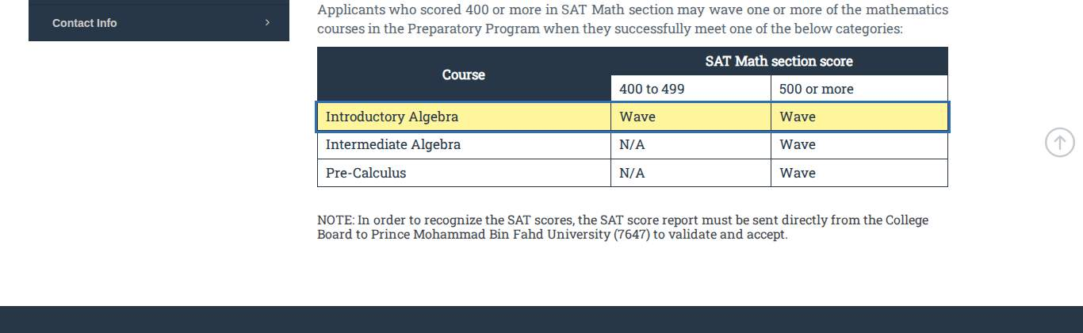
Source: https://pmu.edu.sa/admission/sat-admission

Appendix B — Glossary
Term | Meaning in this report
Aptis | British Council English test used by PMU for placement in the Preparatory Program.
Core Program | Term used on C33 for direct entry to a degree programme; not defined elsewhere.
EXIT exam | Exam required to leave the Preparatory Program (C29); content and passing standard are not published.
Iqama | Residence permit held by non-Saudi residents of the Kingdom.
Qabool (uap.sa) | National unified admission platform for Saudi applicants to universities.
Qudrat | General Aptitude Test (Education and Training Evaluation Commission).
SAT / SAT II | College Board tests; SAT Subject Tests (SAT II) were discontinued in 2021 (X06).
Study in Saudi | National platform for international applicants to Saudi universities.
Tahseely | Standard Achievement Admission Test (Education and Training Evaluation Commission).
TOEFL iBT | ETS English test; reported on a 1–6 scale from 21 January 2026 (X01).
VAT | Value-added tax, 15% in the Kingdom.

Appendix C — External Sources
Ref. | Source | Link
X01 | ETS — TOEFL iBT score scale update (1–6 band scale from 21 January 2026) | https://www.ets.org/toefl/institutions/ibt/score-scale-update.html
X06 | College Board — SAT Subject Tests discontinued (January 2021) | https://blog.collegeboard.org/what-were-sat-subject-tests
X09 | University of Arizona CESL — Graduate English Endorsement ('for UA admission only') | https://cesl.arizona.edu/endorsement
X10 | AACSB — The value of accreditation (fewer than 6% of business schools) | https://www.aacsb.edu/educators/accreditation/value-of-accreditation
External facts were checked against the issuing organisation's own website. The Findings Register and the external-verification log in the audit repository record the full verification trail.

Appendix D — Reproducibility
All material in this report is generated from source files in the audit repository (branch claude/pmu-admissions-audit-jm54d8, folder pmu-admissions-audit/remediation/linkaudit/content):
- extract_text.js — extracts the live text of the 36 pages (read-only).
- content_findings.py / content_findings_en.py — the observations, in Arabic and English.
- shots_content.js — captures the highlighted evidence figures.
- export_en.py and report_en/build_docx.js — build this report; the build stops if any quotation is not verbatim.
- PMU-Admissions-Content-Audit.html — the interactive Arabic edition of the same review.

