

Developing a

Demo Application

Training Sessions Organized by

Club Jeunes Ingénieurs ISAMM



**Presented by DEBBABI Nader**

**20 / 10 / 2017**

**ANGULAR**



**One framework.**

**Web, Mobile & Desktop.**

Agenda

> **About the Application**

> **Setting up a Fake REST API**

> **Angular Material**

> **Angular Router**

> **Introduction to RxJS & Angular Http**

**About the Application**

**A simple management application for a language**

**institute,**

**Using this app, the employee responsible for the registration of new students can add, update, and delete a student, and he can also display the list of the enrolled students,**

**Similarly he can add, update and delete a language**

**course, and he can as well display the list of the available**

**courses.**

**Setting up a Fake**

**REST API**

**json-server**

**Open source tool, allows us to create a fake REST API from a json file database.**

**Set up**

**1 - Install json-server using npm**

**> npm install -g json-server**

**2 - Create a json file**

**3 - Serve the file with json-sever**

**> json-server --watch db.json [--port xxxx]**

**4 - Use the Http requests to consume the API**

**Angular Material**

**Open Source UI Component library for Angular 4 applications based**

**on Material Design.**

**Set up**

**1 - npm install --save @angular/material**

**2 - npm install --save @angular/cdk**

**3 - npm install --save @angular/animations npm install --save mdi**

**4 - import the browser animations module in the AppModule**

**import {BrowserAnimationsModule[} from ‘@angular/platform-](mailto:@angular)**

**browser/animations’;**

**5 - import the angular material components modules**

[**import { … } from ‘@angular/material’;**](mailto:@angular)

**Example: MatToolbarModule, MatSidenavModule,…**

**Angular Router**

**The Angular Router enables the navigation from one**

**view to the next as the user perform application tasks without living the single page,**

**Angular Router is an Angular Module (RouterModule) providing services, directives and a configuration in order to add the navigation task to our app.**

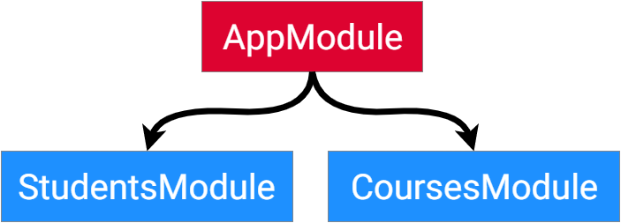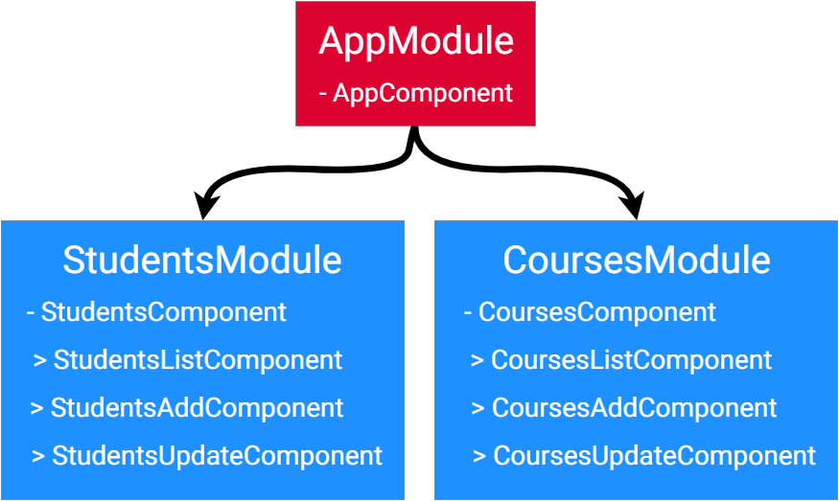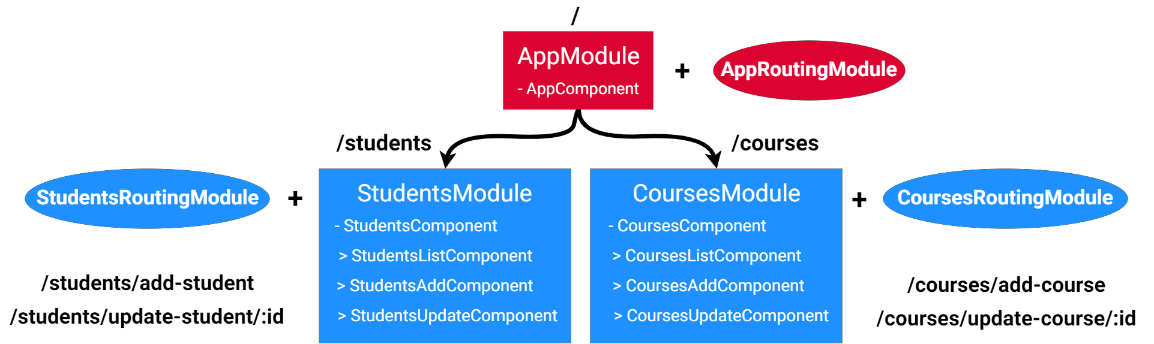

**Introduction to RxJS & Angular Http**

Introduction to RxJS & Angular Http

**Reactive Extensions for JavaScript (RxJS) is a reactive**

**streams library that allows us to work with asynchronous data streams using Observables,**

**Angular relies on RxJS for some of its internal features, in particular its Http Services.**

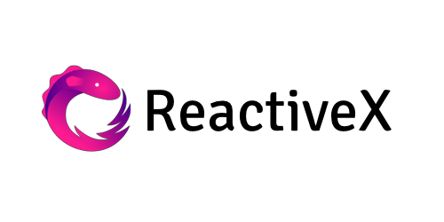

Introduction to RxJS & Angular Http

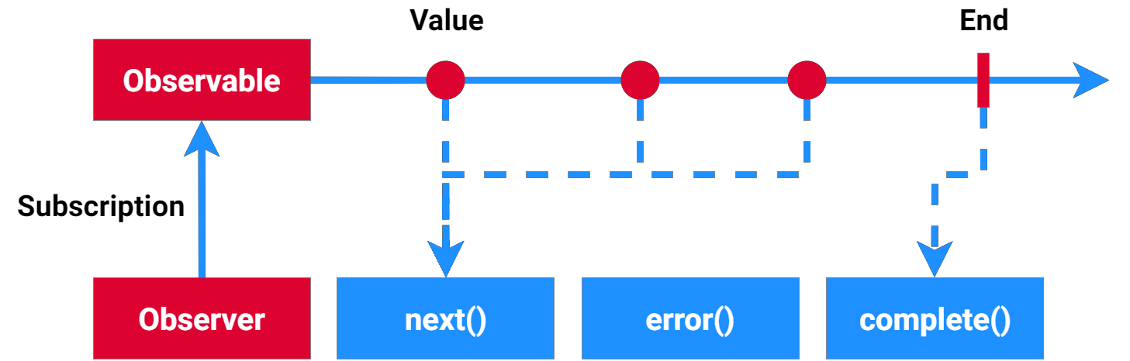

**Thanks for your attention !!**