Introduction:
In this project, I have developed a full-stack application serving as a viewer for h5 files coming from large scale single cell RNA-seq and Spatial Gene Expression experiments. Due to the challenge of online and interactive visualization of massive number of cells (or spots in the spatial data), I aimed to develop a framework for GPU-accelerated rendering of scatter plots of cells in single cell RNA-seq experiments and regions or spots in spatial gene expression data while receiving the user interaction clues from the frontend and retendering of the images on the GPU backend. In the following I will describe the specifications of this application.
The frontend component of this application is a form in which users can identify the type of data that they are inputting (spatial gene expression vs single cell RNA-seq), then provide the files related to their data, and view the figures and interact with them. For spatial gene expression data, scatter plot of spots are provided color by the total number of counts in them, and three of the top differentially expressed genes are also showed with their expression profiles. In addition, for the whole overview of the spots and for specific genes, boxplots are provided which show the distribution of their non-zero values. Upon user zoom, the main image is zoomed in the region along with the three other scatter plots showing the expression levels of top genes and their boxplots are updated accordingly based on the new values in the zoomed region. User has the option to return the figures to normal and choose another region. Similar representations are shown for single cell RNA-seq data but their coordinates are their TSNE embeddings.
As of the required input data types, the pipeline requires only an .h5 for spatial gene expression data, and .h5 gene expression and .csv of TSNE coordinates for single cell RNA-seq data. I tested the pipeline on datasets with various sample sizes to check the performance time of the model.
After this section, the full report of the response time of preprocessing, initial rendering, and zoom rendering, are provided on the server and on the browser on laptop.

1_Single cell RNA-seq data of 10,000 PBMC cells of human.
This is a single cell RNA-seq dataset with 10,000 number of cells. The link to the dataset is as follows: https://www.10xgenomics.com/datasets/10k_3p_Human_diseased_PBMC_Myelofibrosis_Fresh. Here attached a screenshot of the result of analysis for this dataset:
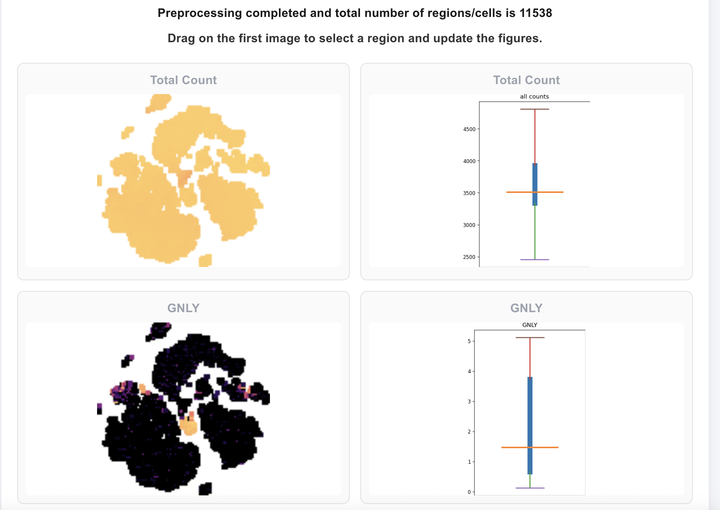

2_ Another dataset is a spatial gene expression dataset of human pancreas based on Visium technology (“https://www.10xgenomics.com/datasets/visium-hd-cytassist-gene-expression-libraries-human-pancreas-4”). In this experiment, the data are provided based on three different resolution levels of 16 um, 8 um, and 2um. Each experiment provides a matrix where on rows the spatial location of bins is provided and the columns we can see the genes. The number of bins/regions in these data are as follows: 2 um resolution has 6,680,622 bins in the input matrix, 8 um has 421,485 number of bins, and eventually the 16 um has 106,583 number of bins. A screenshot of the output of the application for spatial data is as follows:
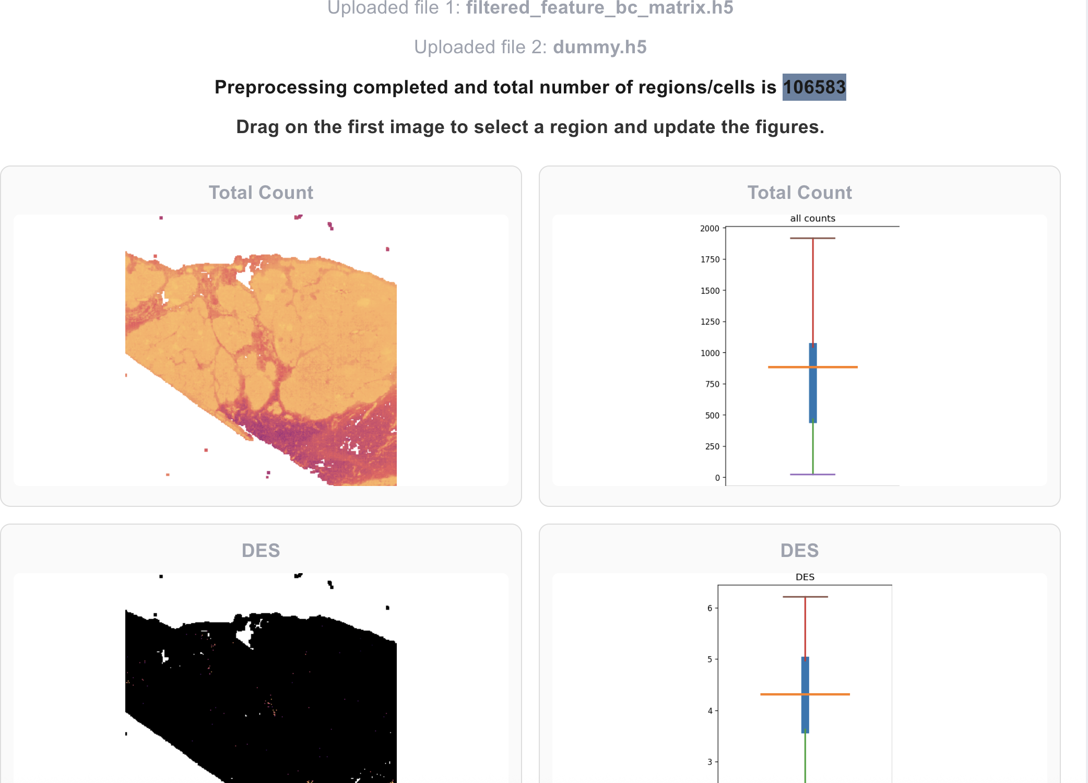

Considered these four datasets, I tested the performance of the pipeline based on input data with 10,000, 100,000, 400,000, and 6,000,000 cells/bins. The results of running the pipeline is as follows. For each experiment, I first show the response time for preprocessing, initial rendering, and repeated zooming and returning to initial form of the images captured on the browser. Then I show the same response times but server-side meaning the time that it takes for the GPU component on the server to receive the user request and re-render the images and return them through the API. Eventually, in the log file of the server-side the memory usage of each experiment is provided.
The server used for deploying the model is a Lambda instance with A10 GPU. The console captured times are as follows:
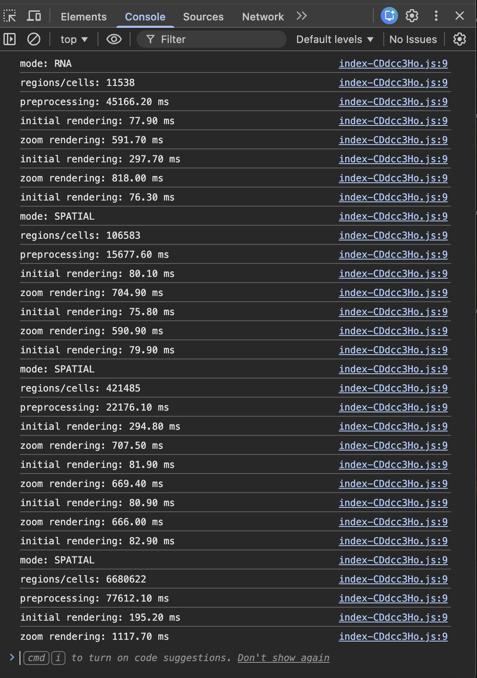
As we can see, the preprocessing and data loading is the most time consuming step which includes loading the h5 data into anndata format, moving the data to GPU for preprocessing of the values and picking top variable genes, in addition to initial rendering of the images. After the preprocessing, the images are returned to the frontend and visualized. Upon user request for zoom, GPU again renders the images in the given window. Once user wants the original image, again the initially generated images are returned. Due to this strategy of initial rendering of full images, and re-rendering upon user request on GPU, we can see that initial rendering is actually faster than zooming. As we can see, for cell numbers 10,000, 100,000 and 400,000 the image rendering after user request on average take 600 milliseconds but for 6 million cells it increases to 1 seconds; however, the application does not crash and remains fully responsive to the user with response time of almost 1 seconds.
IN the following the log file of the server is provided:

Data type is RNATotal number of regions/cells found in the data: 11538
Total init render time: 0.0001 sec
Total zoom render time: 0.5153 sec
Total init render time: 0.0001 sec
Total zoom render time: 0.7401 sec
Total init render time: 0.0001 sec
For number of data point: 11538, RAM usage is: 1674.12 MB

Data type is SPATIALTotal number of regions/cells found in the data: 106583
Total init render time: 0.0002 sec
Total zoom render time: 0.5218 sec
Total init render time: 0.0002 sec
Total zoom render time: 0.4983 sec
Total init render time: 0.0002 sec
For number of data point: 106583, RAM usage is: 1688.61 MB

Data type is SPATIALTotal number of regions/cells found in the data: 421485
Total init render time: 0.0007 sec
Total zoom render time: 0.5581 sec
Total init render time: 0.0006 sec
Total zoom render time: 0.5489 sec
Total init render time: 0.0006 sec
Total zoom render time: 0.5513 sec
Total init render time: 0.0006 sec
For number of data point: 421485, RAM usage is: 1752.91 MB

Data type is SPATIALTotal number of regions/cells found in the data: 6680622
Total init render time: 0.0245 sec
Total zoom render time: 0.9689 sec
For number of data point: 6680622, RAM usage is: 3860.62 MB

As we can see, the zooming responses are slightly smaller than console captured values but initial rendering times are very close to zero. That is because the original images are pre-loaded and sent to user over API. Therefore, the only loading time of original images would be the API communication time. In addition, we can see that the RAM usage increases as the number of cells increase.

Running the web application: Full source codes of this web application are provided in this github repository along with docker files and a docker-compose for automatic construction of all containers and deployment of API on local nodes and the frontend on the main entry point of the instance on which the app is deployed. The deployment can be done in the main directory by the following command:
sudo docker compose up -d
In addition, bash scripts are provided for downloading each of the datasets used for testing this web application.
In addition, the direct links to the datasets are as follows:
For the 10k single cell RNA-seq:
Matrix link: curl -O https://cf.10xgenomics.com/samples/cell-exp/8.0.1/10k_3p_Human_diseased_PBMC_Myelofibrosis_Fresh/10k_3p_Human_diseased_PBMC_Myelofibrosis_Fresh_count_filtered_feature_bc_matrix.h5
Clustering link: curl -O https://cf.10xgenomics.com/samples/cell-exp/8.0.1/10k_3p_Human_diseased_PBMC_Myelofibrosis_Fresh/10k_3p_Human_diseased_PBMC_Myelofibrosis_Fresh_count_analysis.tar.gz
And the .csv table including the TSNE features are provided in the clustering folder.

For the Spatial Gene expression of Human Pancreas (with all bin sizes):
https://cf.10xgenomics.com/samples/spatial-exp/4.0.1/Visium_HD_Human_Pancreas/Visium_HD_Human_Pancreas_binned_outputs.tar.gz

