Battery → DC–DC Converter → DC Bus (Hybrid Ferry Front-End)

In this task, you will build a straightforward power electronics chain used in hybrid electric ferries.
You will model only the front section of the ferry’s electrical system:
Battery → DC–DC Converter → DC Bus
Your goal is to create a working Simulink/Simscape model that takes power from a battery, regulates it using a DC–DC converter, and supplies a stable DC bus voltage.

Your Model Must Contain:

Battery (DC Source)
Use the built-in Simscape block:
- DC Voltage Source
(Simscape → Electrical → Specialized Power Systems → Sources
sps_lib/Sources:
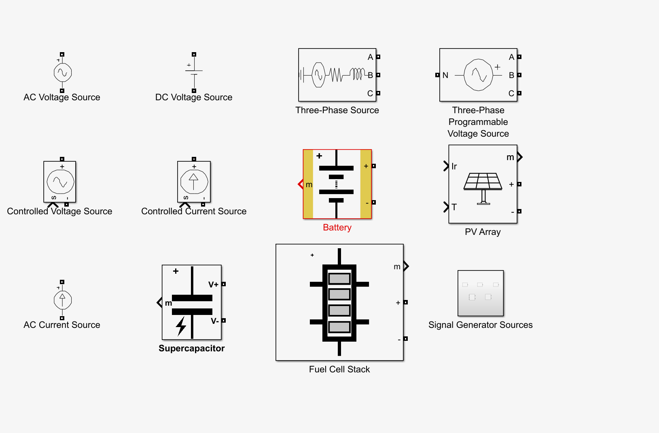
Set any reasonable voltage (e.g., 100–250 V).
Label it Battery.
DC–DC Converter:
You can use:
You may choose either a Buck converter or a Boost converter.
MATLAB already provides complete, working models.
https://www.mathworks.com/help/sps/ug/buck-converter-voltage-control.html
https://www.mathworks.com/help/sps/ug/boost-converter-voltage-control.html

What you do with the example:
- Copy the converter subsystem (the whole circuit + controller + PWM).
- Paste it into your own new model.
- Connect Battery → Converter → DC Bus.
- Adjust:
  - Battery voltage
  - Converter output voltage target
  - (Optional) L and C values (small changes only)
You do not need to modify the PI controller or PWM unless you want to.

DC Bus (Very Simple):
At the converter output, place:
- One Capacitor
- One Resistor (load)
This represents the ferry’s DC bus.
Your converter must regulate the DC bus voltage.
You should be able to see:
- Output voltage settling to the reference
- Inductor current (from the example)
- Battery → Converter → DC Bus connection
Your Simulink model: <group_Number>_ferry.slx

