FromThePage transcription and annotation tool user guide
FromThePage is a browser based transcription and annotation tool. It works with the following browsers: Mozilla Firefox, Chrome, Opera.
FromThePage is useful, if one has text documents in image format and wants to transcribe and annotate them. The transcription and annotation result will be saved to a database in XML format.
Here are the instructions to follow in order to use FromThePage:
1
You have to go to the URL https://kommul.eurac.edu/transcanno/
2 Signing in
You have to sign in (top right corner of the page).
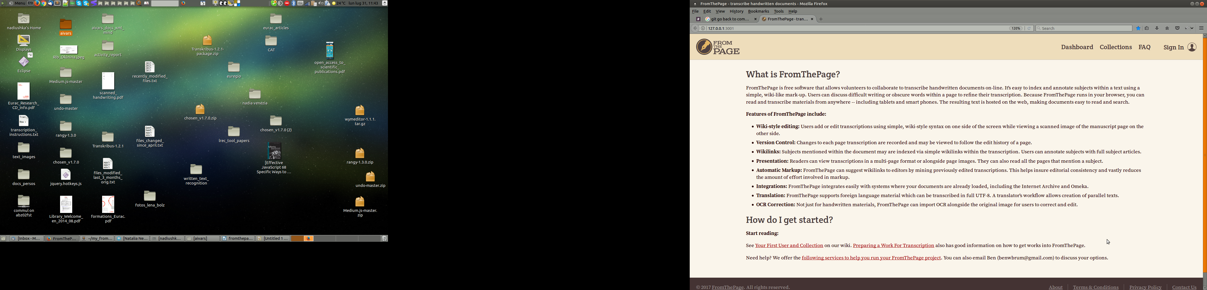

3 Transcribing
In order to start transcribing, go to the Works tab and click on a work, then choose the page you want to transcribe. You will see the scanned page and an empty space for the transcription next to it. You can change the position of the transcription field using the dropdown menu: image at the left, image at the right, image at the top, image at the bottom.
On the right side you will see a list of annotation categories.
There are 2 ways of inserting tags:
1 First insert a tag and then type the text inside.
2 First type the text, then highlight a portion of it with a mouse and tag it.
The tag can be added either using hot keys or using buttons on the right side of the screen.
Here is the list of hot keys:
Alt+C : insert a tag or tag a highlighted piece of text
When you press Alt+C, a pop up menu will appear offering a choice of categories available in this transcription mode. You can choose one of them with the mouse, with an arrow key or by typing the first letters of the category name. Once you have chosen the category, if the latter has attributes, each of them will appear accompanied by a list of possible values or a text input field where you will be able to type a new value. When all the attributes will have their values assigned, the tag will be inserted into the text.
Alt+X: get the cursor out of the current tag in order to continue typing outside the tag
Alt+R: make a pop up menu disappear. In this case no tagging is performed.
Alt+N : delete a tag from the portion of the text where the cursor is
A menu listing all the tags present at the cursor position will appear, the user has to choose the one he wants to delete.
This functionality is also available through the “cross” looking button on the right side of the screen.
Alt+M : modify a tag from the portion of the text where the cursor is
A menu listing all the tags present at the cursor position will appear, the user has to choose the one he wants to modify. Once the tag chosen, its attributes and there values will appear. The user will be able to change the values of these attributes. He won’t be able to add or delete attributes. In order to do this, he should delete the tag and insert another one in its place.
The tag modification functionality is also available through the “electric circuit” looking button on the right side of the screen.
Alt+, : insert a German lower double quote
Alt+. : insert a German upper double quote
All these hot keys may be modified. In order to change them, you have to push the “key” looking button in the right part of the window.
4 Saving transcriptions
Transcriptions are automatically saved every 3 minutes. However, you have the possibility to change the transcription saving frequency using a sand clock looking menu on the right side of the screen. After changing the transcription saving frequency you have to reload the page so that the new value be taken into account. Note that if you decide to use another browser, you will have to repeat the procedure, otherwise, it will be the default value. The custom transcription saving frequency value is saved in the browser cookies.
If there are errors in the XML code of the page (for example, due to accidental mouse mismanipulation), an error message will appear and the page won’t be saved. If you see an error message, it means that there is a mistake in the work you have done during the last 3 minutes (or another period of time if you have redefined it). In that case or if you notice that you have made some other mistakes and want to go back to a previous version of the page, you can go to the Versions tab next to the Overview and Transcribe tabs on the transcription page. This page allows you to compare different versions of the same transcription and choose the one you want to work on.

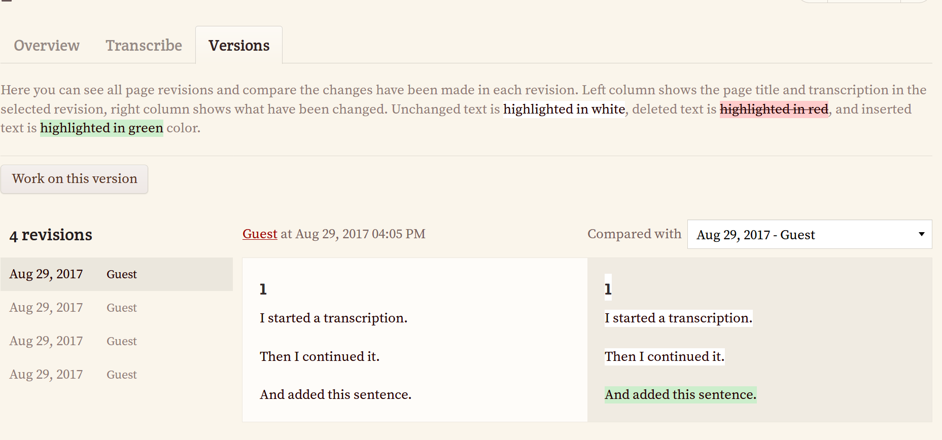

By pushing the Work on this version button on the left side of the screen you define the chosen version as the main one. Now you can go back to the Transcribe tab and continue transcription. You will be working on the version you have just chosen.
Despite of the automatic saving, when you have finished transcribing, you have to push the button Save changes to be sure that all the changes have been saved.
When you are sure that everything is right in your transcription and you will never have to go back to a previous version, you should push the button Transcription finished and leave the transcription page. The Transcription finished button deletes all the previous versions of the page and only leaves the last one. The fact that you leave the Transcription tab insures that no more automatic saving will be made and no more page versions will be registered. It is important to delete the previous versions, because in this way you liberate precious space on the computer hosting the transcriptions database. Thank you in advance for pushing the Transcription finished button every time you have finalised a transcription!
This button also allows you to verify that you have filled in the values of all the header categories. If you have forgotten at least one of them, you will be notified.

