**NADEZHDA STRELCHENIA**

**QA ENGINEER**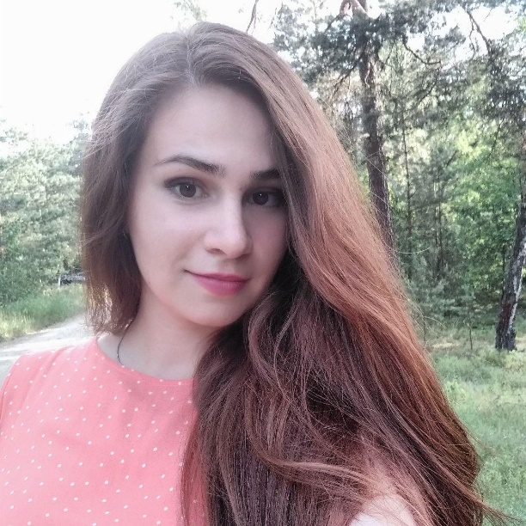

**Name** Nadezhda Strelchenia

**Birthday** 8th October 1993

**Ralationship** Single

**Nationality** Belarusian

**Languages** Russian, Belarusian, English (B1)

**Mobile** +375(33)351-90-56

**Email** nadezhda.strelchenia@gmail.com

**Skype** nadezhda.strelchenia

**PROFILE**

I'm interested in changing my profession and growth as a QA engineer. Have about 4 years of experience in search engine optimization (SEO). Part of my tasks was testing new websites and components which developed in our company. I was responsible for site functional, usability and performance testing. Tasks for all projects include full audit - it's like testing but with particular qualities. Every day I'm doing websites more user-friendly and simple.

I'm happy to see project progress and traffic increase.

I know HTML, CSS and JS. Self-education is an important part of my life. Able to learn quickly. Now my English level is intermediate but I'm working on improving that.

I would like to find a friendly team and interesting projects.

**WORK**

2018

**SEO specialist at Ltd "Search Optimization"**

Technical audit for websites. Functional, usability and performance testing of websites. Compilation of tasks for programmers with problems description and recommendation for website owners.

Configuration robots.txt and sitemap.xml. Keywords research and clustering. Writing tags titles and descriptions. Creating new pages and content management. Changing sites structure without destroying. Creating and implementing long term seo strategy.  
  
Creating technical assignments for copywriters and programmers (writing tasks with description technical problems and necessary results, discussing and testing final results).  
  
Making changes to the templates (setting h1-hn, breadcrumbs, removing / changing any modules on websites, setting pagination, etc.). Setting redirects in .htaccess files.  
  
Editing styles: changing styles for text elements; changing position and appearance of content blocks; creating pop-up; changing header and footer styles (aligning text, adding icons, adding forms, changing position); creating and stylization forms.  
  
Setting events in the Google tag manager. Setting microdatos in the Google tag manager. Working with Yandex metrica and Google analytics.   
  
Analysis of competitors, making recommendations for clients on the development of the project. Working with seo-tools (screaming frog, netpeak, ahrefs, etc.). Buying links. Work with content exchanges (turbotext, advego).   
  
Working as a team with programmers, copywriters, other seo-specialists.  
  
Training interns.  
  
Work with cms: WordPress, MODX, Bitrix, Opencart, Joomla, Magento, etc.

2017

**SEO specialist at VRP Consulting**

Website optimization for American region. Technical audit. Configuration robots.txt. Keywords research and clustering. Writing tags titles and descriptions. Creating new pages and content management.  
  
Creating technical assignments for copywriters, designers and programmers (writing tasks with description technical problems and necessary results, discussing and testing final results).  
  
Setting Yandex metrica and Google analytics. Setting Google Ads. Setting events in the Google tag manager.  
  
Making changes to the template (setting h1-hn, breadcrumbs, removing / changing any modules on sites, setting pagination, etc.). Setting redirects in .htaccess files. Editing styles.  
  
Working as a team with programmers, copywriters and designers.  
  
Buying links. Analysis of competitors, making recommendations for clients on the development of the project. Working with seo-tools (screaming frog, netpeak, ahrefs, etc.).  
  
Work with cms: WordPress.

2016

**SEO specialist at Borovoy Studio**

Technical audit for websites. Configuration robots.txt. Keywords research and clustering. Writing tags titles and descriptions. Creating technical assignments for copywriters and programmers. Content managment. Setting redirects in .htaccess files.  
  
Setting Yandex metrica and Google analytics, Google Webmasters and Yandex Webmasters. Buying links. Work with content exchanges (turbotext, advego). Working with seo-tools (screaming frog, netpeak, ahrefs, etc.).  
  
Work with cms: Bitrix, Joomla.

**EDUCATION**

2018

**JS courses**

Website development using HTML, CSS and JavaScript.

2018

**HTML & CSS courses**

I finished HTML/CSS courses in [Training Center](https://trainingcenter.by/)

2016

**BSEU**

Bachelor of Science in Law.

**SKILLS**

SEO

Google Analytics

Yandex.Metrica

GTM

Google Ads

SEO tools (Screaming Frog , Ahrefs, Netpeak etc.)

HTML5

CSS3

JS (ES6)

React

Bootstrap 4

jQuery

Git

etc.