PROBLEM 1 Q2

The resulting estimated functions are:

* y1(x) = x152.158 + -189.866
* y2(x) = x27.001 + x19.304 + -239.334
* y3(x) = x30.820+ x20.261+ -x10.0103+ - 175.277
* y4(x) = x40.005987 + x30.755 + x20.234 + x11.176 + -175.880
* y5(x) = x50.000853 + -x40.004698 + x30.7528 + x20.5260 + x10.9659 + -176.837

PROBLEM 1 Q3

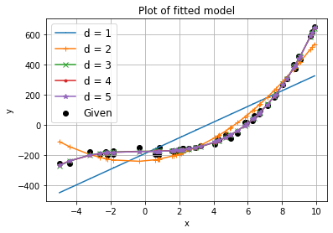

Based on the mean squared error,

﻿MSE for d = 1 is 2471895.407024308

MSE for d = 2 is 1755375.1906050246

MSE for d = 3 is 1347509.4840200478

MSE for d = 4 is 1078219.4383608005

MSE for d = 5 is 898513.3126327494T

The function seems to follow the polynomial d=5, which has the lowest Mean Squared Error

PROBLEM 1 Q4

﻿

y_pred if x = 2 and d = 3 is -166.82657455772826