PROBLEM 2 Q6

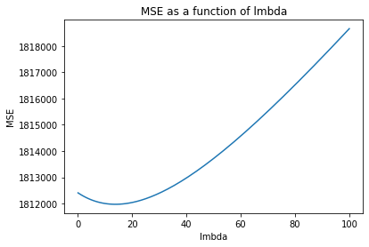

PROBLEM 2 Q7

﻿

y(x) = x\*5115.65136992 + -x\*201.49769618 + -x\*207.15474973 + -x\*1338.2909694 + x\*219.18597862 + -x\*66.36405012 + x\*500.9098275 + x\*74.30622797+ -x\*459.07248485

Predicted price for diamond is: $18168.22