FACE DETECTION with Python using Open CV

Prototype:

Recently we want to perform Face Detection using OpenCV with Python,here the actual code is less than 30 lines of Python code.Thanks,to the terse syntax of python and now,we sharing our requirements of this experiment with you.

Computer Vision: Computer Vision is the broad parent name for any computations involving visual content – that means images,videos,icons,and anything else with pixels involved.  Open CV: Open CV (Open Source Computer Vision ) is a library of programming functions for real time computer vision.It was developed by “*WillowGarage”*, that includes several hundreds of Computer vision algorithms. In that libraries now, we use the library is cv2. cv2: This is the Open CV module and contains functions for face detection and recognition. Here, the cv2 library file which is in the form of pyd document, that pyd file is the primary associated with Python those are dynamic link library that contains a Python module, or set of modules.

Harcascade_frontalface_default.xml: It’s used for detecting the face. So,we load the cascade using the cv2.Cascade Classifier function which takes the path to the cascade xml file.Here, I have copied that xml file into the current directory.That’s why we have used that relative path. It’s used for the frontend of the frame also.

Python 2.7: Here we use the Python code by using Open CV libraries the code which is run in the Python2.7vertion only, because the Open CV libraries are work with this vertion only, that’s the reason why we use python 2.7 vertion.

 The Python code is less than 50 lines, In that code we use the cv2 library, and the frontalface was designed in the xml document by the developer.The python code is run in the python compiler like shell then we get the detectio frame. If we don’t have cv2 library the python code is not valid mean it’s get error message. Here, the detection process is occuring by using the webcam, when we run the program the webcam will open and to detect the faces infr- ront of the camera.If there is no images display then no detection was found.

Conclusion: 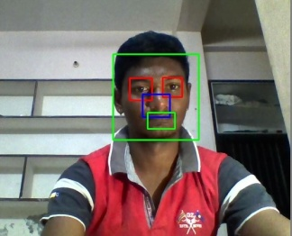

Here we get the output frame as ilke given above Here, we can observe in the detecting process eyes and mouth and nose are also detecting of humans. In the outframe containg some hint also for which part is face,mouth,nose and eyes are detecting by some rectangular boxes.In this way we can detecting the faces by using openCV libraries.