**1) write a java program that create class hierarchy for a employee of company the base class should be employee with subclasses manager developer and programmer each subclass should have the properties such as name address salary and job title implement method for calculating bonus generate the performance report?**

**CODE:**

**class Employee {**

**protected String name;**

**protected String address;**

**protected double salary;**

**protected String jobTitle;**

**public Employee(String name, String address, double salary, String jobTitle) {**

**this.name = name;**

**this.address = address;**

**this.salary = salary;**

**this.jobTitle = jobTitle;**

**}**

**public double calculateBonus() {**

**return salary * 0.1;**

**}**

**public void generatePerformanceReport() {**

**System.out.println("Employee Name: " + name);**

**System.out.println("Job Title: " + jobTitle);**

**System.out.println("Salary: " + salary);**

**}**

**}**

**class Manager extends Employee {**

**private String department;**

**public Manager(String name, String address, double salary, String jobTitle, String department) {**

**super(name, address, salary, jobTitle);**

**this.department = department;**

**}**

**@Override**

**public double calculateBonus() {**

**return super.calculateBonus() * 1.5;**

**}**

**@Override**

**public void generatePerformanceReport() {**

**super.generatePerformanceReport();**

**System.out.println("Department: " + department);**

**}**

**}**

**class Developer extends Employee {**

**private String programmingLanguage;**

**public Developer(String name, String address, double salary, String jobTitle, String programmingLanguage) {**

**super(name, address, salary, jobTitle);**

**this.programmingLanguage = programmingLanguage;**

**}**

**@Override**

**public void generatePerformanceReport() {**

**super.generatePerformanceReport();**

**System.out.println("Programming Language: " + programmingLanguage);**

**}**

**}**

**class Programmer extends Developer {**

**public Programmer(String name, String address, double salary, String jobTitle, String programmingLanguage) {**

**super(name, address, salary, jobTitle, programmingLanguage);**

**}**

**@Override**

**public double calculateBonus() {**

**return super.calculateBonus() * 1.2;**

**}**

**}**

**public class Main {**

**public static void main(String[] args) {**

**Manager manager = new Manager("John Doe", "123 Main St", 100000, "Manager", "IT");**

**manager.generatePerformanceReport();**

**System.out.println("Bonus: " + manager.calculateBonus());**

**Developer developer = new Developer("Jane Smith", "456 Elm St", 80000, "Developer", "Java");**

**developer.generatePerformanceReport();**

**System.out.println("Bonus: " + developer.calculateBonus());**

**Programmer programmer = new Programmer("Bob Johnson", "789 Oak St", 70000, "Programmer", "Python");**

**programmer.generatePerformanceReport();**

**System.out.println("Bonus: " + programmer.calculateBonus());**

**}**

**}**

**OUTPUT:** 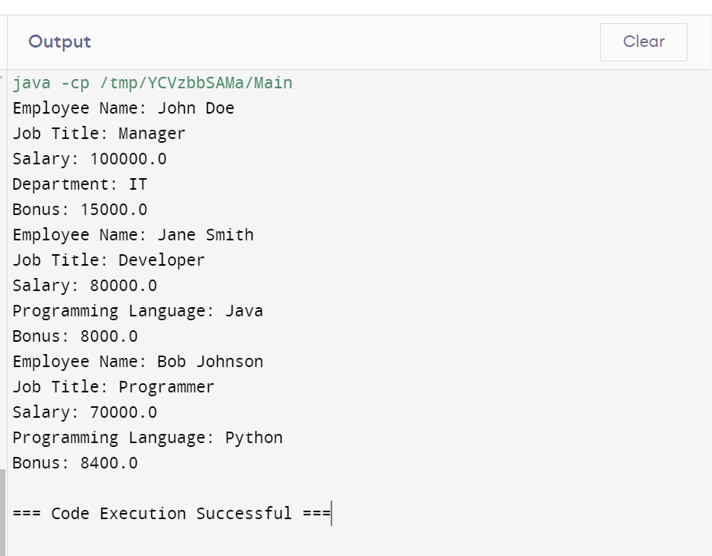

**2) written a java program to create method that take on intergers as parameter throws exception if the number is odd?**

**CODE:**

**public class Main {**

**public static void checkEven(int number) throws Exception {**

**if (number % 2 != 0) {**

**throw new Exception("The number is odd: " + number);**

**} else {**

**System.out.println("The number is even: " + number);**

**}**

**}**

**public static void main(String[] args) {**

**try {**

**checkEven(3);**

**} catch (Exception e) {**

**System.err.println(e.getMessage());}**

**}**

**}**

**OUTPUT:**

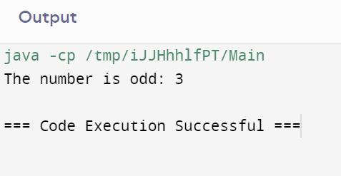

**3) write a java program with main method to create the method that take string as input proves on exception that the string contains vowels or not with user defined input?**

**CODE:**

**import java.util.Scanner;**

**public class VowelChecker {**

**public static void main(String[] args) {**

**Scanner scanner = new Scanner(System.in);**

**System.out.print("Enter a string: ");**

**String input = scanner.nextLine();**

**if (containsVowels(input)) {**

**System.out.println("The string contains vowels.");**

**} else {**

**System.out.println("The string does not contain vowels.");**

**}**

**}**

**public static boolean containsVowels(String str) {**

**String vowels = "aeiouAEIOU";**

**for (char c : str.toCharArray()) {**

**if (vowels.indexOf(c) != -1) {**

**return true;**

**}**

**}**

**return false;**

**}**

**}**

**OUTPUT:**

