**1.BUBBLE SORT:**

**CODE:**

**public class BubbleSort {**

**void bubbleSort(int arr[]) {**

**int n = arr.length;**

**for (int i = 0; i < n-1; i++)**

**for (int j = 0; j < n-i-1; j++)**

**if (arr[j] > arr[j+1]) {**

**// swap arr[j+1] and arr[j]**

**int temp = arr[j];**

**arr[j] = arr[j+1];**

**arr[j+1] = temp;**

**}**

**}**

**void printArray(int arr[]) {**

**int n = arr.length;**

**for (int i = 0; i < n; i++)**

**System.out.print(arr[i] + " ");**

**System.out.println();**

**}**

**public static void main(String args[]) {**

**BubbleSort ob = new BubbleSort();**

**int arr[] = {64, 34, 25, 12, 22, 11, 90};**

**ob.bubbleSort(arr);**

**System.out.println("Sorted array");**

**ob.printArray(arr);**

**}**

**}**

**OUTPUT:**

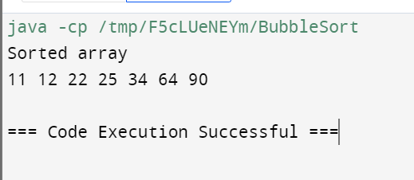

**2. INSERTION SORT:**

**CODE:**

**public class InsertionSort {**

**public static void insertionSort(int[] arr) {**

**int n = arr.length;**

**for (int i = 1; i < n; ++i) {**

**int key = arr[i];**

**int j = i - 1;**

**while (j >= 0 && arr[j] > key) {**

**arr[j + 1] = arr[j];**

**j = j - 1;**

**}**

**arr[j + 1] = key;**

**}**

**}**

**public static void main(String[] args) {**

**int[] arr = {12, 11, 13, 5, 6};**

**insertionSort(arr);**

**System.out.println("Sorted array:");**

**for (int num : arr) {**

**System.out.print(num + " ");**

**}**

**}**

**}**

**OUTPUT:**

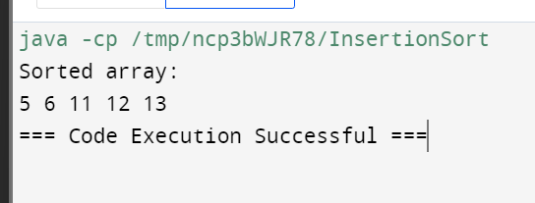

**3. LINEAR SERACH:**

**CODE:**

**public class LinearSearch {**

**public static int linearSearch(int[] arr, int target) {**

**for (int i = 0; i < arr.length; i++) {**

**if (arr[i] == target) {**

**return i;**

**}**

**}**

**return -1;**

**}**

**public static void main(String[] args) {**

**int[] arr = {2, 5, 7, 9, 11, 13, 6};**

**int target = 11;**

**int result = linearSearch(arr, target);**

**if (result == -1) {**

**System.out.println("Element not found in the array.");**

**} else {**

**System.out.println("Element found at index: " + result);**

**}**

**}**

**}**

**OUTPUT:**

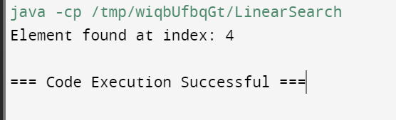

**4. BINARY SERACH:**

**CODE:**

**public class BinarySearch {**

**int binarySearch(int[] arr, int x) {**

**int left = 0, right = arr.length - 1;**

**while (left <= right) {**

**int mid = left + (right - left) / 2;**

**if (arr[mid] == x)**

**return mid;**

**if (arr[mid] < x)**

**left = mid + 1;**

**else**

**right = mid - 1;**

**}**

**return -1;**

**}**

**public static void main(String[] args) {**

**BinarySearch bs = new BinarySearch();**

**int[] arr = {2, 3, 4, 10, 40};**

**int x = 10;**

**int result = bs.binarySearch(arr, x);**

**if (result == -1)**

**System.out.println("Element not present in the array");**

**else**

**System.out.println("Element found at index " + result);**

**}**

**}**

**OUTPUT:**

