1.image:

Code;

package javafxapplication4;

import javafx.application.Application;

import javafx.scene.Scene;

import javafx.scene.image.Image;

import javafx.scene.image.ImageView;

import javafx.scene.layout.StackPane;

import javafx.stage.Stage;

public class JavaFXApplication4 extends Application {

@Override

public void start(Stage primaryStage) {

// Load the image from the specified file path

Image image = new Image("file:C:/Users/selco/Downloads/aishuuuuuuuuuuuuuuuuuuuu.jpeg");

// Create an ImageView to display the image

ImageView imageView = new ImageView(image);

// Optionally, you can set some properties on the ImageView

imageView.setFitWidth(300); // Set the width of the image

imageView.setPreserveRatio(true); // Preserve the aspect ratio

// Create a layout pane and add the ImageView to it

StackPane root = new StackPane();

root.getChildren().add(imageView);

// Create a scene with the layout pane

Scene scene = new Scene(root, 400, 300);

primaryStage.setTitle("Image Display");

primaryStage.setScene(scene);

primaryStage.show();

}

public static void main(String[] args) {

launch(args);

}

}

Output:

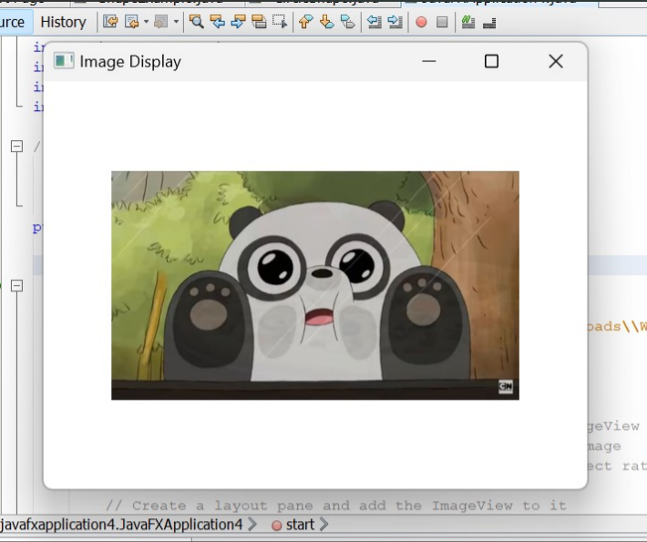

2.Audio:

Code:

package javafxapplication5;

import javafx.application.Application;

import javafx.event.ActionEvent;

import javafx.event.EventHandler;

import javafx.scene.Scene;

import javafx.scene.control.Button;

import javafx.scene.layout.StackPane;

import javafx.stage.Stage;

import javafx.scene.media.Media;

import javafx.scene.media.MediaPlayer;

import java.io.File;

public class JavaFXApplication5 extends Application {

@Override

public void start(Stage primaryStage) {

// Load the audio file

String audioFilePath = "C:\\Users\\selco\\Downloads\\chin-tapak-dum-dum-made-with-Voicemod.mp3"; // Replace with your audio file path

Media audio = new Media(new File(audioFilePath).toURI().toString());

MediaPlayer mediaPlayer = new MediaPlayer(audio);

// Create a button to play the audio

Button btn = new Button();

btn.setText("Play Audio");

btn.setOnAction(new EventHandler<ActionEvent>() {

@Override

public void handle(ActionEvent event) {

mediaPlayer.play(); // Play the audio

System.out.println("Playing audio...");

}

});

StackPane root = new StackPane();

root.getChildren().add(btn);

Scene scene = new Scene(root, 300, 250);

primaryStage.setTitle("Audio Player");

primaryStage.setScene(scene);

primaryStage.show();

}

public static void main(String[] args) {

launch(args);

}

}

Output: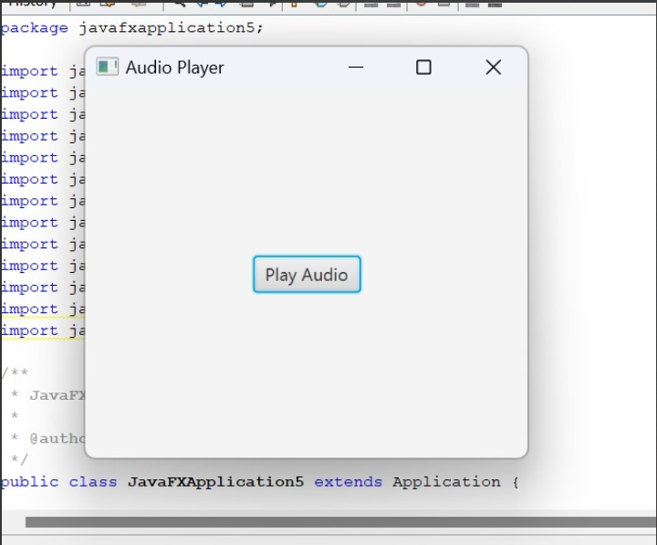

3.keyboard handling:

Code:

package javafxapplication6;

import javafx.application.Application;

import javafx.event.EventHandler;

import javafx.scene.Group;

import javafx.scene.Scene;

import javafx.scene.control.TextField;

import javafx.scene.input.KeyEvent;

import javafx.scene.paint.Color;

import javafx.stage.Stage;

public class JavaFXApplication6 extends Application{

@Override

public void start(Stage primaryStage) throws Exception {

// TODO Auto-generated method stub

//Creating TextFields and setting position for them

TextField tf1 = new TextField();

TextField tf2 = new TextField();

tf1.setTranslateX(100);

tf1.setTranslateY(100);

tf2.setTranslateX(300);

tf2.setTranslateY(100);

//Handling KeyEvent for textfield 1

tf1.setOnKeyPressed(new EventHandler<KeyEvent>() {

@Override

public void handle(KeyEvent key) {

// TODO Auto-generated method stub

tf2.setText("Key Pressed :"+" "+key.getText());

}

});

//setting group and scene

Group root = new Group();

root.getChildren().addAll(tf2,tf1);

Scene scene = new Scene(root,500,200,Color.WHEAT);

primaryStage.setScene(scene);

primaryStage.setTitle("Handling KeyEvent");

primaryStage.show();

}

public static void main(String[] args) {

launch(args);

}

}

Output:

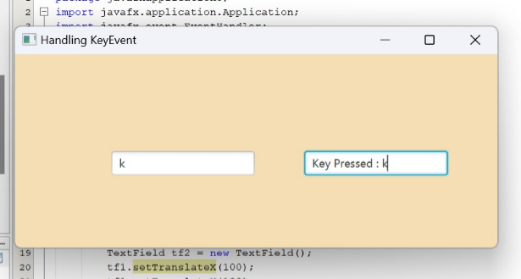

4. mouse handling

Code:

package javafxapplication6;

import javafx.animation.TranslateTransition;

import javafx.application.Application;

import javafx.event.EventHandler;

import javafx.scene.Group;

import javafx.scene.Scene;

import javafx.scene.control.Button;

import javafx.scene.input.MouseEvent;

import javafx.scene.paint.Color;

import javafx.scene.shape.Circle;

import javafx.stage.Stage;

import javafx.util.Duration;

public class JavaFXApplication6 extends Application{

@Override

public void start(Stage primaryStage) throws Exception {

// TODO Auto-generated method stub

//Creating Circle and setting the color and stroke in the circle

Circle c = new Circle(100,100,50);

c.setFill(Color.GREEN);

c.setStroke(Color.BLACK);

//creating play button and setting coordinates for the button

Button btn = new Button("Play");

btn.setTranslateX(125);

btn.setTranslateY(200);

// creating pause button and setting coordinate for the pause button

Button btn1 = new Button("Pause");

btn1.setTranslateX(175);

btn1.setTranslateY(200);

//Instantiating TranslateTransition class to create the animation

TranslateTransition trans = new TranslateTransition();

//setting attributes for the TranslateTransition

trans.setAutoReverse(true);

trans.setByX(200);

trans.setCycleCount(100);

trans.setDuration(Duration.millis(500));

trans.setNode(c);

//Creating EventHandler

EventHandler<MouseEvent> handler = new EventHandler<MouseEvent>() {

@Override

public void handle(MouseEvent event) {

// TODO Auto-generated method stub

if(event.getSource()==btn)

{

trans.play(); //animation will be played when the play button is clicked

}

if(event.getSource()==btn1)

{

trans.pause(); //animation will be paused when the pause button is clicked

}

event.consume();

}

};

//Adding Handler for the play and pause button

btn.setOnMouseClicked(handler);

btn1.setOnMouseClicked(handler);

//Creating Group and scene

Group root = new Group();

root.getChildren().addAll(c,btn,btn1);

Scene scene = new Scene(root,420,300,Color.WHEAT);

primaryStage.setScene(scene);

primaryStage.setTitle("EventHandler example");

primaryStage.show();

}

public static void main(String[] args) {

launch(args);

}

}

Output:

