InsightStream:NavigateTheNewsLandscape

1. **Introduction**

* **ProjectTitle:**Insightstream:NavigateTheNewsLandscape
* **TeamID**:NM2025TMID38921
* **TeamLeader:Nandhini S**

|  |  |
| --- | --- |
| **NAME** | **MAILID** |
| NANDHINI S | nandhini14022007@gmail.com |

* **TeamMembers:**

|  |  |
| --- | --- |
| **NAME** | **MAILID** |
| JAYARAJ | jayarajtailcmedu@gmail.com |
| SUDHARSHAN | Shanthisuresh977@gmail.com |
| LOKESH | Lokeshrajkumar2007@gmail.com |

# PROJECTOVERVIEW

* 1. **Purpose:NKNEWS**connectsclientsandfreelancersthroughprojectpostings,bidding,and real-time communication.

InsightStream aims to make news consumption smarter, faster, and more reliable. With the overwhelmingamountofnewspublisheddaily,readersoftenstruggletofindcredible,unbiased, and relevant information. This project seeks to solve that problem by providing a platform that organizes, summarizes, and contextualizes news stories in real time.

Ourgoalistohelpusersnavigatethroughthenoise,identifythefacts,andunderstandthebigger picture behind major events — all in one streamlined experience.

.

* 1. **KeyFeatures**
     + **SmartNewsSummaries**

**AI-powered,concisesummariesthatdeliverthecorefactsofanystoryinseconds.**

* + - **TopicNavigator**

**Letsusersexploreconnectednewsstoriesthroughtimelines,categories,andrelatedevents.**

* + - **Real-TimeUpdates**

**Continuouslyrefreshestoshowthelatestverifiednewsasithappens.**

* + - **Fact-CheckHighlights**

**Flagsquestionableclaimsandlinkstotrustedfact-checking sources.**

1. **Target Audience**

* GeneralNewsReaders

Peoplewhowantquick,reliable,andunbiasedupdates withoutscrollingthroughmultiple sources.

* Students&Researchers

Thosewhoneedaccurate,summarizednewsandcontextforassignments,projects,orresearch work

* Fact-Checkers&CriticalThinkers

Individualswhovaluetransparency,credibility,andevidence-basedreporting.

* Educators&KnowledgeSeekers

Teachersandlearnerswhowanttousewell-organizednewstodiscusscurrentaffairsin classrooms.

# ARCHITECTURE

* 1. **Frontend–React.jswithBootstrapandMaterialUI**

Thefrontendofisbuiltusing**React.js**,ensuringahighlydynamicandresponsiveuser interface.**Bootstrap**providesarobustgridsystemandlayoutframework,while**Material UI** adds modern, pre-designed components for consistency and visual appeal. Together, they deliver a smooth, intuitive, and interactive user experience across devices.

* 1. **Backend–Node.jsandExpress.js**

The backend is powered by **Node.js** for fast, scalable, and event-driven server operations.**Express.js**isusedtohandlerouting,serverlogic,andAPIendpoints,ensuring efficient communication between the frontend and database. This combination supports secure data processing and reliable application performance.

* 1. **Database– MongoDB**

**MongoDB** serves as the primary database, chosen for its flexibility in handling unstructureddata.Itstoresuserinformation,projectpostings,applicationdetails,andchat messages in asecureand scalable manner. Its document-oriented structuremakes itwell- suited for real-time interactions and large-scale data management.

# SETUPINSTRUCTIONS

* 1. **Prerequisites**

Beforesettingup**NKNEWS**ensurethatthefollowingtoolsandtechnologiesareinstalled on your system:

* **Node.js**–JavaScriptruntimeenvironment.
* **MongoDB**–Databaseforstoringuserdata,projects,andchatmessages.
* **Git**–Forcloningandversion control.
* **React.js**–Frontendframeworkforbuildingtheuserinterface.
* **Express.js**–BackendframeworkforhandlingAPIs andserverlogic.
* **Mongoose**–ODM(ObjectDataModeling)libraryfor MongoDB.
* **VisualStudioCode**–RecommendedIDEfordevelopment.
  1. **Installationsteps**
     1. **Node.js**
* **Knowledge**:basicJavaScript(variables,functions,promises/async-await),basic command-line use (terminal / PowerShell), JSON, and git (recommended).
* **System**:Windows/macOS/Linux(x64orarm64);2GB+RAMrecommended;internetto download installers.
* **Toolstohaveready**:aterminal(CMD/PowerShell/WSLonWindows,Terminalon macOS/Linux), a code editor (VS Code recommended).

**Step-by-stepinstallation**

**Windows—easiest:officialinstaller(orusenpm-windowsforversionmanagement) Official installer (quick)**

1. VisittheofficialNode.jsdownloadspageanddownloadtheWindows**.msi**(choosethe

**LTS**build).

1. RuntheMSIandacceptdefaults(itwillinstallnodeandnpmandaddtoPATH).
2. OpenPowerShellorCommandPromptand verify:

node-v npm-v

you’redone.nodejs.org

**Ifyou wantmultipleNodeversions /saferglobalinstalls—usenpmforWindows**

1. Install**npm-windows**(downloadandruntheinstallerfromthenpm-windows releases).
2. Afterinstall,openanewadminPowerShellorCMDanduse: npm install lts

npmlist

npm use <version> #e.g.npmuse18.16.0OR`npmuselts`ifsupported node -v

npm-windowsletsyouswitchversionswithoutre-installers.GitHub+1npm -v

you’re done.

* + 1. **MongoDB**
* **KnowledgePrerequisites**
* Basic**databaseconcepts**:collections,documents,CRUD(Create,Read,Update,Delete).
* Basic**commandline/terminal**usage.
* JSONknowledge(MongoDBstoresdatainBSON,similartoJSON).
* (Optional)Networkingbasics:ports,IPbinding, authentication.

**SystemPrerequisites**

* **OS**:Windows(x64/arm64supported).
* **Processor**:64-bit,1GHz+recommended.
* **RAM**:Minimum2GB(4GB+recommended fordev;higherforprod).
* **Diskspace**:Atleast5–10GBfree(MongoDBstoreslargeamountsof data).
* **Port**:MongoDB runson27017bydefault(makesureit’s free/unblocked).

**SoftwarePrerequisites**

* **Administrator**(toinstallpackages/services).
* **Packagemanager**(apt,yum,Homebrew)ORdirectinstaller.
* **MongoDBShell(mongosh)**–requiredtointeractwithMongoDB.
* **MongoDBCompass(GUI)**–optionalbutrecommendedforbeginners.
* **Docker**(optional)–forcontainerized setup.
  + 1. **Git**

**Systemprerequisites**

* **OS**:Windows
* **Permissions**:Administrator(Windows)
* **Network**:Internetaccess(forcloning/pushingremotereposlikeGitHub,GitLab, Bitbucket).

**Softwareprerequisites**

* Text/codeeditor(VSCoderecommended).
* SSHclient(optional,forGitHub/GitLabSSHconnections).

**Githubaccountcreation:**

1. SignintoGitHub
   * GotoGitHub.
   * LogintoyourGitHubaccount.Ifyoudon'thaveone,youcansignupforfree.
2. CreateaNew Repository
   * Onceloggedin,clickonthe**+**iconinthetoprightcornerofthepage.
   * Select**"Newrepository"**fromthedropdown menu.
3. FillinRepositoryDetails

You'llneedtofilloutthefollowingfields:

* + **RepositoryName**:Chooseanameforyourrepository(e.g., my-project).
  + **Description**(optional):Provideabriefdescriptionofyourproject(e.g.,"Acoolwebapp").
  + **PublicorPrivate**:Choosewhetheryourrepository willbepublic(anyonecanseeit)or private (only you and collaborators can access it).
  + **Initialize withREADME**:IfyouwanttoaddaREADMEfile(whichishelpfulfor explaining your project), check this box.
  + **Add.gitignore**(optional):Youcanchooseatemplateforyour.gitignorefile,dependingon your project's language or framework (e.g., Python, Node, etc.).
  + **ChooseaLicense**(optional):Youcanchoosealicenseifyou'dliketospecifyhowothers can use your code.

1. CreatetheRepository
   * Onceyou'vefilledeverythingout,clickthe**Createrepository**button.
2. ClonetheRepository(Optional)
   * Aftertherepositoryiscreated,you'llbetakentothe newrepository'spage.
   * Tocloneittoyourlocalmachine,copythe**cloneURL**(eitherHTTPSorSSH)fromthe "Code" button.
   * Inyourterminal,run thefollowing command:
   * gitclone<repository-url>
3. StartAdding Files
   * NowyoucanstartaddingfilestoyourrepositoryeitherthroughtheGitHubwebsiteorby pushing files from your local machine.

That'sit!You'vecreatedanewGitHubrepository.Letmeknowifyouneedhelpwiththenext steps, like pushing files to GitHub.

* + 1. **React.js**

**Systemprerequisites**

* + - **OS**:Windows
    - **Node.js&npm**:
    - Installlatest**LTSversionofNode.js**(includesnpm).
    - Verifywith:
    - node-v
    - npm-v
    - **CodeEditor**:VS Coderecommended.
    - **Browser**:Chrome/Edge/Firefoxfordevelopertools.
    - A.UsingCreateReactApp(CRA)[BeginnerFriendly]
    - Openterminal→navigatetoprojectfolder.
    - Run:
    - npxcreate-react-appmy-app
    - (Herenpxcomes withnpm5.2+,sonoextrainstall needed.)
    - Gointoprojectfolder:
    - cdmy-app
    - Startdevelopmentserver:
    - npmstart
    - Apprunsat[http://localhost:3000.](http://localhost:3000/)
    1. **Express.js–Mongoose–VisualStudioCode**
    - **Prerequisites(Theory)**
    - **JavaScript&Node.js**→neededsinceExpress runson Node.
    - **MongoDBknowledge**→MongooseisanODM forMongoDB.
    - **RESTAPIconcepts** →todesignroutes/endpoints.
    - **VisualStudioCode**→editortowriteandmanagetheproject.
    - **Node.js&npminstalled**→torunserverandinstallpackages.
    - **MongoDBinstalledorAtlasaccount**→for database.
* **InstallationSteps:**

#Clonetherepositorygitclone

#Installclientdependenciescdclient npm install

#Installserverdependenciescd

../servernpminstall

# FOLDERSTRUCTURE

PROJECTSTRUCTURE:

src/

├──App.jsx

├── main.jsx

│

├── context/

│ └──GeneralContext.jsx

│

├── components/

│ ├──Footer.jsx

│ ├──Hero.jsx

│ ├──HomeArticles.jsx

│ ├──NavbarComponent.jsx

│ ├──NewsLetter.jsx

│ └──TopStories.jsx

│

├──pages/

│ ├──Home.jsx

│ ├──CategoryPage.jsx

│ └──NewsPage.jsx

│

└──styles/

├──App.css (optional)

├──Footer.css

├──Hero.css

├──Home.css

├──HomeArticles.css

├──Navbar.css

├──NewsLetter.css

├──TopStories.css

└──CategoryPage.css

Thisstructureensuresaclearseparationbetweenthe**frontend(React)**and**backend(Node.js**

**+Express)**,makingdevelopmentandmaintenancemoreefficient.

# RUNNINGTHEAPPLICATION

Thedocumentprovides commandstorunafrontendandbackend application:

* + **Frontend**:
    - **cdclient**:Thiscommandlikelynavigatestothefrontenddirectoryoftheproject.
    - **npmstart**:StartsthefrontendapplicationusingNodePackageManager(npm).
  + **Backend**:
    - **cdserver**:Navigatestothebackendserverdirectory.
    - **npmstart**:Startsthebackendserverusingnpm.

**AccessingtheApplication**:

* Theapplicationcanbeaccessedvia[http://localhost:3000,](http://localhost:3000/)whichisalocaladdress where the frontend application can be viewed in a browser.

# APIDOCUMENTATION

API documentation serves as a vital part of any application or service, especially when it comes to integrating with backend systems. It provides a clear and structured guide on how to interact with the application through its **API endpoints**. In this case, theAPI documentation appears to outline how to interactwithusermanagement,projecthandling,chatfunctionalities,authentication,androutingsecurity. Here's a breakdown:

1. APIEndpoints:

The endpointslistedinthedocumentationrepresentvariousfunctionalitiesprovidedbythebackendofthe application. Each endpoint corresponds to a specific action or resource. Here's a closer look at what the documentation suggests:

***UserEndpoints:***

* + **/api/user/register**
    - **Purpose**:Thisendpointisforregisteringnewusers.Itlikelyrequiressome userdata(e.g., email, password, name) to create a new account.
    - **HTTPMethod**:Typically,aPOSTrequestisusedhere,sendinguserdatatotheserverto create a new account.
    - **Response**:Itcouldreturnasuccessmessageoranerrormessageiftheregistrationfails (e.g., email already exists).
  + **/api/user/login**
    - **Purpose**: This endpoint handles user login. The user submits credentials (email and password),andiftheloginissuccessful,asessiontoken(suchasa JWT)isreturned.
    - **HTTPMethod**:APOSTrequestiscommonlyusedhere.
    - **Response**:Theresponsetypicallyincludesa**JWTtoken**orasessionidentifierifthelogin is successful. If the credentials are invalid, an error message will be returned.

***ProjectEndpoints:***

* + **/api/projects/create**
    - **Purpose**:Thisendpointallowsuserstocreatenewprojectswithinthesystem. Itwould typically involve sending project details (such as project title, description, and other parameters).
    - **HTTPMethod**:APOSTrequest,sendingdatainthebodytocreatetheproject.
    - **Response**:Returnsaconfirmationmessageorthedetailsofthenewlycreatedproject.
  + **/api/projects/:id**
    - **Purpose**:FetchdetailsofaspecificprojectbasedonitsID.
    - **HTTPMethod**:AGETrequestisusuallyusedtoretrievethedetailsoftheproject.
    - **Response**:Itreturnstheprojectdata(suchastitle,description,andotherattributes)oran error if the project ID doesn't exist.
  + **/api/projects/:id/apply**
    - **Purpose**:Allowsausertoapplytoaproject,whichmeansassociatingtheuserwiththe project in some way (e.g., applying for a job or requesting involvement).
    - **HTTPMethod**:APOSTrequestwouldbeusedtosubmittheapplication.
    - **Response**:Confirmationoftheapplicationorerrorifsomethinggoeswrong.

# USERINTERFACE

The**UserInterface(UI)**sectionofaflavourdiaryapplicationprovidesadescriptionofhow the user will interact with the app or website. It includes the structure, design elements, and features that allow users to search for recipes, view ingredients, and create a meal plan, among other actions.

* 1. **LandingPage**

**Overview**:Thelandingpageisthefirstthingusersseewhentheyvisittheflavourdiaryapp.It should provide a welcoming experience, easy navigation, and access to key functionalities.

**KeyElements**:

* Displayspopularcategorieslike“Breakfast,”“Lunch,”“Dinner,”or“Desserts.”

**Logo/BrandName**:Clearvisibilityoftheapp’snameandlogo.

* **SearchBar**:Allowsuserstosearchforrecipes byingredients,cuisines,ormealtypes.
* **CategoryNavigation**
  + **FeaturedRecipes**:Acarouselorgridshowcasingtrendingorrecommended recipes.
* **8.2.NewsSearchPage–InsightStream:NavigatetheNews Overview**

**Thispageallowsuserstosearchfornewsbykeywords,categories,sources,or regions. It is designed to help users quickly find relevant and credible news articles on topics they care about.**

**keyElements**

* **SearchFilters**

**Filtersfornewscategory(Politics,Sports,Technology,Business,Health), publication date, source credibility, and region.**

* **NewsCards**

**Eachnewsstoryisdisplayedwithaheadline,thumbnailimage,shortsummary, and publication time. Clicking on a news card takes the user to the detailed article or summary page.**

* **SortOptions**

**SortingoptionsbasedonLatest,MostRead,TopRated(Credibility),or Balanced View (showing multiple perspectives side by side).**

**keyElements**

* **SearchFilters**

**Filtersfornewscategory(Politics,Sports,Technology,Business,Health), publication date, source credibility, and region.**

* **NewsCards**

**Eachnewsstoryisdisplayedwithaheadline,thumbnailimage,shortsummary, and publication time. Clicking on a news card takes the user to the detailed article or summary page.**

* **SortOptions**

**SortingoptionsbasedonLatest,MostRead,TopRated(Credibility),or Balanced View (showing multiple perspectives side by side).**

**8.3NewsDetailsPage–InsightStream:NavigatetheNews**

**Overview**

* **Thispagedisplaysthefulldetailsofaselectednewsstory,includingits summary, key facts, related events, and sources. It helps users dive deeper into a topic with clarity and context.**

**Key Elements**

**Headline**

* **Themaintitleofthenewsstory,clearandbold.**

**FeaturedImageorVideo**

* **Arelevantimage,video,orinfographicprovidingvisualcontexttothe story.**

**Summary&KeyPoints**

* **Aconcise,AI-generatedsummaryhighlightingthemostimportantfacts and takeaways.**

**FullArticle/Context**

* **Thecompletearticletextoralinktotheoriginalsourceforfurther reading.**

**Timeline/Background**

* **Amini-timelineorcontextsectionshowinghowthestorydevelopedover time.**

**MultiplePerspectives**

* **Side-by-sideorlinkedviewsofhowdifferentoutletsreportonthesame topic.**

**Source&CredibilityInfo**

* **Detailsaboutthenewssource,publicationdate,andcredibilityrating(if available).**

**UserComments&Ratings(Optional)**

* **Aspaceforreaderstoshareopinions,discussthestory,orupvote relevant perspectives.**

**SavetoFavorites/Bookmark’**

* **Optionforuserstosavenewsarticlesortopicstheywanttorevisitlater.Thesesaved**

**storiesappearinapersonalized“Favorites”or“ReadingList” section.**

UIDesignConsiderations:

* VisualDesign

Colors:Useprofessional,neutral,andtrustworthycolorslikeblue,gray, and white to reflect reliability, with accent colors (yellow/red) for breaking news alerts or highlights.

Typography:Chooseclean,readablefontsforheadlinesandbodytext (e.g., bold for titles, regular for summaries) to make scanning easier.

Images&Media:Usehigh-qualityimages,infographics,orshortvideos that give quick visual context to the story and engage the reader.

1. UserExperience(UX)

ResponsiveDesign:Ensurethelayoutworksseamlesslyondesktop, tablet, and mobile for easy access anywhere.

Navigation:Provideasimple,intuitivenavigationbarwithquicklinksto Home, Categories, Search, Saved Articles, and Profile.

Interactive Elements: Use well-defined buttons for Save, Share, Read More,andFollowTopic.Smoothanimationsforcarouselsandtimelines to enhance engagement.

Personalization:Showrecommendedstoriesbasedonuserintereststo keep them engaged.

1. Accessibility

ReadableLayout:Maintainpropertextcontrastandfontsizesto support users with visual impairments.

# TESTING

**Manualtestingduringmilestones**

ManualTesting

Manualtestingisatypeofsoftwaretestingwherehumantestersmanuallyexecutetestcasesto find defects and ensure the software meets its requirements. This process relies on human observation, creativity, and critical thinking.

Thegeneralstepsinmanualtestinginclude:

1. **UnderstandingRequirements**:Reviewingandunderstandingallsoftwarerequirements, user stories, and design files.
2. **CreatingaTestPla**n:Developingaroadmapfortheentiretestingprocess,including objectives, scope, and resources.
3. **WritingTestCase**s:Creatingdetailedstep-by-stepinstructionsfortestingspecificfeatures and scenarios.
4. **SettinguptheTestEnvironment**:Installingthenecessarysoftware,databases,andother tools to perform the tests.
5. **ExecutingTestCases:**Manuallyinteractingwiththesoftwaretoverifyitbehavesas expected and documenting the results.
6. **LoggingDefects:**Reportinganyissuesorbugsfoundduringtestingintoadefecttracking tool.
7. **RetestingandRegressionTesting:**Re-checkingtheareaswherebugswerefixedand running regression tests to ensure new issues were not introduced.
8. **AnalyzingResultsandReporting**:Reviewingtheentireprocess,documentingfindings, and creating a final report.

# SCREENSHOTS

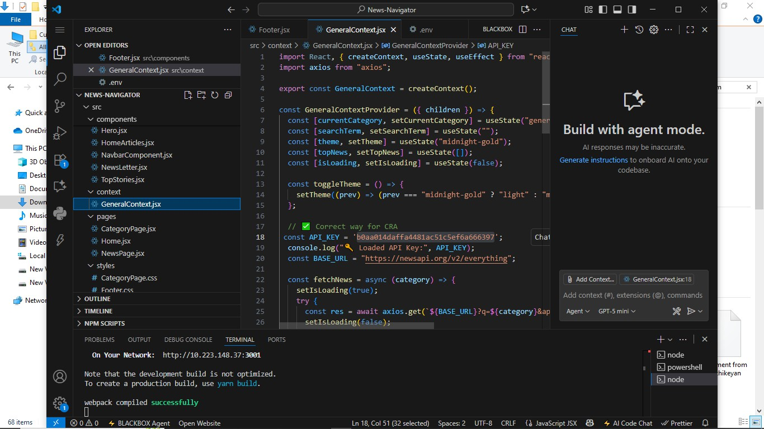

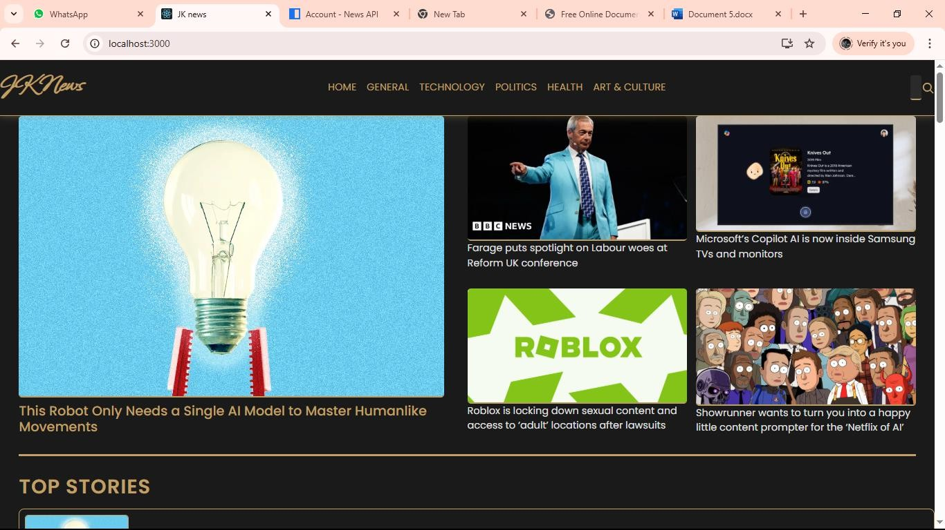

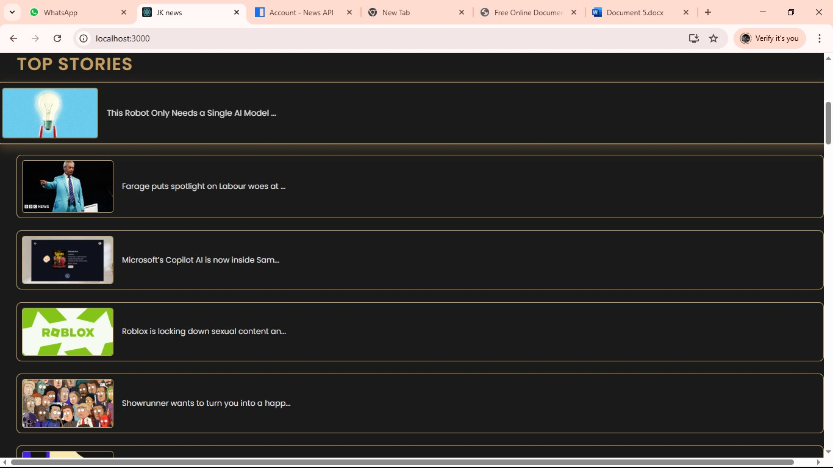

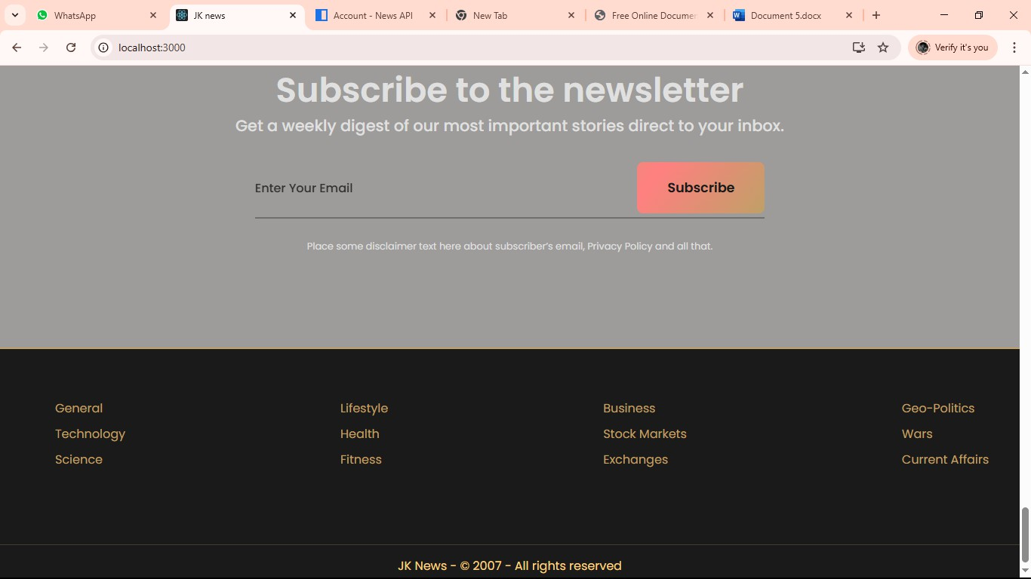

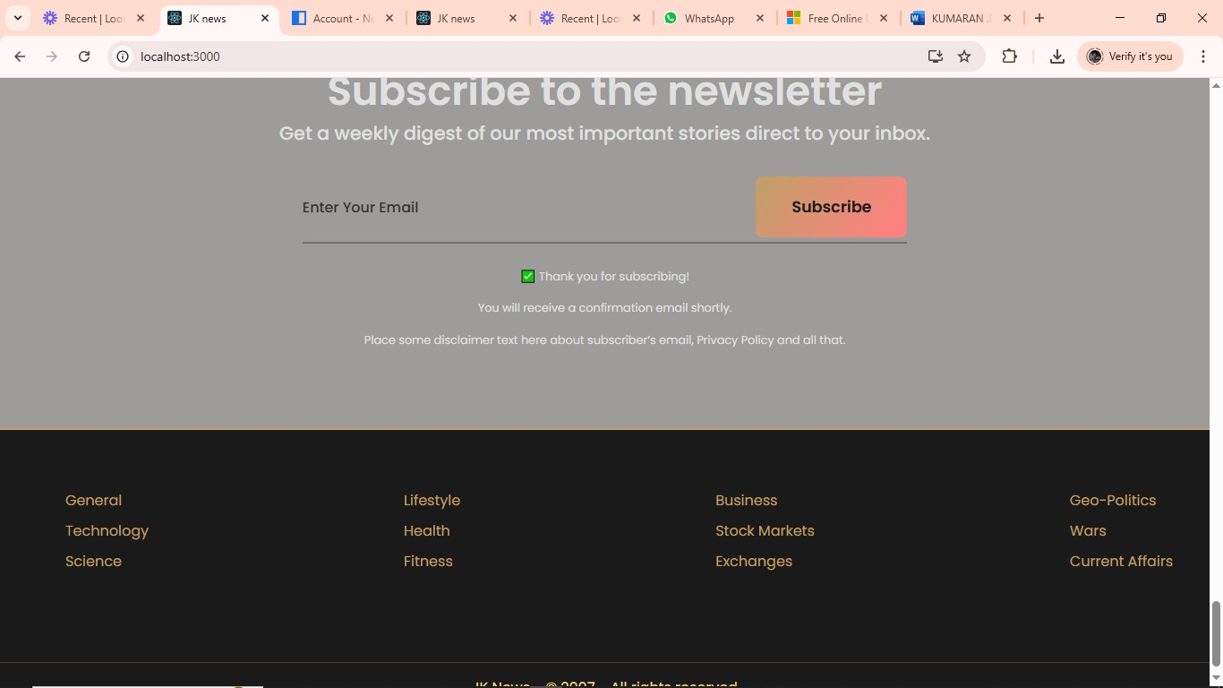

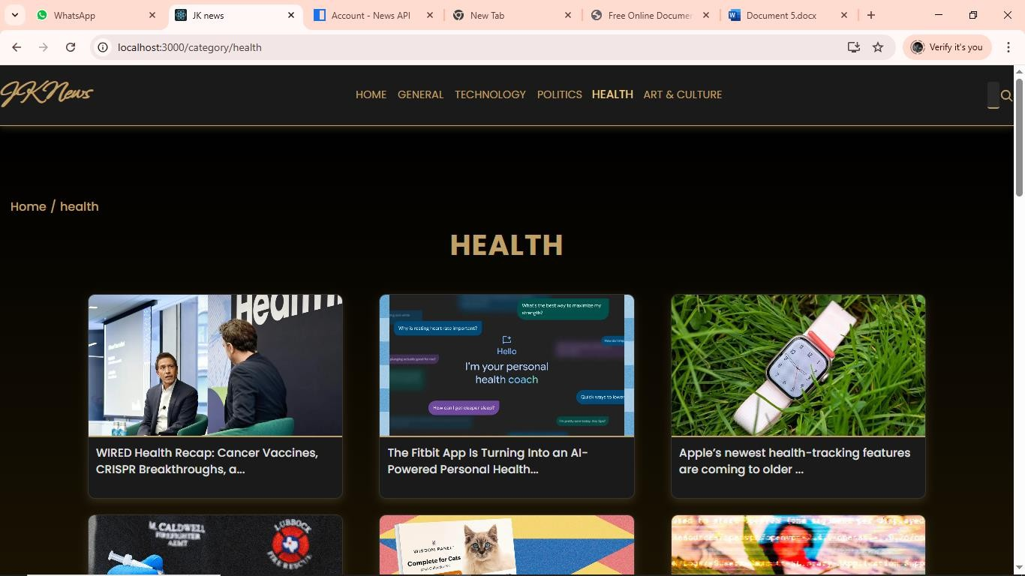

1. **KNOWNISSUES:**

The News Navigate Landscape project faces several known issues that impact its overall performanceanduserexperience.Onemajorchallengeisensuringthereliabilityandneutralityof news sources, as misinformation and bias can affect the credibility of the platform. Duplicate or near-duplicate articles from multiple outlets often clutter the feed, making it necessary to implement effective deduplication and clustering. Frequent changes in news APIs or RSS feeds can break data fetching, leading to delays in updates, which is problematic for time-sensitive content. Balancing real-time updates with efficient caching is also a technical hurdle.

Personalization introduces additional complexity, as collecting user preferences must be done carefully to respect privacy regulations. Navigation can become overwhelming if too many categories or sources are presented without clear organization, while maintaining smooth performanceacrossdevicesremainsapriority.Finally,accessibility,contentmoderation,andad placement require careful consideration to ensure an inclusive, safe, and user-friendly news experience.

Akeyconcernisensuring thecredibilityandneutralityofnewssources,astherisk of misinformation, fake news, and biased reporting can damage user trust. Another major challenge is duplicate or similar articles appearing from multiple sources, which can clutter the interface and overwhelm readers, making deduplication and clustering essential. Technical difficulties also arise due to frequent changes or downtime in news APIs and RSS feeds, which can break datafetching or causemissing content. Ensuring timely updates whilebalancing server load and caching for performance is critical for a seamless user experience. Personalization and recommendation features must be implemented carefully to deliver relevant stories without breaching privacy regulations like GDPR or CCPA. Navigation can become confusing if categories, tags, and filters are not well-structured, leading to poor discoverability of content.

Mobile responsiveness and cross-platform performance present further challenges, particularly with heavy images, videos, and infinite scrolling that can slow down page loads. Accessibility is another known issue, as visually impaired users may face difficulties if alt text, keyboard navigation, and proper contrast are not supported. Ad placement, necessary for monetization, can sometimesinterruptthereadingflowordegradeuserexperience.Additionally,contentmoderation

# KNOWNISSUES: .12

The News Navigate Landscape project faces several known issues that impact its overall performanceanduserexperience.Onemajorchallengeisensuringthereliabilityandneutralityof news sources, as misinformation and bias can affect the credibility of the platform. Duplicate or near-duplicate articles from multiple outlets often clutter the feed, making it necessary to implement effective deduplication and clustering. Frequent changes in news APIs or RSS feeds can break data fetching, leading to delays in updates, which is problematic for time-sensitive content. Balancing real-time updates with efficient caching is also a technical hurdle.

Personalization introduces additional complexity, as collecting user preferences must be done carefully to respect privacy regulations. Navigation can become overwhelming if too many categories or sources are presented without clear organization, while maintaining smooth performanceacrossdevicesremainsapriority.Finally,accessibility,contentmoderation,andad placement require careful consideration to ensure an inclusive, safe, and user-friendly news experience.

Akey concern is ensuring thecredibility and neutrality of news sources, as therisk of misinformation, fake news, and biased reporting can damage user trust. Another major challenge is duplicate or similar articles appearing from multiple sources, which can clutter the interface and overwhelm readers, making deduplication and clustering essential. Technical difficultiesalsoariseduetofrequentchangesordowntimeinnewsAPIsandRSSfeeds,whichcan break datafetching or cause missing content. Ensuring timely updates whilebalancing server load and caching for performance is critical for a seamless user experience. Personalization and recommendation features must be implemented carefully to deliver relevant stories without breaching privacy regulations like GDPR or CCPA. Navigation can become confusing if categories, tags, and filters are not well-structured, leading to poor discoverability of content.

Mobile responsiveness and cross-platform performance present further challenges, particularly with heavy images, videos, and infinite scrolling that can slow down page loads. Accessibility is another known issue, as visually impaired users may face difficulties if alt text, keyboard navigation, and proper contrast are not supported. Ad placement, necessary for monetization, can sometimesinterruptthereadingflowordegradeuserexperience.Additionally,contentmoderation

remains a constant requirement to filter harmful, offensive, or inappropriate material, while maintaining abalanceto avoidunnecessarycensorship.Securityrisks,suchasmaliciouslinksin news feeds, also need to be addressed to protect users from phishing or malware. Finally, scalabilityandhigh-traffichandlingarecriticalchallengesasnewstrafficcanspikeunexpectedly during breaking events, requiring robust backend infrastructure to prevent downtime.

# 13.FUTUREENHANCEMENTS

In the future, the News Navigate Landscape project can be improved with several enhancements to increase usability, performance, and engagement. AI-driven personalization can be implemented to provide users with more relevant and diverse news recommendations while maintaining user privacy through anonymized data handling. Advanced article clustering and summarization techniques, powered by natural language processing (NLP), could group similar news stories together and generate short summaries, saving users time. A more intuitive navigation system with smart filters, trending topics, and keyword-basedsearchcouldmake content discovery seamless.Real-time notificationsforbreaking news, along with offline reading mode, can enhance user convenience. Multi-language support and automatic translation would allow a wider audience to access global news. Improvements in accessibility, such as screenreadercompatibility,voice-basednavigation,andadjustablefontsizes,canmaketheplatformmore inclusive. Integration with social media sharing, bookmarking, anduser-curated collectionscould increase engagement and retention. On the technical side, better caching, load balancing, and scalable cloud infrastructure can ensure faster updates and smooth performance even during high-traffic events.

StrongercontentmoderationpoweredbyAIcanbeintroducedtofilterharmfulormisleadinginformation without human bias. Finally, introducing monetization options such as ad-free subscriptions, sponsored content, or affiliate links can make the platform financially sustainable without compromising the user experience.

AI-driven personalization can be implemented to provide users with more relevant and diverse news recommendations while maintaining user privacy through anonymized data handling. Advanced article clustering and summarization techniques, powered by natural language processing (NLP), could group similar news stories together and generate short summaries, saving users time. A more intuitive navigation system with smart filters, trending topics, and keyword-based search could make content discovery seamless. Real-time notifications for breaking news, along with offline reading mode, can enhance user convenience. Multi-language support and automatic translation would allow a wider audiencetoaccessglobalnews.Improvementsinaccessibility,suchasscreenreadercompatibility,voice- basednavigation,andadjustablefontsizes,canmaketheplatformmoreinclusive.Integrationwithsocial mediasharing,bookmarking,anduser-curatedcollectionscouldincreaseengagementandretention.On the technical side, better caching, load balancing, and scalable cloud infrastructure can ensure faster updatesandsmoothperformanceevenduringhigh-trafficevents.Strongercontentmoderationpowered by AI can be introduced to filter harmful or misleading information without human bias. Finally, introducing monetization options such as ad-free subscriptions, sponsored content, or affiliate links can make the platform financially sustainable without compromising the user experience.

# 13:CONCLUSION

**To navigate the modern news landscape, a combination of technological adoption, critical thinking, and collaborative educationisessentialforbothjournalistsandnewsconsumers.By prioritizing authenticity, adapting to digital platforms, and fostering criticalmedia literacy,society can remain informed and resilient in an age of information overload and rapid change.**