Task 1
A Lambda function nadiia_diachenko_json_parser was created (Python 3.14, execution role dilab-lambda-sf-role)
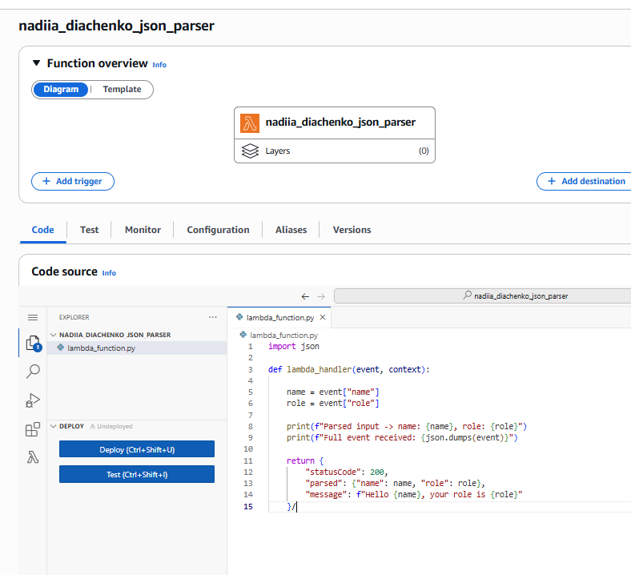
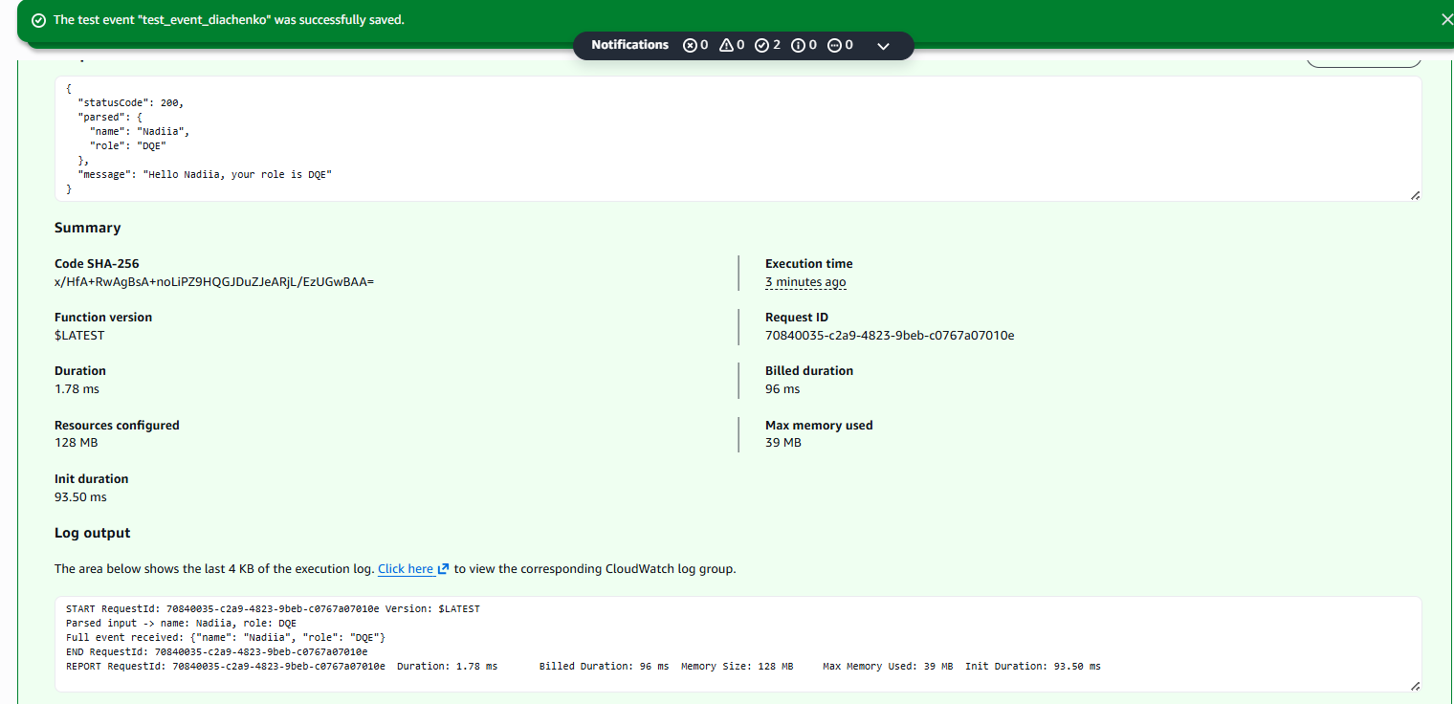
Task 2
Standard Step Function that invokes two Lambda functions. The tested table is the S3 object task07_test_data.json in the bucket nadiia-diachenko-dwh-bucket. Both Lambdas run inside the VPC, subnets and security group copied from dq_lambda_example, with the execution role dilab-lambda-sf-role.
nadiia_diachenko_task2_test reads the file from S3 with boto3, compares the status value against an expected_status supplied in its input, and returns {"test_passed": true/false}. The same function serves both the first and third steps: the Step Function passes "OLD" for the first test and "NEW" for the second, so no separate third Lambda is required.
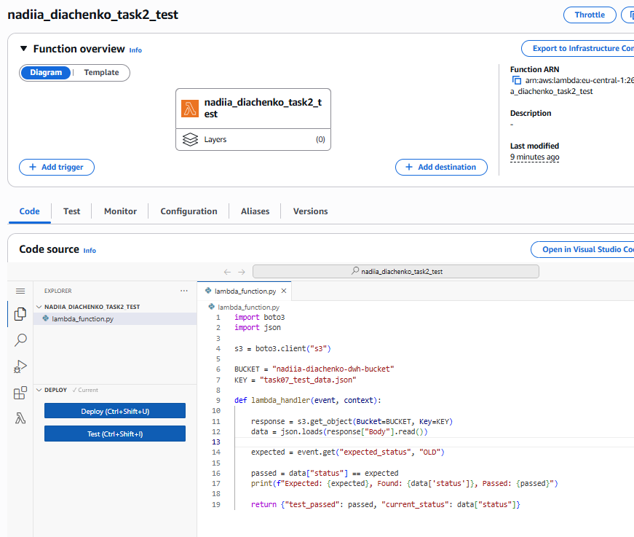

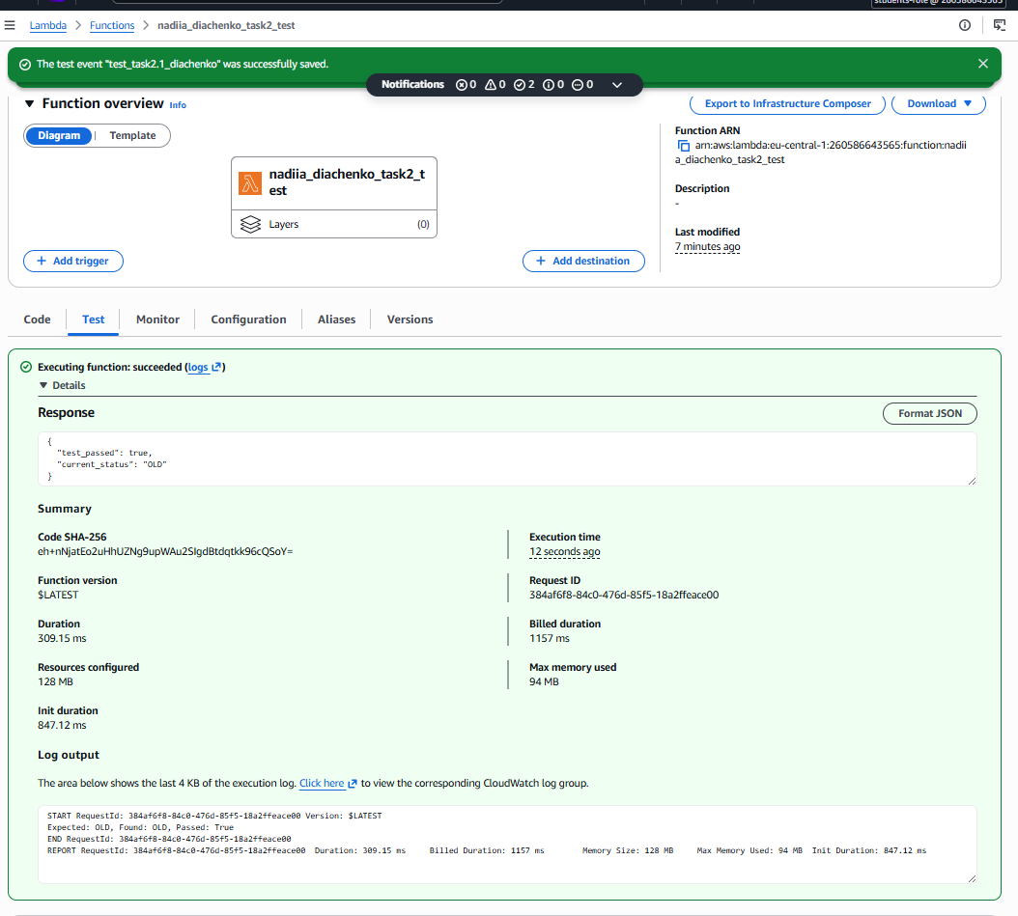

nadiia_diachenko_task2_change reads the same file, changes the status value, and writes the file back to S3 .
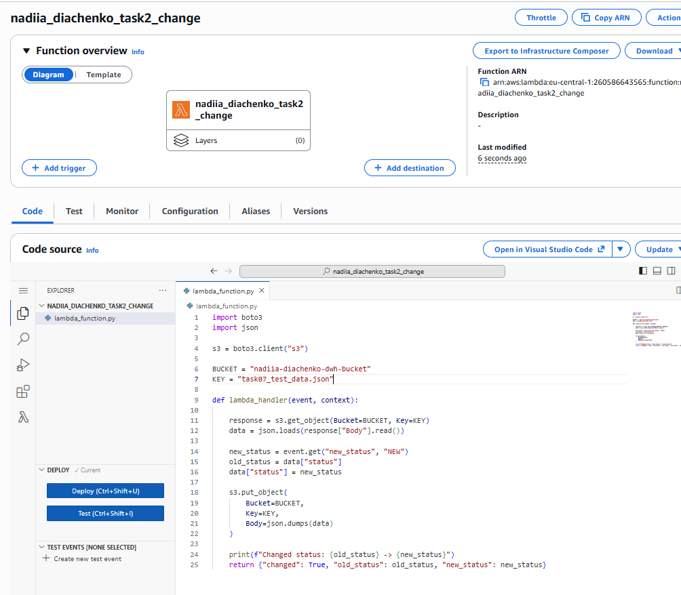

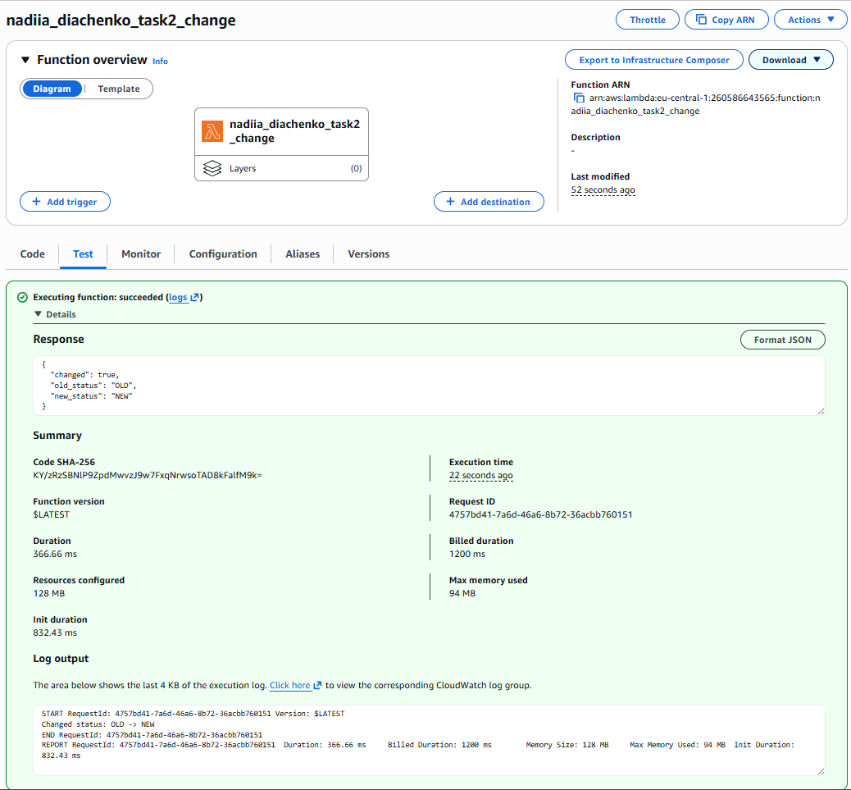

The state machine nadiia_diachenko_step_func chains: Test1 → Choice → ChangeData → Test2 → Choice, ending in Succeed or Fail. The flow reaches the Succeed state only when both the first and the second test pass; failing either test diverts to the shared Fail state.
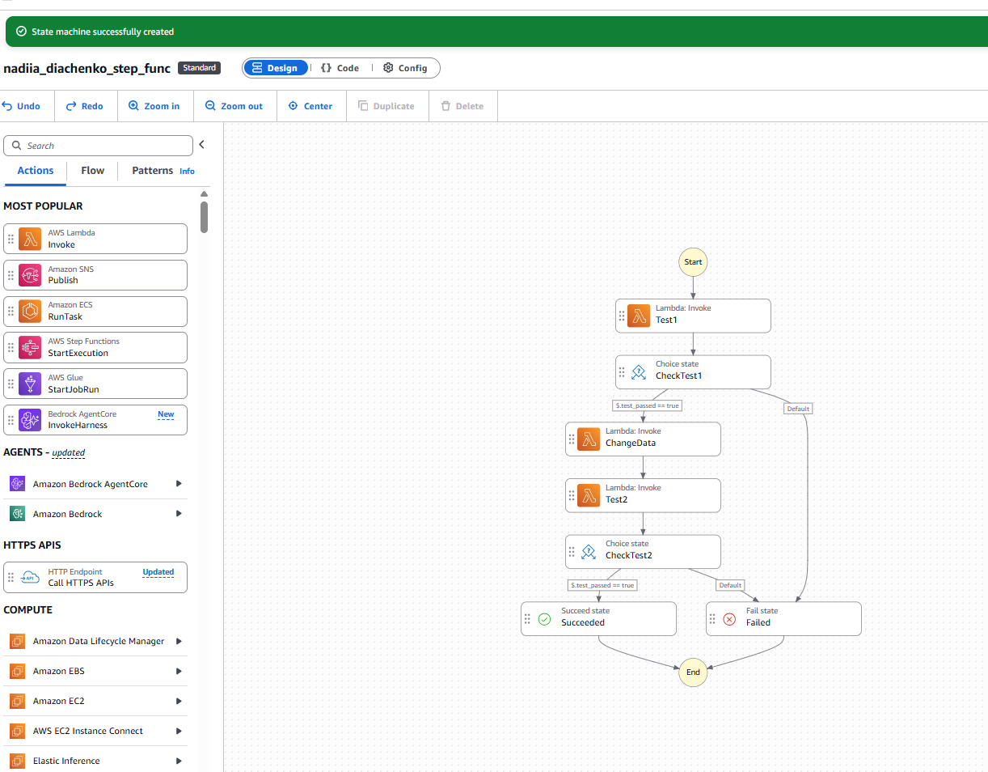

Executions
A successful run (file starting at "OLD") passes both tests and completes with status Succeeded. A second run started while the file was already "NEW" fails the first test and is routed to the Fail state, which demonstrates the "otherwise the Step Function fails" requirement.
