Test Result Report

1. Summary
This report summarises the data-quality test execution performed against the built data warehouse (dwh_hw_db) and its dimensional mart, covering the SRC→LND reconciliation and the DWH / DM test-case execution.
All 26 TestRail cases from the Task 2 export were executed: 14 passed, 8 failed, 3 not applicable to the implemented architecture, and 1 was a duplicate. SRC→LND reconciliation was run across all 8 source-to-landing table pairs (two of which were clean). 16 defects were logged in Jira (Epic DQ26-1692, DWH_ prefix), including 2 Critical.
The two Critical defects — ~39% of sales rows missing from dm_main_dashboard (DQ26-2197), and an incorrect VALID_TO placeholder affecting all 700 S1 clients (DQ26-2243) — block reliable downstream reporting. The mart should not be released for BI consumption until both are fixed. Three findings remain open for follow-up (see Recommendations).

2. Test team
Name | Role | Responsibility
Nadiia Diachenko | Student | Test design; SRC→LND reconciliation (SQL + Python); DWH / DM test-case execution; defect reporting.

3. Testing process description
Environment: PostgreSQL, Windows. Tools: DBeaver (SQL), Python 3.13 (pandas / sqlalchemy) in PyCharm, Jira (defect tracking).
Part 1 — SRC→LND reconciliation. Performed via PostgreSQL dblink, comparing every source table against its Landing counterpart; problem rows only are stored in lnd.reconciliation_results. A parallel Python implementation (Python_reconciliation.ipynb, pandas / sqlalchemy) reproduced matching results, cross-validating the SQL approach.
Part 2 — DWH / DM test-case execution. All 26 TestRail cases were executed against the implemented schema (dwh.*, dm.*). Cases originally authored with placeholder schema / table / column names were adapted to the actual implementation; cases referencing objects absent from the implemented design were marked N/A with justification rather than counted as failures.

4. New defects statistics
16 defects were logged during this reporting period. Breakdown by severity and by priority:
Critical | Major | Minor | Trivial
2 | 7 | 5 | 2

High priority | Medium priority | Low priority
4 | 5 | 7
Test-case execution outcome: 14 Pass, 8 Fail, 3 N/A, 1 Duplicate (26 total).
Note on status. All 16 defects are at status Submitted → In Progress (logged by the DQE; no developer fix cycle has occurred yet), so a Status × Severity matrix would collapse to a single row and is not meaningful for this period. Severity and priority breakdowns are shown instead.

5. New defects list
All defects created in Jira under Epic DQ26-1692 (DWH_ prefix), moved to In Progress, assigned to self. Priority (business urgency) is assessed independently from severity (technical impact).
Jira ID | Summary | Test case | Severity | Priority
DQ26-1690 | lnd_s1_channels.channellocation missing underscore (naming) | C882 | Trivial | Low
DQ26-1714 | s1_channels: channel_location corrupted with 'N/A - ' prefix (5 rows) | No test case | Major | Medium
DQ26-1728 | s1_channels: channel_name character substitution (1 row) | No test case | Minor | Low
DQ26-1736 | s1_channels: 2 rows missing from landing | C866 / C909 | Major | Medium
DQ26-2098 | s1_clients: value mismatches in last_name, phone (2 rows) | No test case | Major | Medium
DQ26-2103 | s1_sales: ~176 rows missing from landing | C866 | Major | High
DQ26-2109 | s2_client_sales: 5 rows missing from landing | C867 | Major | Medium
DQ26-2126 | s2_locations: 2 rows missing from landing | C867 | Major | Low
DQ26-2129 | s2_locations: 1 phantom row not in source | C867 | Minor | Low
DQ26-2133 | s1_products: 1 phantom row not in source | C909 | Minor | Low
DQ26-2160 | s1_clients: 11 duplicate rows (client_id 240–250) | C936 | Major | High
DQ26-2191 | dm_main_dashboard: column typo 'client_iast_name' | No test case | Trivial | Medium
DQ26-2197 | dm_main_dashboard: ~39% of sales rows missing (9,335 rows) | C910 / C1017 | Critical | High
DQ26-2219 | Field-level type/width/precision/naming deviations (4, consolidated) | C995 | Minor | Low
DQ26-2243 | dwh_clients: valid_to=2000-01-01 instead of 2100-01-01 (all 700 S1) | C1005 / C1004 | Critical | High
DQ26-2257 | dwh_locations row count does not match combined Landing count | C909 | Minor | Low

6. Recommendations
- Do not release the dimensional mart for BI / reporting until the two Critical defects are resolved: DQ26-2197 (~39% of sales rows missing from dm_main_dashboard) and DQ26-2243 (valid_to = 2000-01-01 instead of 2100-01-01 for all 700 S1 clients).
- Investigate the three open items: dwh_sales shows +181 rows vs combined Landing count (root cause blocked by a DWH date-type vs Landing text-date incompatibility); dwh_locations is short by 5 rows; 27 S2 clients show an is_valid / valid_to inconsistency not yet explained.
- Treat the landing load as a systemic issue, not per-table: reconciliation surfaced missing rows, phantom rows, prefix / character corruption and duplicates across several tables — review the SA→LND load logic rather than patching individual tables.
- File the two documented-but-unfiled findings if they need separate tracking: dwh_channels missing channel_id 156 (likely caused by the channel_location corruption, DQ26-1714), and dm_main_dashboard TOTAL_COST undervalued beyond what the missing-row count explains.
- Standardise the DWH date type against the Landing text-date storage so row-level reconciliation joins are reliable in future runs.
- Add the reconciliation queries to an automated check so row-count drift is caught on every load.

7. Attachments
Three visualisations of the testing results are included below. The Python reconciliation notebook additionally produces per-table reconciliation plots (per Visualization_examples.jpg), available as a further visual.
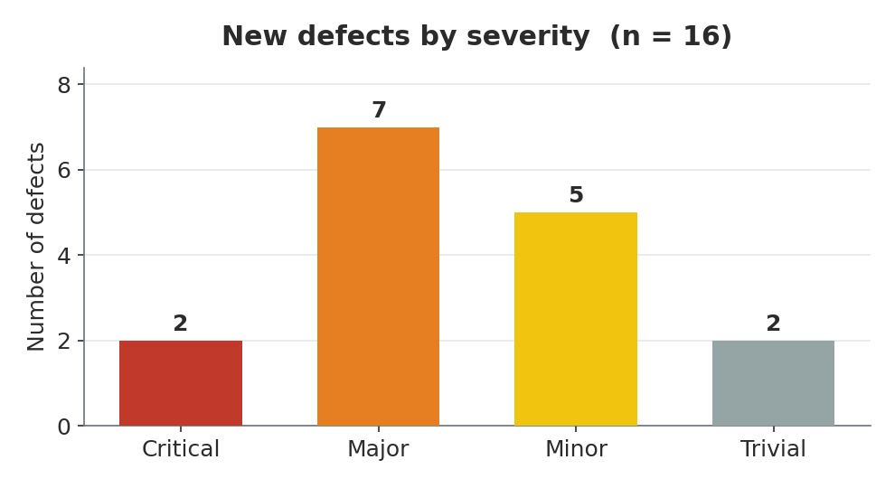
Attachment 1. New defects by severity.
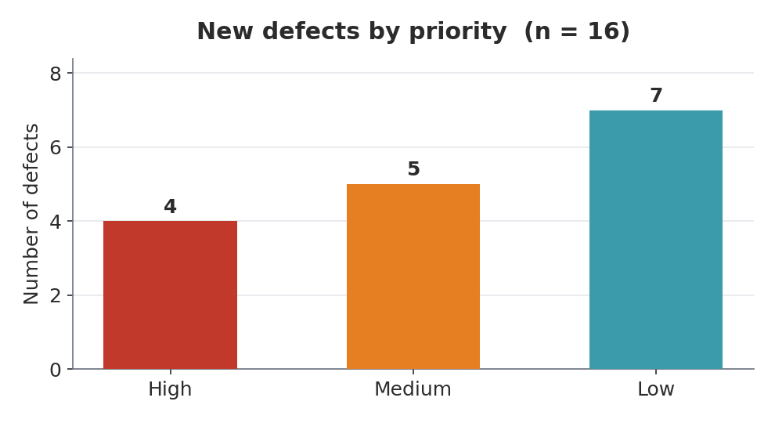
Attachment 2. New defects by priority.
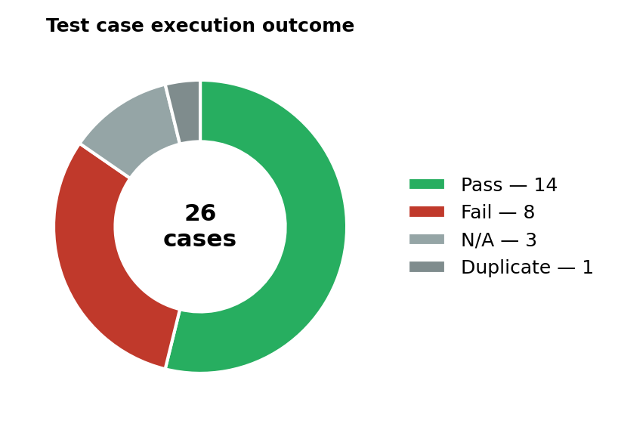
Attachment 3. Test-case execution outcome (26 cases).

