Row level security
A static, region-based RLS pattern is used with two roles. 'US Sales' filters to DimSalesTerritory United States; 'Europe Sales' filters to the UK, France, and Germany. This is static information that is youtube for such type of role.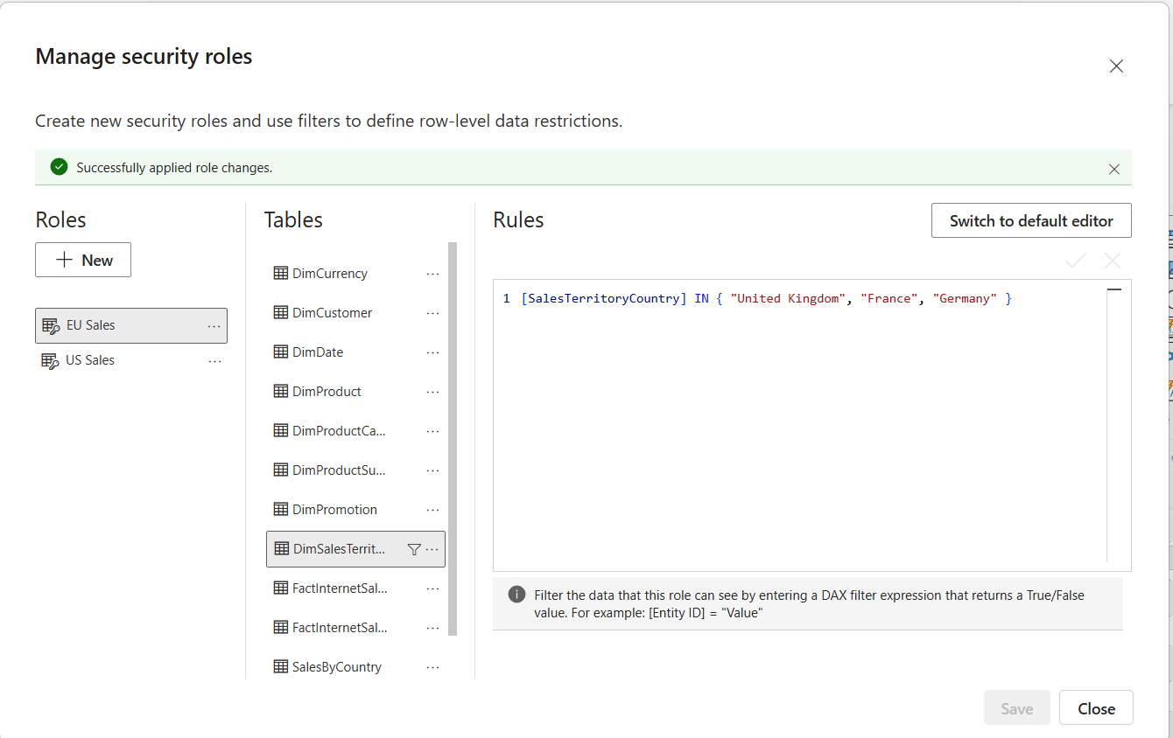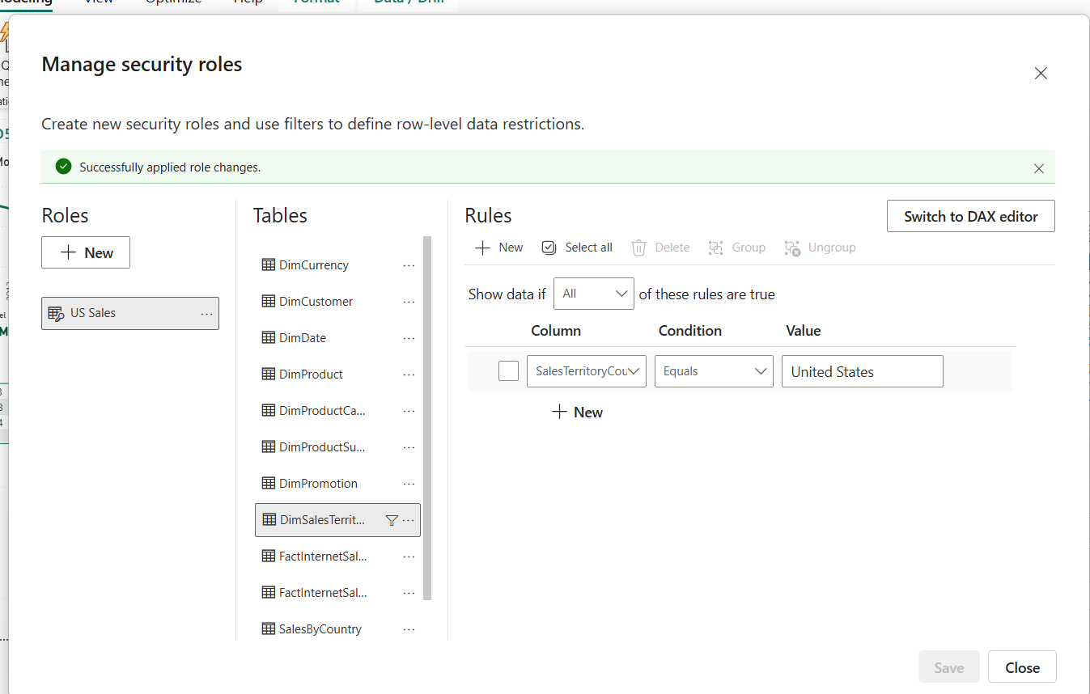
Tested: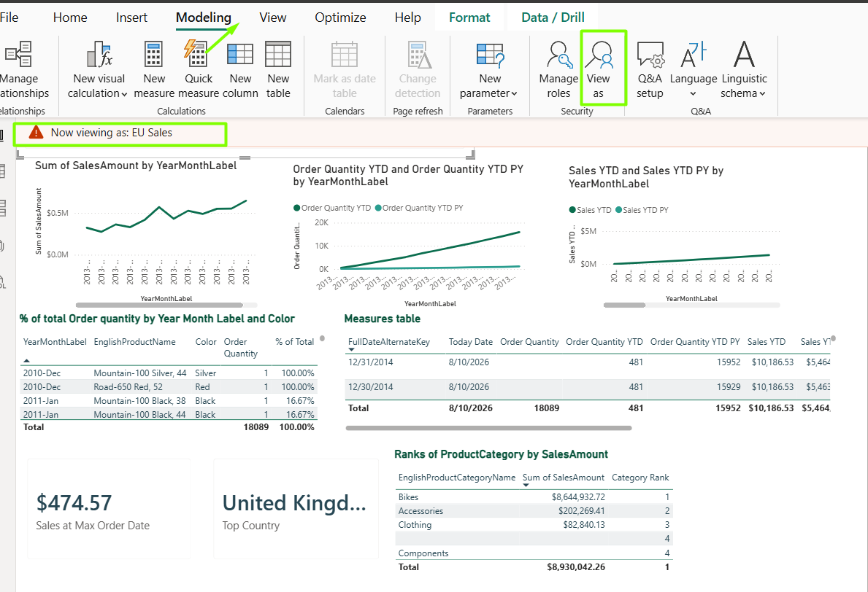

A dynamic RLS with a single 'Dynamic Security' role and a UserSecurity mapping table is created. The rule [UserEmail] = USERPRINCIPALNAME() filters the mapping table to the current user, and the relationship to DimSalesTerritory cascades that filter so each viewer sees only their assigned country's sales.
The mapping table is created and relationship is set:
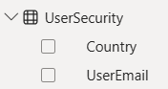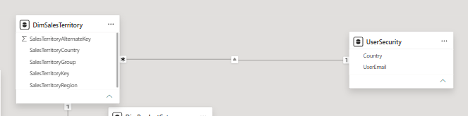
The role is added:
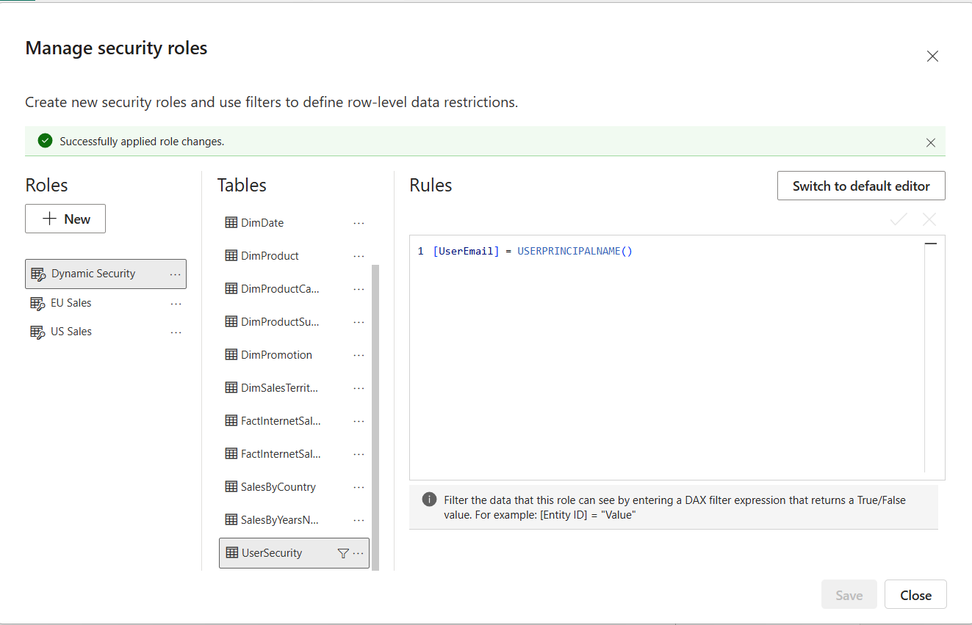
Tested:
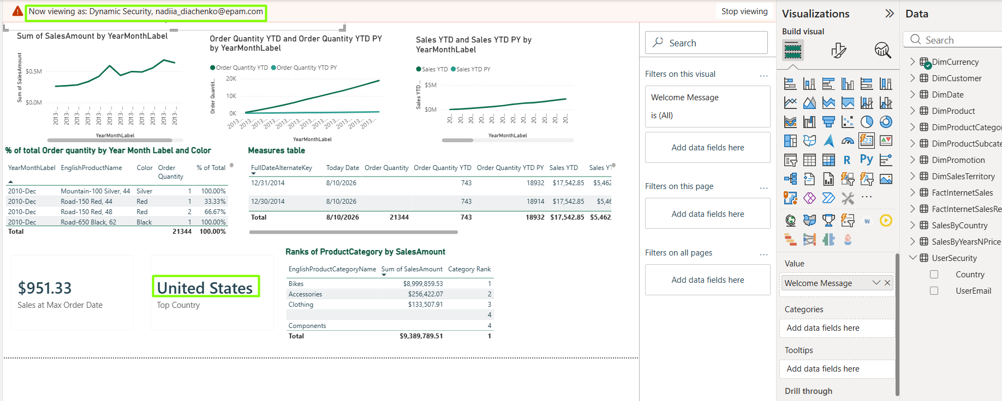

Switch between bar chart and a map visual
Bookmarks&buttons

Two visuals are added at the same place
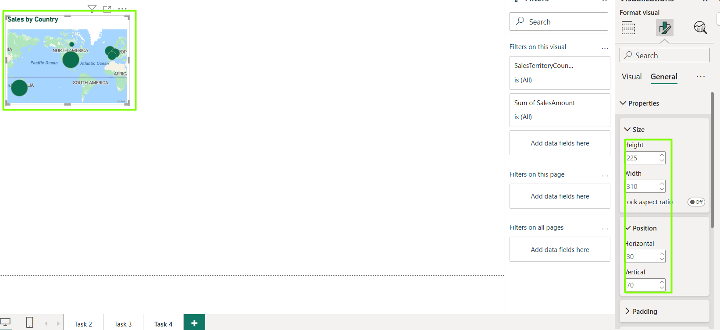
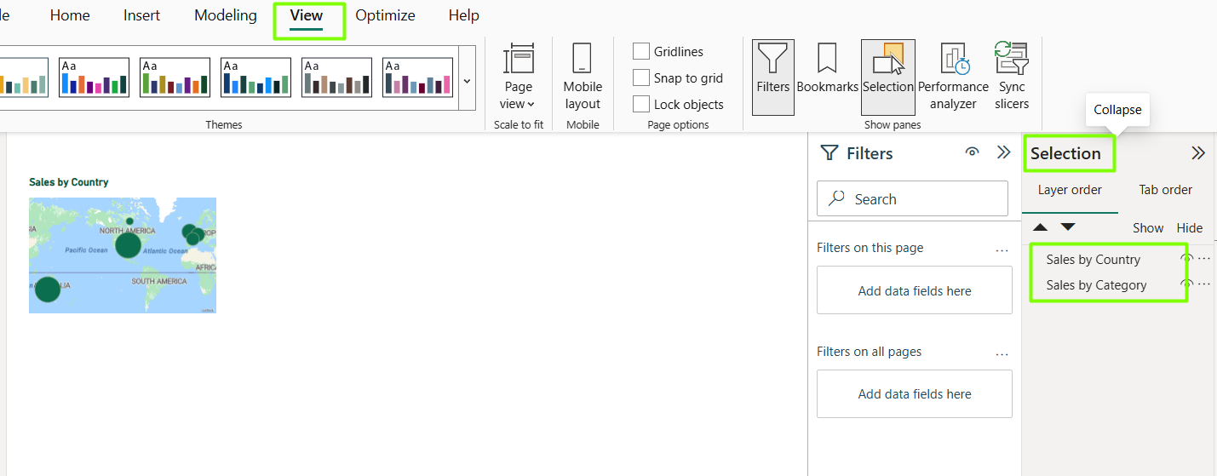
The bookmarks to show or hide map are added
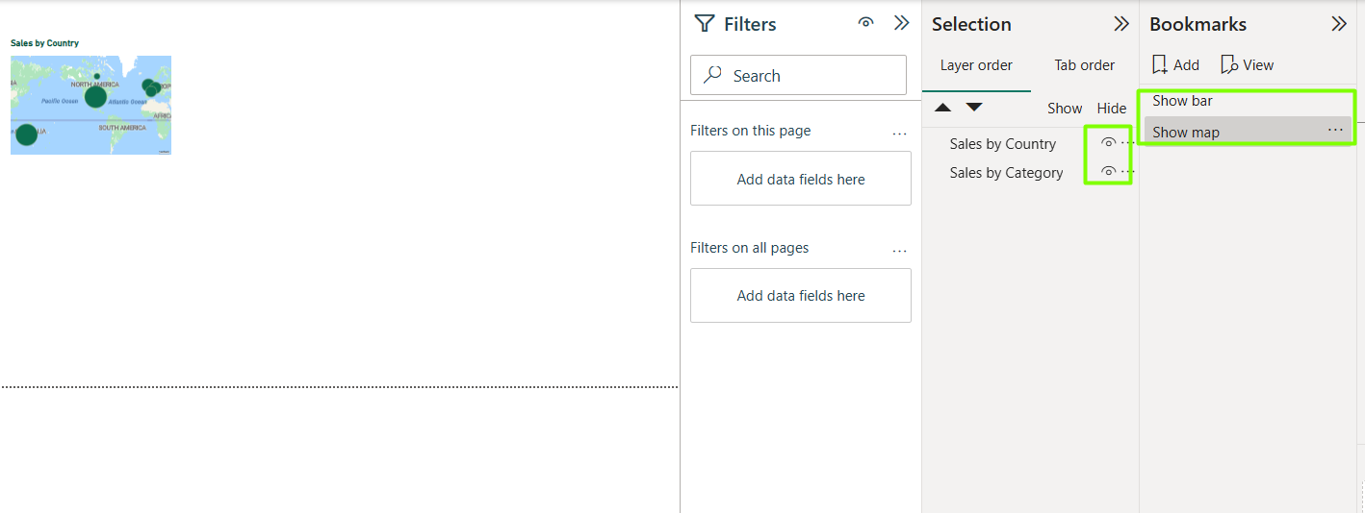

Buttons to toggle views are added
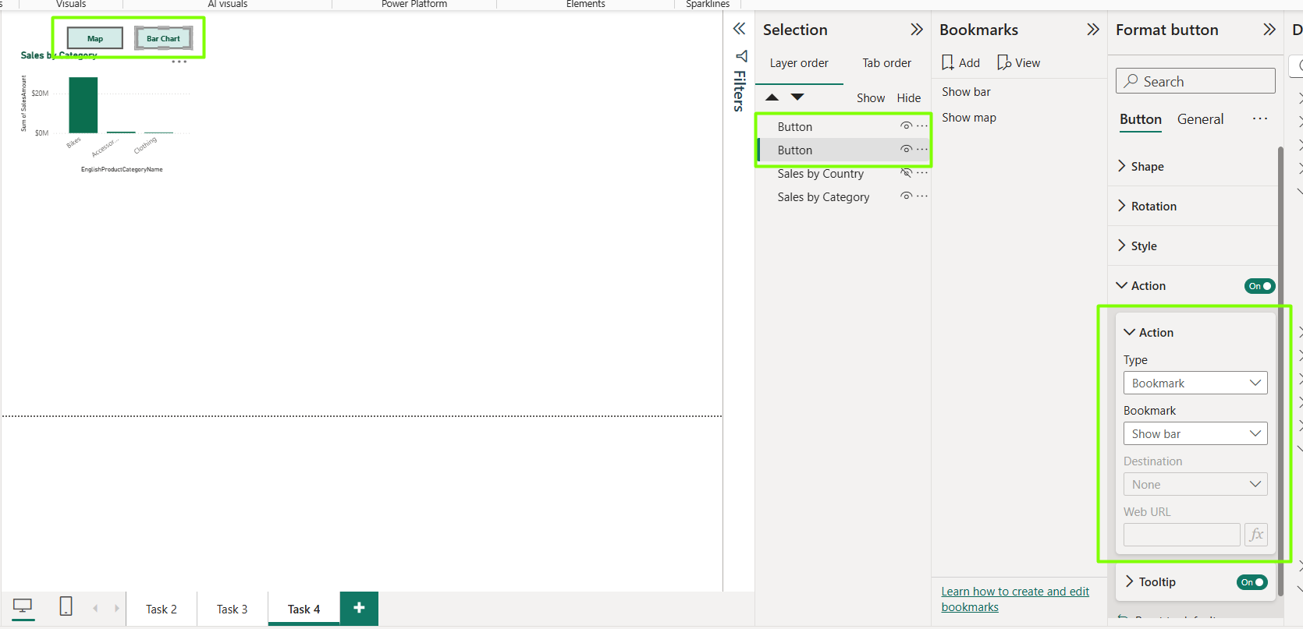

Switch between MTD / QTD / YTD
Field Parameter

A Field Parameter is used to switch between MTD, QTD, and YTD. Field parameters are built for swapping measures via an auto-generated slicer.
The measures are created
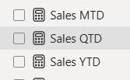
Adding field parameter
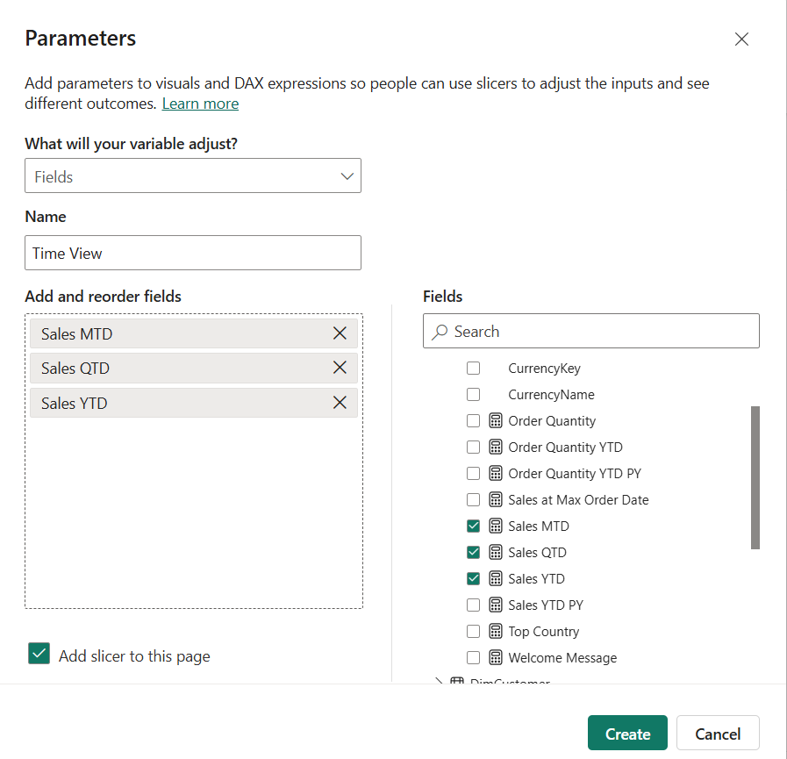
Auto-generated slicer and table are created
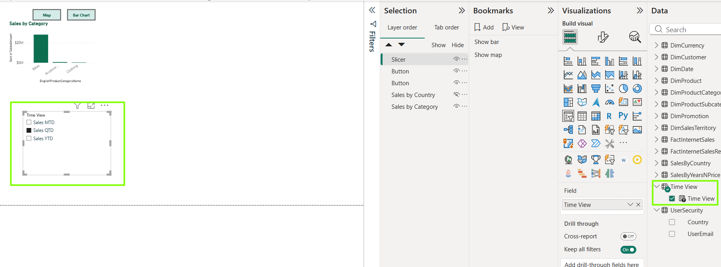
Line chart is added to demonstrate visual recalculation according to slicer option
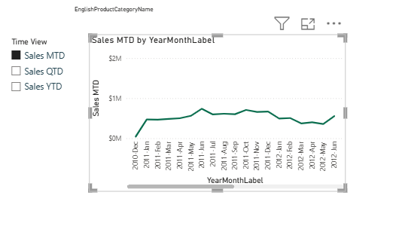

DECOMPOSITION TREE(Page: Task 4 DT)
A decomposition tree is added analyzing SalesAmount, with four 'Explain by' dimensions: Country, Product Category, Calendar Year, and Color. It is possible to drill into the total in any order to find what affects sales.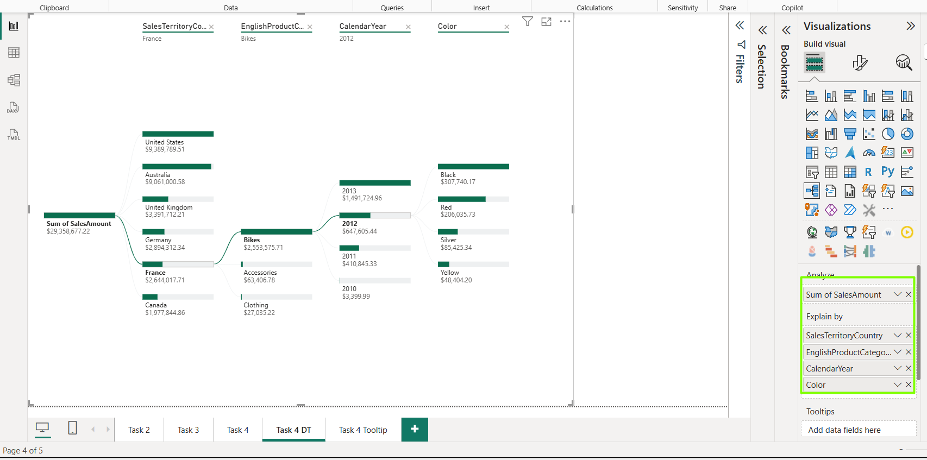

Tooltip(Page: Task 4 Tooltip)
The tooltip page containing a Card visual is added. It assigned to the Sales by Category visual (Page: Task 4). On hover, the custom tooltip appears filtered to the hovered category.
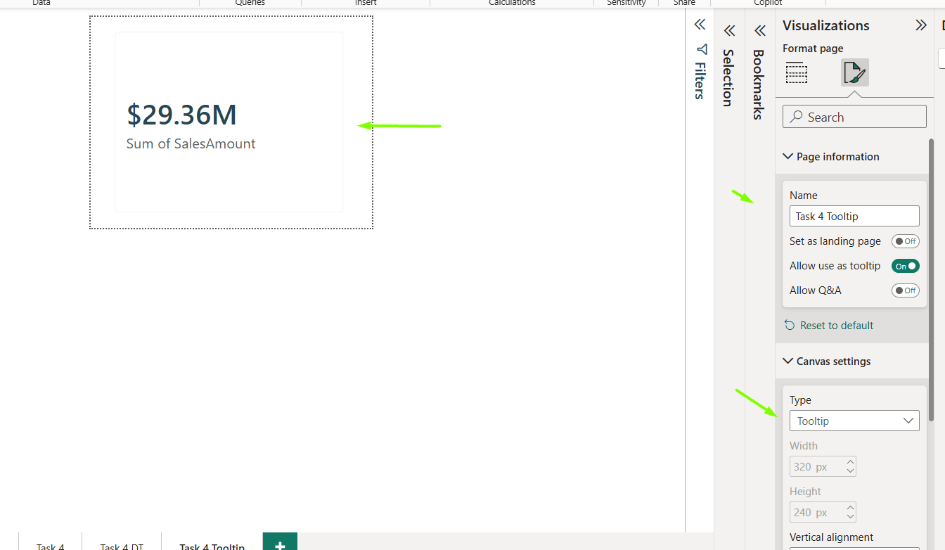

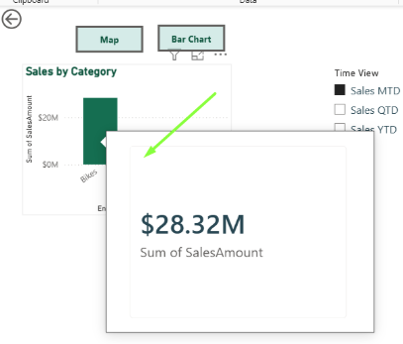

Custom visual

The Line and Clustered Column chart, plotting SalesAmount as columns and Order Quantity as a line on a shared CalendarYear axis, with a separate secondary axis for the line is added.Conditional formatting used(colors, markers, etc.).
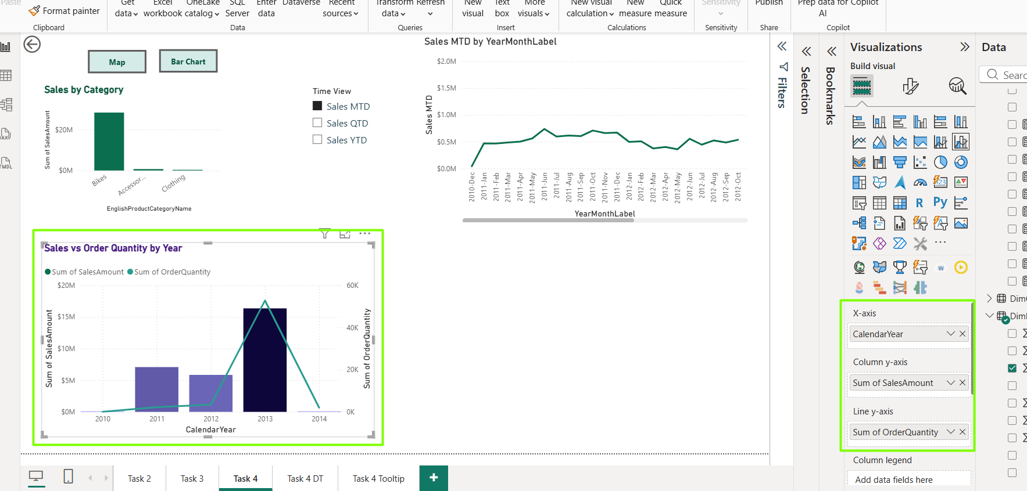
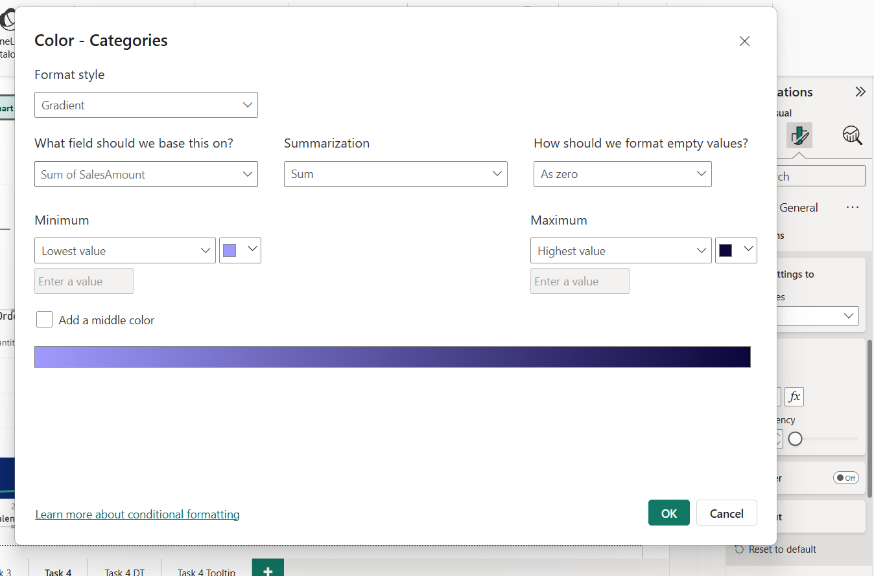

PARAMETERS FOR DATA SOURCE

The parameter is added
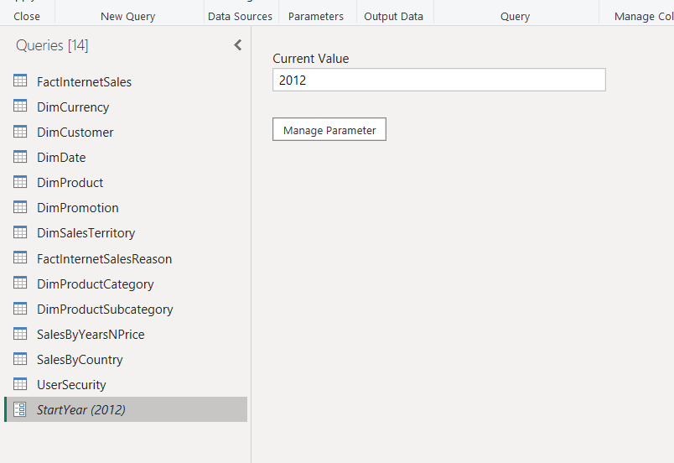
The Calendar Year is filtered by parameter
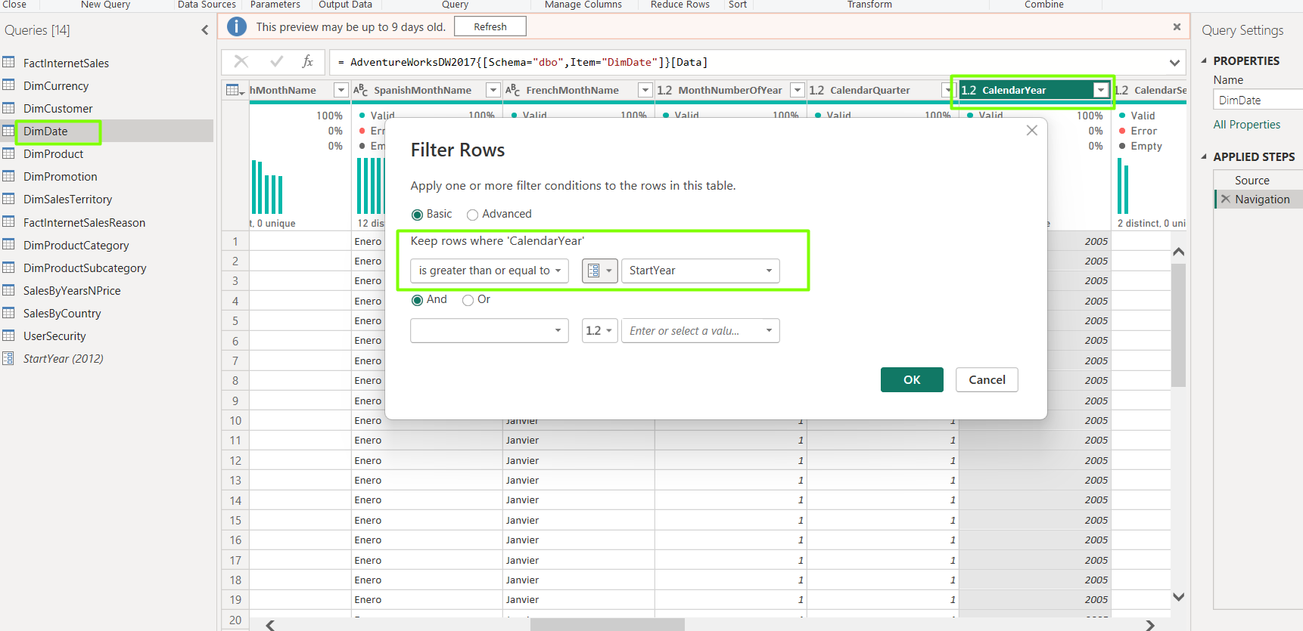

Visuals are updated correspondingly

