1. Creating simple DAX Expressions

Calculated column

The Calculated Column “Year Month Label” is created
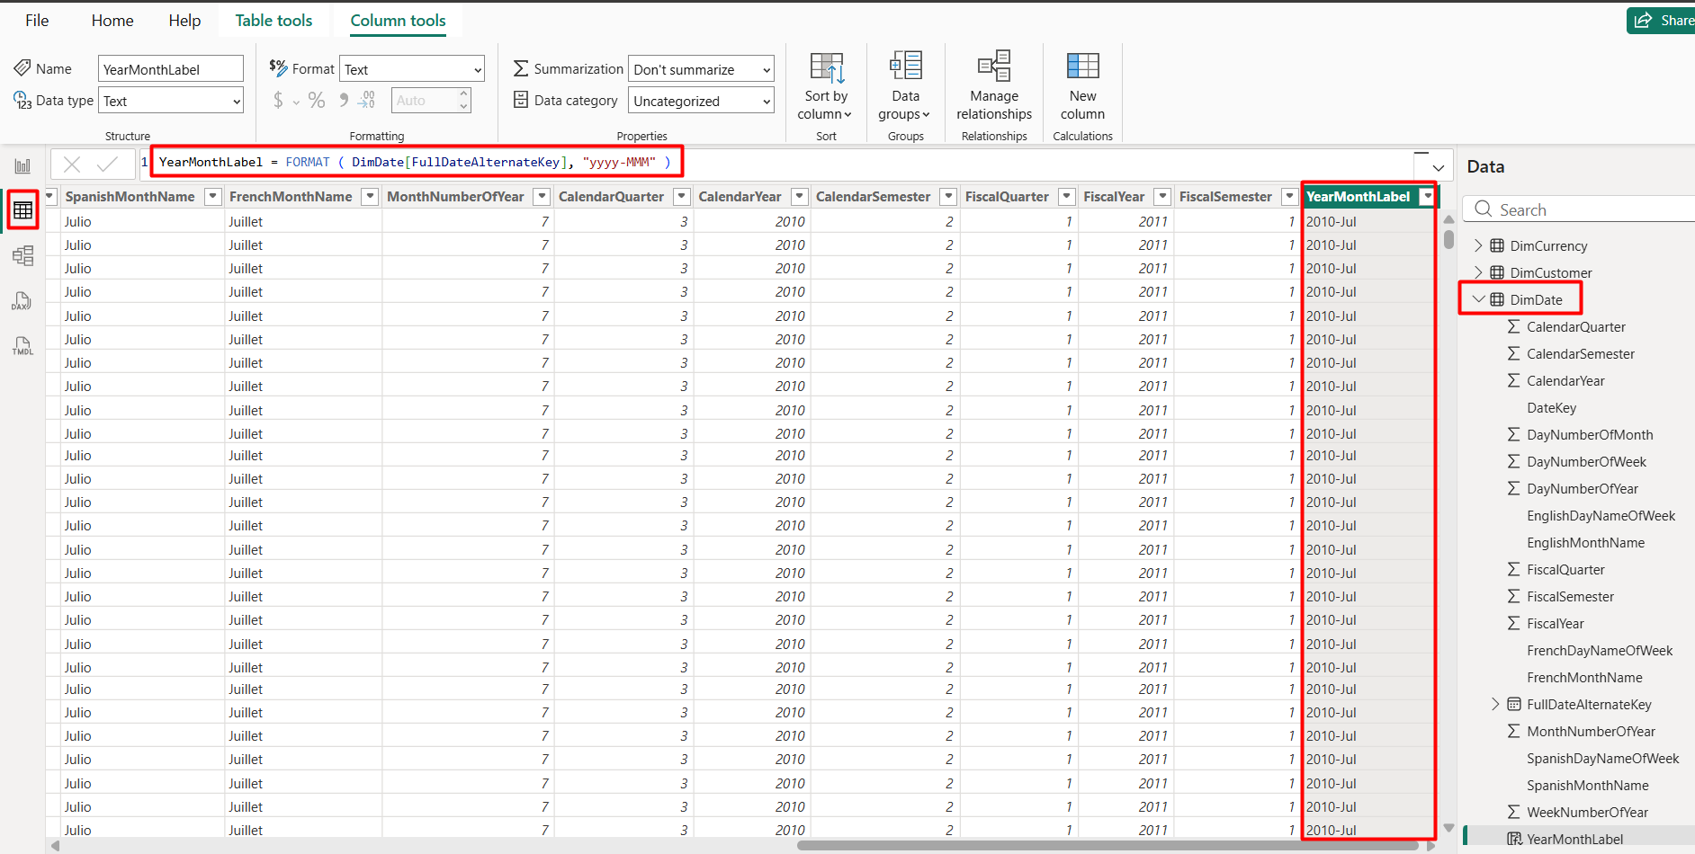

The new Year Month Label column is used as X-axis for line chart

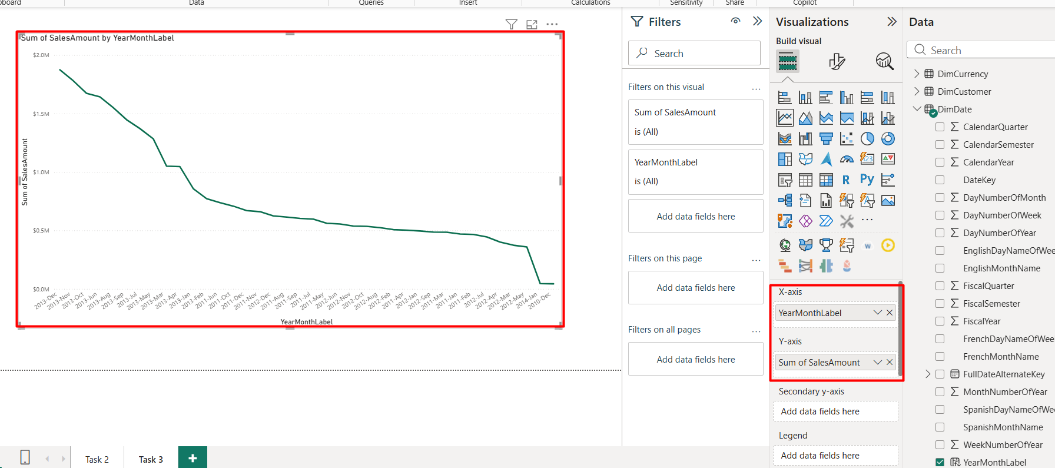

The line chart is filtered by calendar year
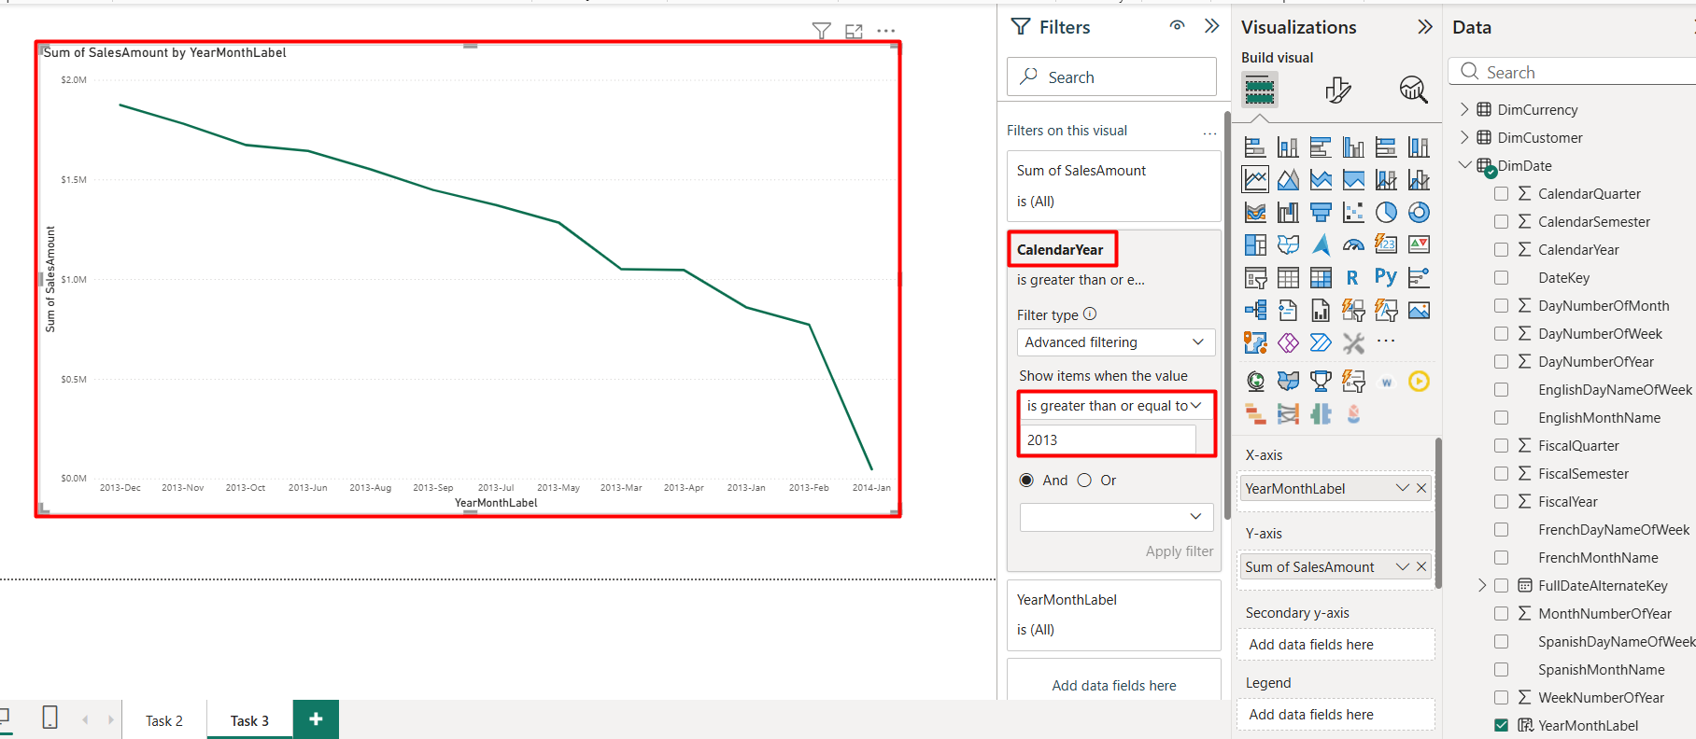

To display the alphabetic order instead of historical order the new YearMonthSort column was created and YearMonthLabel is sorted it
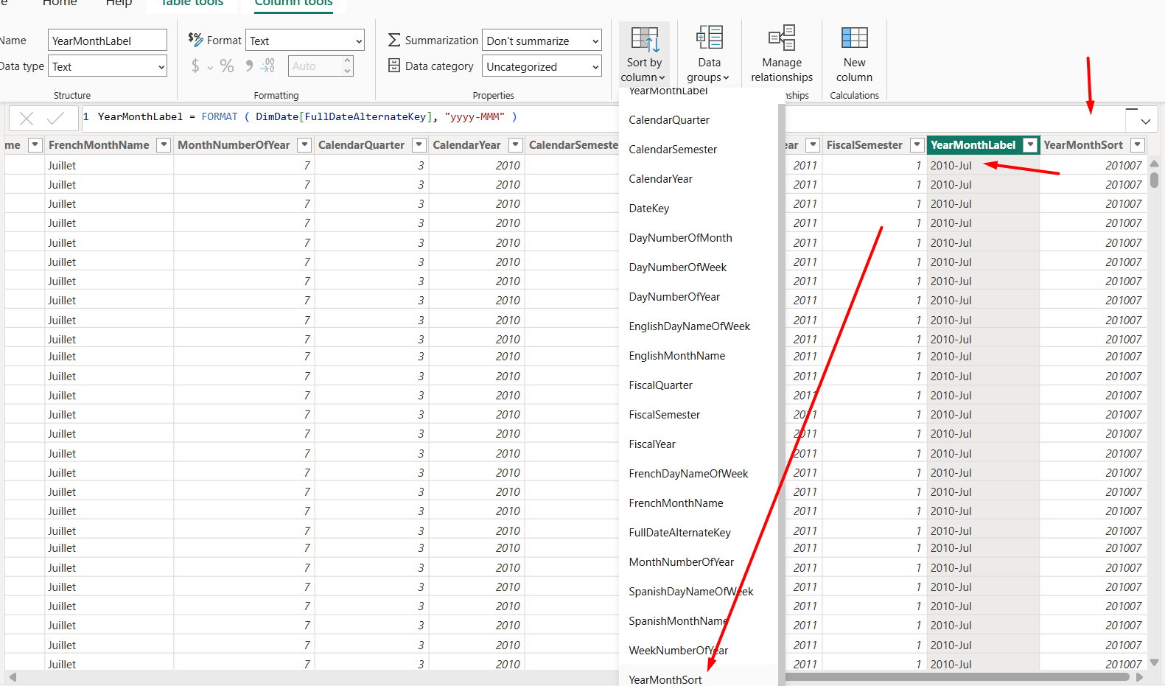
The correction is reflected on report view
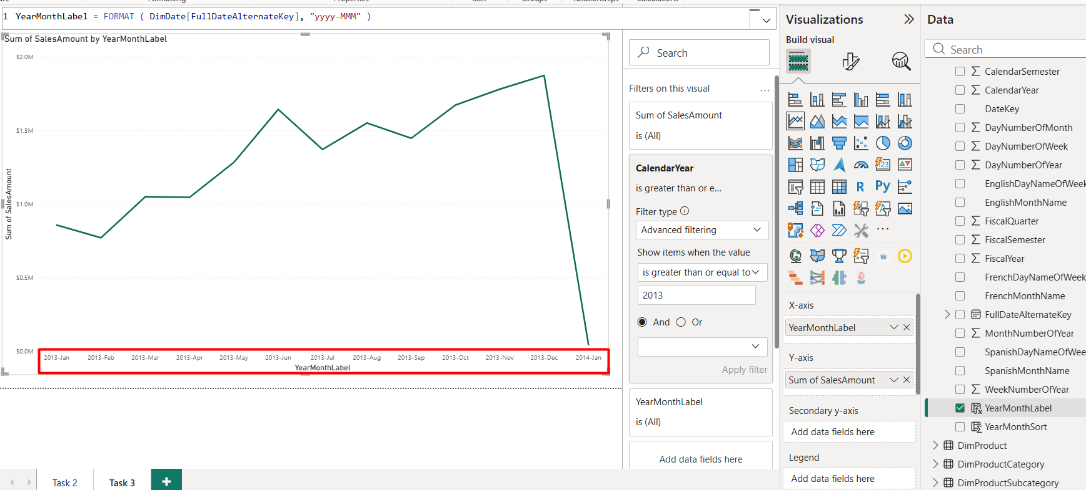

Measure

A new TodayDate measure is created
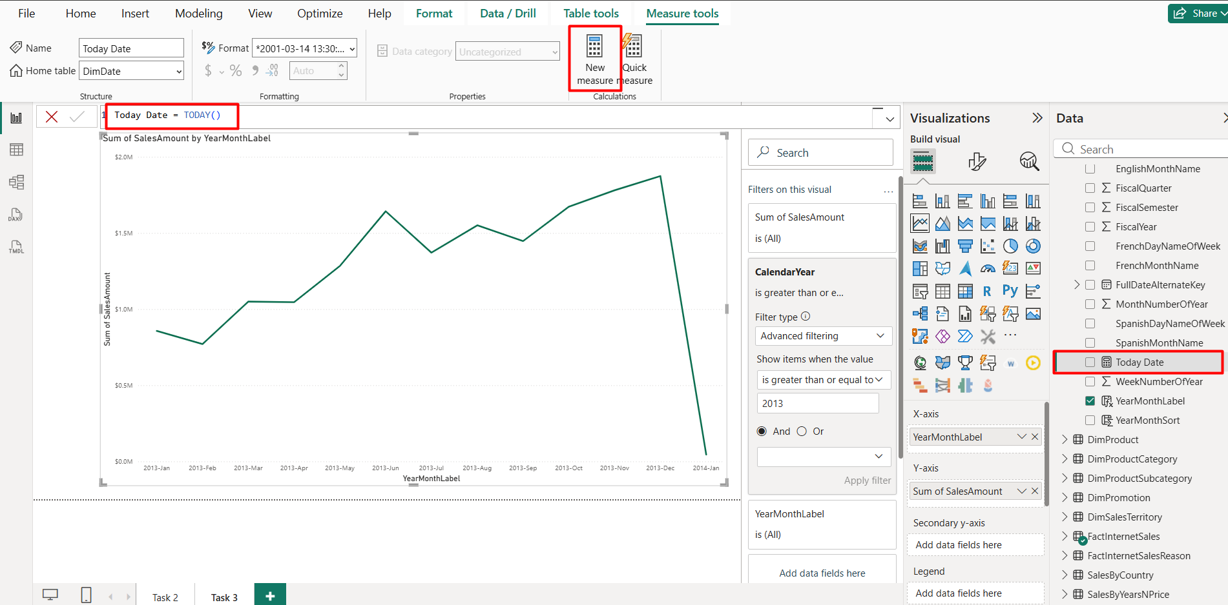

The car visualization is added
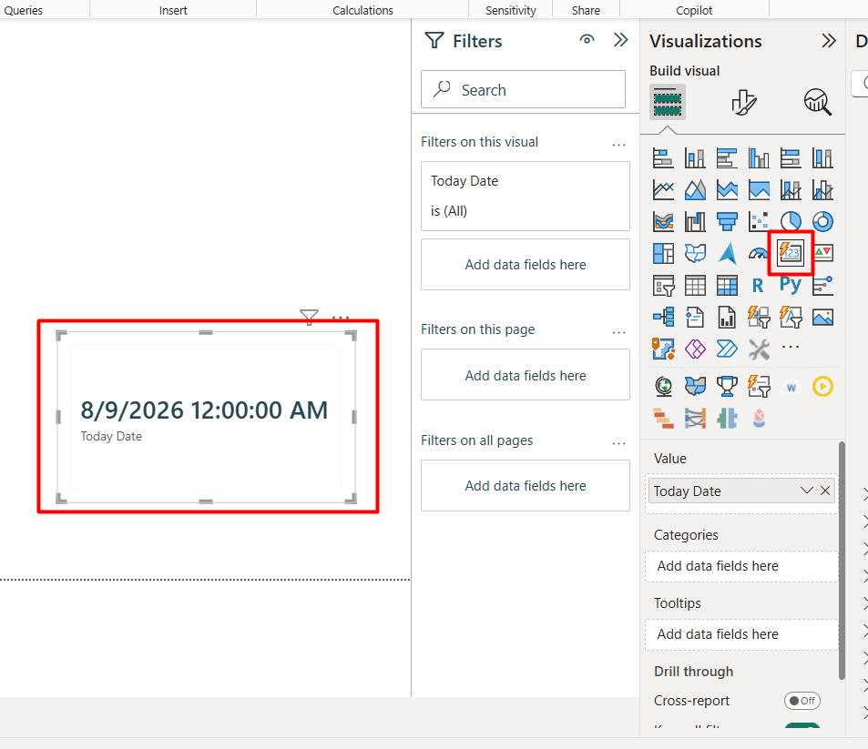
The date format is changed to a shorter one
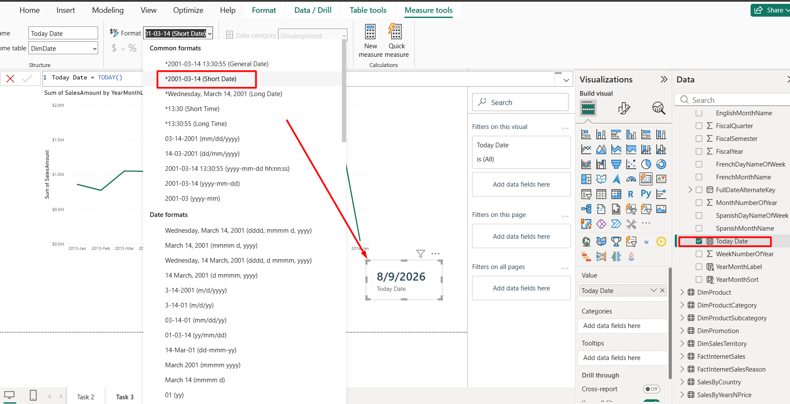

The today’s date is put as a footer in the report
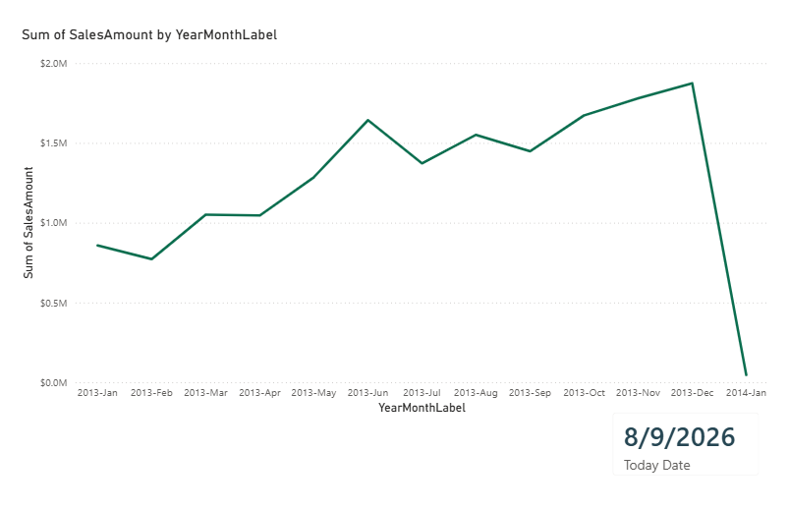
The second (DAX measure) is added
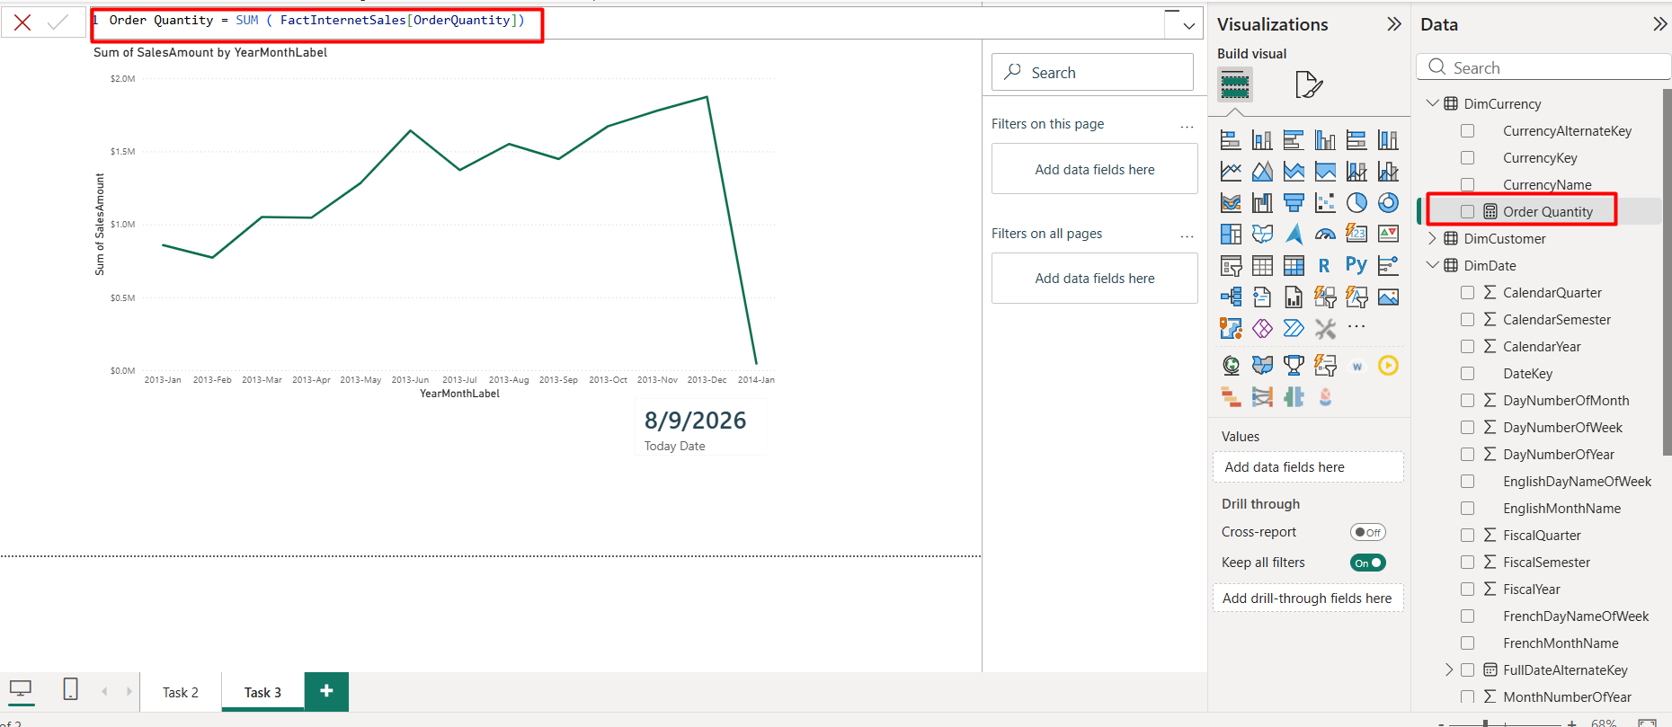

A table visualization with a date column to track the measures is created
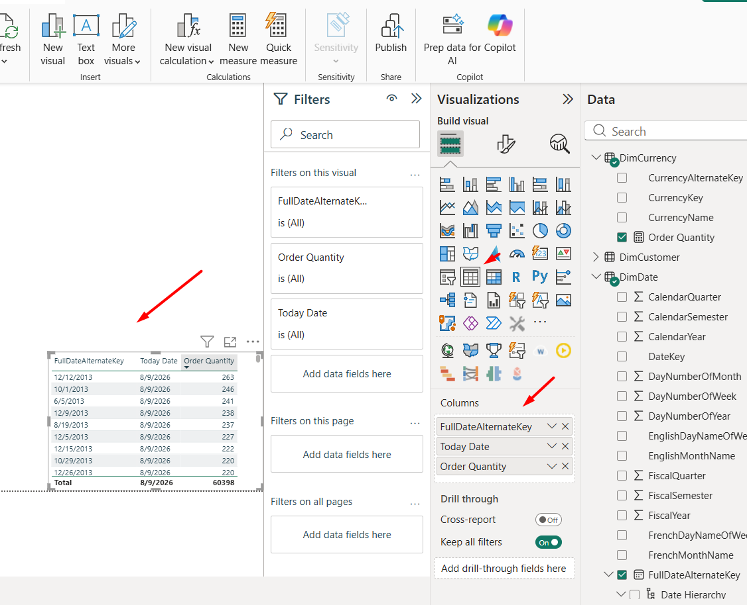
A new cumulative Order Quantity measure is created and added to tracking table
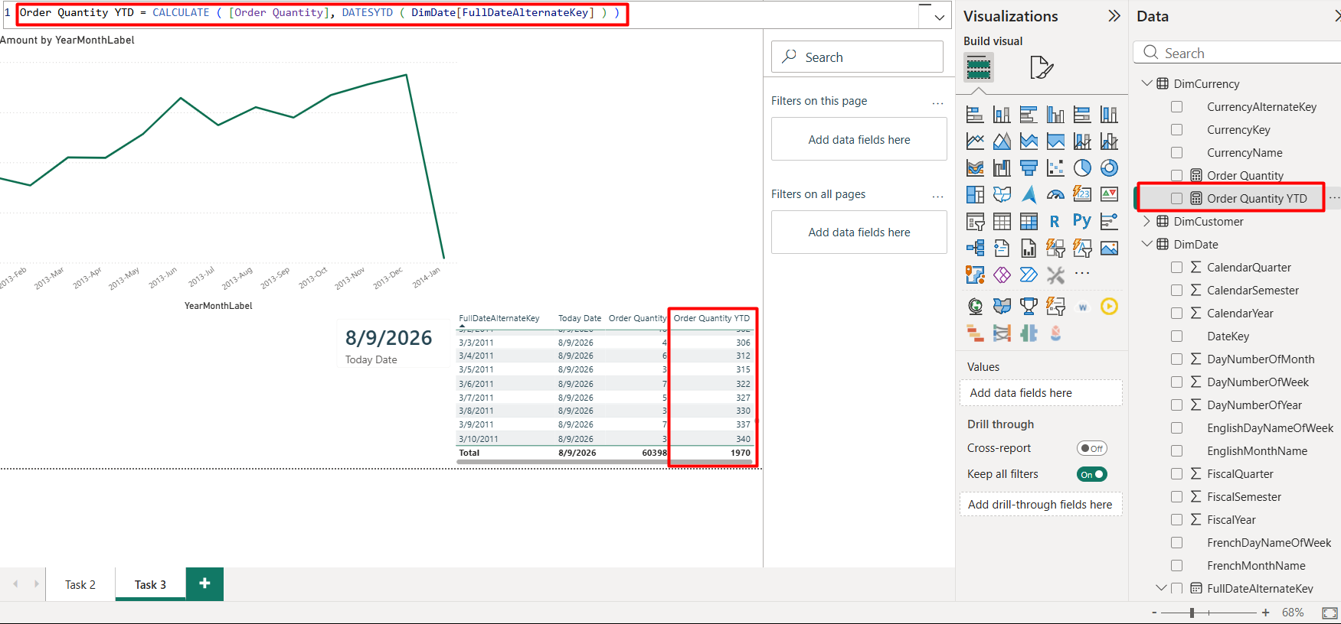
When the new year starts, the calculation starts all over again.
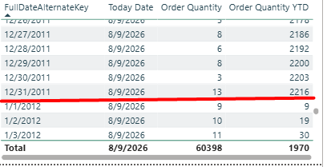

2. Create lab report

A new measure to track previous year order quantity is created
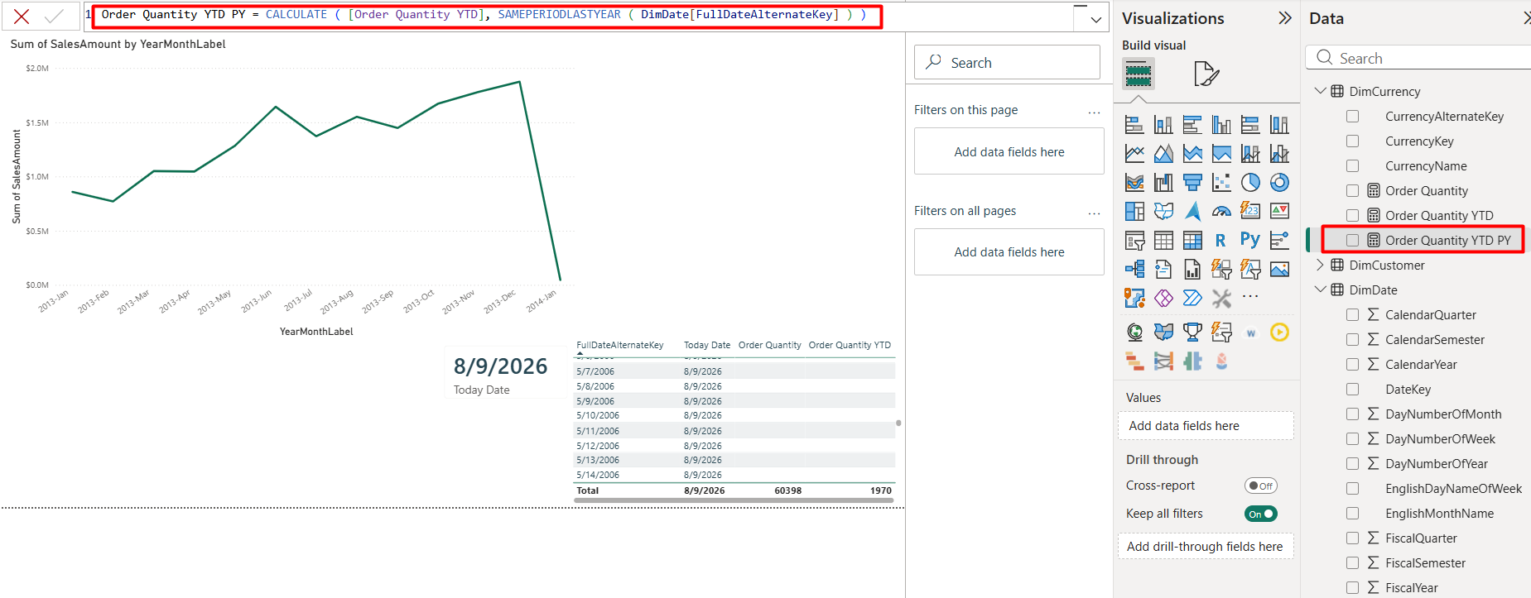
The line chart the displays both Order Quantity YTD line and Order Quantity YTD for Previous Year is added. Filter on Calendar Year is added.
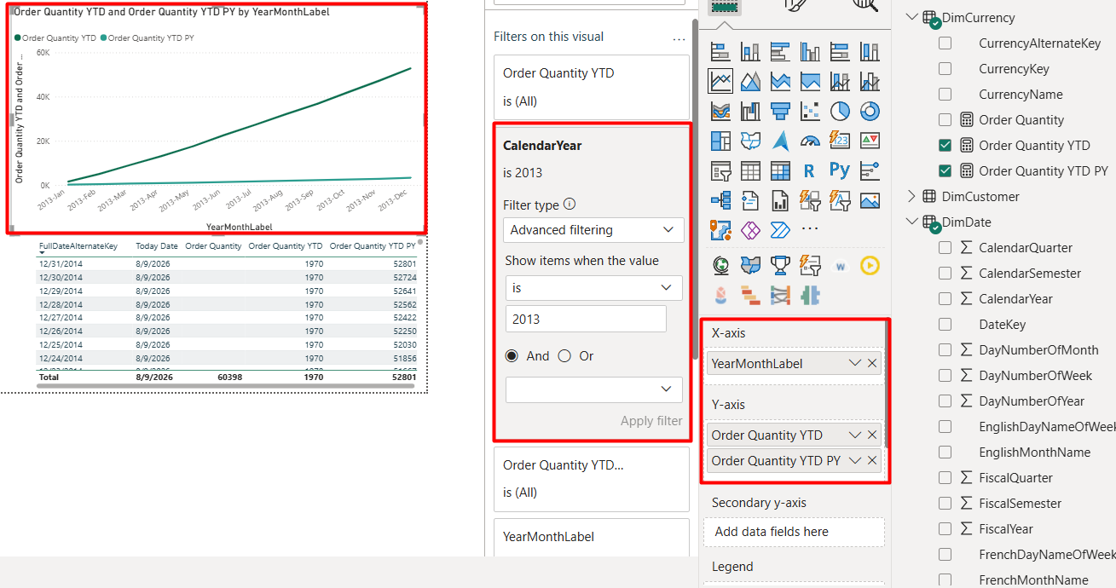

New sales measures are added
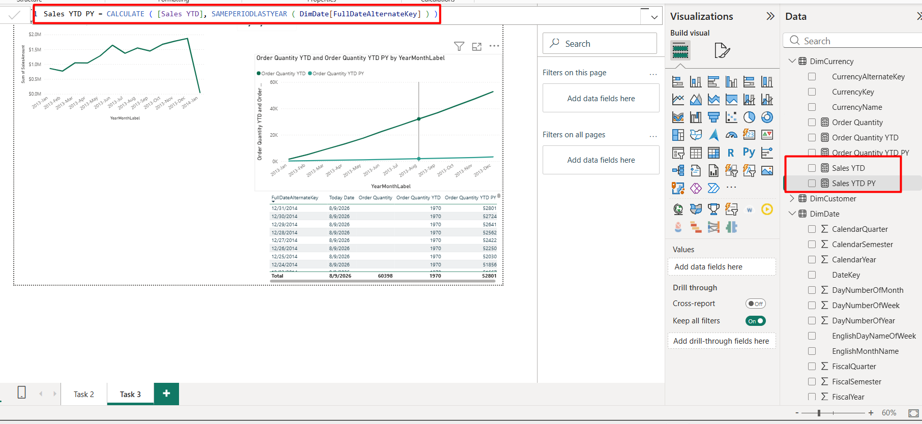

The line chart the displays both Sales YTD line and Sales YTD for Previous Year is added.
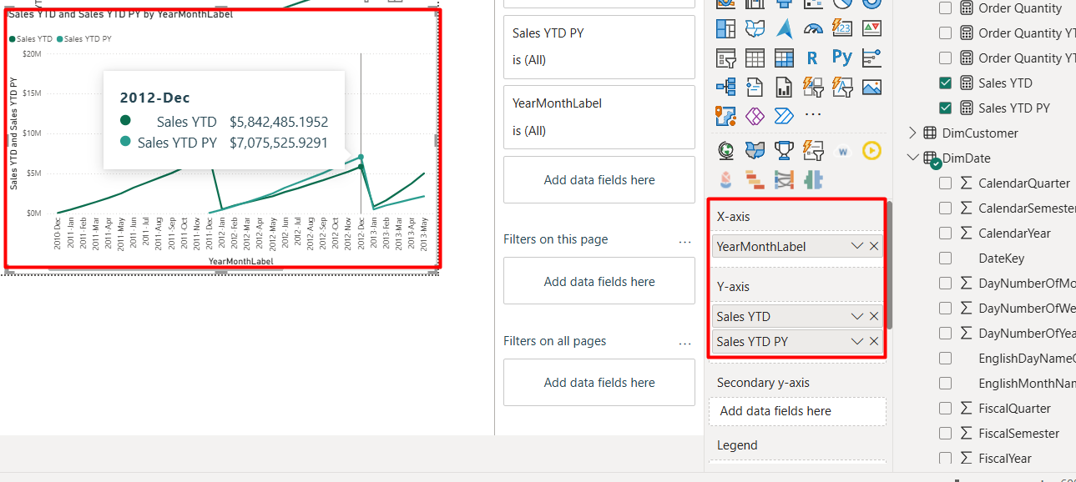
Current username and current date are displayed
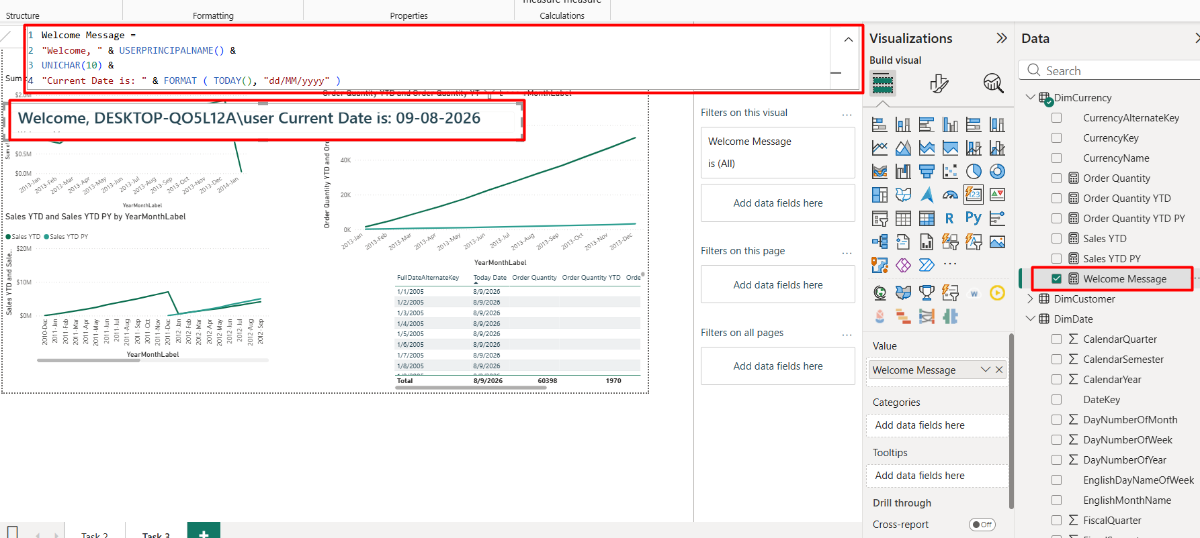
% of total Order quantity by Year Month Label and Color
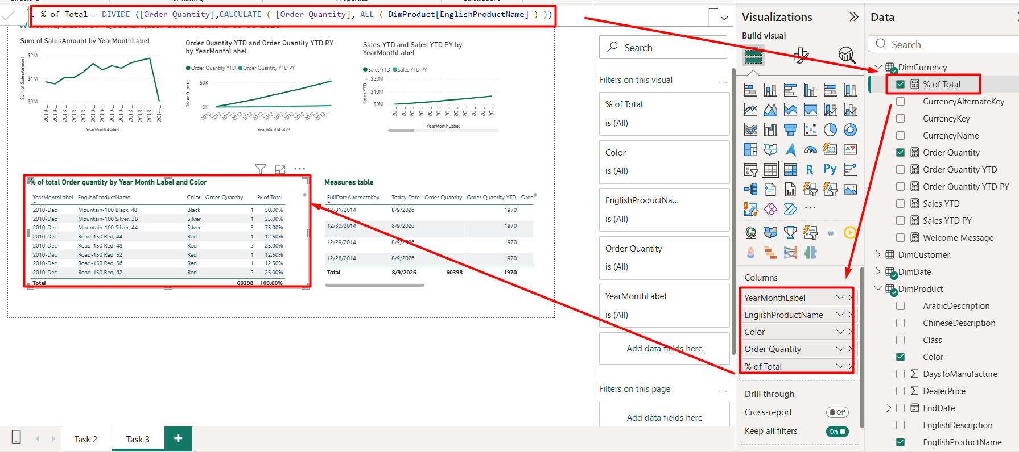

DAX measure for Sales Amount for maximum OrderDate available is added and visualized.The max date is saved in the variable ‘to freeze’ it and ALL ensures that non-required filters are ignored. Card because the answer is a single value.
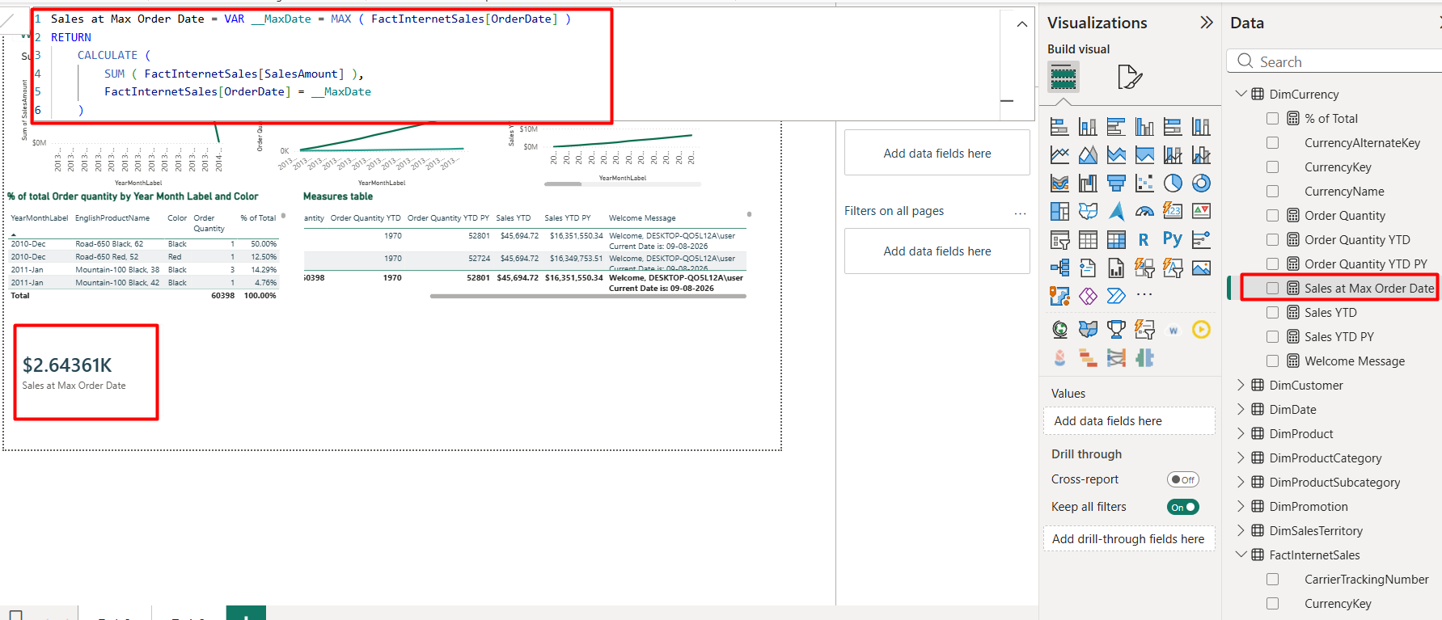

DAX measure for country with the highest sales in all years.
TOPN is used to rank all countries by total sales and keep the single highest, then applied it as a filter in CALCULATE and used FIRSTNONBLANK to return that country's name as text. I displayed the result in a Card because the answer is a single country name.
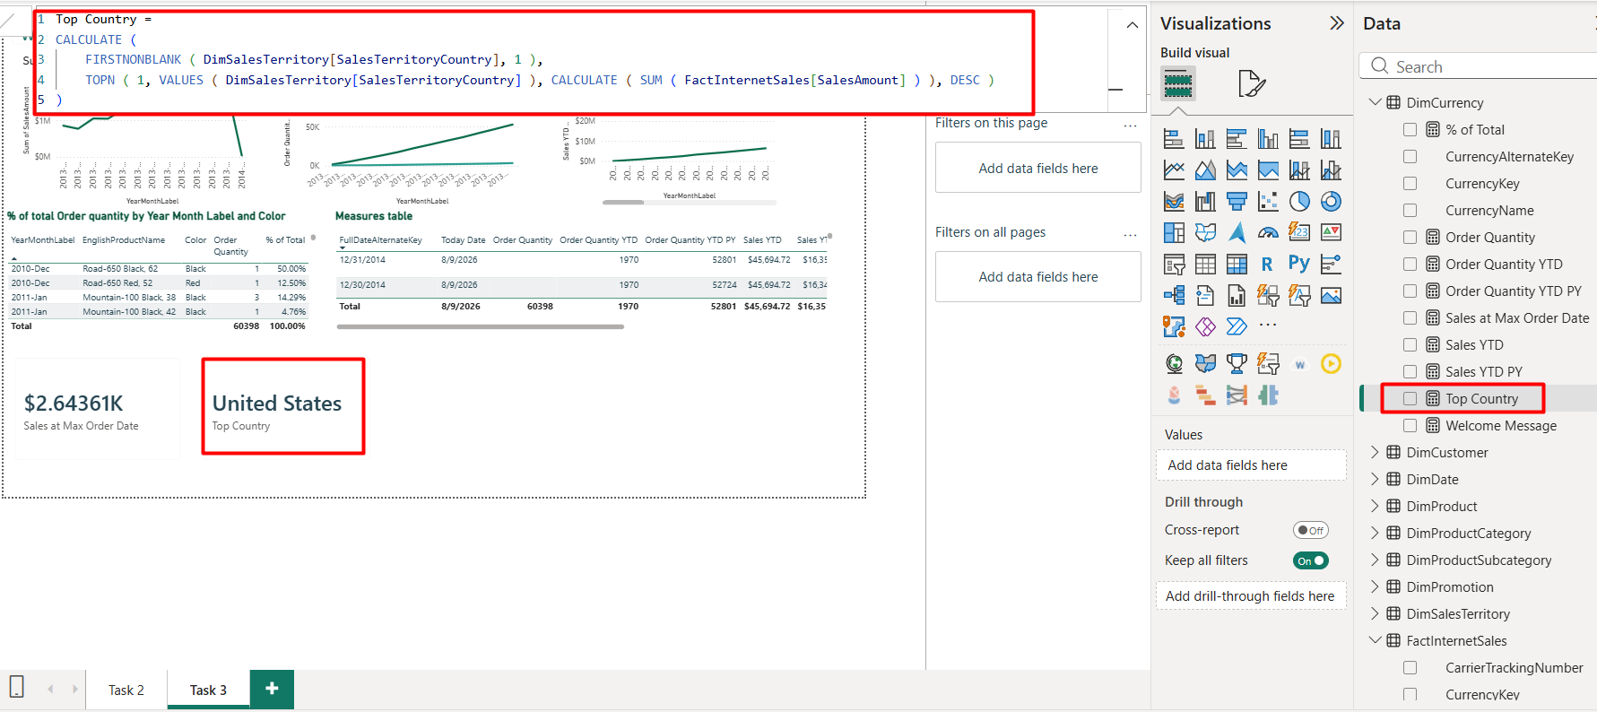

Ranks of ProductCategory by SalesAmount
RANKX is used with ALL over the product categories to rank them by total sales in descending order, so the highest-selling category is ranked 1. ALL removes the current row's filter so each category is evaluated against the complete set rather than only itself.The result in a table ensures that categories, ranks, and sum are displayed
