Data logical model

mountaineering club database

Contents
Business Description 3
1.1 the Benefits of implementing a database. Project Vision 3
2 Model description 3
2.1 Definitions & Acronyms 3
2.2 Logical Scheme 3
2.3 Objects 3

Business Description

the Benefits of implementing a database. Project Vision
- This project is dedicated for mountaineering club database. It is required to track and store information about club members, membership history, competitions, expeditions, activity groups, etc.
- Primary keys, foreign keys, constraints are added to achieve data integrity, consistency, and traceability
- A few associative tables are created to preserve chronology. For example, the Membership_history table is created to track all membership periods of the members if they quit and rejoin.
- Tables are normalized at least to 3NF that simplifies scalability of the database.
- Composite primary keys prevent duplicate records when project grows. For example, the Competition_history, Activity_group_members, Expedition_history tables. The UNIQUE constraints are also added to avoid duplication (for example, email attribute). NOT NULL constraints are applied to ensure that important attributes are populated and no missing information occurs. CHECK constrains (for example, awards table) restrict values to unified data.

Model description

Definitions & Acronyms
- PK - Primary keys (PK attributes are underlined and separated from others)
- FK - Foreign keys
- Used Data types - INT, DATE, VARCHAR,DECIMAL,TEXT,BOOLEAN
- Associative table borders are rounded
- Mandatory attributes font is bold

Tables:
- Members - the ‘starting point’ of the database. Represents club participants. Members can join groups based on preference or be standalone members, participate in competitions with awards and expeditions
- Membership_history – represents chronology of the membership as members may leave and rejoin the club
- Membership_types – levels of member skills(‘Beginner’, ‘Advanced’, etc..)
- Membership_types_history – chronology of the member’s progress
- Competitions – describes the basic information of the competitions.
- Competition_history – designed for archiving the competition/participant/awards
- Awards – table describes awards types
- Activity_groups - reflects the group of members that have similar interests
- Activity_group_members – tracks members of the groups
- Expeditions – describes possible climbing trips
- Expedition_history – describes chronology of the expeditions
- Expedition_mountains – lists mountains visited during expeditions
- Mountains – lists the destination mountains
- Instructors – lists instructors responsible for guiding expeditions

Core relationships:
- Members may be involved in activity groups or be standalone participants
- Members may leave and rejoin the club – one-to-many relationship of member table with Membership_history table
- Member may have chronologically different membership types (‘Beginner’, ‘Advanced’, etc..) - one-to-many relationship with Membership_types_history table
- Members may participate or not in one ore many competitions
- The same competition with the same members may be repeated (e.g. yearly) – one-to-many relationship with Competition_history table
- Expeditions may be organized for activity groups only (no separate members)
- Activity groups may or not participate in expeditions
- The same expedition with the same groups may be repeated (e.g. yearly) – one-to-many relationship with Expedition_history table
- One expedition is lead by one instructor
- One instructor may lead many expeditions or not lead at all
- One mountain may be visited in many expeditions or not visited at all
- During expedition one or many mountains may be visited

Logical Scheme
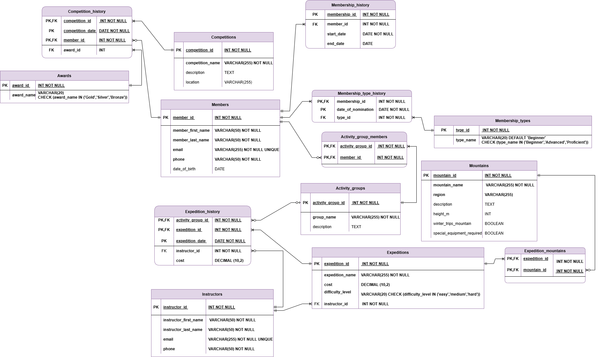
Answer following questions:
- Which modeling decision was the most difficult and why?
It was difficult to achieve chronology tracking, especially for different membership periods and membership types as single person may rejoin the club and change membership type
- Provide examples of potential data anomalies that your design prevents. Explain which constraints or structure elements prevent them.
Changing the information about competitions/mountains/instructors in the corresponding tables will not unnecessary change multiple records in related tables as they have dedicated separate tables – update anomaly prevention
- If you were to add new attributes or participants, would the model remain scalable and why? Which part of your model would most likely change if requirements expand?
It is possible that the complex events may be organized in the future (like expedition and competition intersection). Keeping related data in different tables and separating historical management allows to scale it if needed

Objects
2.3.1 Table Name: Members
The Members table represents individuals who belong to the mountaineering club. This is one of the core that stores basic information about the members.
The member_id attribute was chosen as the primary key(surrogate by nature) because it uniquely identifies each member and prevents cascade operations that will not be avoided in case of composite natural key.
Third Normal Form (3NF) is satisfied because all attributes depend only on the primary key(member_id) and do not depend on each other

Table Name | Field name | Field Description | Data Type
Members | member_id | Unique identifier of a club member PK | INT NOT NULL
 | member_first_name | First name of the club member | VARCHAR(50) NOT NULL
 | member_last_name | Last name of the club member | VARCHAR(50) NOT NULL
 | email | Email address of the club member | VARCHAR(255) NOT NULL UNIQUE
 | phone | Contact phone number | VARCHAR(30) NOT NULL
 | date_of_birth | Date of birth of the member | DATE
Example
member_ID | member_first_name | member_last_name | email | phone | date_of_birth
1 | Anna | Doe | annad@gmail.com | +380963259666 | 2000-05-25
2 | Tom | Smith | tom1@gmail.com | +380474744666 | 1999-05-25

2.3.2 Table Name: Membership_history
This table tracks the chronology of a member’s involvement. This is needed for cases when person want to rejoin the club. Each record represents one membership period for a specific member.
Storing the start date in this table helps avoid overwriting historical data if it were stored in the Members table.
Table Name | Field name | Field Description | Data Type
Membership_history | membership_id | Unique identifier for a membership period PK | INT
 | member_id | Identifier of a related club member FK | INT
 | start_date | Date when the membership period started | DATE NOT NULL
 | end_date | Date when the membership period ended | DATE
Example
membership_id | member_id | start_date | end_date
1 | 1 | 2022-03-01 | 2023-03-01
2 | 1 | 2025-03-01 | NULL

2.3.3 Table Name: Membership_types
The Membership_types table reflects the possible levels of the members skills -'Beginner','Advanced' or ‘'Proficient'
The type_id attribute is a primary key. The table is separated from the members table to track historical levels and avoid duplications.
Table Name | Field name | Field Description | Data Type
Membership_types | type_id | Unique identifier of a membership level PK | INT NOT NULL
 | type_name | Name of the membership level | VARCHAR(20)  DEFAULT 'Beginner'  CHECK (type_name IN ('Beginner','Advanced','Proficient'))
Example
type_id | type_name
1 | Beginner
2 | Advanced

2.3.4 Table Name: Membership_type_history
The Membership_types_history table records the history of membership levels assigned to club members.
This information should be stored separately instead of inside another table because membership levels may change multiple times during a member’s participation in the club.
Table Name | Field name | Field Description | Data Type
Membership_type_history | membership_id | Unique identifier for a membership period PK/FK | INT NOT NULL
 | date_of_nomination | Date when the member received this membership type PK | DATE NOT NULL
 | type_id | Identifier of the membership level FK | INT NOT NULL
Example
membership_id | date_of_nomination | type_id
1 | 2021-03-01 | 1
2 | 2025-03-01 | 2

2.3.5 Table Name: Competitions
The Competitions table represents competitions in which club members may participate. Each record corresponds to a specific competition event.
Storing competition information in a separate table prevents duplication of competition details when multiple members participate in the same event and is required for connection with other tables to track competition chronology.
Table Name | Field name | Field Description | Data Type
Competitions | competition_id | Unique identifier of a competition PK | INT
 | competition_name | Name of the competition | VARCHAR(255)
 | description | Additional information about the competition | TEXT
 | location | Location where the competition is held | VARCHAR(255)
Example
competition_id | competition_name | description | location
1 | Spring Climbing Cup | Annual climbing competition for club members | Dragobrat
2 | Summer Alpine Contest | International alpine climbing competition | Mont Blanc Region

2.3.6 Table Name: Competition_history
The Competition_history is an associative table that displays the chronology of club competitions.
Participants can participate in many competitions, and each competition can have many participants. Moreover, the same participants can participate in the same competitions every year - that is why the date is also added to the primary key. Foreign keys maintain referential integrity between participants, competitions, and awards.
Table Name | Field name | Field Description | Data Type
Competition_history | competition_id | Unique identifier of a competition PK/FK | INT NOT NULL
 | member_id | Identifier of the member participating in the competition PK/FK | INT NOT NULL
 | competition_date | Date of the competition PK | DATE NOT NULL
 | award_id | Award received in the specific competition | INT NOT NULL
Example
competition_id | competition_date | member_id | award_id
1 | 2025-03-01 | 3 | 1
2 | 2025-03-01 | 45 | 3

2.3.7 Table Name: Awards
The Awards table lists different types of awards(‘Gold','Silver','Bronze') that can be given to members during competitions .
Since many participants may receive the same awards in different competitions, storing awards in a special table reduces redundancy and ensures consistent naming of awards.
Table Name | Field name | Field Description | Data Type
Awards | award_id | Unique identifier of an award PK | INT NOT NULL
 | award_name | Name of the award | VARCHAR(20)  CHECK (award_name IN ('Gold','Silver','Bronze'))
Example
award_id | award_name
1 | Gold
2 | Silver

2.3.8 Table Name: Activity_groups
The Activity_groups table describes the possible groups based on specific activities or training levels. These groups allow members to participate in expedition.
Table Name | Field name | Field Description | Data Type
Activity_groups | activity_group_id | Unique identifier of an activity group PK | INT NOT NULL
 | group_name | Name of the activity group | VARCHAR(255) NOT NULL
 | description | Description of the activity group and its purpose | TEXT
Example
activity_group_id | group_name | description
1 | Ice Climbing Team | Group specializing in ice climbing techniques
2 | High Altitude Expedition Team | Advanced climbers preparing for high altitude expeditions

2.3.9 Table Name: Activity_group_members
The Activity_group_members is an associative table that records the membership of club members in different activity groups. Each record represents a relationship between a member and an activity group.
Multiple members can belong to the same group, and a member may participate in multiple groups. Storing this information separately avoids repeating group details and simplifies expedition tracking as it is allowed for groups only (not random members).

Table Name | Field name | Field Description | Data Type
Activity_group_members | member_id | Identifier of a club member PK/FK | INT NOT NULL
 | activity_group_id | Identifier of an activity group PK/FK | INT NOT NULL
Example
member_id | activity_group_id
1 | 1
2 | 1

2.3.10 Table Name: Expeditions
This Expeditions table stores information about expeditions organized by the mountaineering club.
By keeping it separate, we define the trip once and link it to many different groups and dates via the Expedition_history table(next one) and mountains (Expedition_mountains table)
Table Name | Field name | Field Description | Data Type
Expeditions | expedition_id | Unique identifier of a expedition PK | INT NOT NULL
 | expedition_name | Name of the expedition | VARCHAR(255) NOT NULL
 | cost | Cost of the expedition | DECIMAL (10,2)
 | difficulty_level | Degree of the complexity of the expedition | VARCHAR(20)  CHECK (difficulty_level IN ('easy','medium','hard'))
 | instructor_id | Identifier of the instructor | INT NOT NULL
Example
expedition_id | expedition_name | cost | difficulty_level | instructor_id
1 | Himalayan Base Camp | 1450.00 | easy | 3
2 | Alpine Sky-High | 3450.00 | hard | 2

2.3.11 Table Name: Expedition_history
The Expedition_history table is dedicated to track every single trip ever taken. This structure allows the same activity_group to perform the same expedition multiple times on different dates.
Table ensures that overwriting previous facts is not possible. A Composite Primary Key (activity_group_id, expedition_id, expedition_date) was chosen because it uniquely identifies a specific event.
Table Name | Field name | Field Description | Data Type
Expedition_history | expedition_id | Unique identifier of a expedition PK/FK | INT NOT NULL
 | activity_group_id | Identifier of an activity group PK/FK | INT NOT NULL
 | expedition_date | Date of the expedition PK | DATE NOT NULL
 | instructor_id | Identifier of the instructor that will lead the expedition FK | INT NOT NULL)
 | cost | Cost of the current expedition | DECIMAL (10,2)
Example
expedition_id | activity_group_id |  | expedition_date |  | instructor_id |  | cost
1 |  | 3 |  | 2019-03-01 |  | 4 |  | 1450.00
2 |  | 8 |  | 2019-03-02 |  | 5 |  | 4450.00

2.3.12 Table Name: Mountains
The Mountains table describes a specific mountain, including its location, height, characteristics, and special requirements for climbing.
Multiple expeditions target the same mountain, so storing this information separately is the best approach
Table Name | Field name | Field Description | Data Type
Mountains | mountain_id | Unique identifier of a mountain PK | INT NOT NULL
 | mountain_name | Name of the club mountain | VARCHAR(255) NOT NULL
 | region | Region of the mountain location | VARCHAR(255)
 | description | Additional information about mountain | TEXT
 | height_m | Height of the mountain in meters | INT
 | winter_trips_mountain | Describes whether the mountain is eligible for winter routes | BOOLEAN
 | special_equipment_required | Defines whether special equipment required to climb | BOOLEAN
Example
mountain_id | mountain_name | region | description | height_m | wIinter_trips_mountain | special_equipment_required
1 | Mount Elbrus | Caucasus | Highest peak in Europe, challenging climbs | 5642 | TRUE | TRUE
2 | Hoverla | Carpathians | Popular for hiking, accessible to beginners | 2061 | FALSE | FALSE

2.3.13 Table Name: Expedition_mountains
The Expedition_mountains table records which mountains are associated with each expedition. An expedition can include one or more mountains, and a single mountain can be visited by multiple expeditions. Thar’s why this associative table is created.

Table Name | Field name | Field Description | Data Type
Expedition_mountains | mountain_id | Unique identifier of a mountain PK/FK | INT NOT NULL
 | expedition_id | Unique identifier of a expedition PK/FK | INT NOT NULL
Example
mountain_id | expedition_id
1 | 5
1 | 4

2.3.14 Table Name: Instructors
The Instructors table stores information about instructors who guide expeditions and train club members.
Each instructor may lead multiple expeditions, and the instructor_id is referenced in the Expeditions and Expedition_history tables.
Table Name | Field name | Field Description | Data Type
Instructors | instructor_id | Unique identifier of the instructor PK | INT NOT NULL
 | instructor_first_name | First name of the instructor | VARCHAR(255) NOT NULL
 | instructor_last_name | Last name of the instructor | VARCHAR(255) NOT NULL
 | email | Email address of the club member | VARCHAR(255) NOT NULL UNIQUE
 | phone | Contact phone number | VARCHAR(30) NOT NULL
Example
instructor _id | instructor_first_name | instructor _last_name | email | phone
1 | Anna | Doe | annad@gmail.com | +380963259666
2 | Tom | Smith | tom1@gmail.com | +380474744666

