Preconditions:
Required Installations are performed

Load Data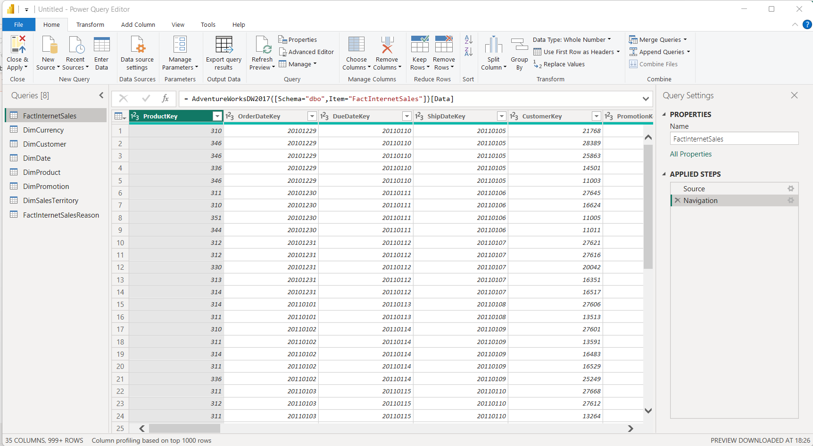Basic Data Transformation
Create a column with full Customer name
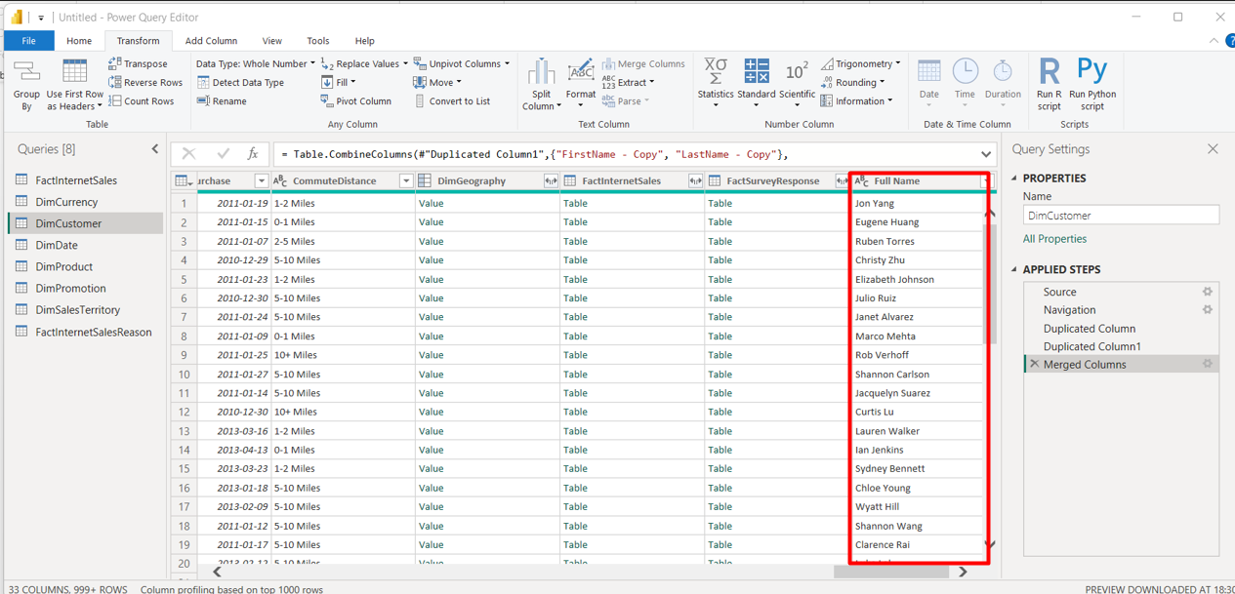

Change column type
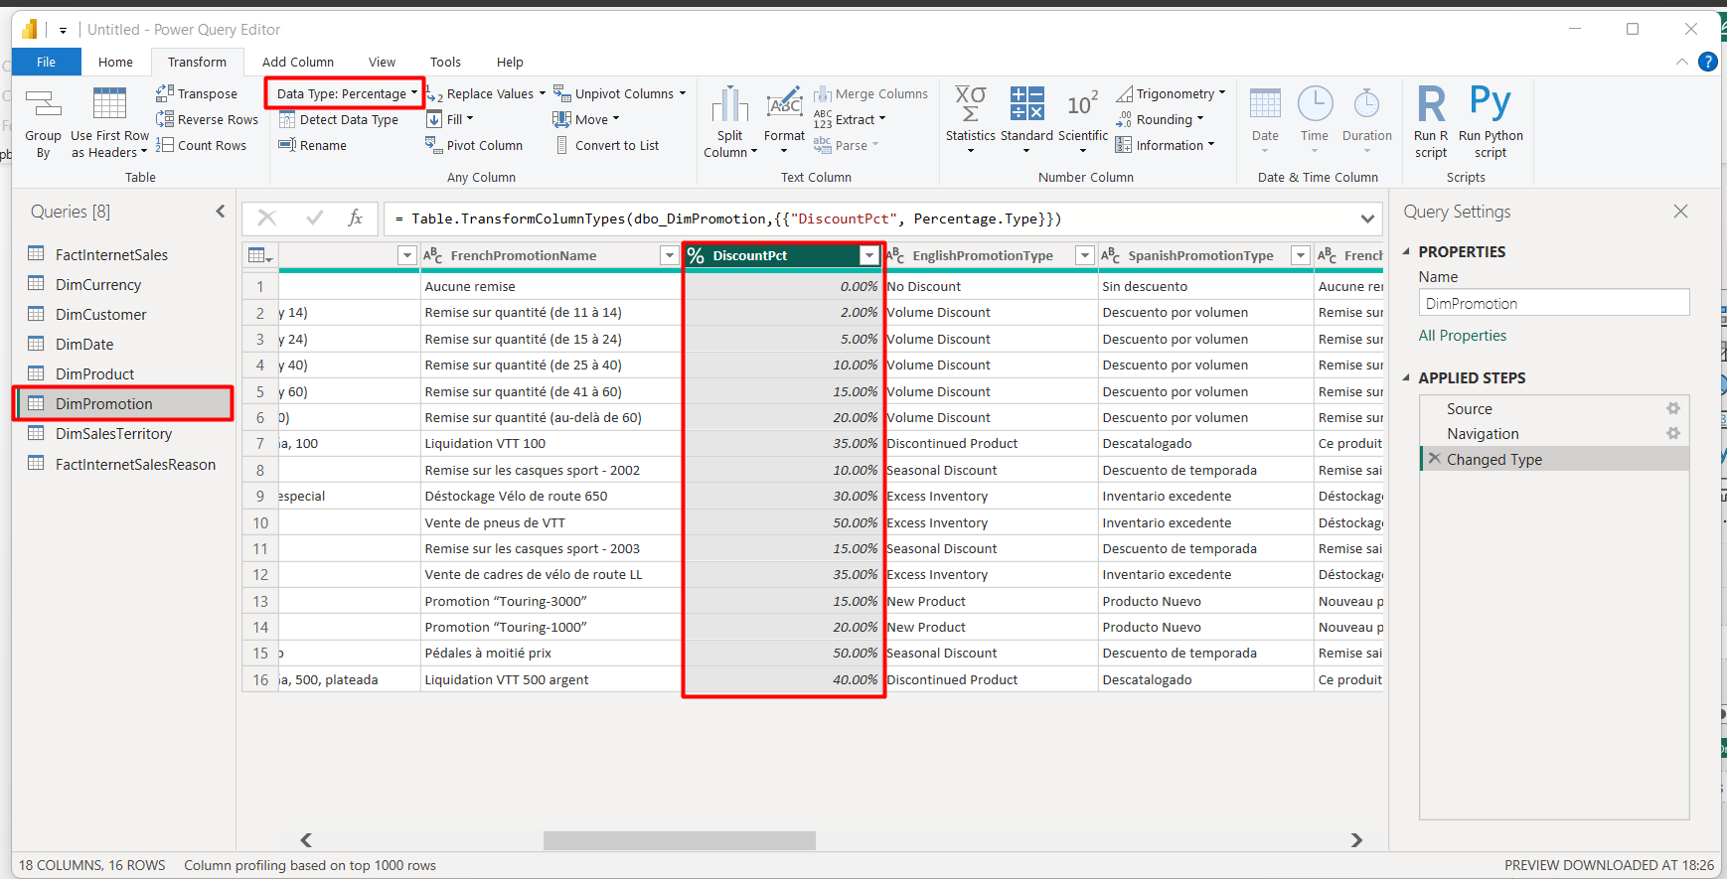
Calculate the length of Promo campaign
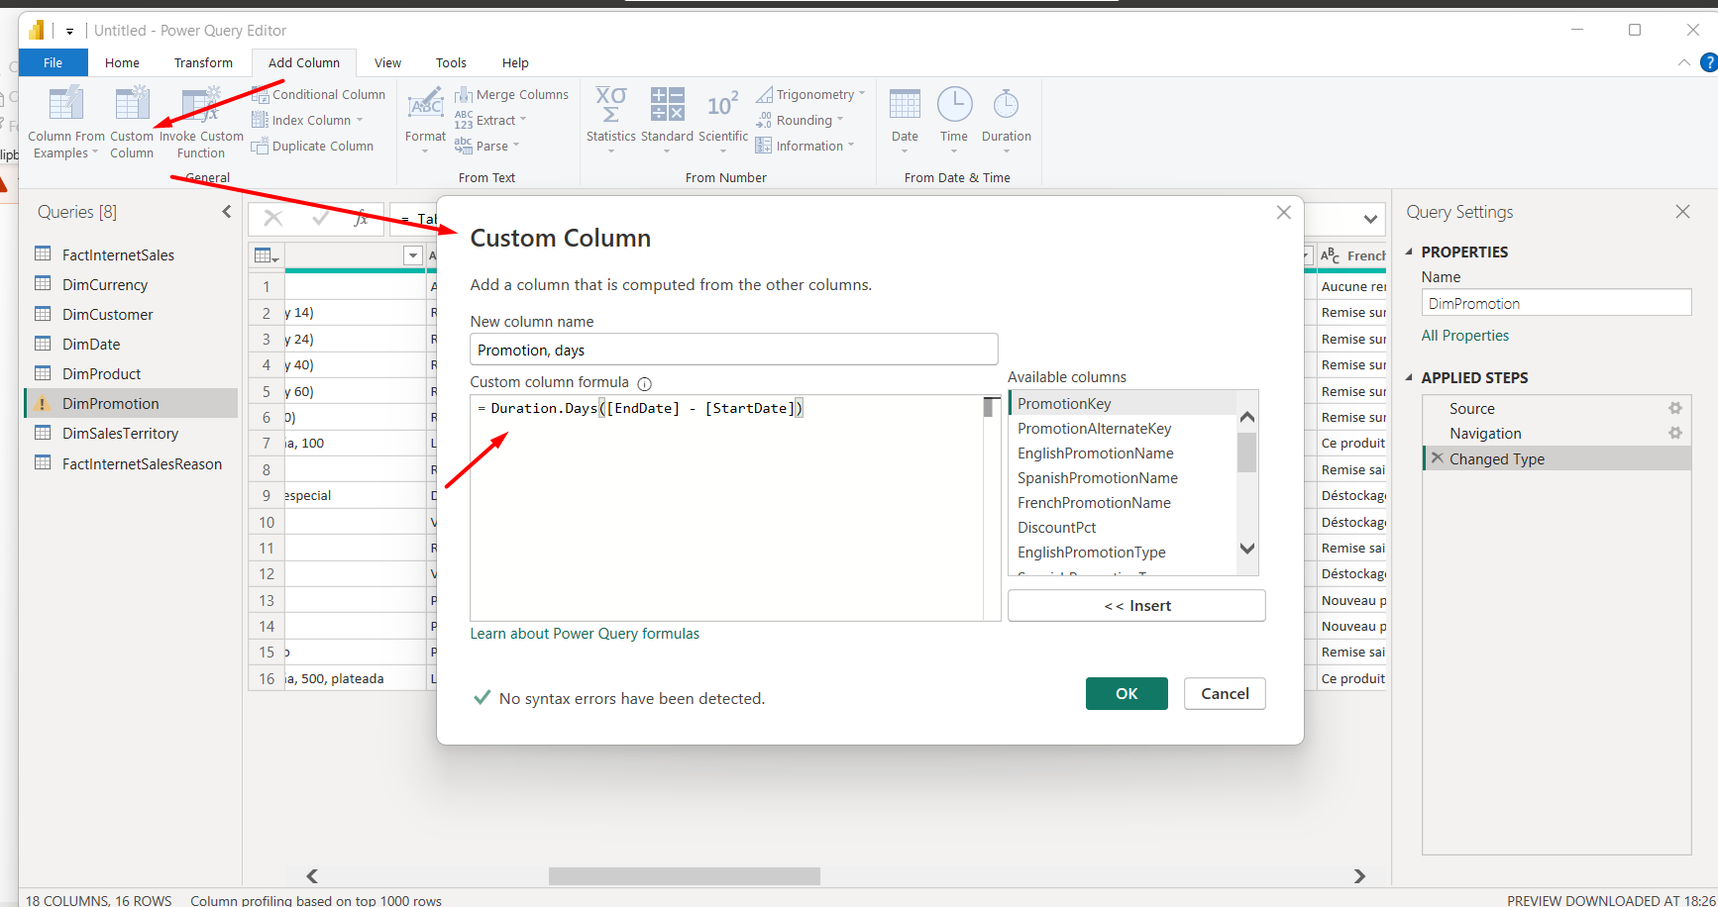
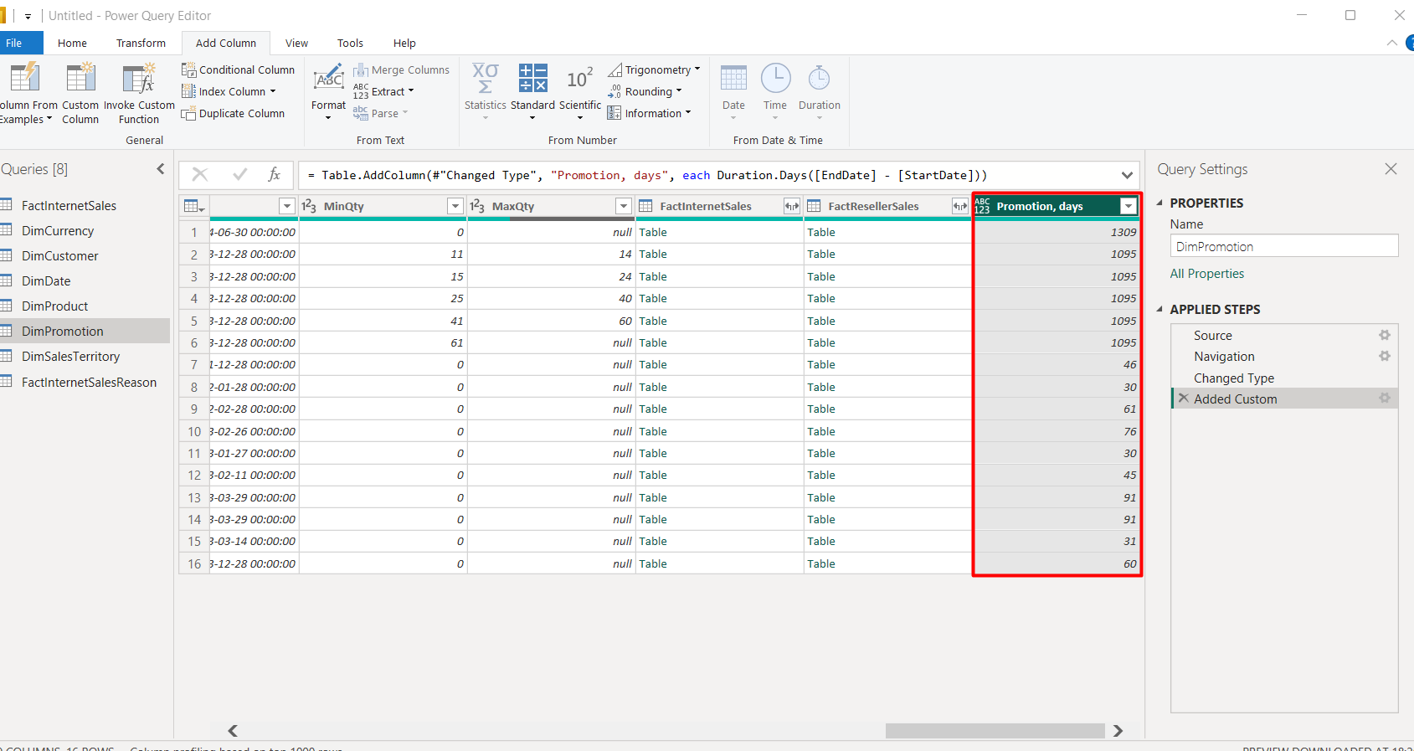

ADDING NEW TABLES
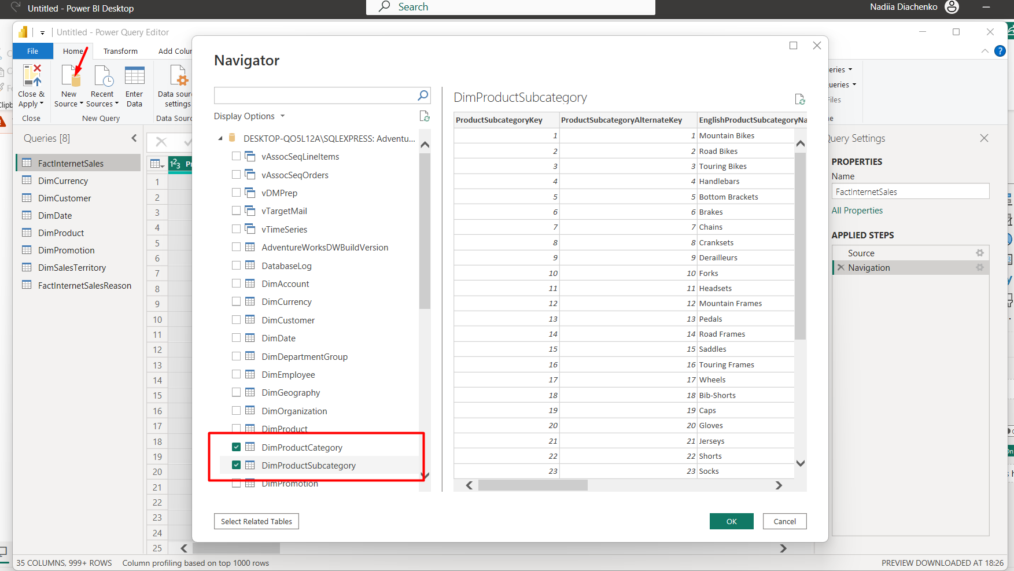
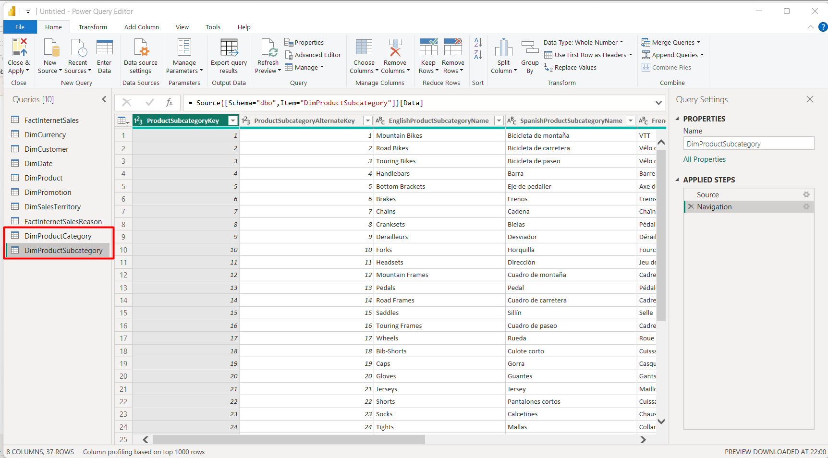

DATA PROFILING
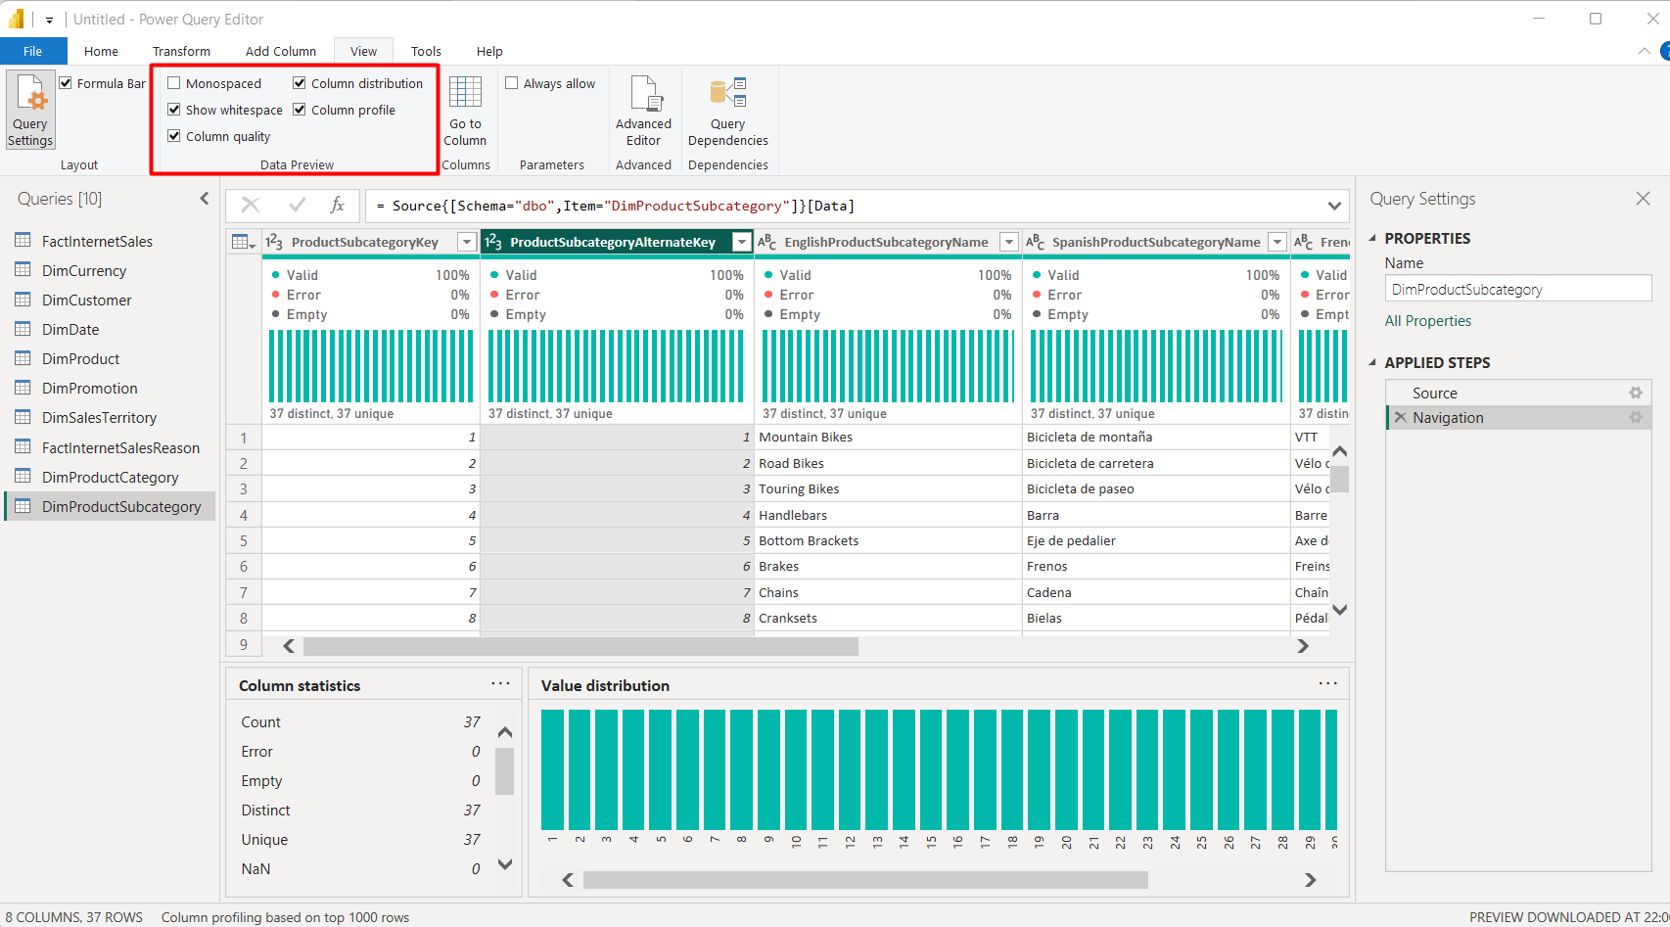

PIVOT COLUMN
Create column ‘Order Year’
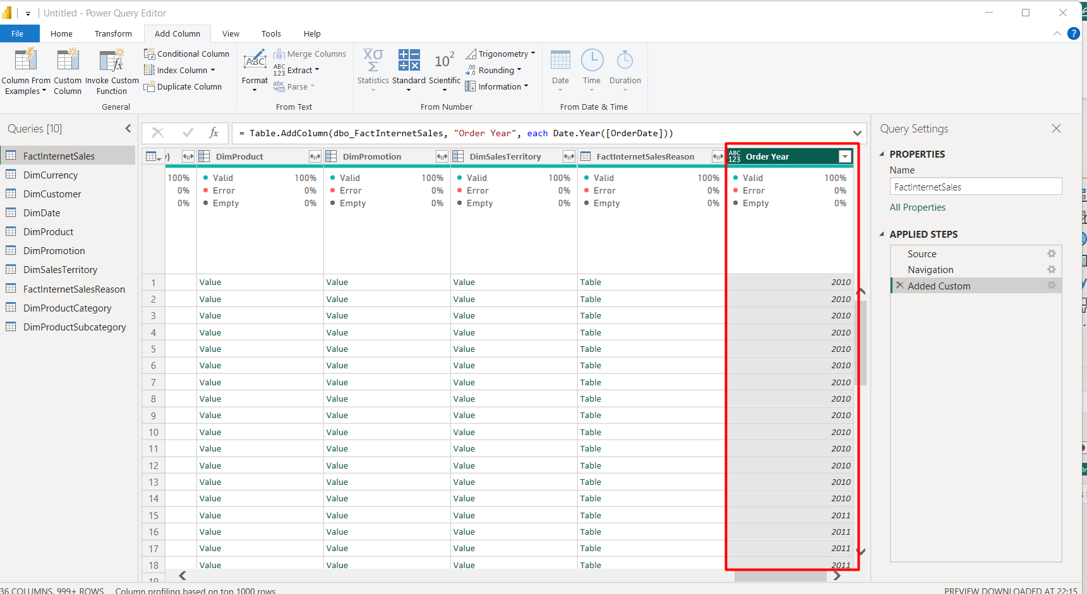
Create a new table based on ‘FactInternetSales’

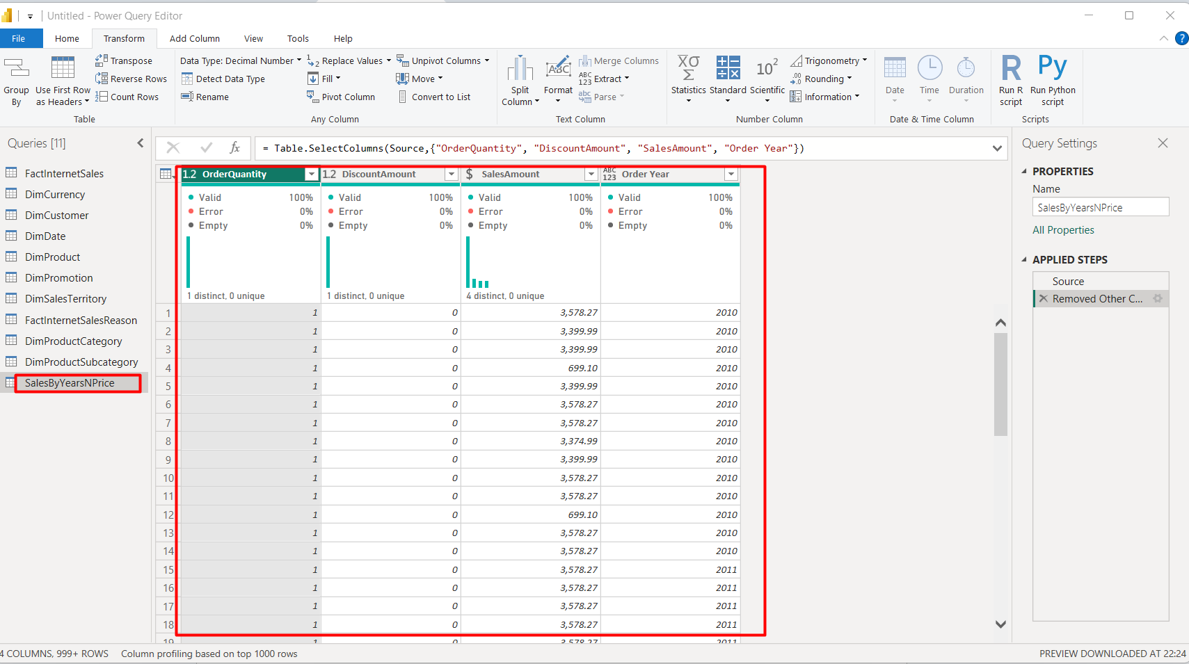

Pivot Column
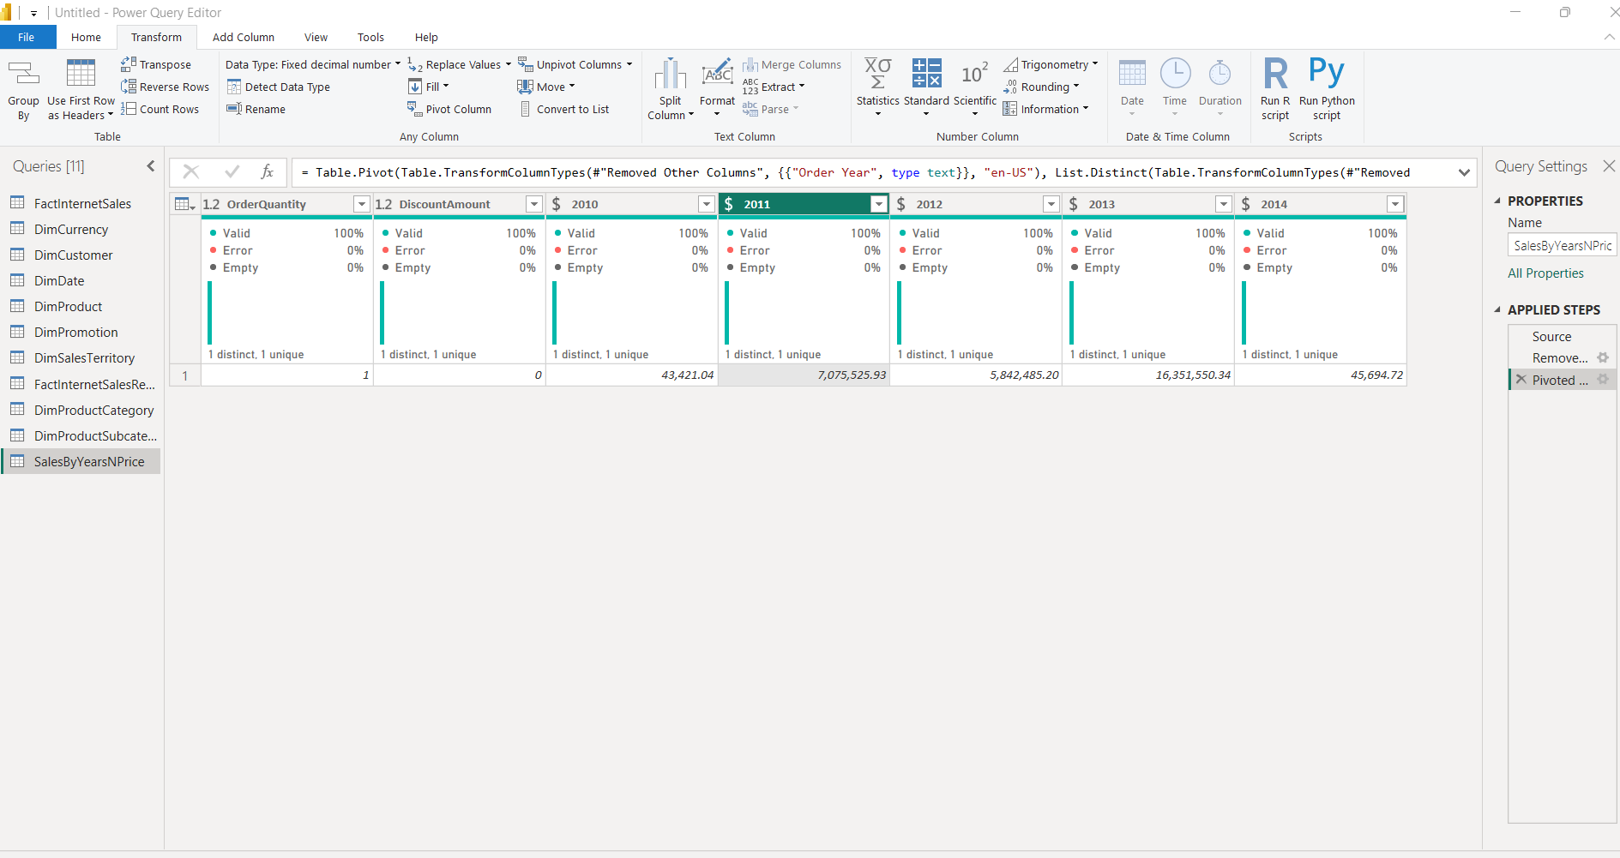

TABLE JOINING

Join ‘SalesByCountry’ and ‘DimSalesTerritory’ tables
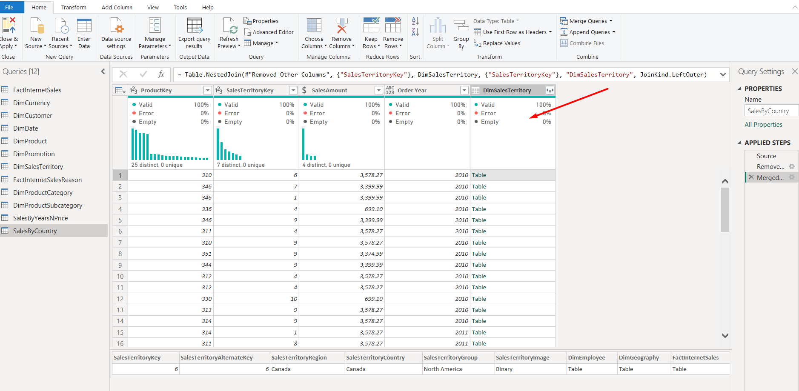

Join DimProductCategory[EnglishProductCategory] column in the same way:
To join this column we need to walk through product>subcategoory>category chain
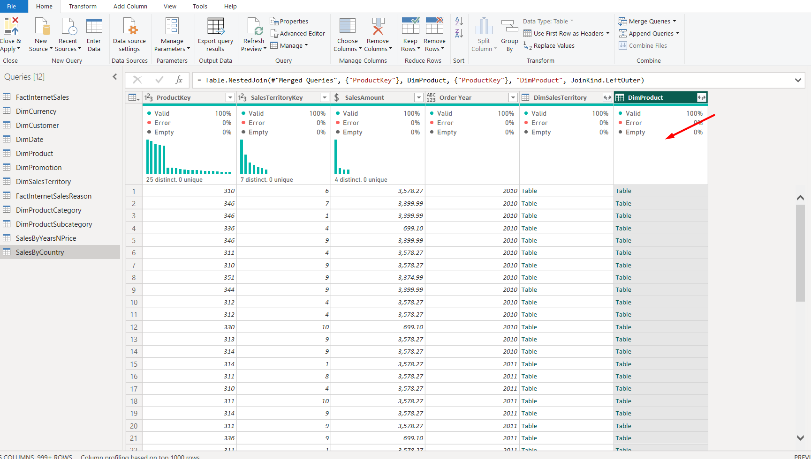
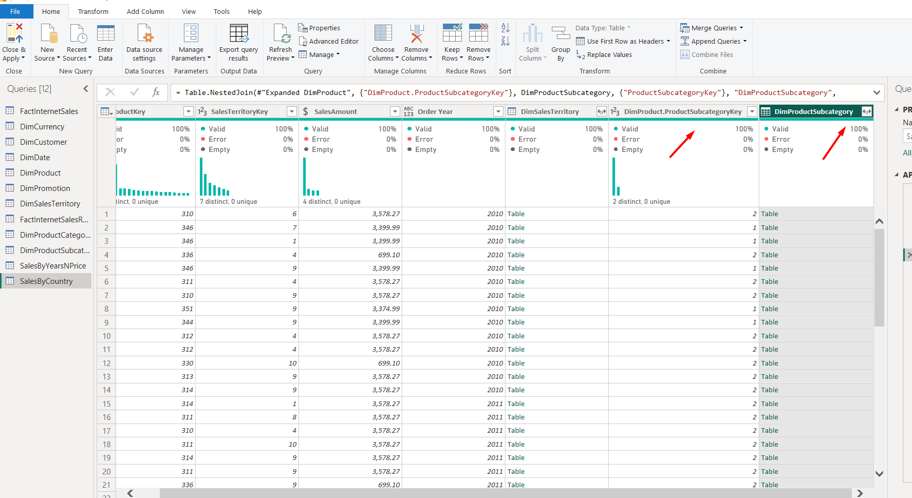
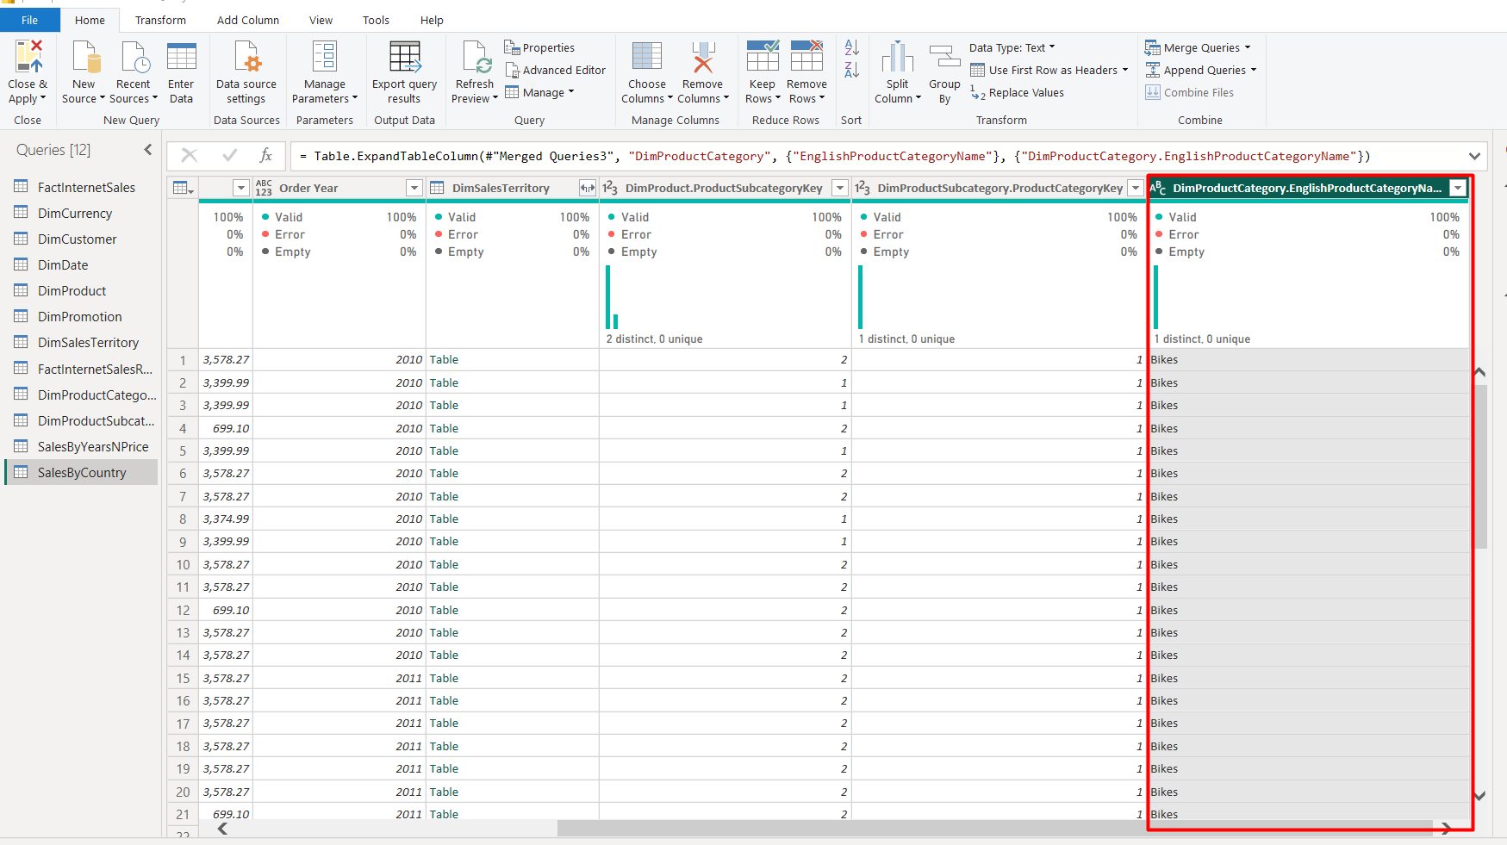

GROUPING DATA
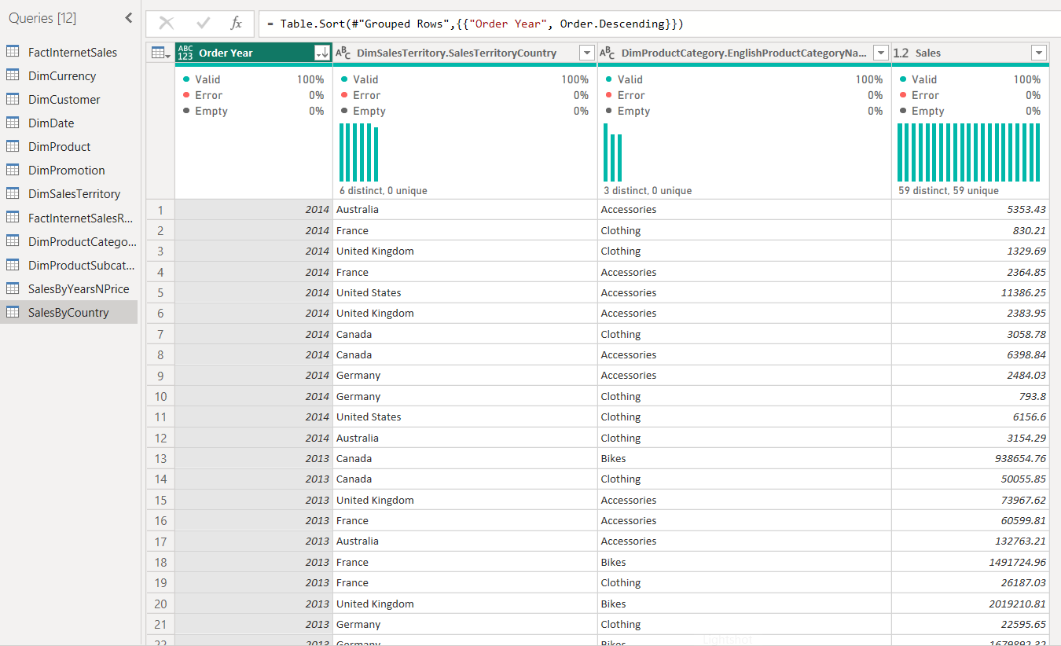

Load Data
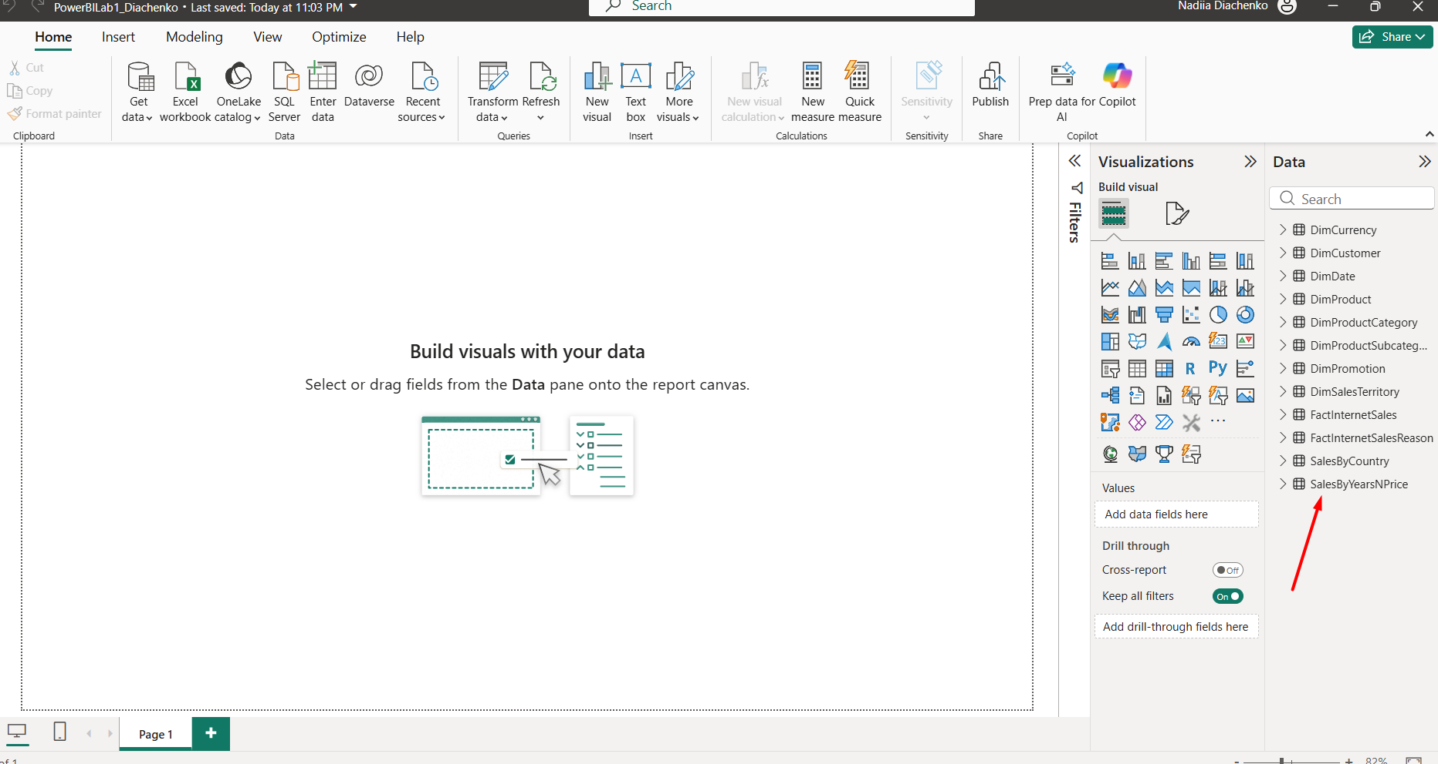

IMPORT VS DIRECT QUERY

Import mode allows the full range of transformations and faster. But direct query gives a possibility to have live data (if any)
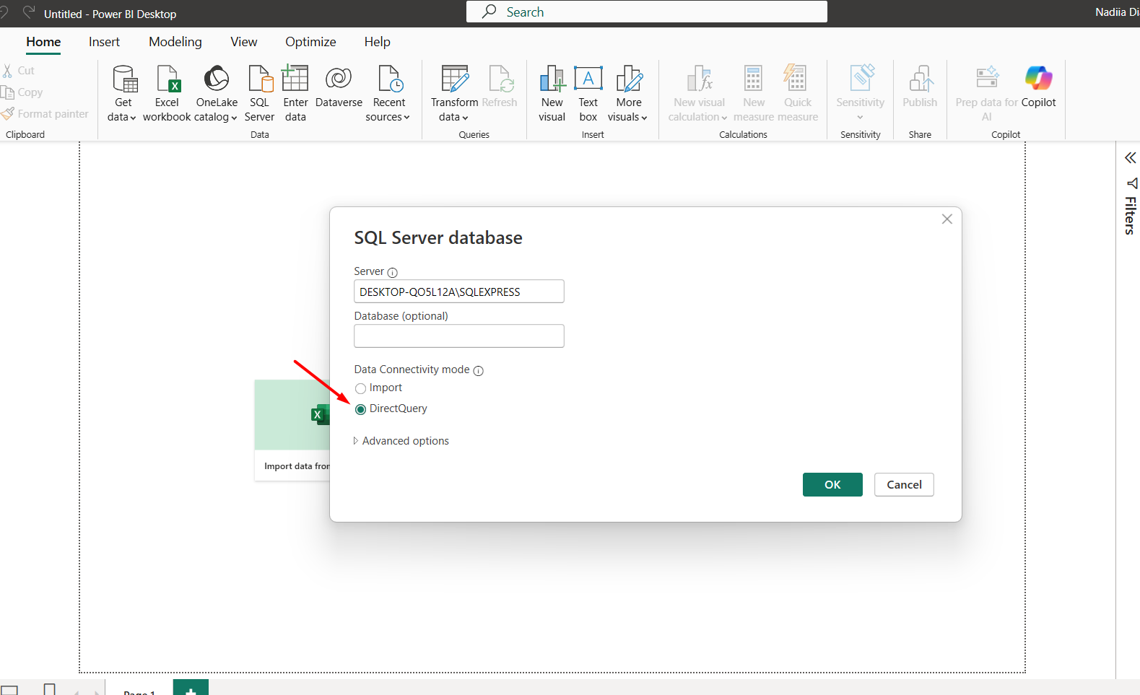

WORKING WITH POWER BI MODEL

Relationships except OrderDate between FactInternetSales table and DimDate are removed and the OrderDate connection is active
