Working with Power BI Model

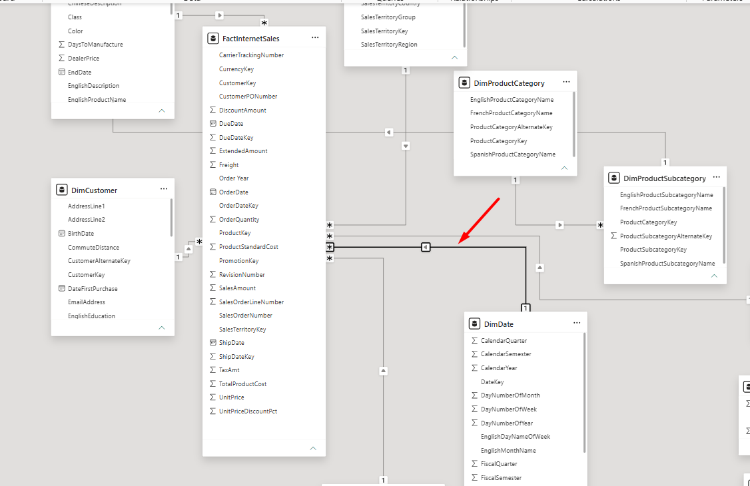
Adding the slicers
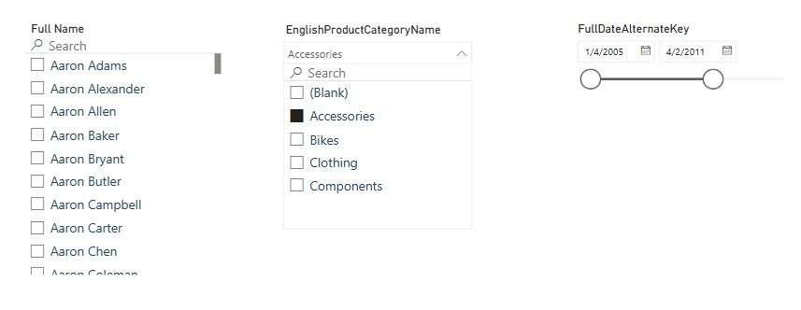

Adding the visuals

Card visual
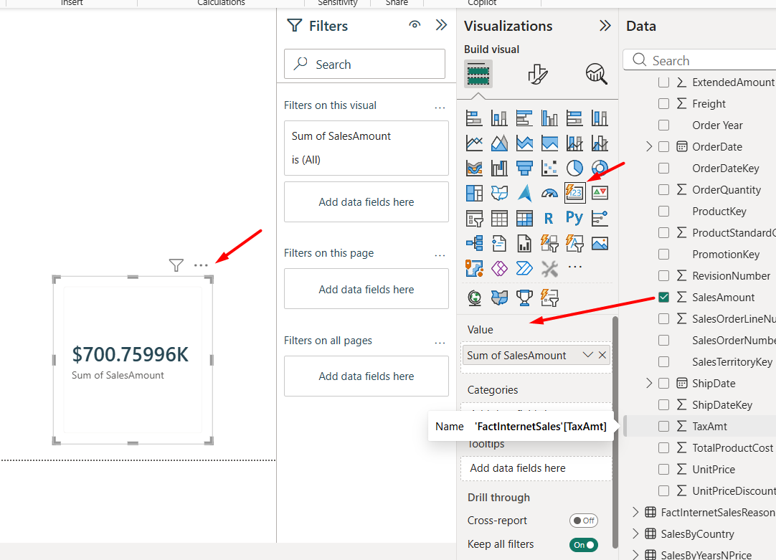
Clustered column chart
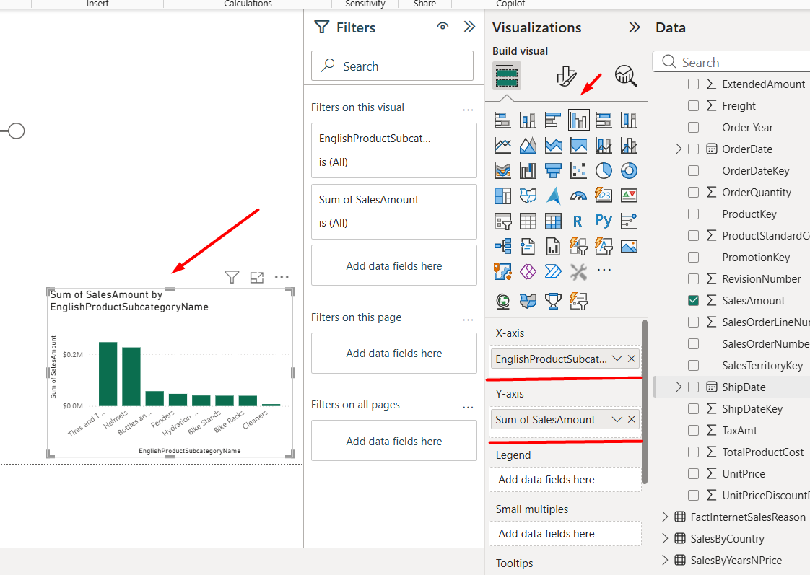

Line chart
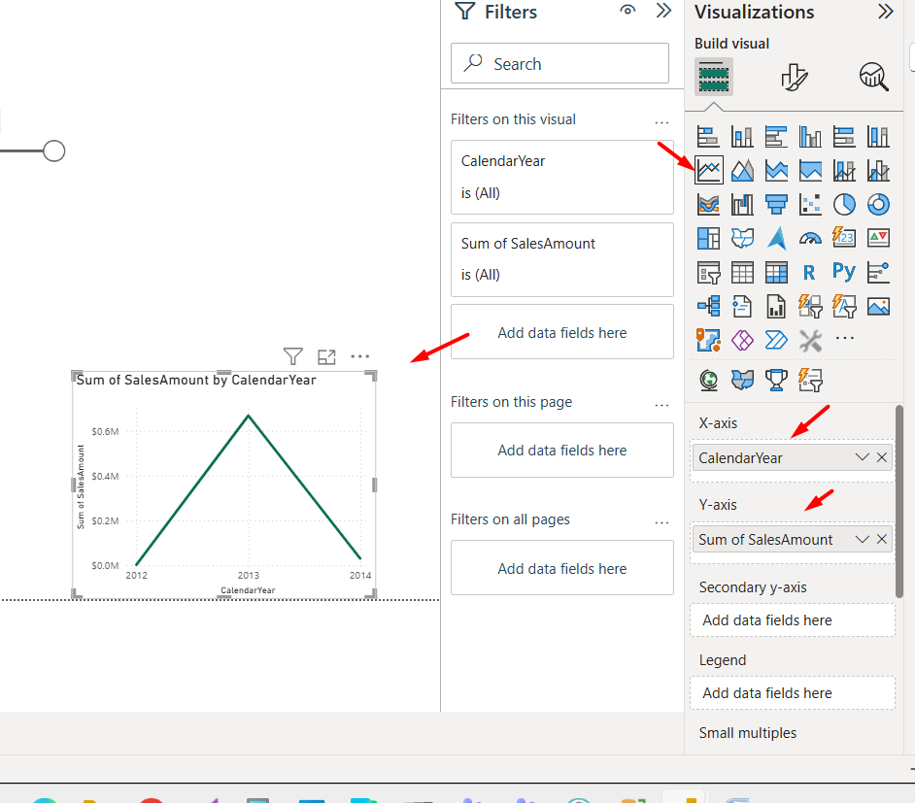
Donut chart
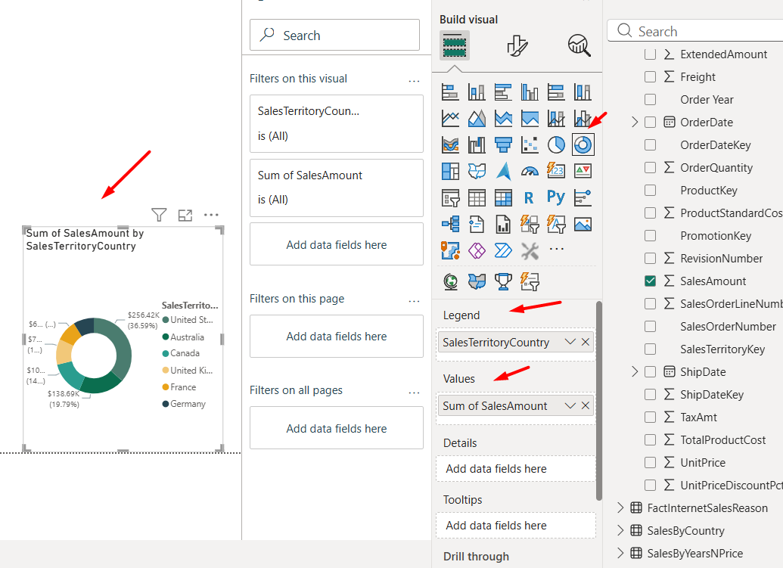
Matrix
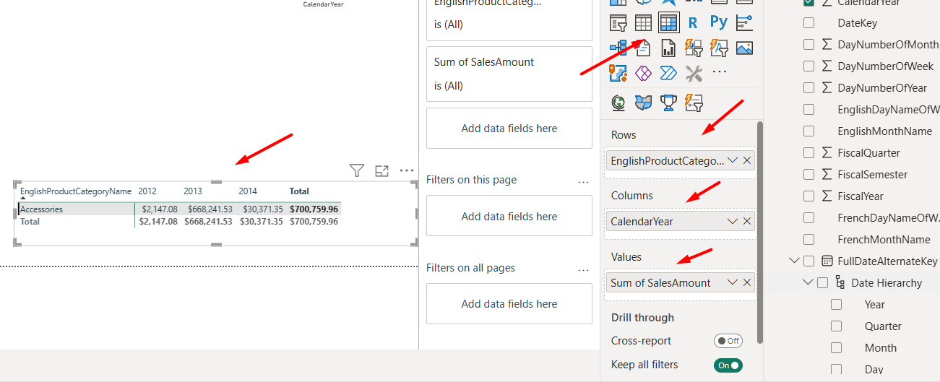
Custom Visuals

Sankey diagram

A Sankey diagram used to show how sales flow from countries into product categories, with ribbon thickness representing sales volume.
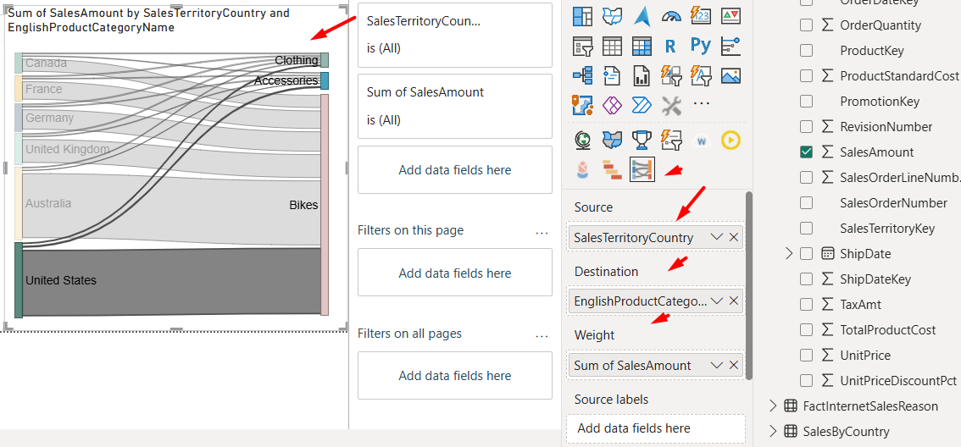

Tornado chart

A Tornado chart used to compare sales amount against freight cost across product categories, showing where shipping costs are proportionally high
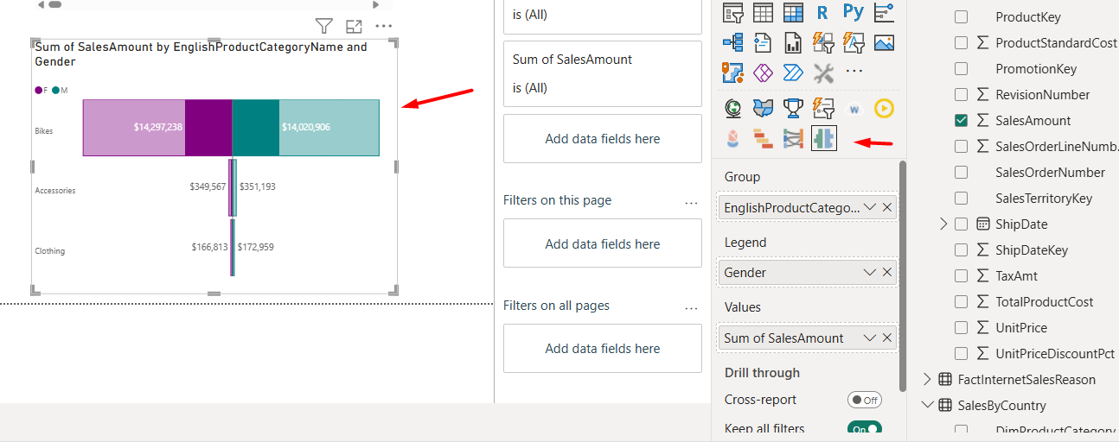
Adding a Map
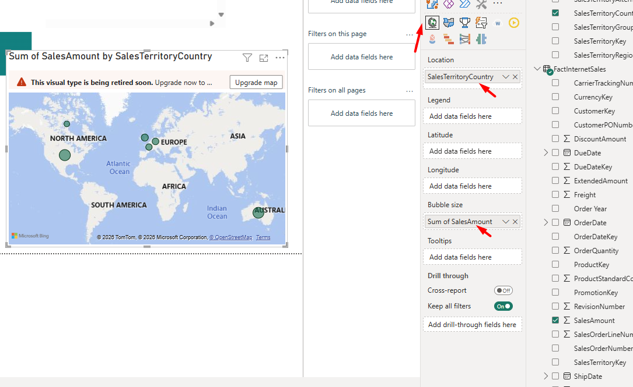

Final layout

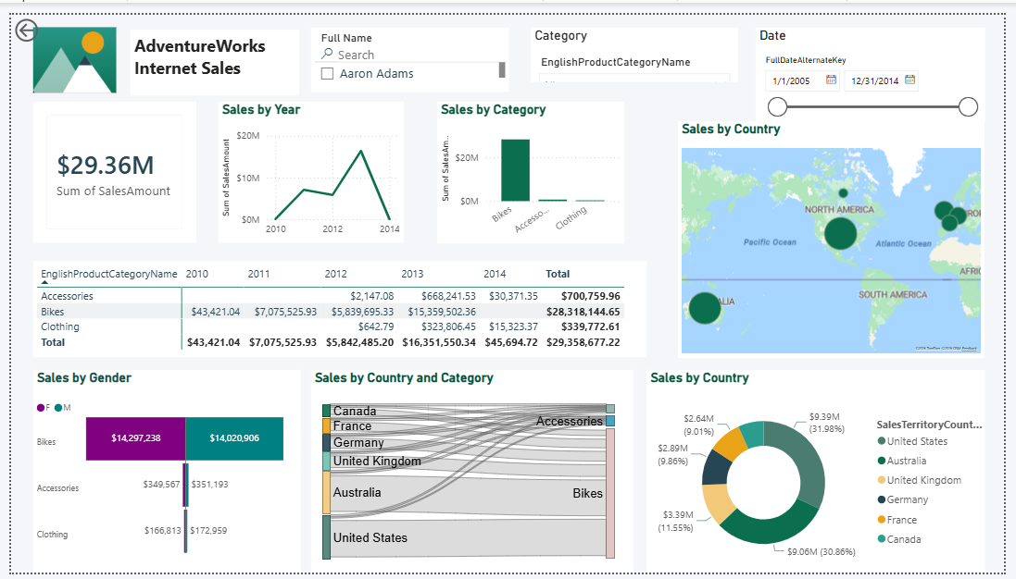

Interactions
The interaction disabled between the category column chart and the total-sales Card so the Card always displays the overall total, regardless of which category is selected.
Before removing interaction (bike category selected):
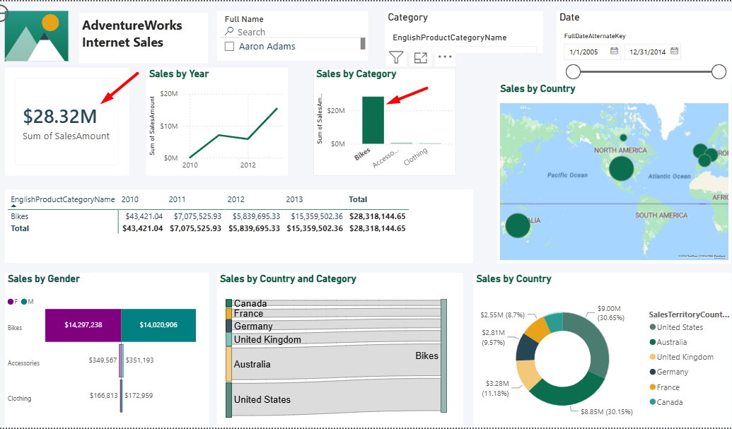
After adding interaction (bike category selected):
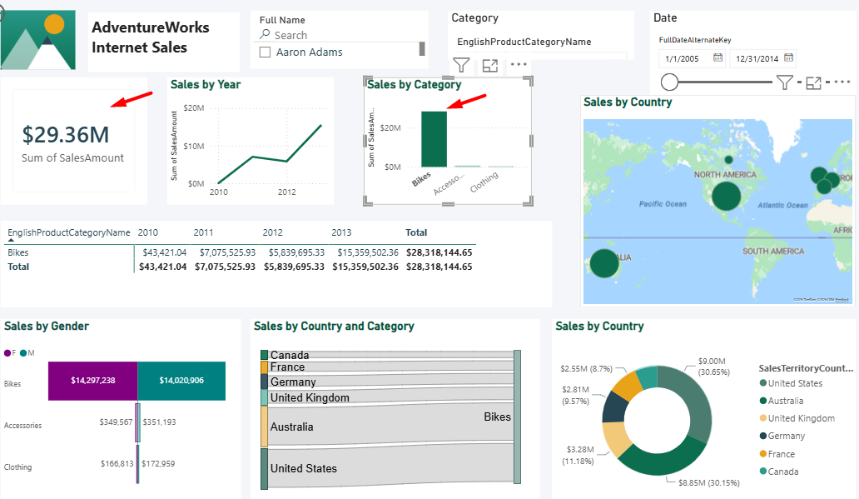
Mobile view is added
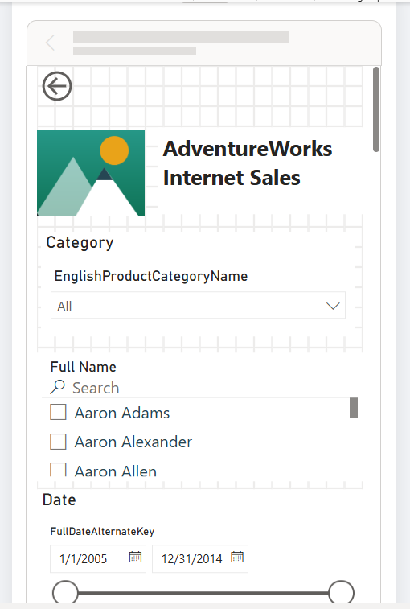
Report is published
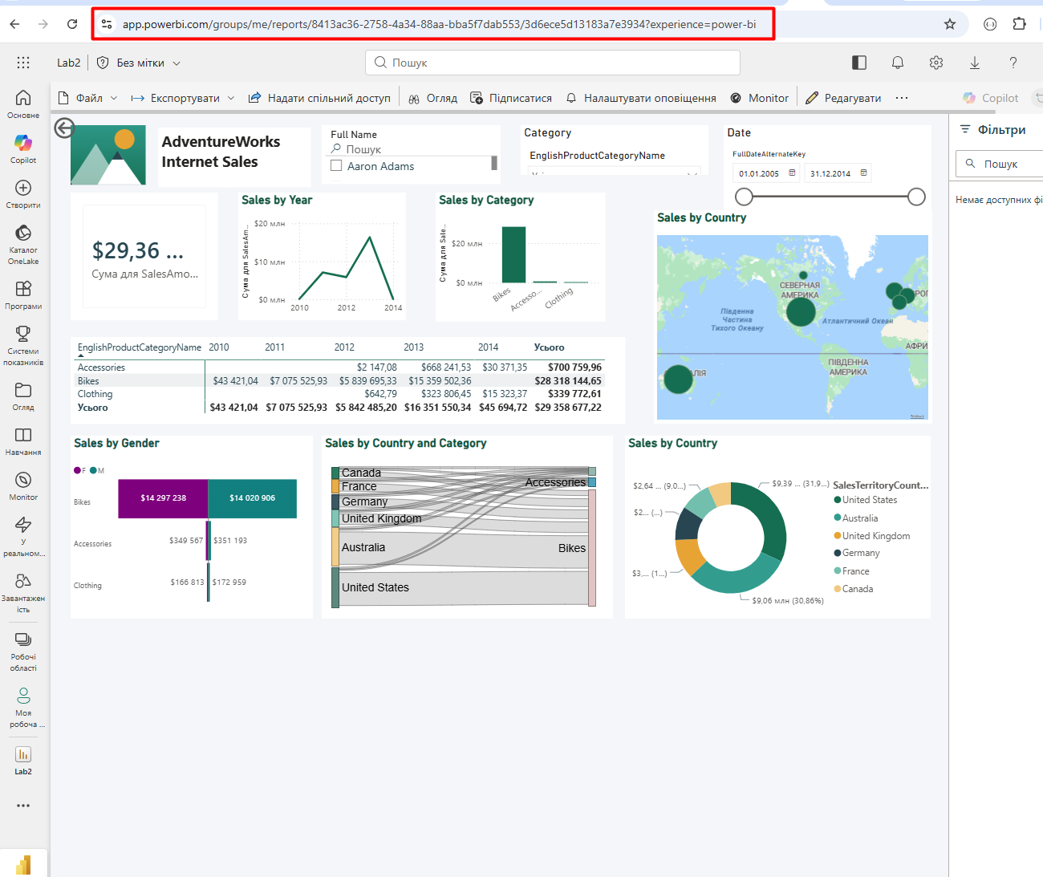
The Personal Gateway and daily refresh are established

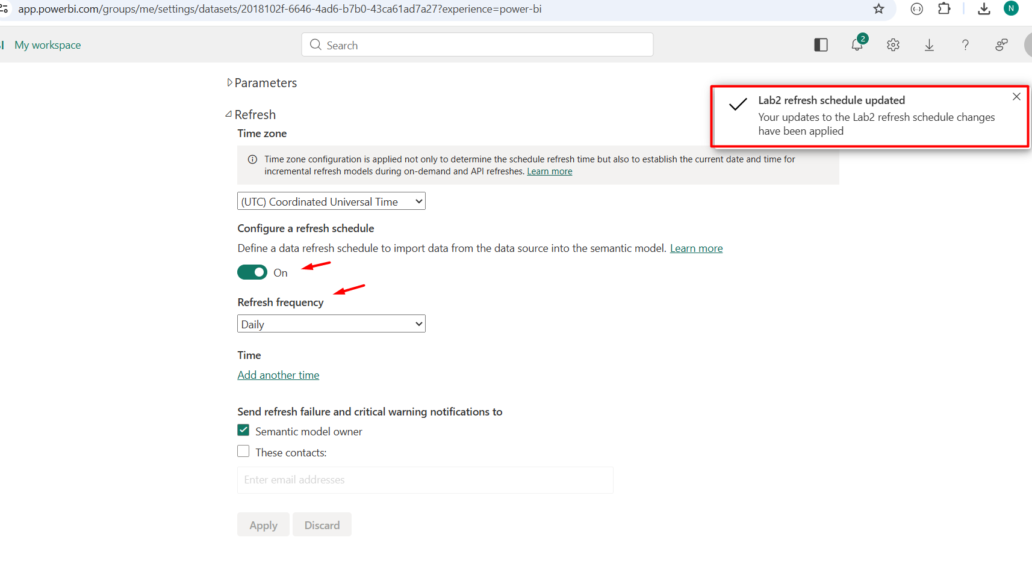
Filtered URL is added
URL link with a built-in filter (country)

