Data logical model

museum database

Contents
Business Description 3
1.1 the Benefits of implementing a database. Project Vision 3
2 Model description 3
2.1 Definitions & Acronyms 3
2.2 Logical Scheme 3
2.3 Objects 3

Business Description

the Benefits of implementing a database. Project Vision
- This project is dedicated for local museum database. It is required to track all artifacts, categorize them and store properly. Also, museum activities (exhibitions) should be documented for accountability.

Model description

Definitions & Acronyms
- PK - Primary keys (PK attributes are underlined and separated from others)
- FK - Foreign keys
- Used Data types - INT, DATE, VARCHAR,DECIMAL,TEXT,BOOLEAN
- Associative table borders are rounded
- Mandatory attributes font is bold

Tables:
- Staff – represents employees of the museum. Stores personal and contact information along with their role (e.g., Curator, Security, Facilities Manager, Admin). Staff members can be responsible for collections, exhibitions, or storage facilities.
- Storage – represents physical storage locations within the museum . Each storage unit is managed by a staff.
- Collections –logical groupings of items (e.g., “Ancient Egypt”, “Modern Art”). Each collection is stored in a specific storage location and managed by a curator responsible for its content.
- Items – represents individual museum objects or artifacts. Each item belongs to a collection and contains descriptive information, acquisition date, and current status (e.g., displayed, stored, under repair).
- Exhibitions – represents museum exhibitions or events. Includes details such as name, duration, ticket cost, format (offline/online), and the responsible staff member organizing the exhibition.
- Exhibition_items – associative table linking items to exhibitions. Tracks which items are displayed in which exhibitions.
- Visits – represents visitor activity for exhibitions (transaction table).
Core relationships:
- Different staff members may be responsible for storage facilities, collections, and exhibitions. Special roles are defined: 'Security', 'Curator', 'Facilities Manager', 'Admin'
- One storage facility is managed by one staff member
- One collection is assigned to one storage location, and each storage location hosts only one collection
- One collection is managed by one staff member (curator), one staff member may manage multiple collections
- One collection may contain many items, each item belongs to exactly one collection
- Items may or may not be displayed in exhibitions. This reflects the status ('Displayed', 'Stored', 'Under Repair')
- One item may be displayed in multiple exhibitions, and one exhibition may include multiple items
- One exhibition is organized by one staff member, one staff member may organize multiple exhibitions
- Exhibitions may or may not have associated visits (e.g., upcoming exhibitions with no visitors yet)
- One exhibition may have multiple visit records over time, while each visit record belongs to one
- Each visit record aggregates visitor activity (number of visitors and revenue) for a specific exhibition on a specific date

Logical Scheme
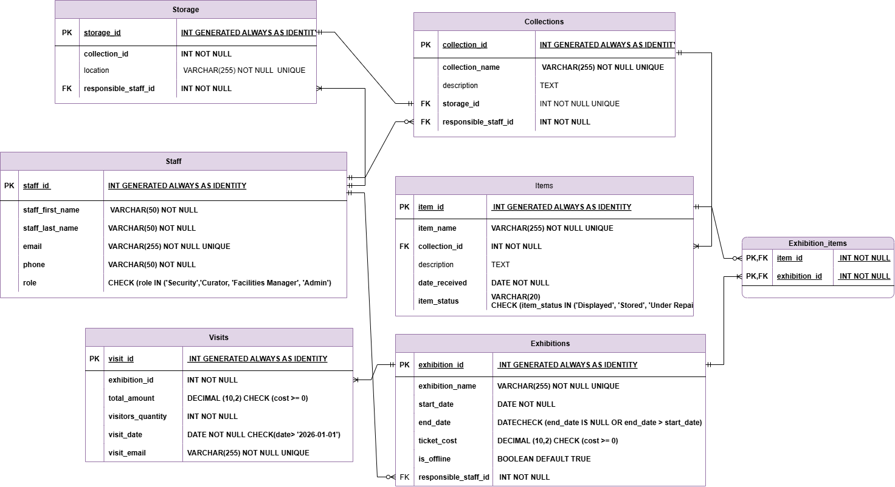

Objects
2.3.1 Table Name: Staff

Table Name | Field name | Field Description | Data Type
Staff | staff_id | Unique identifier of a staff member (PK) | INT GENERATED ALWAYS AS IDENTITY PRIMARY KEY
 | staff_first_name | First name of the staff member | VARCHAR(50) NOT NULL
 | staff_last_name | Last name of the staff member | VARCHAR(50) NOT NULL
 | email | Email address of the staff member | VARCHAR(255) NOT NULL
 | phone | Contact phone number | VARCHAR(50) NOT NULL
 | role | Role of the staff member (e.g., Curator, Security) | VARCHAR(50) NOT NULL
2.3.2 Table Name: Storage

Table Name | Field name | Field Description | Data Type
Storage | storage_id | Unique identifier of storage location (PK) | INT GENERATED ALWAYS AS IDENTITY PRIMARY KEY
 | location | Physical location name of storage | VARCHAR(255) NOT NULL
 | responsible_staff_id | Staff member responsible for storage (FK) | INT NOT NULL REFERENCES core.staff(staff_id)
2.3.3 Table Name: Collections

Table Name | Field name | Field Description | Data Type
Collections | collection_id | Unique identifier of collection (PK) | INT GENERATED ALWAYS AS IDENTITY PRIMARY KEY
 | collection_name | Name of the collection | VARCHAR(255) NOT NULL
 | description | Description of the collection | TEXT
 | storage_id | Storage location of the collection (FK) | INT NOT NULL REFERENCES core.storage(storage_id)
 | responsible_staff_id | Staff member responsible for collection (FK) | INT NOT NULL REFERENCES core.staff(staff_id)

2.3.4 Table Name: Items
Table Name | Field name | Field Description | Data Type
Items | item_id | Unique identifier of item (PK) | INT GENERATED ALWAYS AS IDENTITY PRIMARY KEY
 | item_name | Name of the item | VARCHAR(255) NOT NULL
 | collection_id | Collection to which the item belongs (FK) | INT NOT NULL REFERENCES core.collections(collection_id)
 | description | Description of the item | TEXT
 | date_received | Date when item was acquired | DATE NOT NULL
 | item_status | Current status of item (Displayed, Stored, Under Repair) | VARCHAR(20) NOT NULL

2.3.5 Table Name: Exhibitions

Table Name | Field name | Field Description | Data Type
Exhibitions | exhibition_id | Unique identifier of exhibition (PK) | INT GENERATED ALWAYS AS IDENTITY PRIMARY KEY
 | exhibition_name | Name of the exhibition | VARCHAR(255) NOT NULL
 | start_date | Start date of exhibition | DATE NOT NULL
 | end_date | End date of exhibition | DATE
 | ticket_cost | Ticket price for exhibition | DECIMAL(10,2)
 | is_offline | Indicates if exhibition is physical (offline) | BOOLEAN
 | responsible_staff_id | Staff member responsible for exhibition (FK) | INT NOT NULL REFERENCES core.staff(staff_id)

2.3.6 Table Name: Exhibition_items
Table Name | Field name | Field Description | Data Type
Exhibition_items | item_id | Reference to item displayed (PK, FK) | INT NOT NULL REFERENCES core.items(item_id)
 | exhibition_id | Reference to exhibition (PK, FK) | INT NOT NULL REFERENCES core.exhibitions(exhibition_id)

2.3.7 Table Name: Visits

Table Name | Field name | Field Description | Data Type
Awards | visit_id | Unique identifier of visit record (PK) | INT GENERATED ALWAYS AS IDENTITY PRIMARY KEY
 | exhibition_id | Exhibition being visited (FK) | INT NOT NULL REFERENCES core.exhibitions(exhibition_id)
 | total_amount | Total revenue from visit | DECIMAL(10,2) NOT NULL
 | visitors_quantity | Number of visitors | INT NOT NULL
 | visit_date | Date of visit | DATE NOT NULL
 | visit_email | Contact email associated with visit | VARCHAR(255) NOT NULL

