Цель работы

Целью данной лабораторной работы является ознаĸомление с работа с струĸтура доĸумента LaTeX.

Задание

. Try adding text to your first document, typesetting and seeing the changes in your PDF.
. Make some different paragraphs and add variable spaces.
. Explore how your editor works; click on your source and find how to go to the same line in your PDF.
. Try adding some hard spaces and see how they influence line-breaking.

Теоретичесĸое введение

\documentclass{article}
\usepackage[T1]{fontenc}
\begin{document} Hey world!
This is a first document.
\end{document}

(см. Рис. [-@fig:001]).
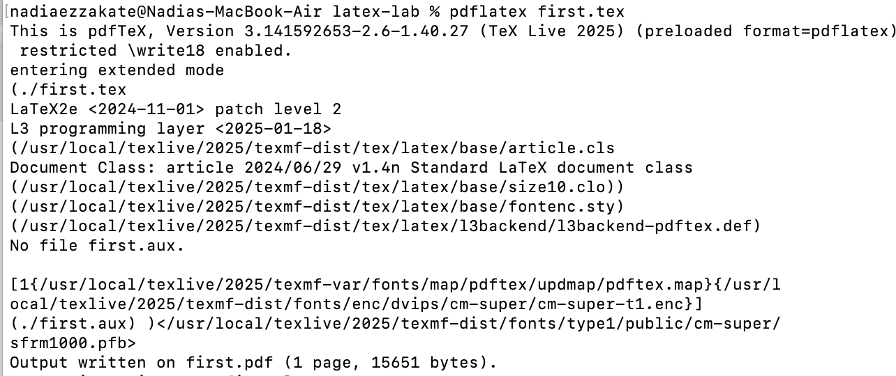
{ #fig:001 width=100% }
Running LaTeX
(см. Рис. [-@fig:002]).

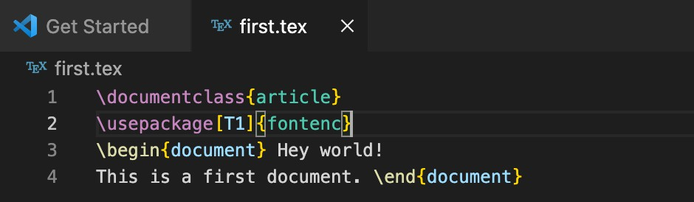
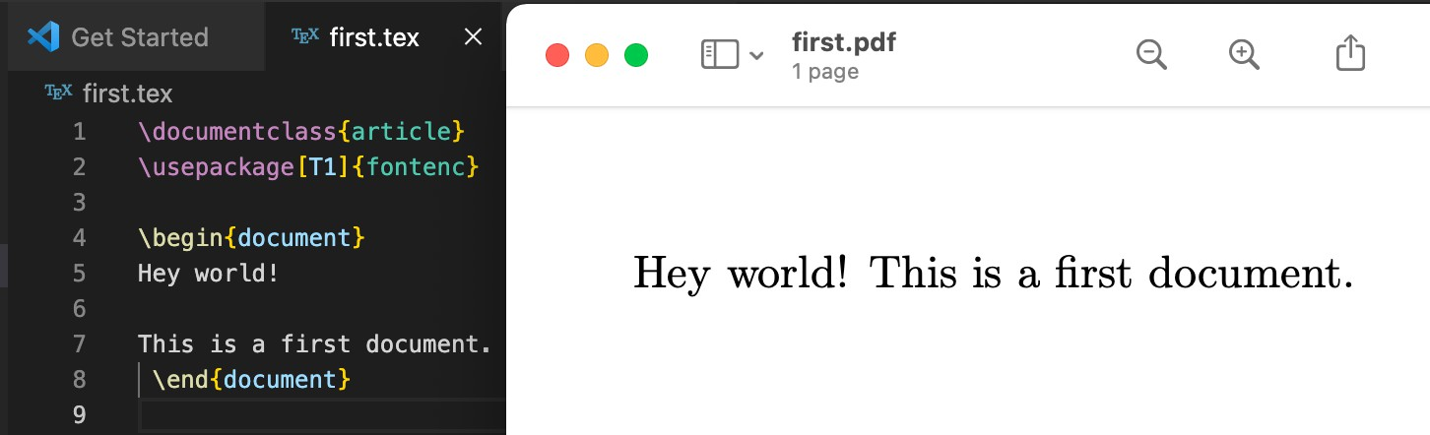
{ #fig:002 width=100% } (см. Рис. [-@fig:003]).

{ #fig:003 width=100% }

Выполнение лабораторной работы

Try adding text to your first document, typesetting and seeing the changes in your PDF.
(см. Рис. [-@fig:004]).

{ #fig:004 width=100% }
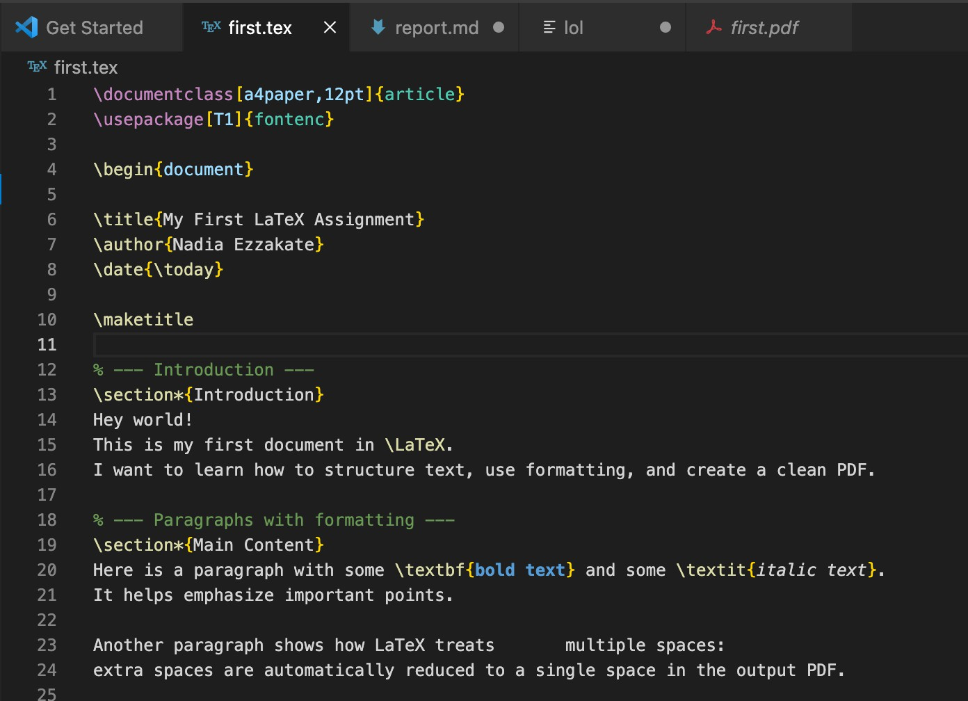
{ #fig:004 width=100% }

\documentclass[a4paper,12pt]{article}
\usepackage[T1]{fontenc}

\begin{document}

\title{My First LaTeX Assignment}
\author{Nadia Ezzakate}
\date{\today}

\maketitle

% --- Introduction ---
\section*{Introduction} Hey world!
This is my first document in \LaTeX.
I want to learn how to structure text, use formatting, and create a clean PDF.

% --- Paragraphs with formatting ---
\section*{Main Content}
Here is a paragraph with some \textbf{bold text} and some \textit{italic text}.
It helps emphasize important points.

Another paragraph shows how LaTeX treats
multiple spaces:
extra spaces are automatically reduced to a single space in the output PDF.

% --- Hard spaces ---
Sometimes we need words to stay together:
Dr.~Brown lives in New~York~City.
The tilde (~) keeps these words on the same line.

% --- Lists ---
Here is a small list of things I want to remember about LaTeX:
\begin{itemize}
\item Paragraphs are separated by blank lines.
\item Special characters like \%, \$, \#, \_ must be escaped.
\item Footnotes add extra information without breaking the text\footnote{This is an example footnote.}.
\item Hard spaces (~) prevent unwanted line breaks.
\end{itemize}

% --- Conclusion ---
\section*{Conclusion}
Overall, creating this document helped me understand the basics of LaTeX: paragraphs, formatting, lists, footnotes, and spacing.
I am ready to explore more advanced features in the next assignments.

\end{document}
Make some different paragraphs and add variable spaces.
(см. Рис. [-@fig:005]).

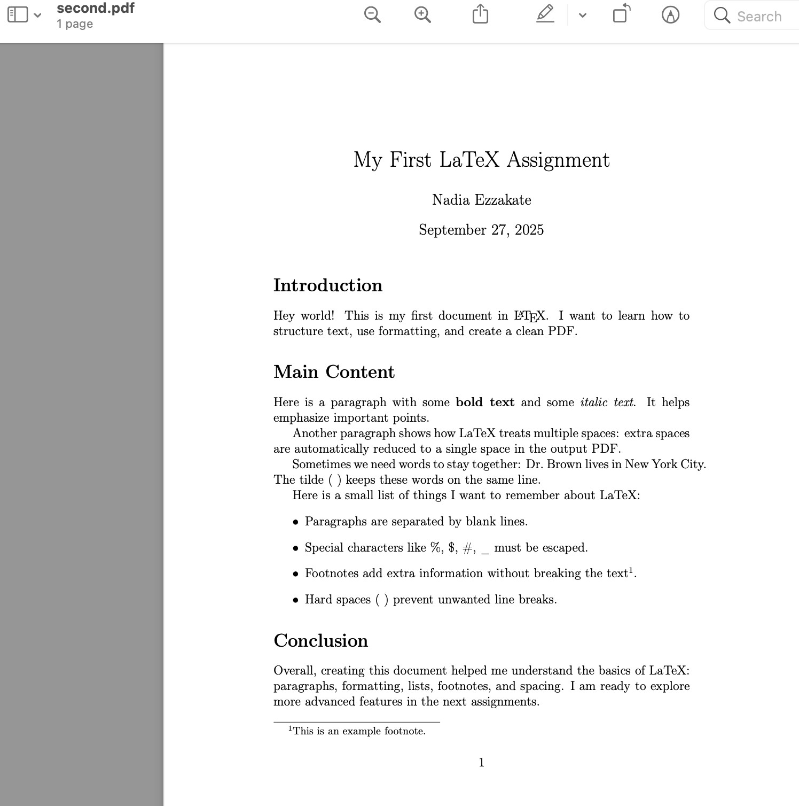
{ #fig:005 width=100% }
Explore how your editor works; click on your source and find how to go to the same line in your PDF.
Try adding some hard spaces and see how they influence line-breaking.

{ #fig:005 width=100% } (см. Рис. [-@fig:006]).

{ #fig:005 width=100% }

