Lab 06 Report: Bibliography in LaTeX
Nadia Ezzakate | March 13, 2026

Objective
To learn how to create and manage bibliographies in LaTeX using BibTeX and the natbib package.

Files Created
- lab06.tex - Main LaTeX document with citations
- references.bib - Bibliography database with references

Bibliography Database (references.bib)
@book{knuth1984, author = {Knuth, Donald E.}, title = {The TeXbook}, publisher = {Addison-Wesley}, year = {1984} }
@book{lamport1994, author = {Lamport, Leslie}, title = {LaTeX: A Document Preparation System}, publisher = {Addison-Wesley}, year = {1994} }
@book{goossens1993, author = {Goossens, Michel and Mittelbach, Frank and Samarin, Alexander}, title = {The LaTeX Companion}, publisher = {Addison-Wesley}, year = {1993} }
text

Compilation Process
To create a document with bibliography, we need multiple compilation steps:
- pdflatex lab06.tex - Creates .aux file with citation info
- bibtex lab06 - Reads .aux and .bib, creates .bbl file
- pdflatex lab06.tex (twice) - Incorporates bibliography and resolves references

Results

Citations in the Text
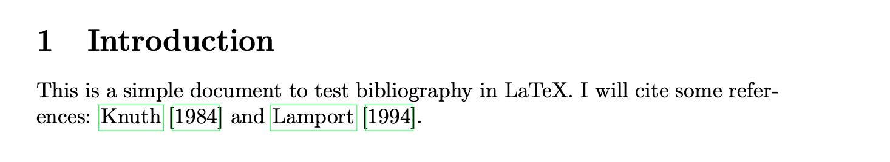
Citations using citet and citep

More Citation Examples
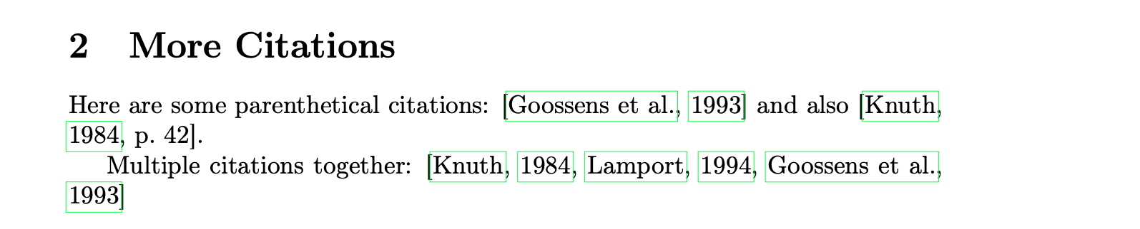
Parenthetical citations and page numbers

Generated Bibliography
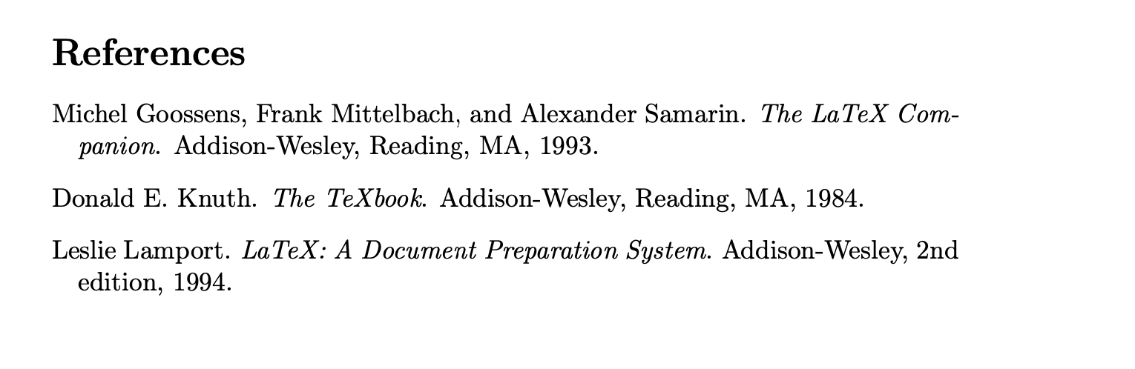
Final bibliography automatically formatted

Citation Commands
Command | Result
\citet{knuth1984} | Textual citation: Knuth (1984)
\citep{lamport1994} | Parenthetical citation: (Lamport, 1994)
\citep[p.~42]{knuth1984} | Citation with page number: (Knuth, 1984, p. 42)
\citep{knuth1984,lamport1994} | Multiple citations: (Knuth, 1984; Lamport, 1994)

Observations
- \citet produces textual citations (author as part of sentence)
- \citep produces parenthetical citations (author in parentheses)
- BibTeX automatically formats all references consistently
- The plainnat style organizes references alphabetically by author

Conclusion
In this lab, I learned: - How to create a .bib file with references - Different citation commands in natbib - The multi-step compilation process for bibliography - How LaTeX automatically formats references
The bibliography system in LaTeX saves time and ensures consistent formatting of references.

